Remote Home

Installation, Maintenance, and User Guide| Current Version [0.8]

Prepared By:

James Wiegand

Christopher Jensen

Brian Vogal

Revision History

|  |  |  |  |
| --- | --- | --- | --- |
| **Date** | **Author** | **Version** | **Comments** |
| 4/23/13 | James Wiegand | 1.0.0 | Initial version added headers and all of section 4 |
| 4/23/13 | Brian Vogel | 1.0.0 | Garage door controller section completed |

Table of Contents

1.0 Welcome 4

2.0 Garage Door Controller 5

2.1 Overview 5

2.2 Installation 5

2.3 Use 5

2.4 Maintenance 5

2.5 Troubleshooting 5

3.0 Base Station 6

3.1 Overview 6

3.2 Installation 6

3.3 Use 6

3.4 Maintenance 6

3.5 Troubleshooting 6

4.0 iPhone Application 7

4.1 Overview 7

4.2 Installation 7

4.3 Use 7

4.3.1 First Time Run Screen 7

4.3.2 First Time Register New Base Station Screen 7

4.3.3 Base Station View Screen 7

4.3.4 Base Station Information Screen 8

4.3.5 Register New Base Station Screen 8

4.3.6 Device Viewer Screen 8

4.3.7 Garage Door Controller 8

4.3.8 Error Screen 8

4.4 Troubleshooting 8

# Welcome

Welcome to your new Remote Home product. In this document we will walk you through all the steps needed to install and use your Remote Home product. Please make sure to follow the steps in the order that they are presented to you.

# Garage Door Controller

## Overview

The first step when installing your remote home system is setting up your garage door controller. The garage door controller is the device that will physically activate your garage door when you use the remote home system. Please make sure that your garage door is compatible with the remote home system before trying to install the garage door controller.

## Installation

The first step to installing the garage door controller is connecting the garage door controller to the garage door motor.

* Insert the two stripped wires into the two slots used for the wall mounted control console as demonstrated in figure 1. (Note: It does not matter which wire is inserted into each slot as long as the slots used are the same as the wall mounted control console.)

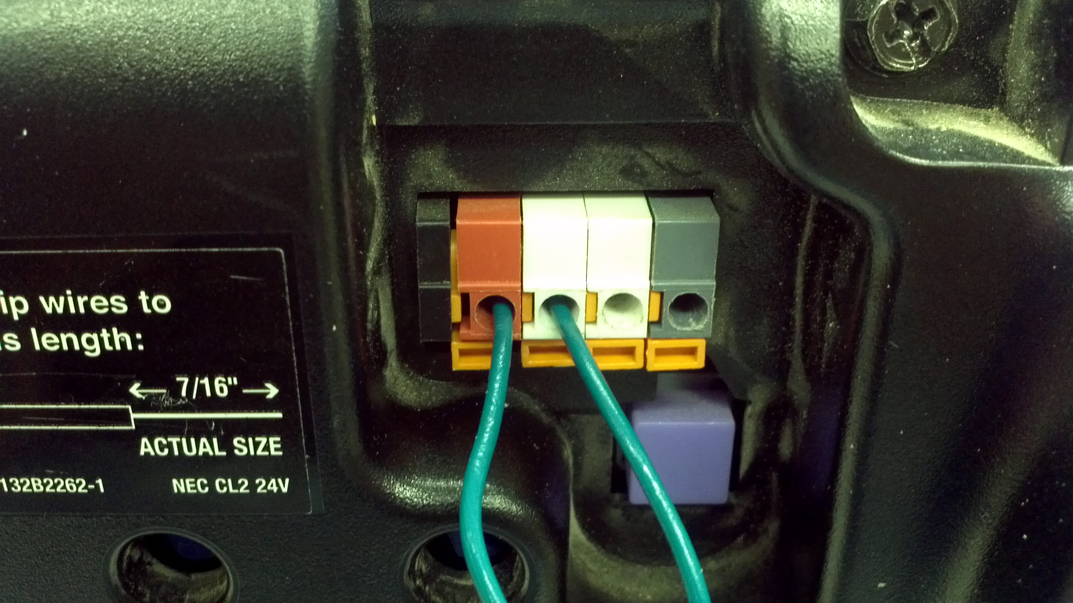

Figure

The second step to installing the garage door controller is positioning the two remote home sensors.

* The sensor labeled “open” should be positioned at the top of the garage door guide rail. The “open” sensor should be fixed so that when the garage door is completely open, the “open” sensor should be completely connected.
* The sensor labeled “closed” should be positioned at the bottom of the garage door guide rail. The “close” sensor should be fixed so that when the garage door is completely closed, the “closed” sensor should be completely connected.

The final step to installing the garage door controller is connecting the garage door controller to the base station.

* Remove the USB 2.0 A/B cable, included with the garage door controller, from its packaging. Insert the USB B side into the proper slot on the garage door controller and insert the USB A side into the proper slot on the base station.

Congratulations, you have now successfully installed the garage door controller. You may now continue to section 3.0 for instructions on how to install the base station for your remote home system.

## Use

The base station, which is installed in the next section, will automatically connect and activate the garage door controller. If the garage door is not automatically connecting with the base station, please read the troubleshooting sections for either the Garage Door Controller or the Base Station.

## Troubleshooting

* The garage door controller will not turn on.

If the garage door controller will not turn on, then the battery has died. Replace the 9v battery connected to the garage door controller with a fresh 9v battery. If the garage door controller will still not turn on after the 9v battery has been replaced, then please contact customer support.

* My garage door will not open.

If the garage door controller is not opening your garage door, then check the connection with the base station. Make sure that it is properly connected both at the garage door controller and the base station, and that the base station is registering that a device is connected to it. If this problem persists, then please contact customer support.

* The iPhone application says that my garage door is open/closed/partially open when it is not open/closed/partially open.

If the iPhone application is reporting an incorrect position of your garage door, back out of garage door controller screen on your iPhone application. Check the remote home sensors at the top and bottom of your garage door guide rail. Make sure the top sensor is completely connected when the garage door is completely open and the bottom sensor is completely connected when the garage door is completely closed. Reenter the garage door controller screen on your iPhone application. If this problem persists, then please contact customer support.

# Base Station

## Overview

## Installation

## Use

## Maintenance

## Troubleshooting

# iPhone Application

## Overview

By this point you have installed the garage door controller and set up the base station. The final step in establishing your Remote Home system is to download and install the Remote Home App on your iPhone, iPad, or iPod touch. This application will allow you to control your garage door from any Wi-Fi, 3G, or 4G connection. Please make sure that you are running the latest version of iOS before attempting this step.

## Installation

To install the Remote Home Application please access the Apple App Store. Touching the App Store icon on your iPhone, iPad, or iPod Touch home screen can access the Apple App Store. Once you are connected to the App Store search Remote Home to find the Remote Home App. Once you have found the App download the app to your iPhone, iPad, or iPod Touch.

## C:\Users\1891613\Downloads\Archive\iOS Simulator Screen shot Apr 23, 2013 4.23.37 PM.pngUse

### First Time Run Screen

When running the app for the first time, you will be presented with the first time run screen. This screen will instruct you to setup the base station and device controllers. Once you have setup the base station and controllers, please note the model number located on your base station and the password you selected when setting up the base station. This information will be needed to set up your first base station. If you have multiple base stations you can set them up from the main base station screen. Once you are ready hit the continue screen.

### C:\Users\1891613\Downloads\Archive\iOS Simulator Screen shot Apr 23, 2013 4.23.59 PM.pngFirst Time Register New Base Station Screen

Once you hit continue on the First Time Run Screen you will be presented with a base station registration dialogue. You may use this dialogue to register your first base station. For this step make sure that you have an active Wi-Fi, 3G, or 4G connection. To register a base station please enter the serial number (located on the base station), a name of your choosing (such as my home, or my office), then finally enter the password you selected when setting up the base station. Once the information is entered correctly you can hit the register button. The iPhone will then connect to the Remote Home network and locate your base station. Once the device is successfully registered you will be notified and the base station view screen will be presented.

### Base Station View Screen

On this screen you can view each and every base station that you have registered. In addition you can register new base station, select a base station to connect to, view and update base station information, and finally delete a base station.

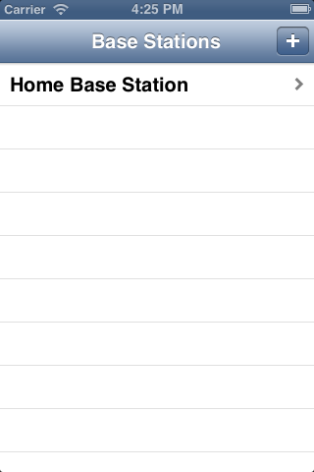

To select a base station tap the base station you wish to connect to. A menu at the bottom of the screen will appear with two options.

* Edit base station : This will produce a new view where you can edit the name and password of an existing base station. (See section 4.3.4)
* Connect to base station : This view will attempt to connect to a base station that you have registered. Please note that this action requires an active Wi-Fi, 3G, or 4G connection. Once you have successfully connected to a base station you can then chose a controller to interact with. (See section 4.3.6)

In addition to this two option you may choose to cancel this operation.

To add a new base station simply tap the + button in the upper right hand corner to present the register new base station view. To delete an existing base station slide your finger from right to left in one motion across the cell of the base station you wish to delete. Once you do this, a red delete button will appear on the right hand side of the screen. Tap this delete button to delete a base station from your list of base stations.

### C:\Users\1891613\Downloads\Archive\iOS Simulator Screen shot Apr 23, 2013 4.25.52 PM.pngBase Station Information Screen

This screen will allow you to view and update information pertaining to your base station. From this view you can change the name or credentials needed to access your base station, also diagnostic information is presented at the bottom of the screen. To change the name of your base station simple change the name that is in the name field of this screen once that is done press the update button. Once you have done that you will be brought back to the base station view screen. To change the password to connect to your base station simply delete the existing password and enter the new password that you set up at the base station. In the event that you need assistance with your base station a technician might request the diagnostic information presented at the bottom of the screen. Please have this information ready for a technician if you require assistance.

### Register New Base Station Screen

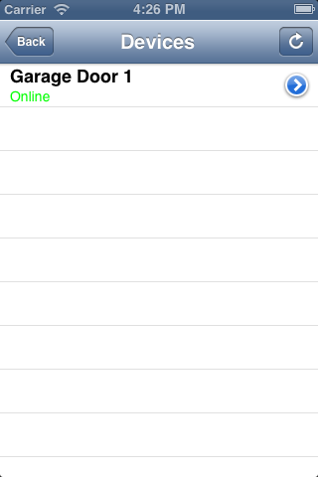This screen will allow you to register new base stations. Please make sure that you have an active Wi-Fi, 3G, or 4G connection before you use this screen. To register a base station please enter the serial number (located on the base station), a name of your choosing (such as my home, or my office), then finally enter the password you selected when setting up the base station. Once the information is entered correctly you can hit the register button. The iPhone will then connect to the Remote Home network and locate your base station. Once the device is successfully registered you will be notified and you can then register another base station or use the back button to return to the Base Station List View.

### Device Viewer Screen

This screen will allow you to view the devices connected to a base station and select those devices so that you may operate them. Please make sure that you have an active Wi-Fi, 3G, or 4G connection before you use this screen. Each device will have a name and a status. You can set the name of the individual devices from the base station. The status will be either online or offline. If a device is online the status text will be green if a device is offline the status text will be red. If you tap on an online device you will be presented with the correct device controller and will be able to operate the device. If you click on an offline device you will be presented with the error status screen (see 4.3.8).

### C:\Users\1891613\Downloads\Archive\iOS Simulator Screen shot Apr 23, 2013 5.22.30 PM.pngGarage Door Controller

This screen will allow you to interact with your garage door. Please make sure that you have an active Wi-Fi, 3G, or 4G connection before you use this screen. When you first connect the device will take a moment to check the state of your garage door. There are three states. The open state is when your garage door is fully open. The close state is when your garage door is fully closed. The indeterminate state is when your garage door is neither open nor closed. The indeterminate state indicates that the safety sensor attached to your garage door has been activated. Most of the time this is due to an obstruction. Please clear the obstruction and try to close your garage door again. The status of your garage door will be indicated by the garage door animation in the center of the screen. The door is open when the image is black, the door is closed when the door is red, and the door is in a indeterminate state when the door is partially red and black. To open and close the door please use the button at the bottom of the screen. This button will tell you the action you will take if you press the button. If the button reads “open” you will open the door if you press the button. Likewise if the button reads “close” you will close the door when you press the button.

### C:\Users\1891613\Downloads\Archive\iOS Simulator Screen shot Apr 23, 2013 5.24.46 PM.pngError Screen

In the event that there is an error with a device, or a device is offline, this screen will present you with some basic troubleshooting information for how to resolve the problem. The device information will be presented on this screen showing you the device name, device serial number, and an error code. The error code presented can be used by a technician to help diagnose problems with your device. In the even that a device is listed as offline please follow the onscreen instruction to attempt to rectify the issue. If the issue persists after you have followed the onscreen instruction please contact customer support.

## Troubleshooting

* When I try and register a new base station I get the message “Could not contact the registration server”

If you receive this message please check your Internet connection. It is possible that your device is disconnected from your Wi-Fi, 3G, or 4G network. If the device is not connected please try again later. If this problem persists for an extended duration please contact customer support

* When I try and register a new base station I get the message “There was an error with the registration. Please try again later.”

If you receive this message please try registering this base station at a later time. If this problem persists for an extended duration please contact customer support.

* When I try and register a new base station I get the message “"The station ID was not found.”

If you receive this message please make sure that your base station is set up properly and connected to the Internet. If the base station is connected to the Internet please try registering the base station at a later time. If this problem persists for an extended duration please contact customer support.

* When I try and connect to a base station I get the message “The password was rejected.”

If you receive this message please check that your password for the base station on your iPhone, iPad, or iPod touch matches the password on the base station. If you cannot remember the password on the base station please reset the password on the base station then update the settings on your phone (See section 4.3.4).

* When I try and connect to a base station I get the message "There was an error with the connection.”

If you receive this message please ensure that your network connection is stable (not disconnecting intermittently). If you are unable to confirm the stability of your connection try a Wi-Fi connection or a new wireless network. If that does not work try again at a later time. If this problem persists for an extended duration please contact customer support.

* When I try and connect to a base station I get the message "Please re-register your base station from the base station portal.”

If you receive this message please reset your base station wait 10 minutes and try to connect again. If this problem persists for an extended duration please contact customer support.

* When I try and connect to a base station I get the message “Please update your base station address from the base station portal”

If you receive this message please reset your base station wait 10 minutes and try to connect again. If this problem persists for an extended duration please contact customer support.

* When I try and connect to a base station I get the message “There was an error with the registration. Please try again later.”

If you receive this message please try registering this base station at a later time. If this problem persists for an extended duration please contact customer support.

* When I try and connect to a device I get the message “The password was rejected.”

If you receive this message please check that your password for the base station on your iPhone, iPad, or iPod touch matches the password on the base station. If you cannot remember the password on the base station please reset the password on the base station then update the settings on your phone (See section 4.3.4)

* When I try and connect to a device I get the message “"There was trouble connecting to the base station.”

If you receive this message please ensure that your base station is turned on and try again. If that does not work please try again at a later date. If this problem persists for an extended duration please contact customer support.

* When I try and use the garage door controller I get the message "Could not connect to your base station"

If you receive this message please make sure that your base station is turned on and try again. If that does not work please try again at a later date. If this problem persists for an extended duration please contact customer support.

* When I view the error screen for an offline device the troubleshooting box reads "Unknown error code.”

If you receive this message please contact customer support.