

CONOPS Document
  - STBMF
  - David Jarman
  - Kevin Worner
  - Marshall Gaucher

- A description of system in an operational mode
  - One or more modes of operation can exist
- Typically a Process Model of one or more of the functions that the system is supposed to perform
- Point-Of-View based model of how a system will function – Multiple POVs are needed
  - User
  - Operator
  - Maintainer/Service Provider
  - Builder
  - Security
  - End-of-Life Disposal

- Helps to find hidden, assumed, or implied needs
- I Helps solidify systems expectations of the users
- I Helps solidify systems expectations of other stake holders
- I Helps to determine the boundaries of sub-systems or functions
- I Helps to determine controlling mechanisms
- I As the starting point for the requirements
- I As a guide to requirements verification or how to test the requirements

Table of Contents
Table of Figures 2
1. Scope 2
2. Reference Documents 2
3. Current System 3
4. Justification and nature of proposed changes 3
5. Deliverables 3
6. Analysis of Proposed System 4
6.1 User of Games 4
7. Summary of Impacts 11

Table of Figures
Figure 1 - Main Menu 4
Figure 2- Apps submenu 5
Figure 3- Games submenu 6
Figure 4 - New Tile Puzzle Game 7
Figure 5 - Settings Popover 8
Figure 6 - Statistics Popover 9
Figure 7 - Help Popover 10
Figure 8 – Gameplay 11

Scope
This document is meant to define the operating environment as it relates to the end-user, game developer, and server maintenance team. The Set Top Box Multiplayer Framework is currently under development by team Plugged In as a Senior Design Project, under the direction of Brian Butterfield and David Springhetti of Innovative Systems L.L.C.

Reference Documents

2.1 IPTV Middleware Architecture and Design

Current System

  - The games will run on Amino Set Top Boxes. These STBs run a custom build of QT, binded to C++. The game server software will be written in C# and must be able to run under .NET 4.5. The server should be able to operate in a Windows or Azure operating system.
  - The multi-player game environment will consist of:

    - One or more APMaxes
    - Amino Set Top Boxes
    - One game server
    - One or more individual servers dedicated to A.I. processing
  - The multi-player game environment will be spread cross country and distributed over many systems already in place. The environment follows the client-server model with an added element in the middle, the APMax, known as middleware.

Justification and nature of proposed changes

  - Copy and pasted from Kiosk team Team Changes – Any changes to the requirements by team KDM must be approved by the project sponsor, Innovative Systems L.L.C.
  - Company Changes – Any changes to the requirements by Innovative Systems L.L.C. to the project must be reviewed and approved.

Deliverables
  - Software Requirements Document
  - Software Design Document
  - Release of server-side software
  - Several games as a proof of concept

Analysis of Proposed System

Subscribers
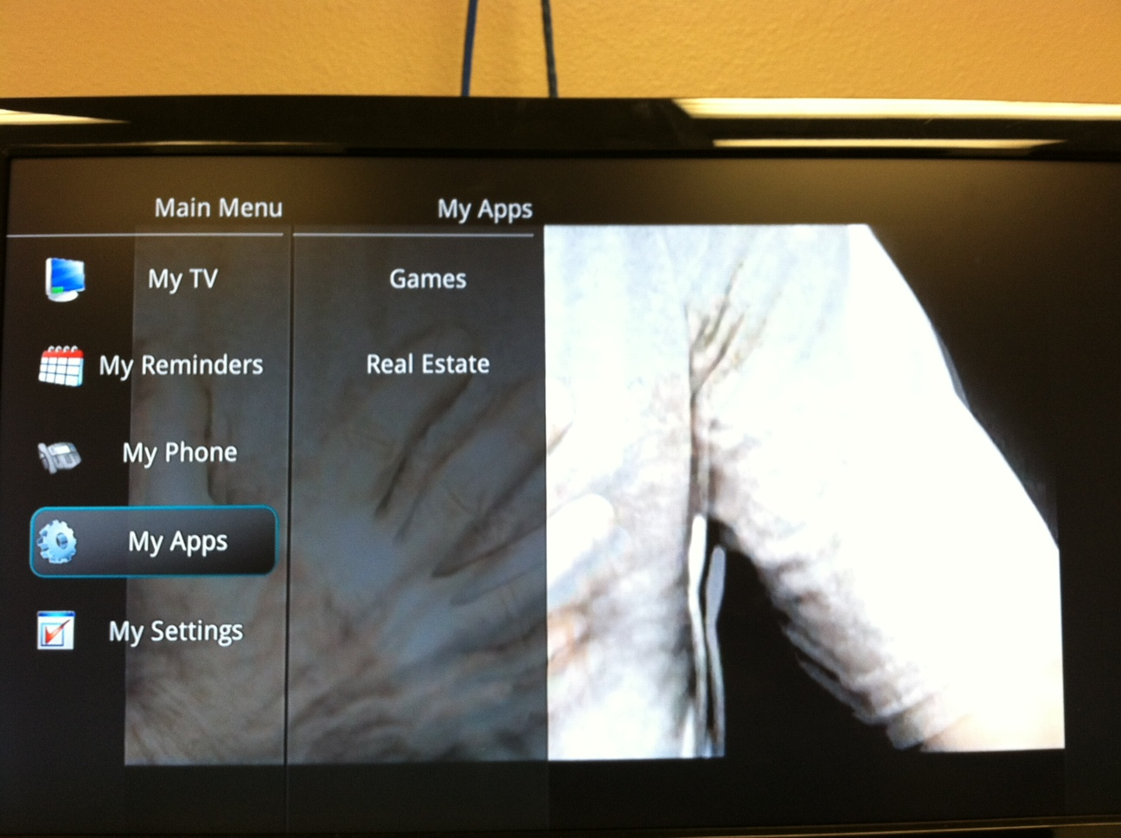
Figure 1 - Main Menu
If a user decides to play a game while using their STB, they will pull up the main menu by pressing the Menu button on their remote control. Now, they will see an option called “My Apps”, and when scrolled over, a submenu will appear that shows Games.
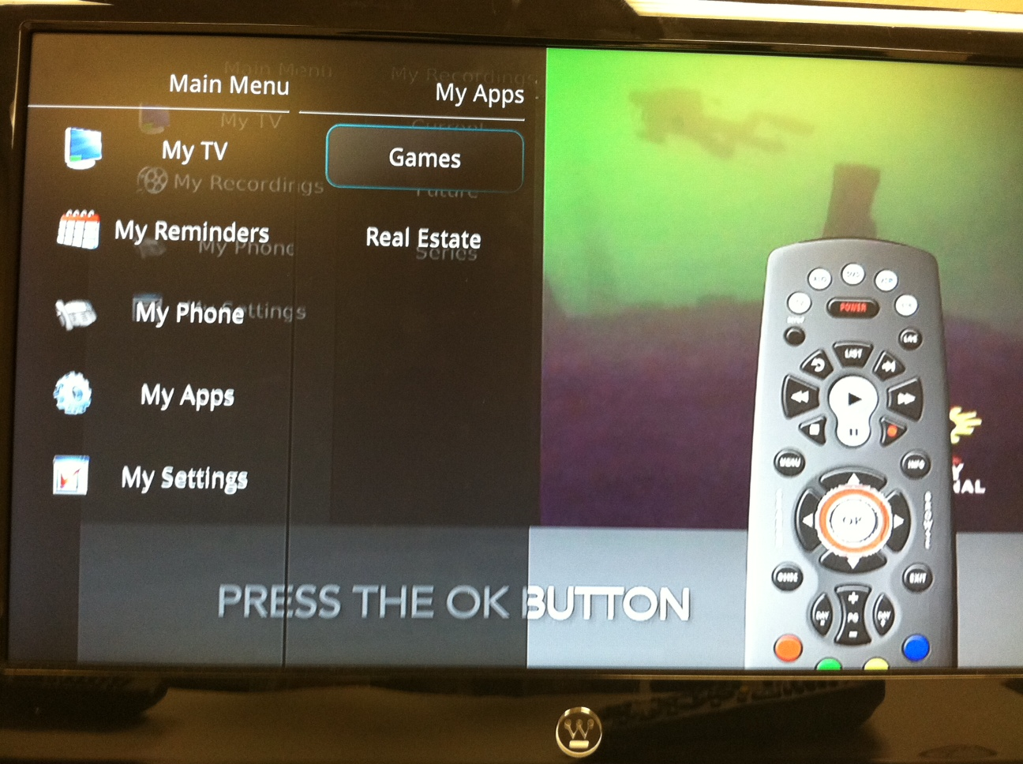
Figure 2- Apps submenu
Once the user scrolls over to the Apps submenu, they will be able to choose the Games App by pressing OK.
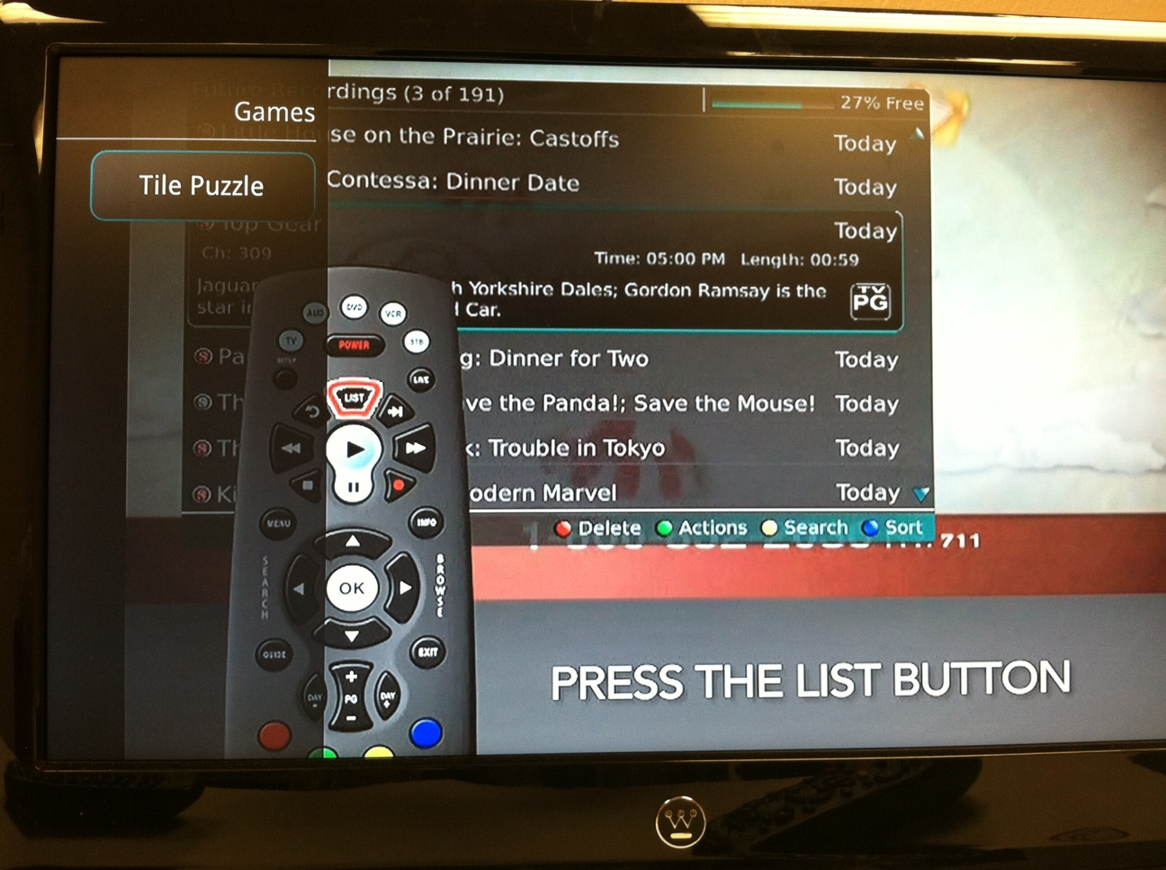
Figure 3- Games submenu
Now that the user has entered the Games submenu, a list of games will appear. Here, there is only one game currently available, but each time this menu is entered, a new list will be retrieved from the server, so when there are more games available, the user will be able to see them. Now that Tile Puzzle is selected, if the user hits OK on their remote, the game will be downloaded and started.
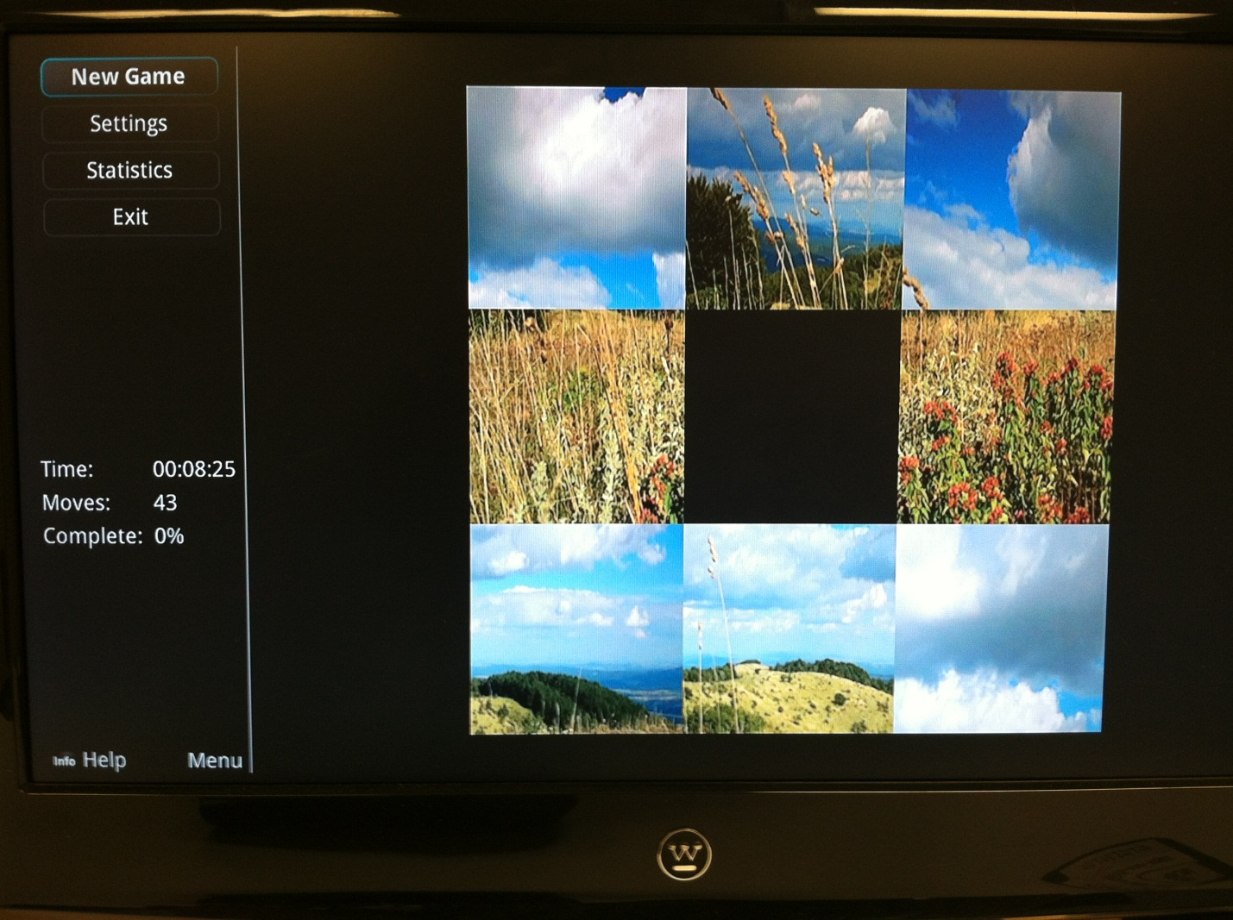
Figure 4 - New Tile Puzzle Game
For all games, there will be a menu on the left, as shown above, with a set of static base commands. Here, we can start a new game, change settings, view statistics, or exit the game. If the user hits the Info button on their remote control, a help screen will also appear. Each game can add options to this menu, but cannot remove these base options.
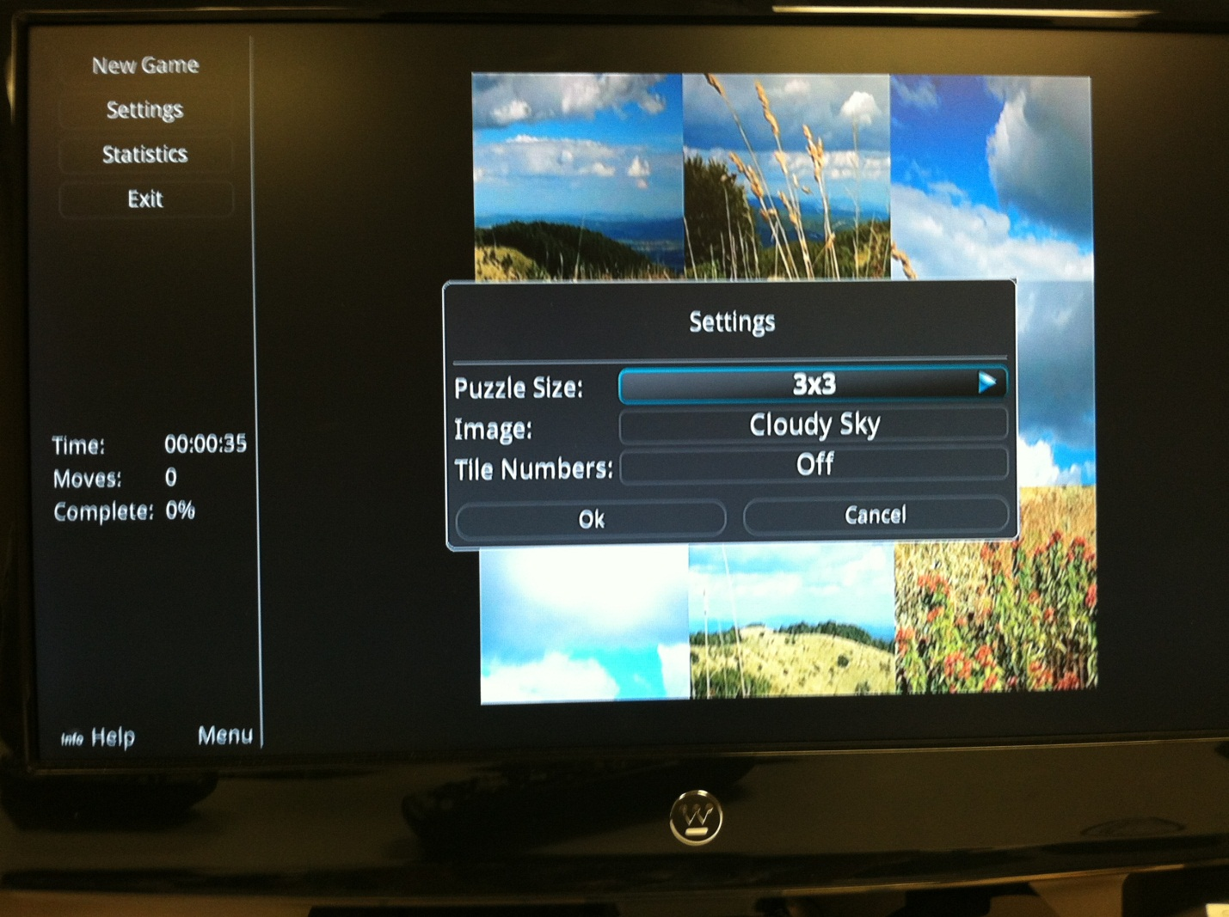
Figure 5 - Settings Popover
When the settings option is pressed, a simple popover is brought up so the user can change personal preferences, difficulties, levels, etc. Here, when the user is done, they can either hit OK to save changes or Cancel to discard the changes and resume play.
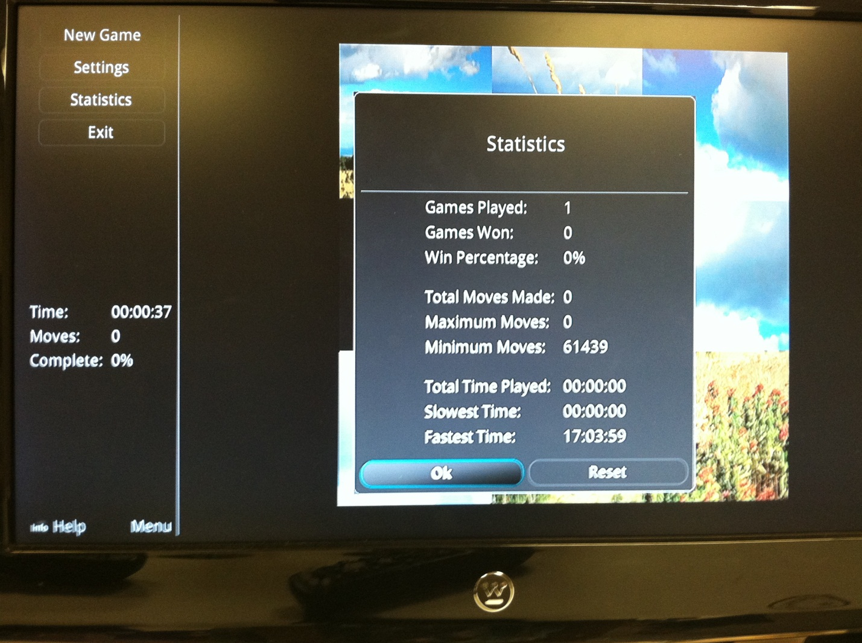
Figure 6 - Statistics Popover
If the user wants to see their statistics of a game, they can bring up the statistics popover and view different stats that cover the lifetime of the game, or since the last reset. When the user is done, they can either select the Ok option or hit Exit on their remote. If a user feels the need to reset the statistics, they can also do this by selecting the Reset option.
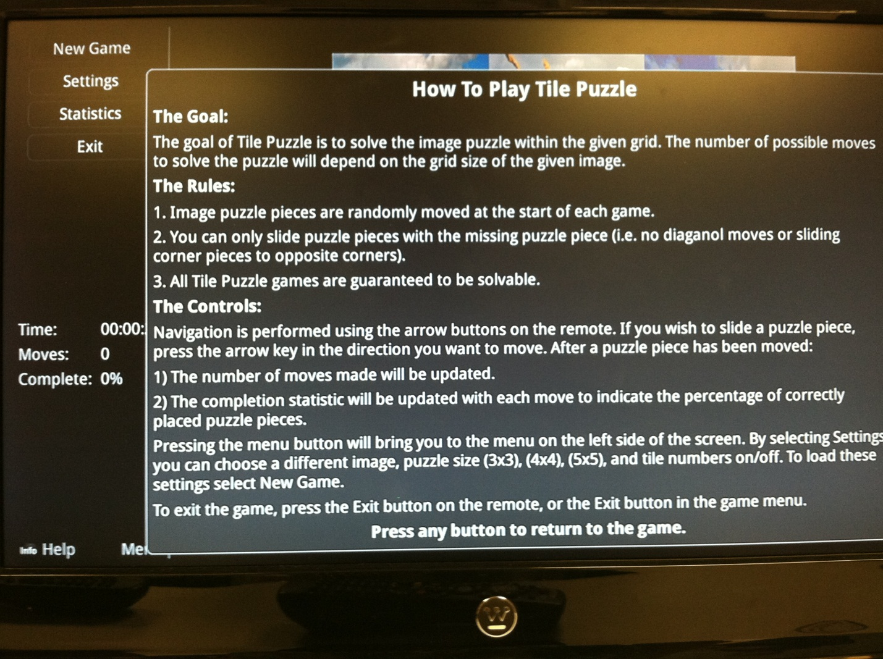
Figure 7 - Help Popover
At any time during gameplay, the user can hit the Info button their remote and bring up the Help popover. When the user is done reading and wants to return to the game, any button press will exit the popover.
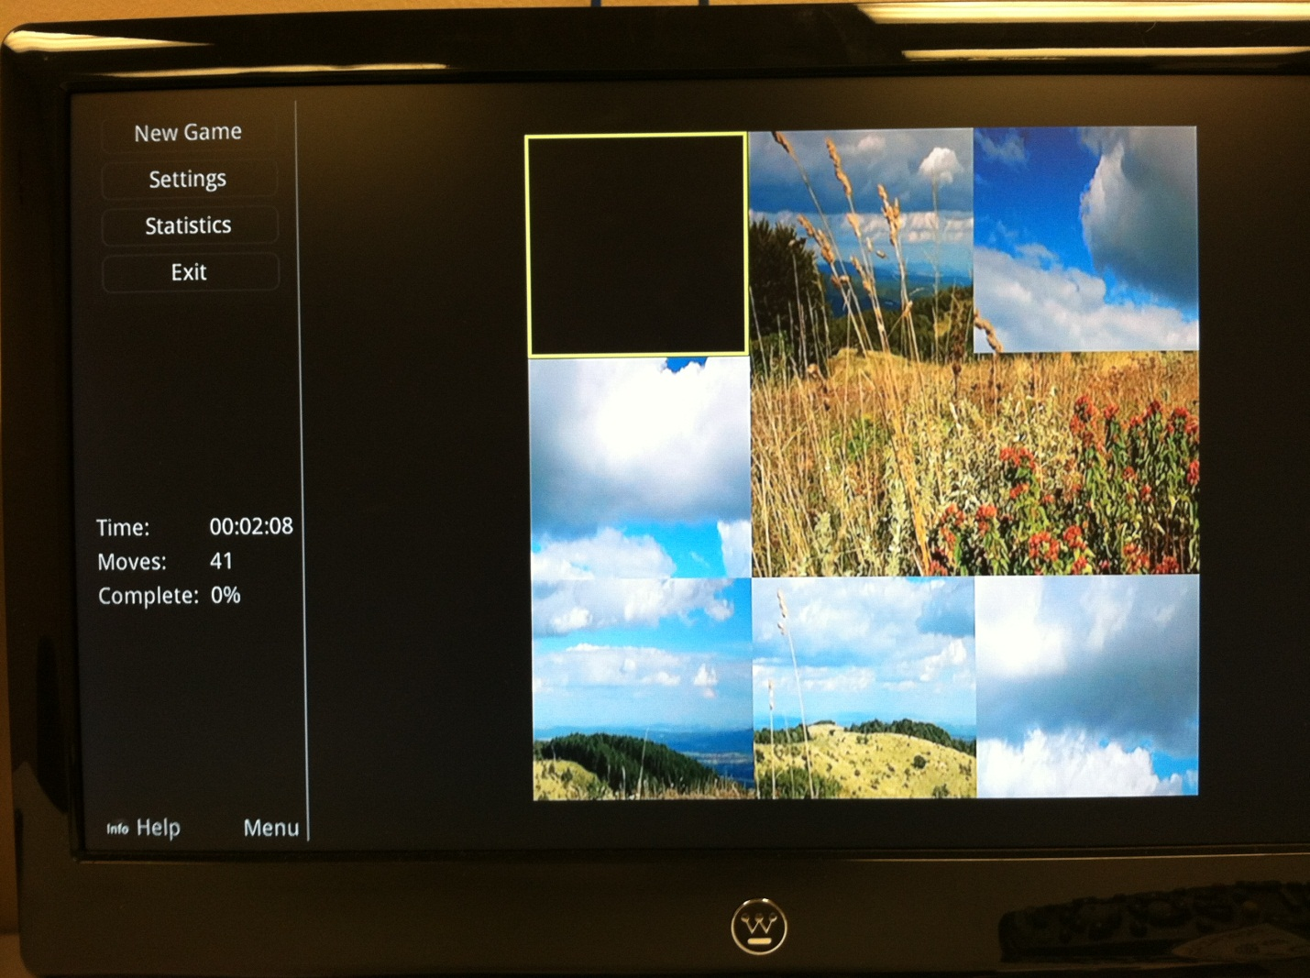
Figure 8 – Gameplay
To the right of the menu, the actual gameplay will take place. Here, arrow keys on the remote will assist the user in playing the game. Remote control buttons functions will vary on each game, but each game should have a similar feel and the user should not have to completely relearn how to play each game. At any time during the game, the user can press the Menu button and the focus of the game will return to the menu on the left. To return focus to the game, the user must press the right arrow button. Also, by pressing the Exit key at any time in the game (other than the Help menu), the game will exit and the user will be brought back to their previously tuned channel.

Summary of Impacts

Client
Innovative Systems’ clients will have another new and unprecedented feature to attract new subscribers and keep existing subscribers interested in their services. Once the system is in place, adding new games will have little to no cost for the client, since all game development will be done by Innovative Systems.

Subscriber
Subscribers will have another channel of entertainment on their STBs that will allow them to interact socially with other subscribers around the nation.

