SDM-Spice

Requirements and Specifications
Capstone Design Project
Department of Electrical Engineering and Computer Science
South Dakota School of Mines & Technology

Submitted On
October 30, 2025

Submitted By
Jonathan Gibbs
Jeremy Friedrichsen
Marc Tchona
Micah Greenfield

Functional Requirements and Specifications

Design Constraints
The Spice program must be compliant to the following design constraints:
- It must be able to run on Python 3.17
- SDM-Spice must be designed with PyQt version 6
- SDM-Spice must be able to load JSON files, which will be the circuits the user is designing
- SDM-Spice must be able to send a netlist file to NG-Spice for simulation
- SDM-Spice must be able to run on Windows, and should strive for platform independence
- SDM-Spice must be able to output any circuit built into a JSON file, no larger than 2Gb
- SDM-Spice must be able to run at smallest 960*1080 resolution, such that the program can be run with another program on the same 1920*1080 monitor
- SDM-Spice has an optional minimal budget to cover AI licensing and EE component kits for testing.

System Features and Requirements
The above design constraints does impact the potential design. For starters, due to the use of python we are able to be platform independent from the start, while still using OS calls due to the abstraction python provides. In addition, using Qt6 allows for easy multi-platform GUI design. This does come at the cost of runtime speed, though that can be mitigated through better coding practices and knowledge of how python’s interpreter works.

Network Requirements
There are no current network requirements, this is currently a local machine desktop program. In the future there are ways to implement networking for simulating large circuits on supercomputer clusters, however they are not required for this project.

Other Requirements
SDM-Spice should be able to Diagram and process all circuits used in SD Mine’s Circuits 1 and 2 class using NG-Spice.

Non-Functional Requirements and Specifications

Responsiveness
The system must be able to run without any delay in the circuit design view. A worst case delay should be no longer than 1 second. This is to prevent user frustration and to provide a high quality feel to the program.

Reliability
The system must behave as expected by both the developers and the users. This includes but is not limited to the default settings being reasonable and concise.

Availability
The program must be able to deliver a service when requested by an user if not in a lockdown state like simulating a circuit. For instances where the program is simulating a circuit, provide a pop up window stating as such to notify the user before they try requesting a service during simulation. Should the user still wish to do so, the option to cancel a simulation should be provided.

Security
There are no security concerns with this program.

Usability
The user should be able to access the needed features and use them responsively and reliably without errors.

Maintainability
The program should be readily updated and new features be able to be implemented without high costs. This will also include keeping technical debt down to a minimum in the program.

Resilience
The program should be able to report simulation failures to the user for the user to fix the circuit. Any program failure should show an error code for the user to contact support. A program failure should only be for catastrophic instances and should never be commonplace in the program.

Engineering Standards
There are currently no engineering standards needed to behold to for SDM-Spice. This may change in future iterations of the project.

Research or Proof of Concept Results
The SDM-Spice team have done considerable research with the EE members of the team and on campus as well as with the stakeholder on what the GUI for SDM-Spice should look like. There is a work in progress design document as well as a proof of concept for user conversations to get the GUI for SDM-Spice at an acceptable quality and usability level for the intended end users.

Reference or Supporting Material

Overview of Spice
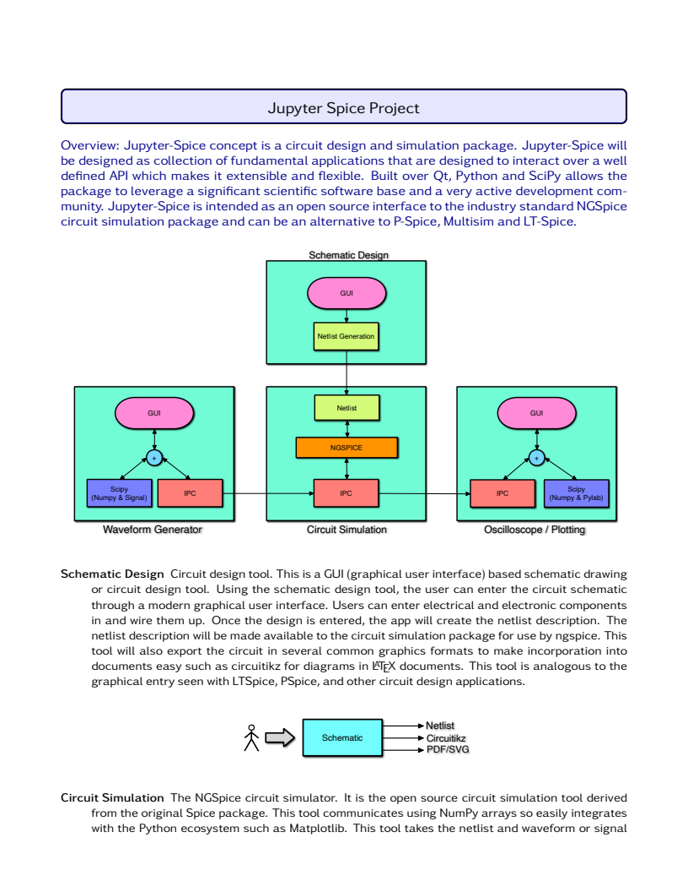
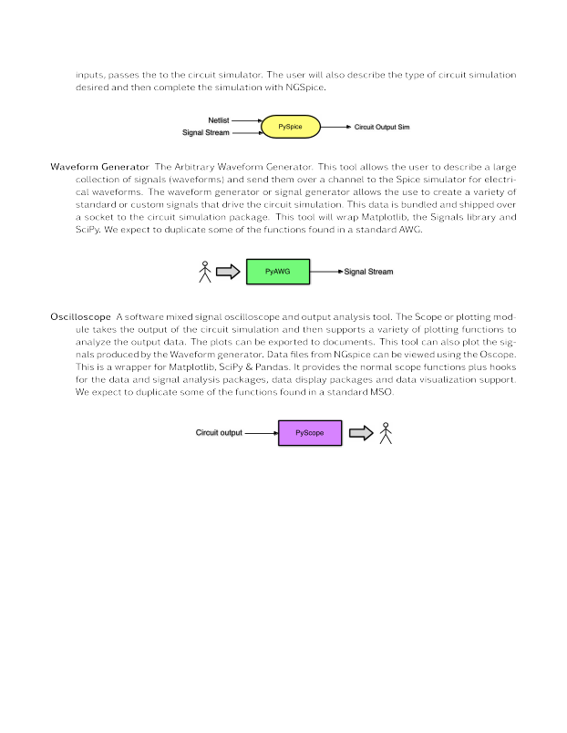

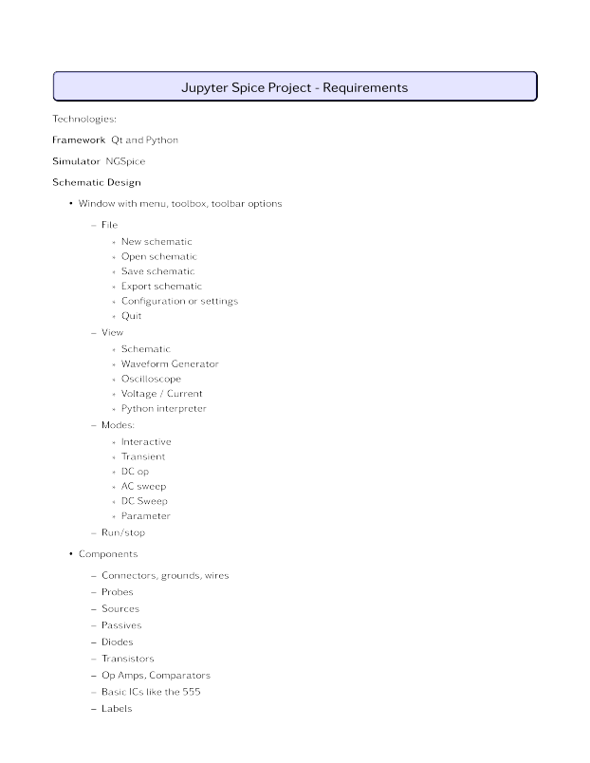

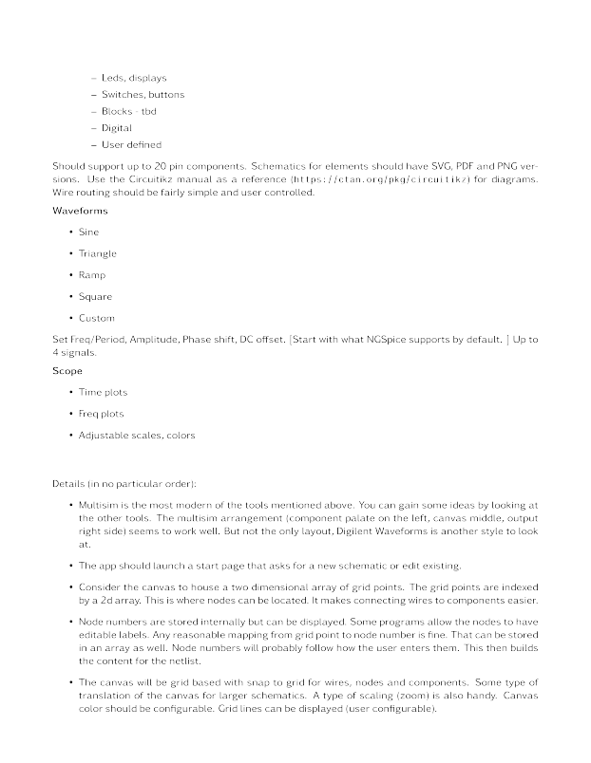

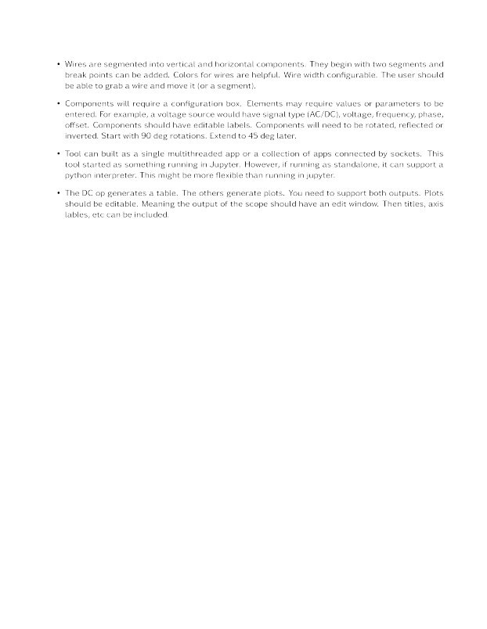

Link to NG Spice Documentation
https://ngspice.sourceforge.io/docs/ngspice-manual.pdf
Link to PyQt6
https://doc.qt.io/qtforpython-6/

Link to Design Document
https://github.com/SDSMT-Capstone-Spice-GUI-Team/Spice-GUI/tree/main/Doc/Jupyter-Spice/UI_UX

