Project: Black Mirror

Software Requirements Specification

Pre-Alpha 0.0.1

Feb 12th 2019

Floyd Askew
Abu Hassan
Brock Maxwell
Sean Thompson

Prepared for
CSU-CSCI3320—Software Engineering Principles I
Instructor: Junfeng Qu, Ph.D.
Spring 2019

Revision History

Date | Description | Author | Comments
2/26/2019 | Version 1 | Abu Hassan, Floyd Askew, Brock Maxwell, Sean Thompson | Section 1, 2, 3.2, 3.3, 3.5, & 5 updated
4/9/2019 | Version 2 | Abu Hassan, Floyd Askew, Brock Maxwell, Sean Thompson | Section 3.4 & 4.1 updated

Document Approval
-
The following Software Requirements Specification has been accepted and approved by the following:
Signature | Printed Name | Title | Date
 | <Your Name> | Lead Software Eng.
 | A. David Doe

Table of Contents
Revision History ii
Document Approval ii
1. Introduction 1
1.1 Purpose 1
1.2 Scope 1
1.3 Definitions, Acronyms, and Abbreviations 1
1.4 References 1
1.5 Overview 1
2. General Description 2
2.1 Product Perspective 2
2.2 Product Functions 2
2.3 User Characteristics 2
2.4 General Constraints 2
2.5 Assumptions and Dependencies 2
3. Specific Requirements 2
3.1 External Interface Requirements 3
3.1.1 User Interfaces 3
3.1.2 Hardware Interfaces 3
3.1.3 Software Interfaces 3
3.1.4 Communications Interfaces 3
3.2 Functional Requirements 3
3.2.1 <Functional Requirement or Feature #1> 3
3.2.2 <Functional Requirement or Feature #2> 3
3.3 Use Cases 3
3.3.1 Use Case #1 4
3.3.2 Use Case #2 5
3.4 Classes / Objects 5
3.4.1 <Class / Object #1> 6
3.4.2 <Class / Object #2> 6
3.5 Non-Functional Requirements 6
3.5.1 Performance 6
3.5.2 Reliability 6
3.5.3 Availability 6
3.5.4 Security 6
3.5.5 Maintainability 6
3.5.6 Portability 6
3.6 Inverse Requirements 6
3.7 Design Constraints 7
3.9 Other Requirements 7
4. Analysis Models 7
4.1 Sequence Diagrams 7
5. UI Design 8
6. Change Management Process 9
7. Appendices 9
A.0 Glossary 9
A.1 Appendix 1 //If any others 9
A.2 Appendix 2 9

1. Introduction
This introduction of the Software Requirements Specification (SRS) document will highlight the entire SRS with definitions, abbreviations, scope, and purpose of the SRS. The aim of this SRS document is to give a detailed insight of the Black Mirror Project which is a smart home project. This document will also focus on the capacity required by stakeholders and their wants/needs while detailing high-level product specifications/features. The Black Mirror Project’s detailed requirements are also highlighted in this document.

1.1 Purpose
The purpose of this SRS document is to define a system and its requirements that detail the extension of a SafeHome project into a SmartHome project with respects to users.
Or….
The purpose of this SRS document is to provide an extensive overview of our smart home software product, its parameters, and its goals.

1.2 Scope
Primarily, the scope pertains to the smart home product features for making the Black Mirror Project live. It focuses on the details, stakeholders, and application of our software. This document also aims to specify the requirements of software to be developed.

1.3 Definitions, Acronyms, and Abbreviations
IoT | Internet of things
SEPA | Smart Electric Power Alliance
ASD | Agile Software Development
FAQs | Frequently Asked Questions

1.4 References
The references are:

1.5 Overview
The remaining sections of this SRS document provide a general description (including characteristics) for the users of this smart home project, the details of the software, and the data and functional requirements of the software. A general description of the project is discussed in section 2 of this SRS document. Functional requirements of the project are detailed in section 3, as well as the use cases and non-functional requirements.

2. General Description
The smart home application will be used to connect with appliances, lighting, and other electronic devices so that they can be controlled remotely by the user. The mobile application will give users a simply effective way to interact with their smart devices. The smart home application also allows users to automate specific tasks such as turning lights off at a specified time in order to conserve energy. Below are general functionalities and limitations of this implementation of a smart home, it does not go into specific requirements. See section 3 for specific requirements.

2.1 Product Perspective
This smart home application is a mobile application that allows users to automate home devices. It is able to communicate between different home devices and allows users to view information about home appliances as well as control the devices all from the mobile application interface.

2.2 Product Functions
Below is a list of general product functions.
- User interface via mobile application
- Control connected home devices from mobile app
- Sensors to detect specific things such as temperature and motion
- Turn on and off devices such as lights
- Enable automation such as turn off lights at night
- Allow multiple users to access application
- Alarm capabilities

2.3 User Characteristics
This product is designed to be used by the general public of android users. The application will give these users a user friendly interface to make interacting with various smart home devices simpler.

2.4 General Constraints
The application will only be designed to work with specific IoT devices as well as the specific mobile application made for the Android OS.

2.5 Assumptions and Dependencies
Below is a list of assumptions made for the product to be successful.
- There will be power to all home devices and mobile application at all times.
- There will be a network that all devices will be connected to.
- There will be necessary sensors to gather the information needed to perform above functions.

3. Specific Requirements
This will be the largest and most important section of the SRS. The customer requirements will be embodied within Section 2, but this section will give the D-requirements that are used to guide the project’s software design, implementation, and testing.

Each requirement in this section should be:
- Correct
- Traceable (both forward and backward to prior/future artifacts)
- Unambiguous
- Verifiable (i.e., testable)
- Prioritized (with respect to importance and/or stability)
- Complete
- Consistent
- Uniquely identifiable (usually via numbering like 3.4.5.6)

Attention should be paid to the carefuly organize the requirements presented in this section so that they may easily accessed and understood. Furthermore, this SRS is not the software design document, therefore one should avoid the tendency to over-constrain (and therefore design) the software project within this SRS.

3.1 External Interface Requirements

3.1.1 User Interfaces

3.1.2 Hardware Interfaces

3.1.3 Software Interfaces

3.1.4 Communications Interfaces

3.2 Functional Requirements

Actor | Goal
User | Control Specific IoTs Settings
 | Login to access personal set of IoTs
 | Sign up into application
 | Register new IoTs to account
 | Deregister inactive IoTs
 | Register other accounts to access the same set of IoTs
 | Check status of a device
 | Set restrictions / rules on specific devices
 | Room specific control of IoTs
System Application | Alarm after sensor detection
 | Notify user of device changes
 | Contact Emergency services in high alert situations
 | Location awareness of particular devices
 | Real-time response to user request
 | Compatibility with new IoTs
 | Connect user authentication with database
 | Realtime update of database
 | Realtime virus scanning
 | Prevent unauthorized access
 | Update status of a device

User

3.2.1 Control Specific IoTs Settings
Purpose | Allows user the ability to manipulate the status of devices connected to the system
Inputs | Dependent on type of device
Processing | Record user input on settings and send out instructions to IoT
Output | Signal inputted change to selected device and apply
Error Handling | Notify user of manipulation error and default device to previous setting.

3.2.2 Login to access personal set of IoTs
Purpose | Grant access to user to manipulate and monitor their personal set of registered IoTs
Inputs | User login and password
Processing | Verify login and password entry
Output | Grant access to user and display set of IoTs via Home Screen of application
Error Handling | Notify user of invalid credentials and default back to login screen

3.2.3 Sign up into application
Purpose | Grant access to user to create an account
Inputs | Register user login, password, and email
Processing | Submit information into user database
Output | Grant user access to login and register their personal set of IoTs
Error Handling | Notify user of invalid credentials or a disconnect to database and default back to the sign-up screen

3.2.4 Register new IoTs to account
Purpose | Grants user the ability to bind personal IoTs to their account and manipulate them accordingly
Inputs | Dependent on type of device and manufacturer
Processing | Update user database and add IoT information to the account for manipulation
Output | Display IoT setting for user manipulation
Error Handling | Notify user of failure to add IoT device and return to home screen

3.2.5 Deregister inactive IoTs
Purpose | Grants user the ability to deregister personal IoTs from their account
Inputs | Selection of the IoT and Admin user password or form of confirmation of the deregistering
Processing | Update user database and remove IoT information to the account
Output | Return to home screen of application
Error Handling | Notify user of failure to remove IoT device and return to home screen

3.2.6 Register other accounts to access the same set of IoTs
Purpose | Allow the user to grant access to other accounts who can also manipulate certain IoTs
Inputs | Child account inputs verification code of the parent account
Processing | Update user database and add IoT information to the account for manipulation
Output | Return to home screen with updated IoTs information
Error Handling | Notify parent user of failed attempt to register new account

3.2.7 Check status of a device
Purpose | Allows user the ability to check if a device is working as intended or is having issues and give description on what the error issue maybe
Inputs | Selection of IoT from home screen
Processing | Retrieve data on selected IoT from database
Output | Display information regarding the selected IoT’s current state
Error Handling | Notify user of failure to retrieve IoT data and default back to home screen

3.2.8 Set restrictions / rules on specific devices
Purpose | Give user the ability to set specific timer, restrictions, max, and min for settings on a specific IoT
Inputs | Dependent on type of device and manufacturer
Processing | Real-time changes to the IoT dependent on the settings
Output | Haptic/Visual feedback of sliders and buttons of new settings and real-life change of IoT
Error Handling | Notify user of inability to change settings and default back to home screen

3.2.9 Room specific controls of IoTs
Purpose | Provides user the ability to organize and control IoTs into specific portions/rooms of a SmartHome
Inputs | Input room of home where the IoT is located within the house
Processing | Place location in home in the database with the specific IoT
Output | Return to home screen with IoT listed under room tab
Error Handling | Notify user of the invalid room selection for IoTs and default back to default room selection

System Application

3.2.10 Update status of a device
Purpose | System runs diagnostic on IoT device to determine if the device is running properly or its issues and record information
Inputs | N/A
Processing | Compare status of IoT to last properly working status of IoT
Output | Notification to the user of any major changes in the status of an IoT
Error Handling | Notify user of the device errors

3.2.11 Alarm after sensor detection
Purpose | Provide user with vital information regarding if any sensor based IoT discovers moment, smoke, or any other trigger for the IoT
Inputs | Software trigger message from the IoT
Processing | Decoding the message sent from the IoT
Output | Notification to the user that there is a detection trigger with a description of what may cause it and its location
Error Handling | Notify user of the sensor detection feature errors

3.2.12 Notify user of device changes
Purpose | Provide user with vital information regarding if any the IoTs receive a massive change in settings or unexpected change in settings
Inputs | Dependent on device
Processing | Process and record drastic changes in settings or properties of the IoT
Output | Notification to the user that there was a change in the device’s setting with a description of what changes were made and by what account
Error Handling | Notify user of the device changes detection errors

3.2.13 Contact Emergency services in high alert situations
Purpose | To provide an extra level of security and safety for users if any IoTs of health or quality of living setting are outside of normal settings
Inputs | Settings and status of IoTs directly related to emergency services ex smoke detector
Processing | Process and record status of the IoT and location of the user’s address where the IoT is located
Output | Contact local emergency services with information on the IoT’s status and user’s address
Error Handling | -

3.2.14 Location awareness of particular devices
Purpose | Understand where the IoT is located and allow IoTs access to locational information if necessary
Inputs | Input room of home where the IoT is located within the house
Processing | Assign location to IoT to provide information on the where in the SmartHome a selected IoT is located
Output | The location of where the selected IoT
Error Handling | Notify user of no valid location given or found

3.2.15 Real-time response to user request
Purpose | Provide real time changes to IoTs according to setting set by users, ex changing of a light’s hue as the user slides the hue control
Inputs | User setting changes
Processing | Transfer control changes information to IoT
Output | Change is applied to IoT
Error Handling | Notify user of failure to send response/changes to IoT

3.2.16 Compatibility with new IoTs
Purpose | Provides versatility to the software to connect to majority if not all of the different IoT devices to allow users a singular place to access all their systems to their SmartHome
Inputs | IoT manufacturer, IoT model number, IoT type
Processing | Compare and register IoT model to compatible models in database
Output | Notify user of a successful connection between the IoT and software
Error Handling | Notify user that the IoT is not compatible with the software

3.2.17 Connect user authentication with database
Purpose | Bind parents accounts to a specific set of personal IoTs and their children accounts to the same set of IoTs
Inputs | User login, user password, user email, children accounts information
Processing | Compare user information to user information stored in database
Output | Grant or deny access to IoTs given a successful comparison
Error Handling | Default back to home screen and notify user and software developers of error connecting to user database

3.2.18 Realtime virus scanning
Purpose | Provide security to user and IoTs from being able to change or disable device’s settings, user access, and ultimately corrupt IoTs firmware.
Inputs | Current state of IoT
Processing | Comparison of IoT files and settings to factory files and settings
Output | Result of the virus scan and any problematic IoTs
Error Handling | Notify user of any viruses or problematic IoTs

3.2.19 Prevent unauthorized access
Purpose | Provide security to user accounts to prevent access to unauthorized accounts
Inputs | User login, user password, user email, children accounts information
Processing | Compare inputted user information to the login information and database registry the user is trying to access / record information on the attempt
Output | Notify user of possible attempt of unauthorized or unusual activity with account
Error Handling | Send recorded information to software developers to look into the activity.

3.3 Use Cases
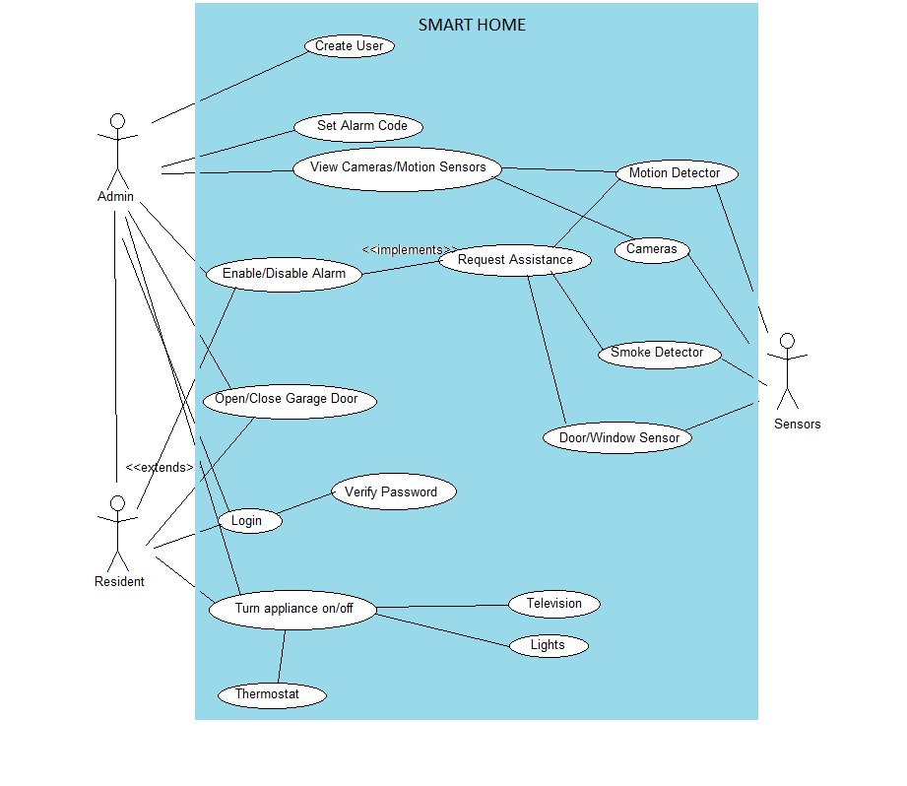

3.3.1 Use Case #1
Use Case Name:Login | ID: UC-001
Version: 0.0.1 | Author: Brock Maxwell
Primary Actor: Resident

Brief Description:
Resident signs in to account
Trigger: User opens the application
Normal Flow of Events:
- User opens application
- User inputs username/password
- Application verifies username/password
- User is redirected to the main menu screen

Alternate/Exceptional Flows:
- User inputs incorrect username/password
- Application returns to sign in menu and asks user to try again

Pre-Conditions:
User opens application
Post-Conditions:
User is logged into their account and can begin using the application

3.3.2 Use Case #2
Use Case Name: Create User | ID:UC-002
Version: 0.0.1 | Author: Brock Maxwell
Primary Actor: Admin

Brief Description:
Admin creates new resident account
Trigger: Admin enters the create menu and selects ‘new user’
Normal Flow of Events:
- User opens the create menu and selects new user
- User sets username and password for new account
- User sets permissions for created account
- New Resident account added to the database
Alternate/Exceptional Flows:
- Username is already taken
- Ask the admin to select a new one
Pre-Conditions:
Admin is logged in to the system

Post-Conditions:
A new Resident account has been created

3.3.2 Use Case #3
Use Case Name: Turn Appliance On/Off | ID:UC-003
Version: 0.0.1 | Author: Brock Maxwell
Primary Actor: Resident

Brief Description:
User ……
Trigger: User starts to use the system
Normal Flow of Events:
- User opens management menu
- User selects appliance to modify
- User sets the selected appliance to the on/off state
Alternate/Exceptional Flows:
- Application is unable to connect to the selected appliance
- Troubleshoot the problem and ask the user to try again
Pre-Conditions:
Appliance is connected to the system and user is logged in
Post-Conditions:
An appliance is turned on or off

3.3.2 Use Case #4
Use Case Name: Request Assistance | ID:UC-004
Version: 0.0.1 | Author: Brock Maxwell
Primary Actor: Resident

Brief Description:
Police/Fire Department alerted to issue
Trigger: Motion Detector, Smoke Detector, Door/Window Sensor, User
Normal Flow of Events:
- User notices problem and requests assistance
- Corresponding department is notified

Alternate/Exceptional Flows:
- Sensor detects problem and signals a request for assistance
Pre-Conditions:
User needs help or sensor detects that help is required
Post-Conditions:
Local authorities are notified that the user’s home needs assistance

3.3.2 Use Case #5
Use Case Name: Add/Remove Device | ID:UC-005
Version: 0.0.1 | Author: Sean Thompson
Primary Actor: Resident
Brief Description:
User ……
Trigger: User starts to use the system
Normal Flow of Events:
- User opens management menu
- User inputs device to add / remove
Alternate/Exceptional Flows:
- Device is unable to be added / removed
- Troubleshoot the problem and ask the user to try again
Pre-Conditions:
Admin is logged in into system
Post-Conditions:
Device is added to the SafeHome App

3.4 Classes / Objects

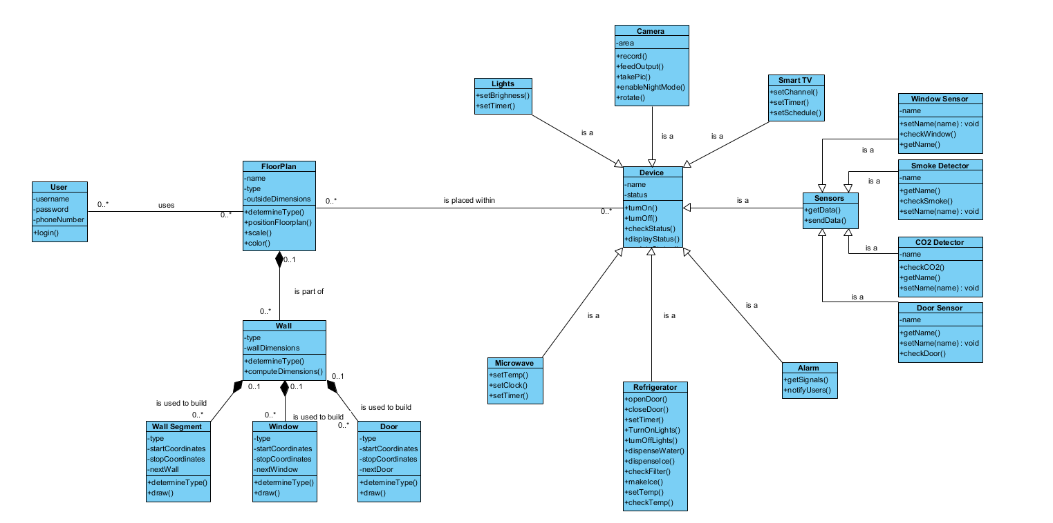

3.4.1 <Class / Object #1>

3.4.1.1 Attributes
3.4.1.2 Functions
<Reference to functional requirements and/or use cases>

3.4.2 <Class / Object #2>
…

3.5 Non-Functional Requirements
Non-functional requirements may exist for the following attributes. Often these requirements must be achieved at a system-wide level rather than at a unit level. State the requirements in the following sections in measurable terms (e.g., 95% of transaction shall be processed in less than a second, system downtime may not exceed 1 minute per day, > 30 day MTBF value, etc).

3.5.1 Performance
- The system shall add no more than three seconds to the time required to perform an action if the system is not connected.
- The system shall ask for a confirmation from the user in real time.
- Researcher information shall be logged and sent to the research center on a daily basis.

3.5.2 Reliability
- The system shall not fail on average more than once per month.
- The system shall not take on average longer than one day to repair after a system failure has occurred.

3.5.3 Availability
- The system shall be available 97% of the time unless a system backup/maintenance period has been scheduled.

3.5.4 Security
- The system shall keep all personal data that corelates to usage statistics/scenarios private.
- All system development work shall be password protected
- Any transmitted information between system devices should be carried in encrypted form

3.5.5 Maintainability
- The system shall provide the ability to reset all settings to the default, a factory default, or a saved configuration.
- The system administrator should be able to grant developer privileges to users.
- Any programming code developed for the system shall conform to the programming standards.
- Any programming code developed for the system shall be heavily documented/commented.
- Any programming code developed for the system shall be reviewed prior to the publication of the code.

3.5.6 Portability
- All system applications should be able to run properly via mobile/local infrastructure

3.6 Inverse Requirements
State any *useful* inverse requirements.

3.7 Design Constraints
Specify design constrains imposed by other standards, company policies, hardware limitation, etc. that will impact this software project.

3.9 Other Requirements
Catchall section for any additional requirements.

4. Analysis Models
List all analysis models used in developing specific requirements previously given in this SRS. Each model should include an introduction and a narrative description. Furthermore, each model should be traceable the SRS’s requirements.

4.1 Sequence Diagrams
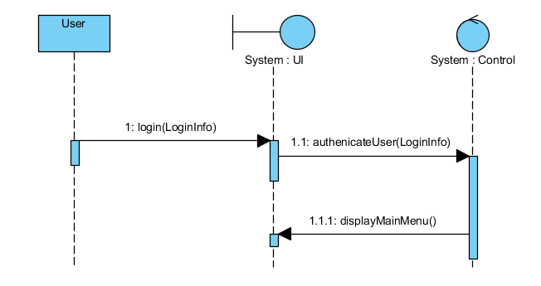
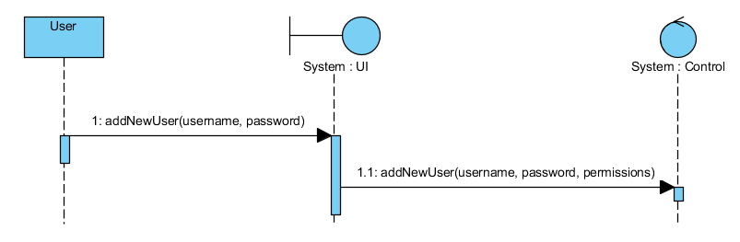
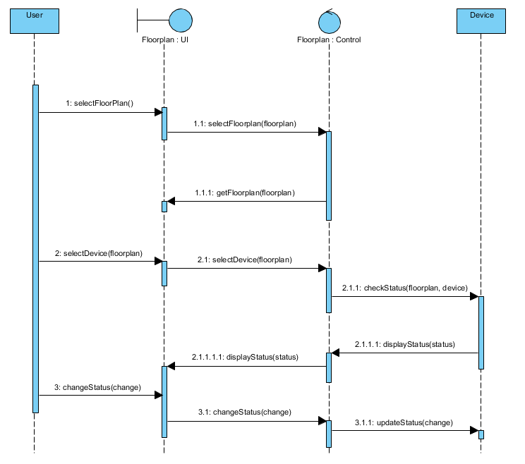
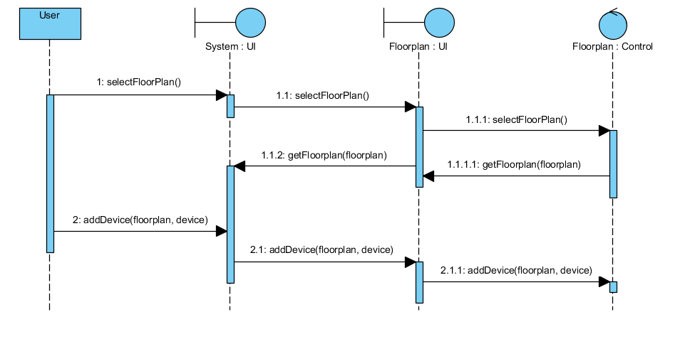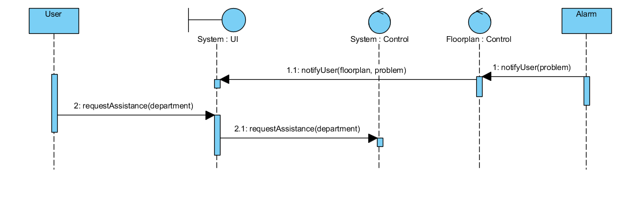

5. UI Design

For this section, demo the pseudo user interface and navigational paths of each use case.

5.1 Use case -- User Login Mock Screen

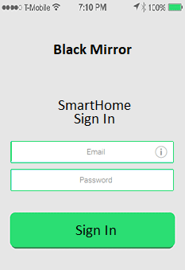

5.2 Use case -- Create User Mock Screen
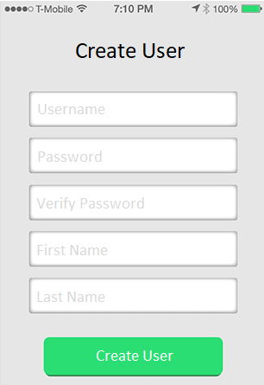

5.3 Use case – Turn Appliance On/Off Mock Screen
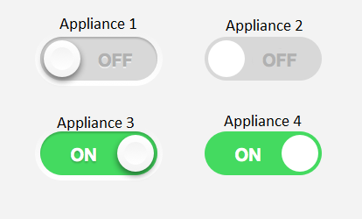

5.4 Use case – Request Assistance Mock Screen

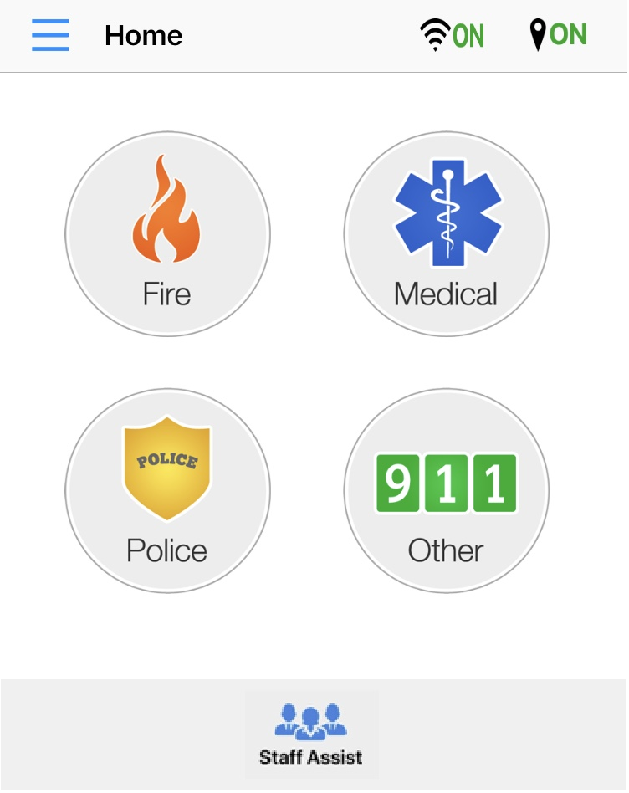

6. Change Management Process
Identify and describe the process that will be used to update the SRS, as needed, when project scope or requirements change. Who can submit changes and by what means, and how will these changes be approved.

7. Appendices
Appendices may be used to provide additional (and hopefully helpful) information. If present, the SRS should explicitly state whether the information contained within an appendix is to be considered as a part of the SRS’s overall set of requirements.

Example Appendices could include (initial) conceptual documents for the software project, marketing materials, minutes of meetings with the customer(s), etc.

A.0 Glossary
lists all the terminology used in this documentation, such as http, admin, student, https, database etc

A.1 Appendix 1 //If any others

A.2 Appendix 2

