**Pyomo:**

优化结果计算公式：np.sum(cost) + α * np.sum(result_phase)

最大功率负载：2200（200辆车时）

200辆车运行时间：46.39425730705261 优化结果： 845.9835069632063

300辆车运行时间：156.24649667739868 优化结果：3802.9449249857757

400辆车运行时间：298.59270787239075 优化结果：4987.775405085014

**遗传算法：**

200辆车

|  |  |  |  |  |
| --- | --- | --- | --- | --- |
| α=0.001 | | | | |
| 运行时间 | 迭代 | 优化结果 | | |
|  |  | 电费 | 惩罚 | 三相不平衡 |
| 39.46207809448242 | 3代 | 838.925 | 21.460393272534624 | 44.091854835909515 |

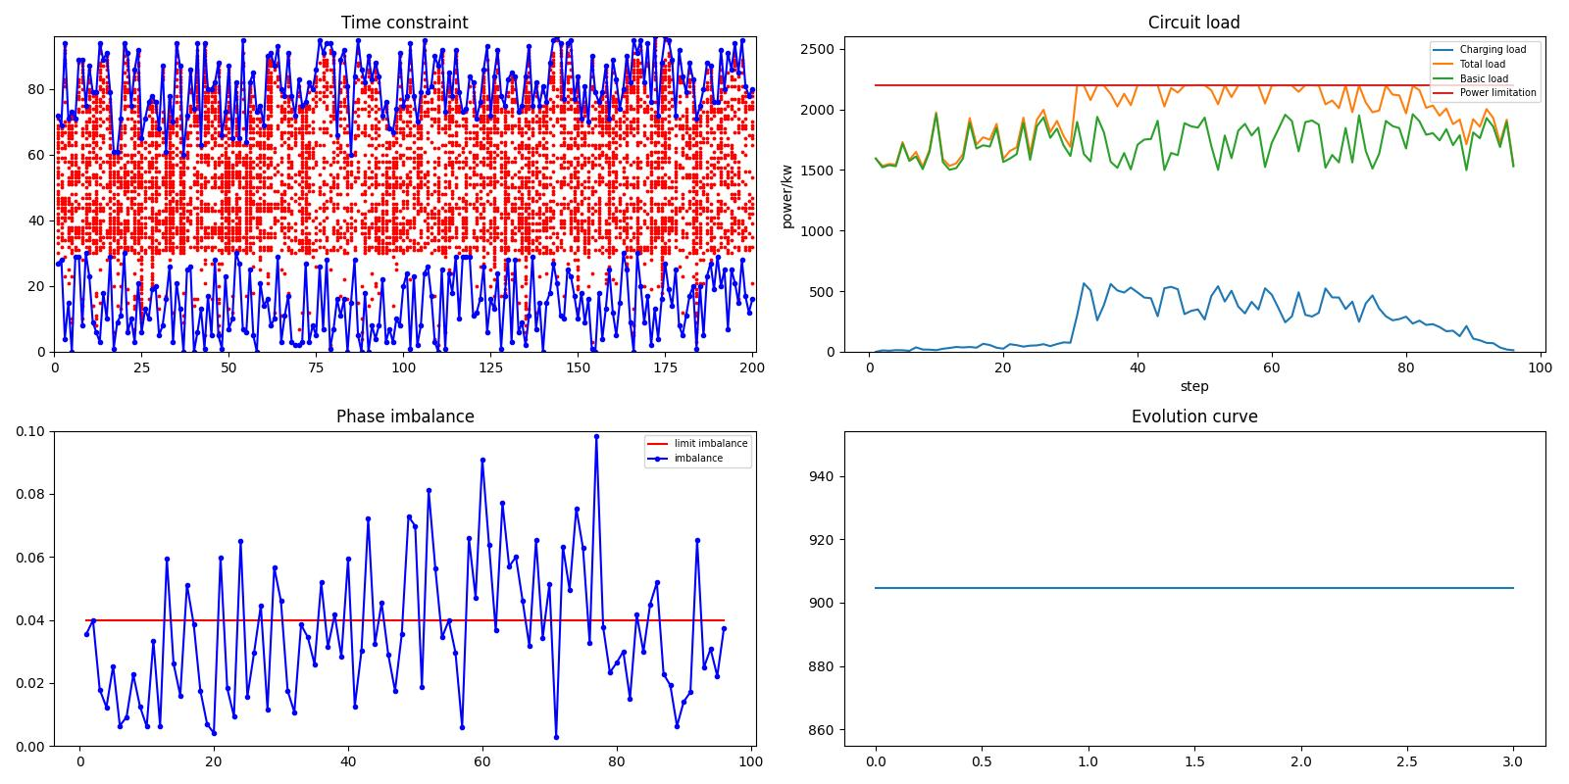

α=0.001

|  |  |  |  |  |
| --- | --- | --- | --- | --- |
| α=0.01 | | | | |
| 运行时间 | 迭代 | 优化结果 | | |
|  |  | 电费 | 惩罚 | 三相不平衡 |
| 39.60210871696472 | 3代 | 855.125 | 20.237618813137242 | 381.21914893114916 |

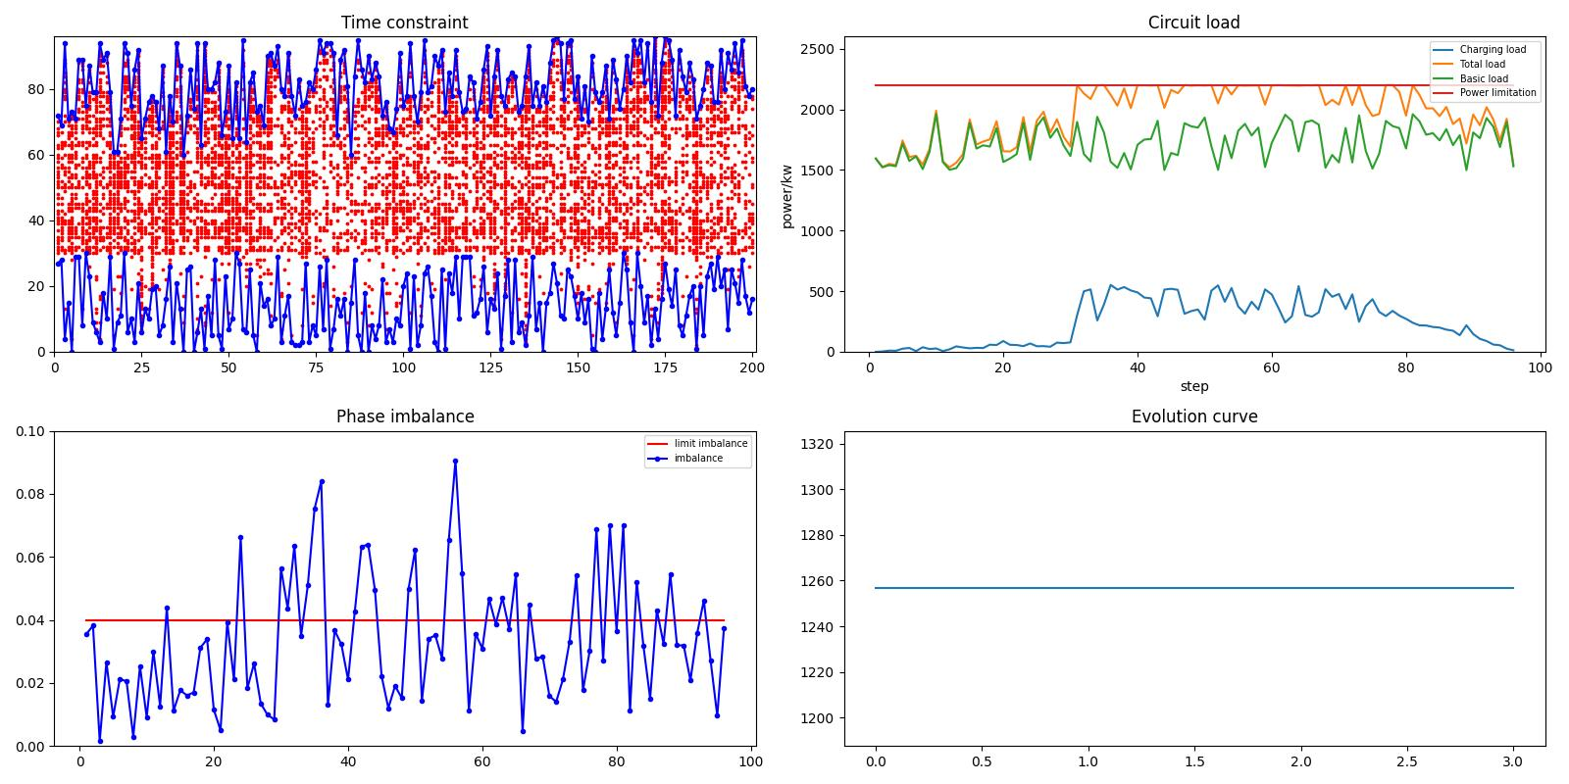

α=0.01

|  |  |  |  |  |
| --- | --- | --- | --- | --- |
| α=0.1 | | | | |
| 运行时间 | 迭代 | 优化结果 | | |
|  |  | 电费 | 惩罚 | 三相不平衡 |
| 40.98691725730896 | 3代 | 855.2 | 20.71182060020952 | 3563.5137107499454 |

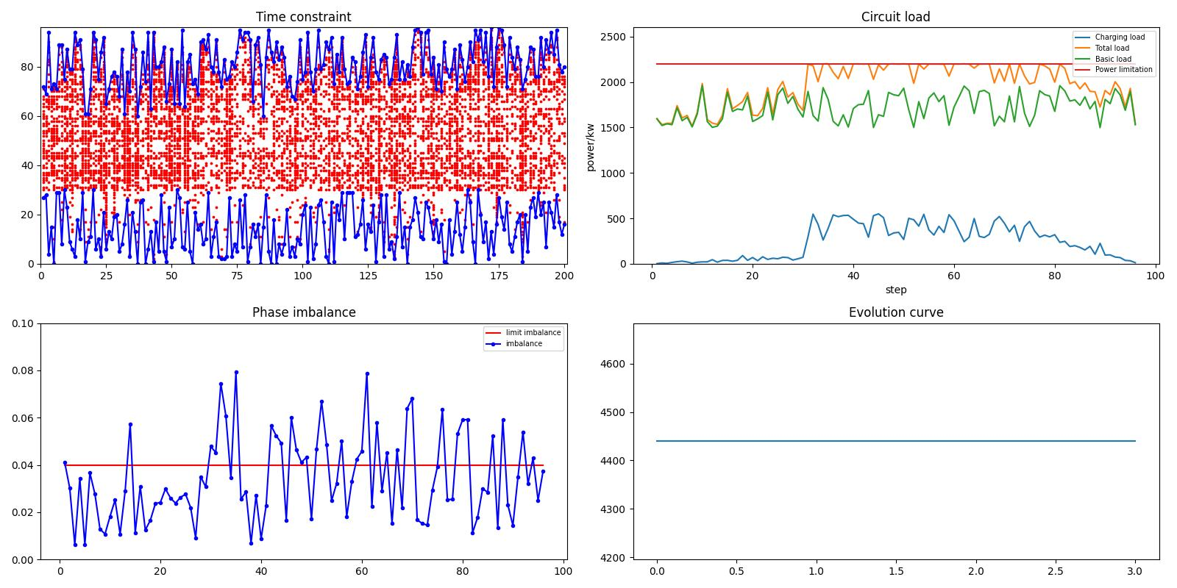

α=0.1

|  |  |  |  |  |
| --- | --- | --- | --- | --- |
| α=1 | | | | |
| 运行时间 | 迭代 | 优化结果 | | |
|  |  | 电费 | 惩罚 | 三相不平衡 |
| 93.5757040977478 | 16代 | 1203.45 | 3.005701664798991 | 27374.758303562045 |

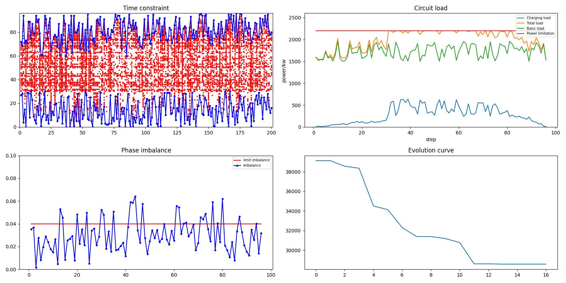

|  |  |  |  |  |
| --- | --- | --- | --- | --- |
| α=10 | | | | |
| 运行时间 | 迭代 | 优化结果 | | |
|  |  | 电费 | 惩罚 | 三相不平衡 |
| 55.175745248794556 | 7代 | 1179.525 | 5.016639705386369 | 365292.65267656476 |

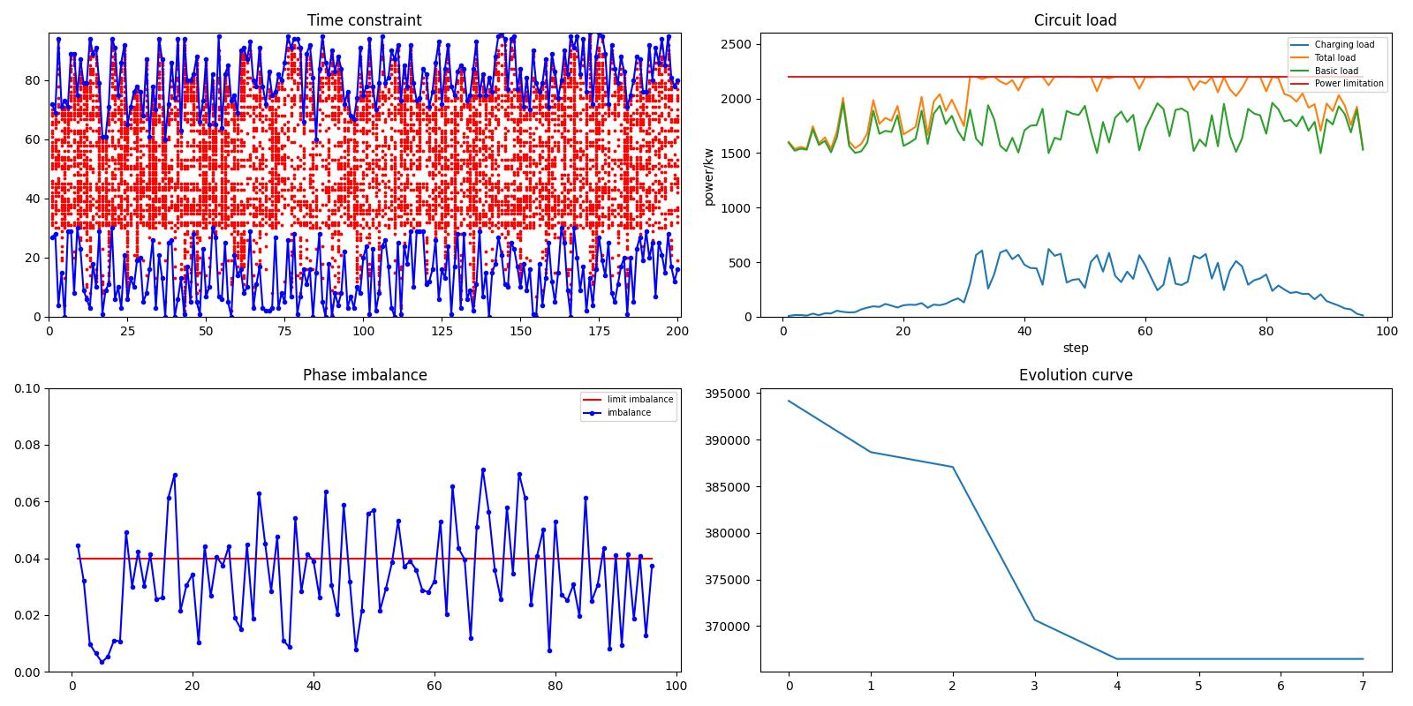

|  |  |  |  |  |
| --- | --- | --- | --- | --- |
| α=100 | | | | |
| 运行时间 | 迭代 | 优化结果 | | |
|  |  | 电费 | 惩罚 | 三相不平衡 |
| 147.06872606277466 | 27代 | 1190.55 | 2.622840583564171 | 1890877.8912836781 |

