α=0.001

|  |  |  |  |  |
| --- | --- | --- | --- | --- |
| 200辆车 | | | | |
| 运行时间 | 迭代 | 优化结果 | | |
|  |  | 电费 | 惩罚 | 三相不平衡 |
| 39.46207809448242 | 3代 | 838.925 | 21.460393272534624 | 44.091854835909515 |

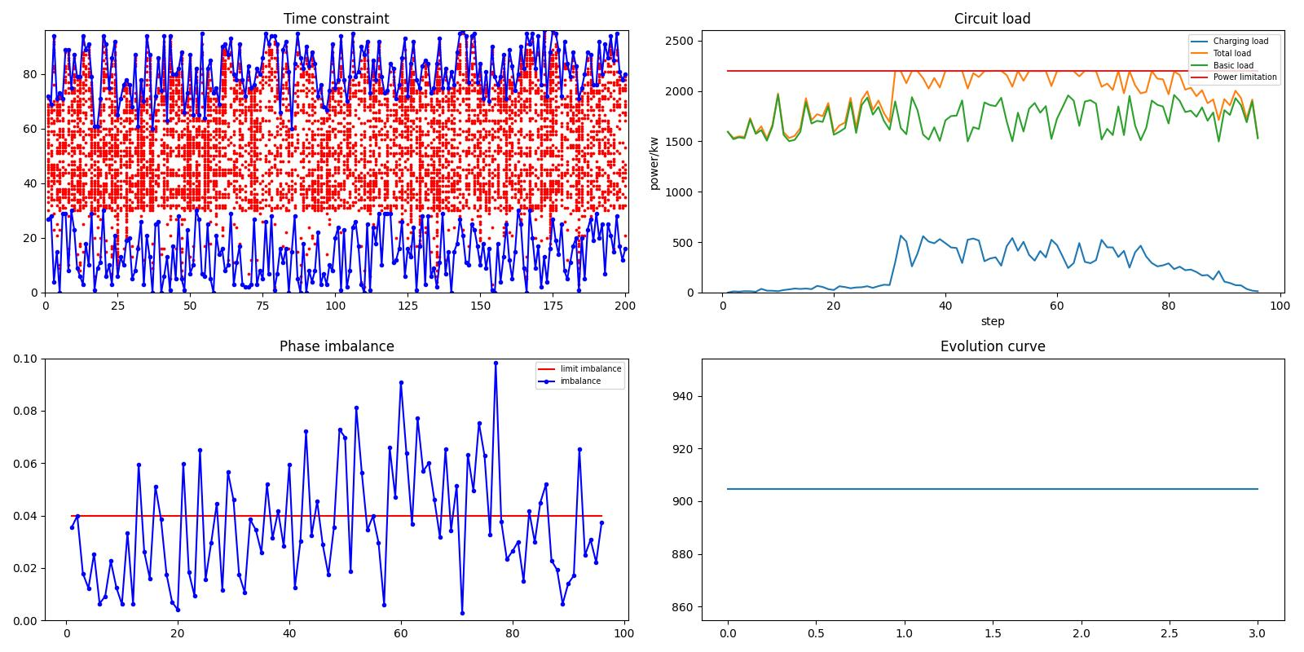

|  |  |  |  |  |
| --- | --- | --- | --- | --- |
| 300辆车 | | | | |
| 运行时间 | 迭代 | 优化结果 | | |
|  |  | 电费 | 惩罚 | 三相不平衡 |
| 77.36934113502502 | 3代 | 1737.175 | 29.212721222751636 | 94.54541177242977 |

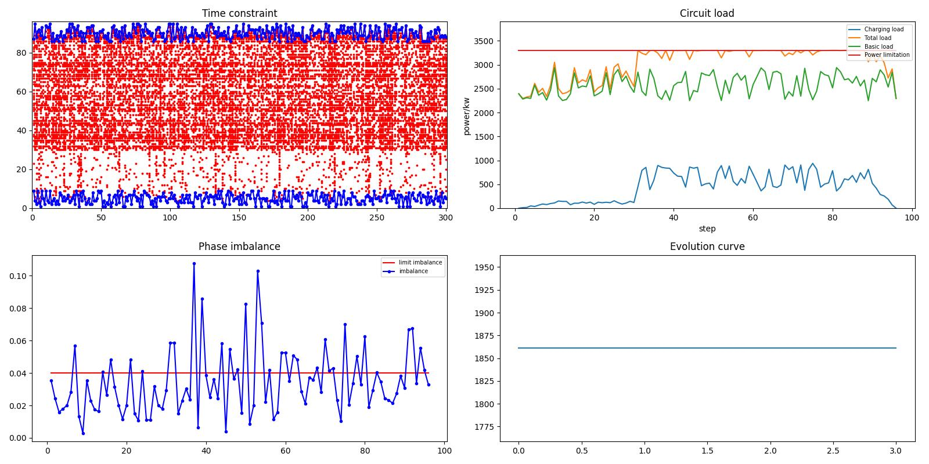

|  |  |  |  |  |
| --- | --- | --- | --- | --- |
| 400辆车 | | | | |
| 运行时间 | 迭代 | 优化结果 | | |
|  |  | 电费 | 惩罚 | 三相不平衡 |
| 130.73161721229553 | 3代 | 2388.5 | 38.061726992941374 | 128.03584327687946 |

