Seminar #1
This section consists of 2 topics and both are required to be presented during the 1st seminar, September, 19th. Each group (2 or 3 people) should prepare for one presentation.

Topic 1
Select one power electronic equipment in your daily life and:
- Describe its function, input and output features
- Take a picture and then differentiate as well as mark down:
  - Power stage
  - Drive circuit
  - Control circuit
- Find the model of the power electronic device and component used in this equipment and describe its major parameters
(Such a power electronic equipment could be found in the Lab of Department of
Industrial Automation, 3-4153 room, NO.3 building, iHarbour. Or you can find one on the Internet.)

Topic 2
This topic aims to help you get a basic understanding of power electronic devices through simulation.
Each group will be assigned with a typical fully-controllable power device (MOSFET or IGBT) of certain model. The work to be done includes:
- Carrying out simulation in LTspice to test the characteristics of the assigned device
- Comparison between simulation results and the characteristics given by datasheet

The testing circuit for MOSFET is shown as below.
V
GS
V
DS

The characteristics required to test includes:
- Output characteristics ( I_{D} = f(V_{DS}) under different V_{GS} )
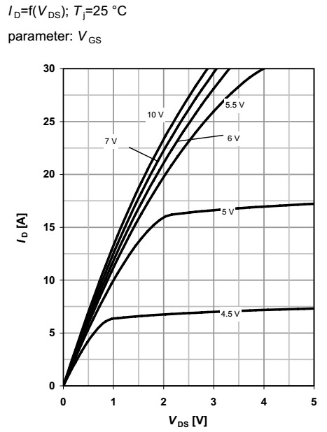

- Drain-source on resistance ( R_{DS(on)} = f(I_{D}) under different V_{GS} )
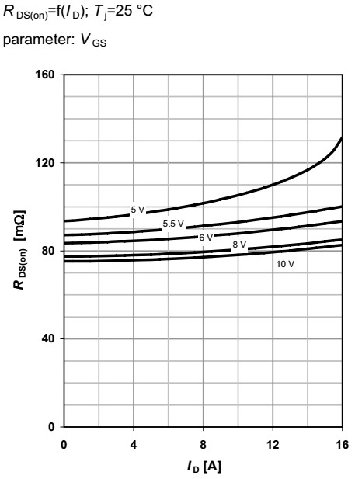
- Transfer characteristics ( I_{D} = f(V_{GS}) with fixed V_{DS} )
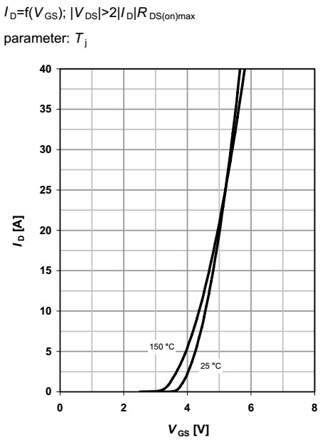
- Forward characteristics of reverse diode ( I_{F} = f(V_{SD}) )
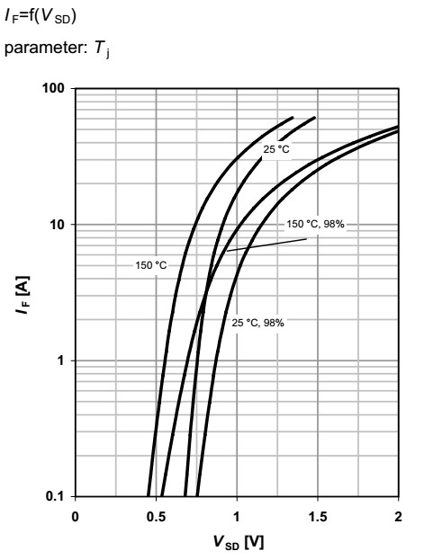

- Switching waveform (real-time simulation, V_{GS} being pulsating signal)

The testing circuit for IGBT is shown as below.
V
GE
V
CE

The characteristics required to test includes:
- Output characteristics ( I_{C} = f(V_{CE}) under different V_{GE} )
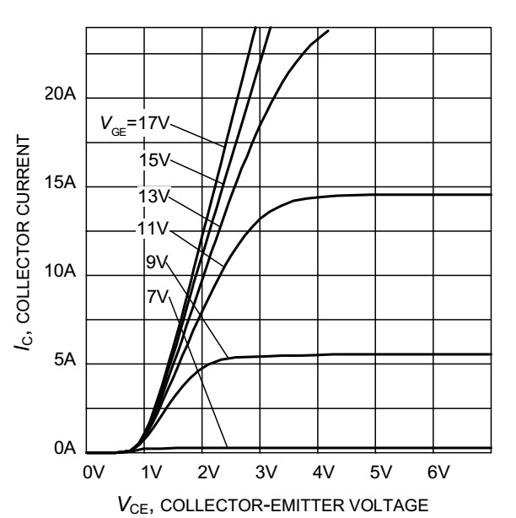

- Transfer characteristics ( I_{C} = f(V_{GE}) with fixed V_{CE} )
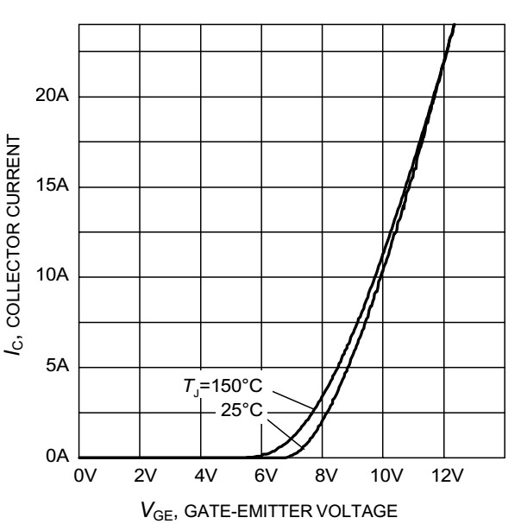

- Forward characteristics of reverse diode ( I_{F} = f(V_{EC}) )
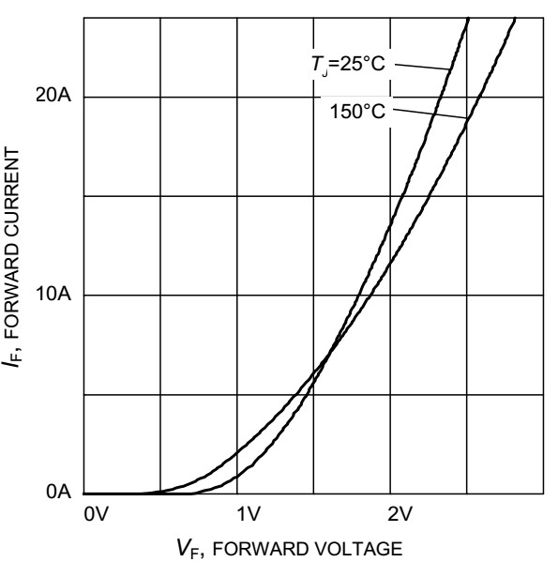

- Switching waveform
(real-time simulation, V_{GE} being pulsating signal)

The installation file of LTspice as well as corresponding datasheet, tutorial and guide documents are available in Curriculum Resource.

