# Windows ping TCP端口工具之tcping

ping这个小工具你们都很是熟悉，可是他不能ping端口，当咱们须要知道目的地址的某端口是否开放时，这时须要用到这个tcping小工具了，Windows没有自带这个小工具，须要本身下载下来，放到指定目录里面。php

下载地址：                              ***[X64](http://www.javashuo.com/link?url=https://download.elifulkerson.com/files/tcping/0.39/x64/tcping64.exe" \t "http://www.javashuo.com/article/_blank)***

放到C:\Windows\System32这个文件夹下app

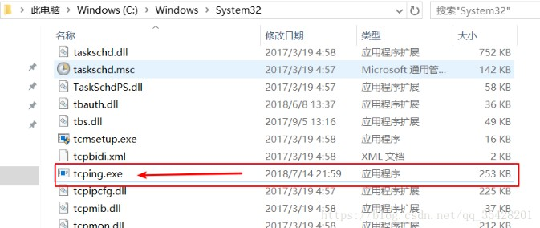

如今在测试一下：tcp

这是32位的 tcping工具

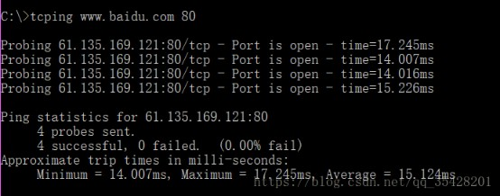

64位的为tcping64，使用方法为：oop

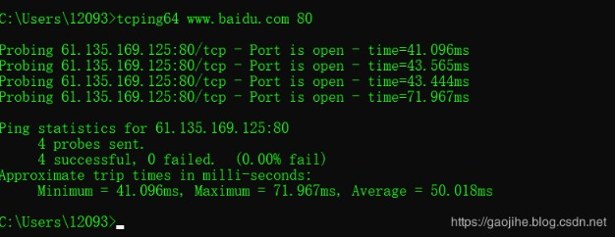

官方有个英文版的具体参数使用说明post

NAME

tcping - simulate "ping" over tcp by establishing a connection to network hosts.

Measures the time for your system to [SYN], receive the target's [SYN][ACK] and send [ACK]. Note that the travel time for

the last ACK is not included - only the time it takes to be put on the wire a tthe sending end.

SYNOPSIS

tcping [-tdsvf46] [-i interval] [-n times] [-w interval] [-b n] [-r times][-j depth] [*--tee filename] [-f] destination [port]*

DESCRIPTION

tcping measures the time it takes to perform a TCP 3-way handshake (SYN, SYN/ACK, ACK) between itself and a remote host.

The travel time of the outgoing final ACK is not included, only the (minimal) amount of time it has taken to drop it on

the wire at the near end. This allows the travel time of the (SYN, SYN/ACK) to approximate the travel time of the

ICMP (request, response) equivalent.

OPTIONS

-4 Prefer using IPv4

-6 Prefer using IPv6

-t ping continuously until stopped via control-c

-n count

send _count_ pings and then stop. Default 4.

-i interval

Wait _interval_ seconds between pings. Default 1. Decimals permitted.

-w interval

Wait _interval_ seconds for a response. Default 2. Decimals permitted.

-d include date and time on every output line

-f Force sending at least one byte in addition to making the connection.

-g count

Give up after _count_ failed pings.

-b type

Enable audible beeps.

'-b 1' will beep "on down". If a host was up, but now its not, beep.

'-b 2' will beep "on up". If a host was down, but now its up, beep.

'-b 3' will beep "on change". If a host was one way, but now its the other, beep.

'-b 4' will beep "always".

-c only show output on a changed state

-r count

Every _count_ pings, we will perform a new DNS lookup for the host in case it changed.

-s Exit immediately upon a success.

-v Print version and exit.

-j Calculate jitter. Jitter is defined as the difference between the last response time and the historical average.

-js depth

Calculate jitter, as with -j but with an optional _depth_ argument specified. If _depth_ is specified tcping will

use the prior _depth_ values to calculate a rolling average.

*--tee _filename_*

Duplicate output to the _filename_ specified. Windows can still not be depended upon to have a useful command line

environment. Don't tease me, *nix guys.

--append

When using --tee, append to rather than overwrite the output file.

--file

Treat the "destination" option as a filename. That file becomes a source of destinations, looped through on a

line by line basis. Some options don't work in this mode and statistics will not be kept.

destination

A DNS name, an IP address, or (in "http" mode) a URL.

Do not specify the protocol ("http://") in "http" mode. Also do not specify server port via ":port" syntax.

For instance: "tcping http://www.elifulkerson.com:8080/index.html" would fail

Use the style: "tcping www.elifulkerson.com/index.html 8080" instead.

port

A numeric TCP port, 1-65535. If not specified, defaults to 80.

*--header*

include a header with the command line arguments and timestamp. Header is implied if using *--tee.*

HTTP MODE OPTIONS

-h Use "http" mode. In http mode we will attempt to GET the specified document and return additional values including

the document's size, http response code, kbit/s.

-u In "http" mode, include the target URL on each output line.

--post Use POST instead of GET in http mode.

--head Use HEAD instead of GET in http mode.

--get Shorthand to invoke "http" mode for consistency's sake.

*--proxy-server _proxyserver_*

Connect to _proxyserver_ to request the url rather than the server indicated in the url itself.

*--proxy-port _port_*

Specify the numeric TCP port of the proxy server. Defaults to 3128.

*--proxy-credentials username:password*

Specify a username:password pair which is sent as a 'Proxy-Authorization: Basic' header.

RETURN VALUE

tcping returns 0 if all pings are successful, 1 if zero pings are successful and 2 for mixed outcome.

BUGS/REQUESTS

Please report bugs and feature requests to the author via contact information on http://www.elifulkerson.com

AVAILABILITY

tcping is available at http://www.elifulkerson.com/projects/tcping.php