# Parte 1

## Punto 1

{

    "message": "https://images.dog.ceo/breeds/mountain-bernese/n02107683_4782.jpg",

    "status": "success"

}

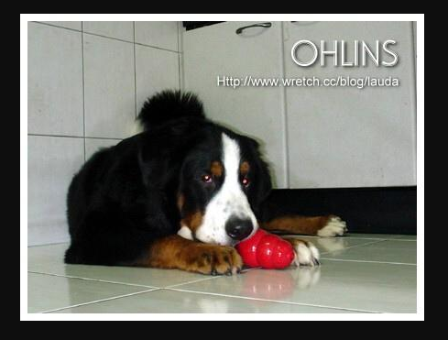

{

    "message": "https://images.dog.ceo/breeds/mountain-bernese/n02107683_4884.jpg",

    "status": "success"

}

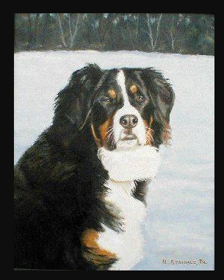

{

    "message": "https://images.dog.ceo/breeds/mountain-bernese/n02107683_20.jpg",

    "status": "success"

}

## Punto 2

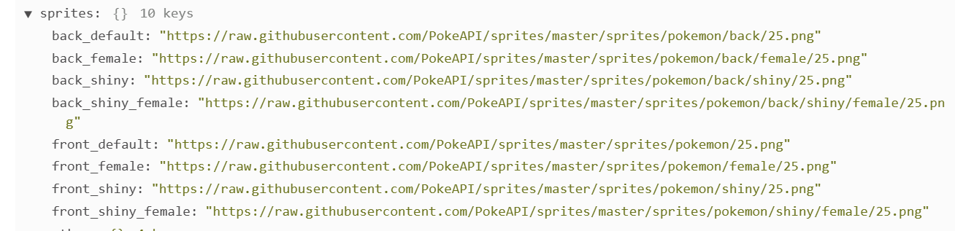

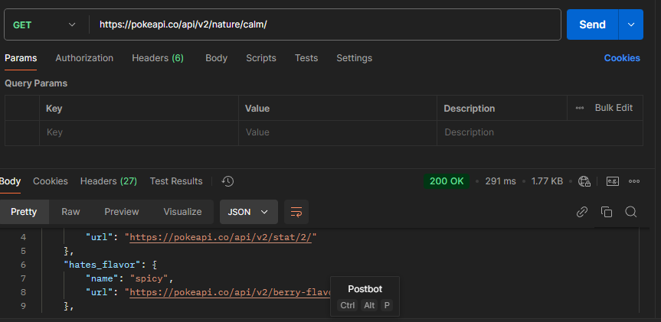



## Punto 3

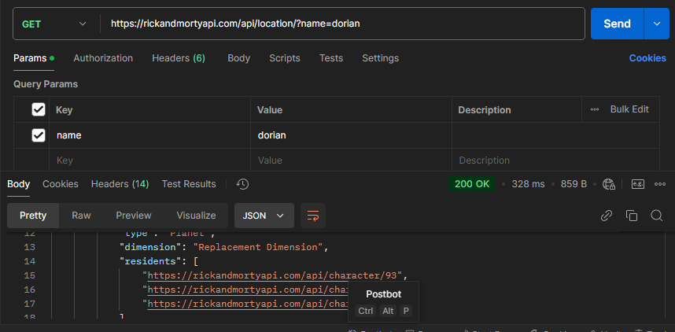



# Parte 2

## Punto 5



