THEVENIN’S EQUIVALENT- A/H/P 2

# Thevenin’s DC sources

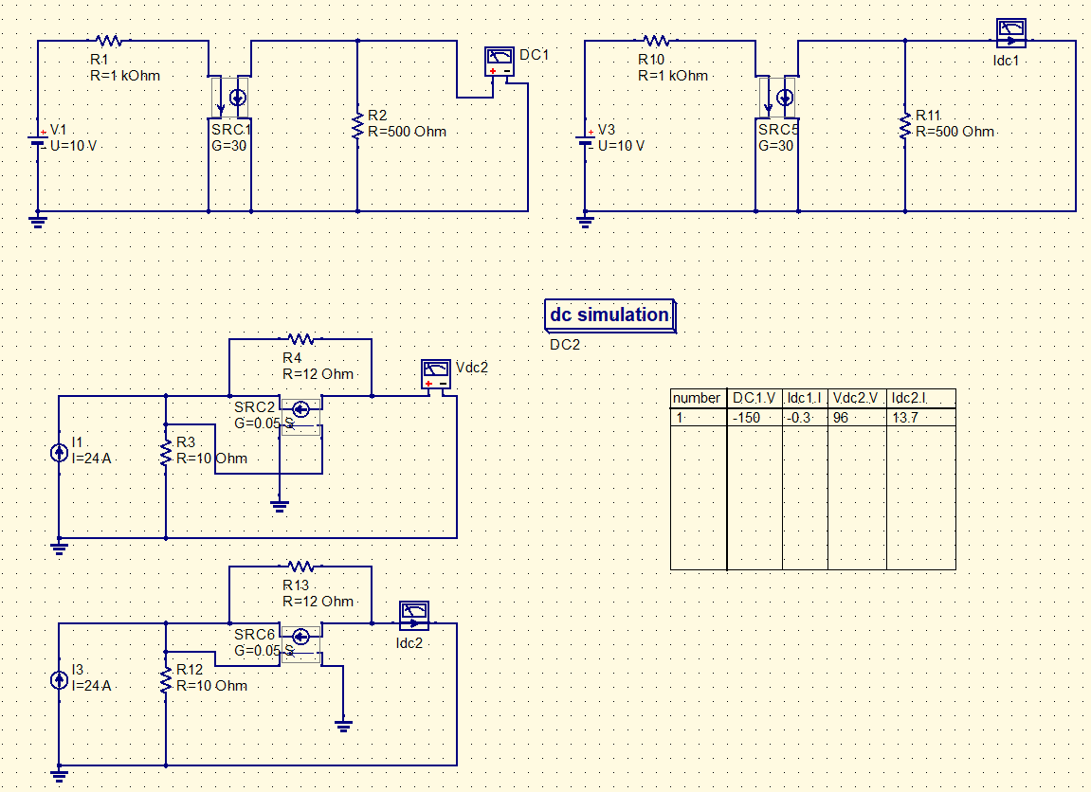

# Thevenin’s AC sources

