**EX 7: PENCIL SKETCH IMAGE**

DUPLICATE LAYER:

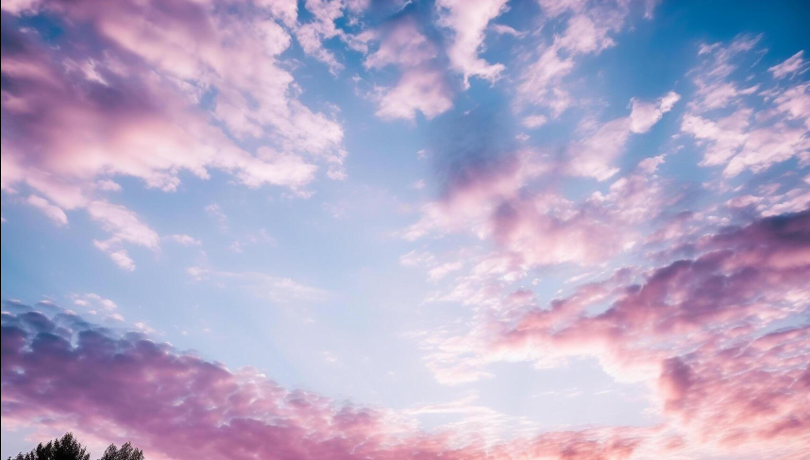

HUE/SATURATION:

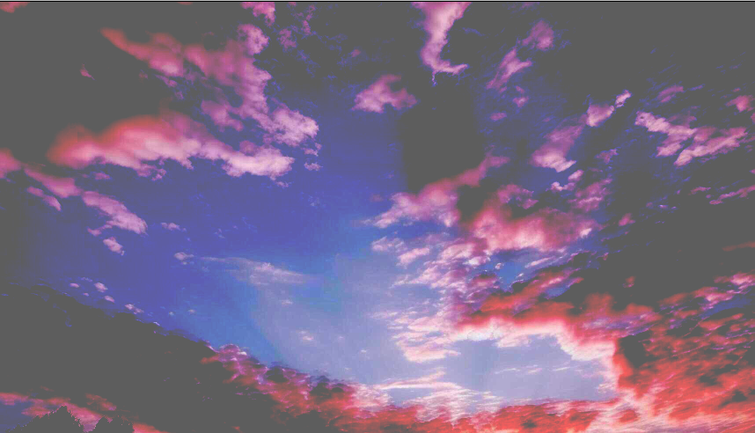

PENCIL SKETCH EFFECT:

