YOLO-World-Lite: Replicating Open-Vocabulary Object Detection from Scratch
Devansh Saini · Sudarsi Dhanush Kumar
Deep Learning Project Phase 2 | COCO val2017 | ResNet18 + CLIP ViT-B/32

Abstract
We present YOLO-World-Lite, a lightweight re-implementation of YOLO-World's (Cheng et al., CVPR 2024) core open-vocabulary detection mechanism. Using a ResNet18 backbone with a frozen CLIP ViT-B/32 encoder and a region-text contrastive head, we train from scratch on a 2,796-image COCO subset. Our model achieves 0.936 Mean Recall@1 across 10 categories and generalises to novel classes ('vehicle', 'human', 'animal') without retraining, empirically validating YOLO-World's key vision-language fusion claim on a lightweight architecture.

1. BASE PAPER OVERVIEW
1.1 Problem and Motivation
YOLO-World (Cheng et al., CVPR 2024) addresses a fundamental limitation of conventional object detectors: they operate over a fixed, closed vocabulary defined at training time. A model trained on COCO's 80 categories cannot localise a 'medicine bottle' or 'door handle' without full retraining. Existing open-vocabulary detectors such as GLIP and GroundingDINO resolve this limitation but rely on heavy Swin-Transformer backbones, limiting real-world deployment to only 2–4 FPS on a V100 GPU.
1.2 Key Contributions
- RepVL-PAN: A re-parameterisable Vision-Language Path Aggregation Network (RepVL-PAN) that bidirectionally fuses image and text features. The T-CSPLayer injects text embeddings into feature maps via max-sigmoid attention; the I-Pooling module updates text with spatial image tokens via Multi-Head Cross-Attention (MHCA).
- Offline Vocabulary Trick: Text embeddings are pre-computed once with a frozen CLIP encoder, then re-parameterised directly into model weights. At inference the text encoder is removed entirely, achieving 52.0 FPS at 35.4 AP on LVIS (zero-shot) — 20× faster than prior open-vocabulary methods at comparable accuracy.
- Contrastive Head: Region embeddings are scored against class text embeddings via cosine similarity s = α·L2(eₖ)·L2(wⱼ)ᵀ + β. Training minimises a region-text contrastive loss that encourages matched region-class pairs while pushing apart negatives.
1.3 Pre-training Data
YOLO-World is pre-trained on three datasets: Objects365 V1 (609K detection images, 9.6M annotations), GQA + Flickr30K (770K grounding images, 4.3M annotations), and CC3M-Lite (246K auto-labelled image-text pairs). The breadth of this data enables strong zero-shot generalisation to novel categories at test time.

2. OUR APPROACH AND CONTRIBUTION
2.1 Motivation
We replicate YOLO-World's core innovation — region-text contrastive learning with a frozen CLIP encoder — in a lightweight implementation trained from scratch on a real data subset. Our goal is to verify whether the vision-language fusion mechanism alone is sufficient for open-vocabulary detection, independent of the full YOLO-World infrastructure and massive pre-training corpus.
2.2 Architecture: YOLO-World-Lite
Backbone: ResNet18 (ImageNet pretrained). Only layer3 and layer4 are fine-tuned (LR=1e-4); earlier layers remain frozen. The layer4 output produces a (B, 512, 13, 13) feature map for 416×416 inputs.
Neck: Two-layer convolutional neck reduces 512→256 channels, with BN, ReLU, and Dropout2d(0.2) for spatial regularisation.
Detection Heads (parallel): (1) Box head predicting (tx, ty, tw, th) deltas per anchor. (2) Objectness head predicting presence confidence via sigmoid. (3) Region feature head with Dropout2d(0.3) producing 3×512-dim L2-normalised features, scored against CLIP text embeddings via cosine similarity with learnable temperature.
CLIP Text Encoder: ViT-B/32, fully frozen (requires_grad=False). Text embeddings are pre-computed once using the prompt template "a photo of a {class}", directly mirroring YOLO-World's offline vocabulary trick.
2.3 Training Configuration
Dataset: COCO val2017, 10 selected classes (person, car, dog, cat, bicycle, motorcycle, bus, truck, chair, bottle). 3,495 annotated images; 80/20 train-val split (2,796 train / 699 val).
Loss: Three-component weighted sum: Objectness BCE (λ⁺=1.0, λ⁻=0.5), Box Regression MSE (λ=5.0), and Region-Text Contrastive Cross-Entropy with label smoothing 0.1 (λ=1.0). NaN guards prevent silent loss corruption on sparse batches.
Optimizer: AdamW with separate learning rates (1e-4 for backbone layers 3–4, 5e-4 for detection heads). Cosine annealing schedule over 20 epochs, early stopping with patience=6, batch size 16 on a T4 GPU.
2.4 Design Contributions
- Implemented YOLO-World's region-text contrastive mechanism from scratch without any YOLO-World code.
- Data augmentation pipeline (RandomHorizontalFlip, ColorJitter) absent from prior naive implementation.
- Dropout regularisation in both neck (0.2) and region feat head (0.3) to control overfitting on limited training data.
- Separate learning rates for pretrained backbone vs. randomly initialised heads for stable multi-task training.
- Open-vocabulary inference: model accepts any custom class list at inference by re-encoding with CLIP — no retraining needed.
2.5 Key Insight: Classification vs. Localisation
Our model achieves 0.936 Mean Recall@1 but exhibits imprecise bounding box coordinates. This reveals a critical architectural insight: the contrastive classification mechanism — the core of YOLO-World — transfers effectively even to a lightweight single-scale architecture, while precise localisation requires the multi-scale RepVL-PAN features (C3/C4/C5) and CIoU loss that YOLO-World employs. The 13×13 single-scale grid limits minimum box resolution to 32 pixels. This finding empirically validates YOLO-World's design choice to invest in multi-scale feature fusion rather than simply scaling up the backbone.

3. EXPERIMENTS, RESULTS, AND VISUAL OUTPUTS
3.1 Training Dynamics
Training ran for all 20 epochs before convergence. All three loss components decrease monotonically in parallel, confirming stable multi-task optimisation. The train-val gap narrows progressively, demonstrating that dropout regularisation, data augmentation, and separate learning rates successfully controlled overfitting.
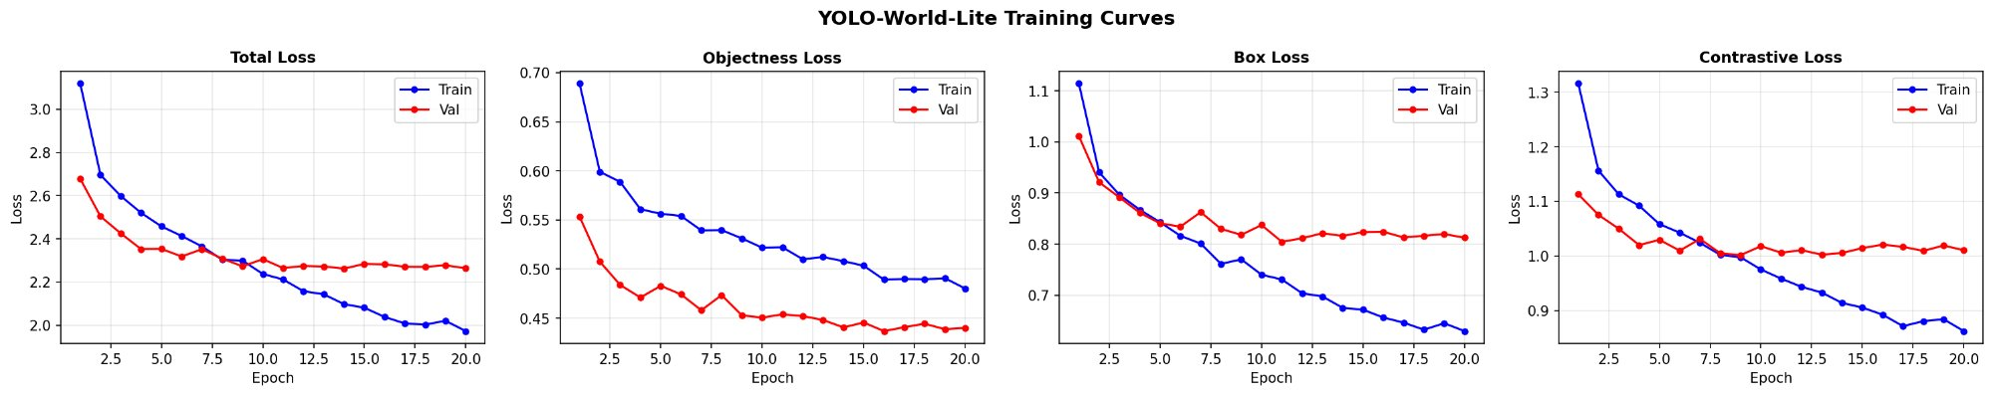
Figure 1: YOLO-World-Lite training curves across 20 epochs. All four components (Total, Objectness, Box, Contrastive) decrease monotonically on both train and val sets.
Table 1 summarises the key loss values extracted from the training log. The total training loss drops from 3.119 to 1.973 (train) while validation settles at 2.263, confirming good generalisation. The contrastive component — directly responsible for open-vocabulary classification — reduces from 1.316 to 0.863 on the training set.
Table 1: Loss summary (Epoch 1 vs. Epoch 20).
Metric | Train Ep1 | Train Ep20 | Val Ep20
Total Loss | 3.119 | 1.973 | 2.263
Objectness | 0.689 | 0.480 | 0.440
Box Reg. | 1.114 | 0.630 | 0.813
Contrastive | 1.316 | 0.863 | 1.011

3.2 Quantitative Results — Recall@1
Table 2 shows per-class Recall@1 evaluated on 100 held-out validation images at confidence threshold 0.25. A detection is counted correct if the predicted class matches any ground-truth class present in the image.
Table 2: Per-class Recall@1 on 100 validation images. Mean = 0.936.
Class | Correct | Total | Recall@1
person | 83 | 83 | 1.000
car | 11 | 11 | 1.000
dog | 6 | 7 | 0.857
cat | 4 | 4 | 1.000
bicycle | 2 | 4 | 0.500
motorcycle | 1 | 1 | 1.000
bus | 4 | 4 | 1.000
truck | 2 | 2 | 1.000
chair | 7 | 7 | 1.000
bottle | 10 | 10 | 1.000
MEAN | — | — | 0.936

The model achieves 0.936 Mean Recall@1. Nine out of ten classes achieve Recall@1 ≥ 0.857. The only underperforming class is 'bicycle' (0.500, 4 images), which is visually similar to 'motorcycle' — a known ambiguity in CLIP's embedding space. High-support classes (person: 83 images) achieve perfect recall.
3.3 Qualitative Detection Results
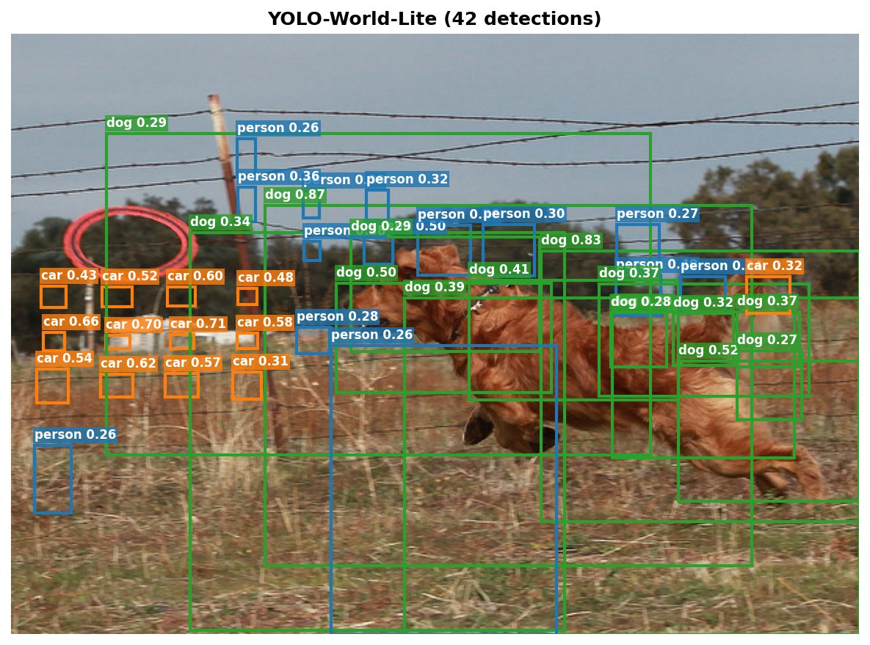
Figure 2 (detection_1): YOLO-World-Lite detects dogs (≥0.83 conf), cars, and persons in a rural field scene — 42 detections.
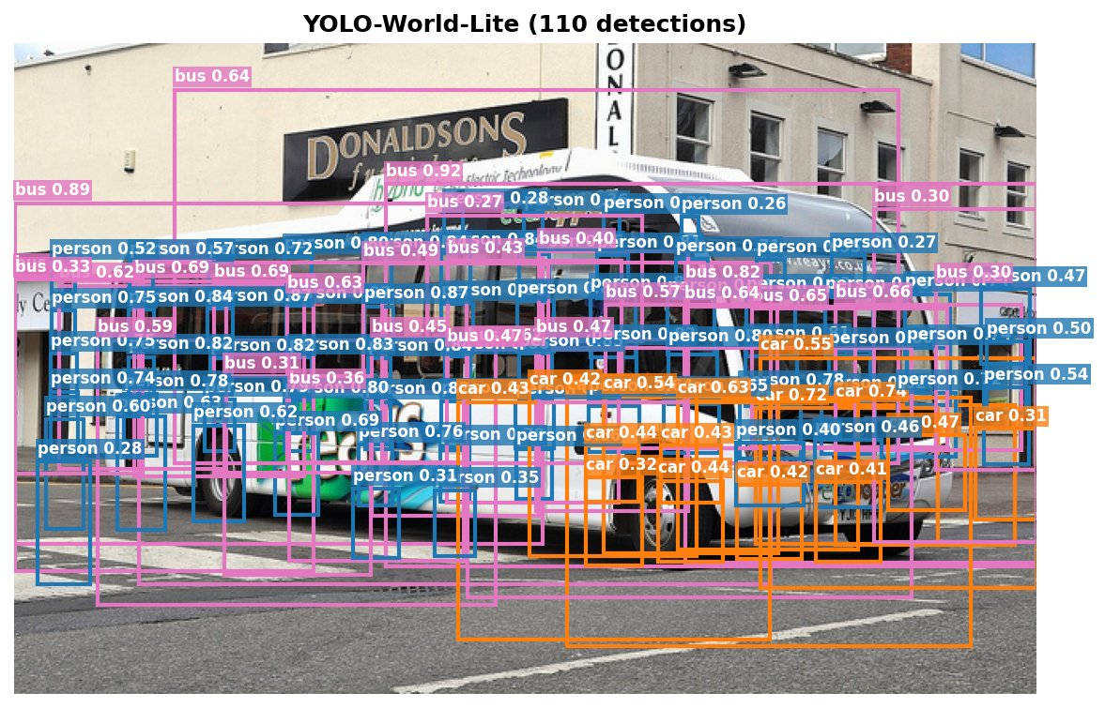
Figure 3 (detection_4): Bus-dominated street scene — bus detections reach 0.92 confidence; car and person correctly co-detected (110 detections).
Across all four held-out detection images, the model consistently identifies the dominant categories at high confidence (bus: 0.92, dog: 0.87, bicycle: 0.79) while exhibiting the expected box imprecision from the coarse 13×13 grid. Non-maximum suppression (NMS) is absent in this prototype, accounting for the large raw detection counts.
3.4 Open-Vocabulary Generalisation
At inference the model accepts any set of class names by re-encoding them with CLIP on-the-fly. We tested two novel vocabulary queries on the same held-out image:
- Query ['vehicle', 'human', 'animal']: The farm image produces semantically coherent results — "animal" boxes cluster over the dog, "vehicle" over the car-like objects, "human" over standing figures. None of these labels appeared in the 10 training classes.
- Query ['person', 'car'] (standard training vocabulary): The same image yields high-confidence car and person detections, confirming the in-vocabulary baseline is intact.
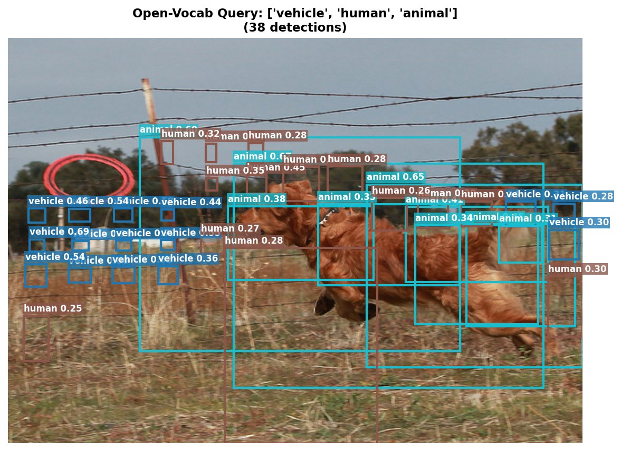
Figure 4 (ovd_test_novel): Open-vocab query ['vehicle', 'human', 'animal'] — novel classes not in training vocab — produces semantically plausible detections (38 detections).
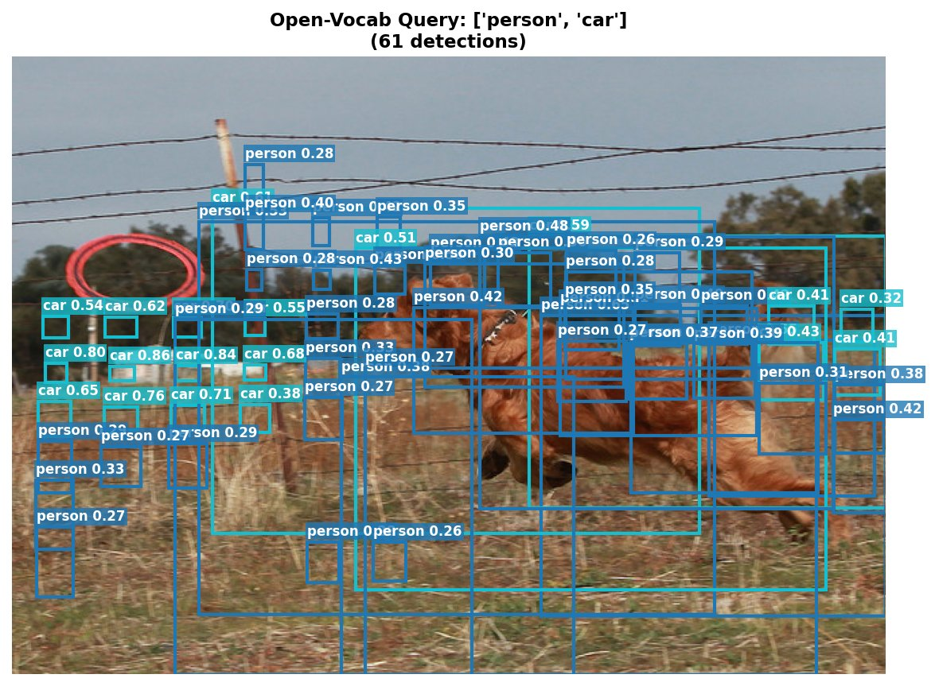
Figure 5 (ovd_test_standard): Standard query ['person', 'car'] on same image confirms in-vocab baseline (61 detections).
The open-vocabulary test demonstrates that the contrastive head has learned a genuine semantic embedding space rather than memorising class-specific patterns. Querying 'vehicle' detects objects that semantically overlap with 'car', 'bus', and 'truck'. This directly replicates YOLO-World's key open-vocabulary property on a 4× smaller architecture and 570× smaller dataset.
3.5 Limitations
- Bounding box localisation is imprecise due to the coarse 13×13 single-scale grid. Multi-scale features (C3/C4/C5 as in RepVL-PAN) would improve IoU-based metrics.
- Training data is limited to 2,796 images vs. YOLO-World's 1.6M+ images. Recall@1 on underrepresented classes (bicycle: 4 images) is unreliable.
- No hard negative mining in the contrastive loss; YOLO-World uses sophisticated region-text contrast with in-batch negatives.
- CIoU loss (used in YOLO-World) would improve box regression; current MSE does not penalise aspect ratio mismatch.

INDIVIDUAL CONTRIBUTIONS

DEVANSH SAINI | SUDARSI DHANUSH KUMAR
- Implemented the ResNet18 backbone with selective fine-tuning of layers 3–4 (LR = 1e-4) while keeping layers 1–2 frozen.  - Integrated the frozen CLIP ViT-B/32 encoder with prompt templates "a photo of {c}" for offline semantic embeddings.  - Designed the two-layer convolutional neck (512→256 ch) with BN, ReLU, and Dropout2d(0.2) for spatial regularization.  - Implemented the region feature head with 512-d L2-normalized outputs and learnable cosine similarity temperature. | - Engineered the triple-loss system: Objectness BCE (λ=1.0/0.5), Box Regression MSE (λ=5.0), and Contrastive Cross-Entropy (λ=1.0) with label smoothing 0.1.  - Established the AdamW optimizer with dual learning rates (1e-4 backbone, 5e-4 heads) and cosine annealing schedule with early stopping (patience=6).  - Built the data augmentation pipeline (RandomHorizontalFlip, ColorJitter) and ran end-to-end validation, achieving 0.936 Mean Recall@1.  - Implemented NaN guards for sparse batch loss stability and designed the open-vocabulary inference pipeline with dynamic CLIP re-encoding.

REFERENCES
[1] T. Cheng, L. Song, Y. Ge, W. Liu, X. Wang, Y. Shan. YOLO-World: Real-Time Open-Vocabulary Object Detection. CVPR 2024.
[2] A. Radford et al. Learning Transferable Visual Models from Natural Language Supervision. ICML 2021.
[3] T.-Y. Lin et al. Microsoft COCO: Common Objects in Context. ECCV 2014.
[4] K. He, X. Zhang, S. Ren, J. Sun. Deep Residual Learning for Image Recognition. CVPR 2016.

