**DAC INTERFACING**

**TRIANGULAR WAVEFORM:**

#include <LPC17xx.H>

#include "GLCD.H"

#define __FI 1 /* Font index 16x24 */

void delay(void) /* Delay Routine */

{

unsigned char i;

for(i=0;i<100;i++);

}

main()

{

unsigned int i,j;

LPC_SC->PCONP |= (1 << 15); /* enable power to GPIO */

LPC_GPIO0->FIODIR |= 0x007F8000; /* PortA and PortB as outputs*/

LPC_GPIO1->FIODIR |= 0x07F80000;

#ifdef __USE_LCD

GLCD_Init(); /* Initialize graphical LCD */

GLCD_Clear(White); /* Clear graphical LCD display */

GLCD_SetBackColor(Blue);

GLCD_SetTextColor(White);

GLCD_DisplayString(0, 0, __FI, " ESA ");

GLCD_DisplayString(1, 0, __FI, " Bangalore ");

GLCD_DisplayString(2, 0, __FI, " www.esaindia.com ");

GLCD_SetBackColor(White);

GLCD_SetTextColor(Blue);

GLCD_DisplayString(5, 0, __FI, " Dual DAC ");

GLCD_DisplayString(6, 0, __FI, " Triangular Wave ");

#endif

while(1)

{

for(i=0; i<0x0FF; i++)

{

LPC_GPIO0->FIOPIN =(LPC_GPIO0->FIOPIN & 0xFF807FFF) | i << 15; //send Positive pulse on PortA

LPC_GPIO1->FIOPIN = (LPC_GPIO1->FIOPIN & 0xF807FFFF) | i << 19; //send Positive pulse on PortB

delay();

}

for(j=0xFF; j>0; j--)

{

LPC_GPIO0->FIOPIN =(LPC_GPIO0->FIOPIN & 0xFF807FFF) | j << 15; //send Negative pulse on PortA

LPC_GPIO1->FIOPIN = (LPC_GPIO1->FIOPIN & 0xF807FFFF) | j << 19; //send Negative pulse on PortB

delay();

}

}

}

**SQUARE WAVEFORM:**

#include <LPC17xx.H>

#include "GLCD.H"

#define __FI 1 /* Font index 16x24 */

void delay(void) /* Delay Routine */

{

unsigned char i;

for(i=0;i<100;i++);

}

main()

{

unsigned int i,j;

LPC_SC->PCONP |= (1 << 15); /* enable power to GPIO & IOCON */

LPC_GPIO0->FIODIR |= 0x007F8000; /* PortA and PortB as outputs */

LPC_GPIO1->FIODIR |= 0x07F80000;

#ifdef __USE_LCD

GLCD_Init(); /* Initialize graphical LCD */

GLCD_Clear(White); /* Clear graphical LCD display */

GLCD_SetBackColor(Blue);

GLCD_SetTextColor(White);

GLCD_DisplayString(0, 0, __FI, " ESA ");

GLCD_DisplayString(1, 0, __FI, " Bangalore ");

GLCD_DisplayString(2, 0, __FI, " www.esaindia.com ");

GLCD_SetBackColor(White);

GLCD_SetTextColor(Blue);

GLCD_DisplayString(5, 0, __FI, " Dual DAC ");

GLCD_DisplayString(6, 0, __FI, " Square Wave ");

#endif

while(1)

{

for(i=0; i<0x0FF; i++)

{

LPC_GPIO0->FIOPIN =(LPC_GPIO0->FIOPIN & 0xFF807FFF) | 0x007F8000; //send High on PortA

LPC_GPIO1->FIOPIN = (LPC_GPIO1->FIOPIN & 0xF807FFFF) | 0x07F80000; //send High on PortB

delay();

}

for(j=0xFF; j>0; j--)

{

LPC_GPIO0->FIOPIN =(LPC_GPIO0->FIOPIN & 0xFF807FFF); //send Low on PortA

LPC_GPIO1->FIOPIN = (LPC_GPIO1->FIOPIN & 0xF807FFFF); //send Low on PortB

delay();

}

}

}

**TRIANGULAR AND SQUARE WAVEFORM – DAC INTERFACING:**

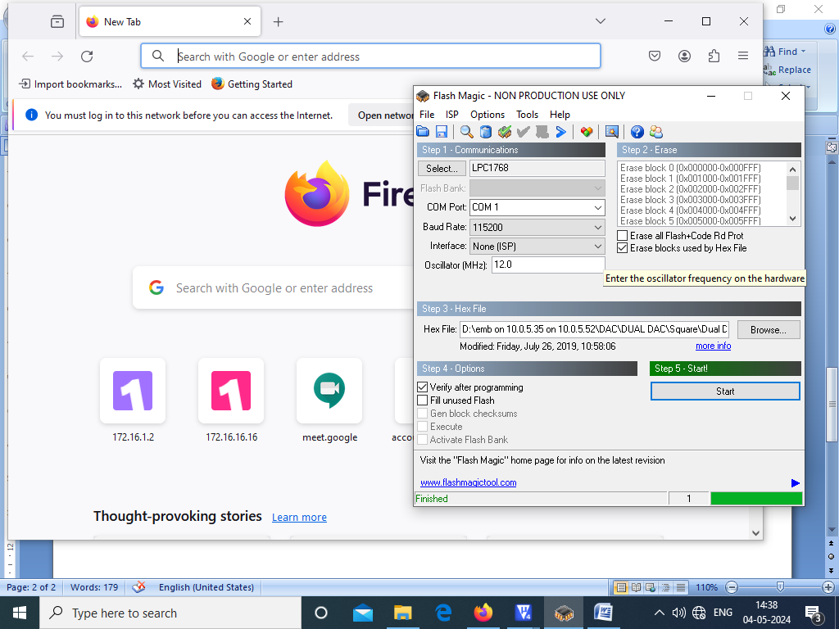

**DUAL DAC INTERFACING:**

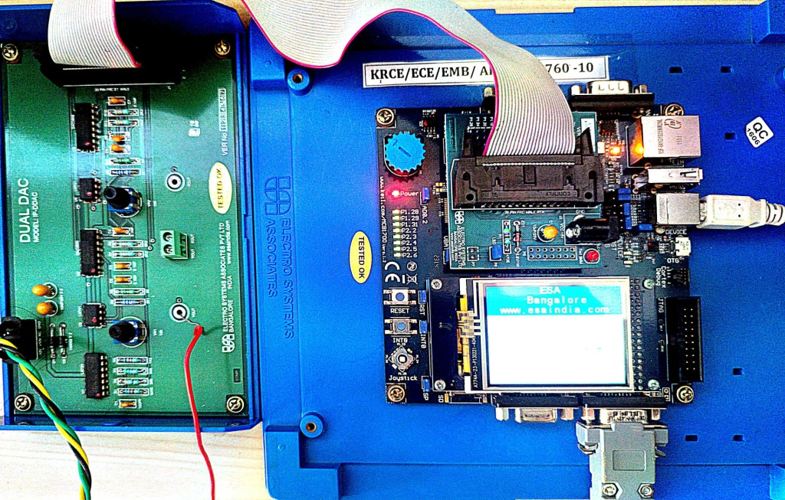

**TRIANGULAR WAVEFORM:**

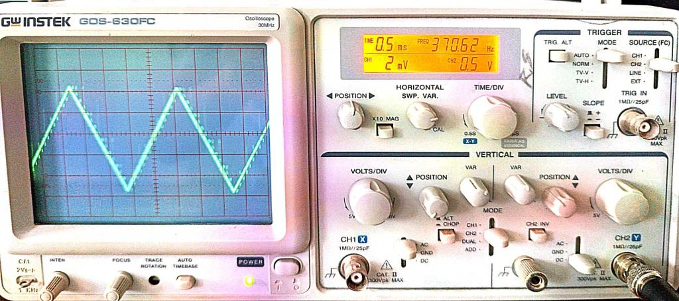

**SQUARE WAVEFORM:**

