**[This is a Header]**

# **MILKY WAY GALAXY**

**[This is a Paragraph]**

The Milky Way is the galaxy that includes the Solar System, with the name describing the galaxy's appearance from Earth: a hazy band of light seen in the night sky formed from stars that cannot be individually distinguished by the naked eye.

**[This is a Paragraph]**

The Milky Way is a barred spiral galaxy with a D25 isophotal diameter estimated at 26.8 ± 1.1 kiloparsecs (87,400 ± 3,600 light-years), but only about 1,000 light-years thick at the spiral arms (more at the bulge). Recent simulations suggest that a dark matter area, also containing some visible stars, may extend up to a diameter of almost 2 million light-years (613 kpc). The Milky Way has several satellite galaxies and is part of the Local Group of galaxies, which form part of the Virgo Supercluster, which is itself a component of the Laniakea Supercluster.

**[This is a Paragraph]**

It is estimated to contain 100–400 billion stars[30][31] and at least that number of planets.[32][33] The Solar System is located at a radius of about 27,000 light-years (8.3 kpc) from the Galactic Center,[34] on the inner edge of the Orion Arm, one of the spiral-shaped concentrations of gas and dust. The stars in the innermost 10,000 light-years form a bulge and one or more bars that radiate from the bulge. The Galactic Center is an intense radio source known as Sagittarius A*, a supermassive black hole of 4.100 (± 0.034) million solar masses.[35][36] The oldest stars in the Milky Way are nearly as old as the Universe itself and thus probably formed shortly after the Dark Ages of the Big Bang.[37]

**[This is an Equation]**

Tully Fisher Equation: MB​=−21.3−10.8log10​(W20​)

**[This is an image]**

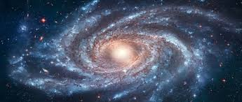

**[This is an image]**

