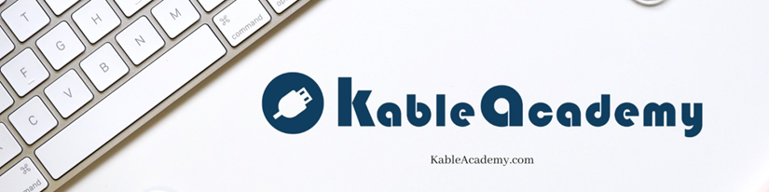

Part A: Multiple Choice
Circle the best answer for each question.

1. According to the chapter, what is the primary purpose of an interview?
a) To verify the technical credentials listed on a resume
b) To assess whether a candidate can communicate, handle pressure, and respond to feedback
c) To compare candidates’ years of experience
d) To test a candidate’s knowledge of industry software

2. A candidate says: “I just helped reset passwords and did some basic troubleshooting.” According to the chapter, what is the main problem with this statement?
a) It is too technical for a non-IT interviewer to understand
b) It reveals a gap in the candidate’s hard skills
c) The hedging language communicates insecurity before the facts are even considered
d) It does not include enough detail about the tools used

3. Which of the following best follows the chapter’s “context, growth, forward focus” structure?
a) “I’m sorry for the gap—I know it looks bad, but I was going through some personal things.”
b) “I took time away to care for a family member. During that period I continued building my skills through coursework. I’m now fully focused on a long-term IT support role.”
c) “I was between jobs and tried to stay current. I’d rather not get into the details if that’s okay.”
d) “I was laid off, which gave me time to really reflect on what I want from a career.”

4. According to the chapter, what does “confidence” mean in an interview context?
a) Speaking loudly and maintaining strong eye contact
b) Having all the answers before the interviewer finishes the question
c) Steadiness—knowing where your answer is going before you begin speaking
d) Projecting enthusiasm and energy throughout the entire conversation

5. The chapter says soft skills “determine whether someone gets hired, promoted, or let go.” What is the main argument behind that claim?
a) Technical skills can be trained quickly, so employers focus on personality first
b) Communication, composure, and professionalism are observable behaviors that directly affect workplace performance
c) Most employers now use personality assessments instead of technical screens
d) Entry-level IT roles rarely require technical expertise

6. What does the chapter say happens when a candidate uses phrases like “I’m still learning, but…”?
a) It signals humility, which many interviewers appreciate
b) The interviewer hears the hedge before the content and may discount what follows
c) It demonstrates self-awareness, a valued soft skill
d) It has little effect on how the interviewer evaluates the candidate

