

**Naming Conventions**

**For**

EMPLOYEE MANAGEMENTSYSTEM



VNR Vignana Jyothi Institute of Engineering & Technology Bachupally, Nizampet (S.O), Hyderabad–90

***Submitted By***

***Group Details:***

**A. Nikhita -20075A0513**

**D. Shyam Kumar– 20075A0514**

**Pooja Kumari Singh –20075A0516**

**SK. Yasmin Sulthana – 20075A0517**

**S.Arun –20075A0518**

Contents

Revision History 2

1.1 Purpose 3

1.2 Audience 3

1.3 Design Process 3

# Revision History

|  |  |  |  |  |
| --- | --- | --- | --- | --- |
| Revision | Date | Author | Section | Comments/Changes |
| 1.0.0 | 27 April 21 | All | All | Initial Revision |
|  |  |  |  |  |
|  |  |  |  |  |
|  |  |  |  |  |
|  |  |  |  |  |
|  |  |  |  |  |
|  |  |  |  |  |
|  |  |  |  |  |
|  |  |  |  |  |

1. **Project Overview**

## Purpose

The purpose of this document is to specify the Naming Conventions for the project to be developed for the system “Employee Management System”.

## Audience

This Naming convention is intended to be used by members of the development team that will implement the functionality of the “Employee Management System”. This document will also be used to communicate the Coding conventions to the system developers’ team.

## Design Process

|  |  |  |
| --- | --- | --- |
| **S. No** | **Document type** | **Document Naming Convention** |
|  | Design Documentation | IIBtech_CSEC_Team-2_**Employee Management System**_V1.1. |
|  | Source Code | SRS_EMS_Team-2  HLD_EMS_Team-2 |
|  | Example: Folder Naming Conventions | @angular/platform-browser – Browser Module  @angular/common/http – HTTP Client Module  @angular/core - NgModule  Root Component  AdminModule  Components  -Employeemaintenance.Component  -AttendaceComponent  -ProjectComponent  -SalaryComponent  -PerformanceComponent  EmployeeModule  Components  - mydetailsComponent  -myprojectComponent  -myattendanceComponent  -mysalaryComponent  -myperformanceComponent  -FAQComponent  \  Mongo_DB – node.js module |

**1.4 Central Repository**

**Organization:**

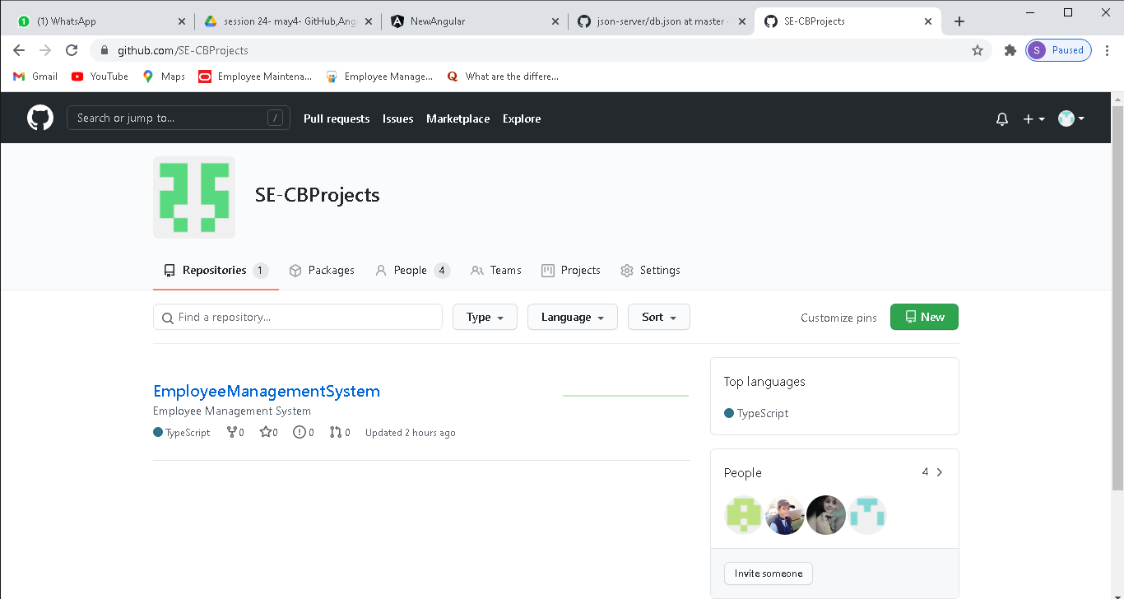

**EMS Repository**

