1. Proposal description

* Function

① messenger -> only 1:1

② time table -> put personal time table or from API

③ scheduler -> put personal schedule

④ sharing -> combine time table and schedule and make weekly scheduler for users.

* It shows rest time for users
* Constraints

① messenger only provides 1:1 yet

1. UI diagram => draw user diagram

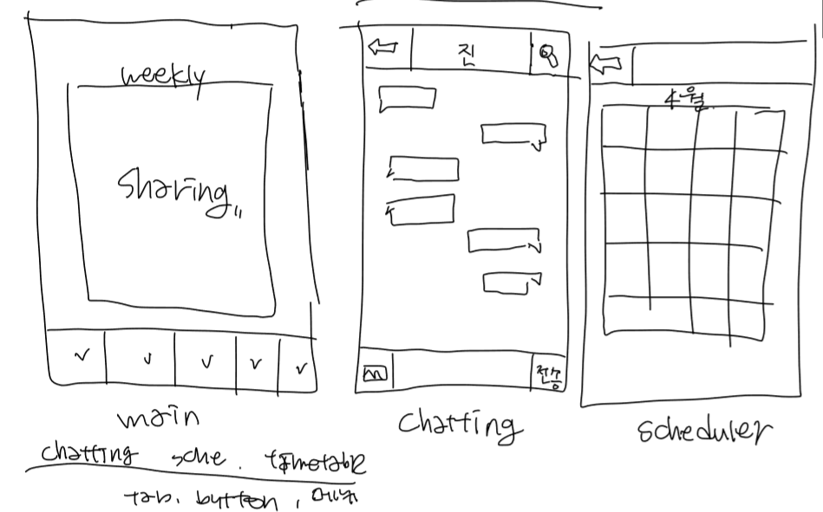

1. Use cases(Usage scenario)

1) Initial assumption

-A college student whose time management is difficult wants to manage the schedule and timetable together.

-Couple that time is difficult to match.

-People who want to share their schedule in real time and talk.

2) normal

-Add the class you want to add to the time table.

-Add your personal schedule to the scheduler.

-Sharing function shows integrated weekly scheduler.

-Talk to each other in the messenger and adjust the time.

3) Other activities

-Supports backup and restoration of schedule, time table, and messanger

1. Process description

* Tool : Android
* Why? Application is commonly used by people. Accessibility good!
* Role

① messenger (2) :

② time table, scheduler, sharing (2) :

③ UI (2) :

* Time line
* 6th week : make more detail
* 7th week : design
* 8th week : midterm test
* 9th ~ 11th week : implement
* 12th ~ 13th week : correct along the customer’s requirement
* 14th ~ 15th week : debug and implement additional function, Demo, prepare presentation.
* Risk Summary
* There isn’t any time to recommend for users.
* The changes according to date

★★ Document (Due : 4/7 23:59PM to Jin)

* Role

1. Jin : translate file to English, design GUI of application, make whole document
2. Juhyeon : draw user diagram concretely
3. Antoine : write risk summary, reason why we use android specifically
4. Chan : Usage scenario
5. JongHyeon : make timeline, combine detail of function altogether
6. Rajat : write proposal description more specifically
7. Each function team : write the detail of function and send to JongHyeon.