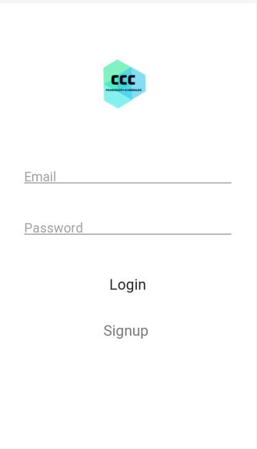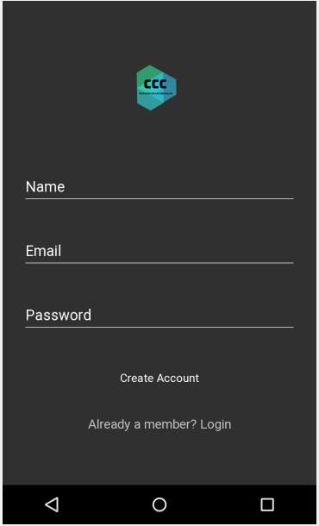

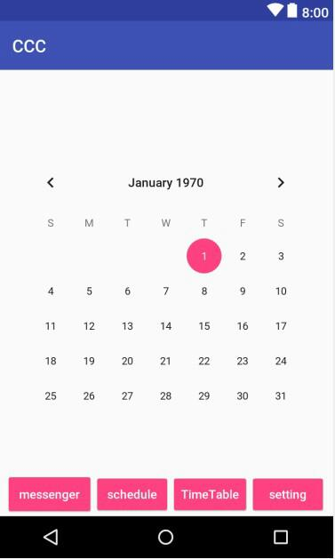Pros :

* Simple , Lucid design of Login and Signup Pages
* Using Tabbed Menu lets User
* It makes it easy to find the current location of entry.
* It allows designer to jump frequently among all entries without losing direction.
* It shows directly the contents of the most important entry.

Cons:

* Not good for too many entries.