**Requirement Document**

Team CCC

(Hong Jin, Park Juhyeon, Kim Kyoungchan, Choi Jonghyun, Rajat, Antoine)

1. **Proposal description**

* Project Description: CCC is a messenger app like any other messenger app especially developed for University Student’s but it has some added functionalities which can be very useful for managing day to day activities. It comes with a scheduler which can access your university time table and show you when you classes or not and lets you to even manage your individual schedule, added to this you can also use schedule sharing function which lets you to share your schedule over the messenger so that you can arrange your meeting with your without going over calendar again and again. So basically with this app you can
* Talk with your with friend whenever and wherever you want.
* Manage your personal schedule.
* Share your schedule with your friends.

1. **UI diagram**

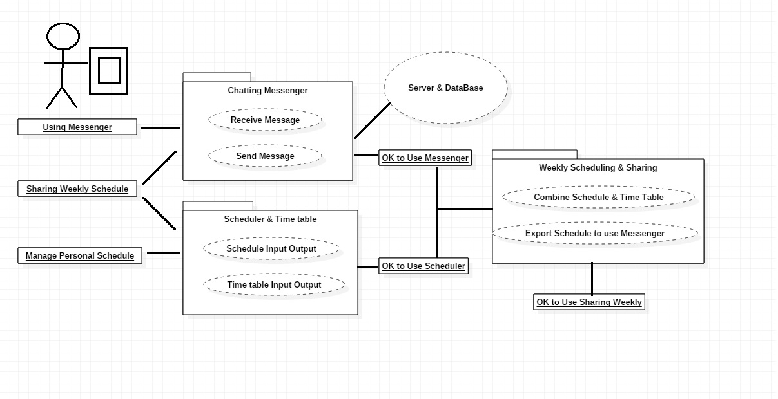

Figure 1 use case diagram

1. **Use cases(Usage scenario)**

1) Initial assumption

-A college student whose time management is difficult wants to manage the schedule and timetable together.

-Couple that time is difficult to match.

-People who want to share their schedule in real time and talk.

2) normal

-Add the class you want to add to the time table.

-Add your personal schedule to the scheduler.

-Sharing function shows integrated weekly scheduler.

-Talk to each other in the messenger and adjust the time.

3) Other activities

-Supports backup and restoration of schedule, time table, and messanger

1. **Process description**

* **Tool** : Android
* Why using android :
* The available platforms are Android, IOS and Windows phone.
* Android is a really friendly platform to launch our application because there is lot of android users and Android application are really easy to build on any kind of system, and android application are very accessible.
* Windows Phone does not have enough users to make our application on it.
* The biggest problem with IOS is that we need specific apple system and swift language to build our application otherwise it’s pretty the same as Android.   
  That’s why we decided to use Android platform.
* **Role**

① messenger (2) : Park Juhyeon, Kim kyoungchan

텍스트, 스크린샷이(가) 표시된 사진

매우 높은 신뢰도로 생성된 설명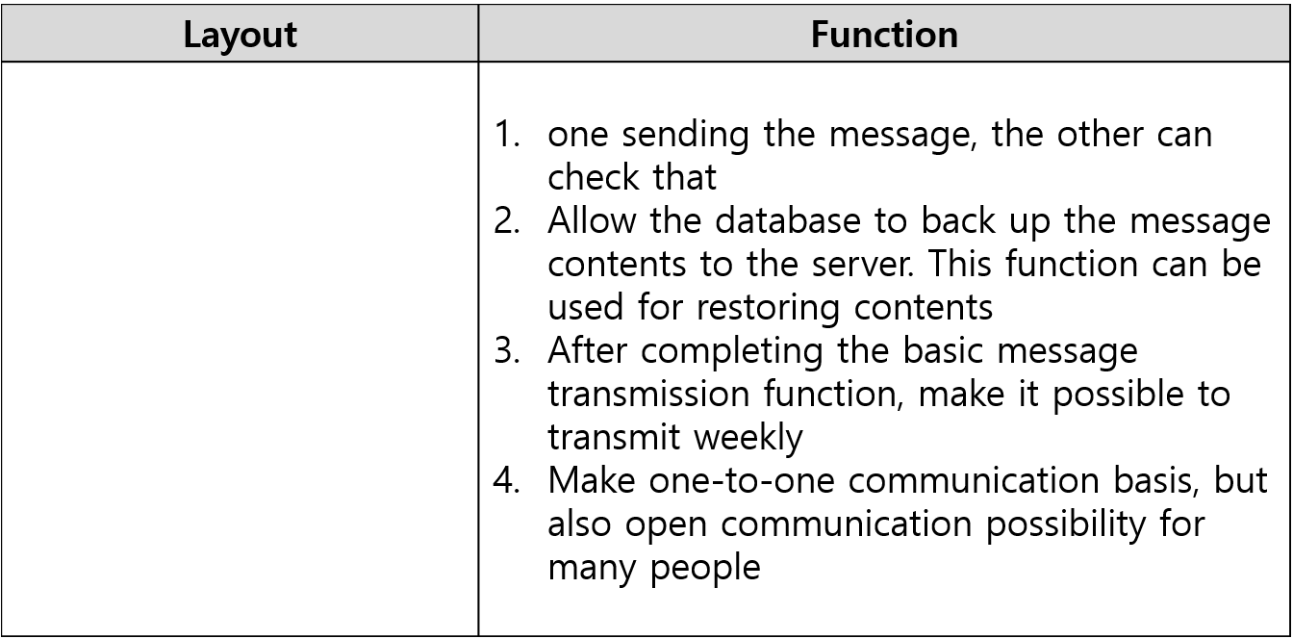

② time table, scheduler, sharing (2) : Hong Jin, Choi Jonghyun

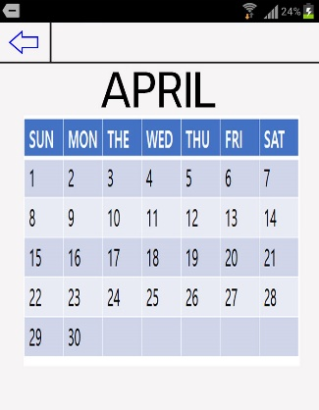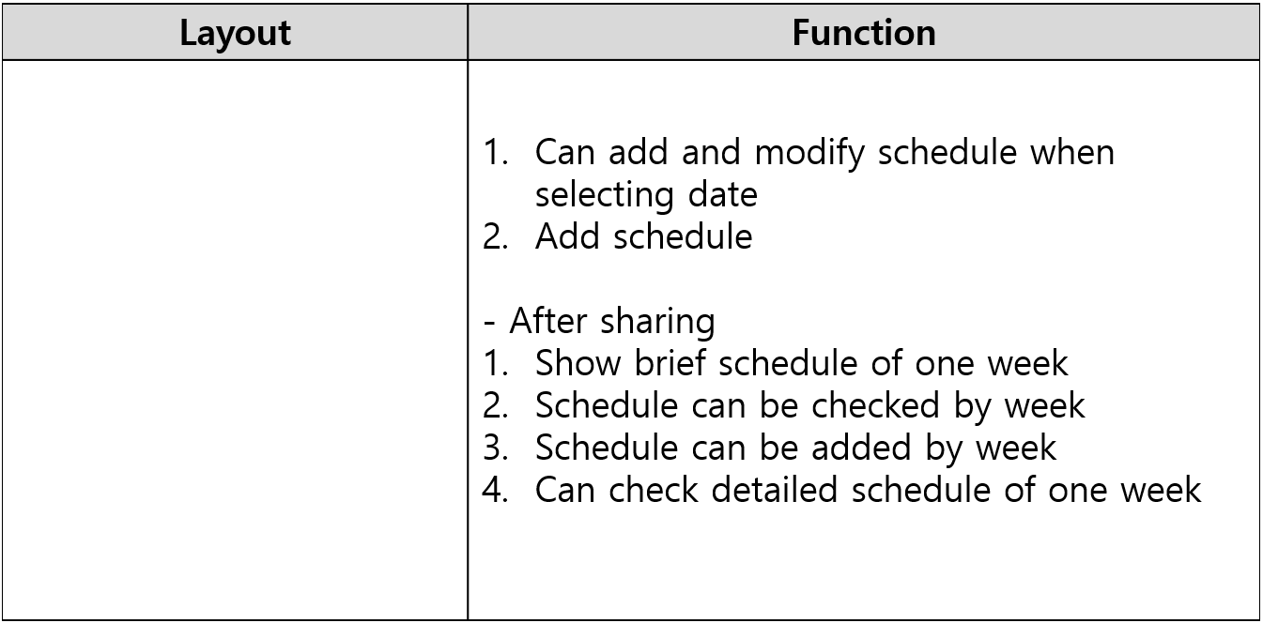

③ UI (2) : Rajat, Antoine

스크린샷이(가) 표시된 사진

매우 높은 신뢰도로 생성된 설명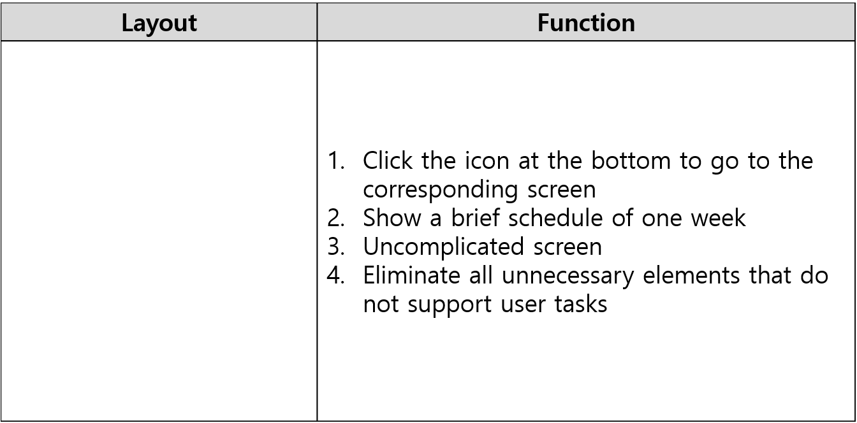

* **Time line**

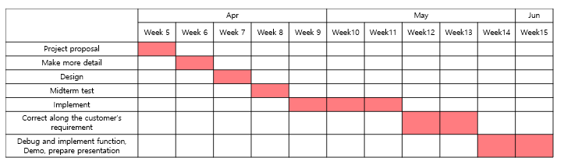

Figure 2 Whole time line

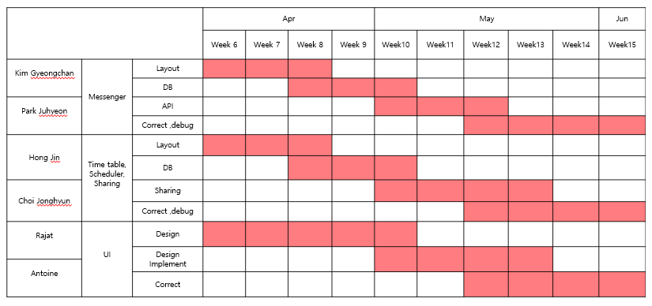

Figure 3 Part time line

* **Risk Summary:**
* Lack of time to recommend users
* Changes according to date
* Usage of personal data