**Midterm Project**

# **Overview**

**Members:**

1. **Aidar Askarov**

**Email:** 203043@astanait.edu.kz

**Barcode:** 203043

**Role:** Leader, Developer

1. **Amina Kabykenova**

**Email:** 203057@astanait.edu.kz

**Student ID:** 203057

**Role:** Developer

1. **Dias Shaymerdenov**

**Email:** 203026@astanait.edu.kz

**Student ID:** 203026

**Role:** Developer

1. **Assem Atygayeva**

**Email:** 203002@astanait.edu.kz

**Student ID:** 203002

**Role:** Writer

**Communication strategy:**

Created a telegram group, where discussed our project and developed website together. Also we communicated (call) via MS Teams.

**Motivation:**

To showcase our knowledge and skills in building websites, gained in 10 weeks. This project will be a good start for those who are planning to become web developers in the future. Knowledge in this area is a great opportunity to get a job in a good IT company. After all, people with IT skills are now in demand.

**Screen shots:**

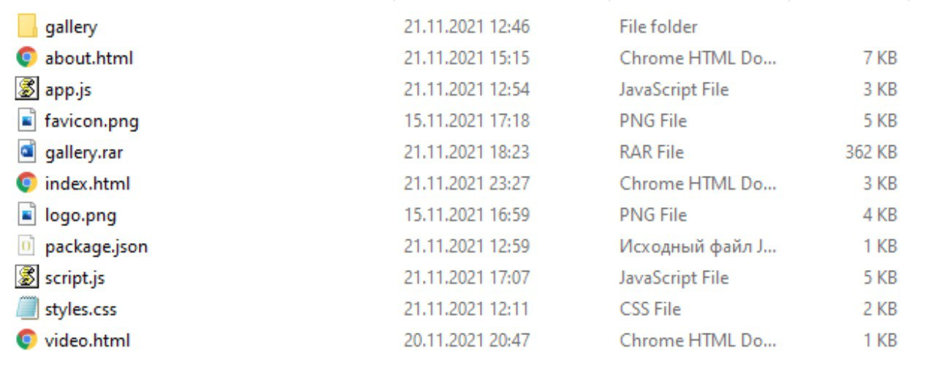

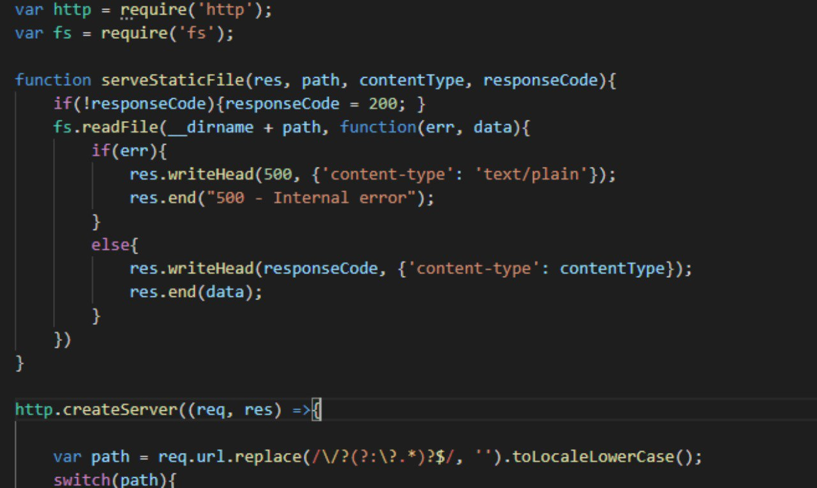

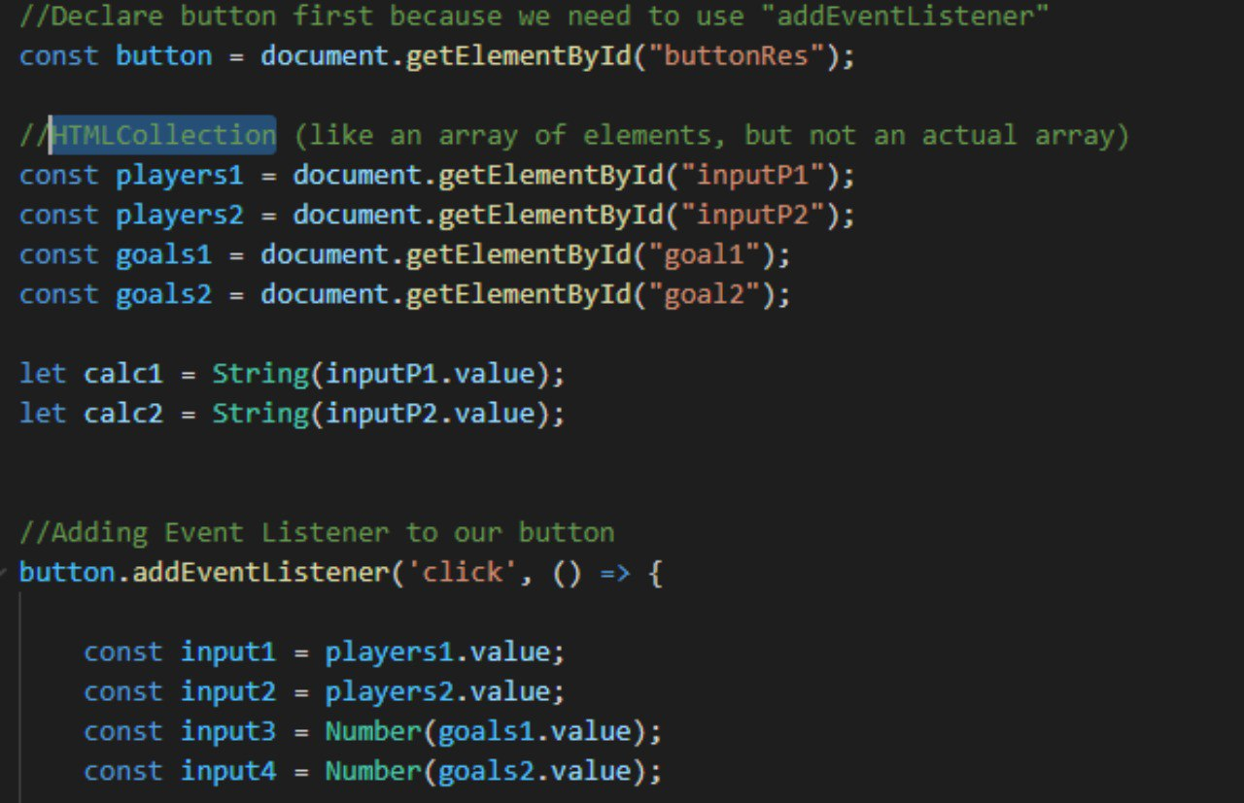

# **Project goals and team interests**

**Project goals**

* Create convenient and easy to use website for football lovers.
* Provide a simple and understandable syntax.
* Calculate the victory of a football match faster.

**Team interests**

* Improve skills and knowledge in writing HTML and CSS, JavaScript codes by creating the website
* Improve social skills by making discussion, talks and collaboration in team in general
* Understand the principles of creating and designing the website and then using these s skills in the future career

# **Phases**

* Phase 1- Create Homepage with HTML/CSS (Navbar, Calculator, Footer)
* Phase 2- Create a About Us page with HTML/CSS and Bootstrap
* Phase 3- Create a working calculator via javascript (front-end), and server-side js (back-end)
* Phase 4- Write a documentation, prepare a presentation, create a package.json via express.js.

# **Content structure**

**Site map**

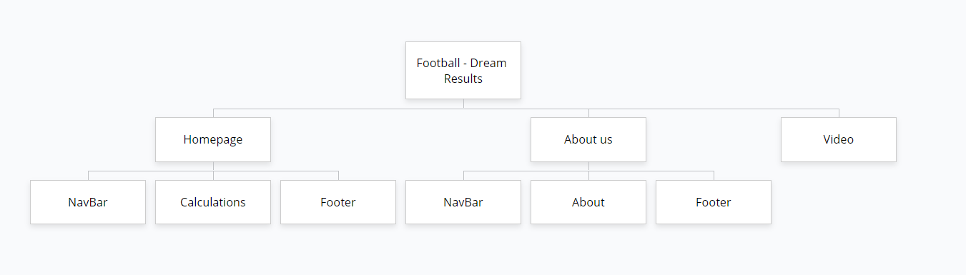

**Content types**

* Homepage
* About Us
* Video

**Design**

Our design UI/UX was simple enough, we just did a logotype, used simple and good-looking font (Montserrat). Also we used only black and white colors. Some transitions are made with CSS. Web Design is responsive, so you can open it with mobile device and it will look as good as on Computer.

**Functionality**

Our website consist of Homepage, there you can see navigation bar, main part of the calculator and footer. Second page is about us. It consist of Navbar, about part and footer. Here you can see 4 photos of us. In calculator we should type players of the first team, number of goals scored by team 1. And the same for the 2 team. Then it should output the results, including the match winner, match results and all possible variations of the scored goals.

**Hosting**

• Sign in to GitHub. Create a new repository and name it.   
• Select the "public" option so that everyone has access to view the repository.   
• Initialize repository by clicking “README file” and click “Create repository”.   
• Then we clicking “Add file” and uploading HTML, CSS and photos that we used to create the website.   
• We go to the “Settings”, and see the “GitHub Pages”.   
• Choose “main” in source option. As folder we choose “/docs” and save it.   
• Go to the end of the “Settings” page and see the link of our website, that published in GitHub.

**Accessibility**

Our website is clean and simple made in black and white style, accessible for everyone. We have an organized content and good-looking design as well. Navbar, Footer and Font of the texts are appropriate for modern internet.

**Deadlines**

* Phase 1- November 15, 23:50
* Phase 2- November 17, 15:00
* Phase 3- November 19, 23:59
* Phase 4- November 22, 10:00

# **Summary**

Starting something new is always a good idea and improving yourself in different areas is also great. At the beginning it seemed like it something hard to do, but when we started doing this project it was not so hard. However, it was challenging and a lot of time consuming for some members of our group.

We think that we tried hard and did a good job to provide a great website for people that will use it. We guess that we achieved project goals and team interests, because we had so many mistakes and we were trying to correct them thinking about principles of creating website. Thanks for that, we learned a lot of new things about writing code.

Overall, we really enjoyed the teamwork. All participants approached the task very responsibly. We immediately assigned responsibilities and started them. The performance of a certain type of work by one person is limited by his personal abilities and skills. Dias did back-end javascript server-side work. Aidar did html/css for homepage and front-end javascript. Amina worked on html/css about us page. I (Assema) worked on documentation and presentation, I was a meeting organizer. We believe that we have managed to create a really convenient, comfortable and interesting website for football lovers. Also, the development of this project will have a positive effect on the skills for all of our members, in other words, it will be a useful experience.