Modified Project Proposal

Dominic Allen
Maximus Collier
Nathan Fang
Momar K Shirley
California State University San Marcos
CIS 444-01: Web Programming (42267)
Dr. Shaun-inn Wu
November 10, 2026

Modified Project Proposal

- Problem, Purpose, and Unique Value.
  - Abstract. Legislative Accountability & Constituent Engagement (LACE) is a proposed federal legislative-information and community-discussion website. It will help visitors find legislation and recorded votes, review legislators’ public information, discuss proposed laws and individual recorded votes, and contribute attributed supporting sources. The project deliberately balances political accountability and public discussion, rather than attempting to tell users which political positions to support.
  - Background. Public legislative records and constituent conversations often exist in separate places. A visitor may locate an official bill or roll call yet still needs to search elsewhere for an attributed public explanation, discussion of the possible effects of legislation, or reactions from other residents. The length of a legislator service alone does not demonstrate whether they are responsive; LACE instead emphasizes observable actions, source context, and clearly labeled community perspectives.
  - Unique Value.Congress.gov does not allow constituents to comment on any legislation proposed or voted on. LACE will provide a searchable, bill-centered website that combines publicly available federal legislative records with registered-member participation. Guests will inspect bills, legislators, roll-call votes, and discussions. Members will create and maintain comments, replies, support/opposition feedback, and attributed source submissions. Moderators will handle reports and source review; administrators will manage accounts, technical issues, roles and suspension decisions. A hybrid API and database design will store only the information needed for responsive pages and user transactions. The first release is federal; California legislative data is a future enhancement.
- Users and Core Requirements. Guest access does not require registration. User registration collects username, email, password (stored as a secure hash), self-reported state and congressional district, and optional political affiliation. Only username, state, and district are displayed publicly by default.
Role | Actions & Operations
Guest | Search/list/view bills, legislators, votes, discussions, and submitted public sources
Member | Register/login/logout; create/view/update/delete own comments; reply; express bill support/opposition; submit source links; report comments; edit own profile
Moderator | Search/list reports and pending sources; approve/reject sources; retain/remove reported comments; recommend suspension (cannot suspend accounts)
Administrator | Create/search/list/edit/disable user accounts; set roles; approve suspensions; review logs and technical reports; administer site content

- Implementation.
  - Frontend: HTML, CSS, and JavaScript will provide user interface, forms, search filters, and interactive webpage elements.
  - Backend: PHP will process HTTP GET and POST requests, validate user submissions, manage authentication and sessions, and execute database operations.
  - Database: PostgreSQL will store registered users, comments, legislative feedback, supporting sources, reports, and moderation actions. SQL operations will include INSERT, SELECT, UPDATE, and DELETE. Where appropriate, content will be soft-deleted by updating its status to inactive or hidden.
  - API: The Congress.gov API will provide available legislative information, including bills, summaries, congressional members, committees, and supported House roll-call voting records. Selected records will be stored in PostgreSQL to support searching and reduce repeated API requests. Additional official sources may be required for Senate voting records.
- Required Webpages, Inputs, Results, and Transitions
The website will use 11 consolidated pages. Each row states the page, user input/actions, and result or destination after submission. All pages will support navigation back to Home.
Page | Input (User Action) | Result / Next Page
home.html | Search term, browse recent bills/discussions | Matched list -> legislator.html / bill_details.html  Login -> access.html
legislator.html | Name and state/district filters; select vote, bill, compare | Voting history, party/district, time in office  -> bill_details.html / discussion.html
bill_details.html | Bill Search; support/oppose;  Open-source info or discussion | Status, summary, votes, feedback totals  -> discussion.html / submit_source.html
discussion.html | New comment/reply;  Edit/delete own entry;  report | Updated thread or report created  -> discussion.html / report_issue.html
access.html | Username/email + password;  login/registration | Authenticated -> home.html / profile.html  Logout -> home.html
submit_source.html | Bill/vote, source type, cited claim, url | Pending source submitted -> bill_details.html  Moderator queue(validation) -> moderator.html
profile.html | Edit account, district, optional affiliation | Member content -> discussion.html
report_issue.html | Target comment or technical issue; reason/details | Report saved  -> moderator.html (content)  -> admin.html (technical)
moderator.html | Filter reports/sources; approve/reject/remove; recommend suspension | Escalation -> admin.html
admin.html | Search/create/edit/disable users; resolve technical tickets; set role/suspension | Update user/ticket/role -> admin.html
compare.html | Choose two legislators | Side-by-side votes, bills, activity -> legislator.html

- Webpage Transition Diagram.
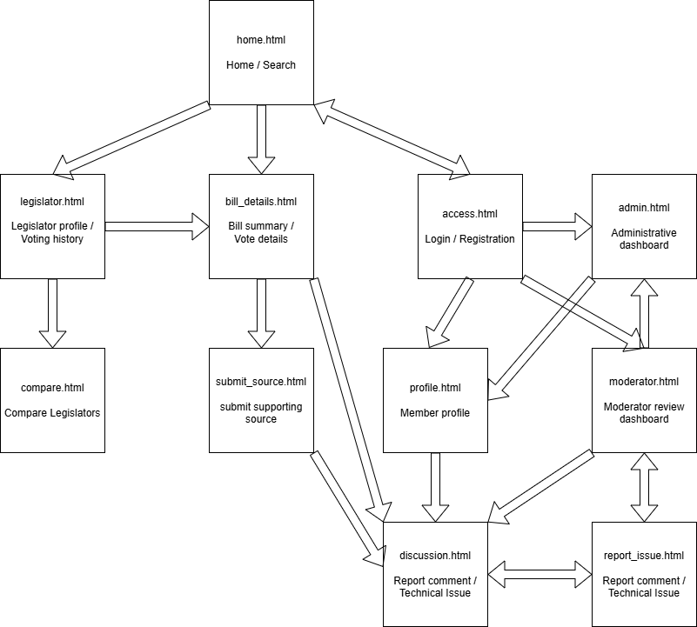

- Abstract Wireframes. Illustrative data shown for layout purposes only.
  - Wireframe for home.html
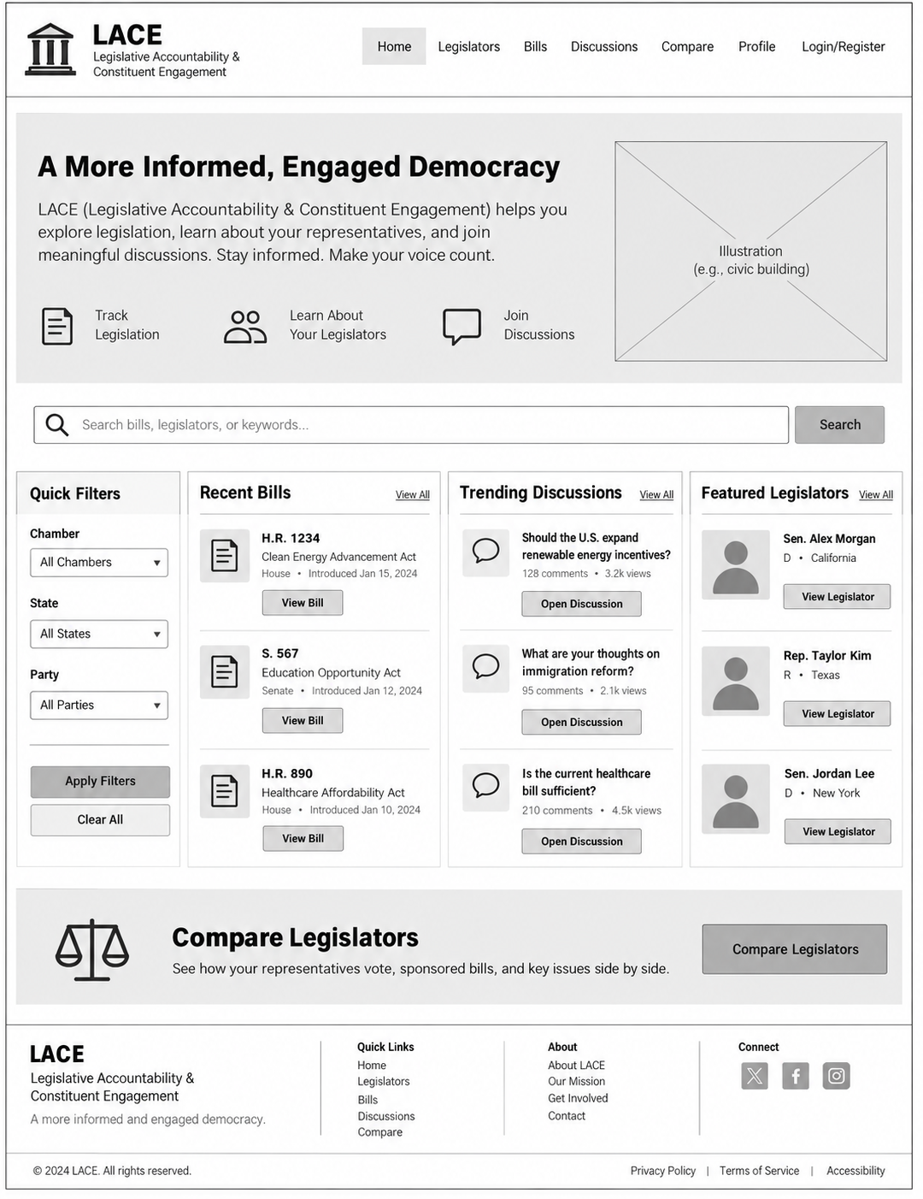
  - Wireframe for legislator.html
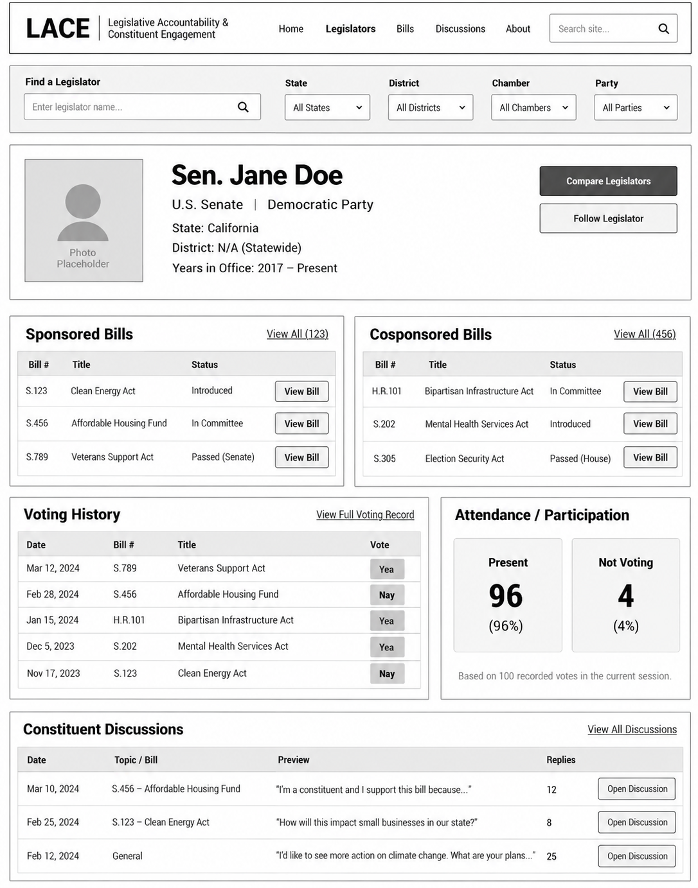
  - Wireframe for bill_details.html
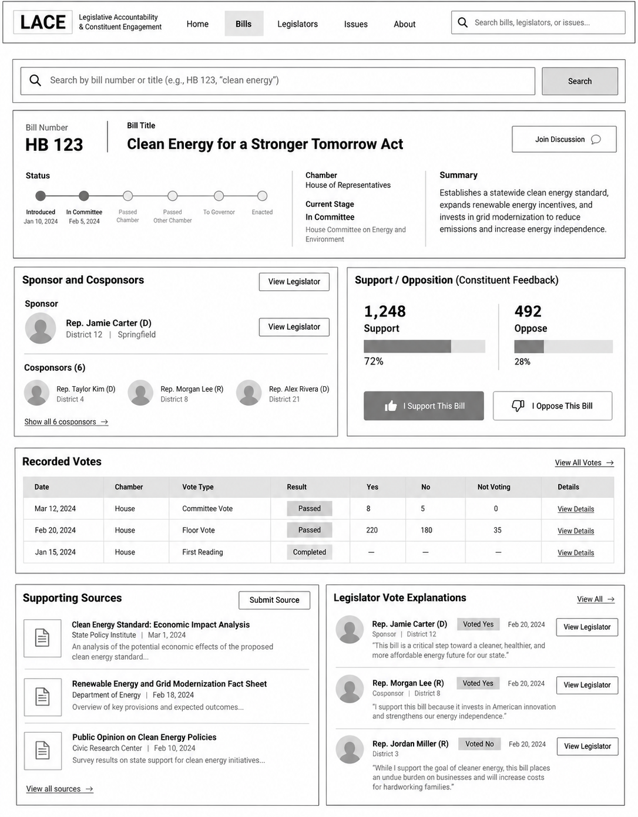
  - Wireframe for discussion.html
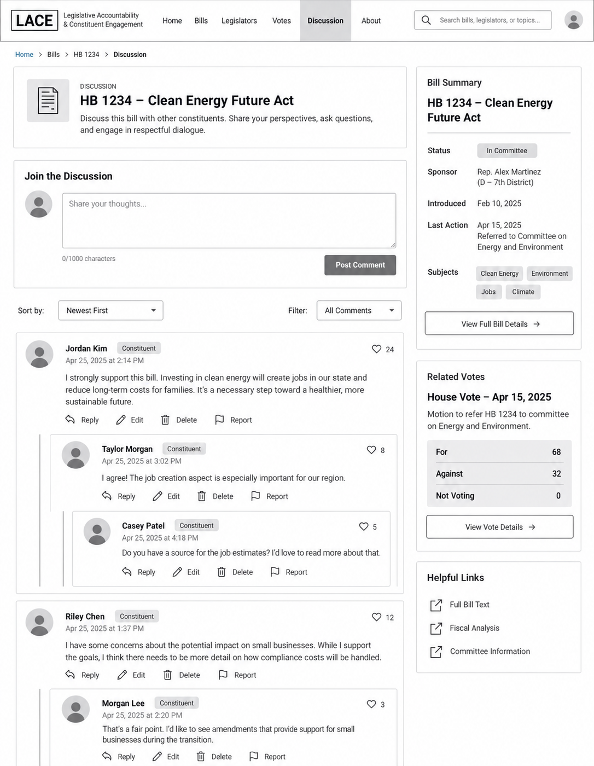
  - Wireframe for access.html
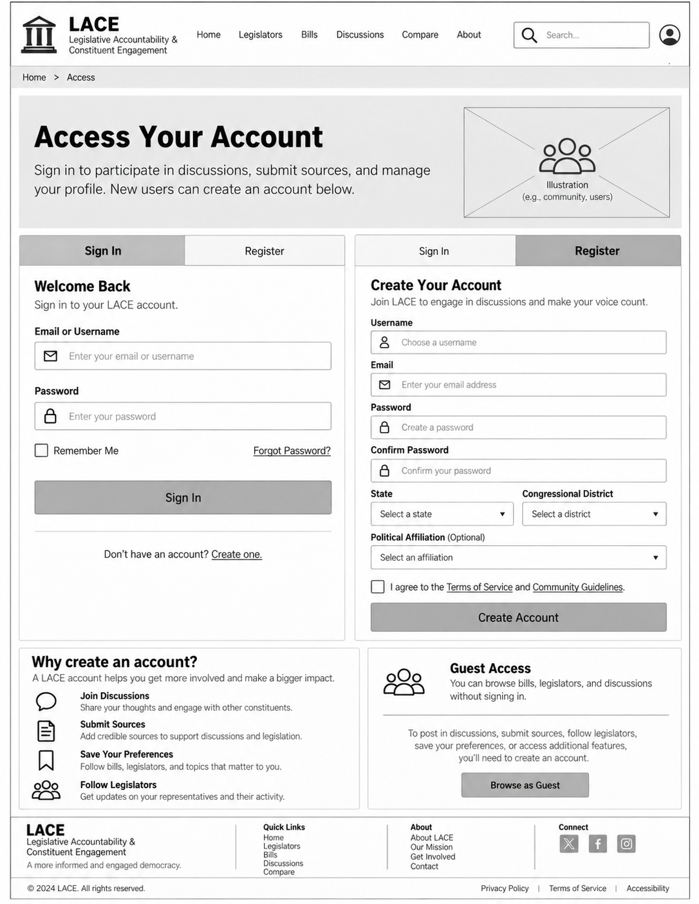
  - Wireframe for submit_source.html

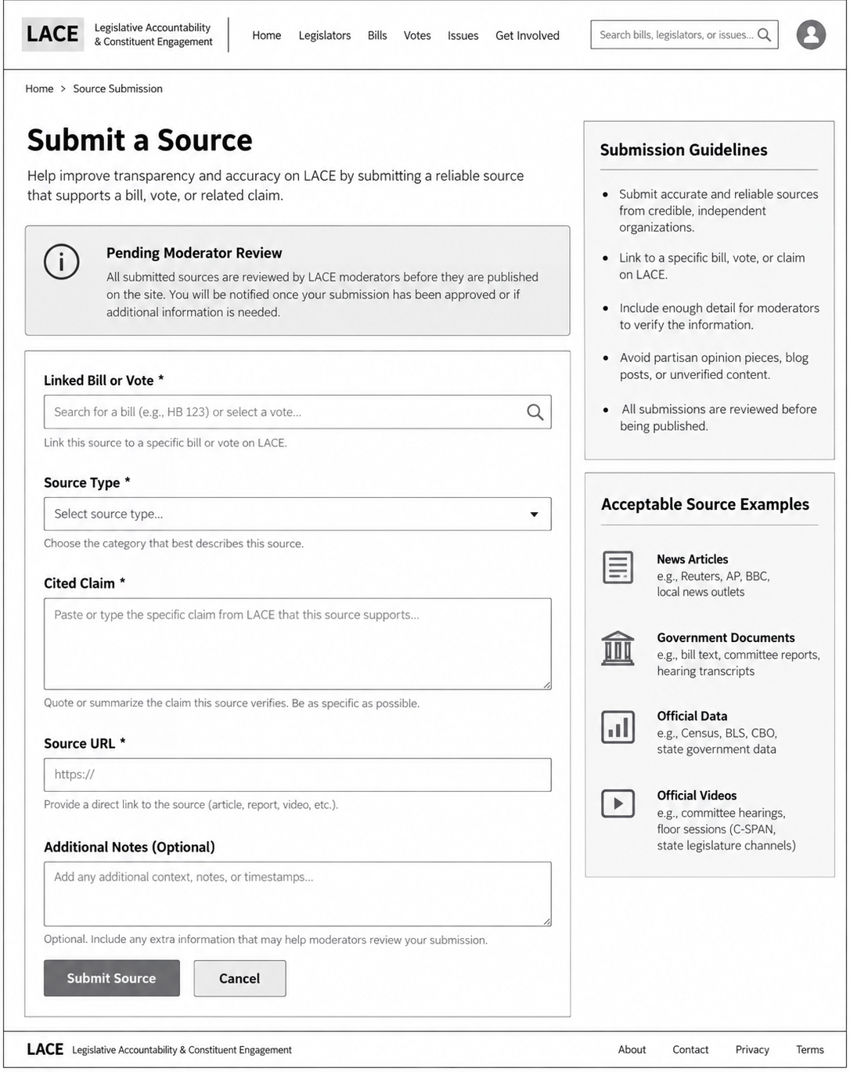
  - Wireframe for profile.html
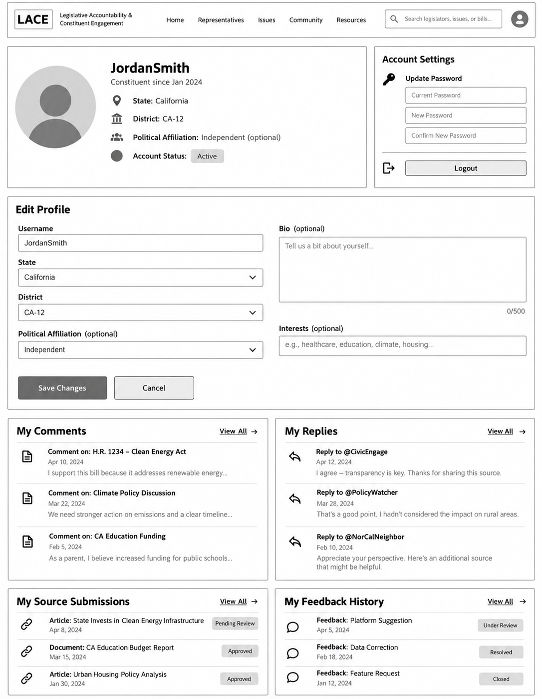
  - Wireframe for report_issue.html
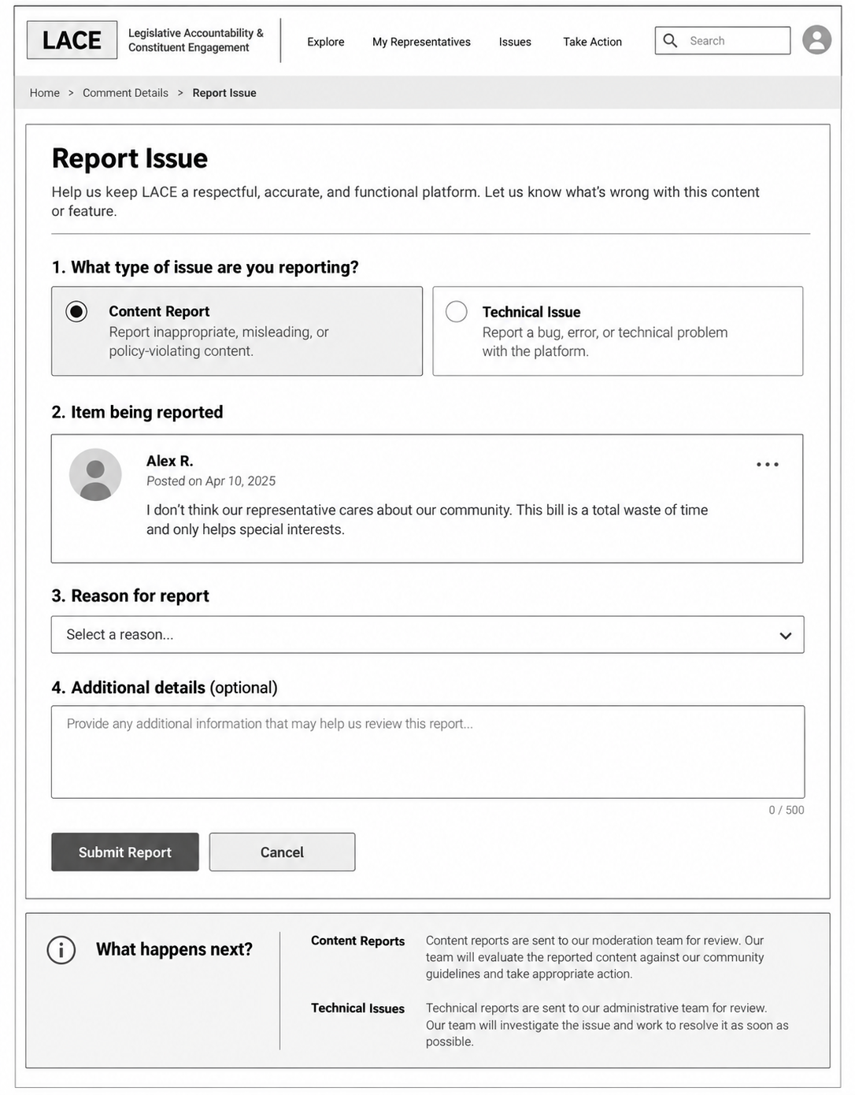
  - Wireframe for moderator_dashboard.html
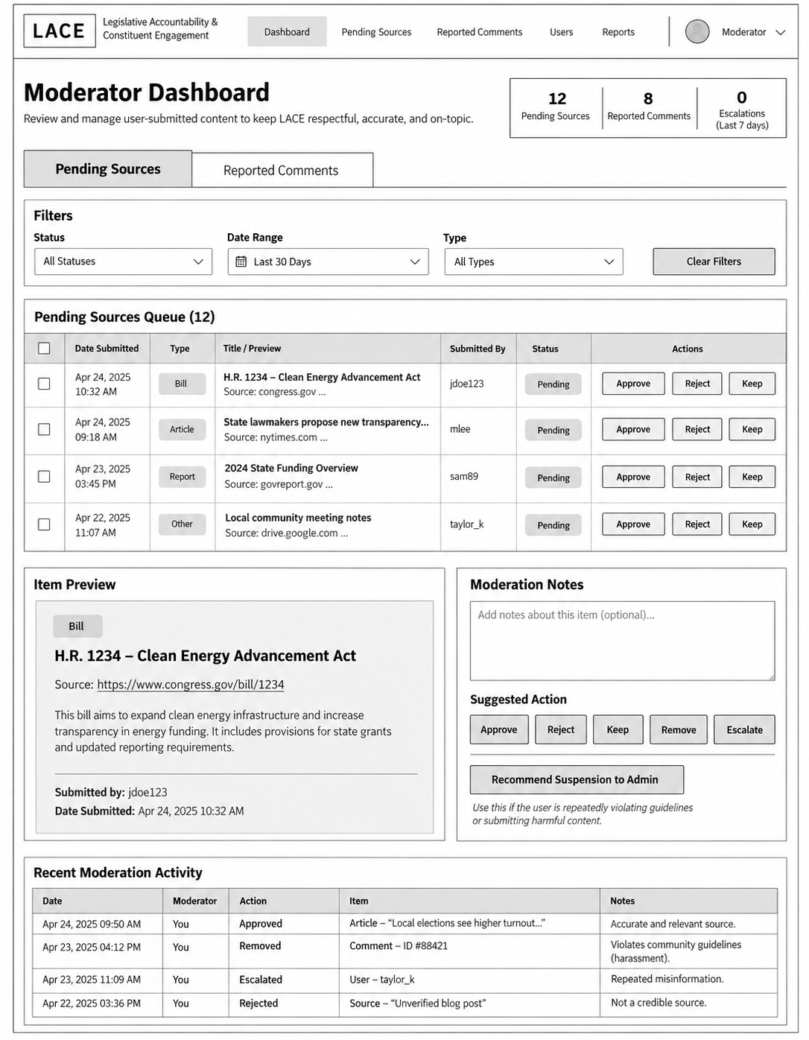
  - Wireframe for admin_dashboard.html
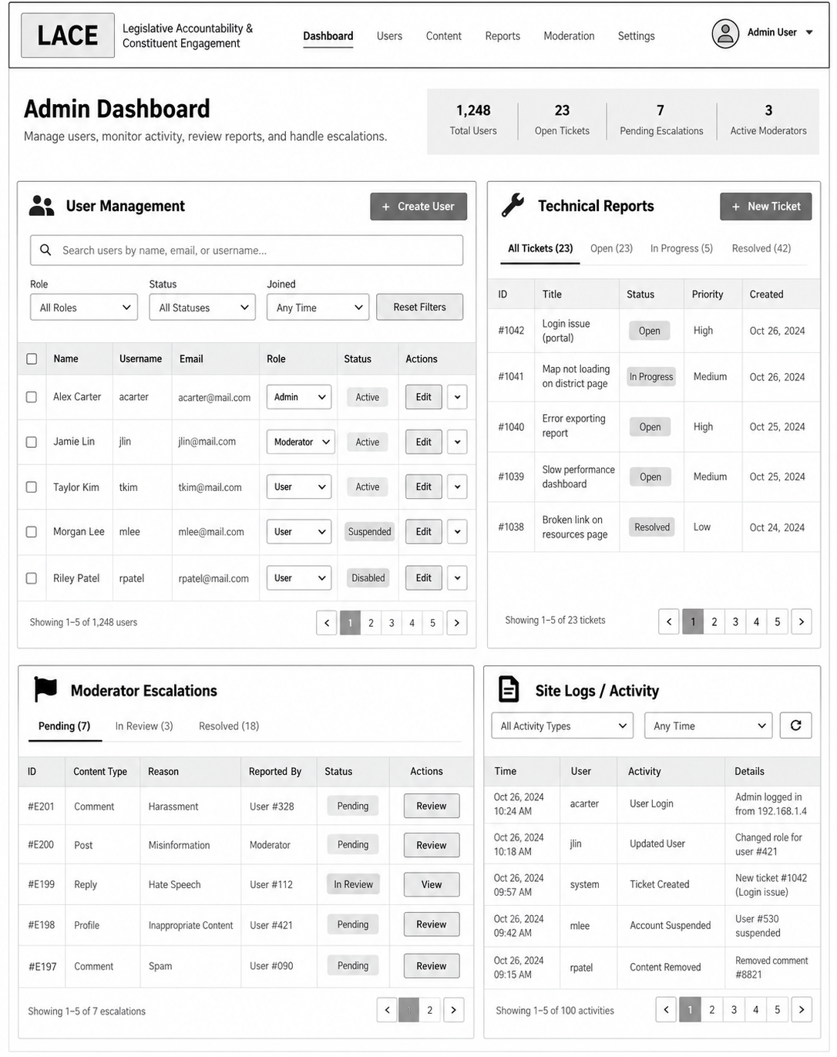
  - Wireframe for compare.html
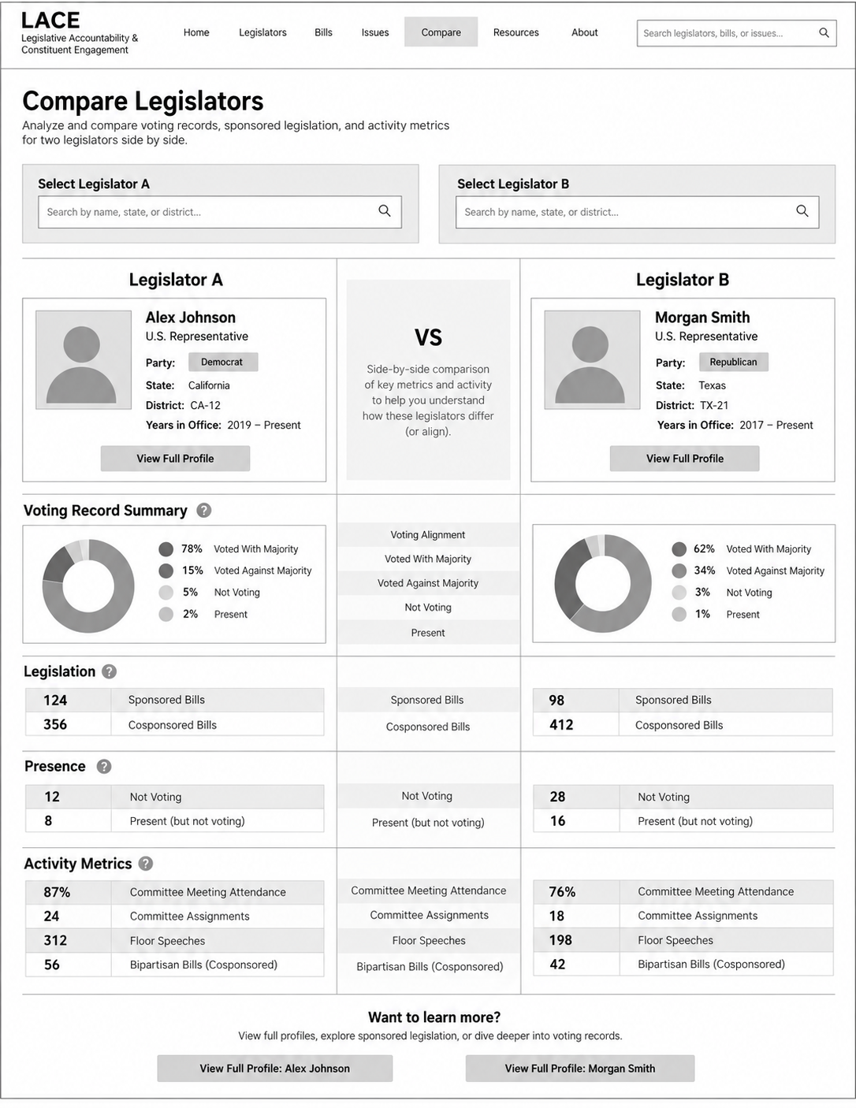
- Content and Approval Rules. User discussion comments are published immediately and can be reported. A reported comment enters a pending moderation queue while remaining public unless removed. Submitted source links remain pending until reviewed. Moderator decisions are recorded as approved/rejected/removed, all with justification. Moderators can recommend account suspensions, but Administrators make the final decision. Sources (facts/opinions) shown from official records, cited claims, and member opinions appear with distinct labels. Approving a link confirms review of the submission, not necessarily the truth of every linked claim.
- Meeting Documentation and Team Implementation
  - Meeting
When/Duration |  |  | 09/24/2026 [8:20PM – 8:25PM]
Where |  |  | Classroom
Who |  |  | Dominic, Maximus, Nathan, Momar
What was completed |  |  | Initial meeting for group creation, exchanged contact information
What are next tasks |  |  | Each member create soft project proposal.
Issues/Roadblocks |  |  | NONE
Team  Performance | Dominic | Maximus |  | Nathan | Momar
Contribution to the agenda | SAT | SAT |  | SAT | SAT
Attendance | PRESENT | PRESENT |  | PRESENT | PRESENT
Action Item completed | N/A | N/A |  | N/A | N/A
Input Quality | N/A | N/A |  | N/A | N/A
Effective decision-making | N/A | N/A |  | N/A | N/A
Problem-solving skills | N/A | N/A |  | N/A | N/A
Active participation | SAT | SAT |  | SAT | SAT
Effective Communication | SAT | SAT |  | SAT | SAT
Encouraging others | SAT | SAT |  | SAT | SAT
Constructive conflict | N/A | N/A |  | N/A | N/A

When/Duration |  |  | 09/29/2026 [6:15PM – 6:53PM]
Where |  |  | Computer Lab
Who |  |  | Dominic, Maximus, Nathan, Momar
What was completed |  |  | Delivered and voted on which project proposal
What are next tasks |  |  | Research backend for API creation and database SQL to use, obtain API key
Issues/Roadblocks |  |  | Compatible languages for project creation
Team  Performance | Dominic | Maximus |  | Nathan | Momar
Contribution to the agenda | SAT | SAT |  | SAT | SAT
Attendance | PRESENT | PRESENT |  | PRESENT | PRESENT
Action Item completed | COMPLETED | COMPLETED |  | COMPLETED | COMPLETED
Input Quality | SAT | SAT |  | SAT | SAT
Effective decision-making | SAT | SAT |  | SAT | SAT
Problem-solving skills | SAT | SAT |  | SAT | SAT
Active participation | SAT | SAT |  | SAT | SAT
Effective Communication | SAT | SAT |  | SAT | SAT
Encouraging others | SAT | SAT |  | SAT | SAT
Constructive conflict | SAT | SAT |  | SAT | SAT

When/Duration |  |  | 10/6/2026 [6:30PM – 6:50PM]
Where |  |  | Computer Lab
Who |  |  | Dominic, Maximus, Nathan, Momar
What was completed |  |  | Received Congress API key, voted on backend languages
What are next tasks |  |  | Webpage Transition Diagram
Issues/Roadblocks |  |  | NONE
Team  Performance | Dominic | Maximus |  | Nathan | Momar
Contribution to the agenda | SAT | SAT |  | SAT | SAT
Attendance | PRESENT | PRESENT |  | PRESENT | PRESENT
Action Item completed | COMPLETED | COMPLETED |  | COMPLETED | COMPLETED
Input Quality | SAT | SAT |  | SAT | SAT
Effective decision-making | SAT | SAT |  | SAT | SAT
Problem-solving skills | SAT | SAT |  | SAT | SAT
Active participation | SAT | SAT |  | SAT | SAT
Effective Communication | SAT | SAT |  | SAT | SAT
Encouraging others | SAT | SAT |  | SAT | SAT
Constructive conflict | SAT | SAT |  | SAT | SAT

When/Duration |  |  | 10/13/2026 [6:27PM – 6:51PM ]
Where |  |  | Computer Lab
Who |  |  | Dominic, Maximus, Nathan, Momar
What was completed |  |  | Webpage Transition Diagram
What are next tasks |  |  | Create wireframe images for each webpage
Issues/Roadblocks |  |  | NONE
Team  Performance | Dominic | Maximus |  | Nathan | Momar
Contribution to the agenda | SAT | SAT |  | SAT | SAT
Attendance | PRESENT | PRESENT |  | PRESENT | PRESENT
Action Item completed | COMPLETED | COMPLETED |  | COMPLETED | COMPLETED
Input Quality | SAT | SAT |  | SAT | SAT
Effective decision-making | SAT | SAT |  | SAT | SAT
Problem-solving skills | SAT | SAT |  | SAT | SAT
Active participation | SAT | SAT |  | SAT | SAT
Effective Communication | SAT | SAT |  | SAT | SAT
Encouraging others | SAT | SAT |  | SAT | SAT
Constructive conflict | SAT | SAT |  | SAT | SAT

When/Duration |  |  | 10/20/2026 [7:50PM – 8:15PM]
Where |  |  | Computer Lab
Who |  |  | Dominic, Maximus, Nathan, Momar
What was completed |  |  | Created wireframe for each webpage
What are next tasks |  |  | Review project proposal for submission on 10/22/2026 by 6:30pm, create repository
Issues/Roadblocks |  |  | NONE
Team  Performance | Dominic | Maximus |  | Nathan | Momar
Contribution to the agenda | SAT | SAT |  | SAT | SAT
Attendance | PRESENT | PRESENT |  | PRESENT | PRESENT
Action Item completed | COMPLETED | COMPLETED |  | COMPLETED | COMPLETED
Input Quality | SAT | SAT |  | SAT | SAT
Effective decision-making | SAT | SAT |  | SAT | SAT
Problem-solving skills | SAT | SAT |  | SAT | SAT
Active participation | SAT | SAT |  | SAT | SAT
Effective Communication | SAT | SAT |  | SAT | SAT
Encouraging others | SAT | SAT |  | SAT | SAT
Constructive conflict | SAT | SAT |  | SAT | SAT

When/Duration |  |  | 10/27/2026 [6:42PM – 6:59PM]
Where |  |  | Computer Lab
Who |  |  | Dominic, Maximus, Nathan, Momar
What was completed |  |  | Repository was created, bran
What are next tasks |  |  | Division of webpages
Issues/Roadblocks |  |  | NONE
Team  Performance | Dominic | Maximus |  | Nathan | Momar
Contribution to the agenda | SAT | SAT |  | SAT | SAT
Attendance | PRESENT | PRESENT |  | PRESENT | PRESENT
Action Item completed | COMPLETED | COMPLETED |  | COMPLETED | COMPLETED
Input Quality | SAT | SAT |  | SAT | SAT
Effective decision-making | SAT | SAT |  | SAT | SAT
Problem-solving skills | SAT | SAT |  | SAT | SAT
Active participation | SAT | SAT |  | SAT | SAT
Effective Communication | SAT | SAT |  | SAT | SAT
Encouraging others | SAT | SAT |  | SAT | SAT
Constructive conflict | SAT | SAT |  | SAT | SAT

  - Tentative Schedule.
10/23/2026 - 11/05/2026 | Design/database work
11/06/2026 - 11/19/2026 | Implement main public pages API integration
11/20/2026 - 12/03/2026 | CRUD member/moderation/admin
12/04/2026 - 12/09/2026 | Integration, testing, presentation prep
12/10/2026 | Project presentation

