Evaluating Zalo Application Quality Based on ISO/IEC 25010

1. Application Overview
Application: Zalo – An app for messaging and connecting Vietnamese people
Developer: VNG Corporation
Category: Communication / Social Networking / Messaging
Platform: Android, iOS, Web
Purpose: Messaging, calling, connecting with friends, sharing content, and facilitating both individual and group communication on a single platform.
Zalo is a popular messaging and social networking app in Vietnam, focused on user communication and connectivity. Key features include individual and group messaging, voice and video calls, photo and file sharing, posting to the "Timeline" (Diary), finding friends, creating groups, and interacting with the Official Accounts of organizations and businesses.
Beyond personal communication, Zalo offers various lifestyle utilities—such as Zalo Official Accounts, Zalo Mini Apps, location sharing, document transfer, and integration with online services—enabling users to perform a wide range of activities on a single platform.

2. Evaluation Summary
ISO/IEC 25010 Characteristic | Score
Functional Suitability | 5/5
Performance Efficiency | 4/5
Compatibility | 4/5
Interaction Capability | 4/5
Reliability | 4/5
Security | 5/5
Maintainability | 5/5
Flexibility | 4/5
Safety | 4/5
Overall | 4.3/5

3. Functional Suitability
Evaluation
Zalo is a Vietnamese communication and social networking application that offers various features to meet users' needs for staying in touch and sharing information. Key functions include messaging, voice and video calls, photo and video sharing, file transfers, and group chats.
The team selected six key functions for practical testing:
Function | Results | Evidence
Texting | Active | 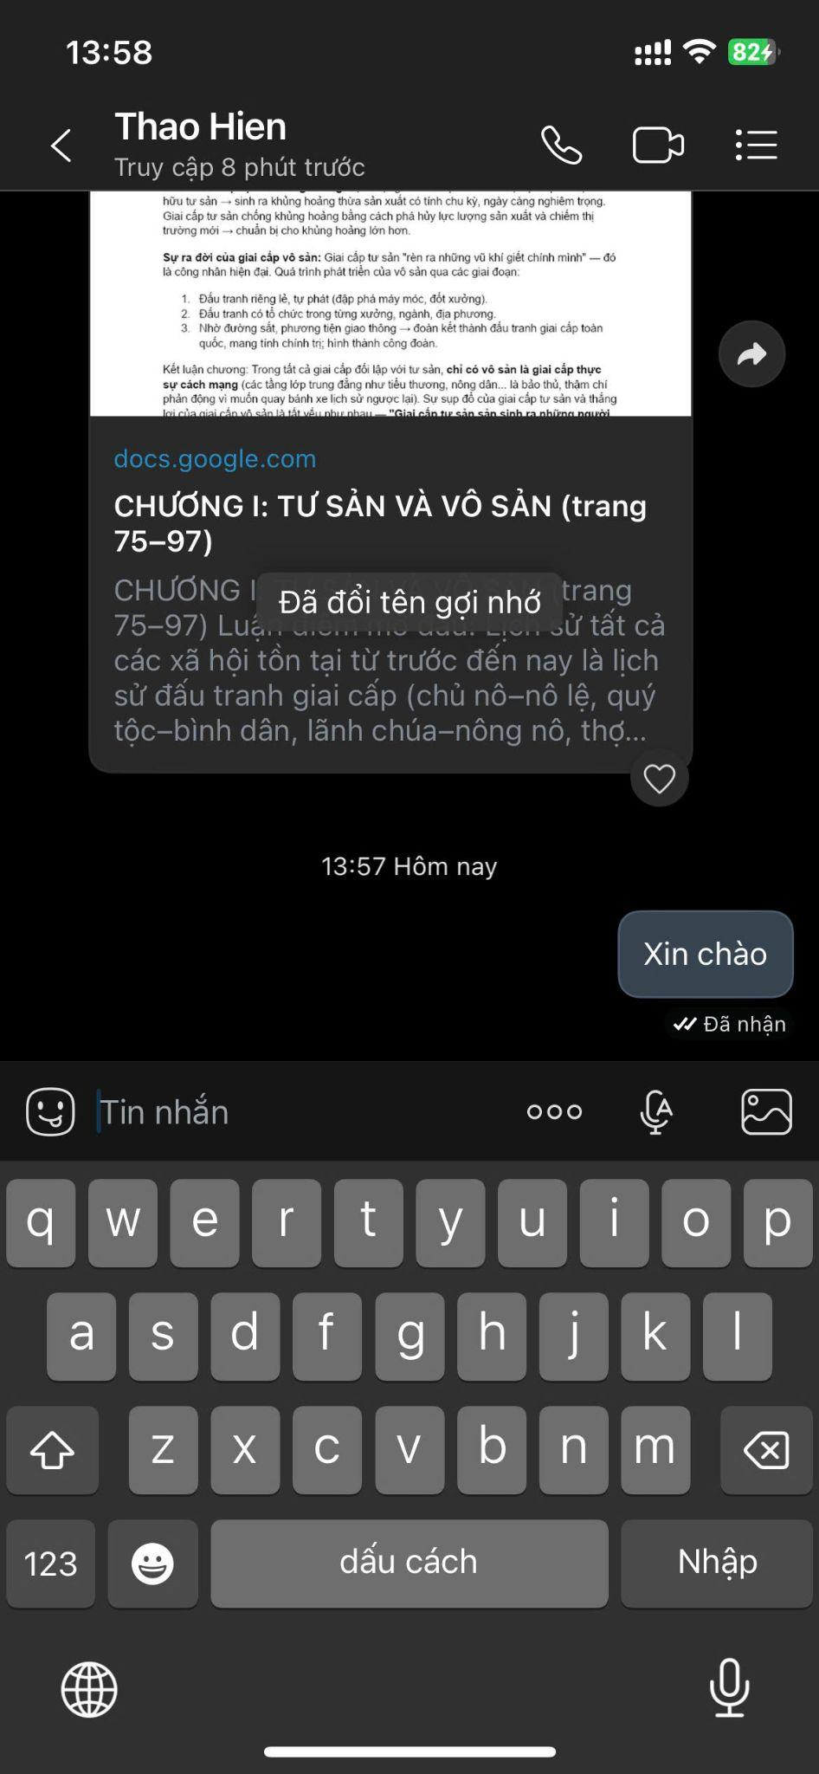
Voice call | Active | 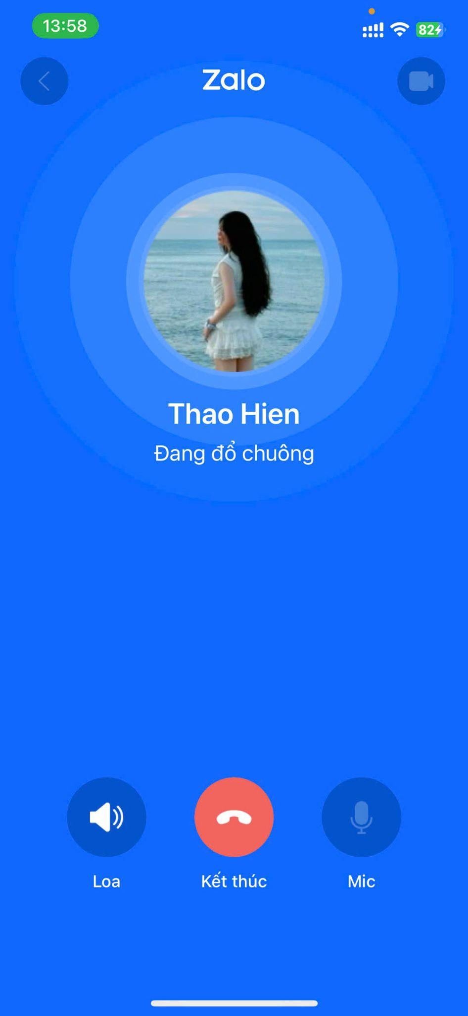
Video call | Active | 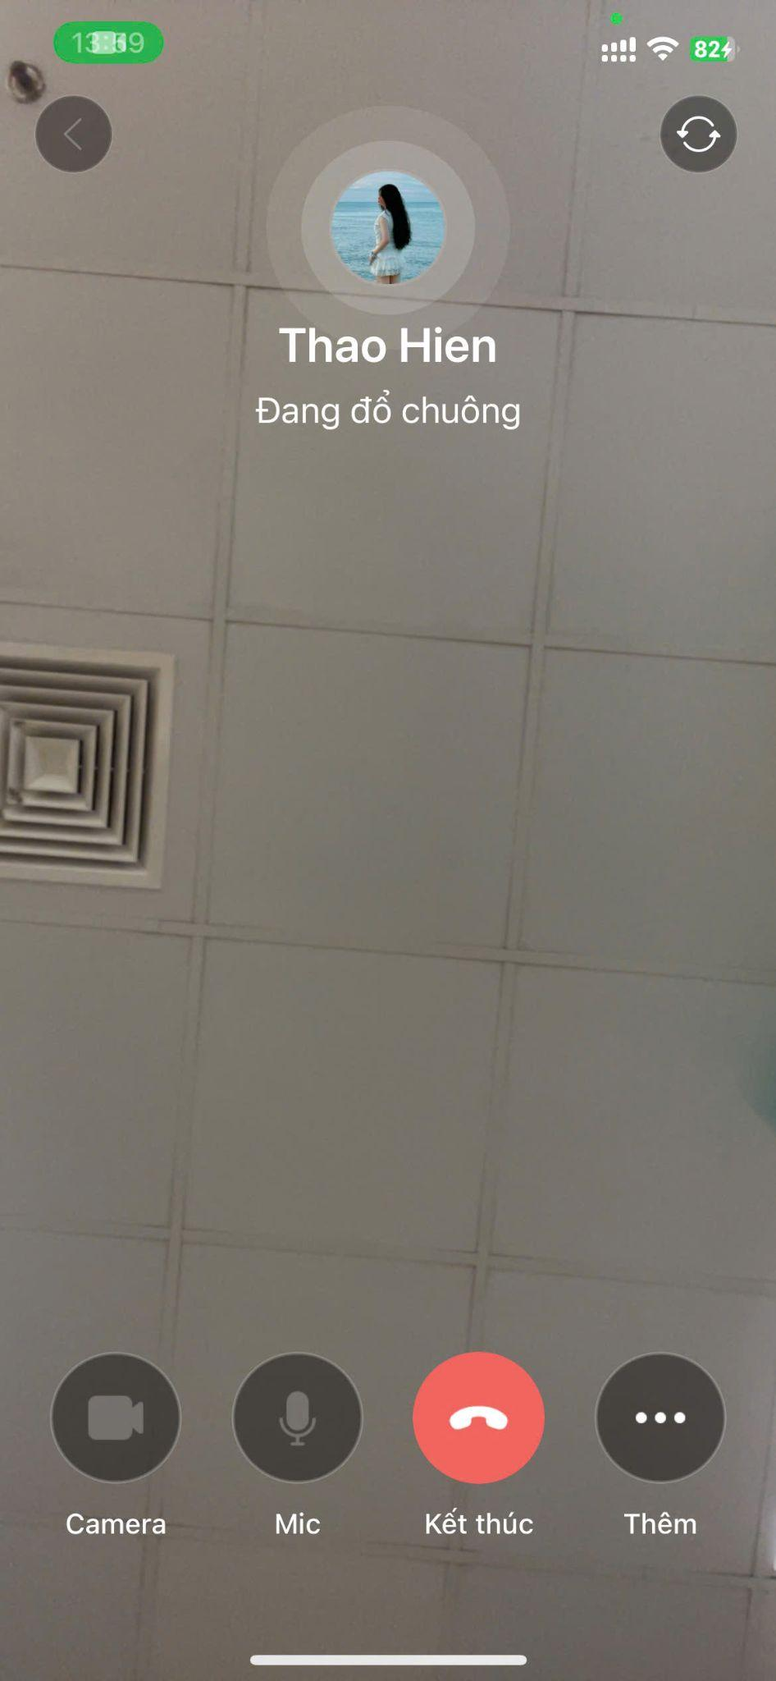
Send image/video | Active | 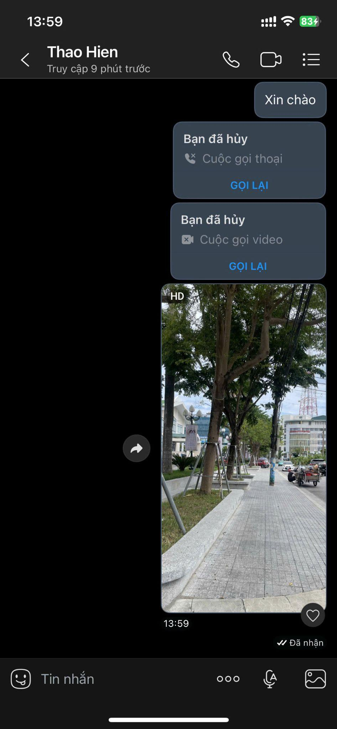
Send file | Active | 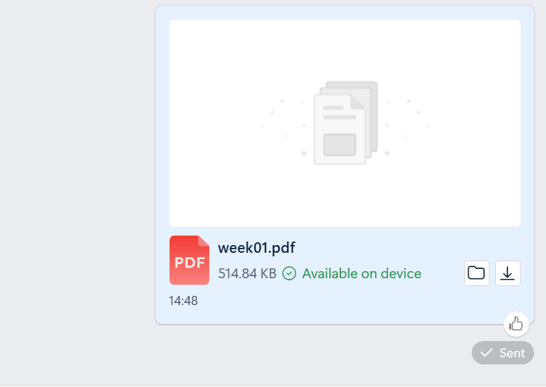
Create group chat | Active | 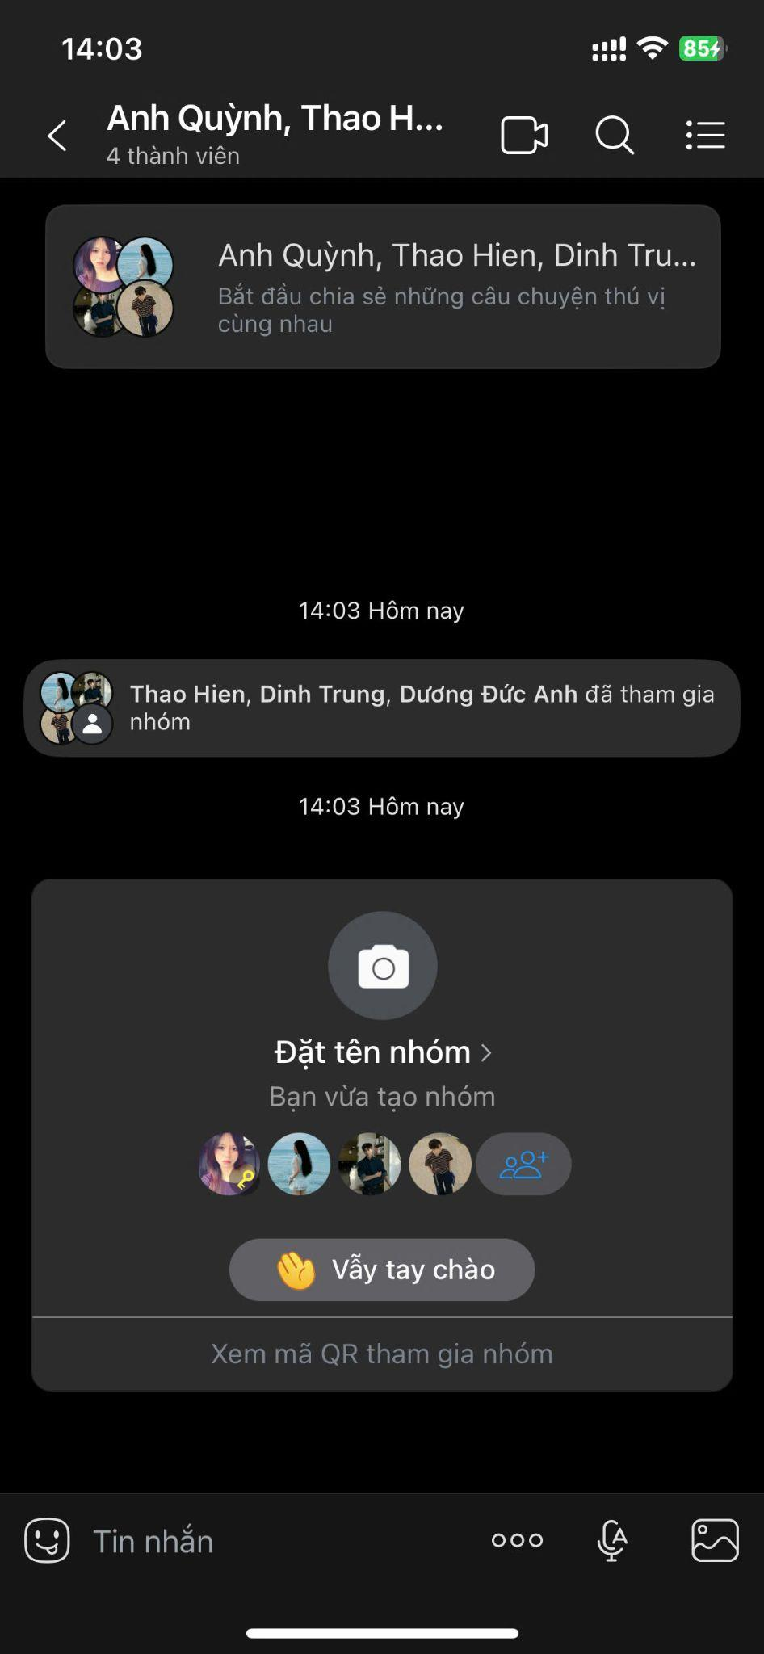

All the aforementioned functions can be accessed directly from the app and verified through actual usage.
Assessment: Zalo effectively meets the basic communication requirements of a messaging app. The functions selected by the team are all available and fully operational during testing.
Score: 5/5

4. Performance Efficiency
The team evaluated Zalo's performance by measuring the application's response time during common operations. Each operation was performed three times on the same device and under identical network conditions to minimize the impact of external factors.
Inspection procedure | 1st time | 2nd time | 3rd time | Average
Open the Zalo app | 0.01 s | 0.01 s | 0.01 s | 0.01 s
Open the conversation | 0.001 s | 0.001 s | 0.001 s | 0.001 s
Send a message | 0.001 s | 0.001 s | 0.001 s | 0.001 s
Open the image in the conversation | 0.001 s | 0.001 s | 0.001 s | 0.001 s
Testing conditions:
- Device: iPhone 14 Pro Max
- Operating system: iOS
- Network connection: 4G
- Test time: 14:00, August 12
The average time for each action is calculated based on the mean of three measurements.
Assessment: Based on actual measurements, Zalo demonstrated good response times under the team's testing conditions. However, results may vary depending on the device, network quality, and system load at the time of testing.
Score: 4/5

5. Compatibility
The team evaluates Zalo's compatibility by testing its operability across various platforms and operating system versions, as well as its ability to interact with other applications.
Selected criteria for testing include:
Criteria | Testing methods | Results
Android compatibility | Test Zalo on an Android device (Redmi Note 14 Pro 5G) | Success
iOS compatibility | Test Zalo on an iOS device (iPhone 14 Pro Max, iOS 26.5.2) | Success
Windows compatibility | Log in to and use Zalo PC on a Dell computer (Windows 10 Pro) | Success
Cross-device data synchronization | Send messages from the phone and verify receipt/display on the computer | Success
Interaction with other applications | Test sharing images, files, or links from other apps (Messenger, Facebook, Files) to Zalo | Success
During the testing process, the team focused on Zalo's ability to maintain core functions when users switch between platforms and devices. The team also evaluated the synchronization of messages and content across devices logged into the same account.
Assessment: Zalo demonstrates good compatibility with popular platforms such as Android, iOS, and Web. Core communication functions remain relatively consistent across devices; however, certain features or interface elements may vary depending on the platform and application version.
Score: 4 / 5

6. Interaction Capability
The team evaluated Zalo's usability by performing common tasks and recording the number of steps required to complete each one.
The four tasks selected for testing were:
Task | Number of steps | Result
Send a message | 4 steps: Open Zalo → select contact → enter message → send | Success
Make a video call | 4 steps: Open Zalo → select contact → open conversation → tap video call | Success
Send an image | 5 steps: Open Zalo → select contact → open conversation → select photo → send | Success
Create a group chat | 4 steps: Open Zalo → select create group → select members → confirm group creation | Success

During testing, key functions could be accessed directly from the chat interface or the app's function menus. Icons for messaging, voice calls, video calls, and content sharing enabled users to easily identify and perform the corresponding actions.
The team also evaluated system responsiveness to invalid user actions or issues encountered during use—such as attempting to send content unsuccessfully or trying to use features without a network connection.
Assessment: Zalo's common communication functions are relatively easy to locate and use. Users can complete basic tasks in just a few steps. However, given the wide range of features available, some less frequently used functions may require more steps to access.
Score: 4/5

7. Reliability
The team evaluated Zalo’s reliability based on its ability to maintain stable operation, handle errors, and recover after incidents.
Several tests were conducted, including:
Task / Test | Number of tests | Result
Send consecutive messages | 5 times | Success 5/5  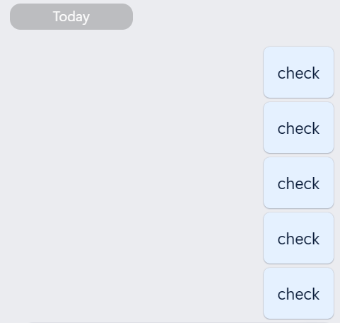
Send images/files | 5 times | Success 5/5  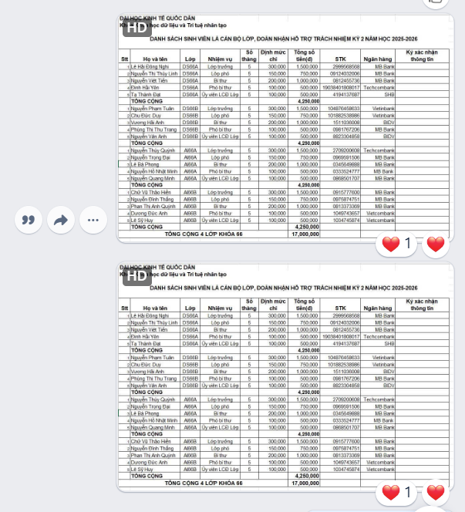
Make a video call | 2 times | Success 2/2  
Use during unstable network conditions (messaging, sending images) | 3 times | Success 3/3
Reopen the app after being closed | 5 times | Success 5/5
The team also tested the app’s recovery ability in situations such as loss of Internet connection, switching between Wi-Fi and mobile data, or the app closing unexpectedly. After the connection was restored, the team checked whether unfinished messages and actions were processed or synchronized again.
Assessment: Zalo generally operates stably for common communication functions. When a network disconnection occurs, the app is able to notify the connection status and resume operating once the connection is restored. However, actual stability still depends on network quality, the device, and the app version.
Success rate of operations: 100%
Score: 4.8 / 5

8. Security — 5/5
The team evaluated Zalo’s security through account protection mechanisms, user authentication, access control, and personal data protection.
The criteria selected for testing include:
Criteria | Testing method | Evidence
Account authentication | Test the login mechanism and phone number verification | 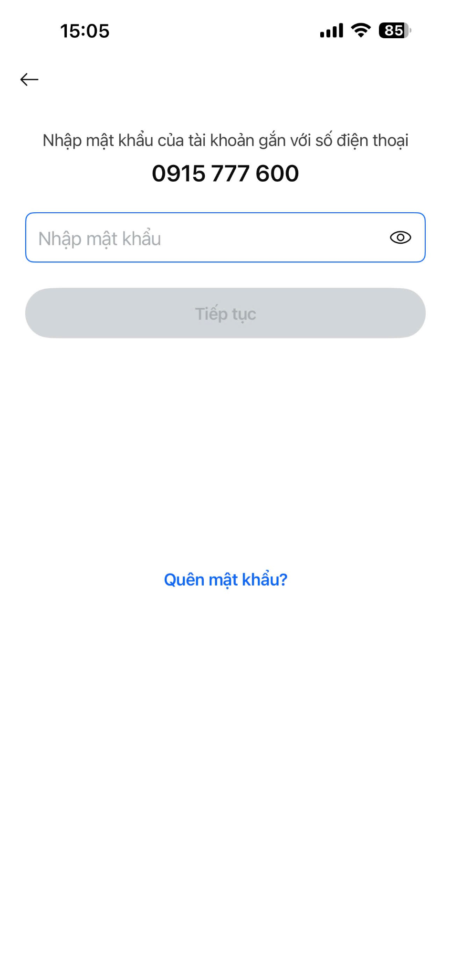
Account protection | Test the security options and management of logged-in devices | 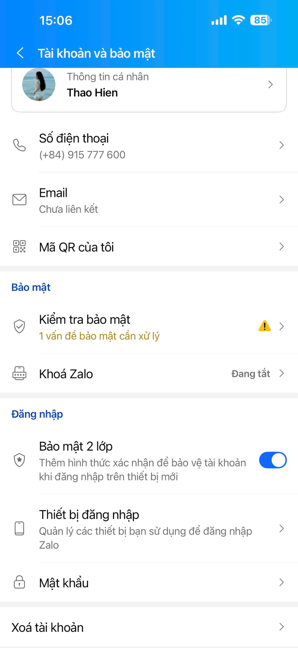
App lock | Test the ability to use a password/app-lock measure, if supported | 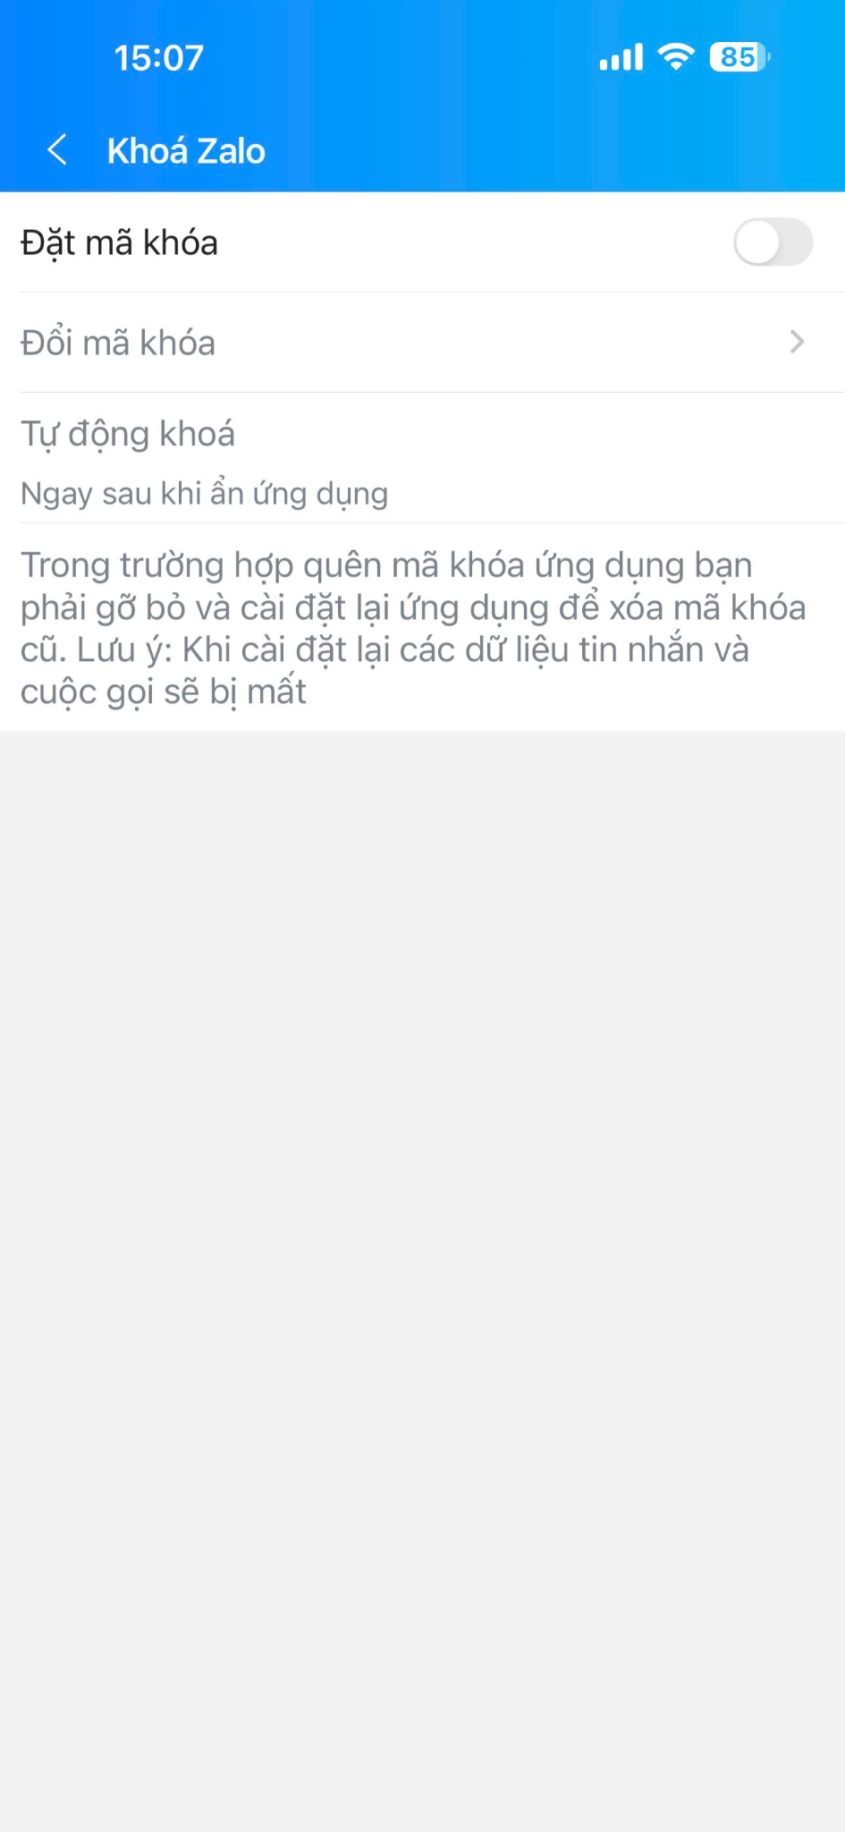
Privacy control | Test the options that allow others to search, add as friends, and view personal information | 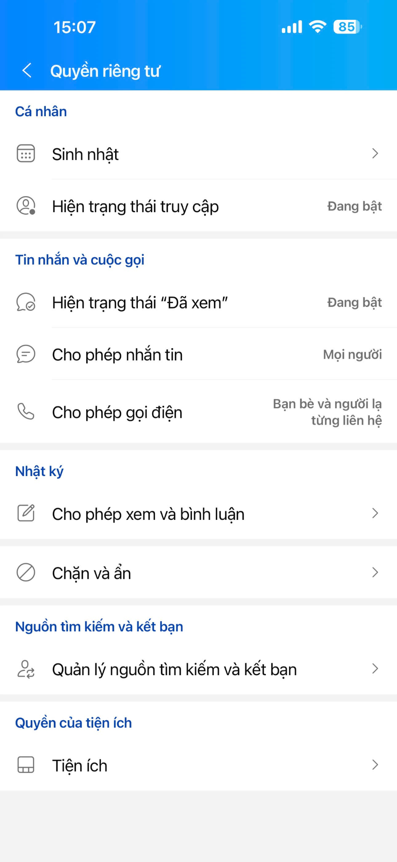
Login session management | Log in on another device and test the ability to manage/log out devices | 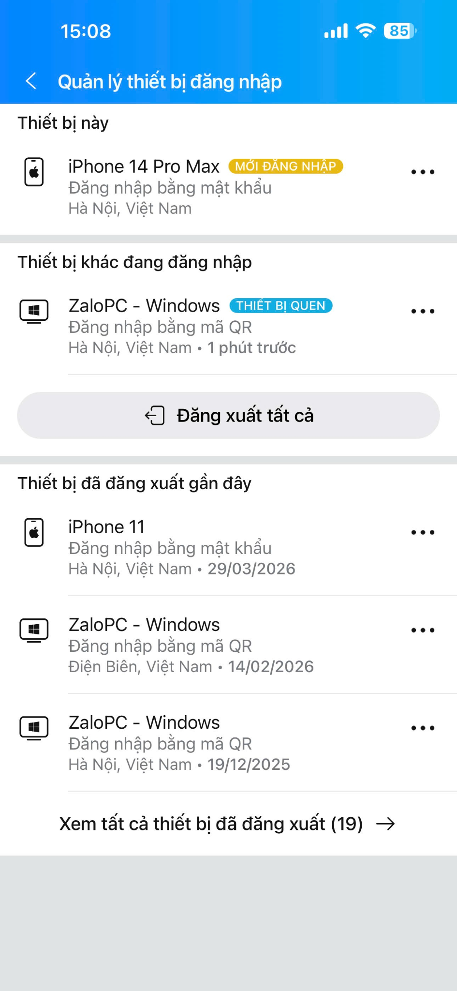
The team also tested privacy settings related to personal information, contacts, photos, and the ability to interact with other users. In addition, the team checked whether users could proactively manage logged-in devices and change security settings.
Assessment: Zalo provides many mechanisms to support account protection and user privacy. Users can manage certain settings related to their account, access permissions, and the ability to interact with others. However, since Zalo processes a large volume of personal data and exchanged content, users still need to proactively configure their privacy settings and protect their login information.
Score: 5 / 5

9. Maintainability
The team evaluated Zalo’s maintainability based on update frequency, bug-fixing ability, and the app’s continued operation across versions.
The criteria used include:
Criteria | Testing method | Result
Update frequency | Check the update history on the App Store/Google Play | Frequency ~ once every 1 week.  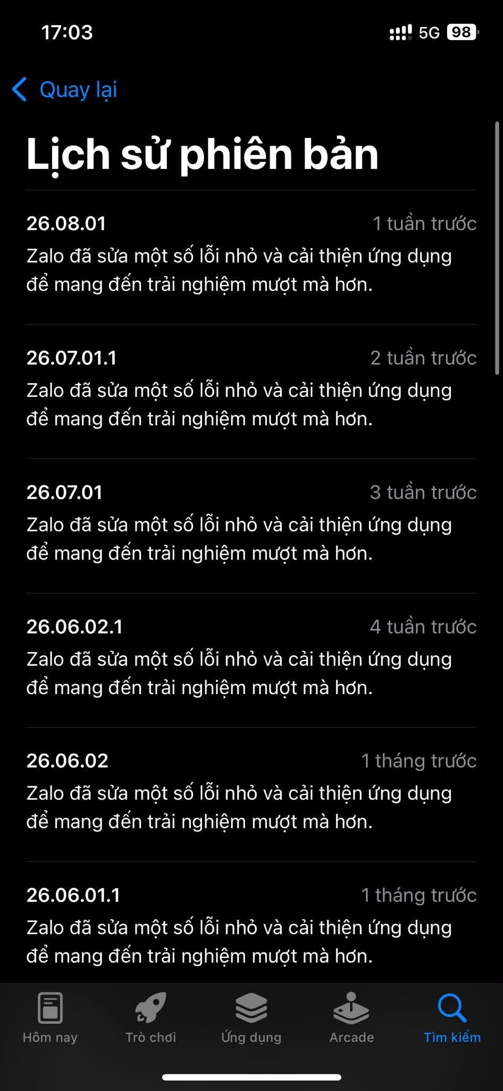
Version update | Check the time and size of the most recent update | -Version update time: 16/07/2026  - Size: 265.7 MB  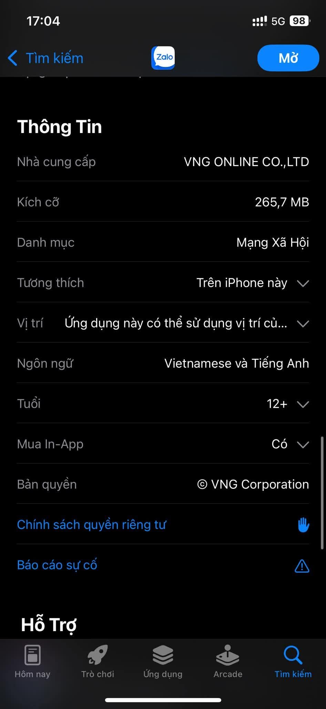
Bug fixes | Check the "What's New" content or update information | “Zalo has fixed several bugs and improved the app to deliver a smoother experience”
Feature maintenance | Compare some functions between the current version and the previous version | - Messaging: Retains the basic feature of composing and sending messages. Added a feature for automatically deleting messages after viewing and a feature for pinning group messages.  - Zalo AI :  +Integrated an AI Agent into Zalo via the OpenClaw plugin  + AI-powered translation
The team found that Zalo is regularly updated to add features, improve the user experience, and fix emerging bugs. Releasing new versions helps the app maintain compatibility with new operating systems and devices.
Testing conditions:
- Device: iPhone 14 Pro Max
- Operating system: iOS
- Network connection: 4G
- Test time: 17:00, August 12
Assessment: Zalo demonstrates relatively good maintainability, reflected in the frequent release of updates and app improvements. However, users cannot directly assess the source code structure or the level of maintainability inside the system. Therefore, this assessment is based mainly on signs observable from the user’s side.
Score: 5/ 5

10. Flexibility
The team evaluated Zalo’s adaptability when users change devices, usage environments, or connection methods.
The tests selected include:
Situation | Testing method | Result
Switching Wi-Fi → 4G/5G | Using Zalo while switching networks | - Zalo continues to operate when switching from Wi-Fi to 4G/5G; messages and the connection resume once the new network stabilizes → Passed.  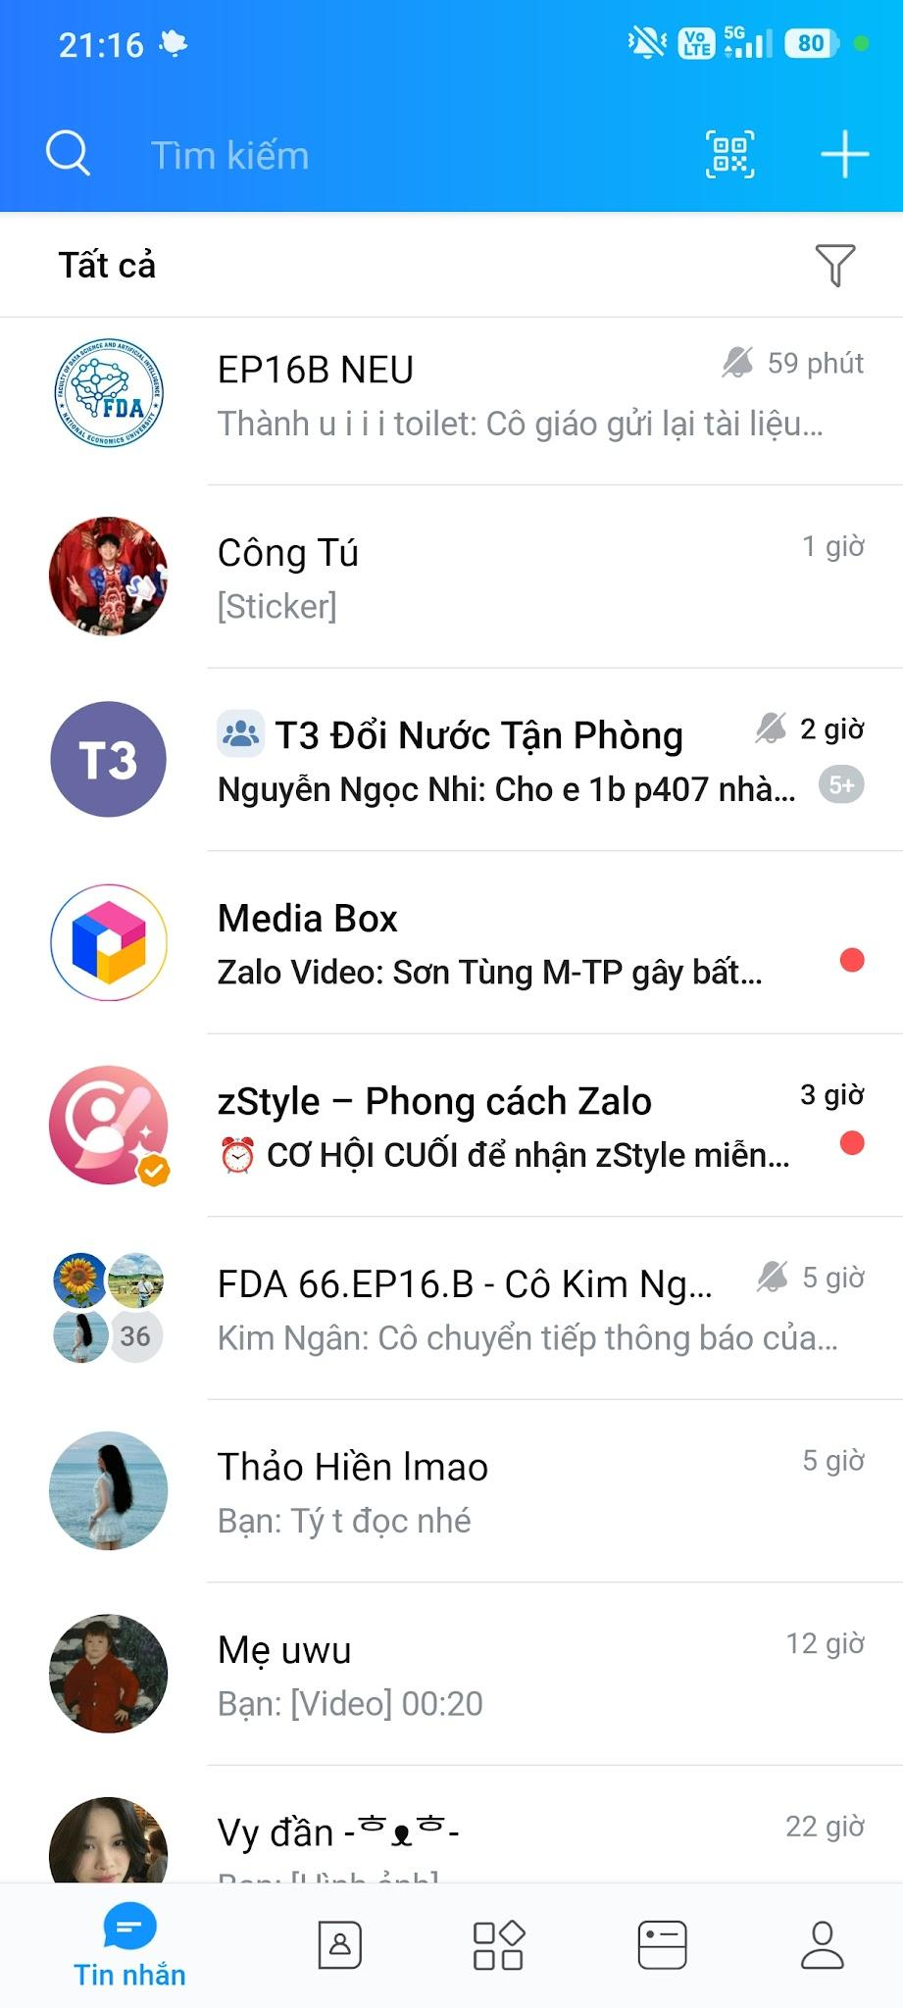  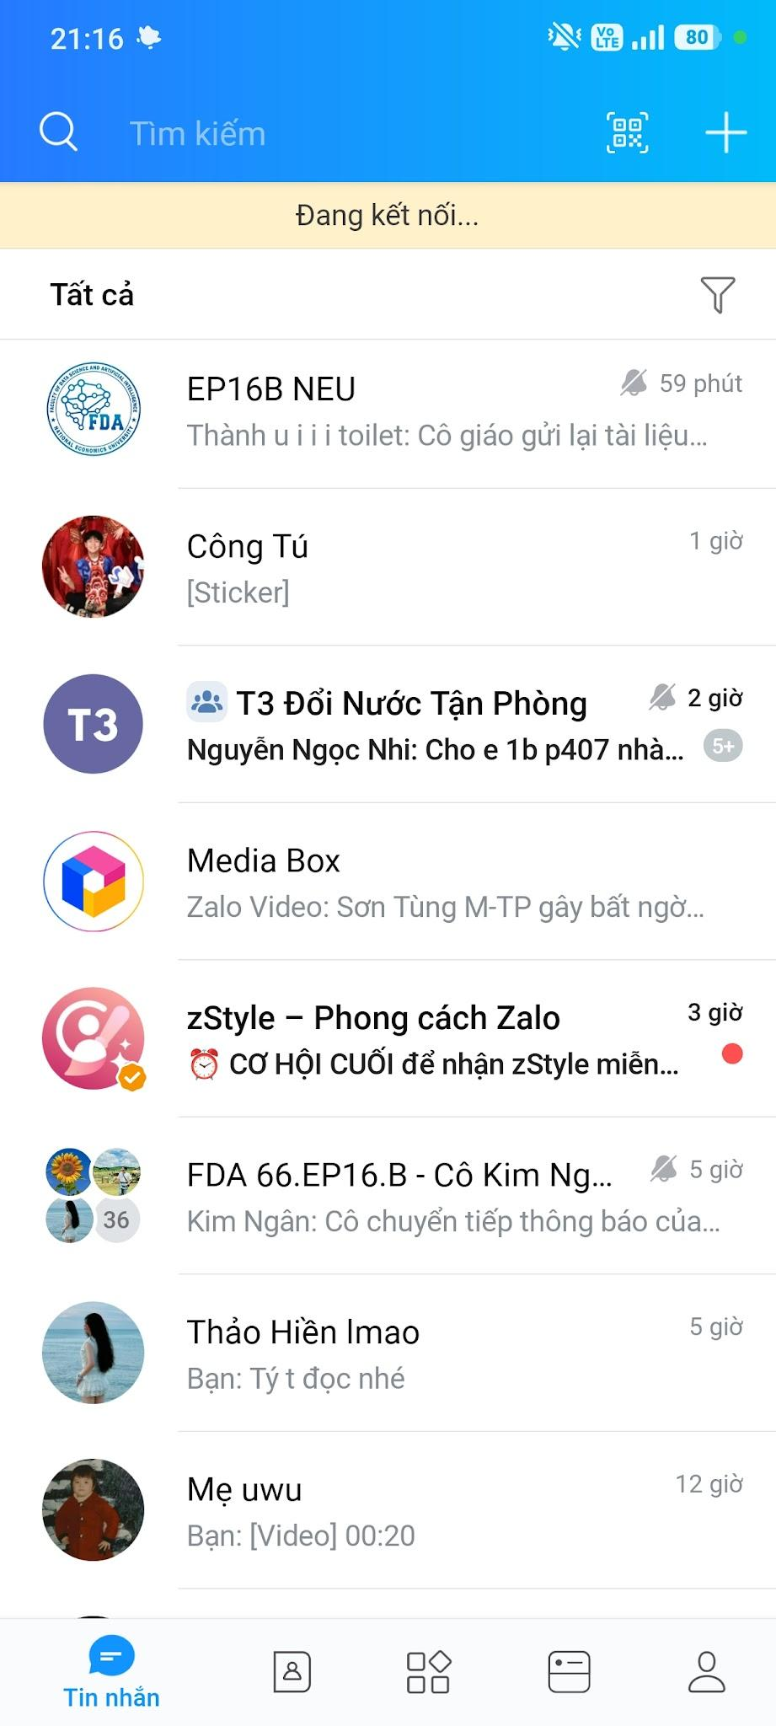
Switching devices | Log in with the same account on another device | - Except for Zalo PC, the same account cannot be logged in on 2 different mobile devices at the same time
Use on a different operating system | Test the same account on Android/iOS | - The same account can be used on both Android and iOS, with core functions supported on both platforms → Passed well.
Using Zalo Web | Log in and perform basic functions in the browser | - Temporary backup for a short period of time  - Basic functions such as: Login/Logout, Messaging, Find friends, etc. are still maintained on Zalo Web.  - Some functions such as Zalo Video, Zalo AI, calling, etc. are not supported  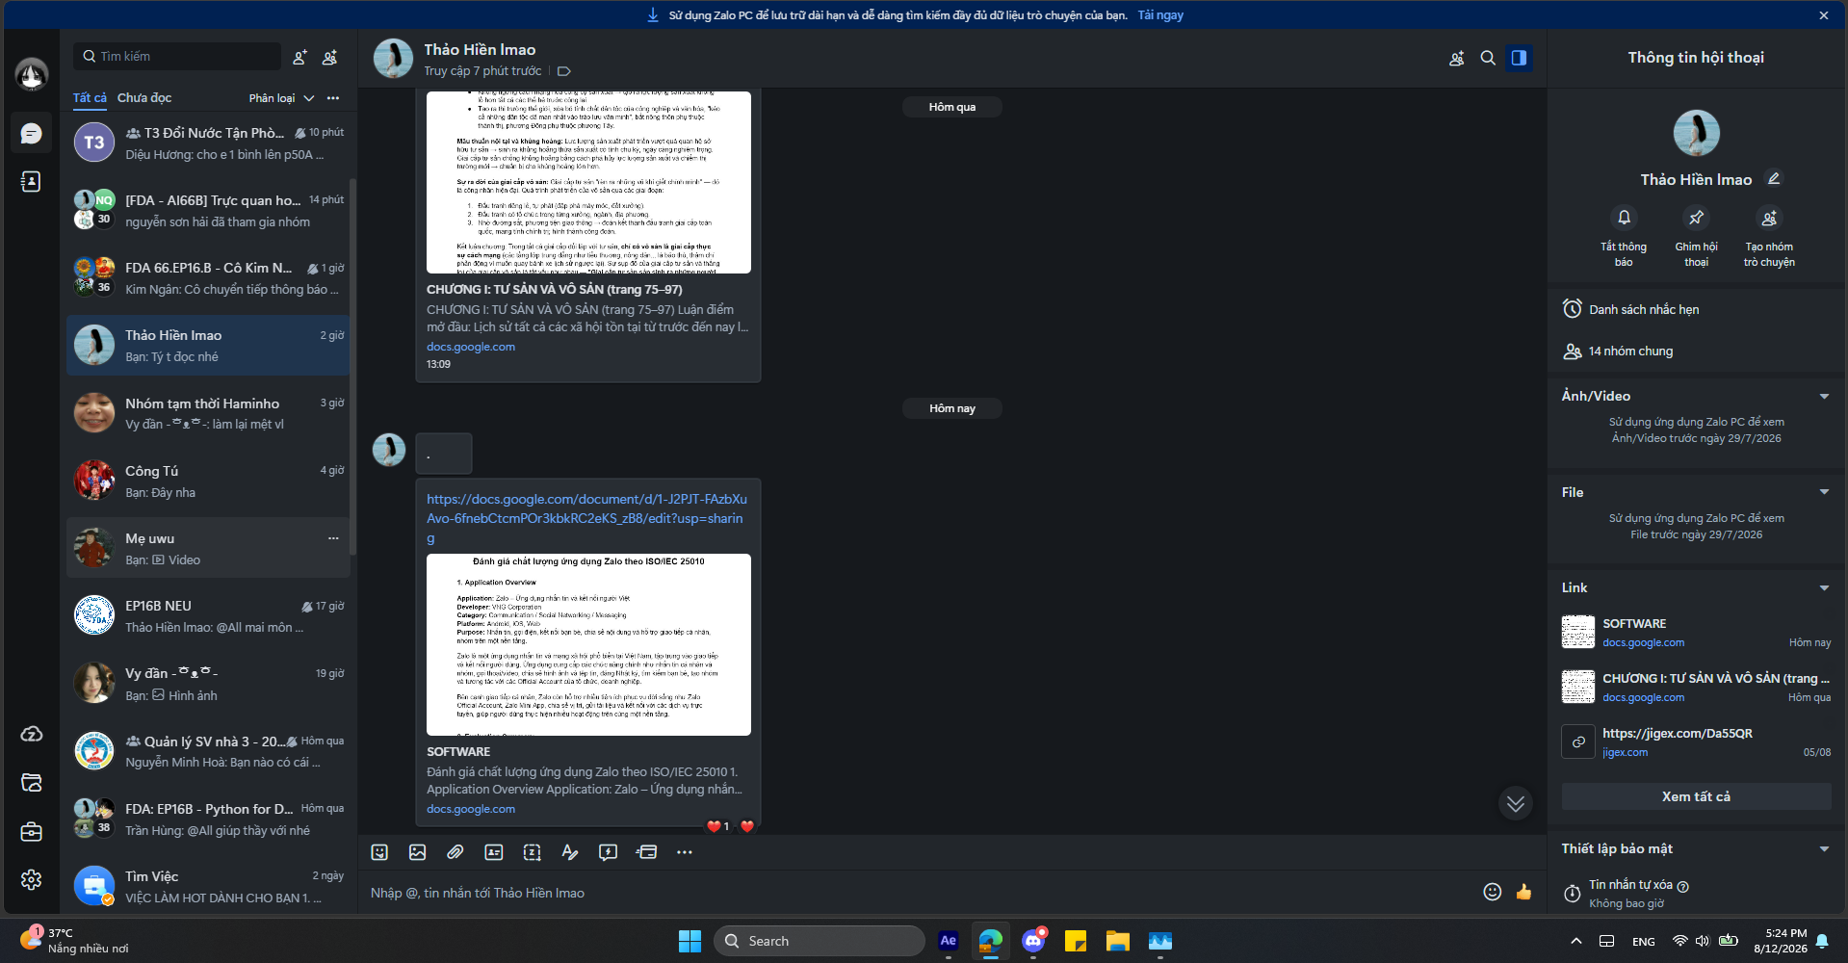
Changing network conditions | Test the app under a weak network or a temporary connection loss | - When the network is weak, Zalo may load/send messages slowly; when the connection is lost, unsent messages wait for connection and are resent once the network is restored → Passed.  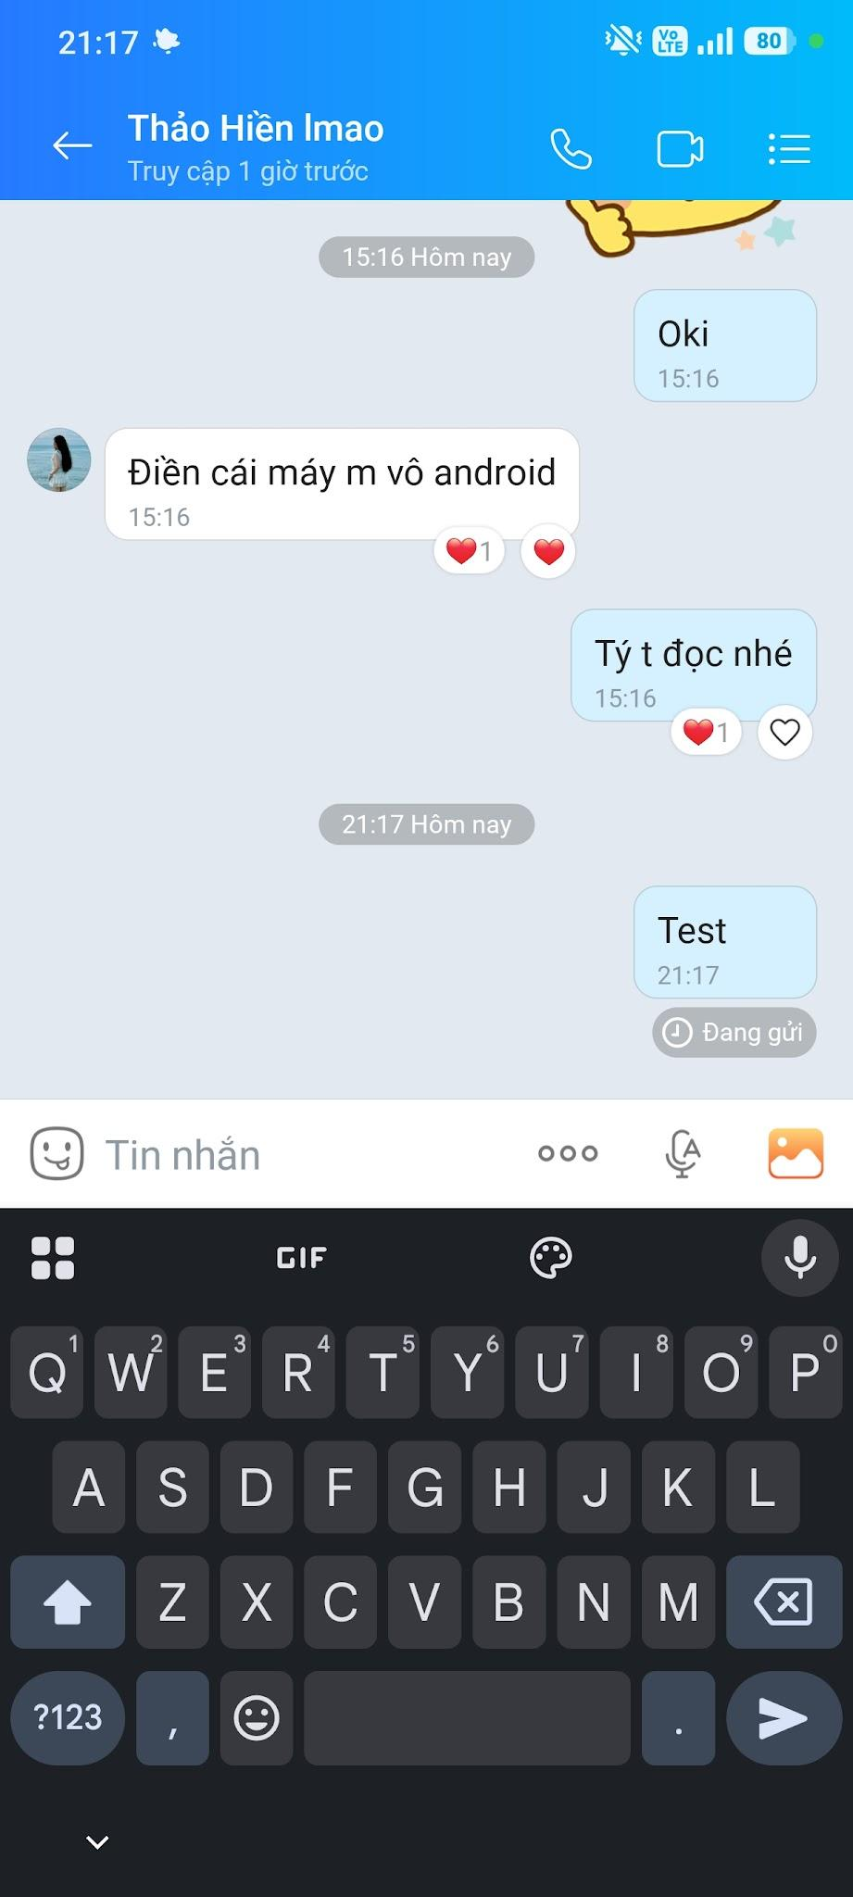  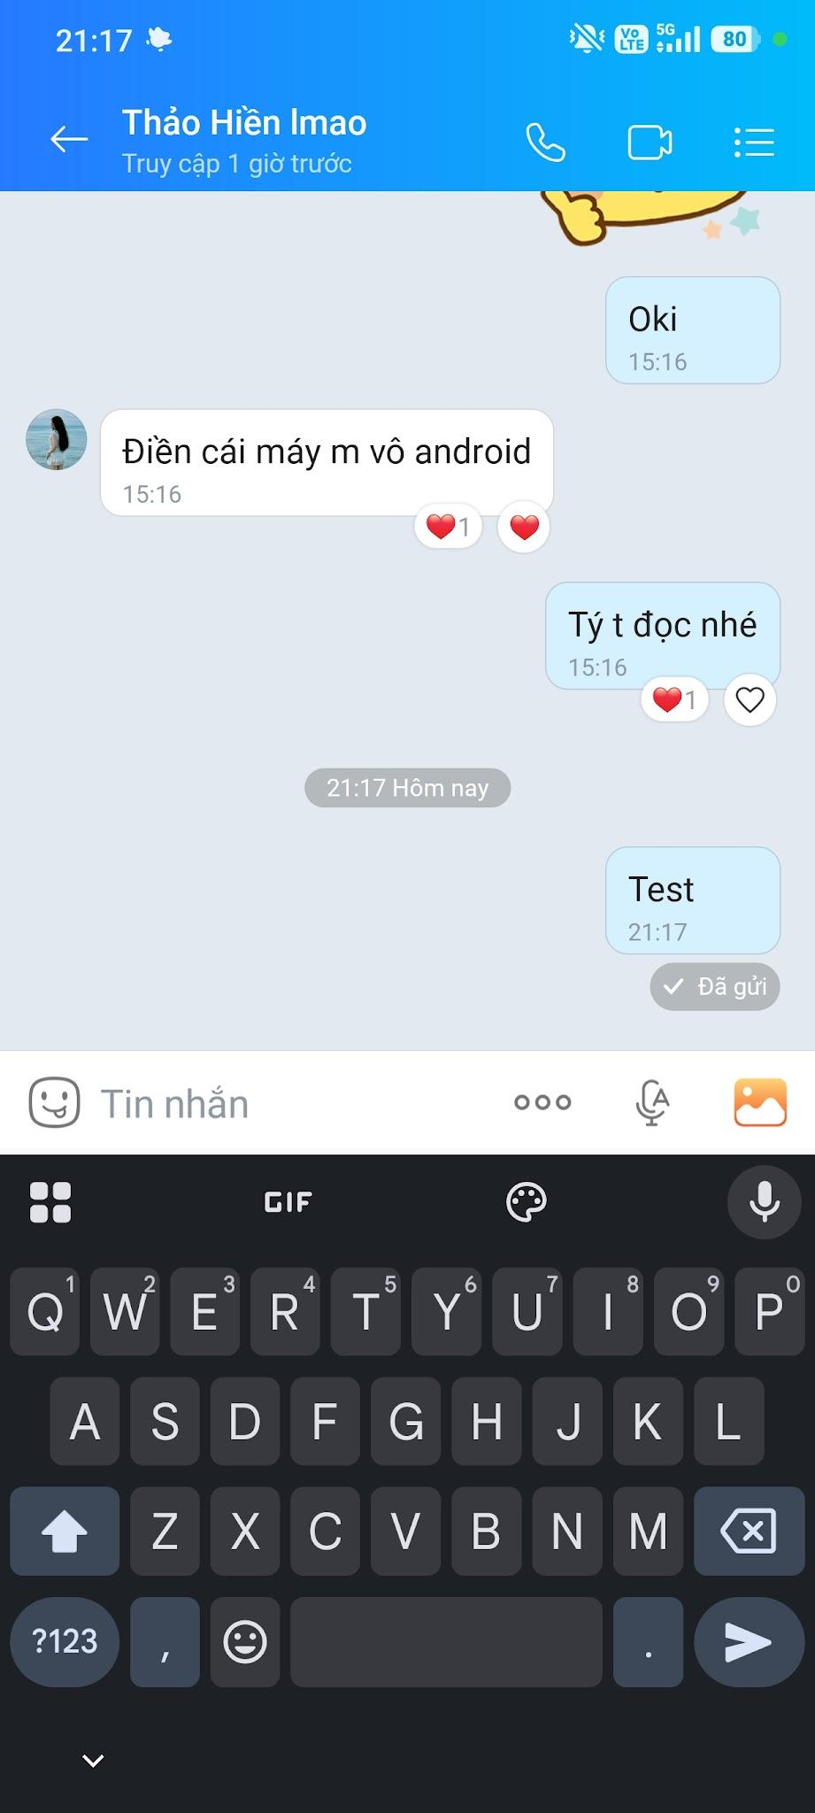
During testing, the team focused on Zalo’s ability to continue providing core functions when the usage environment changes. In particular, the team tested the ability to switch between different types of network connections and synchronize data when users move to a different device or platform.
Testing conditions:
- Device: Lenovo Legion 5 laptop, Redmi Note 14 Pro 5G
- Operating system: Microsoft & Android
- Network connection: 5G
- Test time: 18:00 - August 12 & 21:00 - August 12
Assessment: Zalo adapts well to various usage environments. Users can use the app on their phone or via the Web and switch between different types of network connections. However, performance and certain functions may vary depending on the device, operating system, and network quality.
Score: 4/5

11. Safety
The team evaluated Zalo’s ability to ensure safety for users and data during app usage.
The criteria selected for testing include:
Criteria | Testing method | Result
Blocking users | Test the function of blocking unwanted accounts | Passed 5/5  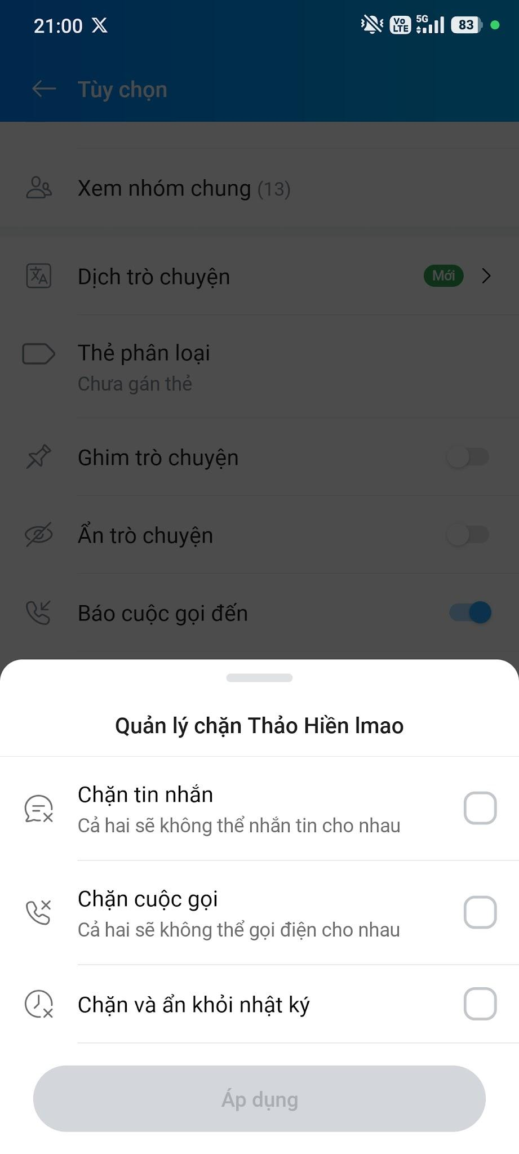
Reporting content/accounts | Test the ability to report inappropriate accounts or content | Passed 5/5  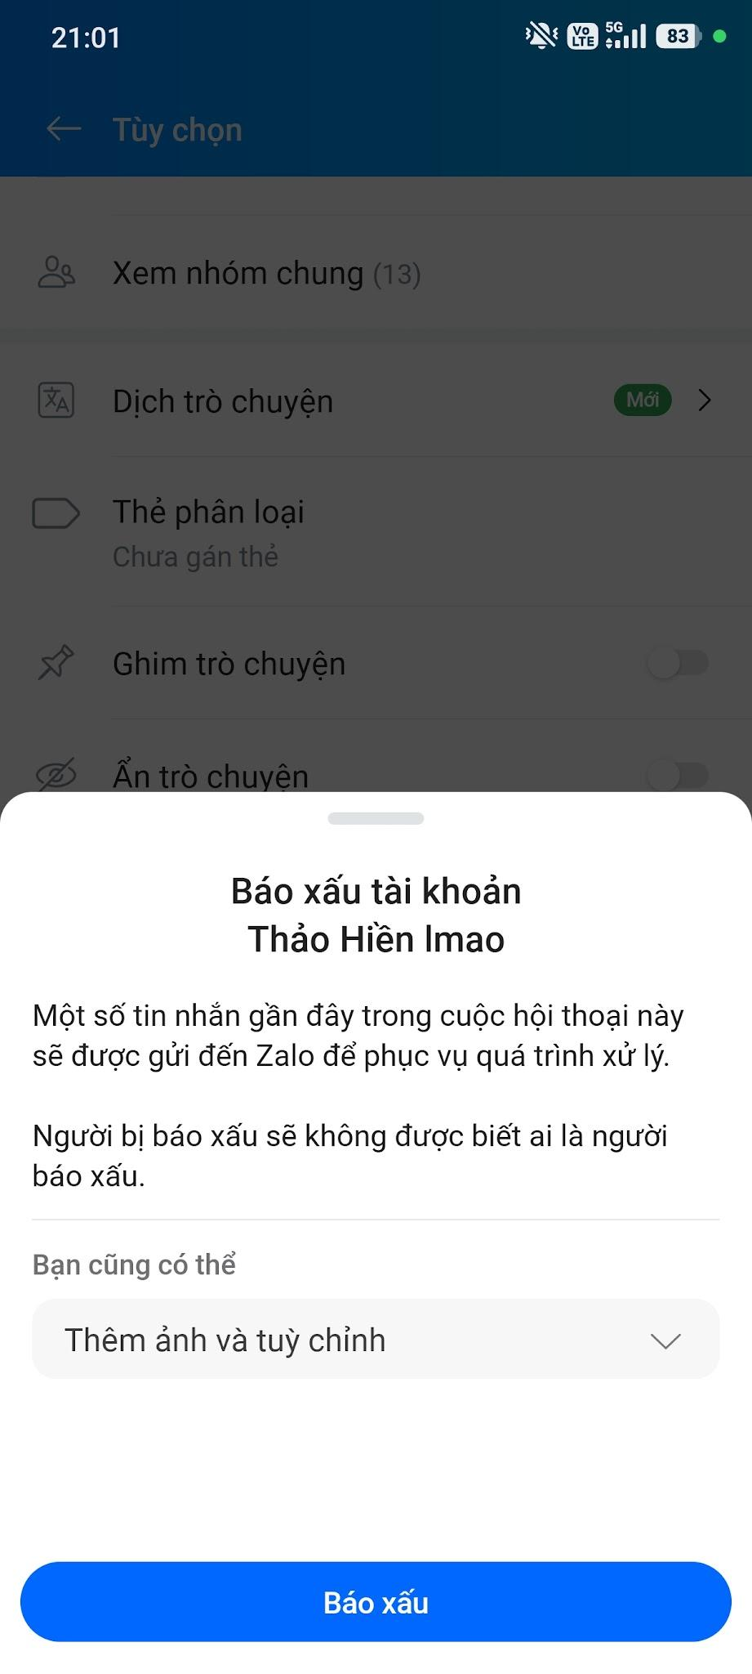
Privacy control | Test the ability to restrict strangers from searching, adding as friends, or viewing information | Passed 4/5  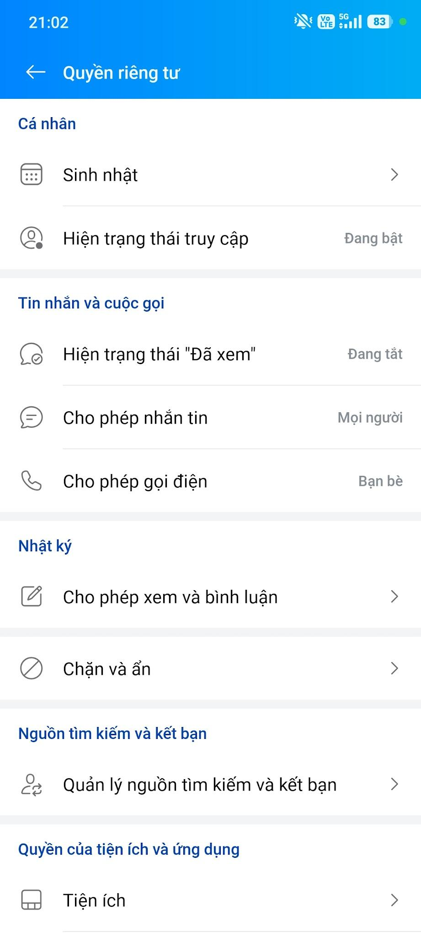
Protection of personal information | Test the display options for phone number, date of birth, profile photo, and personal information | Passed 5/5  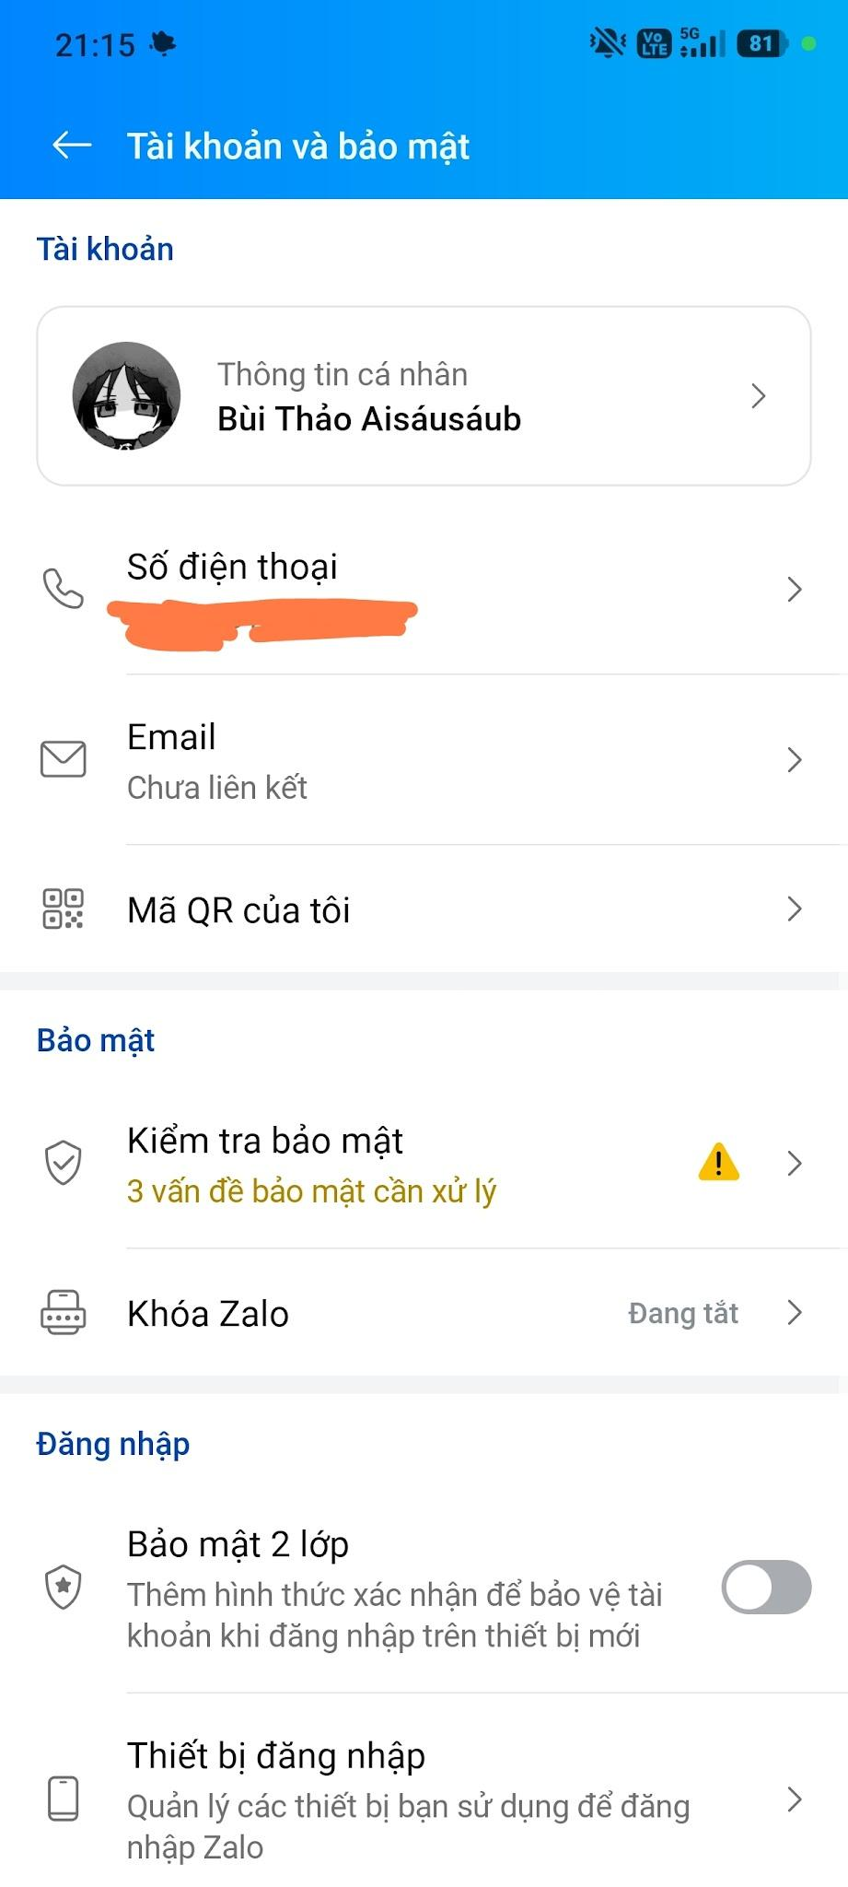
Safety when using links/files | Test warnings or handling mechanisms for suspicious content | Passed 4/5
The team focused on testing features that help users limit unwanted interactions and protect personal information. Functions such as blocking, reporting, and privacy settings help users proactively control who can contact or interact with them
Testing conditions:
- Device: Redmi Note 14 Pro 5G
- Operating system: Android
- Network connection: 5G
- Test time: 21:00, August 12
Assessment: Zalo provides basic functions to help users protect themselves during online communication, particularly the ability to block, report, and control privacy. However, the level of safety still depends partly on how users configure their privacy settings and recognize suspicious content or links.
Score: 4/ 5

12. Final Evaluation
- Main strengths: Zalo has strong functionality, security, and maintainability. It provides a wide range of useful communication features and is generally stable and easy to use.
- Weaknesses: Some features can be difficult to find due to the large number of functions. Performance, compatibility, and reliability may also vary depending on the device, operating system, and network conditions.
- Quality trade-offs: The large number of features improves functionality and convenience but can make the interface more complex. Supporting multiple platforms and maintaining strong security also requires greater system complexity, which may affect performance and consistency.
Overall, Zalo demonstrates good software quality and effectively meets the needs of most users.

