|  |  |  |
| --- | --- | --- |
| 方法声明 | 测试用例 | 预期结果 |
| Public void testYueFen() | 12,18 | "2/3" |
| Public void  testExchange() | "1+2" | "1 2 +" |
| "1*2" | "1 2 *" |
| "（1+2）÷3" | "1 2 + 3 ÷" |
| "1/3÷（1+2）" | "1/3 1 2 + ÷" |
| "1+2*3" | "1 2 3 * +" |
| "1+2*3-4" | "1 2 3 * + 4 -" |
| "1+2+3*4" | "1 2 + 3 4 * +" |
| "3*（1+2）-4" | "3 1 2 + * 4 -" |
| "4+3*（1+2）" | "4 3 1 2 + * +" |
| "4+（1+2）*3" | "4 1 2 + 3 * +" |
| "（1+2）*（1/3+4）" | "1 2 + 1/3 4 + *" |
| public void  testJiSuan() | "1 2 +" | "3" |
| "1 2 *" | "2" |
| "1 2 + 3 ÷" | "1" |
| "1/3 1 2 + ÷" | "1/9" |
| "1 2 3 * +" | "7" |
| "1 2 3 * + 4 -" | "3" |
| "1 2 + 3 4 * +" | "15" |
| "3 1 2 + * 4 -" | "5" |
| "4 3 1 2 + * +" | "13" |
| "4 1 2 + 3 * +" | "13" |
| "1 2 + 1/3 4 + *" | "13" |
| public void  testCalculate() | "1","2","+" | "3" |
| "2","1","-" | "1" |
| "2","3","*" | "6" |
| "2","3","÷" | "2/3" |
| "1/2","1/2","+" | "1" |
| "1","1/2","-" | "1/2" |
| "1/2","2","*" | "1" |
| "1","1/2","÷" | "1" |

对主要函数进行了测试如下：

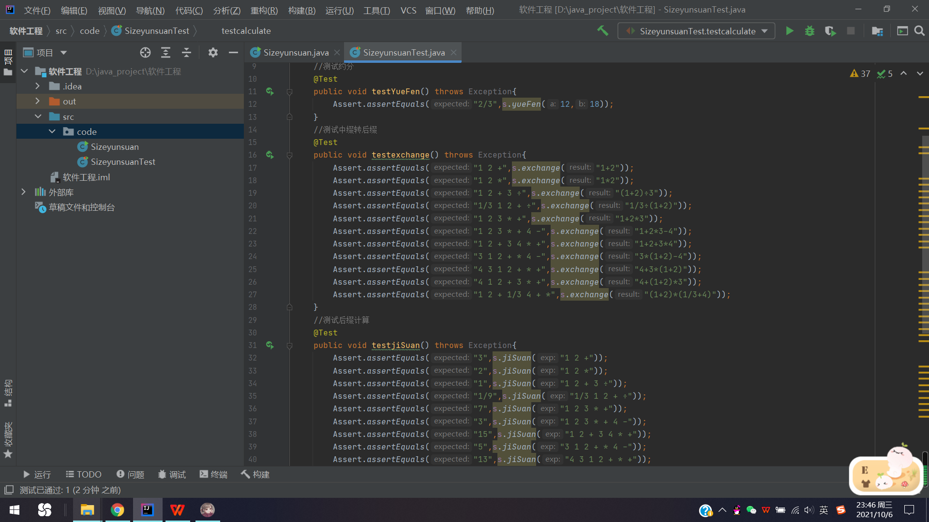测试代码图：

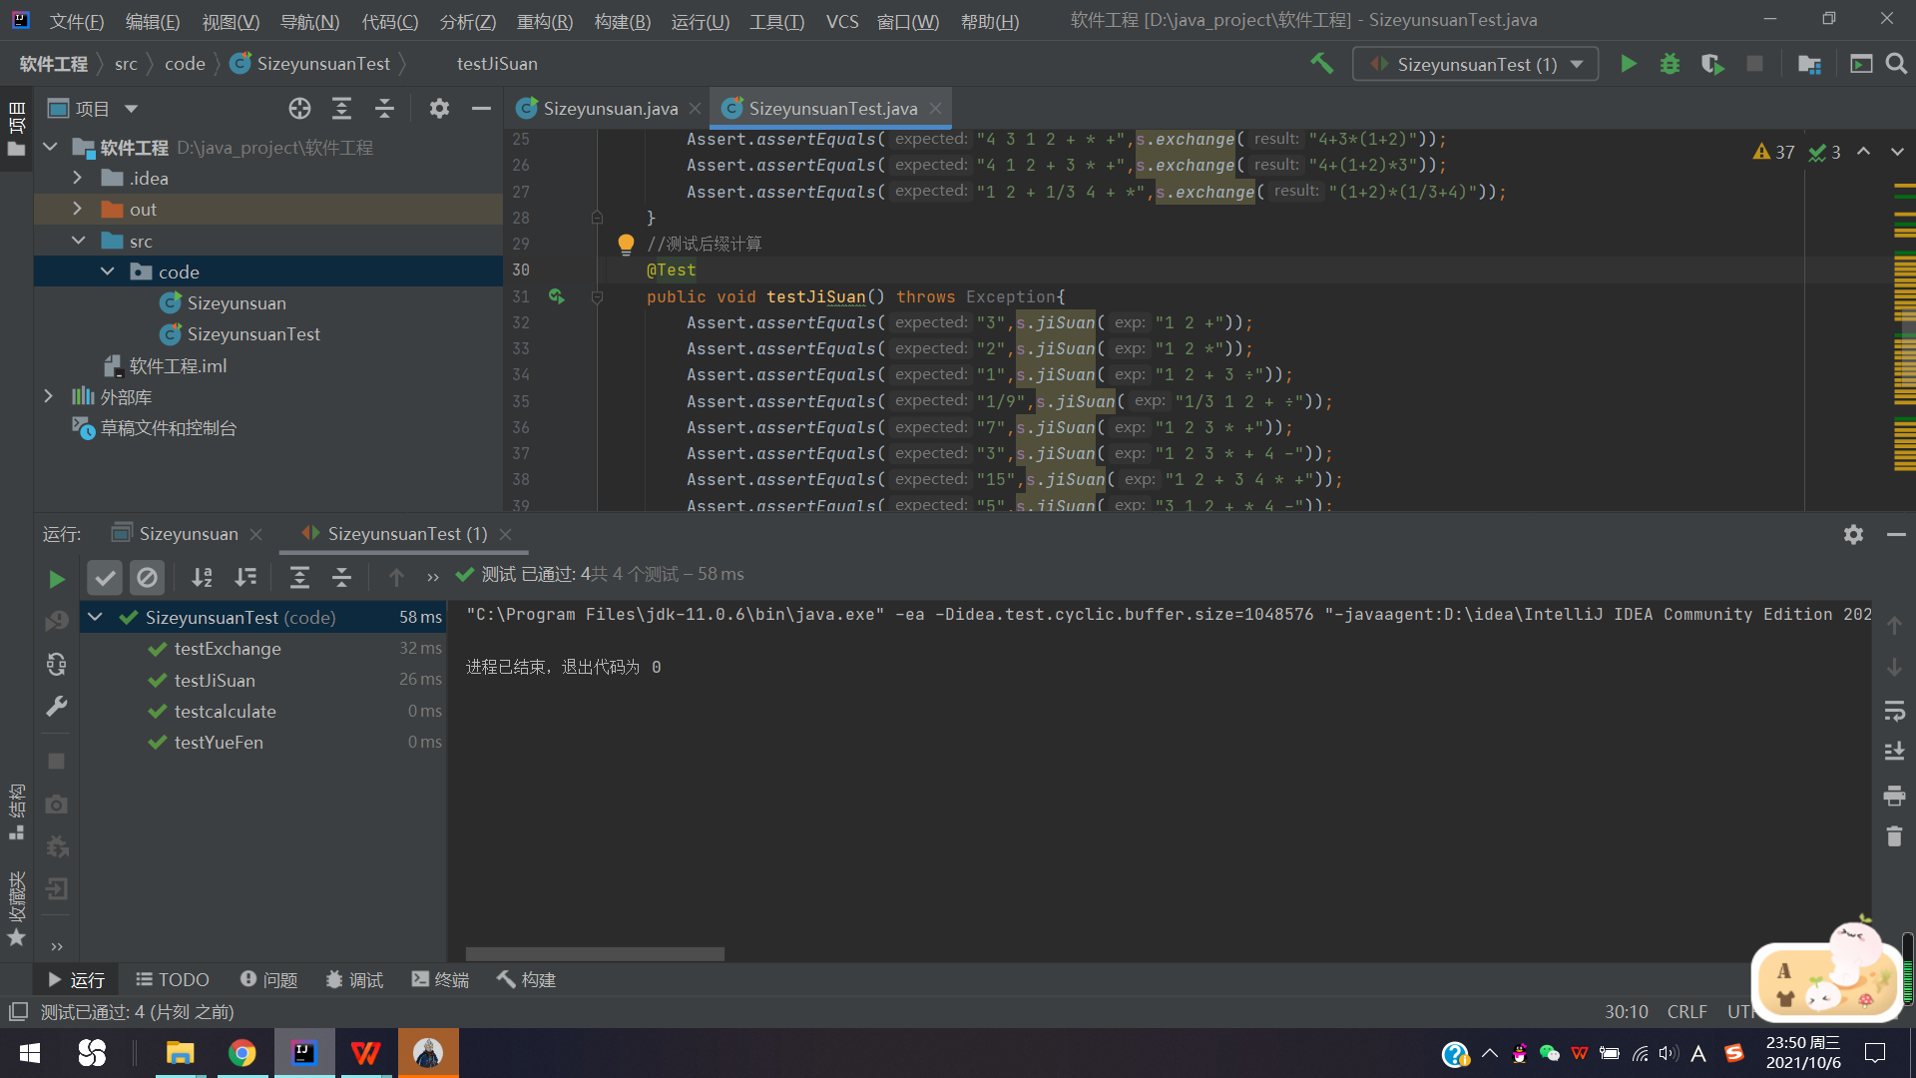测试结果图：