Software Design Document
Face Recognition-Based Smart Attendance Management System
Project ID: 20
Version 1.0
UE24CS341A - Software Engineering, Jackfruit Mini-Project

Team Details
Field | Details
Team Name | SE GROUP
Team Member 1 | MITHUN S | SRN: PES2UG24AM208
Team Member 2 | BHARATH H G | SRN: PES2UG24AM197
Team Member 3 | VARUN C H | SRN: PES2UG24AM180
Team Member 4 | YASHWANT ADITYA VARMA | SRN: PES2UG24AM190
Prepared by | MITHUN S
Date Created | 5.10.2026

Revision History
Name | Date | Reason For Changes | Version
MITHUN S | 5.10.2026 | Initial draft | 1.0

Table of Contents

(Right-click the table above and choose “Update Field” in Word to populate page numbers.)

1. Introduction
This Software Design Document (SWD) provides the detailed, implementation-level design of the system described at a high level in the Architecture Document: module decomposition, class/data design (UML), interaction (sequence) design, the database schema, and the API/internal-interface definitions required for the team to divide and implement the work. It maps directly onto the functional requirements (REQ-xx) in the SRS.

2. Module Decomposition
Module (file) | Responsibility | Owning feature (SRS)
app.py – route controllers | HTTP routing, request validation, session/flash messaging | 5.6 Auth
capture_face_samples() | Webcam capture + Haar cascade face detection for enrollment | 5.1 Enrollment
train_model() | Rebuilds the LBPH model from all images in dataset/ | 5.1 Enrollment
recognize_and_mark() | Live recognition + attendance insertion | 5.2 Attendance capture
dashboard() / export_csv() | Attendance % computation and CSV export | 5.4 Analytics, 5.5 Reports
get_db() / init_db() | SQLite connection and schema setup | all
setup() / admin_exists() | First-run bootstrap: creates the first Admin account, then locks itself | 5.6 Auth
register() | Creates new Admin/Faculty accounts, authorized by an existing Admin's credentials | 5.6 Auth
login() / logout() / start_session() | Authenticates a user and establishes/clears their session | 5.6 Auth
This maps onto a suggested 4-person split: (1) Enrollment & face capture, (2) Recognition & attendance marking, (3) Analytics, reporting & CSV export, (4) Auth/roles & UI/templates – matching the SRS feature sections and satisfying the course requirement that each member owns one full functionality.

3. Class Diagram (UML)
The diagram below shows the logical design: this mini-project's codebase is currently organised as functions grouped by responsibility rather than formal Python classes, so this is the target object-oriented decomposition the team should refactor toward as the implementation matures (or may implement directly as classes from the start).
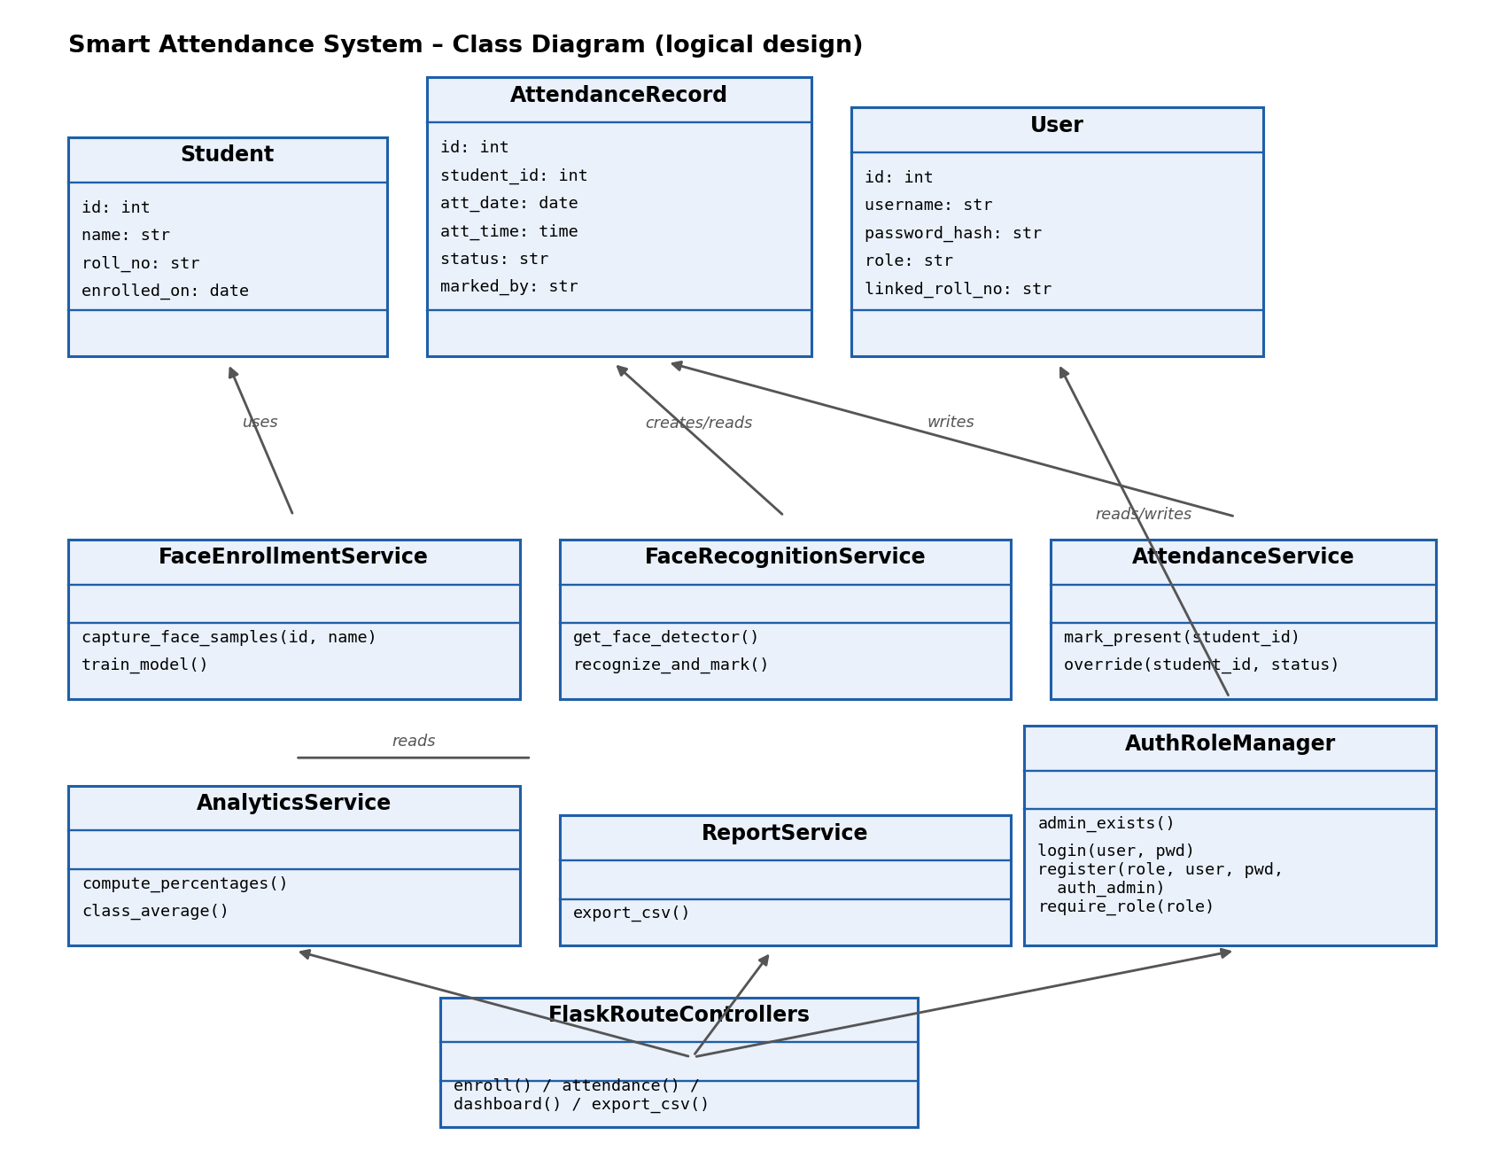
Class | Responsibility | Key methods
Student | Data model for an enrolled student | (data only)
AttendanceRecord | Data model for one attendance entry | (data only)
User | Data model for a login account (Admin/Faculty/Student), optionally linked to a Student by roll number | (data only)
FaceEnrollmentService | Captures and stores face samples; retrains the model | capture_face_samples(), train_model()
FaceRecognitionService | Loads the model and recognizes faces live | get_face_detector(), recognize_and_mark()
AttendanceService | Marks/overrides attendance records | mark_present(), override()
AnalyticsService | Computes per-student and class-wide attendance % | compute_percentages(), class_average()
ReportService | Builds the CSV export | export_csv()
AuthRoleManager | First-run admin setup, authorized account creation, login/logout, and role-based access checks | admin_exists(), login(), register(), require_role()
FlaskRouteControllers | Entry point wiring HTTP requests to the above services | enroll(), attendance(), dashboard(), export_csv()

4. Entity-Relationship Diagram
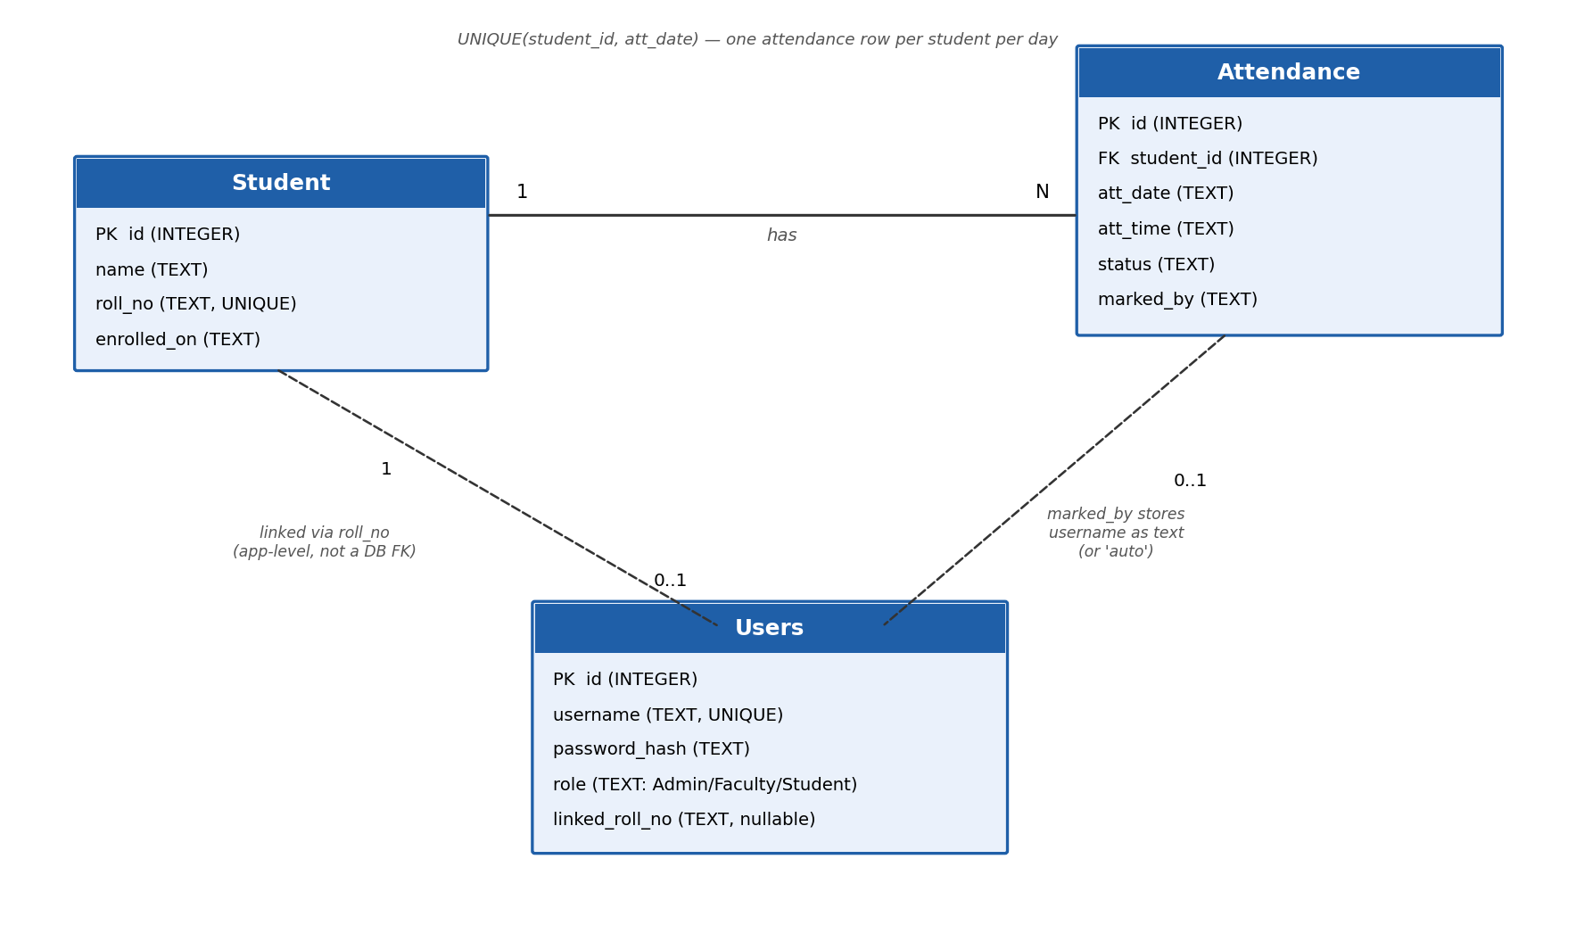
Student (1) has many Attendance records (N); a UNIQUE(student_id, att_date) constraint on Attendance enforces REQ-AT-4/REQ-OV-2's rule of one attendance outcome per student per day (later overrides update, rather than duplicate, that row). This expands on the field layouts already given in SRS Appendix B.
The Users table (added to support REQ-AU-1..4) is linked to Student only loosely, at the application level: a Student-role user's linked_roll_no is matched against Student.roll_no at query time (in the Dashboard and login-enrollment-check logic), not enforced as a database foreign key, since a user account can briefly exist without a matching student record (e.g. right after an Admin/Faculty account is created, or if a student is later un-enrolled). Attendance.marked_by stores a username as plain text (or the literal value 'auto') for the same reason - it is an audit trail, not a referential link.

5. Sequence Diagram: Take Attendance
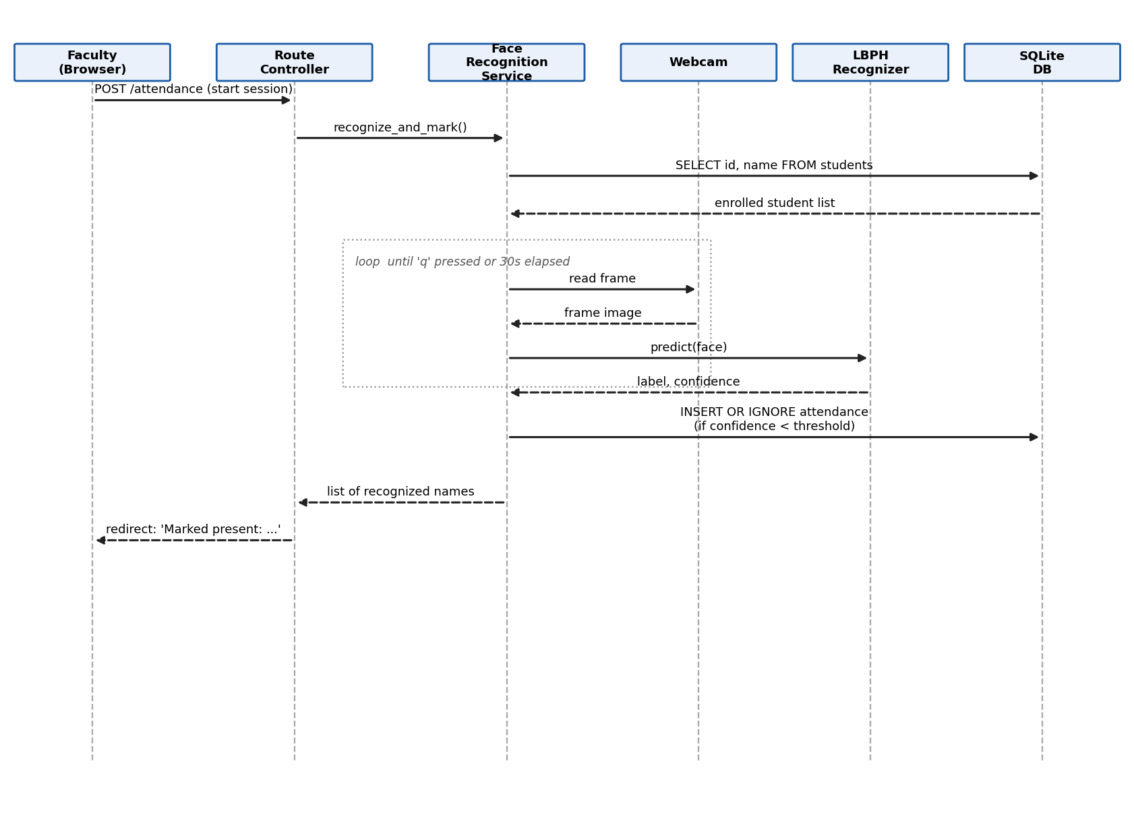
Steps: (1) Faculty submits the attendance form; (2) the Route Controller calls the Face Recognition Service; (3) the service loads the enrolled student list from SQLite; (4) it loops, reading frames from the webcam and asking the LBPH recognizer to predict a label and confidence for each detected face, until 'q' is pressed or 30 seconds elapse; (5) matches under the confidence threshold are inserted into the attendance table (ignored if already present today); (6) the list of recognized names is returned up to the browser.

5.1 Sequence outline: Enrollment (for comparison)
- Faculty submits the enroll form (name, roll number) -> Route Controller inserts a Student row.
- Route Controller calls FaceEnrollmentService.capture_face_samples(student_id, name).
- Service opens the webcam, loops capturing frames, detects a face per frame via the Haar cascade, and saves cropped grayscale images until 30 samples are captured or the user presses 'q'.
- Route Controller calls FaceEnrollmentService.train_model(), which re-reads every image in dataset/ and retrains the LBPH recognizer, saving trainer/trainer.yml.
- A success/failure flash message is returned to the browser.

5.2 Sequence outline: First-run Admin setup
- Any request, by anyone, before an Admin account exists -> a before_request hook (force_first_admin_setup) intercepts it and redirects to /setup.
- The first visitor chooses any username/password on the /setup form -> AuthRoleManager validates length and confirmation match, then inserts the first Users row with role='Admin'.
- Once that Admin row exists, /setup immediately redirects to /login for every subsequent visit - it cannot be used to create a second Admin this way.

5.3 Sequence outline: Authorized Admin/Faculty registration
- An existing Admin/Faculty's username+password is submitted on /register alongside the new account's desired role/username/password (the 'Create new user' link from the login page).
- AuthRoleManager looks up the submitted auth_username, confirms it belongs to an Admin, and checks the password hash -> wrong credentials reject the whole request before any new account is touched.
- If authorized, the new username is checked against both existing Users and existing Student roll numbers (to avoid an Admin/Faculty username silently colliding with a student's login) before the new Users row is inserted.

6. API Definitions (Flask routes)
Method & Route | Request | Response | Notes
GET/POST /setup | form: username, password, confirm | Creates first Admin; redirects to /login once one exists | First-run only; REQ-AU-1
GET/POST /register | form: role, username, password, confirm, auth_username, auth_password | Creates an Admin/Faculty account if authorization is valid | REQ-AU-1, REQ-AU-4
GET/POST /login | form: username, password | Starts a session; rejects with flash on bad credentials or an unenrolled student | REQ-AU-1, REQ-AU-2
GET /logout | none | Clears the session, redirects to /login | REQ-AU-1
GET / | none | HTML: overview counts (students, sessions, present today) | Home dashboard; login required
GET /enroll | none | HTML: enroll form + roster table | Admin/Faculty only
POST /enroll | form: name, roll_no | Redirect + flash message | Triggers webcam capture + retrain; REQ-EN-1..4; Admin/Faculty only
GET /attendance | none | HTML: capture button + today's present list | Admin/Faculty only
POST /attendance | none (session-triggered) | Redirect to the review screen with the camera's recognized result | Triggers live recognition; REQ-AT-1..5; Admin/Faculty only
GET /attendance/review | none | HTML: editable checklist of the pending recognition result | REQ-OV-1; Admin/Faculty only
POST /attendance/save | form: present_<id> checkboxes | Upserts attendance rows, redirect + flash | REQ-OV-1..3; Admin/Faculty only
GET /dashboard | none | HTML: per-student attendance % table (own record only if Student) | REQ-AN-1..4; login required
GET /export | none | CSV file download (Content-Disposition: attachment) | REQ-RP-1..3; Admin/Faculty only
All routes are server-rendered (Flask + Jinja templates), not a separate JSON REST API, since the UI and backend are not decoupled in this version. Future work could expose these as JSON endpoints for a mobile client.

7. Internal Module Interfaces (‘ABI’-equivalent)
Because this system is a single compiled-together Python process rather than separately compiled binaries, there is no true binary interface (ABI) in the C/C++ sense. The equivalent contract for this project is the set of internal Python function signatures each module exposes to the rest of the app – these are the boundaries other modules are allowed to call across, and the ones that must stay stable if a module's internals are later swapped out (e.g. replacing LBPH with a different recognizer).
Function signature | Returns | Raises
capture_face_samples(student_id: int, name: str) -> int | number of face samples captured | RuntimeError if webcam unavailable
train_model() -> bool | True if at least one face was trained on | —
get_face_detector() -> cv2.CascadeClassifier | a loaded Haar cascade detector | RuntimeError if the cascade file is missing/empty
recognize_and_mark() -> list[str] | names of students marked present this session | RuntimeError if no trained model exists, or webcam unavailable
get_db() -> sqlite3.Connection | a row-factory-enabled DB connection | —
init_db() -> None | none (side effect: creates tables if absent) | —
admin_exists() -> bool | True if at least one Admin-role user exists | —
start_session(user: sqlite3.Row) -> None | none (side effect: populates the Flask session) | —

8. Design Patterns Used
- Layered architecture / separation of concerns: route controllers never touch OpenCV or SQL directly in the target design – they delegate to service functions (Section 2), matching the Architecture Document's 3-layer model.
- Service-oriented functions: each feature (enrollment, recognition, analytics) is exposed as a small set of functions with a clear input/output contract (Section 7), similar in spirit to a service layer in MVC.
- Fail-safe default: recognize_and_mark() defaults an unmatched face to ‘Unknown’ rather than guessing the nearest enrolled student with low confidence, reducing false attendance (tunable via CONFIDENCE_THRESHOLD).

9. Error Handling Strategy
Scenario | Handling
Webcam not available / already in use | RuntimeError is raised, caught by the Flask route, and shown as a red flash message rather than crashing the app.
No face detected during enrollment capture | Frame is skipped silently; if zero samples are captured by the time the user stops, a 'try again' flash message is shown.
Duplicate roll number on enroll | sqlite3.IntegrityError is caught and converted to a user-facing 'already enrolled' flash message.
Attendance taken before any student is enrolled / before a model is trained | RuntimeError with a clear message ('enroll at least one student first'), caught and flashed.
Cascade/model file missing or corrupted | get_face_detector() checks .empty() explicitly and raises a descriptive RuntimeError instead of letting OpenCV's low-level assertion crash the process.
Wrong admin authorization submitted on /register | The whole request is rejected with a flash message before any new account is created; no partial account is ever inserted.
Someone revisits /setup after an Admin already exists | Immediately redirected to /login; the setup form never re-renders once the system is bootstrapped.
A student's account still exists after they are un-enrolled | login() re-checks enrollment status against the students table on every login attempt and rejects access with a clear message, even though the Users row itself was not deleted.
New roll number collides with an existing Admin/Faculty username | enroll() checks for this explicitly and rejects with a flash message before any student row is created.

10. Traceability to SRS Requirements
Requirement | Design element
REQ-EN-1..4 | FaceEnrollmentService (capture_face_samples, train_model) – Section 2, 7
REQ-AT-1..5 | FaceRecognitionService (recognize_and_mark) – Section 2, 5, 7
REQ-OV-1..3 | AttendanceService override path + UNIQUE constraint – Section 4, 9
REQ-AN-1..4 | AnalyticsService (dashboard route) – Section 2, 6
REQ-RP-1..3 | ReportService (export_csv route) – Section 2, 6
REQ-AU-1..4 | AuthRoleManager: admin_exists()/setup(), register(), login()/logout(), require_role() – Section 2, 5.2, 5.3, 6, 7

