Software Requirements Specification (SRS)

Project: Blood Donation Management System
Version: 1.0
Authors: Tusti S, Pavithra Reddy, Vedanth Kiran, Vrushant K P
Date: 11-10-2026
Status: Team review / approval

Revision history
Version | Date | Author | Change summary | Approval
1.0 | 11-10-2026 | Team | Requirements arranged in the university SRS template; functional/NFR tables, acceptance criteria, security and RTM included. | Pending team sign-off

Approvals
Role | Name | Signature / Email | Date
Project team representative | Tusti S |  | 11-10-2026
Team member | Pavithra Reddy |  | 11-10-2026
Team member | Vedanth Kiran |  | 11-10-2026
Team member | Vrushant K P |  | 11-10-2026

Table of Contents
1. Introduction
2. Overall description
3. External interfaces
4. System features (detailed)
5. Non-functional requirements (detailed)
6. Quality attributes & Acceptance tests
7. UML Use-Case Diagram
8. Requirements Traceability Matrix (RTM)

1. Introduction

1.1 Purpose
This document specifies the functional, non-functional, interface, security and acceptance requirements for the Blood Donation Management System.

1.2 Scope
The system is a centralized web application supporting donor management, donation appointments, completed donation records, blood inventory and availability, requester blood requests, request review, allocation and user/access administration. Medical diagnosis, laboratory testing, physical blood collection, transportation, external hospital/government integrations, payment processing and emergency medical decisions are out of scope.

1.3 Audience
Project team members, developers, testers, reviewers and assessment evaluators.

1.4 Definitions
FR: Functional Requirement; NFR: Non-Functional Requirement; BR: Business Rule; IR: Interface Requirement; SO: Security Objective; SR: Security Requirement; AC: Acceptance Criterion; RTM: Requirements Traceability Matrix; TBD: To Be Decided; TC: Test Case

2. Overall description

2.1 Product perspective
The system is a web application for the software-side workflow of blood donation and blood requests. It does not replace physical blood-bank procedures, laboratory systems or clinical decision-making.

2.2 Major product functions
- Account creation, login, role-based authorization and logout
- Donor registration, profile, eligibility information and donation history
- Appointment booking, viewing, rescheduling and cancellation
- Recording completed donations
- Blood inventory and availability management
- Request submission, review, approval/rejection, tracking and allocation
- User, role and account administration

2.3 User roles and characteristics
- Donor: registers, manages permitted profile information, views history and manages appointments.
- Hospital/Requester: submits and tracks own blood requests.
- Blood bank staff: manages donor-related operations, appointments, donations, inventory and requests.
- Admin: manages permitted user roles, access and account activation.
2.4 Operating environment
A browser-accessed web application with a persistent database and client/server communication. Specific browser, operating system, framework, database and hosting choices remain implementation decisions.

2.5 Constraints
The project follows the university-required Agile methodology. The system excludes physical blood handling and external medical/government integrations. Deployed authenticated communication is expected to use HTTPS.

3. External interface requirements

3.1 User interfaces
- Login interface.
- Role-appropriate interfaces for donors, requesters, blood bank staff and administrators.
- Donor profile, eligibility, donation history and appointment interfaces.
- Requester request-submission and status interfaces.
- Staff operational interfaces and admin user/access management interface.

3.2 Hardware interfaces
No dedicated hardware interface is required by the current system scope.
3.3 Software interfaces
- Persistent database for application data.
- Defined interfaces between application components.
- Application APIs where required by the selected architecture.

3.4 Communications
- Standard web client/server communication.
- HTTPS for deployed authenticated communication.
- Notification interface only if notifications are included in the final scope.

This SRS includes 40 functional requirements, 21 non-functional requirements, 2 security objectives and 5 security requirements.

4. System features (detailed)
Each functional requirement is documented with the template's required columns: requirement ID, requirement, type, priority, source/stakeholder, acceptance criteria/test case reference, and comments/dependencies.

4.1 Authentication
Description: Account creation, login, authentication before protected operations, role-appropriate functionality, authorization enforcement and logout.
Req ID | Requirement (shall...) | Type | Priority | Source/Stakeholder | Acceptance criteria / Test case ref | Comments / Dependencies
FR-001 | The system shall allow account creation for permitted user roles. | Functional | High | Authentication / users | AC-001; TC-01 | Permitted roles must be defined.
FR-002 | The system shall authenticate users through login. | Functional | High | Security / users | AC-002; TC-01 | Valid and invalid credentials.
FR-003 | The system shall require authentication before access to protected functions. | Functional | High | Security | AC-002; TC-02
FR-004 | The system shall present role-appropriate functions and navigation to the authenticated user. | Functional | High | Usability / users | AC-002; TC-02
FR-005 | The system shall enforce role permissions for protected operations, including direct requests outside the UI. | Functional | High | Security / administrators | AC-002; TC-02 | API enforcement where APIs exist.
FR-006 | The system shall allow an authenticated user to log out. | Functional | High | Users | AC-002; TC-01

4.2 Donor Management
Description: Donor registration/profile information, eligibility information and donation history.

Req ID | Requirement (shall...) | Type | Priority | Source/Stakeholder | Acceptance criteria / Test case ref | Comments / Dependencies
FR-007 | The system shall allow a donor to register by providing required donor information. | Functional | High | Donors | AC-003; TC-03 | Required fields TBD.
FR-008 | The system shall allow a donor to view their own profile. | Functional | High | Donors | AC-003; TC-03
FR-009 | The system shall allow a donor to update permitted profile information. | Functional | Medium | Donors | AC-003; TC-03 | Permitted fields TBD.
FR-010 | The system shall allow authorized staff to view donor information required for operations. | Functional | High | Blood bank staff | AC-003; TC-03
FR-011 | The system shall record and display donor eligibility information. | Functional | High | Donors / staff | AC-003; TC-04 | Eligibility rules TBD.
FR-012 | The system shall maintain completed donation records linked to the corresponding donor. | Functional | High | Donors / staff | AC-003; TC-05
FR-013 | The system shall allow a donor to view their completed donation history. | Functional | Medium | Donors | AC-003; TC-03

4.3 Donation and Appointment Management
Description: Donors manage permitted appointments (booking, viewing, rescheduling and cancellation); staff manage appointments and record completed donations; accepted donations increase the appropriate inventory.

Req ID | Requirement (shall...) | Type | Priority | Source/Stakeholder | Acceptance criteria / Test case ref | Comments / Dependencies
FR-014 | The system shall allow an eligible donor to book a donation appointment. | Functional | High | Donors | AC-004; TC-04 | Eligibility and slot rules TBD.
FR-015 | The system shall allow a donor to view their donation appointments. | Functional | Medium | Donors | AC-004; TC-04
FR-016 | The system shall allow a donor to reschedule a permitted donation appointment. | Functional | Medium | Donors | AC-004; TC-04 | Rescheduling rules TBD.
FR-017 | The system shall allow a donor to cancel a permitted donation appointment. | Functional | Medium | Donors | AC-004; TC-04 | Cancellation rules TBD.
FR-018 | The system shall allow authorized staff to view and manage donation appointments. | Functional | High | Blood bank staff | AC-004; TC-04
FR-019 | The system shall allow authorized staff to record a completed blood donation. | Functional | High | Blood bank staff | AC-004; TC-05
FR-020 | The system shall record the information required for a completed donation. | Functional | High | Blood bank staff | AC-004; TC-05 | Donation fields TBD.
FR-021 | The system shall update blood inventory when a completed donation is accepted. | Functional | High | Blood bank staff | AC-004/005; TC-05 | Acceptance criteria TBD.

4.4 Blood Inventory and Availability
Description: Staff maintain inventory; authorized users check availability; allocation must not exceed available quantity. Includes inventory maintenance, availability lookup, status management and allocation quantity controls.

Req ID | Requirement (shall...) | Type | Priority | Source/Stakeholder | Acceptance criteria / Test case ref | Comments / Dependencies
FR-022 | The system shall allow authorized staff to add blood units to inventory. | Functional | High | Blood bank staff | AC-005; TC-06 | Inventory model TBD.
FR-023 | The system shall maintain available blood units according to blood group/type. | Functional | High | Blood bank staff | AC-005; TC-06 | Blood group/Rh scope TBD.
FR-024 | The system shall allow authorized users to view inventory information. | Functional | High | Staff / authorized users | AC-005; TC-06
FR-025 | The system shall allow authorized users to check availability by blood group/type. | Functional | High | Requesters / staff | AC-005; TC-06
FR-026 | The system shall maintain the status of blood units or inventory quantities as defined by the system. | Functional | Medium | Blood bank staff | AC-005; TC-06 | Status values TBD.
FR-027 | The system shall reduce available inventory when units are successfully allocated to an approved request. | Functional | High | Blood bank staff | AC-005; TC-06/08
FR-028 | The system shall prevent allocation when requested quantity exceeds available inventory. | Functional | High | Blood bank staff | AC-005; TC-06/08

4.5 Blood Requests and Administration
Description: Requesters submit and track their own requests; staff review, approve/reject and allocate to approved requests; administrators manage permitted users and access.

Req ID | Requirement (shall...) | Type | Priority | Source/Stakeholder | Acceptance criteria / Test case ref | Comments / Dependencies
FR-029 | The system shall allow an authorized requester to submit a blood request. | Functional | High | Hospital/requester | AC-006; TC-07
FR-030 | The system shall require a blood request to specify blood group/type and quantity. | Functional | High | Hospital/requester | AC-006; TC-07
FR-031 | The system shall assign an appropriate status to a submitted blood request. | Functional | High | System / requester | AC-006; TC-07 | Status transitions TBD.
FR-032 | The system shall allow a requester to retrieve their own submitted requests. | Functional | Medium | Hospital/requester | AC-006; TC-07
FR-033 | The system shall display current status for each request in the requester's list or details. | Functional | Medium | Hospital/requester | AC-006; TC-07
FR-034 | The system shall allow authorized staff to view requests requiring operational processing. | Functional | High | Blood bank staff | AC-006; TC-08
FR-035 | The system shall allow authorized staff to approve or reject a blood request. | Functional | High | Blood bank staff | AC-006; TC-08 | Rejection reason rules TBD.
FR-036 | The system shall update request status when an authorized action is performed. | Functional | High | Blood bank staff | AC-006; TC-08
FR-037 | The system shall allow authorized staff to allocate available units to an approved request. | Functional | High | Blood bank staff | AC-006; TC-08
FR-038 | The system shall allow an administrator to view system users. | Functional | Medium | Admin | AC-007; TC-09
FR-039 | The system shall allow an administrator to manage permitted user roles and access. | Functional | High | Admin | AC-007; TC-09 | Admin permissions TBD.
FR-040 | The system shall allow an administrator to activate or deactivate user accounts. | Functional | Medium | Admin | AC-007; TC-09

5. Non-functional requirements (detailed)
Non-functional requirements below are tied to proposed acceptance criteria and planned test cases. TBD targets remain open until the team agrees them.

Req ID | Requirement | Category | Priority | Acceptance criteria / Measurement
NFR-001 | Normal UI response-time target shall be defined by the team. | Performance | High | AC-008; numeric target TBD; performance test blocked until agreed.
NFR-002 | Expected concurrent-user target shall be defined by the team. | Capacity | Medium | AC-008; numeric target TBD; capacity test blocked until agreed.
NFR-003 | Inventory allocation and accepted-donation updates shall be performed atomically. | Data integrity | High | AC-009; verify no partial updates leave quantities inconsistent.
NFR-004 | The system shall require authentication for protected functions. | Security | High | AC-010; TC-01/02.
NFR-005 | The system shall enforce role-based authorization. | Security | High | AC-010; TC-02.
NFR-006 | Passwords shall be stored using secure password hashing and not as plaintext. | Security | High | AC-010; TC-10; inspect test database/logs.
NFR-007 | The system shall validate user inputs before processing them. | Input validation | High | AC-010; TC-07/10.
NFR-008 | Sensitive information shall be protected from unauthorized access. | Privacy | High | AC-010; TC-03/07/10.
NFR-009 | Deployed authenticated communication shall use HTTPS. | Communications security | High | AC-010; TC-10; verify deployed configuration.
NFR-010 | The scope of audit information shall be decided and documented. | Auditability | Medium | AC-010; TC-10; audit-event scope TBD.
NFR-011 | The system shall maintain referential and state consistency across related records. | Data consistency | High | AC-009; TC-05/06/08.
NFR-012 | The system shall prevent duplicate processing where it could create duplicate records or allocations. | Reliability | High | AC-009; TC-06/08.
NFR-013 | The system shall provide an appropriate error state when an operation cannot be completed. | Error handling | Medium | TC-07/10.
NFR-014 | Navigation shall be appropriate to the authenticated user's role. | Usability | Medium | TC-02; usability review.
NFR-015 | The system shall provide clear validation messages for invalid or incomplete input. | Usability | Medium | TC-07/10.
NFR-016 | The system shall display current appointment and request status to authorized users. | Usability | Medium | TC-04/07.
NFR-017 | The system shall use modular responsibilities to support maintainability. | Maintainability | Medium | Design/code review.
NFR-018 | Presentation, business logic and data responsibilities shall be separated as appropriate to the design. | Architecture | Medium | Design/code review.
NFR-019 | Changes to one functional area should minimize unrelated changes to other areas. | Maintainability | Medium | Code review.
NFR-020 | The project shall include automated tests for selected functionality. | Testing | High | Automated test execution; scope to be agreed.
NFR-021 | The project shall use automated CI checks as required by project deliverables. | Build quality | High | GitHub Actions workflow run.

5.1. Security

5.1.1 Security Objectives
Security objectives:
SO-001: Protect user accounts and prevent unauthenticated access to protected functions.
SO-002: Restrict system data and operations according to the authenticated user's permitted role.

5.1.2 Security Requirements
Req ID | Requirement (shall...) | Type | Priority | Acceptance criteria / Test case ref
SR-001 | The system shall authenticate users before allowing access to protected functions. | Security | High | AC-010; TC-01/02.
SR-002 | The system shall enforce authorization according to the user's permitted role. | Security | High | AC-010; TC-02.
SR-003 | The system shall store passwords using a secure password-hashing mechanism and shall not store them as plaintext. | Security | High | AC-010; TC-10.
SR-004 | The system shall protect sensitive information from unauthorized access. | Security | High | AC-010; TC-03/07/10.
SR-005 | Deployed authenticated communication shall use HTTPS. | Security | High | AC-010; TC-10.

6. Quality attributes & Acceptance tests

6.1 Acceptance Criteria Register (AC)
The following criteria define observable pass conditions and link requirements to test cases. AC IDs are referenced in the functional and non-functional requirement tables.
AC ID | Related requirements | Acceptance criteria | Test case reference
AC-001 | FR-001 | A permitted user can create an account with valid required information; invalid or missing required values are rejected. | TC-01
AC-002 | FR-002–FR-006; NFR-004–NFR-005 | Valid credentials allow login; invalid credentials are rejected; protected functions require authentication; role-restricted operations are denied; logout ends the authenticated session. | TC-01, TC-02
AC-003 | FR-007–FR-013; NFR-008 | Donors can access their own permitted profile/history; authorized staff can access operational donor information; unauthorized cross-account access is denied. | TC-03
AC-004 | FR-014–FR-021 | Appointment operations follow configured eligibility and scheduling rules; completed donations are recorded and linked to the donor; only accepted donations increase inventory. | TC-04, TC-05
AC-005 | FR-022–FR-028; NFR-003, NFR-011–NFR-012 | Inventory reflects accepted donations and successful allocations; invalid or excessive allocations are rejected; updates remain consistent and are not duplicated. | TC-05, TC-06, TC-08
AC-006 | FR-029–FR-037; BR-006–BR-011 | Valid requests include blood group/type and quantity; requesters see only their own requests; only authorized staff review requests; allocation is allowed only after approval. | TC-07, TC-08
AC-007 | FR-038–FR-040; BR-012 | Admin can perform permitted user/role actions; non-admin users are denied those operations; deactivated-account behaviour follows the agreed implementation rule. | TC-09
AC-008 | NFR-001–NFR-002 | Response-time and concurrent-user tests pass only against numeric targets approved by the team; currently blocked until those targets are set. | Performance test (TBD)
AC-009 | NFR-003, NFR-011–NFR-012; BR-005, BR-009–BR-010 | Inventory changes are atomic and consistent; accepted donations and successful allocations update quantities correctly; over-allocation and duplicate processing are prevented. | TC-05, TC-06, TC-08
AC-010 | NFR-004–NFR-010; SR-001–SR-005 | Authentication and authorization are enforced; passwords are not stored/logged in plaintext; sensitive data is restricted; deployed authenticated traffic uses HTTPS; agreed audit events are recorded. | TC-01, TC-02, TC-10

6.1 Acceptance Criteria Register (AC)
The following criteria define observable pass conditions and link requirements to test cases. AC IDs are referenced in the functional and non-functional requirement tables.
- Exit criteria for acceptance: All high-priority functional requirements implemented and verified, no critical NFR failures, and RTM shows all test cases passed.
- Acceptance test suites: Authentication, Donor Management, Appointments and Donations, Inventory, Blood Requests, Administration, and Security tests; Performance tests once NFR-001 and NFR-002 targets are agreed.

7. System models and diagrams
Insert the team-prepared UML use-case diagram(s) in the spaces below. The university SRS template requires at least one use-case diagram. Add figure numbers, captions and a short description of actors and key use cases. No diagrams are embedded in this version.

7.1 System Overview Use-Case Diagram
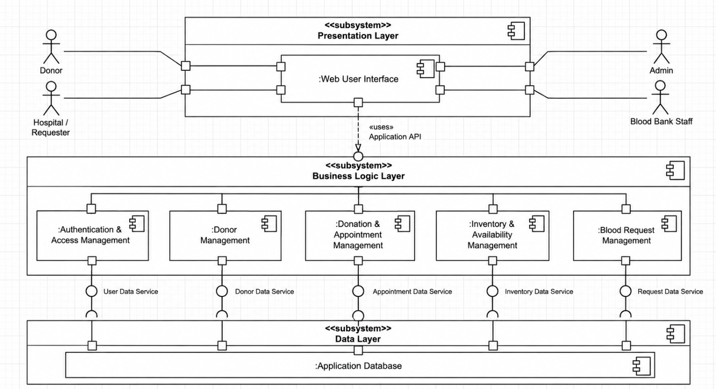
Figure 7.1. System Overview Use-Case Diagram

7.2 Additional Use-Case Diagram (if used)
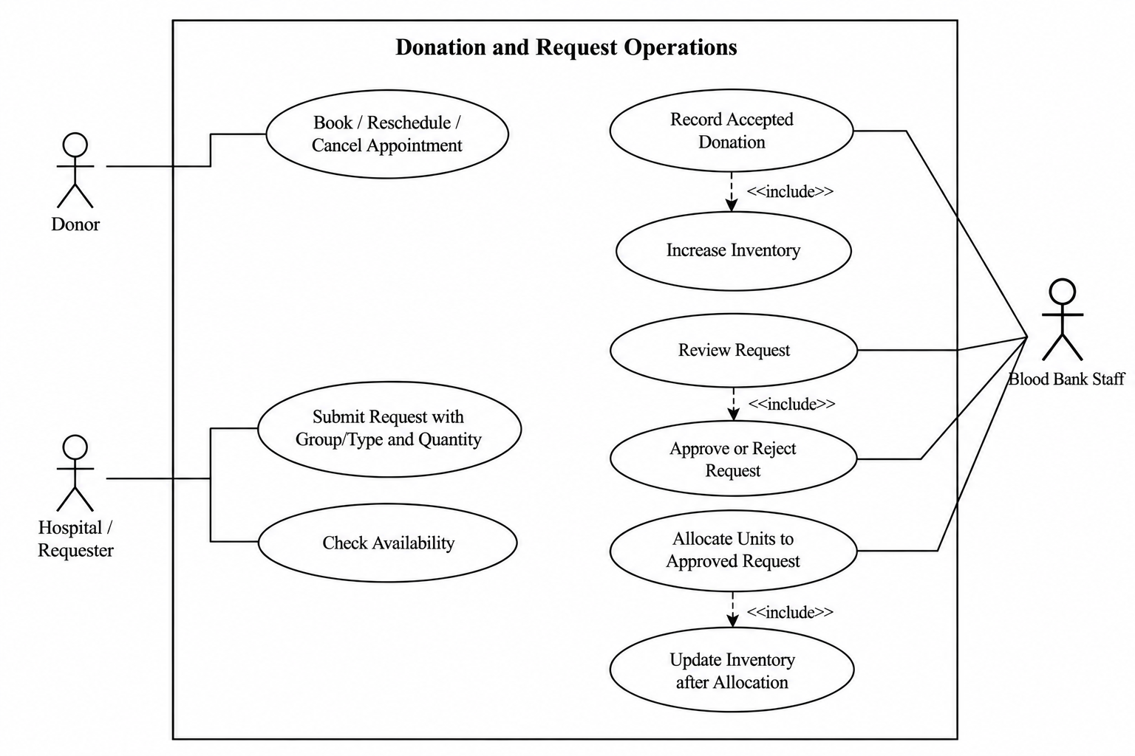
Figure 7.2. Additional Use-Case Diagram (optional unless required by the instructor)
Diagram review: verify that actor permissions and use cases agree with the final functional requirements and BR-001–BR-012. Update the RTM if diagram decisions change requirement interpretation.

Business Rules Register (BR)
These business rules constrain system behaviour and are included for traceability; they are not a separate university-mandated document.
ID | Business rule | Source / related requirements
BR-001 | Access follows the permissions assigned to the user's role. | FR-004–FR-005; SR-002
BR-002 | A donor account is required before booking an appointment. | FR-007; FR-014
BR-003 | A donor must satisfy the configured eligibility criteria before booking. | FR-011; FR-014
BR-004 | Each completed donation is linked to the corresponding donor. | FR-012; FR-019–FR-020
BR-005 | An accepted donation increases the appropriate inventory quantity. | FR-021–FR-023
BR-006 | A blood request must specify blood group/type and quantity. | FR-029–FR-030
BR-007 | Only authorized staff may approve or reject a blood request. | FR-035
BR-008 | Only an approved request may proceed to allocation. | FR-035–FR-037
BR-009 | An allocation must not exceed the available quantity. | FR-027–FR-028
BR-010 | Successful allocation updates the available inventory quantity. | FR-027
BR-011 | A requester may view only their own submitted requests. | FR-032–FR-033
BR-012 | Only authorized administrators may manage permitted user roles/access. | FR-038–FR-040

8. Requirements Traceability Matrix (RTM)

Req ID | Requirement short | Section ref / Design Spec | Module | Test case(s) | Status (N/P/A) | Comments
FR-001 | The system shall allow account creation for permitted user roles. | 4 / FR register | Authentication / users | TC-01 | N | Permitted roles must be defined.
FR-002 | The system shall authenticate users through login. | 4 / FR register | Security / users | TC-01 | N | Valid and invalid credentials.
FR-003 | The system shall require authentication before access to protected functions. | 4 / FR register | Security | TC-02 | N
FR-004 | The system shall present role-appropriate functions and navigation to the authenticated user. | 4 / FR register | Usability / users | TC-02 | N
FR-005 | The system shall enforce role permissions for protected operations, including direct requests outside the UI. | 4 / FR register | Security / administrators | TC-02 | N | API enforcement where APIs exist.
FR-006 | The system shall allow an authenticated user to log out. | 4 / FR register | Users | TC-01 | N
FR-007 | The system shall allow a donor to register by providing required donor information. | 4 / FR register | Donors | TC-03 | N | Required fields TBD.
FR-008 | The system shall allow a donor to view their own profile. | 4 / FR register | Donors | TC-03 | N
FR-009 | The system shall allow a donor to update permitted profile information. | 4 / FR register | Donors | TC-03 | N | Permitted fields TBD.
FR-010 | The system shall allow authorized staff to view donor information required for operations. | 4 / FR register | Blood bank staff | TC-03 | N
FR-011 | The system shall record and display donor eligibility information. | 4 / FR register | Donors / staff | TC-04 | N | Eligibility rules TBD.
FR-012 | The system shall maintain completed donation records linked to the corresponding donor. | 4 / FR register | Donors / staff | TC-05 | N
FR-013 | The system shall allow a donor to view their completed donation history. | 4 / FR register | Donors | TC-03 | N
FR-014 | The system shall allow an eligible donor to book a donation appointment. | 4 / FR register | Donors | TC-04 | N | Eligibility and slot rules TBD.
FR-015 | The system shall allow a donor to view their donation appointments. | 4 / FR register | Donors | TC-04 | N
FR-016 | The system shall allow a donor to reschedule a permitted donation appointment. | 4 / FR register | Donors | TC-04 | N | Rescheduling rules TBD.
FR-017 | The system shall allow a donor to cancel a permitted donation appointment. | 4 / FR register | Donors | TC-04 | N | Cancellation rules TBD.
FR-018 | The system shall allow authorized staff to view and manage donation appointments. | 4 / FR register | Blood bank staff | TC-04 | N
FR-019 | The system shall allow authorized staff to record a completed blood donation. | 4 / FR register | Blood bank staff | TC-05 | N
FR-020 | The system shall record the information required for a completed donation. | 4 / FR register | Blood bank staff | TC-05 | N | Donation fields TBD.
FR-021 | The system shall update blood inventory when a completed donation is accepted. | 4 / FR register | Blood bank staff | TC-05 | N | Acceptance criteria TBD.
FR-022 | The system shall allow authorized staff to add blood units to inventory. | 4 / FR register | Blood bank staff | TC-06 | N | Inventory model TBD.
FR-023 | The system shall maintain available blood units according to blood group/type. | 4 / FR register | Blood bank staff | TC-06 | N | Blood group/Rh scope TBD.
FR-024 | The system shall allow authorized users to view inventory information. | 4 / FR register | Staff / authorized users | TC-06 | N
FR-025 | The system shall allow authorized users to check availability by blood group/type. | 4 / FR register | Requesters / staff | TC-06 | N
FR-026 | The system shall maintain the status of blood units or inventory quantities as defined by the system. | 4 / FR register | Blood bank staff | TC-06 | N | Status values TBD.
FR-027 | The system shall reduce available inventory when units are successfully allocated to an approved request. | 4 / FR register | Blood bank staff | TC-06/08 | N
FR-028 | The system shall prevent allocation when requested quantity exceeds available inventory. | 4 / FR register | Blood bank staff | TC-06/08 | N
FR-029 | The system shall allow an authorized requester to submit a blood request. | 4 / FR register | Hospital/requester | TC-07 | N
FR-030 | The system shall require a blood request to specify blood group/type and quantity. | 4 / FR register | Hospital/requester | TC-07 | N
FR-031 | The system shall assign an appropriate status to a submitted blood request. | 4 / FR register | System / requester | TC-07 | N | Status transitions TBD.
FR-032 | The system shall allow a requester to retrieve their own submitted requests. | 4 / FR register | Hospital/requester | TC-07 | N
FR-033 | The system shall display current status for each request in the requester's list or details. | 4 / FR register | Hospital/requester | TC-07 | N
FR-034 | The system shall allow authorized staff to view requests requiring operational processing. | 4 / FR register | Blood bank staff | TC-08 | N
FR-035 | The system shall allow authorized staff to approve or reject a blood request. | 4 / FR register | Blood bank staff | TC-08 | N | Rejection reason rules TBD.
FR-036 | The system shall update request status when an authorized action is performed. | 4 / FR register | Blood bank staff | TC-08 | N
FR-037 | The system shall allow authorized staff to allocate available units to an approved request. | 4 / FR register | Blood bank staff | TC-08 | N
FR-038 | The system shall allow an administrator to view system users. | 4 / FR register | Admin | TC-09 | N
FR-039 | The system shall allow an administrator to manage permitted user roles and access. | 4 / FR register | Admin | TC-09 | N | Admin permissions TBD.
FR-040 | The system shall allow an administrator to activate or deactivate user accounts. | 4 / FR register | Admin | TC-09 | N
NFR-001 | Normal UI response-time target shall be defined by the team. | 5 / NFR register | Performance | performance test blocked until agreed. | N | AC-008; numeric target TBD; performance test blocked until agreed.
NFR-002 | Expected concurrent-user target shall be defined by the team. | 5 / NFR register | Capacity | capacity test blocked until agreed. | N | AC-008; numeric target TBD; capacity test blocked until agreed.
NFR-003 | Inventory allocation and accepted-donation updates shall be performed atomically. | 5 / NFR register | Data integrity | verify no partial updates leave quantities inconsistent. | N | AC-009; verify no partial updates leave quantities inconsistent.
NFR-004 | The system shall require authentication for protected functions. | 5 / NFR register | Security | TC-01/02. | N | AC-010; TC-01/02.
NFR-005 | The system shall enforce role-based authorization. | 5 / NFR register | Security | TC-02. | N | AC-010; TC-02.
NFR-006 | Passwords shall be stored using secure password hashing and not as plaintext. | 5 / NFR register | Security | inspect test database/logs. | N | AC-010; TC-10; inspect test database/logs.
NFR-007 | The system shall validate user inputs before processing them. | 5 / NFR register | Input validation | TC-07/10. | N | AC-010; TC-07/10.
NFR-008 | Sensitive information shall be protected from unauthorized access. | 5 / NFR register | Privacy | TC-03/07/10. | N | AC-010; TC-03/07/10.
NFR-009 | Deployed authenticated communication shall use HTTPS. | 5 / NFR register | Communications security | verify deployed configuration. | N | AC-010; TC-10; verify deployed configuration.
NFR-010 | The scope of audit information shall be decided and documented. | 5 / NFR register | Auditability | audit-event scope TBD. | N | AC-010; TC-10; audit-event scope TBD.
NFR-011 | The system shall maintain referential and state consistency across related records. | 5 / NFR register | Data consistency | TC-05/06/08. | N | AC-009; TC-05/06/08.
NFR-012 | The system shall prevent duplicate processing where it could create duplicate records or allocations. | 5 / NFR register | Reliability | TC-06/08. | N | AC-009; TC-06/08.
NFR-013 | The system shall provide an appropriate error state when an operation cannot be completed. | 5 / NFR register | Error handling | TC-07/10. | N | TC-07/10.
NFR-014 | Navigation shall be appropriate to the authenticated user's role. | 5 / NFR register | Usability | usability review. | N | TC-02; usability review.
NFR-015 | The system shall provide clear validation messages for invalid or incomplete input. | 5 / NFR register | Usability | TC-07/10. | N | TC-07/10.
NFR-016 | The system shall display current appointment and request status to authorized users. | 5 / NFR register | Usability | TC-04/07. | N | TC-04/07.
NFR-017 | The system shall use modular responsibilities to support maintainability. | 5 / NFR register | Maintainability | Design/code review. | N | Design/code review.
NFR-018 | Presentation, business logic and data responsibilities shall be separated as appropriate to the design. | 5 / NFR register | Architecture | Design/code review. | N | Design/code review.
NFR-019 | Changes to one functional area should minimize unrelated changes to other areas. | 5 / NFR register | Maintainability | Code review. | N | Code review.
NFR-020 | The project shall include automated tests for selected functionality. | 5 / NFR register | Testing | scope to be agreed. | N | Automated test execution; scope to be agreed.
NFR-021 | The project shall use automated CI checks as required by project deliverables. | 5 / NFR register | Build quality | GitHub Actions workflow run. | N | GitHub Actions workflow run.
BR-001 | Access follows assigned role | 2.3 / 4 | Authentication/access | TC-02 | N | Role matrix to be confirmed.
BR-002 | Donor account required before appointment booking | 4.3 | Appointments | TC-04 | N
BR-003 | Donor must satisfy configured eligibility criteria | 4.3 | Eligibility | TC-04 | N | Eligibility criteria TBD.
BR-004 | Completed donation is linked to donor | 4.3 | Donation records | TC-05 | N
BR-005 | Accepted donation increases inventory | 4.3/4.4 | Donation/inventory | TC-05 | N
BR-006 | Request must specify blood group/type and quantity | 4.5 | Requests | TC-07 | N
BR-007 | Only authorized staff may approve/reject requests | 4.5 | Requests/access | TC-08 | N
BR-008 | Only approved requests may be allocated | 4.4/4.5 | Allocation | TC-08 | N
BR-009 | Allocation cannot exceed available quantity | 4.4 | Inventory/allocation | TC-06/08 | N
BR-010 | Allocation updates inventory | 4.4 | Inventory/allocation | TC-06/08 | N
BR-011 | Requester sees only their own requests | 4.5 | Request privacy | TC-07 | N
BR-012 | Admin manages permitted user roles/access | 4.5 | Administration | TC-09 | N
SO-001 | Protect accounts and prevent unauthenticated access | 5.1.1 | Security | TC-01/02/10 | N
SO-002 | Restrict data and operations according to role | 5.1.1 | Security | TC-02/03/10 | N
SR-001 | The system shall authenticate users before allowing access to protected functions. | 5.1.2 | Security | TC-01/02. | N
SR-002 | The system shall enforce authorization according to the user's permitted role. | 5.1.2 | Security | TC-02. | N
SR-003 | The system shall store passwords using a secure password-hashing mechanism and shall not store them as plaintext. | 5.1.2 | Security | TC-10. | N
SR-004 | The system shall protect sensitive information from unauthorized access. | 5.1.2 | Security | TC-03/07/10. | N
SR-005 | Deployed authenticated communication shall use HTTPS. | 5.1.2 | Security | TC-10. | N

