Software Architecture and Design Specification
Project: Blood Donation Management System
Version: 1
Authors: Tusti S, Pavithra Reddy, Vedanth Kiran, Vrushant K P
Date: 11-10-2026
Status: Approval pending

Revision History
Version | Date | Author | Change Summary | Approval
1 | 11-10-2026 | Team | Initial SAD aligned with SRS Version 1.0 and Test Plan Version 1.0. | Pending approval

Approvals
Role | Name | Signature / Date
Project Team Representative | Tusti S | 11-10-2026
Team Member | Pavithra Reddy | 11-10-2026
Team Member | Vedanth Kiran | 11-10-2026
Team Member | Vrushant K P | 11-10-2026

1. Introduction

1.1 Purpose
This document describes the proposed architecture and software design for the Blood Donation Management System. It provides a shared design baseline for implementation, testing and review, and is consistent with the project's SRS Version 1.0 and Test Plan Version 1.0.

1.2 Scope
The system is a web application supporting account access, donor management, appointment booking and completed donation records, blood inventory and availability, requester blood requests, request review, allocation, and user/access administration.
Out of scope are medical diagnosis or treatment recommendations, laboratory testing, physical blood collection, blood transportation, external hospital/government integrations, payments and emergency medical decisions.

1.3 Audience
The intended audience is the project team, developers, testers, reviewers and assessment evaluators.

1.4 Definitions
Term | Meaning
SRS | Software Requirements Specification
STP | Software Test Plan
FR / NFR | Functional Requirement / Non-Functional Requirement
BR / SR | Business Rule / Security Requirement
AC / RTM | Acceptance Criterion / Requirements Traceability Matrix
RBAC | Role-Based Access Control
API / HTTPS | Application Programming Interface / Hypertext Transfer Protocol Secure
ADR / TBD | Architecture Decision Record / To Be Decided

2. Document Overview

2.1 How to use this document
Use this document as the proposed architecture/design baseline. The component descriptions and flows guide implementation and test design. Update it when the team approves architectural decisions or changes to the SRS; keep requirement traceability and the test plan synchronized.

2.2 Related Documents
- Blood Donation Management System — SRS Version 1.0, dated 11-10-2026.
- Blood Donation Management System — Software Test Plan Version 1.0, dated 11-10-2026.
- Project backlog, GitHub issues and pull requests maintained by the team.

3. Architecture

3.1 Goals & Constraints
Goals: secure role-based access; accurate and consistent donor, appointment, donation, inventory and request records; understandable workflows; modular development; and traceability to requirements and tests.
Constraints: the deliverable is a web application within the mini-project timeline. The final programming framework, database, deployment environment and supported browsers are to be confirmed by the team. SRS NFR-001 (response-time target) and NFR-002 (concurrency target) remain TBD and must not be assumed.

3.2 Stakeholders & Concerns
Stakeholder | Primary concerns
Donors | Privacy, accurate profile and donation history, clear eligibility information and appointment status.
Requesters | Valid request submission, status visibility and privacy of their own requests.
Blood-bank staff | Correct appointment/donation records, inventory accuracy and controlled request allocation.
Administrators | Secure user, role and account-status management.
Developers and testers | Modularity, clear interfaces, testability, traceability and maintainability.
Project reviewers | Consistency with the SRS, Test Plan and course deliverables.

3.3 Component (UML) Diagram
The diagram shows the proposed logical components and their relationships. The application/service layer routes operations to functional modules; modules use the persistence layer/database for data access. Authorization must be enforced in protected service operations, not only in the UI.
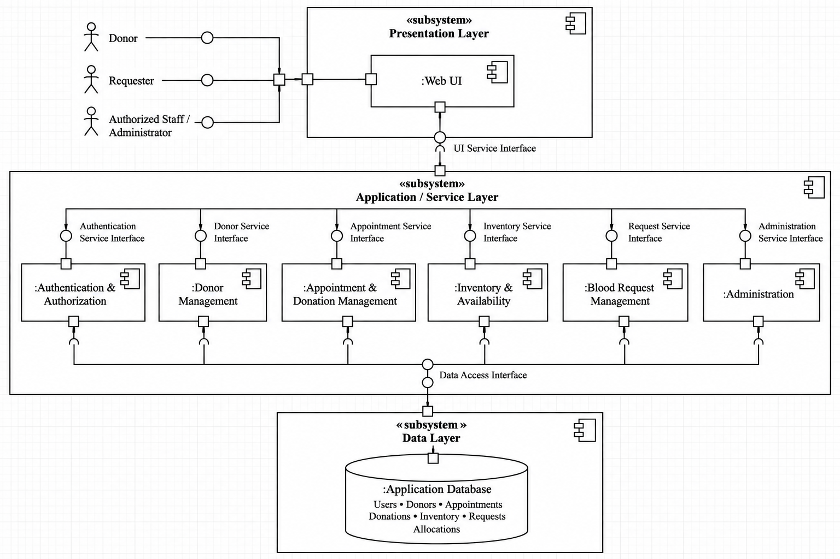

3.4 Component Descriptions
Component | Responsibility
Web UI | Displays role-appropriate pages and forms, collects input, and presents validation and workflow status.
Authentication & Authorization | Handles login/logout and enforces role permissions for protected operations.
Donor Management | Supports donor registration, profile viewing/updating, eligibility information and donation history.
Appointment & Donation Management | Supports appointment booking, viewing, rescheduling/cancellation, staff management and recording completed donations.
Inventory & Availability | Maintains blood group/type quantities and statuses, answers availability queries, and enforces allocation limits.
Blood Request Management | Stores requester submissions, tracks request status and supports authorized review and allocation workflows.
Administration | Allows authorized administrators to view/manage users, roles and account activation.
Application Database | Persists user, donor, appointment, donation, inventory and request records and their relationships.

3.5 Chosen Architecture Pattern and Rationale
The proposed pattern is a modular layered web architecture: a presentation layer for UI, an application/service layer for use cases and workflow rules, and a persistence layer for stored records. Functional modules remain logically separated while sharing a single application deployment and database for the current mini-project.
This choice separates UI, business rules and data access; supports unit and integration testing; and is manageable for a four-member team and the project timeline. Independently deployed microservices would add deployment and coordination overhead that is not currently justified by the SRS scope.

3.6 Technology Stack & Data Stores
The Blood Donation Management System will be developed as a web-based application using a modular, layered architecture. The selected technology stack prioritizes maintainability, data consistency, security, ease of development, and compatibility with the project’s short implementation timeline.
Frontend: React.js with Vite will be used to develop the user interface. React’s component-based structure will support reusable pages and interface elements for donors, hospital/requester users, blood bank staff, and administrators. Vite will provide a lightweight development and build environment.
Backend: Node.js with Express.js will implement the server-side application logic and RESTful APIs. The backend will handle authentication, role-based authorization, donor management, appointment scheduling, donation recording, inventory updates, blood requests, and administrative operations. Business rules will be enforced on the server rather than relying only on frontend validation.
Database: PostgreSQL will be used as the primary relational database. It is suitable for storing related entities such as users, donor profiles, appointments, donation records, blood inventory, and blood requests. Primary keys, foreign keys, unique constraints, transactions, and appropriate validation will help maintain referential integrity and prevent inconsistent inventory updates.
Database Access: Prisma ORM will be used to access PostgreSQL from the backend. It will provide a structured data-access layer, schema definitions, database migrations, and type-safe queries. Database operations involving donation acceptance, request allocation, and inventory changes will use transactions where required to maintain consistency.
Authentication and Security: Passwords will be stored using bcrypt hashing and will never be stored as plaintext. Express middleware will enforce authentication and role-based access control for protected routes and operations. The application will use secure, HTTP-only cookies for session handling, input validation, parameterized database operations, and HTTPS in deployment. Sensitive information will be restricted according to user roles.
Testing: Vitest and React Testing Library will be used for frontend unit and component tests. Jest and Supertest will be used for backend unit and API integration tests. Tests will cover authentication, permissions, donor workflows, appointment management, inventory updates, request approval, and allocation rules.
Version Control and Continuous Integration: GitHub will be used for source-code management, issues, pull requests, code reviews, and project coordination. GitHub Actions will run the configured automated checks and test suites when code is pushed or a pull request is created.
Data Stores: PostgreSQL will be the system’s persistent data store. The application will not require a separate NoSQL database, distributed cache, or message broker for the initial version. Blood inventory quantities and their associated records will be maintained in PostgreSQL to support transactional updates and consistency.
Deployment: The frontend and backend will be deployed as separate application components, with the backend connecting to a PostgreSQL instance. Environment variables will hold deployment configuration and database connection details; secrets will not be committed to the GitHub repository. Development, testing, and production configuration will be kept separate.
This technology stack provides a practical foundation for implementing the system within the planned sprints while supporting modular development, automated testing, secure access, and reliable management of blood inventory and requests.

3.7 Risks & Mitigations
Risk | Mitigation
Integration between modules is delayed. | Agree module responsibilities and interfaces early; integrate incrementally through reviewed GitHub pull requests.
Inventory can be over-allocated or updated more than once. | Centralize allocation rules; use transactional/atomic persistence where supported; test insufficient-stock and duplicate-processing scenarios.
Authorization is applied only in the UI. | Enforce permissions in service operations and test unauthorized direct requests where applicable.
Performance/concurrency acceptance thresholds are not yet defined. | Agree NFR-001 and NFR-002 targets before performance acceptance testing.
Requirement or identifier changes break traceability. | Use SRS Version 1.0 as the baseline and update SAD, test mappings and RTM after approved changes.

3.8 Traceability to Requirements
SRS requirement(s) | Design component(s) / responsibility
FR-001–FR-006 | Authentication & Authorization; Web UI.
FR-007–FR-013 | Donor Management.
FR-014–FR-021 | Appointment & Donation Management; Inventory & Availability for accepted donation updates.
FR-022–FR-028 | Inventory & Availability; allocation constraints and stock consistency.
FR-029–FR-037 | Blood Request Management; Inventory & Availability for approved allocation.
FR-038–FR-040 | Administration; Authentication & Authorization.
NFR-003, NFR-011–NFR-012 | Persistence layer, consistency checks, atomic updates and duplicate-processing protection.
NFR-004–NFR-009; SR-001–SR-005; SO-001–SO-002 | Authentication, authorization, password handling, data protection and HTTPS.
BR-001–BR-012; AC-001–AC-010 | Service-layer business rules and acceptance checks; see Test Plan TC-001–TC-032.

3.9 Security Architecture
The design addresses the security objectives SO-001–SO-002 and requirements SR-001–SR-005. Protected operations require authentication; role permissions and requester ownership are checked server-side; passwords are securely hashed; sensitive donor/request information is limited to authorized roles; and deployed authenticated communication uses HTTPS.
Input validation, safe error messages and controlled inventory/request state transitions help reduce malformed-input, tampering and duplicate-processing risks. Logs must not contain passwords or unnecessary sensitive information. Security tests in the Test Plan include role enforcement, session/logout checks, data exposure checks and HTTPS verification. This document does not claim a formal compliance certification or completed penetration test.

4. Design

4.1 Design Overview
The presentation layer receives user actions and shows results. The service layer authenticates/authorizes operations, validates inputs and applies workflow/business rules. The persistence layer saves records and maintains relationships. The key workflows are donor appointment management and the request review/allocation process. Exact implementation details should follow the approved SRS.

4.2 UML Sequence Diagrams
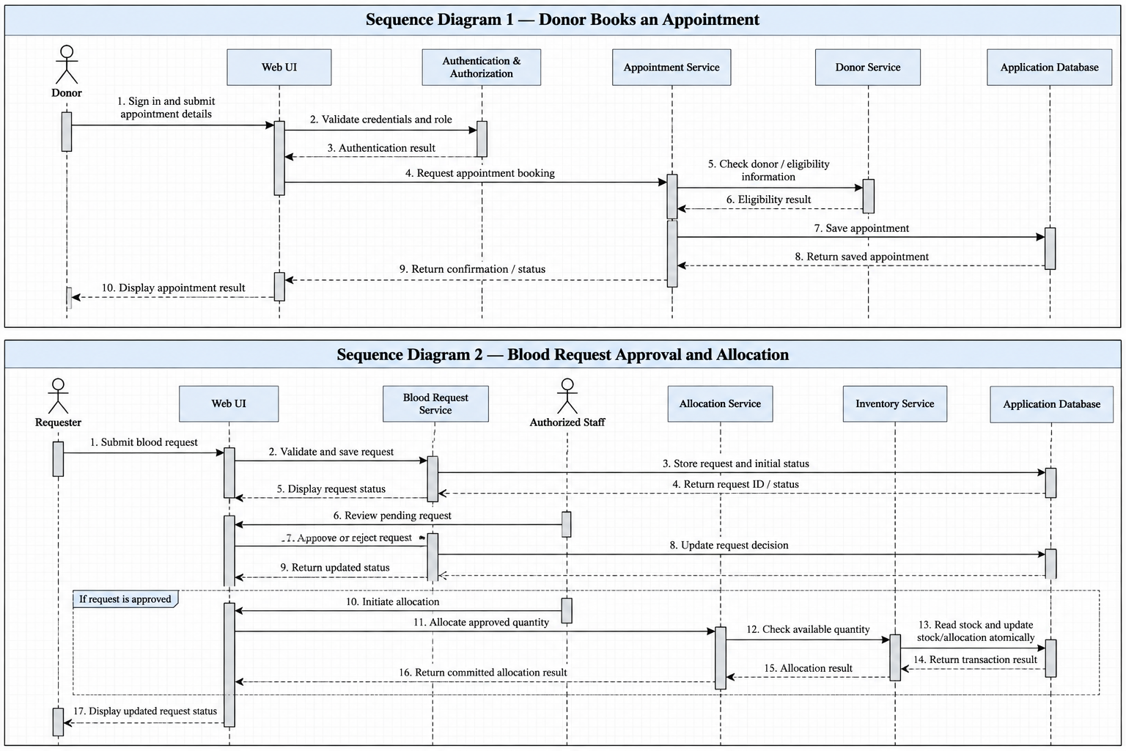

4.3 API Design
The system will expose RESTful APIs through the Node.js and Express.js backend. The React frontend will communicate with these APIs over HTTPS in the deployed environment. The backend will validate requests, authenticate users, enforce role-based permissions, execute business logic, and interact with PostgreSQL through Prisma ORM.
All endpoints will use the common prefix /api/v1. JSON will be used for request and response bodies. Protected endpoints will require an authenticated session, and authorization will be checked on the server for every operation.

4.3.1 Authentication and User Management Interface
Purpose: To register users, authenticate accounts, retrieve the current user's information, and terminate authenticated sessions.
Method | Endpoint | Description | Access
POST | /api/v1/auth/register | Create a user account and donor profile where applicable | Public
POST | /api/v1/auth/login | Validate credentials and establish an authenticated session | Public
GET | /api/v1/auth/me | Retrieve the current user's profile and role | Authenticated users
POST | /api/v1/auth/logout | Terminate the current session | Authenticated users
GET | /api/v1/admin/users | Retrieve system users | Administrator
PATCH | /api/v1/admin/users/:userId/status | Activate or deactivate a user account | Administrator
PATCH | /api/v1/admin/users/:userId/role | Update a user's permitted role | Administrator
Example — Login
Request:
{
"email": "donor@example.com",
"password": "example-password"
}
Successful response (200 OK):
{
"message": "Login successful",
"user": {
"id": "user-123",
"role": "DONOR"
}
}
The actual session will be established using a secure HTTP-only cookie. The response body will not contain the password or session secret.
Expected errors include 400 Bad Request for invalid input, 401 Unauthorized for invalid credentials, 403 Forbidden for insufficient permissions, and 409 Conflict when a registration conflicts with an existing account.

4.3.2 Donor Management Interface
Purpose: To maintain donor profiles, display eligibility information, and retrieve donation history.
Method | Endpoint | Description | Access
POST | /api/v1/donors | Create a donor profile when not created during registration | Authenticated donor, subject to validation
GET | /api/v1/donors/me | Retrieve the current donor's profile | Donor
PATCH | /api/v1/donors/me | Update permitted profile fields | Donor
GET | /api/v1/donors/:donorId | Retrieve donor details for operational use | Authorized staff
GET | /api/v1/donors/:donorId/donations | Retrieve a donor's donation history | The donor concerned or authorized staff
The backend will validate submitted fields and restrict profile updates to permitted attributes. Donors will not be allowed to retrieve other donors' private information by changing an identifier in a request.

4.3.3 Appointment and Donation Management Interface
Purpose: To manage donation appointments and record completed donations.
Method | Endpoint | Description | Access
POST | /api/v1/appointments | Book a donation appointment | Eligible donor
GET | /api/v1/appointments/me | Retrieve the current donor's appointments | Donor
PATCH | /api/v1/appointments/:appointmentId | Reschedule an appointment | Donor who owns the appointment, subject to rules
PATCH | /api/v1/appointments/:appointmentId/cancel | Cancel an appointment | Donor who owns the appointment or authorized staff
GET | /api/v1/appointments | View appointments for operational management | Authorized staff
PATCH | /api/v1/appointments/:appointmentId/status | Update an appointment's operational status | Authorized staff
POST | /api/v1/donations | Record a completed donation against a donor and appointment | Authorized staff
Example — Record a completed donation
Request:
{
"donorId": "donor-123",
"appointmentId": "appointment-456",
"bloodGroup": "O+",
"units": 1
}
Successful response (201 Created):
{
"message": "Donation recorded successfully",
"donation": {
"id": "donation-789",
"status": "ACCEPTED",
"units": 1
}
}
The example illustrates the proposed contract; actual fields and permitted values will be validated against the implemented data model. A completed donation will update inventory only when it is accepted under the system's donation rules. The donation record and associated inventory update will be handled transactionally to avoid partial updates.

4.3.4 Blood Inventory and Availability Interface
Purpose: To maintain blood inventory, display available quantities, and support safe allocation of blood units.
Method | Endpoint | Description | Access
GET | /api/v1/inventory | Retrieve inventory quantities by blood group and type | Authorized users
GET | /api/v1/inventory/availability | Check availability for a specified blood group and quantity | Authorized users
POST | /api/v1/inventory/adjustments | Record an authorized inventory adjustment | Authorized staff
GET | /api/v1/inventory/transactions | Retrieve inventory movement records | Authorized staff
The availability endpoint will accept query parameters such as bloodGroup and units. The backend will validate the requested values and return the relevant available quantity.
Example request:
GET /api/v1/inventory/availability?bloodGroup=O%2B&units=2
Example response (200 OK):
{
"bloodGroup": "O+",
"requestedUnits": 2,
"availableUnits": 5,
"available": true
}
Inventory changes must not result in negative stock. Any operation that changes stock will use a database transaction and appropriate consistency checks. The system will not allow allocation beyond the available quantity.

4.3.5 Blood Request and Allocation Interface
Purpose: To allow requesters to submit and track blood requests and authorized staff to review requests and allocate available units.
Method | Endpoint | Description | Access
POST | /api/v1/requests | Submit a blood request | Authenticated requester
GET | /api/v1/requests/me | Retrieve requests submitted by the current requester | Requester
GET | /api/v1/requests | Retrieve requests requiring operational processing | Authorized staff
GET | /api/v1/requests/:requestId | Retrieve an individual request | Its requester or authorized staff
PATCH | /api/v1/requests/:requestId/decision | Approve or reject a request | Authorized staff
POST | /api/v1/requests/:requestId/allocations | Allocate available units to an approved request | Authorized staff
Example — Submit a blood request
Request:
{
"bloodGroup": "O+",
"unitsRequested": 2,
"reason": "Hospital blood requirement"
}
Successful response (201 Created):
{
"message": "Blood request submitted successfully",
"request": {
"id": "request-101",
"status": "PENDING",
"bloodGroup": "O+",
"unitsRequested": 2
}
}
The server will associate the request with the authenticated requester rather than trusting a requester ID supplied by the client. A new request will be assigned the initial status PENDING. Only authorized staff can approve or reject it, and allocation will be permitted only after approval. Allocation and inventory reduction will be performed atomically so that insufficient stock or a concurrent allocation cannot produce an inconsistent inventory quantity.

4.3.6 Common Error Responses
The API will use standard HTTP status codes and a consistent JSON error structure.
Status code | Meaning | Example situation
400 Bad Request | Invalid or incomplete request data | Missing blood group or invalid quantity
401 Unauthorized | Authentication is missing or invalid | Accessing a protected endpoint without a session
403 Forbidden | The user lacks permission | A donor attempts an administrative operation
404 Not Found | The requested resource does not exist or is not accessible | Invalid request identifier
409 Conflict | The operation conflicts with current data or state | Duplicate registration or an invalid state transition
422 Unprocessable Content | The request is well-formed but violates a business rule | Attempting allocation for a request that has not been approved
500 Internal Server Error | Unexpected server-side failure | An unhandled internal error
Example error response:
{
"error": {
"code": "INSUFFICIENT_INVENTORY",
"message": "The requested quantity is not available."
}
}
The API will not expose stack traces, passwords, session secrets, database credentials, or other sensitive internal information in error responses. Detailed diagnostic information will be restricted to server-side logs.

4.3.7 API Security and Implementation Rules
- All protected endpoints will require a valid authenticated session.
- Role-based authorization will be enforced in Express middleware and in the relevant business operations, including when requests are sent directly to the API.
- Request bodies, path parameters, and query parameters will be validated before processing.
- Passwords will be stored using bcrypt hashing. Secure, HTTP-only cookies will be used for session handling.
- Database queries will use Prisma ORM, with appropriate constraints and transactions for operations affecting related records or inventory.
- The server will derive the identity of the current user from the authenticated session, not from untrusted client-supplied identifiers.
- API tests will cover successful requests, invalid input, unauthorized access, insufficient inventory, invalid request states, and duplicate or concurrent operations.
These interfaces define the planned backend contract for implementation. They support the SRS functional requirements for authentication and administration (FR-001–FR-006 and FR-038–FR-040), donor management (FR-007–FR-013), appointments and donations (FR-014–FR-021), inventory (FR-022–FR-028), and blood requests and allocation (FR-029–FR-037). The corresponding API behaviors will be verified using the test cases in Test Plan Version 1.0.

Interface A — Account authentication
Field | Design
Operation | Authenticate account / login
Method | POST if exposed as an HTTP API; otherwise use the framework's session mechanism.
Request | Account identifier and password.
Success response | Authenticated session/token and role-appropriate result; never return password data.
Errors | Invalid credentials, invalid/missing fields, inactive account or unauthorized access.

Interface B — Submit blood request
Field | Design
Operation | Create blood request
Method | POST if exposed as an HTTP API.
Request | Blood group/type, quantity and other fields finalized in the SRS/UI.
Success response | Request identifier and initial status.
Errors | Missing/invalid fields, unauthenticated user or unauthorized requester.

Interface C — Review and allocate request
Field | Design
Operation | Approve/reject a request and allocate an approved quantity.
Method | Application service operation or API route to be finalized.
Request | Request identifier, decision and, for allocation, quantity.
Success response | Updated request status and allocation result.
Errors | Insufficient stock, request not approved, invalid quantity or unauthorized role.

4.4 Error Handling, Logging & Monitoring
Validation errors should identify the field or action requiring correction without revealing internal implementation details. Authorization failures must not return protected records. Inventory/allocation operations should fail safely when the request is invalid or stock is insufficient. Avoid logging passwords and unnecessary sensitive information.
Where supported, monitor application errors, failed authorization attempts, inventory/allocation failures, automated test results and CI failures. Monitoring capabilities depend on the final implementation and deployment environment.

4.5 UX Design
The interface should provide role-appropriate navigation, clear form validation and understandable appointment/request statuses, consistent with SRS NFR-014–NFR-016. Donors should see their own profile and history; requesters should see their own requests; staff should see operational functions; and administration functions should be restricted to authorized administrators.

4.6 Open Issues & Next Steps
- Confirm the implementation language/framework, database, deployment environment, supported browsers and test framework.
- Agree measurable response-time and concurrency targets for SRS NFR-001 and NFR-002.
- Finalize API routes, request/response schemas and validation rules against the implementation.
- Review the diagrams against the final component boundaries and update them when the architecture is implemented.
- Confirm whether any additional audit-log requirements are needed; do not assume a broader audit scope without an approved requirement.
- Keep SRS, SAD, Test Plan, RTM and GitHub backlog consistent as changes are approved.

5. Appendices

5.1 Glossary
SRS — Software Requirements Specification; STP — Software Test Plan; FR — Functional Requirement; NFR — Non-Functional Requirement; BR — Business Rule; SR — Security Requirement; AC — Acceptance Criterion; RTM — Requirements Traceability Matrix; RBAC — Role-Based Access Control; API — Application Programming Interface; HTTPS — Hypertext Transfer Protocol Secure; ADR — Architecture Decision Record; TBD — To Be Decided.

5.2 References
- Blood Donation Management System — SRS Version 1.0, dated 11-10-2026.
- Blood Donation Management System — Software Test Plan Version 1.0, dated 11-10-2026.
- Project backlog and approved GitHub issues/pull requests.

5.3 Tools
The following tools and technologies will be used during the design, development, testing, and maintenance of the Blood Donation Management System.
Tool | Purpose
Visual Studio Code | Primary code editor for frontend and backend development.
Git | Local version control and management of code changes.
GitHub | Remote repository hosting, issue tracking, pull requests, code reviews, and project coordination.
GitHub Actions | Continuous integration for running automated checks and tests on pushes and pull requests.
React with Vite | Development and local execution of the frontend user interface.
Node.js and Express.js | Implementation and execution of backend services and RESTful APIs.
PostgreSQL | Storage and management of relational application data, including users, donors, appointments, donations, inventory, and blood requests.
Prisma ORM | Database schema management, migrations, and backend database access.
Postman | Manual testing and verification of REST API requests, responses, and error handling.
Vitest and React Testing Library | Frontend unit and component testing.
Jest and Supertest | Backend unit and API integration testing.
PlantUML | Creation of UML component and sequence diagrams for architectural and design documentation.
Draw.io (diagrams.net) | Preparation and editing of architecture diagrams and other supporting design diagrams.
Microsoft Word | Preparation and maintenance of the SRS, Software Architecture and Design Specification, and Test Plan documents.
PDF export tools | Generation of PDF versions of project documentation for submission and review.
These tools support the team's layered development approach, collaborative GitHub workflow, API-based integration, automated testing, and documentation requirements. The team will maintain the selected technology stack and tool configuration consistently across the design documents and implementation.

