Software Requirements Specification (SRS)
Project: Event Management System (EMS)
Version: 2.0
Authors: Varun Rao (PES1UG24CS520), Thanishq Raam Patil (PES1UG24CS502), Vishruta (PES1UG24CS538), Nithin Kumar M (PES1UG25CS829)
Date: 10-11-2026
Status: Final (end of Sprint 2)
Course: UE24CS341A Software Engineering, PES University. Group 7 (to confirm)

Revision history
Version | Date | Author | Change summary | Approval
1.0 | 11-10-2026 | Team | Initial SRS with requirements, security section and use case diagrams
2.0 | 10-11-2026 | Team | Final version after Sprint 2: requirements unchanged; traceability matrix completed with design, modules, test cases and test status; implementation deviations listed in section 8.1

Approvals
Role | Name | Signature / Email | Date
Course faculty
Team (feature owners) | Varun Rao, Thanishq Raam Patil, Vishruta, Nithin Kumar M |  | 10-11-2026

Table of Contents
1. Introduction
2. Overall description
3. External interface requirements
4. System features (detailed)
5. Non-functional requirements (detailed)
5.1 Security
6. Quality attributes and acceptance tests
7. System models and diagrams
8. Requirements Traceability Matrix (RTM)

1. Introduction

1.1 Purpose
This document is the Software Requirements Specification (SRS) for the Event Management System (EMS). It defines the functional and non-functional requirements, external interfaces, security requirements and verification criteria of the system. It is the baseline for the architecture and design specification, the test plan, the project plan and the implementation.

1.2 Scope
EMS is a web application that lets organizers create and manage events and lets attendees discover events and register for them.
In scope:
- User accounts with role-based access (Attendee, Organizer, Admin)
- Event creation, editing, publishing, cancellation, categorization, search and filtering
- Event registration, waitlisting, cancellation and ticket generation
- Attendance check-in, email and in-app notifications, event reports and CSV export
- Administrative user management and a platform dashboard
Out of scope:
- Online payments and paid ticketing
- Venue booking and seat maps
- Native mobile applications
- Integration with third-party calendars or social networks

1.3 Audience
Developers, QA engineers, project guides and evaluators, and the maintenance team.

1.4 Definitions, Acronyms and Abbreviations
Term | Meaning
EMS | Event Management System
SRS / SAD / STP / RTM | Software Requirements Specification / Software Architecture and Design Specification / Software Test Plan / Requirements Traceability Matrix
RBAC | Role-Based Access Control
JWT | JSON Web Token, used for session authentication
API / REST | Application Programming Interface / Representational State Transfer
HTTPS / TLS | Hypertext Transfer Protocol Secure / Transport Layer Security
SMTP | Simple Mail Transfer Protocol, used for sending email
QR code | Quick Response code, a 2D barcode that encodes a ticket ID
CSV | Comma-Separated Values file
FIFO | First In, First Out
Waitlist | Ordered queue of attendees waiting for a seat in a full event

2. Overall Description

2.1 Product Perspective
EMS is a standalone client-server web application. A React.js single-page frontend communicates with a Node.js/Express REST API, which stores data in a PostgreSQL database and sends email through an external SMTP service.

2.2 Major Product Functions
- F1 Authentication and role management: account registration, login, logout, role-based access, profile management, user administration
- F2 Event creation and management: create, edit, publish, cancel, categorize, browse, search and filter events
- F3 Event registration and ticketing: register, waitlist, cancel, automatic waitlist promotion, ticket with QR code, attendee lists
- F4 Check-in, notifications and reports: ticket check-in, email and in-app notifications, event reports, CSV export, admin dashboard

2.3 User Roles and Characteristics
Role | Description | Characteristics
Visitor | Unauthenticated user | Can browse and search published events and create an account
Attendee | Registered user who attends events | Basic web skills, expects quick registration and a clear confirmation
Organizer | Registered user who runs events | Moderate skills, needs control over event details, capacity and attendance data
Admin | Platform administrator | Manages users, roles and categories, monitors platform activity
Email Service | External system (secondary actor) | Delivers notification emails on behalf of EMS

2.4 Operating Environment
- Client: latest two versions of Google Chrome, Mozilla Firefox and Microsoft Edge, on desktop and mobile screens from 360 px to 1920 px width
- Server: Node.js LTS on Linux, packaged with Docker
- Database: PostgreSQL

2.5 Constraints
- Technology stack: React.js, Node.js with Express, PostgreSQL
- Development follows Agile with GitHub Projects, GitHub Actions for CI and SonarQube for static analysis
- No payment processing, so every event is free to register for
- The project must be completed within the academic semester by a team of four

2.6 Assumptions and Dependencies
- Users have an internet connection and a valid email address
- An SMTP service is available for notification emails
- All event times are handled in a single configured time zone
- A device camera is optional. Check-in also works by typing the ticket ID.

2.7 Requirement ID Conventions
Prefix | Meaning | Range in use
EVT-F-### | Functional requirement | F1: 001-007, F2: 010-016, F3: 020-027, F4: 030-037
EVT-NF-### | Non-functional requirement | 001-006
EVT-SR-### | Security requirement | 001-007

3. External Interface Requirements

3.1 User Interfaces
- Responsive web interface with a navigation bar that depends on the user role
- Pages: home and event listing, event details, login and sign-up, my registrations, organizer dashboard, event form, check-in screen, reports, admin console
- Accessibility: keyboard navigation, text alternatives for images and sufficient colour contrast

3.2 Hardware Interfaces
EMS needs no special hardware. Optional: a device camera for scanning QR codes at check-in.

3.3 Software Interfaces
Interface | Purpose
EMS REST API (JSON over HTTPS) | Communication between the React frontend and the Node.js backend
PostgreSQL | Persistent storage of users, events, registrations, notifications and audit logs
SMTP email service | Sending confirmation, waitlist, cancellation and reminder emails

3.4 Communications Interfaces
- All client-server traffic uses HTTPS (TLS 1.2 or higher)
- The API exchanges JSON and authenticates requests with a JWT in the Authorization header
- Email is sent asynchronously so a slow mail server does not block user actions
The requirements meet the minimum set for the project: 30 functional requirements, 6 non-functional requirements, 3 security objectives and 7 security requirements.

4. System features (detailed)
Each requirement below includes acceptance criteria and a reference test case. IDs follow EVT-F-###. Each feature is owned end to end by one team member.

4.1 Authentication and Role Management (Feature F1)
Feature owner: Varun Rao (PES1UG24CS520)
Description: Allows visitors to create accounts and log in, enforces role-based access for Attendees, Organizers and Admins, and lets users and admins manage accounts.
Req ID | Requirement | Type | Priority | Source / Stakeholder | Acceptance Criteria / Test Case Ref | Comments / Dependencies
EVT-F-001 | The system shall allow a visitor to register an account by providing name, email, password and role (Attendee or Organizer). | Functional | High | Visitor | AC-EVT-F-001: A valid form creates the account, and an existing email is rejected with the message "Email already registered". Test: TC-AUTH-01, TC-AUTH-02 | Password must have at least 8 characters with a letter and a digit
EVT-F-002 | The system shall authenticate a user with email and password and issue a session token valid for 60 minutes. | Functional | High | All users | AC-EVT-F-002: Correct credentials return a token and open the role dashboard, and wrong credentials return an error without revealing which field was wrong. Test: TC-AUTH-03 | Depends on EVT-F-001 and EVT-SR-002
EVT-F-003 | The system shall lock an account for 15 minutes after 5 consecutive failed login attempts. | Functional | High | Security | AC-EVT-F-003: The 6th attempt within the lock period is refused even with the correct password, and login works again after 15 minutes. Test: TC-AUTH-04 | Failed attempts are recorded in the audit log (EVT-SR-006)
EVT-F-004 | The system shall allow a logged-in user to log out, which invalidates the session. | Functional | Medium | All users | AC-EVT-F-004: After logout the old token is rejected with HTTP 401. Test: TC-AUTH-05
EVT-F-005 | The system shall restrict every feature to the roles permitted to use it and respond with HTTP 403 when a user lacks permission. | Functional | High | Security | AC-EVT-F-005: An Attendee calling an Organizer-only or Admin-only action receives HTTP 403 and no data change occurs. Test: TC-AUTH-06 | Applies to all features
EVT-F-006 | The system shall allow an Admin to view all users, change a user's role, and deactivate or reactivate an account. | Functional | Medium | Admin | AC-EVT-F-006: A deactivated user cannot log in, and a role change takes effect on the user's next login. Test: TC-AUTH-07 | An Admin cannot deactivate their own account
EVT-F-007 | The system shall allow a user to view and update their name and phone number and to change their password by supplying the current password. | Functional | Low | All users | AC-EVT-F-007: A correct current password allows the change, and a wrong one is rejected. Test: TC-AUTH-08

4.2 Event Creation and Management (Feature F2)
Feature owner: Thanishq Raam Patil (PES1UG24CS502)
Description: Lets organizers create, edit, publish and cancel events, lets admins maintain event categories, and lets all users browse, search and filter published events.
Req ID | Requirement | Type | Priority | Source / Stakeholder | Acceptance Criteria / Test Case Ref | Comments / Dependencies
EVT-F-010 | The system shall allow an Organizer to create an event with title, description, category, venue, start date-time, end date-time and capacity. | Functional | High | Organizer | AC-EVT-F-010: Submitting all mandatory fields saves the event with status Draft and shows it in the organizer's event list. Test: TC-EVT-01 | Requires Organizer role (EVT-F-005)
EVT-F-011 | The system shall validate event data and reject an event whose title is empty, whose start is not in the future, whose end is not after the start, or whose capacity is not a whole number from 1 to 10000. | Functional | High | Organizer | AC-EVT-F-011: Each invalid case returns a specific error message and nothing is saved. Test: TC-EVT-02, TC-EVT-03 | Also enforces EVT-SR-003
EVT-F-012 | The system shall allow an Organizer to edit only their own events, and shall refuse to reduce the capacity below the number of confirmed registrations. | Functional | High | Organizer | AC-EVT-F-012: Edits to own events are saved, a capacity below confirmed registrations is rejected, and editing another organizer's event gives HTTP 403. Test: TC-EVT-04 | Depends on F3 registration count
EVT-F-013 | The system shall allow an Organizer to publish a Draft event, after which it is visible to all users, and shall keep Draft events hidden from Attendees and Visitors. | Functional | High | Organizer | AC-EVT-F-013: A published event appears in public search, and a Draft does not. Test: TC-EVT-05
EVT-F-014 | The system shall allow an Organizer to cancel their own event, set its status to Cancelled and cancel all its registrations. | Functional | High | Organizer | AC-EVT-F-014: The event shows as Cancelled, every registration for it becomes Cancelled, and cancellation notifications are triggered (EVT-F-032). Test: TC-EVT-06 | Depends on EVT-F-032
EVT-F-015 | The system shall allow an Admin to add, rename and delete event categories, and shall refuse to delete a category that is in use. | Functional | Medium | Admin | AC-EVT-F-015: A new category is selectable on the event form, and deleting a category with events is refused with a message. Test: TC-EVT-07
EVT-F-016 | The system shall allow any user to browse published events, search by keyword in title or description, and filter by category and date range, with results paginated at 10 per page. | Functional | High | Visitor, Attendee | AC-EVT-F-016: A keyword returns only matching published events, filters combine correctly, and page 2 shows the next 10 results. Test: TC-EVT-08, TC-EVT-09 | Cancelled events are shown with a Cancelled label

4.3 Event Registration and Ticketing (Feature F3)
Feature owner: Vishruta (PES1UG24CS538)
Description: Lets attendees register for published events, joins them to a waitlist when an event is full, handles cancellations with automatic waitlist promotion, and provides tickets with QR codes.
Req ID | Requirement | Type | Priority | Source / Stakeholder | Acceptance Criteria / Test Case Ref | Comments / Dependencies
EVT-F-020 | The system shall allow a logged-in Attendee to register for a published event that has not started and has a free seat, and shall create a confirmed registration with a unique ticket ID. | Functional | High | Attendee | AC-EVT-F-020: The registration is Confirmed, the seat count drops by 1, and a unique ticket ID is shown. Registering for a Draft, Cancelled or started event is refused. Test: TC-REG-01, TC-REG-02 | Depends on EVT-F-013
EVT-F-021 | The system shall prevent an Attendee from holding more than one active registration (Confirmed or Waitlisted) for the same event. | Functional | High | Organizer | AC-EVT-F-021: A second registration attempt is rejected with the message "Already registered". Test: TC-REG-03
EVT-F-022 | The system shall add an Attendee to a first-in-first-out waitlist when the event has no free seats. | Functional | High | Attendee, Organizer | AC-EVT-F-022: The registration status is Waitlisted and the waitlist position is shown. Test: TC-REG-04
EVT-F-023 | The system shall allow an Attendee to cancel their own registration before the event starts and shall release the seat. | Functional | High | Attendee | AC-EVT-F-023: The status becomes Cancelled and the free seat count increases by 1. Cancelling after the start time is refused. Test: TC-REG-05
EVT-F-024 | The system shall automatically promote the first Waitlisted Attendee to Confirmed when a seat is released and shall notify them. | Functional | High | Attendee | AC-EVT-F-024: The first waitlisted attendee becomes Confirmed, the next one moves up, and a notification is triggered (EVT-F-032). Test: TC-REG-06 | Depends on EVT-F-032
EVT-F-025 | The system shall show an Attendee a list of their registrations with event name, date and status (Confirmed, Waitlisted, Cancelled). | Functional | Medium | Attendee | AC-EVT-F-025: The list shows only the logged-in attendee's registrations, each with the correct status. Test: TC-REG-07 | See EVT-SR-005
EVT-F-026 | The system shall provide for each Confirmed registration a ticket page showing the ticket ID, event details and a QR code that encodes the ticket ID. | Functional | Medium | Attendee | AC-EVT-F-026: Scanning the QR code returns the ticket ID shown on the page. Test: TC-REG-08 | Used by check-in (EVT-F-030)
EVT-F-027 | The system shall allow an Organizer to view the list of registrations (Confirmed, Waitlisted, Cancelled) for their own events. | Functional | Medium | Organizer | AC-EVT-F-027: The list shows attendee name, email, status and registration time, and is refused for another organizer's event. Test: TC-REG-09

4.4 Attendance Check-in, Notifications and Reports (Feature F4)
Feature owner: Nithin Kumar M (PES1UG25CS829)
Description: Lets organizers check attendees in with their tickets, sends email and in-app notifications for key events, and provides attendance reports, CSV export and an admin dashboard.
Req ID | Requirement | Type | Priority | Source / Stakeholder | Acceptance Criteria / Test Case Ref | Comments / Dependencies
EVT-F-030 | The system shall allow an Organizer to check in an attendee for their own event by scanning or entering the ticket ID, and shall record the check-in time. | Functional | High | Organizer | AC-EVT-F-030: A valid Confirmed ticket becomes Checked-in with a timestamp and the screen shows the attendee name. Test: TC-CHK-01 | Uses the ticket from EVT-F-026
EVT-F-031 | The system shall reject a check-in for a ticket that is invalid, Cancelled, Waitlisted, already used, or belongs to a different event, with a specific message for each case. | Functional | High | Organizer | AC-EVT-F-031: Each of the five cases shows its own message and no check-in is recorded. Test: TC-CHK-02, TC-CHK-03
EVT-F-032 | The system shall send an email to the attendee when their registration is confirmed, when they are promoted from the waitlist, when they cancel, and when the event is cancelled. | Functional | High | Attendee | AC-EVT-F-032: Each of the four situations sends one email with the event name and the new status. Test: TC-CHK-04 | Triggered by EVT-F-014, EVT-F-020, EVT-F-023 and EVT-F-024
EVT-F-033 | The system shall send a reminder email 24 hours before the start of an event to every Confirmed attendee. | Functional | Medium | Attendee | AC-EVT-F-033: Each Confirmed attendee gets exactly one reminder 24 hours (plus or minus 5 minutes) before the start. Test: TC-CHK-05 | Uses a scheduled job
EVT-F-034 | The system shall show each user an in-app notification list that records the notifications sent to them and lets them mark notifications as read. | Functional | Low | Attendee | AC-EVT-F-034: New notifications appear as unread and change to read when marked. Test: TC-CHK-06
EVT-F-035 | The system shall give an Organizer a report for each of their events showing counts of Confirmed, Waitlisted, Cancelled and Checked-in registrations and the attendance rate (checked-in divided by confirmed, as a percentage). | Functional | High | Organizer | AC-EVT-F-035: For 10 confirmed registrations with 8 checked in, the attendance rate shows 80%. Test: TC-CHK-07
EVT-F-036 | The system shall allow an Organizer to export the attendee list of their own event as a CSV file with name, email, status and check-in time. | Functional | Medium | Organizer | AC-EVT-F-036: The downloaded CSV opens correctly and has one row per registration with the four columns. Test: TC-CHK-08
EVT-F-037 | The system shall give an Admin a dashboard showing total users by role, total events by status and total registrations. | Functional | Low | Admin | AC-EVT-F-037: The dashboard totals match the database counts. Test: TC-CHK-09

5. Non-functional requirements (detailed)
NFRs below are measurable and tied to test plans. IDs EVT-NF-###.
Req ID | Requirement | Category | Priority | Acceptance Criteria / Measurement
EVT-NF-001 | At least 95% of API requests shall complete within 2 seconds with 100 concurrent users on the reference test environment. | Performance | High | Load test report shows the 95th percentile at or below 2 s. Test: TC-NFR-01
EVT-NF-002 | The system shall be available at least 99% of each month, measured by health-check pings every minute, excluding announced maintenance. | Reliability | Medium | Uptime report shows 99% or higher. Test: TC-NFR-02
EVT-NF-003 | A new Attendee shall be able to register for an event in no more than 3 clicks after opening its details page, and every page shall display correctly at screen widths from 360 px to 1920 px. | Usability | Medium | Usability walkthrough with 5 users and layout checks at 360 px and 1920 px. Test: TC-NFR-03
EVT-NF-004 | Under 500 simultaneous registration attempts for an event, the system shall never confirm more registrations than the event capacity. | Scalability / Correctness | High | Concurrency test finds confirmed registrations less than or equal to capacity in every run. Test: TC-NFR-04
EVT-NF-005 | The backend code shall reach at least 70% unit test line coverage and pass the static-analysis quality gate with no blocker or critical issues before each release. | Maintainability | Medium | Coverage report shows 70% or higher and the SonarQube quality gate passes. Test: TC-NFR-05
EVT-NF-006 | The web interface shall work correctly on the latest two versions of Google Chrome, Mozilla Firefox and Microsoft Edge. | Compatibility | Medium | All acceptance tests pass on each listed browser. Test: TC-NFR-06

5.1 Security

5.1.1 Security Objectives
The following security objectives apply to the whole Event Management System. The security requirements in section 5.1.2 (EVT-SR-001 to EVT-SR-007) implement them.
ID | Objective | Description | Related Requirements
SO-1 | Confidentiality | Credentials and personal data of attendees, organizers and admins are protected from unauthorized access, in storage and in transit. | EVT-SR-001, EVT-SR-004, EVT-SR-005
SO-2 | Integrity | Event, registration and attendance data can be created or changed only by authenticated users who hold the right role and own the data, and inputs cannot be used to corrupt the system. | EVT-SR-002, EVT-SR-003, EVT-SR-005
SO-3 | Accountability and Availability | Security-relevant actions are recorded so they can be traced to a user, and abuse such as brute-force or request flooding is limited so the service stays available to genuine users. | EVT-SR-006, EVT-SR-007

5.1.2 Security Requirements
Req ID | Requirement (shall...) | Type | Priority | Acceptance Criteria / Test Case Ref
EVT-SR-001 | Passwords shall be stored only as salted bcrypt hashes (cost factor 10 or higher) and shall never appear in logs or API responses. | Security | High | Database inspection shows no plaintext password, and log review finds none. Test: TC-SEC-01
EVT-SR-002 | Session tokens shall be signed JWTs that expire after 60 minutes, and expired, tampered or missing tokens shall be rejected with HTTP 401. | Security | High | A modified or expired token gets HTTP 401. Test: TC-SEC-02
EVT-SR-003 | All user input shall be validated and sanitized on the server, and database access shall use parameterized queries, to prevent SQL injection and cross-site scripting. | Security | High | Injection strings such as ' OR 1=1 -- and <script> in any field are rejected or stored harmlessly. Test: TC-SEC-03
EVT-SR-004 | All communication between the browser and the server shall use HTTPS with TLS 1.2 or higher, and plain HTTP requests shall be redirected or refused. | Security | High | A TLS scan shows no protocol below 1.2 and an HTTP request is redirected. Test: TC-SEC-04
EVT-SR-005 | The system shall enforce ownership checks so that an Attendee can access only their own registrations and tickets, and an Organizer only the registrations of their own events. | Security | High | Requesting another user's registration or ticket by ID returns HTTP 403. Test: TC-SEC-05
EVT-SR-006 | The system shall record an audit log entry with timestamp, user ID and action for every login success or failure, role change, event cancellation and check-in, and the log shall never contain passwords or tokens. | Security | High | Performing each listed action creates one correct log entry, and a log search finds no passwords or tokens. Test: TC-SEC-06
EVT-SR-007 | The system shall limit each IP address to 100 API requests per minute and to 10 login attempts per minute, and shall answer excess requests with HTTP 429. | Security | Medium | The 101st request in a minute returns HTTP 429. Test: TC-SEC-07

6. Quality Attributes and Acceptance Tests

6.1 Exit Criteria for Acceptance
- All High-priority functional requirements are implemented and verified
- No critical or high-severity defect is open
- All non-functional and security requirements meet their measured targets
- The Requirements Traceability Matrix (section 8) shows every requirement mapped to at least one passed test case

6.2 Acceptance Test Suites
Suite | Covers | Test Case Prefix
Authentication and Roles | EVT-F-001 to EVT-F-007 | TC-AUTH
Event Management | EVT-F-010 to EVT-F-016 | TC-EVT
Registration and Ticketing | EVT-F-020 to EVT-F-027 | TC-REG
Check-in, Notifications and Reports | EVT-F-030 to EVT-F-037 | TC-CHK
Non-Functional (performance, availability, usability, concurrency, maintainability, compatibility) | EVT-NF-001 to EVT-NF-006 | TC-NFR
Security | EVT-SR-001 to EVT-SR-007 | TC-SEC

6.3 Quality Attributes Summary
Attribute | Target
Performance | 95% of API requests within 2 s at 100 concurrent users
Reliability | 99% monthly availability
Usability | A new attendee registers for an event in 3 clicks or fewer after opening it
Scalability and correctness | No overbooking under 500 simultaneous registration attempts
Maintainability | At least 70% unit test line coverage and a passing static-analysis quality gate
Compatibility | Latest two versions of Chrome, Firefox and Edge

7. System models and diagrams

7.1 UML Use-Case diagram
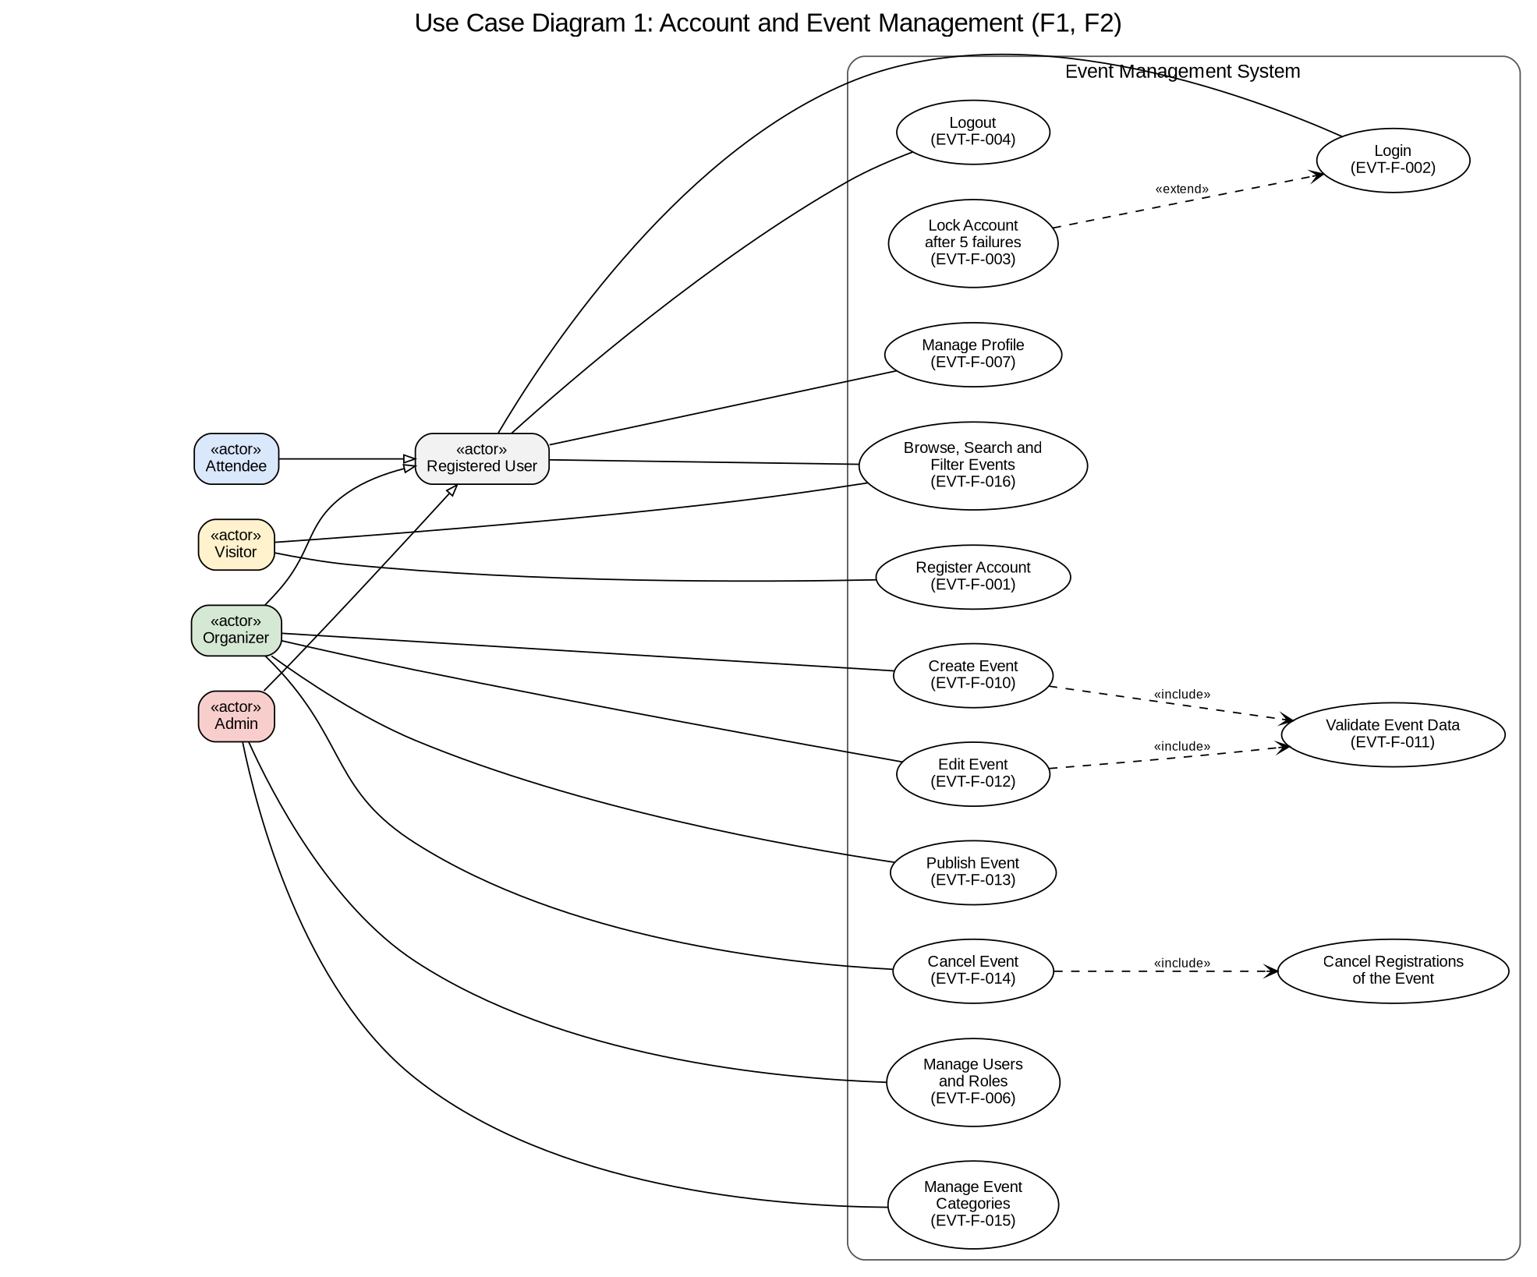
Figure 7.1: Use case diagram 1, account and event management (F1, F2)
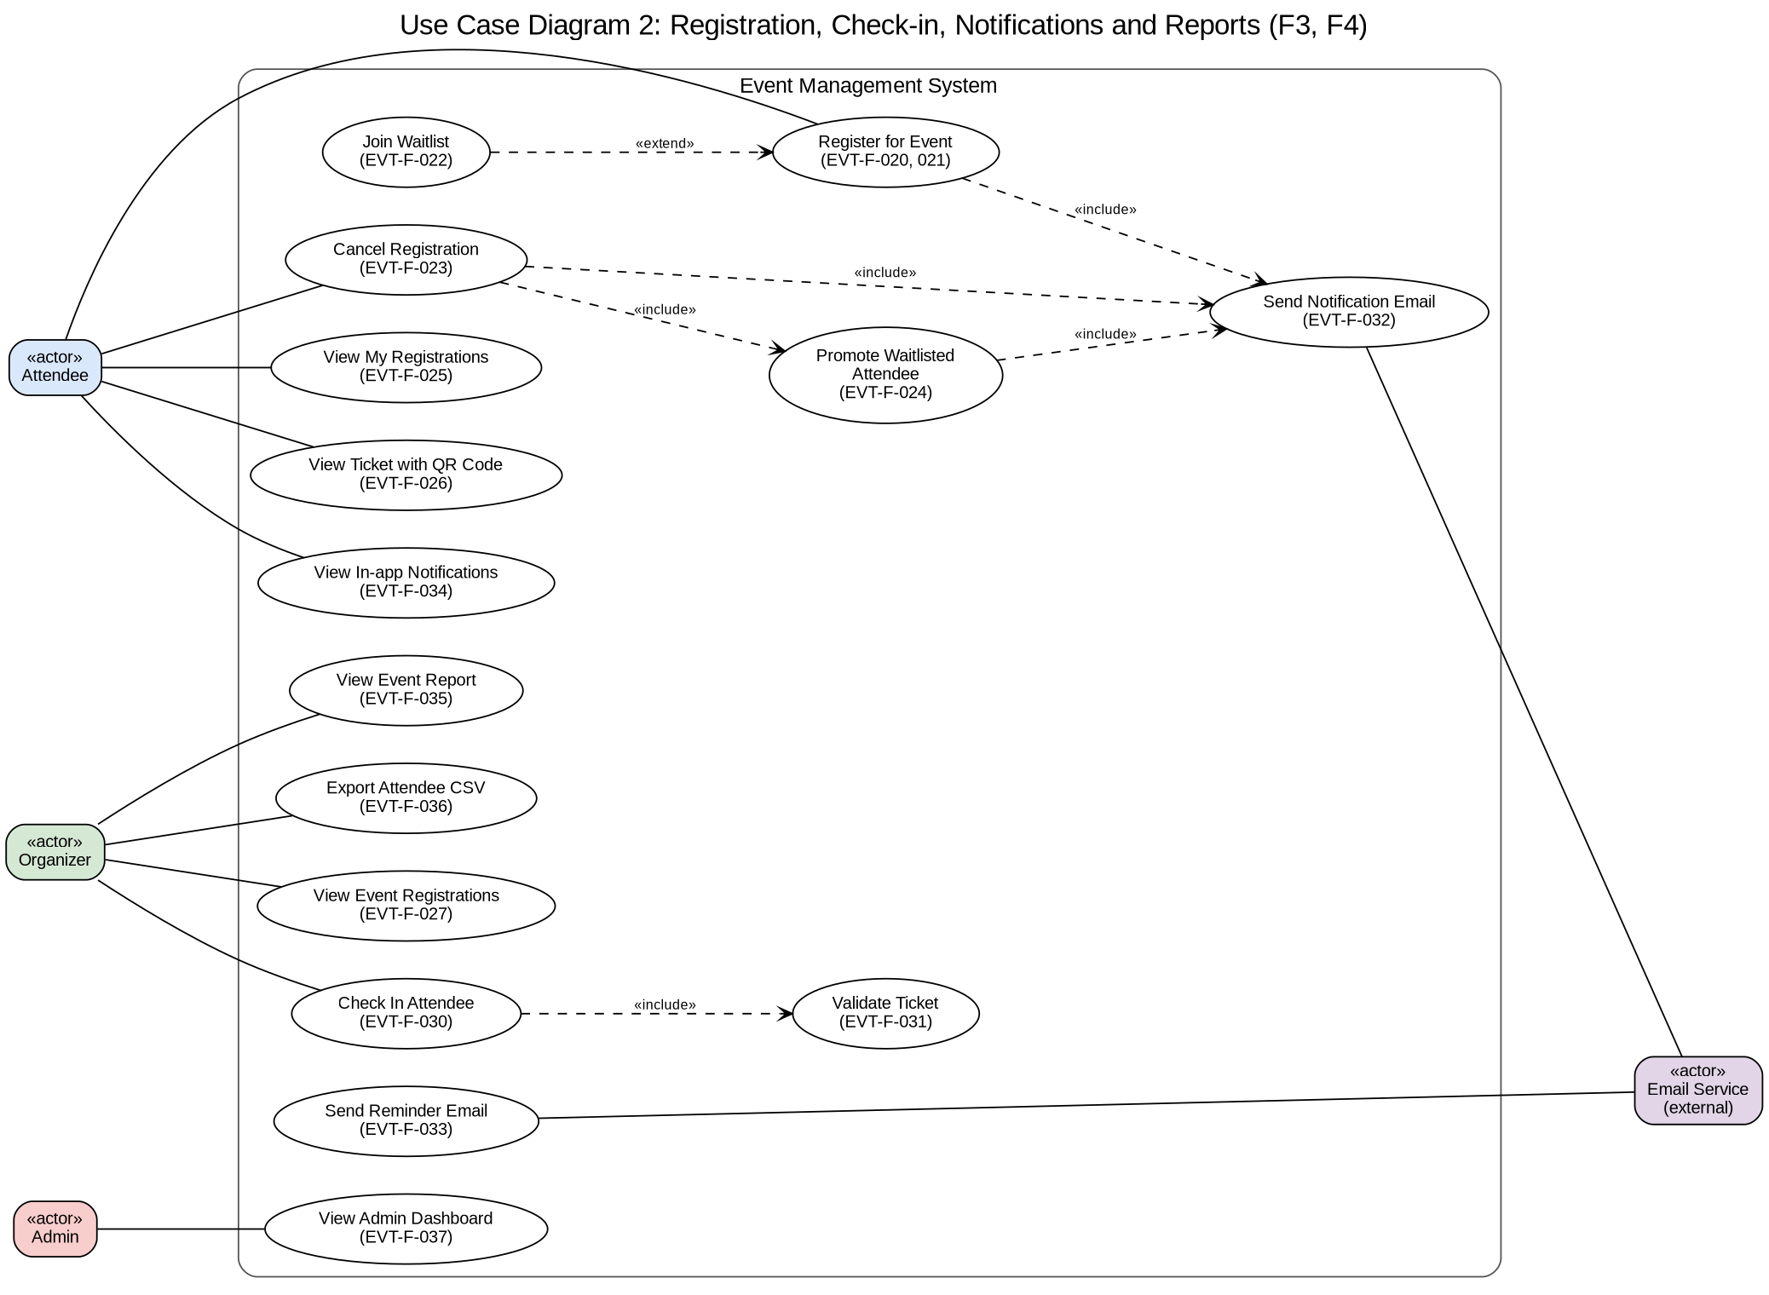
Figure 7.2: Use case diagram 2, registration, check-in and reports (F3, F4)

8. Requirements Traceability Matrix (RTM)
Each requirement is traced to its SRS section, its design in the SAD (component, API endpoint and sequence diagram), the code module that implements it, the test cases in the Test Plan, and the result of running those test cases on the final Sprint 2 build (10-11-2026).
Status: P = all test cases passed; A = passed with an accepted deviation or note (see comments); N = not fully tested (see comments).
Req ID | Requirement short | Section ref | Design spec (SAD) | Module | Test case(s) | Status (N/P/A) | Comments
EVT-F-001 | Register user account | 4.1 | Auth Module; POST /api/auth/register | backend/src/modules/auth | TC-AUTH-01, TC-AUTH-02, TC-AUTH-10 | P
EVT-F-002 | Log in with email and password | 4.1 | Auth Module; POST /api/auth/login; SD: SD-1 | backend/src/modules/auth | TC-AUTH-03, TC-AUTH-09 | P
EVT-F-003 | Lock account after repeated failed logins | 4.1 | Auth Module, Audit Logger; POST /api/auth/login; SD: SD-1 | backend/src/modules/auth | TC-AUTH-04 | P
EVT-F-004 | Log out and invalidate session | 4.1 | Auth Module, Security Middleware; POST /api/auth/logout | backend/src/modules/auth | TC-AUTH-05 | P
EVT-F-005 | Role-based access control | 4.1 | Security Middleware (RBAC); All protected endpoints | backend/src/middleware/rbac.js | TC-AUTH-06, TC-EVT-10 | P
EVT-F-006 | Admin user and role management | 4.1 | Auth Module; GET /api/users, PATCH /api/users/:id/role, PATCH /api/users/:id/status | backend/src/modules/auth | TC-AUTH-07 | P
EVT-F-007 | Profile and password management | 4.1 | Auth Module; GET and PUT /api/users/me, PUT /api/users/me/password | backend/src/modules/auth | TC-AUTH-08 | P
EVT-F-010 | Create event | 4.2 | Event Module; POST /api/events | backend/src/modules/events | TC-EVT-01, TC-EVT-10 | P
EVT-F-011 | Validate event data | 4.2 | Event Module, Security Middleware (validation); POST /api/events, PUT /api/events/:id | backend/src/modules/events | TC-EVT-02, TC-EVT-03 | P
EVT-F-012 | Edit own event | 4.2 | Event Module; PUT /api/events/:id | backend/src/modules/events | TC-EVT-04 | P
EVT-F-013 | Publish draft event | 4.2 | Event Module; POST /api/events/:id/publish | backend/src/modules/events | TC-EVT-05 | P
EVT-F-014 | Cancel event and its registrations | 4.2 | Event Module, Registration Module, Notification Module; POST /api/events/:id/cancel; SD: SD-2 | backend/src/modules/events | TC-EVT-06 | P
EVT-F-015 | Manage event categories | 4.2 | Event Module; /api/categories endpoints | backend/src/modules/events | TC-EVT-07 | P
EVT-F-016 | Browse, search and filter events | 4.2 | Event Module; GET /api/events, GET /api/events/:id | backend/src/modules/events | TC-EVT-08, TC-EVT-09 | P | TC-EVT-09 updated: only upcoming published events are listed (deviation)
EVT-F-020 | Register for an event | 4.3 | Registration Module; POST /api/events/:id/registrations; SD: SD-3 | backend/src/modules/registrations | TC-REG-01, TC-REG-02 | P
EVT-F-021 | Prevent duplicate registrations | 4.3 | Registration Module; POST /api/events/:id/registrations; SD: SD-3 | backend/src/modules/registrations | TC-REG-03 | P
EVT-F-022 | Join waitlist when event is full | 4.3 | Registration Module; POST /api/events/:id/registrations; SD: SD-3 | backend/src/modules/registrations | TC-REG-04 | P
EVT-F-023 | Cancel registration | 4.3 | Registration Module; POST /api/registrations/:id/cancel | backend/src/modules/registrations | TC-REG-05, TC-REG-10 | P
EVT-F-024 | Promote first waitlisted attendee | 4.3 | Registration Module, Notification Module; POST /api/registrations/:id/cancel | backend/src/modules/registrations | TC-REG-06 | P
EVT-F-025 | View my registrations | 4.3 | Registration Module; GET /api/registrations/me | backend/src/modules/registrations | TC-REG-07 | P
EVT-F-026 | Ticket with QR code | 4.3 | Registration Module (TicketService); GET /api/registrations/:id/ticket | backend/src/modules/registrations | TC-REG-08 | P
EVT-F-027 | Organizer views event registrations | 4.3 | Registration Module; GET /api/events/:id/registrations | backend/src/modules/registrations | TC-REG-09 | P
EVT-F-030 | Check in attendee by ticket ID | 4.4 | Check-in Module; POST /api/events/:id/checkins; SD: SD-4 | backend/src/modules/checkin | TC-CHK-01 | P
EVT-F-031 | Reject invalid tickets at check-in | 4.4 | Check-in Module; POST /api/events/:id/checkins; SD: SD-4 | backend/src/modules/checkin | TC-CHK-02, TC-CHK-03 | P
EVT-F-032 | Registration status emails | 4.4 | Notification Module; Internal calls from Event and Registration modules; SD: SD-2, SD-3 | backend/src/modules/notifications | TC-CHK-04 | P
EVT-F-033 | 24-hour reminder emails | 4.4 | Notification Module, Scheduler; Internal scheduled job | backend/src/modules/notifications (scheduler) | TC-CHK-05 | P
EVT-F-034 | In-app notifications | 4.4 | Notification Module; GET /api/notifications, PATCH /api/notifications/:id/read | backend/src/modules/notifications | TC-CHK-06 | P
EVT-F-035 | Event attendance report | 4.4 | Reporting Module; GET /api/events/:id/report | backend/src/modules/reports | TC-CHK-07, TC-CHK-10 | P
EVT-F-036 | Export attendee list as CSV | 4.4 | Reporting Module; GET /api/events/:id/attendees.csv | backend/src/modules/reports | TC-CHK-08 | P
EVT-F-037 | Admin dashboard | 4.4 | Reporting Module; GET /api/admin/dashboard | backend/src/modules/reports | TC-CHK-09 | P
EVT-NF-001 | Performance: 95% within 2 s | 5 | All modules, database indexes; All endpoints | backend/scripts/load-test.js, database indexes | TC-NFR-01 | P | Team load-test script used instead of JMeter
EVT-NF-002 | Availability: 99% monthly uptime | 5 | Deployment (Docker), health check; GET /health | health module, docker-compose.yml | TC-NFR-02 | A | Measured over a short test period; a month needs a deployed server
EVT-NF-003 | Usability and responsive layout | 5 | React SPA | frontend/src (pages, styles.css) | TC-NFR-03 | P
EVT-NF-004 | No overbooking under concurrency | 5 | Registration Module (transaction with row lock); POST /api/events/:id/registrations; SD: SD-3 | backend/src/modules/registrations | TC-NFR-04 | P
EVT-NF-005 | 70% unit test coverage and quality gate | 5 | CI pipeline, test suites, SonarQube | backend/package.json (coverage gate), CI | TC-NFR-05 | A | Coverage 86.8% lines, 78.6% branches; SonarQube replaced by ESLint and the coverage gate in CI (deviation)
EVT-NF-006 | Browser compatibility | 5 | React SPA | frontend/vite.config.js | TC-NFR-06 | N | Chrome passes; Firefox and Edge not tested
EVT-SR-001 | Passwords stored as bcrypt hashes | 5.1.2 | Auth Module (bcrypt); POST /api/auth/register, POST /api/auth/login; SD: SD-1 | backend/src/modules/auth | TC-SEC-01 | P
EVT-SR-002 | Signed JWT sessions, 60 minutes | 5.1.2 | Security Middleware (JWT); All protected endpoints; SD: SD-1 | backend/src/middleware/auth.js | TC-SEC-02 | P
EVT-SR-003 | Input validation and parameterized queries | 5.1.2 | Security Middleware (validation), Repositories; All endpoints that accept input | validation files, utils/sanitize.js | TC-SEC-03 | P
EVT-SR-004 | HTTPS with TLS 1.2 or higher | 5.1.2 | Deployment (HTTPS reverse proxy); All endpoints | frontend/nginx.conf, Dockerfile | TC-SEC-04 | P | Self-signed certificate for local use (deviation)
EVT-SR-005 | Ownership checks | 5.1.2 | Security Middleware, Registration and Event modules (ownership checks); Registration and event endpoints; SD: SD-2, SD-4 | service ownership checks | TC-SEC-05 | P
EVT-SR-006 | Audit logging of security events | 5.1.2 | Audit Logger (used by the Auth, Event and Check-in modules); Login, role change, event cancel, check-in; SD: SD-1, SD-2, SD-4 | backend/src/utils/auditLogger.js | TC-SEC-06 | P
EVT-SR-007 | Rate limiting | 5.1.2 | Security Middleware (rate limiter); All endpoints, strictest on login | backend/src/middleware/rateLimiter.js | TC-SEC-07 | P

Summary: 43 requirements, each traced to at least one test case. Status P: 40, A: 2, N: 1. No requirement failed its tests.

8.1 Implementation deviations
The requirements did not change during implementation. Where the implementation differs in detail from this SRS or from the SAD, the difference and the reason are recorded in the sprint reviews and summarized in SAD section 4.6.1. The ones that touch requirements in this SRS:
- EVT-F-016: search lists only upcoming published events; a cancelled event is not listed, its own page shows "Cancelled".
- EVT-F-033: the reminder job runs every minute and reminds each Confirmed attendee once when the event is within 24 hours, so late registrations also get a reminder.
- EVT-F-035: "Confirmed" in the report includes attendees already checked in, so the attendance rate is checked-in divided by all seat holders.
- EVT-F-012, F-014, F-027, F-030, F-035, F-036: admins may also perform these organizer actions.
- EVT-SR-004: HTTPS uses a self-signed certificate for local use (TLS 1.2 and 1.3 only).
- EVT-NF-005: the static-analysis quality gate is enforced by ESLint and the coverage threshold in CI; SonarQube was not run.
- EVT-NF-006: tested in Chrome only.
- EVT-F-032: an extra email is sent when an attendee joins the waitlist.

