Software Architecture and Design Specification
Project: Event Management System (EMS)
Version: 2.0
Authors: Varun Rao (PES1UG24CS520), Thanishq Raam Patil (PES1UG24CS502), Vishruta (PES1UG24CS538), Nithin Kumar M (PES1UG25CS829)
Date: 10-11-2026
Status: Final (end of Sprint 2)
Course: UE24CS341A Software Engineering, PES University. Group 7 (to confirm)

Revision History
Version | Date | Author | Change Summary
1.0 | 13-10-2026 | Team | Initial architecture and design: component diagram, pattern, security architecture, four sequence diagrams, API design and traceability
1.1 | 24-10-2026 | Team | Review fixes: audit logging of event cancellation, revoked_tokens table, reminder_sent_at flag, traceability corrections
2.0 | 10-11-2026 | Team | Final version after Sprint 2: implementation status, open issues updated, and the implementation deviations with reasons (section 4.6.1)

Approvals
Role | Name | Signature/Date
Course faculty
Architecture and design | Varun Rao, Thanishq Raam Patil, Vishruta, Nithin Kumar M | 10-11-2026

1. Introduction

1.1 Purpose
This document specifies the architecture and design of the Event Management System (EMS). It explains how the requirements in the SRS are realized by components, interfaces and interactions, and it is the basis for implementation and for the test plan.

1.2 Scope
The design covers the four functional features of EMS: authentication and role management (F1), event creation and management (F2), event registration and ticketing (F3), and check-in, notifications and reports (F4). Payment processing and native mobile applications are out of scope, as in the SRS.

1.3 Audience
Developers, QA engineers, security reviewers, project guides and evaluators, and the maintenance team.

1.4 Definitions
EMS, SRS, STP, RTM, SAD, REST, JWT, RBAC, STRIDE, TLS, SMTP, ADR, CI. The full list is in the appendix (section 5.1).

2. Document Overview

2.1 How to Use This Document
Section 3 describes the architecture: goals, components, the chosen pattern, the technology stack, risks, traceability and security. Section 4 describes the design: data model, UML sequence diagrams, API design, error handling and UX. Section 5 contains the appendices.

2.2 Related Documents
SRS v1.0 (requirements and security requirements), Software Test Plan v1.0 (test cases and security validation), and the Requirements Traceability Matrix.

3. Architecture

3.1 Goals and Constraints
Goals
- Correctness under concurrency: no event is ever overbooked (EVT-NF-004).
- Security: protect credentials, enforce roles and ownership, and record security events (EVT-SR-001 to EVT-SR-007).
- Performance and availability: 95% of API requests within 2 seconds, and 99% monthly availability (EVT-NF-001, EVT-NF-002).
- Maintainability: modular code that each team member can own, with at least 70% unit test coverage (EVT-NF-005).
Constraints
- Technology stack fixed to React.js, Node.js with Express and PostgreSQL.
- No payment processing, so every event is free to register for.
- Delivered by a team of four within the academic semester, using Agile with GitHub, GitHub Actions and SonarQube.
- Email delivery depends on an external SMTP service.

3.2 Stakeholders and Concerns
Stakeholder | Concerns
Attendee | Easy registration, reliable tickets and notifications, privacy of personal data
Organizer | Control of own events, accurate registration and attendance data
Admin | User and category management, platform visibility
Developers | Modularity, clear interfaces, ability to work in parallel
QA engineers | Testable components and traceability to requirements
Security reviewers | Compliance with the security requirements, defence against common attacks
Project guide and evaluators | Fit with the SRS, clear documentation, explainable design

3.3 Component (UML) Diagram
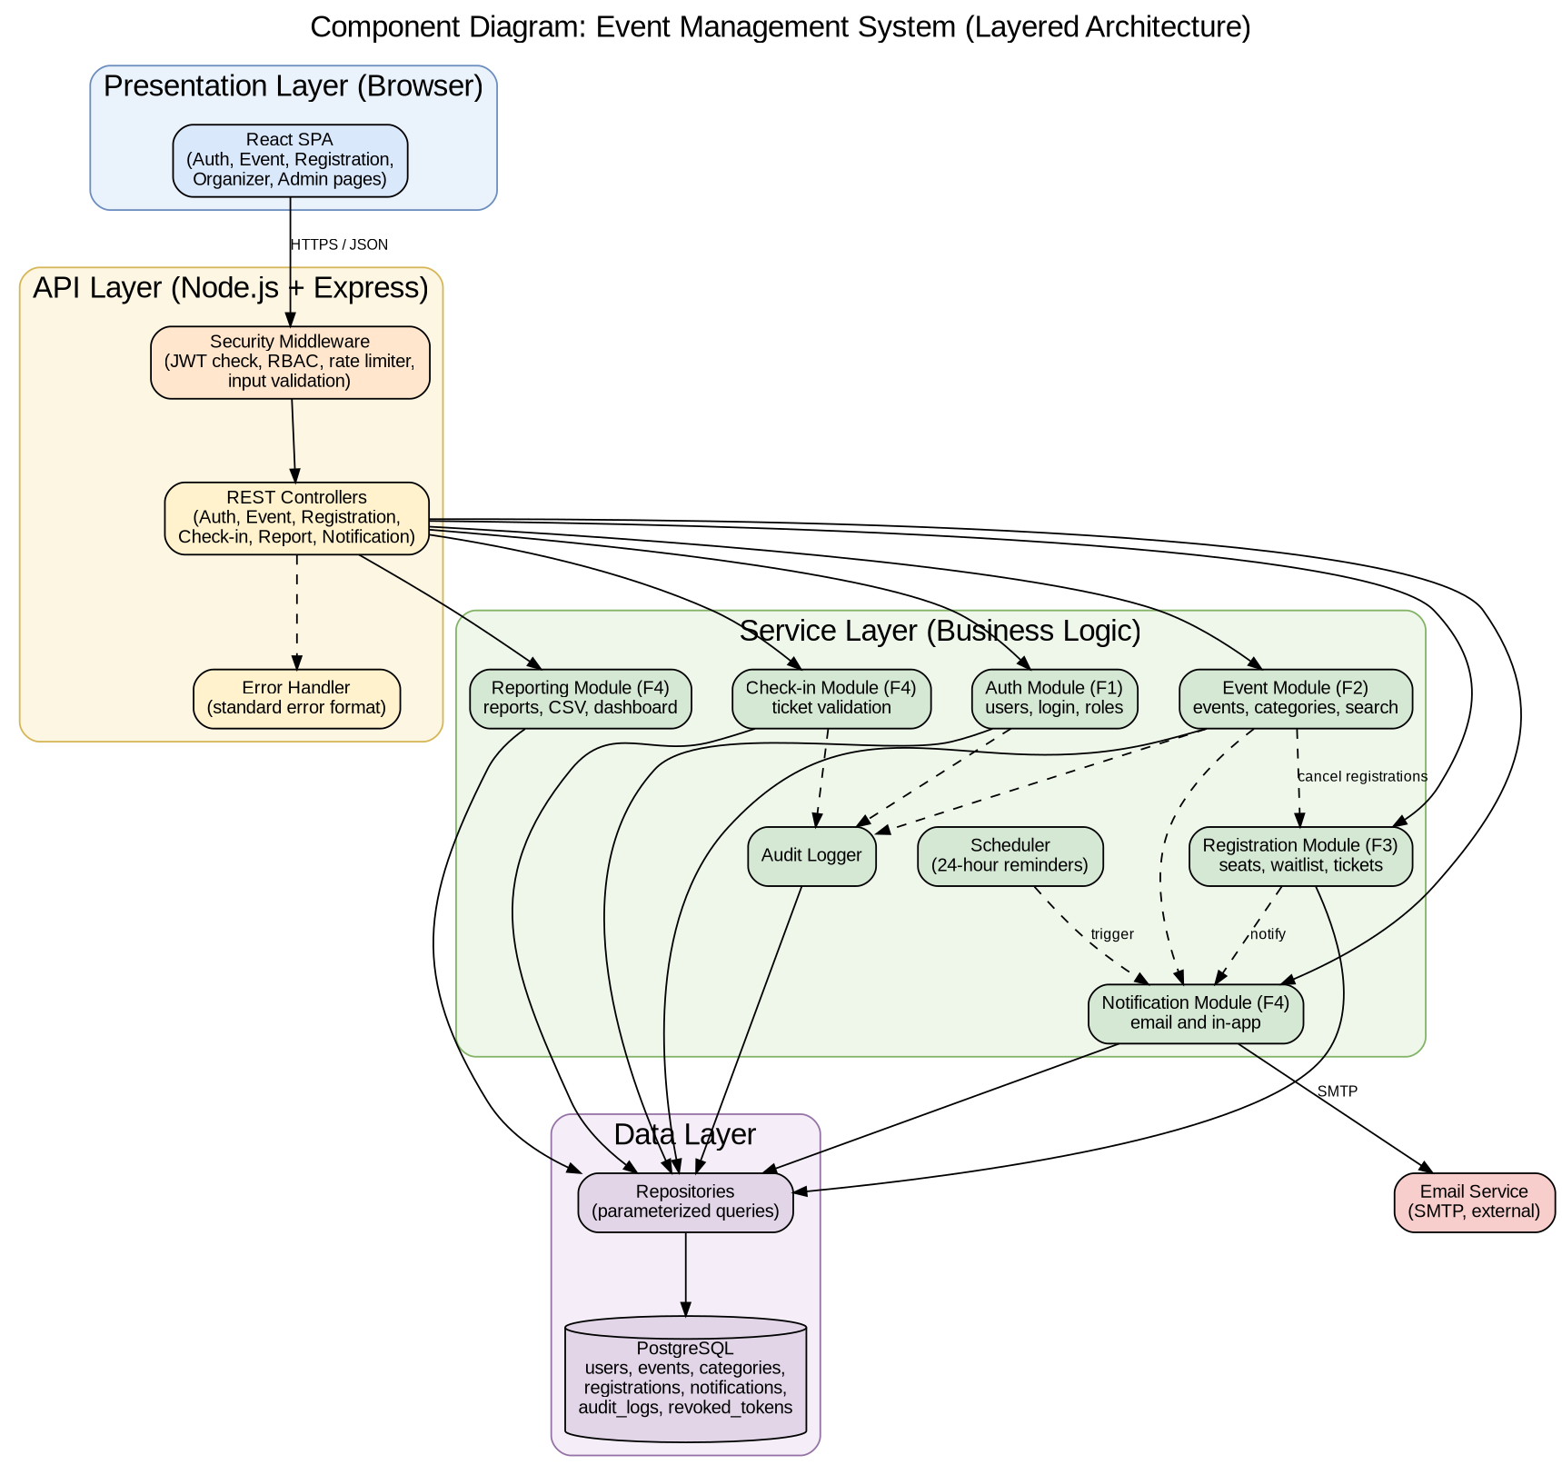
Figure 3.1: Component diagram of EMS. The editable source is docs/diagrams/component-diagram.dot.

3.4 Component Descriptions

3.4.1 Frontend and Cross-Cutting Components
Component | Responsibility
React SPA | Single-page web interface with pages for visitors, attendees, organizers and admins. It calls the REST API over HTTPS, keeps the token in memory, and adapts the navigation to the user's role.
Security Middleware | Runs before every protected endpoint. It checks the JWT (EVT-SR-002), enforces role-based access (EVT-F-005), applies rate limiting (EVT-SR-007) and validates and sanitizes input (EVT-SR-003).
REST Controllers | Thin request handlers. They read the request, call one service method and return the response. They contain no business logic.
Error Handler | Converts every error into the standard error response format (see section 4.4).
Audit Logger | Writes audit entries for logins, role changes, event cancellations and check-ins (EVT-SR-006).
Repositories | The only code that talks to the database. All queries are parameterized (EVT-SR-003).
PostgreSQL | Persistent store for users, events, categories, registrations, notifications and audit logs.
Email Service (external) | SMTP provider used by the Notification Module to deliver emails.

The descriptions of the feature modules follow in 3.4.2 (Auth, in 02-f1-authentication-design.md), 3.4.3 (Event), 3.4.4 (Registration) and 3.4.5 (Check-in, Notification and Reporting).

3.4.2 Auth Module (Component Description)
Item | Description
Purpose | Registers users, authenticates them, enforces account lockout and lets admins manage users and roles
Requirements | EVT-F-001 to EVT-F-007, EVT-SR-001, EVT-SR-002
Main classes | AuthController, AuthService, UserService, UserRepository
Depends on | Repositories (users table), Audit Logger, Security Middleware (JWT)
Key rules | Passwords are stored only as bcrypt hashes. Five consecutive failed logins lock the account for 15 minutes. Tokens are signed JWTs that expire after 60 minutes. A deactivated user cannot log in. An admin cannot deactivate their own account. Logins (success and failure) and role changes are written to the audit log. Logout stores the token ID in the revoked_tokens table until the token expires.

3.4.3 Event Module (Component Description)
Item | Description
Purpose | Lets organizers create, edit, publish and cancel events, lets admins manage categories, and provides search and filtering of published events
Requirements | EVT-F-010 to EVT-F-016, EVT-NF-002, EVT-NF-006, EVT-SR-003
Main classes | EventController, EventService, CategoryService, EventRepository, CategoryRepository
Depends on | Repositories (events and categories tables), Registration Module (cancel registrations), Notification Module, Audit Logger
Key rules | New events start as DRAFT and are visible to the public only after publishing. Only the owning organizer can edit, publish or cancel an event. Capacity cannot drop below the number of confirmed registrations. A category that is in use cannot be deleted. Cancelling an event cancels all its registrations and notifies the attendees. Every event cancellation is written to the audit log (EVT-SR-006).

Event statuses: DRAFT, PUBLISHED, CANCELLED.

3.4.4 Registration Module (Component Description)
Item | Description
Purpose | Registers attendees for events, manages the waitlist, handles cancellations with automatic promotion, and provides tickets with QR codes
Requirements | EVT-F-020 to EVT-F-027, EVT-NF-003, EVT-NF-004, EVT-SR-004, EVT-SR-005
Main classes | RegistrationController, RegistrationService, TicketService, RegistrationRepository
Depends on | Repositories (registrations and events tables), Notification Module
Key rules | A registration is CONFIRMED when a seat is free and WAITLISTED when the event is full. An attendee can have only one active registration per event. Registration and cancellation each run in one transaction with the event row locked, so confirmed registrations never exceed capacity. When a confirmed registration is cancelled, the first waitlisted attendee (first in, first out) is promoted to CONFIRMED in the same transaction and notified. Cancelling after the start time is refused.

Registration statuses: CONFIRMED, WAITLISTED, CANCELLED, CHECKED_IN.

3.4.5 Check-in, Notification and Reporting Modules (Component Description)
Component | Responsibility
Check-in Module (CheckinController, CheckinService) | Validates a ticket ID for an event and marks the registration CHECKED_IN with a timestamp. Rejects unknown tickets, tickets of another event, and cancelled, waitlisted and already used tickets, each with its own message (EVT-F-030, EVT-F-031). The organizer must own the event.
Notification Module (NotificationService, Mailer, Scheduler) | Creates in-app notifications and sends emails for confirmation, waitlist promotion, cancellation and event cancellation (EVT-F-032). A scheduled job sends one reminder 24 hours before each event to Confirmed attendees only (EVT-F-033). Emails are sent asynchronously with up to 3 retries. Users can list and mark notifications as read (EVT-F-034).
Reporting Module (ReportController, ReportService) | Builds the event report with counts of Confirmed, Waitlisted, Cancelled and Checked-in registrations and the attendance rate, which is checked-in divided by confirmed as a percentage, and shows 0% when nobody is confirmed (EVT-F-035). Exports the attendee list as CSV (EVT-F-036) and provides the admin dashboard totals (EVT-F-037).
Audit Logger | Records logins, role changes, event cancellations and check-ins with timestamp, user ID and action (EVT-SR-006).

Requirements covered: EVT-F-030 to EVT-F-037, EVT-NF-005, EVT-SR-006, EVT-SR-007.

3.5 Chosen Architecture Pattern and Rationale
Pattern: a layered (n-tier) architecture, deployed as a single backend application with a separate React frontend. The layers are Presentation, API, Service and Data. A layer may only call the layer directly below it.
Rationale
- Separation of concerns: UI, request handling, business rules and data access can be developed and tested separately.
- Parallel work: each team member owns one service module and its controller, repository and tests, which fits the one-feature-per-member rule.
- Simple deployment and debugging for a project of this size, with one Docker container for the backend.
- Transactions are easy: seat allocation and waitlist promotion run in one database transaction in the Registration Module, which prevents overbooking.
Alternatives rejected
- Microservices: rejected as too complex for four developers and one semester. They would add network calls, distributed transactions and deployment overhead without a matching benefit.
- Serverless functions: rejected because cold starts and scattered state make seat allocation and scheduled reminders harder to control.

3.6 Technology Stack and Data Stores
Concern | Choice
Frontend | React.js with React Router
Backend | Node.js with Express
Database | PostgreSQL, with tables users, events, categories, registrations, notifications, audit_logs and revoked_tokens (see section 4.1)
Authentication | JWT, bcrypt for password hashing
Email | Nodemailer with an SMTP provider (a local mail catcher such as MailHog in testing)
Scheduling | node-cron for the 24-hour reminder job
QR codes | qrcode library
Testing | Jest and Supertest, with load tests in k6 or JMeter
CI/CD and quality | GitHub Actions, SonarQube, npm audit
Packaging | Docker and Docker Compose

3.7 Risks and Mitigations
ID | Risk | Impact | Mitigation
R1 | Two attendees take the last seat at the same moment, leading to overbooking | High | Registration runs in a database transaction with the event row locked, verified by the 500-request concurrency test (TC-NFR-04)
R2 | The SMTP service is slow or down | Medium | Emails are sent asynchronously with up to 3 retries, and failures never block the user's request. In-app notifications still work.
R3 | A stolen or leaked token is misused | High | Short 60-minute expiry, HTTPS only, logout revokes the token, and the token is kept in memory in the browser
R4 | The database is lost or corrupted | High | Docker volume with regular backups, and a seed script to rebuild test data
R5 | The 2-second response target is missed as data grows | Medium | Indexes on event and registration lookups, paginated lists, and load tests in CI
R6 | Features owned by different members depend on each other (event cancel calls registration and notification) | Medium | Service interfaces are fixed in this document and each cross-module call is covered by an integration test
R7 | Delays in the semester schedule | Medium | Agile sprints with story points, with high-priority requirements built first

3.8 Traceability to Requirements
Each requirement of the SRS maps to the component that realizes it, the API endpoint that exposes it and, where one exists, the sequence diagram that shows it. SD-1 is the login diagram, SD-2 the event cancellation diagram, SD-3 the registration diagram and SD-4 the check-in diagram. The test cases for each requirement are listed in the Test Plan (section 13).
Requirement | Component(s) | API endpoint(s) | Sequence diagram
EVT-F-001 | Auth Module | POST /api/auth/register | -
EVT-F-002 | Auth Module | POST /api/auth/login | SD-1
EVT-F-003 | Auth Module, Audit Logger | POST /api/auth/login | SD-1
EVT-F-004 | Auth Module, Security Middleware | POST /api/auth/logout | -
EVT-F-005 | Security Middleware (RBAC) | All protected endpoints | - (enforced in the middleware before the controller)
EVT-F-006 | Auth Module | GET /api/users, PATCH /api/users/:id/role, PATCH /api/users/:id/status | -
EVT-F-007 | Auth Module | GET and PUT /api/users/me, PUT /api/users/me/password | -
EVT-F-010 | Event Module | POST /api/events | -
EVT-F-011 | Event Module, Security Middleware (validation) | POST /api/events, PUT /api/events/:id | -
EVT-F-012 | Event Module | PUT /api/events/:id | -
EVT-F-013 | Event Module | POST /api/events/:id/publish | -
EVT-F-014 | Event Module, Registration Module, Notification Module | POST /api/events/:id/cancel | SD-2
EVT-F-015 | Event Module | /api/categories endpoints | -
EVT-F-016 | Event Module | GET /api/events, GET /api/events/:id | -
EVT-F-020 | Registration Module | POST /api/events/:id/registrations | SD-3
EVT-F-021 | Registration Module | POST /api/events/:id/registrations | SD-3
EVT-F-022 | Registration Module | POST /api/events/:id/registrations | SD-3
EVT-F-023 | Registration Module | POST /api/registrations/:id/cancel | -
EVT-F-024 | Registration Module, Notification Module | POST /api/registrations/:id/cancel | - (see 3.4.4)
EVT-F-025 | Registration Module | GET /api/registrations/me | -
EVT-F-026 | Registration Module (TicketService) | GET /api/registrations/:id/ticket | -
EVT-F-027 | Registration Module | GET /api/events/:id/registrations | -
EVT-F-030 | Check-in Module | POST /api/events/:id/checkins | SD-4
EVT-F-031 | Check-in Module | POST /api/events/:id/checkins | SD-4
EVT-F-032 | Notification Module | Internal calls from Event and Registration modules | SD-2, SD-3
EVT-F-033 | Notification Module, Scheduler | Internal scheduled job | -
EVT-F-034 | Notification Module | GET /api/notifications, PATCH /api/notifications/:id/read | -
EVT-F-035 | Reporting Module | GET /api/events/:id/report | -
EVT-F-036 | Reporting Module | GET /api/events/:id/attendees.csv | -
EVT-F-037 | Reporting Module | GET /api/admin/dashboard | -
EVT-NF-001 | All modules, database indexes | All endpoints | -
EVT-NF-002 | Deployment (Docker), health check | GET /health | -
EVT-NF-003 | React SPA | - | -
EVT-NF-004 | Registration Module (transaction with row lock) | POST /api/events/:id/registrations | SD-3
EVT-NF-005 | CI pipeline, test suites, SonarQube | - | -
EVT-NF-006 | React SPA | - | -
EVT-SR-001 | Auth Module (bcrypt) | POST /api/auth/register, POST /api/auth/login | SD-1
EVT-SR-002 | Security Middleware (JWT) | All protected endpoints | SD-1
EVT-SR-003 | Security Middleware (validation), Repositories | All endpoints that accept input | -
EVT-SR-004 | Deployment (HTTPS reverse proxy) | All endpoints | -
EVT-SR-005 | Security Middleware, Registration and Event modules (ownership checks) | Registration and event endpoints | SD-2, SD-4
EVT-SR-006 | Audit Logger (used by the Auth, Event and Check-in modules) | Login, role change, event cancel, check-in | SD-1, SD-2, SD-4
EVT-SR-007 | Security Middleware (rate limiter) | All endpoints, strictest on login | -

3.9 Security Architecture
Section owner: Thanishq Raam Patil (PES1UG24CS502)
This section shows how the architecture meets the security objectives SO-1 (Confidentiality), SO-2 (Integrity) and SO-3 (Accountability and Availability) and the security requirements EVT-SR-001 to EVT-SR-007 of the SRS.

3.9.1 Trust Boundaries
Boundary | Between | Controls
TB-1 | Browser and API | HTTPS with TLS 1.2 or higher, JWT authentication, rate limiting, input validation
TB-2 | API and database | Parameterized queries only, a least-privilege database account, credentials in environment variables
TB-3 | API and email service | Credentials in environment variables, TLS to the SMTP server, no sensitive data in email bodies

3.9.2 Threat Modeling (STRIDE)
Threat | Example in EMS | Mitigation in the architecture | Requirement
Spoofing | Someone logs in as another user or forges a token | bcrypt password hashes, signed JWTs with a 60-minute expiry, account lockout after 5 failed logins, same error message for wrong password and unknown email | EVT-SR-001, EVT-SR-002, EVT-F-003
Tampering | Modified request data, SQL injection, altered token | Server-side validation and sanitization, parameterized queries, TLS in transit, signature check on every token | EVT-SR-003, EVT-SR-004, EVT-SR-002
Repudiation | A user denies cancelling an event or a role change | Audit log with timestamp, user ID and action for security-relevant actions | EVT-SR-006
Information disclosure | Reading another attendee's ticket, passwords in logs, stack traces in errors | Ownership checks on every object, TLS, hashed passwords, no secrets in logs, generic error messages | EVT-SR-005, EVT-SR-004, EVT-SR-001
Denial of service | Flooding login or search endpoints | Rate limiting per IP (100 requests per minute, 10 login attempts per minute) with HTTP 429, paginated lists, request size limits | EVT-SR-007
Elevation of privilege | An attendee calls an organizer or admin endpoint | Role-based access control in the Security Middleware, object-level ownership checks, role stored on the server side and re-read at login | EVT-F-005, EVT-SR-005

3.9.3 Security Controls by Layer
Layer | Controls
Presentation | The token is kept in memory (not local storage), output is escaped by React, no secrets in the frontend bundle
API | Security Middleware in a fixed order: rate limiter, JWT check, RBAC, input validation. A central error handler returns generic messages.
Service | Ownership and state checks in every service method, and transactions for registration changes
Data | Parameterized queries only, unique constraint on email, and no plaintext secrets in any table
Operations | Secrets only in environment variables, .env files git-ignored, npm audit and SonarQube in CI, HTTPS enforced by the reverse proxy

3.9.4 Data Protection
Data | Protection
Passwords | Salted bcrypt hash, cost factor 10 or higher, never returned or logged
Personal data (name, email, phone) | Shown only to the owner, to the organizer of an event the person registered for, and to admins
Tokens | Signed, short-lived, never logged
Audit logs | Contain user ID, action and timestamp only, with no passwords or tokens

4. Design

4.1 Design Overview

4.1.1 Design Principles
- Layered modules: controllers call services, services call repositories, and no layer skips another.
- One module per feature: each feature has its own controller, service, repository and tests, so team members can work in parallel.
- Thin controllers, rich services: all business rules (seat limits, ownership, state changes) live in the service layer.
- Transactions for shared state: every change to registrations (register, cancel, promote) runs in one database transaction with the event row locked, which guarantees no overbooking (EVT-NF-004).
- Fail safely: every error goes through the central error handler, and no internal detail reaches the client.

4.1.2 Code Structure
backend/
src/
config/ environment and database setup
middleware/ auth (JWT), rbac, rateLimiter, validate, errorHandler
modules/
auth/ controller, service, repository, routes
events/ controller, service, repository, routes
registrations/ controller, service, repository, routes
checkin/ controller, service, routes
reports/ controller, service, routes
notifications/ controller, service, mailer, scheduler
utils/ auditLogger, logger
tests/ unit and integration tests per module
frontend/
src/
pages/ by role: public, attendee, organizer, admin
components/ shared UI parts
services/ API client

4.1.3 Data Model
Table | Main columns | Notes
users | id, name, email (unique), password_hash, phone, role (ATTENDEE, ORGANIZER, ADMIN), active, failed_attempts, locked_until, created_at | Used by F1
categories | id, name (unique) | Used by F2
events | id, organizer_id (FK users), category_id (FK categories), title, description, venue, start_time, end_time, capacity, status (DRAFT, PUBLISHED, CANCELLED), created_at | Used by F2
registrations | id, event_id (FK), user_id (FK), status (CONFIRMED, WAITLISTED, CANCELLED, CHECKED_IN), ticket_id (unique), queue_position, created_at, checked_in_at, reminder_sent_at | reminder_sent_at makes sure the 24-hour reminder is sent only once. Unique on (event_id, user_id) for active registrations. Used by F3 and F4.
notifications | id, user_id (FK), type, message, read, created_at | Used by F4
audit_logs | id, user_id, action, details, created_at | Used by F1, F2 and F4
revoked_tokens | token_id, expires_at | Holds logged-out tokens until they expire (EVT-F-004). Used by F1.

Indexes: events(status, start_time), events(category_id), registrations(event_id, status) and registrations(ticket_id), to support the 2-second response target (EVT-NF-001).

4.2 UML Sequence Diagrams
Four sequence diagrams, one for a key flow of each feature. The editable PlantUML sources are in docs/diagrams.

4.2.1 Sequence Diagram: User Login with Account Lockout
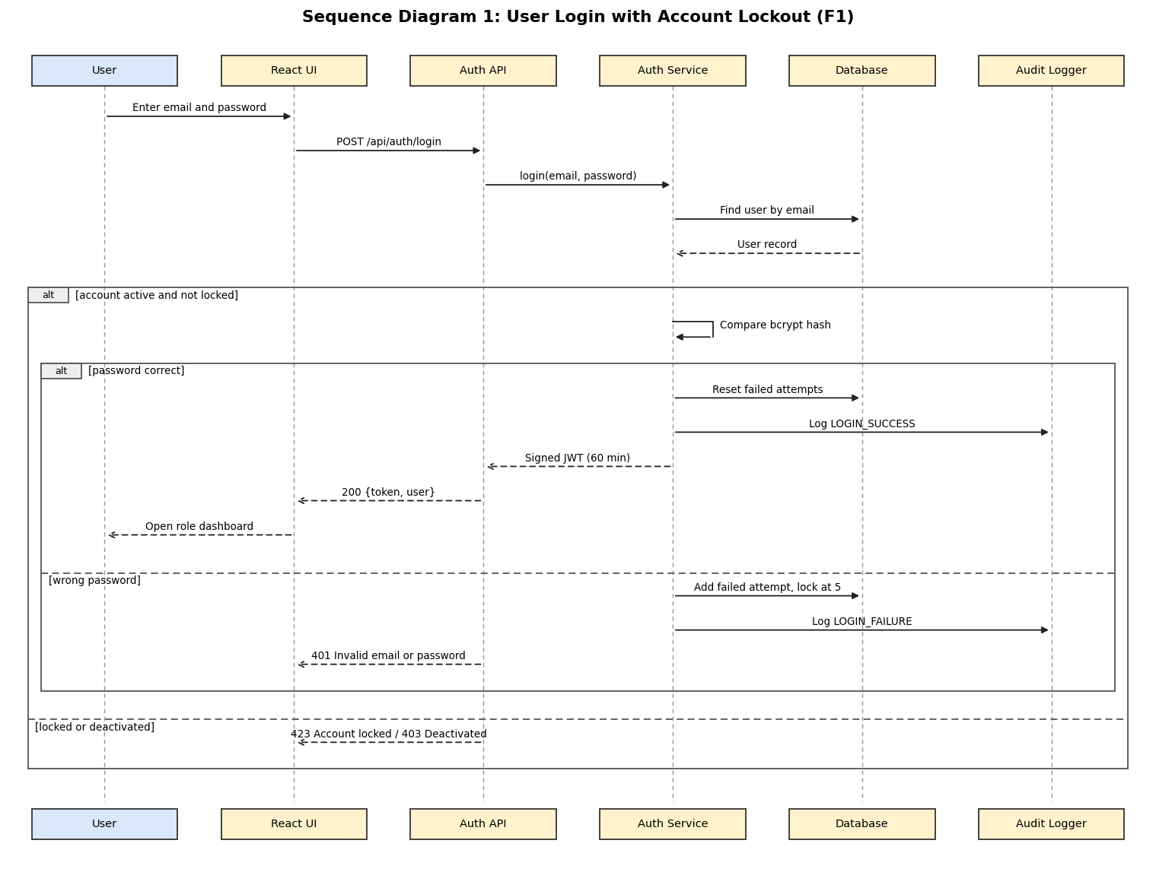
The editable PlantUML source is docs/diagrams/sequence-1-login.puml. This flow covers EVT-F-002 and EVT-F-003.

4.2.2 Sequence Diagram: Organizer Cancels an Event
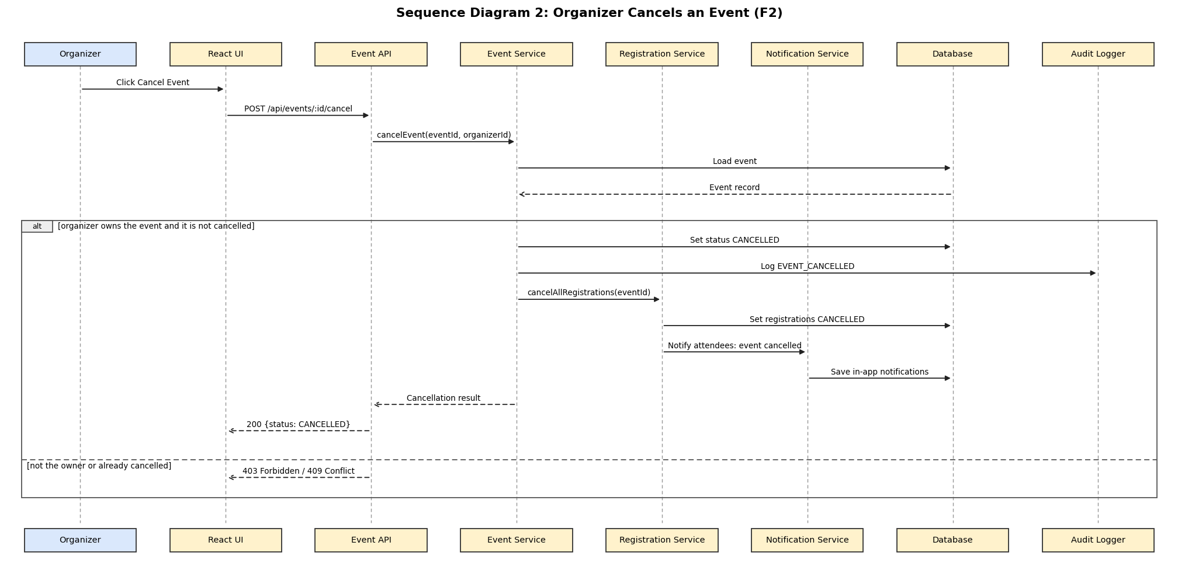
The editable PlantUML source is docs/diagrams/sequence-2-cancel-event.puml. This flow covers EVT-F-014, the notification trigger in EVT-F-032 and the audit entry required by EVT-SR-006.

4.2.3 Sequence Diagram: Attendee Registers for an Event
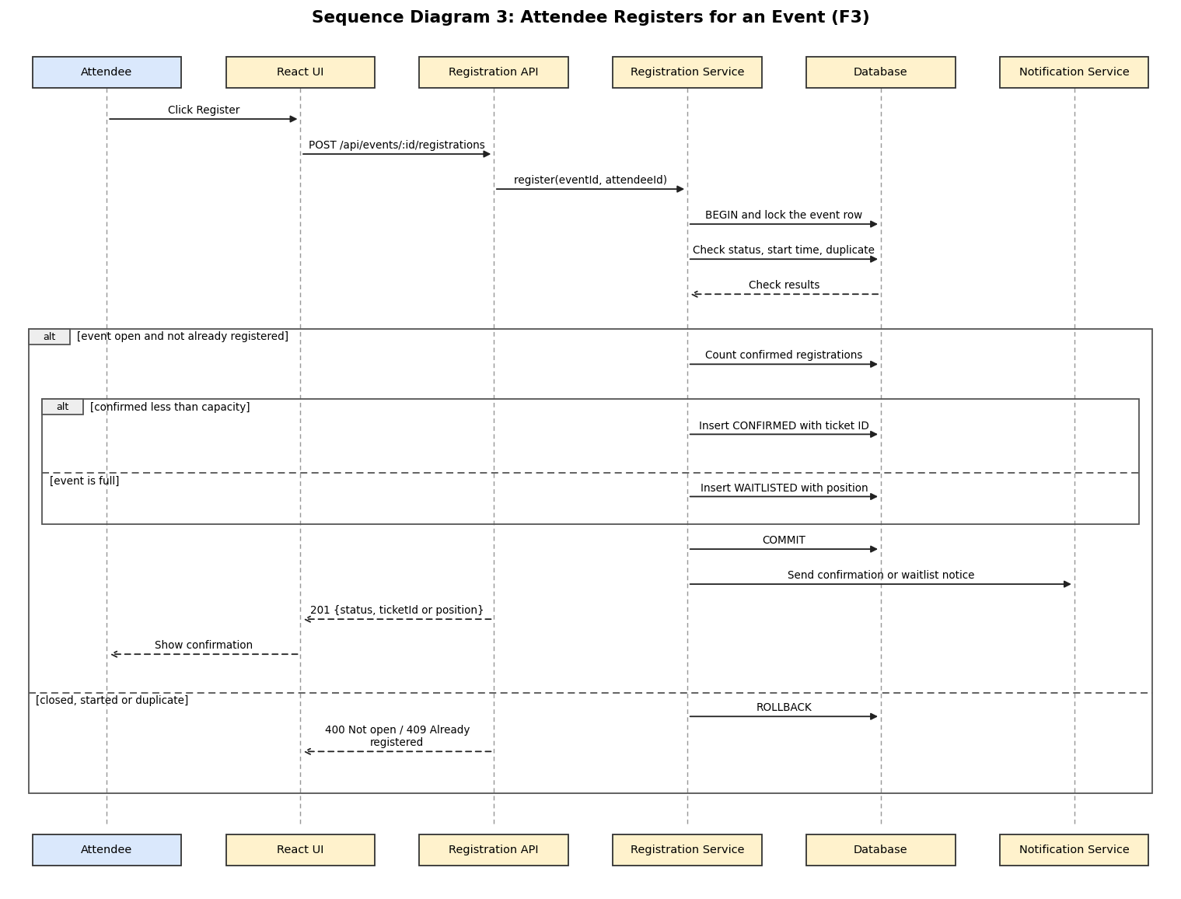
The editable PlantUML source is docs/diagrams/sequence-3-register-for-event.puml. This flow covers EVT-F-020, EVT-F-021 and EVT-F-022, and shows how overbooking is prevented (EVT-NF-004).

4.2.4 Sequence Diagram: Organizer Checks In an Attendee
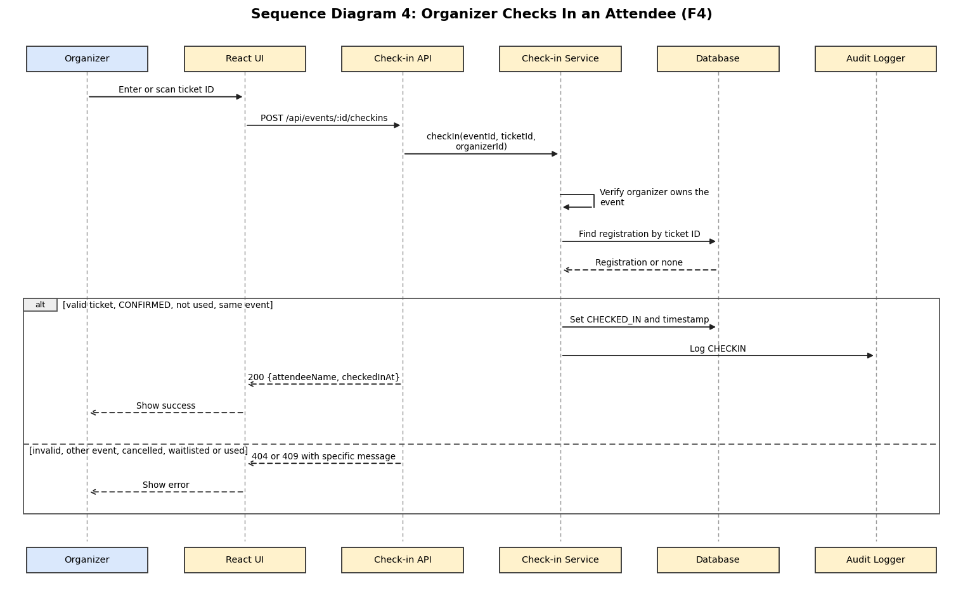
The editable PlantUML source is docs/diagrams/sequence-4-check-in.puml. This flow covers EVT-F-030 and EVT-F-031.

4.3 API Design
REST API over HTTPS with JSON bodies. All protected endpoints need a valid token (Authorization: Bearer <token>); errors use the standard format in section 4.4. Interfaces are listed per component.

4.3.1 API Design: Auth Module
All endpoints use JSON over HTTPS. Errors use the standard format in section 4.4.

POST /api/auth/register
Item | Details
Access | Public
Request | { "name": "Asha", "email": "asha@ems.test", "password": "Test@1234", "role": "ATTENDEE" }
Success | 201 { "userId": 12, "name": "Asha", "email": "asha@ems.test", "role": "ATTENDEE" }
Errors | 400 VALIDATION_ERROR (weak password, bad email or role), 409 EMAIL_EXISTS
Requirement | EVT-F-001

POST /api/auth/login
Item | Details
Access | Public
Request | { "email": "asha@ems.test", "password": "Test@1234" }
Success | 200 { "token": "<jwt>", "expiresIn": 3600, "user": { "id": 12, "name": "Asha", "role": "ATTENDEE" } }
Errors | 401 INVALID_CREDENTIALS (same message for wrong password and unknown email), 403 ACCOUNT_DEACTIVATED, 423 ACCOUNT_LOCKED, 429 TOO_MANY_REQUESTS
Requirement | EVT-F-002, EVT-F-003

POST /api/auth/logout
Item | Details
Access | Any logged-in user
Request | Authorization header with the token
Success | 204 with no body. The token is added to a revoked-token list until it expires.
Errors | 401 UNAUTHORIZED
Requirement | EVT-F-004

User administration and profile
Method and path | Access | Purpose | Main errors | Requirement
GET /api/users | Admin | List users with role and status | 401, 403 | EVT-F-006
PATCH /api/users/:id/role | Admin | Body { "role": "ORGANIZER" }, change a user's role | 400, 403, 404 | EVT-F-006
PATCH /api/users/:id/status | Admin | Body { "active": false }, deactivate or reactivate | 403, 404, 409 (own account) | EVT-F-006
GET /api/users/me | Logged-in user | View own profile | 401 | EVT-F-007
PUT /api/users/me | Logged-in user | Update name and phone number | 400, 401 | EVT-F-007
PUT /api/users/me/password | Logged-in user | Body { "currentPassword", "newPassword" } | 400, 401, 403 (wrong current password) | EVT-F-007

4.3.2 API Design: Event Module

POST /api/events
Item | Details
Access | Organizer
Request | { "title": "Tech Meetup", "description": "...", "categoryId": 2, "venue": "Hall A", "startTime": "2026-11-05T10:00:00+05:30", "endTime": "2026-11-05T13:00:00+05:30", "capacity": 50 }
Success | 201 { "eventId": 31, "status": "DRAFT", ... }
Errors | 400 VALIDATION_ERROR (empty title, start not in the future, end not after start, capacity not 1 to 10000), 401, 403 FORBIDDEN
Requirement | EVT-F-010, EVT-F-011

PUT /api/events/:id
Item | Details
Access | Organizer who owns the event
Request | Any editable event fields, using the same validation rules as creation
Success | 200 with the updated event
Errors | 400 VALIDATION_ERROR, 403 FORBIDDEN (not the owner), 404 NOT_FOUND, 409 CAPACITY_BELOW_CONFIRMED
Requirement | EVT-F-012

POST /api/events/:id/publish and POST /api/events/:id/cancel
Item | Details
Access | Organizer who owns the event
Request | No body
Success | 200 { "eventId": 31, "status": "PUBLISHED" } or { "status": "CANCELLED" }
Errors | 403 FORBIDDEN, 404 NOT_FOUND, 409 INVALID_STATE (for example publishing a cancelled event)
Requirement | EVT-F-013, EVT-F-014

GET /api/events
Item | Details
Access | Public (published events only)
Query | q (keyword), categoryId, from, to (dates), page (default 1). The page size is fixed at 10.
Success | 200 { "page": 1, "pageSize": 10, "total": 25, "events": [ ... ] }
Errors | 400 VALIDATION_ERROR (bad date or page)
Requirement | EVT-F-016

Other event and category endpoints
Method and path | Access | Purpose | Main errors | Requirement
GET /api/events/:id | Public (published) or owner (draft) | Event details | 404 | EVT-F-016
GET /api/events/mine | Organizer | The organizer's own events with registration counts | 401, 403 | EVT-F-010
GET /api/categories | Public | List categories | none | EVT-F-015
POST /api/categories | Admin | Add a category | 400, 409 | EVT-F-015
PUT /api/categories/:id | Admin | Rename a category | 400, 404 | EVT-F-015
DELETE /api/categories/:id | Admin | Delete a category | 404, 409 (in use) | EVT-F-015

4.3.3 API Design: Registration Module

POST /api/events/:id/registrations
Item | Details
Access | Attendee
Request | No body. The attendee comes from the token and the event from the path.
Success | 201 { "registrationId": 88, "status": "CONFIRMED", "ticketId": "TKT-7F3A21" } or 201 { "registrationId": 89, "status": "WAITLISTED", "waitlistPosition": 1 }
Errors | 400 EVENT_NOT_OPEN, 401, 403 FORBIDDEN, 404 NOT_FOUND, 409 ALREADY_REGISTERED
Requirement | EVT-F-020, EVT-F-021, EVT-F-022

POST /api/registrations/:id/cancel
Item | Details
Access | Attendee who owns the registration
Request | No body
Success | 200 { "registrationId": 88, "status": "CANCELLED", "promotedRegistrationId": 89 } (the promoted ID is null when nobody was waiting)
Errors | 400 EVENT_NOT_OPEN (event already started), 403 FORBIDDEN, 404 NOT_FOUND, 409 INVALID_STATE (already cancelled)
Requirement | EVT-F-023, EVT-F-024

Other registration endpoints
Method and path | Access | Purpose | Main errors | Requirement
GET /api/registrations/me | Attendee | The attendee's registrations with event name, date and status | 401 | EVT-F-025
GET /api/registrations/:id/ticket | Attendee who owns it | { "ticketId", "event", "qrCode" } where qrCode is a data URL of a QR image encoding the ticket ID | 403, 404, 409 (not confirmed) | EVT-F-026
GET /api/events/:id/registrations | Organizer who owns the event | Registrations with name, email, status and time | 403, 404 | EVT-F-027

4.3.4 API Design: Check-in and Reporting

POST /api/events/:id/checkins
Item | Details
Access | Organizer who owns the event
Request | { "ticketId": "TKT-7F3A21" }
Success | 200 { "registrationId": 88, "attendeeName": "Asha", "checkedInAt": "2026-11-05T10:12:30+05:30" }
Errors | 400 VALIDATION_ERROR (missing ticket ID), 403 FORBIDDEN (not the organizer of the event), 404 NOT_FOUND (unknown ticket ID or a ticket of another event), 409 TICKET_ALREADY_USED, 409 INVALID_STATE (cancelled or waitlisted ticket)
Requirement | EVT-F-030, EVT-F-031

GET /api/events/:id/report
Item | Details
Access | Organizer who owns the event
Success | 200 { "confirmed": 10, "waitlisted": 2, "cancelled": 1, "checkedIn": 8, "attendanceRate": 80.0 }
Errors | 401, 403 FORBIDDEN, 404 NOT_FOUND
Requirement | EVT-F-035

Other F4 endpoints
Method and path | Access | Purpose | Main errors | Requirement
GET /api/events/:id/attendees.csv | Organizer who owns the event | CSV with name, email, status and check-in time | 403, 404 | EVT-F-036
GET /api/notifications | Logged-in user | The user's in-app notifications | 401 | EVT-F-034
PATCH /api/notifications/:id/read | Owner of the notification | Mark a notification as read | 403, 404 | EVT-F-034
GET /api/admin/dashboard | Admin | Totals of users by role, events by status and registrations | 401, 403 | EVT-F-037
GET /health | Public | Status of the API and the database | 503 when the database is unreachable | EVT-NF-002

4.4 Error Handling, Logging and Monitoring

4.4.1 Standard Error Response
Every failed request returns this JSON structure:
{
"error": {
"code": "EMAIL_EXISTS",
"message": "Email already registered",
"details": []
}
}
details carries field-level messages for validation errors, for example [{ "field": "password", "message": "Must have at least 8 characters" }].

4.4.2 HTTP Status and Error Codes
HTTP status | Error code | When it is used
400 | VALIDATION_ERROR | Invalid or missing input
400 | EVENT_NOT_OPEN | Registering for a draft, cancelled or started event
401 | UNAUTHORIZED | Missing, expired, tampered or revoked token
401 | INVALID_CREDENTIALS | Wrong email or password (one message for both)
403 | FORBIDDEN | Role not allowed, or the object belongs to someone else
403 | ACCOUNT_DEACTIVATED | The account was deactivated by an admin
404 | NOT_FOUND | Object does not exist (also used for unknown ticket IDs)
409 | EMAIL_EXISTS, ALREADY_REGISTERED, INVALID_STATE, TICKET_ALREADY_USED, CAPACITY_BELOW_CONFIRMED | Conflict with the current state of the data
423 | ACCOUNT_LOCKED | Account locked after 5 failed logins
429 | TOO_MANY_REQUESTS | Rate limit exceeded
500 | INTERNAL_ERROR | Unexpected failure. The client gets a generic message and a request ID.

4.4.3 Handling Rules
- Errors are thrown by services as typed errors and converted by the central error handler, so controllers contain no try/catch formatting.
- Unexpected errors return HTTP 500 with a generic message. The stack trace is written only to the server log.
- A failed database transaction is rolled back before the error is returned.
- A failed email delivery never fails the user's request. The email is retried up to 3 times and the failure is logged.

4.4.4 Logging
- Structured JSON logs with timestamp, level (error, warn, info), request ID, user ID, route and status code.
- No passwords, tokens or full email bodies are ever logged (EVT-SR-001, EVT-SR-006).
- Security-relevant actions go to the separate audit log (EVT-SR-006).

4.4.5 Monitoring
Item | How
Availability | GET /health is checked every minute and returns the status of the API and database (EVT-NF-002)
Response time | The 95th percentile response time is measured in load tests (EVT-NF-001)
Error rate | Count of responses with status 5xx
Security signals | Failed logins, locked accounts and HTTP 429 responses taken from the audit log
Email health | Count of failed email deliveries

4.5 UX Design

4.5.1 Principles
- Show only what the user's role needs. The navigation bar changes for visitors, attendees, organizers and admins.
- Keep the main attendee task short: from an event page to a confirmed registration in 3 clicks or fewer (EVT-NF-003).
- Always show the status of a registration (Confirmed, Waitlisted, Cancelled) with text and colour.
- Give clear, specific error messages next to the field that caused them.

4.5.2 Main Screens
Role | Screens
Visitor | Home and event list with search and filters, event details, sign-up, login
Attendee | My registrations, ticket with QR code, notifications, profile
Organizer | My events, event form (create and edit), registration list, check-in screen, event report
Admin | User management, category management, dashboard

4.5.3 Accessibility and Responsiveness
- Layouts work from 360 px to 1920 px wide with no horizontal scrolling.
- Keyboard navigation for all actions, labelled form fields, text alternatives for images and the QR code, and sufficient colour contrast.
- Check-in also works by typing the ticket ID, so a camera is not required.

4.6 Open Issues & Next Steps
Item | Status
Implementation | Complete. All 48 backlog items (30 functional, 6 non-functional, 7 security requirements and 5 setup items) were delivered in two sprints and the development was frozen on 10-11-2026.
Choice of the production SMTP provider | Open. MailHog (mock SMTP) is used for development, testing and the demo; a real provider only needs the SMTP settings changed.
Hosting target for the demo | Decided: Docker Compose on a team laptop, served over HTTPS by nginx at https://localhost:8443.
TLS certificate | A self-signed certificate is created at build time for local use. A public deployment needs a certificate from a certificate authority.
Static analysis result (SonarQube) | Pending: to be run and recorded before the final demo (TC-NFR-05).
Online payments and paid tickets | Future enhancement, out of scope
Calendar integration and push notifications | Future enhancement
Native mobile applications | Future enhancement

4.6.1 Implementation Deviations
The table lists every place where the implementation differs from version 1.0 of this document or from the SRS, with the reason. They were recorded in the sprint reviews (docs/sprint-reviews) as required for the demo.

# | Sprint | Document | What the document says | What was built | Reason
1 | 1 | SAD 4.2 (F1), EVT-SR-001 | Passwords hashed with bcrypt | The bcryptjs library is used | Pure JavaScript, so it installs on every team member's Windows machine and in Docker without native build tools. It produces standard bcrypt hashes with cost 10, so EVT-SR-001 is still met.
2 | 1 | SAD 4.1.3, data model | events.category_id references categories | category_id is required (NOT NULL) | Every event must belong to a category for filtering (EVT-F-016), so an event without one is rejected.
3 | 1 | SAD 4.1.3, data model | audit_logs.user_id | user_id can be empty, and details is stored as JSON | A failed login with an unknown email has no user to record, but must still be logged (EVT-SR-006). JSON keeps the details structured.
4 | 1 | SRS EVT-F-032 | Emails on confirmation, promotion, cancellation and event cancellation | An email is also sent when an attendee joins the waitlist | Tells the attendee their waitlist position straight away. It is an addition and changes no existing behaviour.
5 | 1 | SRS EVT-F-020, data model | A ticket ID for each confirmed registration | Waitlisted registrations also get a ticket ID when created | The ticket_id column is unique and required. The ticket page and check-in (Sprint 2) only accept Confirmed registrations, so a waitlisted ticket cannot be used.
6 | 1 | SRS EVT-SR-007 | 100 API requests and 10 logins per minute per IP | Same limits, but they can be changed with API_RATE_LIMIT and LOGIN_RATE_LIMIT | Needed to raise the limit for the load and concurrency tests (EVT-NF-001, EVT-NF-004). The defaults match the SRS.
7 | 1 | SRS EVT-F-016 | Browse published events | Only published events that have not started yet are listed | Past events cannot be registered for, so listing them would confuse attendees.
8 | 2 | SAD 2.1 and 3 (Presentation layer), risk R3 | The browser keeps the login token in memory, not in local storage | The token is kept in the browser's local storage until it expires | Keeping it only in memory logged users out on every page refresh, which made the app hard to use. The risk is limited by the 60-minute expiry, logout revoking the token on the server, React escaping all output, and the Content-Security-Policy header, which together block the script injection that could read the token.
9 | 2 | SRS EVT-SR-004 | HTTPS with TLS 1.2 or higher | HTTPS through nginx at https://localhost:8443, with a self-signed certificate created when the image is built | The project runs on team laptops without a public domain, so no certificate authority can issue a certificate. The browser shows a one-time warning, but the connection is encrypted with TLS 1.2 or 1.3. A real deployment would use a certificate from a certificate authority.
10 | 2 | SRS EVT-F-012, EVT-F-014, EVT-F-027, EVT-F-030, EVT-F-035, EVT-F-036 | The organizer of the event can edit, cancel, check in, and see registrations and reports | The same actions are also allowed for admins | Admins need to step in when an organizer is unavailable, for example to cancel an event. Other organizers and attendees are still refused with 403 (EVT-SR-005).
11 | 2 | SRS EVT-F-033 | A reminder 24 hours before the start to every Confirmed attendee | The reminder job runs every minute and reminds every Confirmed attendee whose event starts within the next 24 hours, once each | An attendee who registers less than 24 hours before the start still gets a reminder, soon after registering. Each attendee is reminded only once (reminder_sent_at).
12 | 2 | SRS EVT-F-035 | Report counts of Confirmed and Checked-in registrations and the attendance rate | "Confirmed" in the report counts everyone holding a seat, including those already checked in | A checked-in registration changes status from Confirmed to Checked in. Counting both gives the expected rate (10 confirmed, 8 checked in = 80%).
13 | 2 | SRS EVT-F-006 | Admin changes roles and deactivates or reactivates accounts | An admin cannot change their own role or deactivate themselves (409), and reactivating an account also clears an account lock; both actions are audited | Stops the system from being left without an admin by mistake, and gives admins a way to unlock an account early. Status changes are logged as ACCOUNT_STATUS_CHANGED in addition to ROLE_CHANGED (EVT-SR-006).
14 | 2 | SRS EVT-F-014 | Organizer cancels an event | An event can be cancelled or edited only before it starts | Changing an event that has already started would make check-in and reports inconsistent.
15 | 2 | SRS EVT-NF-005 | 70% unit test coverage of backend code | The 70% gate covers the backend src code; test scripts (backend/scripts) and database scripts are excluded | The load, concurrency and uptime scripts are test tools run by hand, not application code.

5. Appendices

5.1 Glossary
Term | Meaning
ADR | Architecture Decision Record
CI | Continuous Integration
EMS | Event Management System
JWT | JSON Web Token
RBAC | Role-Based Access Control
REST | Representational State Transfer
RTM | Requirements Traceability Matrix
SAD | Software Architecture and Design Specification
SMTP | Simple Mail Transfer Protocol
STRIDE | Spoofing, Tampering, Repudiation, Information disclosure, Denial of service, Elevation of privilege
TLS | Transport Layer Security
Waitlist | First-in-first-out queue of attendees waiting for a seat

5.2 References
IEEE 42010 (architecture description), OWASP Top 10 and OWASP ASVS, NIST SP 800-160, and the project's SRS and Test Plan.

5.3 Tools
Graphviz and draw.io for component diagrams, PlantUML for sequence diagrams, Postman and Swagger for API documentation, GitHub Projects for the backlog, SonarQube for static analysis.

