PES University
Department of Computer Science and Engineering

UE24CS341A Software Engineering
Mini Project Report

Event Management System (EMS)
A web application for creating events, registering attendees, managing waitlists, checking in with QR tickets and reporting attendance

Aug to Nov 2026
Group 7 (to confirm)

Name | SRN | Feature owned
Varun Rao | PES1UG24CS520 | F1 Authentication and role management
Thanishq Raam Patil | PES1UG24CS502 | F2 Event creation and management
Vishruta | PES1UG24CS538 | F3 Event registration and ticketing
Nithin Kumar M | PES1UG25CS829 | F4 Check-in, notifications and reports

Faculty: ______________________
Repository: https://github.com/SE-MINIPROJECT-ORG/SWE-MiniProject

Contents
1. Project overview (proposal)
2. Requirements
3. Project plan
4. Architecture and design
5. Agile execution: backlog, sprints and CI/CD
6. Testing and validation
7. Deviations from the design documents
8. Screenshots of the working system
9. Conclusion
Appendix: where to find each document

1. Project overview

Problem
Events in colleges are often run with forms, spreadsheets and group messages. Seats get overbooked, confirmations get lost, waitlists are handled by hand, and organizers do not know who actually attended.

Solution
EMS puts the whole event lifecycle in one web application. Organizers create and publish events with a fixed capacity. Attendees register and get a ticket with a QR code; when an event is full they join a waitlist and are promoted automatically when a seat frees up. Organizers check attendees in by ticket ID and get an attendance report and a CSV list. Email and in-app notifications keep everyone informed, and admins manage users, roles and categories.

Users
User | What they do
Visitor | Browses and searches events, signs up
Attendee | Registers, joins waitlists, views tickets and notifications, cancels
Organizer | Creates, edits, publishes and cancels events; checks attendees in; views reports
Admin | Manages users, roles and categories; views platform totals

Features and ownership
Each member owned one feature end to end: requirements, design, code, tests and demo.
Feature | Owner | Main functions
F1 Authentication and role management | Varun Rao | Sign-up, login, lockout, logout, roles, admin user management, profile
F2 Event creation and management | Thanishq Raam Patil | Create, validate, edit, publish, cancel events; categories; search and filter
F3 Event registration and ticketing | Vishruta | Register, waitlist and promotion, cancel, my registrations, QR ticket, organizer list
F4 Check-in, notifications and reports | Nithin Kumar M | Check-in, emails, reminders, in-app notifications, report, CSV, admin dashboard

Technology: React (frontend), Node.js with Express (REST API), PostgreSQL (database), Docker Compose, GitHub Actions.

2. Requirements
The requirements are specified in the SRS (IEEE format, docs/submission/SRS_EMS_v2.0.docx). Every requirement has an ID, a priority, measurable acceptance criteria and a linked test case.
Type | Count | ID format | Example
Functional | 30 | EVT-F-### | EVT-F-022: an attendee who registers for a full event is put on a first-in-first-out waitlist
Non-functional | 6 | EVT-NF-### | EVT-NF-001: 95% of API requests complete within 2 s with 100 concurrent users
Security objectives | 3 | SO-# | SO-1 Confidentiality, SO-2 Integrity, SO-3 Accountability and Availability
Security requirements | 7 | EVT-SR-### | EVT-SR-001: passwords stored only as salted bcrypt hashes

Non-functional requirements
ID | Requirement | Target
EVT-NF-001 | Performance | 95% of requests within 2 s at 100 concurrent users
EVT-NF-002 | Availability | 99% monthly uptime
EVT-NF-003 | Usability | Register within 3 clicks; layouts from 360 px to 1920 px
EVT-NF-004 | Correctness under load | No overbooking under 500 simultaneous registrations
EVT-NF-005 | Maintainability | At least 70% unit test coverage, quality gate in CI
EVT-NF-006 | Compatibility | Latest two versions of Chrome, Firefox and Edge

Security requirements
ID | Requirement
EVT-SR-001 | Passwords stored only as salted bcrypt hashes, never logged
EVT-SR-002 | Signed session tokens (JWT) that expire after 60 minutes
EVT-SR-003 | All input validated on the server; parameterized SQL queries
EVT-SR-004 | HTTPS with TLS 1.2 or higher; plain HTTP redirected
EVT-SR-005 | Ownership checks: users only see and change their own data
EVT-SR-006 | Audit log of logins, role changes, event cancellations and check-ins
EVT-SR-007 | Rate limiting: 100 requests and 10 logins per minute per IP

Use case diagrams
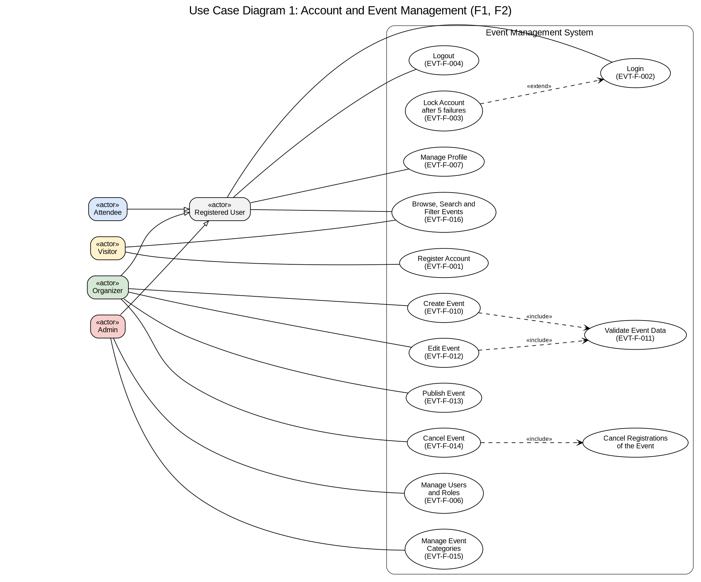
Figure 2.1: Account and event management (F1, F2)
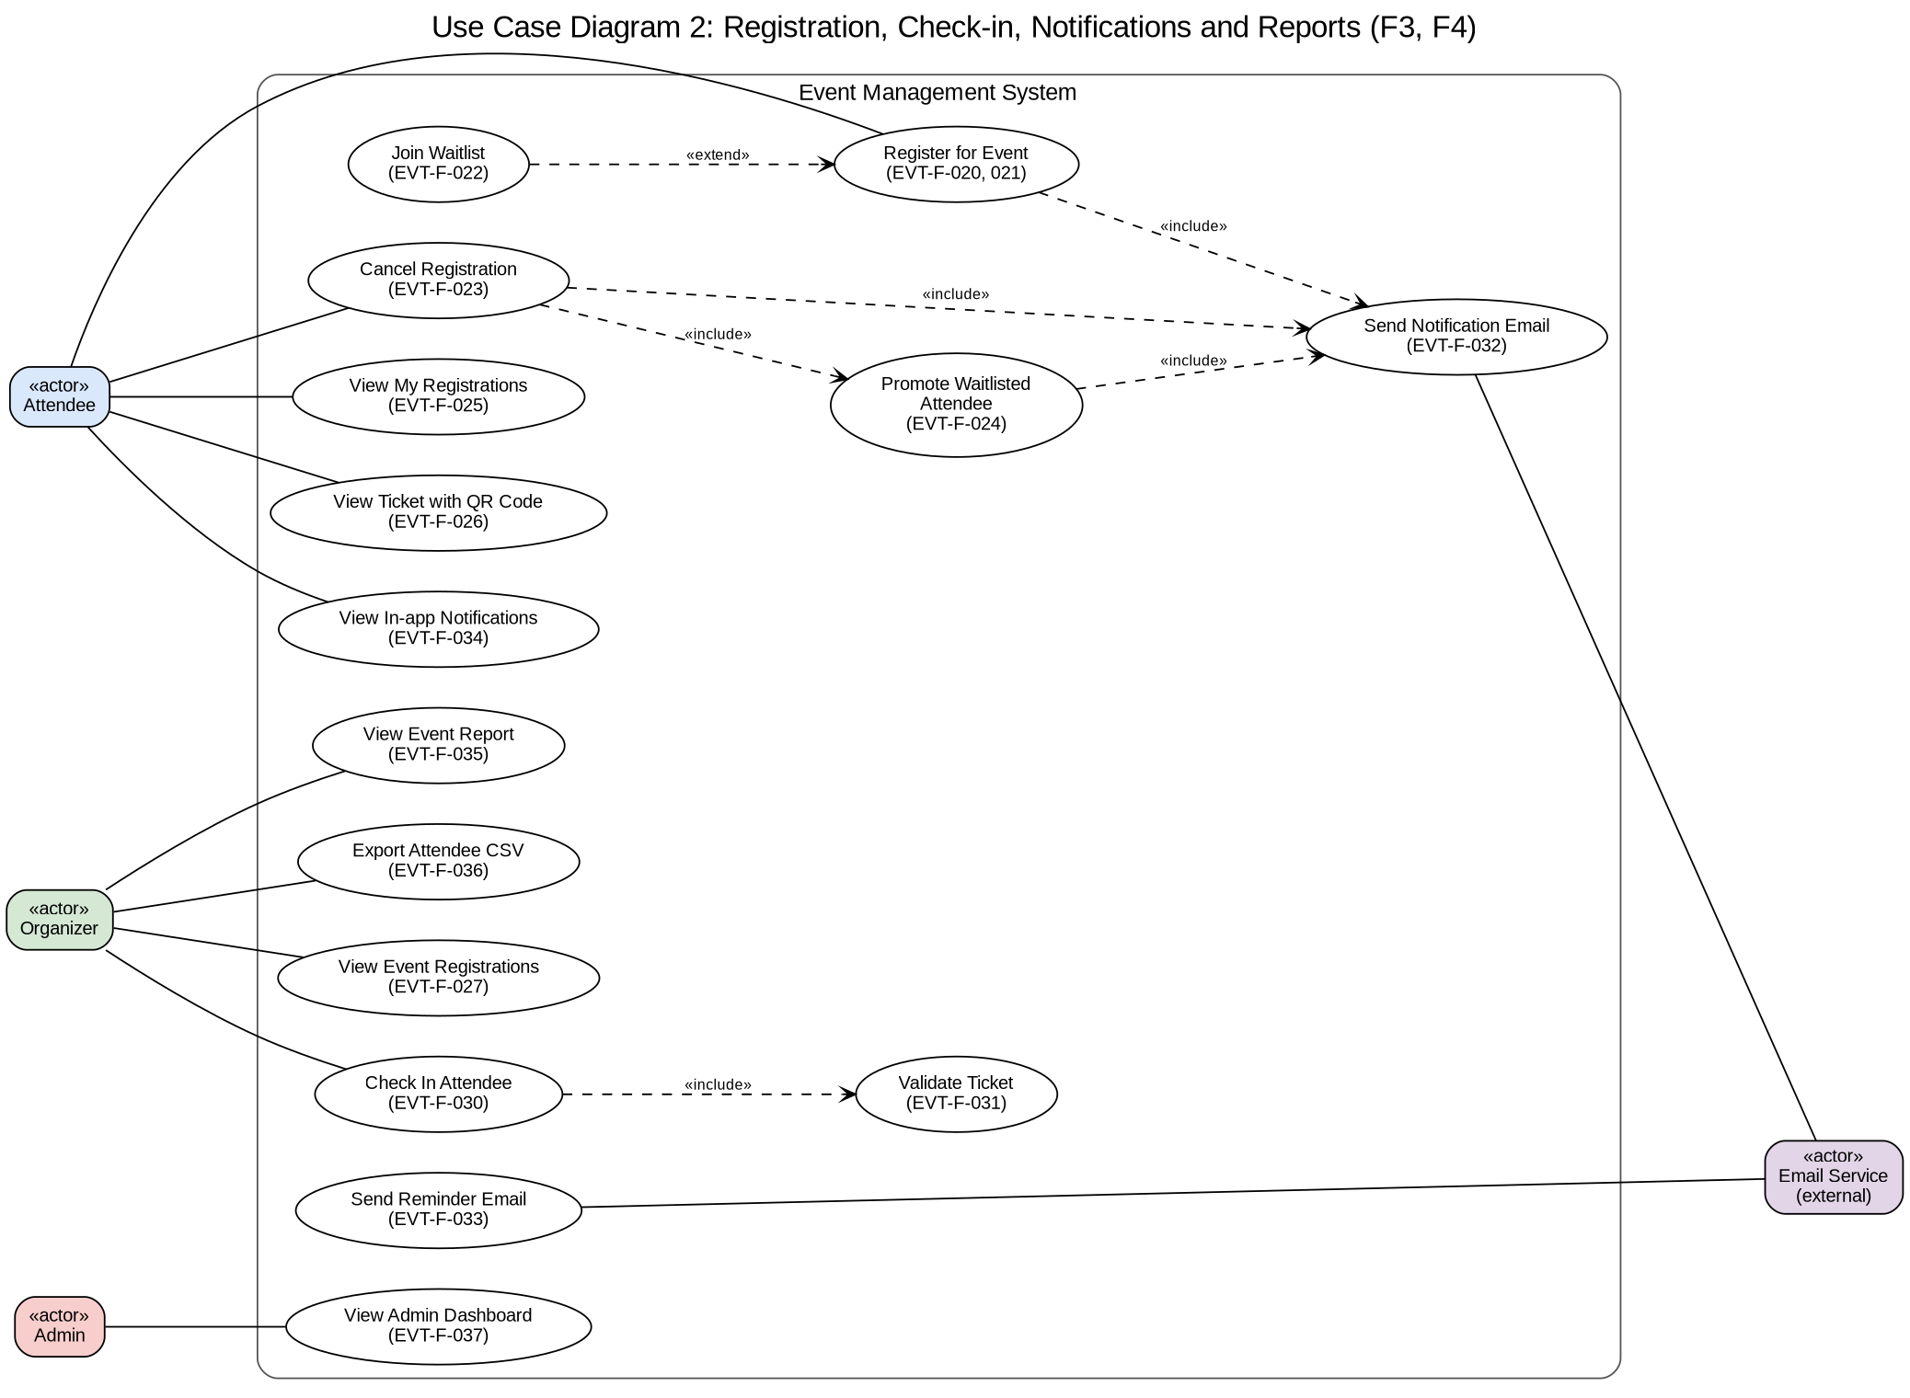
Figure 2.2: Registration, check-in and reports (F3, F4)

3. Project plan
The full plan is in docs/project-plan/project-plan.pdf.

Lifecycle model: Agile (Scrum)
- Why: the course requires Agile; each member owns one feature, which fits per-member user stories; working software is demonstrated at the end of each sprint; the teacher reviews between sprints, and changes are recorded at each sprint review.
- How: an up-front phase ("Sprint 0") for the IEEE documents and project setup, then two one-week sprints, each ending with a working product, a video and a sprint review.

Work breakdown structure
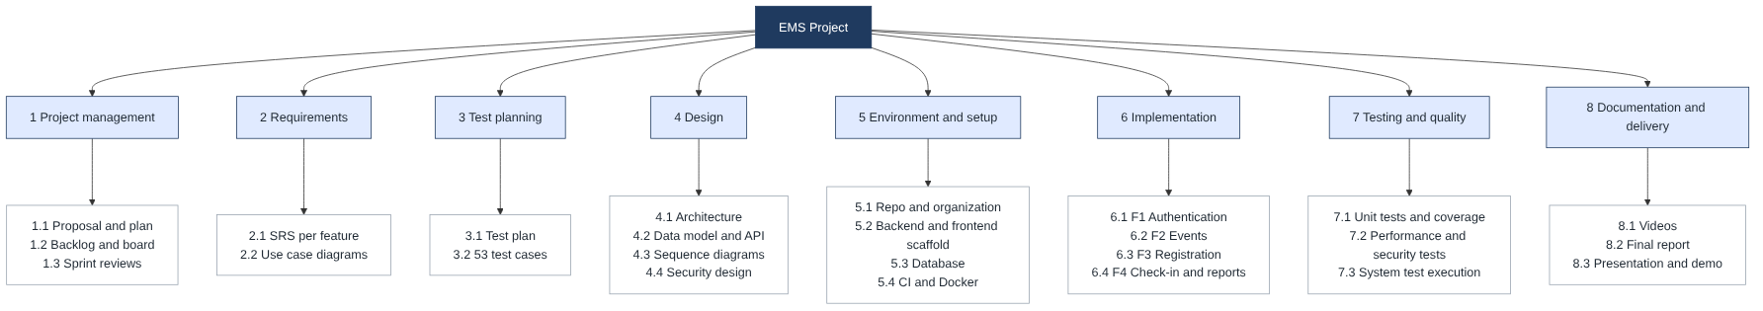
Figure 3.1: Work breakdown structure (8 work packages)

Effort estimation
Method | Result
Story points | 167 points in total (Sprint 1: 86, Sprint 2: 81); per member 41 to 43 points
Bottom-up estimate | 425 person-hours = 2.7 person-months (implementation at about 1.25 hours per point)
COCOMO (basic, organic, 4.6 KLOC) | 11.9 person-months, 6.4 months, used as an upper bound: COCOMO assumes industrial overheads and code written from scratch, while this project reuses frameworks and libraries

Schedule
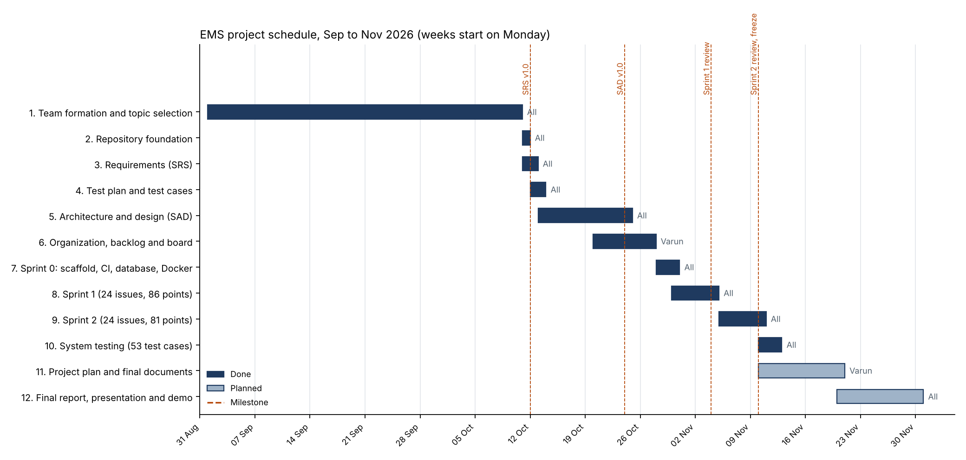
Figure 3.2: Gantt chart built from the actual dates in the repository history

4. Architecture and design
The full design is in the SAD (IEEE format, docs/submission/SAD_EMS_v2.0.docx).

Architecture pattern: layered monolith
One deployable backend split into four layers: Presentation (React app), API (Express routes, security middleware), Service (business rules, one module per feature) and Data (repositories with SQL).
- Why: clear separation of concerns; each member works in their own module; seat allocation and waitlist promotion need one database transaction, which is simple inside one service; easy to run on a laptop with Docker.
- Rejected: microservices (network calls and distributed transactions for a four-person, one-semester project) and serverless functions (cold starts and scattered state make seat allocation and scheduled reminders harder).
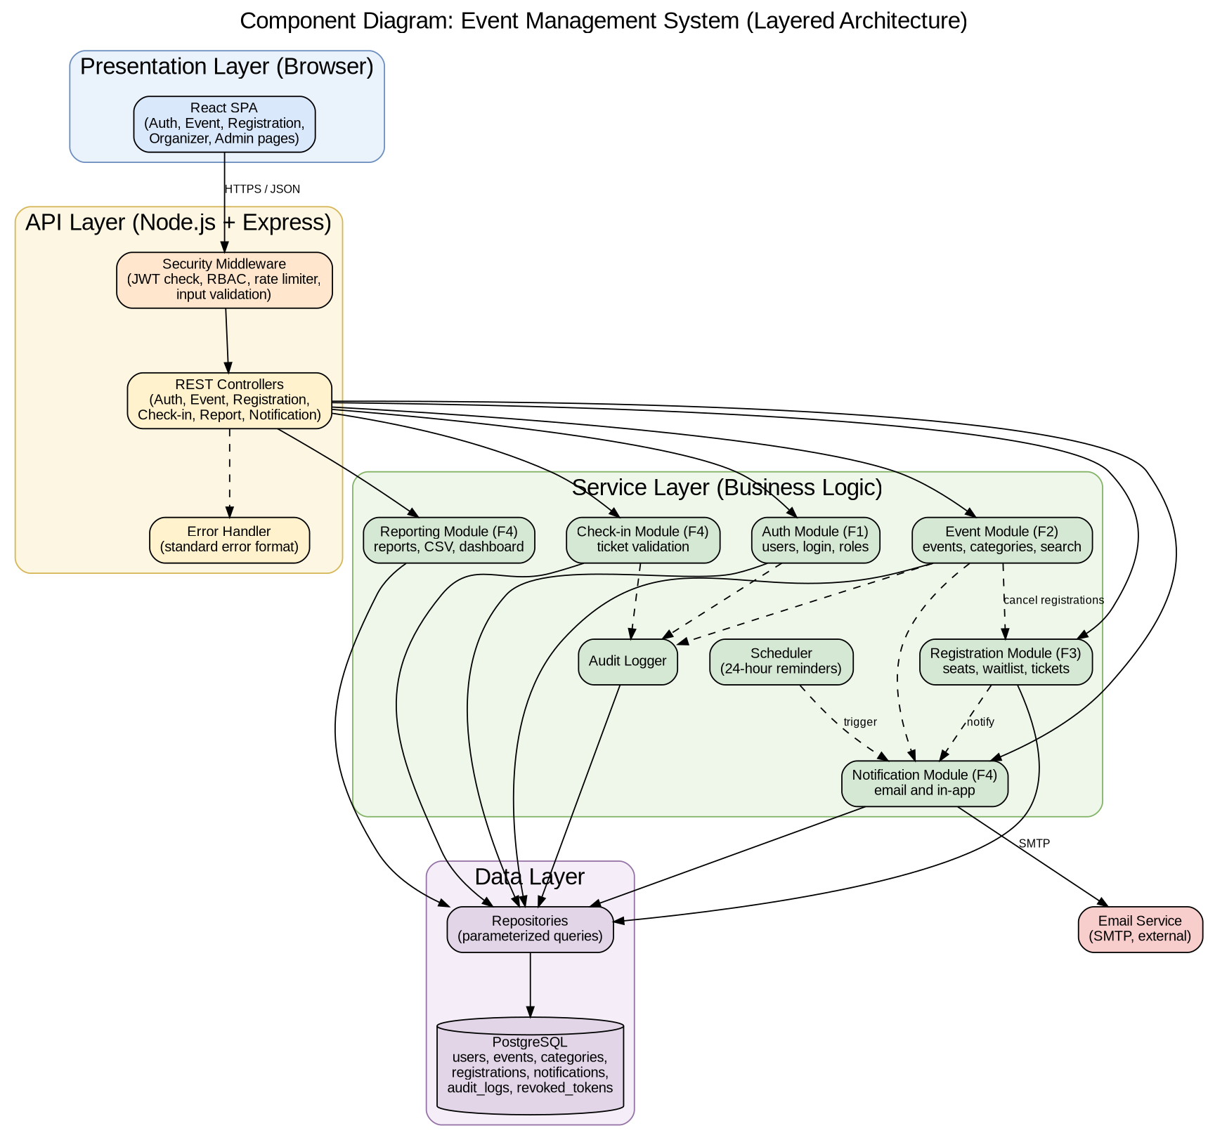
Figure 4.1: Component diagram

Data model
Table | Purpose
users | Accounts, roles, active flag, failed-login counter and lock time
categories | Event categories
events | Event details, capacity and status (Draft, Published, Cancelled)
registrations | Status (Confirmed, Waitlisted, Cancelled, Checked in), ticket ID, queue position, reminder flag
notifications | In-app notifications per user
audit_logs | Security events (who, what, when)
revoked_tokens | Logged-out tokens, kept until they expire

Key design decisions
Decision | Reason | Requirement
Registration and cancellation run in one transaction with the event row locked | Two people can never take the last seat at the same time | EVT-NF-004
Emails are sent in the background with 3 retries | A slow mail server never fails or slows the user's request | EVT-F-032
Reminder job runs every minute and records reminder_sent_at | Each attendee gets exactly one reminder | EVT-F-033
Logout stores the token ID in revoked_tokens | A stolen token stops working after logout | EVT-F-004
One standard error format { error: { code, message, details } } | The frontend shows clear messages; no stack traces leak | SAD 4.4

Sequence diagrams
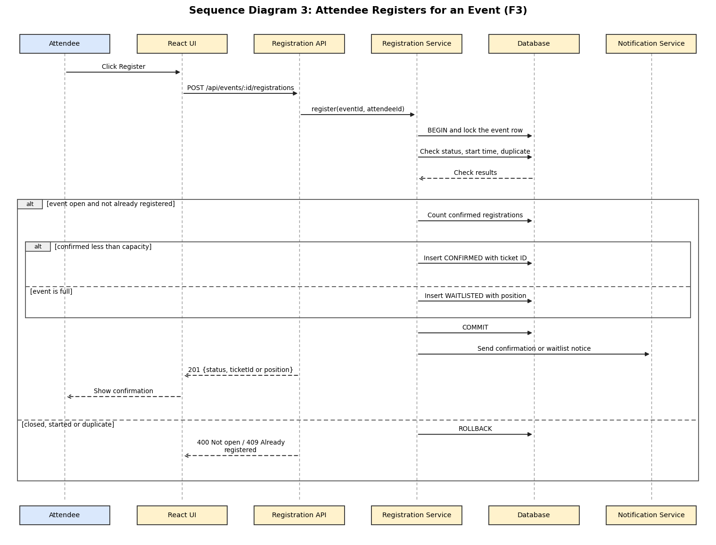
Figure 4.2: Attendee registers for an event (seat lock and waitlist)
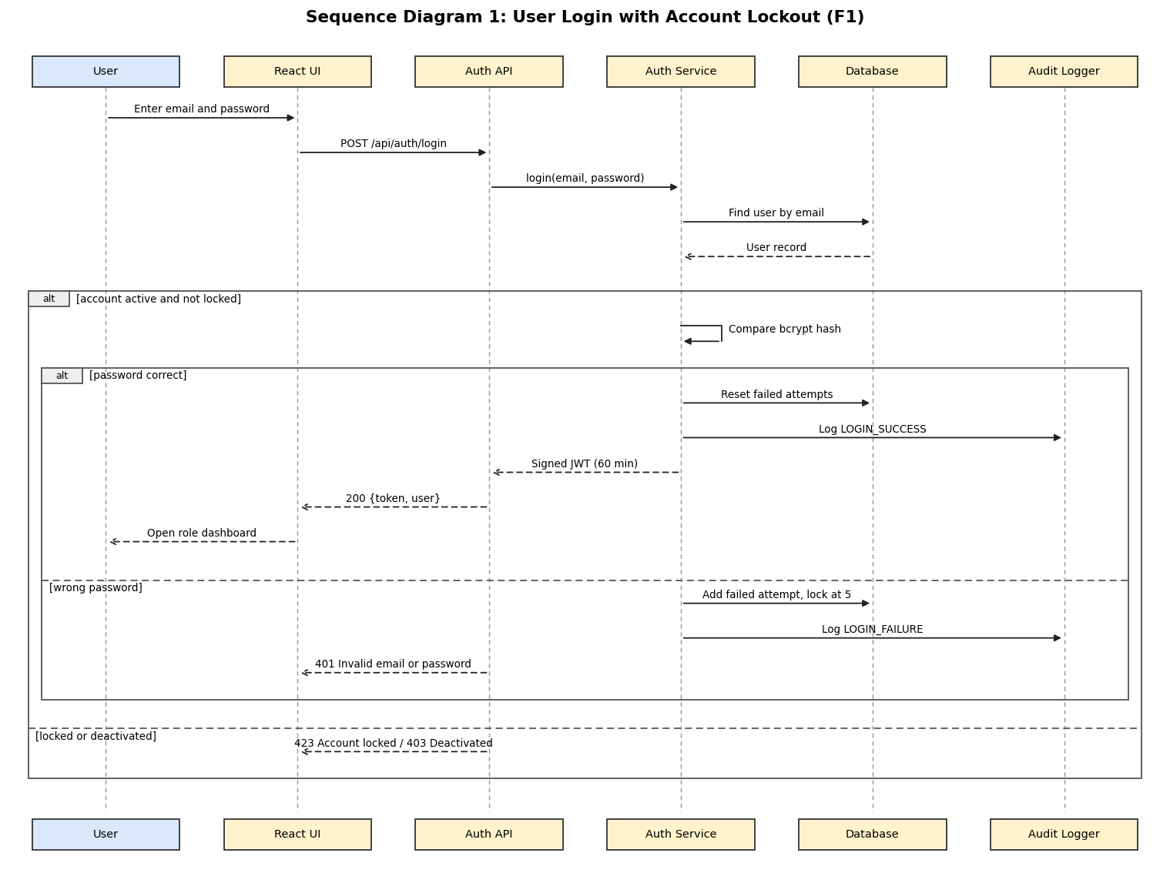
Figure 4.3: Login with account lockout. Two more diagrams (event cancellation, check-in) are in the SAD.

API design
32 REST endpoints over HTTPS with JSON, grouped by module. Examples:
Endpoint | Who | Purpose
POST /api/auth/login | Anyone | Log in, returns a 60-minute token
POST /api/events | Organizer | Create an event (saved as Draft)
POST /api/events/:id/registrations | Attendee | Register, or join the waitlist when full
POST /api/events/:id/checkins | Organizer | Check in a ticket
GET /api/events/:id/report | Organizer | Attendance report

Security architecture (STRIDE)
Threat | Example | Control
Spoofing | Guessing passwords | bcrypt, account lockout, login rate limit
Tampering | Changing a token or SQL injection | Signed JWT, parameterized queries, validation
Repudiation | Denying a role change | Audit log
Information disclosure | Reading another user's ticket | Ownership checks, HTTPS
Denial of service | Flooding the API | Rate limiting
Elevation of privilege | Attendee calling an admin endpoint | Role-based access control (HTTP 403)

5. Agile execution: backlog, sprints and CI/CD

Backlog and board
- 48 GitHub Issues: every functional, non-functional and security requirement of the SRS plus 5 setup items, each with story points (sp-N labels), a priority, a feature label and an assignee.
- GitHub Project "EMS Product Backlog" linked to the repository, with Sprint 1 and Sprint 2 as milestones.
Member | Sprint 1 | Sprint 2 | Total points
Varun Rao | 25 | 16 | 41
Thanishq Raam Patil | 21 | 21 | 42
Vishruta | 20 | 21 | 41
Nithin Kumar M | 20 | 23 | 43
Total | 86 | 81 | 167

Sprints
Sprint | Goal | Result
Sprint 0 | IEEE documents, repository, scaffold, database, CI, Docker | SRS, Test Plan, SAD; working build pipeline
Sprint 1 (24 issues) | Accounts, events, registration with waitlist, emails, audit log, rate limiting | All 24 closed; 1-minute video; sprint review with 7 deviations
Sprint 2 (24 issues) | Remaining features, security and performance requirements, tests | All 24 closed; 2-minute video; sprint review with 8 deviations; development frozen

Development workflow
1. Each issue is developed on its own branch (feature/<member>-<topic>).
2. The assigned member raises the pull request, with Closes #n linking it to the backlog item.
3. GitHub Actions runs lint, unit tests with the coverage gate, and the frontend build.
4. A teammate reviews and approves (fixed review rotation); the repository owner merges with Squash and merge.
5. Branch protection on main blocks merging without a green CI run and one approval, and blocks direct pushes.
Sprints were ordered so that features depending on others came later (for example, notifications before waitlist promotion, and promotion before event editing). Blockers met during the sprints, and how they were resolved: a CI workflow lost in a revert (re-added in a new pull request), Docker memory limits on one laptop (WSL memory settings), and GitHub Actions queue delays (re-running the check).

6. Testing and validation

Strategy
Level | Tool | Scope
Unit | Jest and Supertest (backend), Vitest (frontend) | 241 tests, run in CI on every pull request
Integration | API calls against the backend and PostgreSQL | Test cases marked (I)
System | Full system in the browser over HTTPS | Test cases marked (S)
Performance and concurrency | Team scripts (backend/scripts) | Load, overbooking and uptime tests
Security | Test cases TC-SEC-01 to 07 | Hashing, tokens, injection, TLS, ownership, audit, rate limits

Results
Measure | Result
System test cases (53) | 50 pass, 2 pass with a note, 1 partially executed (browsers: Chrome only), 0 failed
Unit tests | 205 backend + 36 frontend, all pass
Backend coverage | 86.79% lines, 78.64% branches (target 70% lines)
Performance | 95th percentile 138 ms with 100 users for 5 minutes (target 2 s)
No overbooking | 3 runs of 500 simultaneous requests for 100 seats: exactly 100 confirmed each time
HTTPS | TLS 1.0 and 1.1 refused; 1.2 and 1.3 accepted; HTTP redirected

Every requirement is traced to its design, code module and test cases in the RTM (SRS section 8). Test cases changed by the sprints were updated and marked. Reports: docs/test-reports (unit test report, code and branch coverage report, system validation report, and one report per non-functional and security requirement).

7. Deviations from the design documents
Deviations were recorded at each sprint review and are explained in full in SAD section 4.6.1.
# | Change | Reason
1 | bcryptjs instead of bcrypt | Installs on every laptop without build tools; same hash format
2 | Event category is required | Needed for filtering
3 | Audit log user can be empty | Failed logins for unknown emails must still be logged
4 | Extra email when joining the waitlist | Attendee learns their position at once
5 | Waitlisted registrations also get a ticket ID | Database column is required; the ticket is unusable until confirmed
6 | Rate limits configurable | Needed for load tests; defaults match the SRS
7 | Only upcoming published events are listed | Past events cannot be registered for
8 | Login token kept in browser storage, not memory | Users stayed logged in after refresh; risk limited by expiry, logout revocation and CSP
9 | Self-signed HTTPS certificate | Runs locally without a public domain
10 | Admins can also do organizer actions | Lets an admin step in for an organizer
11 | Reminder sent to late registrations too | Every attendee gets one reminder
12 | Report "Confirmed" includes checked-in attendees | Gives the expected attendance rate
13 | Admin cannot change or deactivate themselves | Never leaves the system without an admin
14 | Events cannot be edited or cancelled after they start | Keeps check-in and reports consistent
15 | Coverage gate covers backend application code | Test scripts are tools, not application code

Two planned checks were changed in testing: the SonarQube quality gate was replaced by ESLint and the coverage gate in CI, and browser testing was done in Chrome only.

8. Screenshots of the working system
Taken from the final build running with Docker Compose over HTTPS, with sample data.
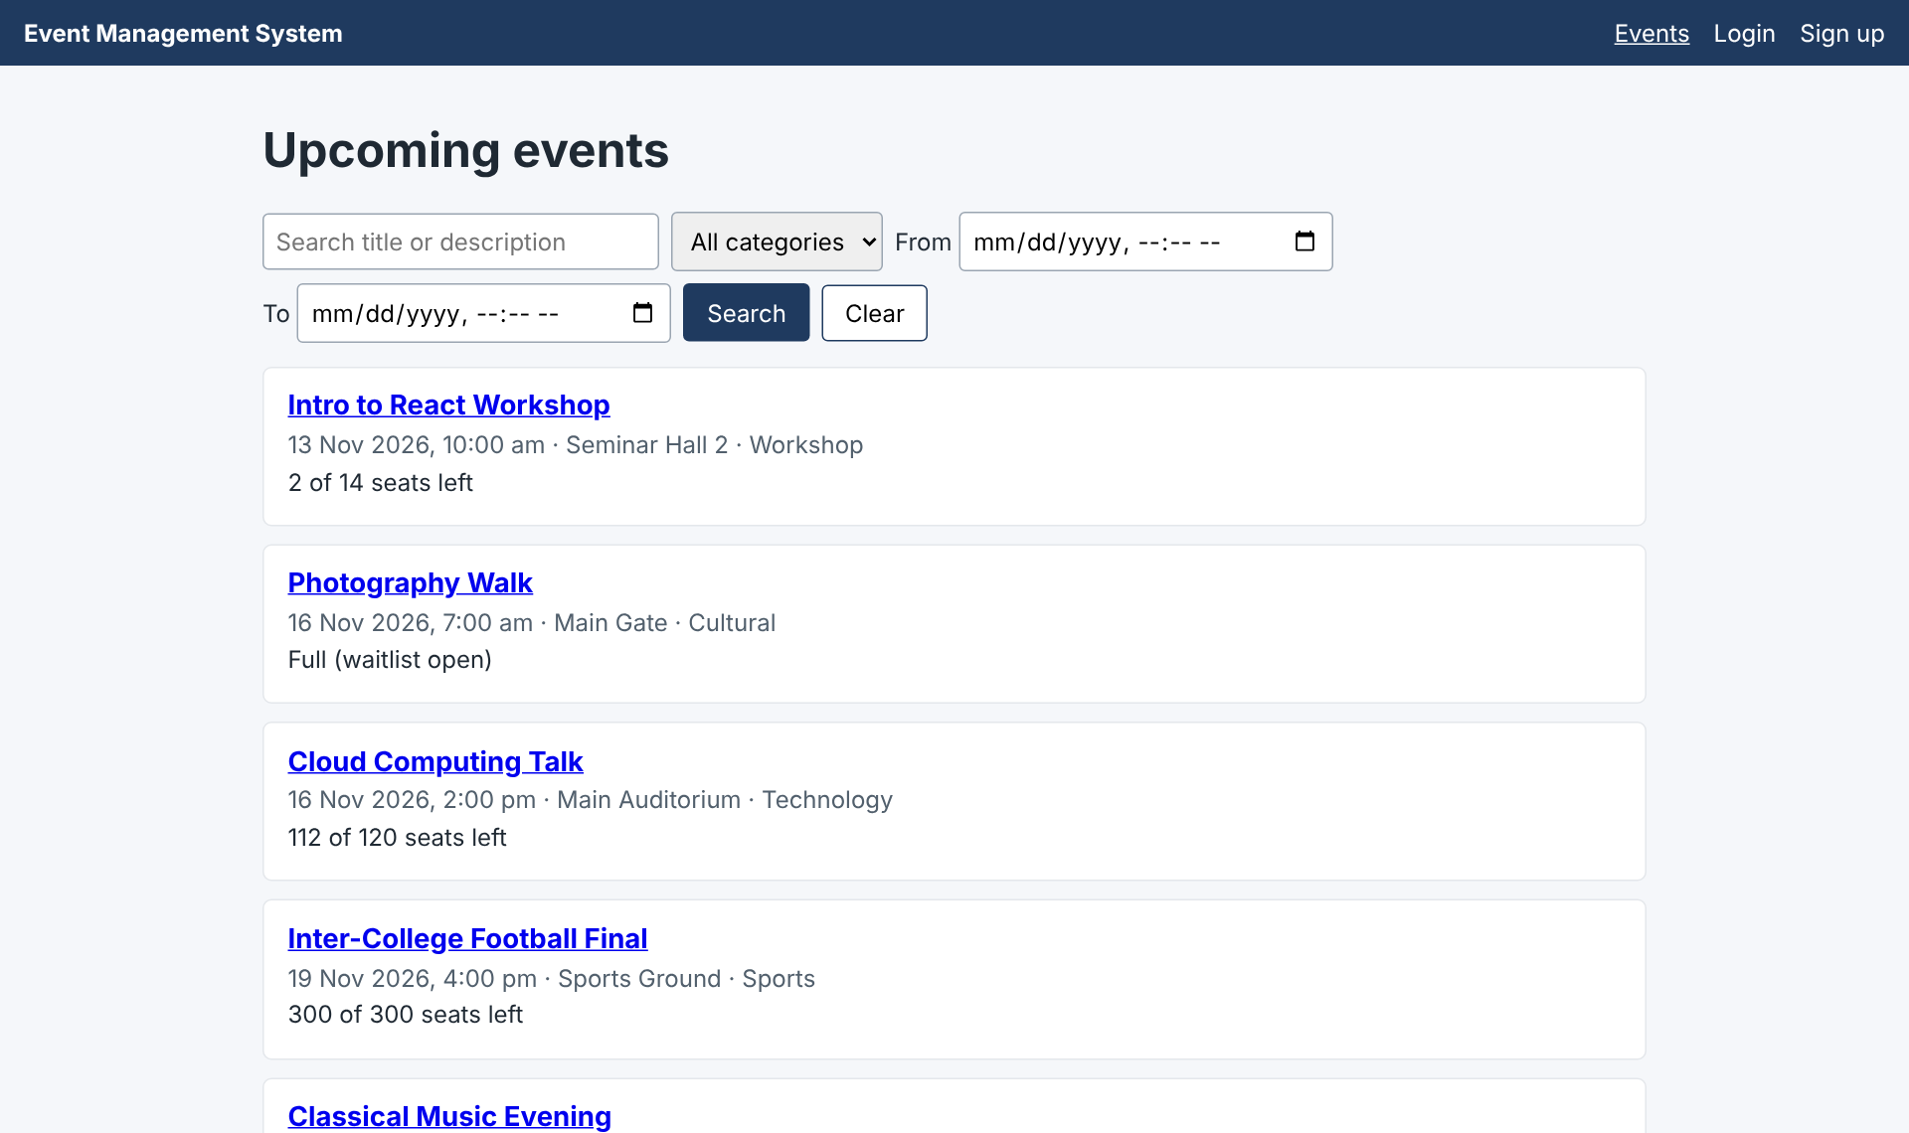
Figure 8.1: Visitor: upcoming events with search and filters (EVT-F-016)
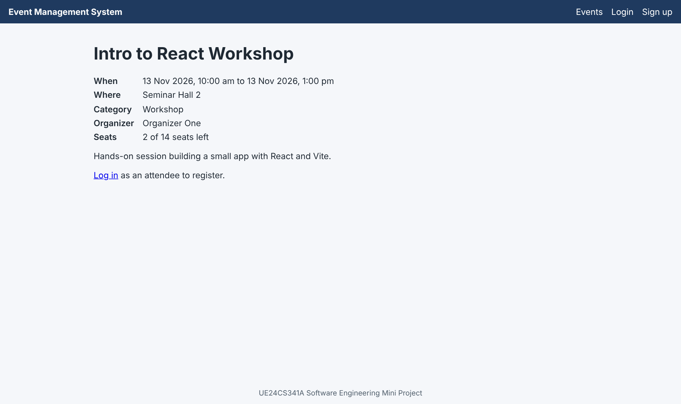
Figure 8.2: Event page with seats left
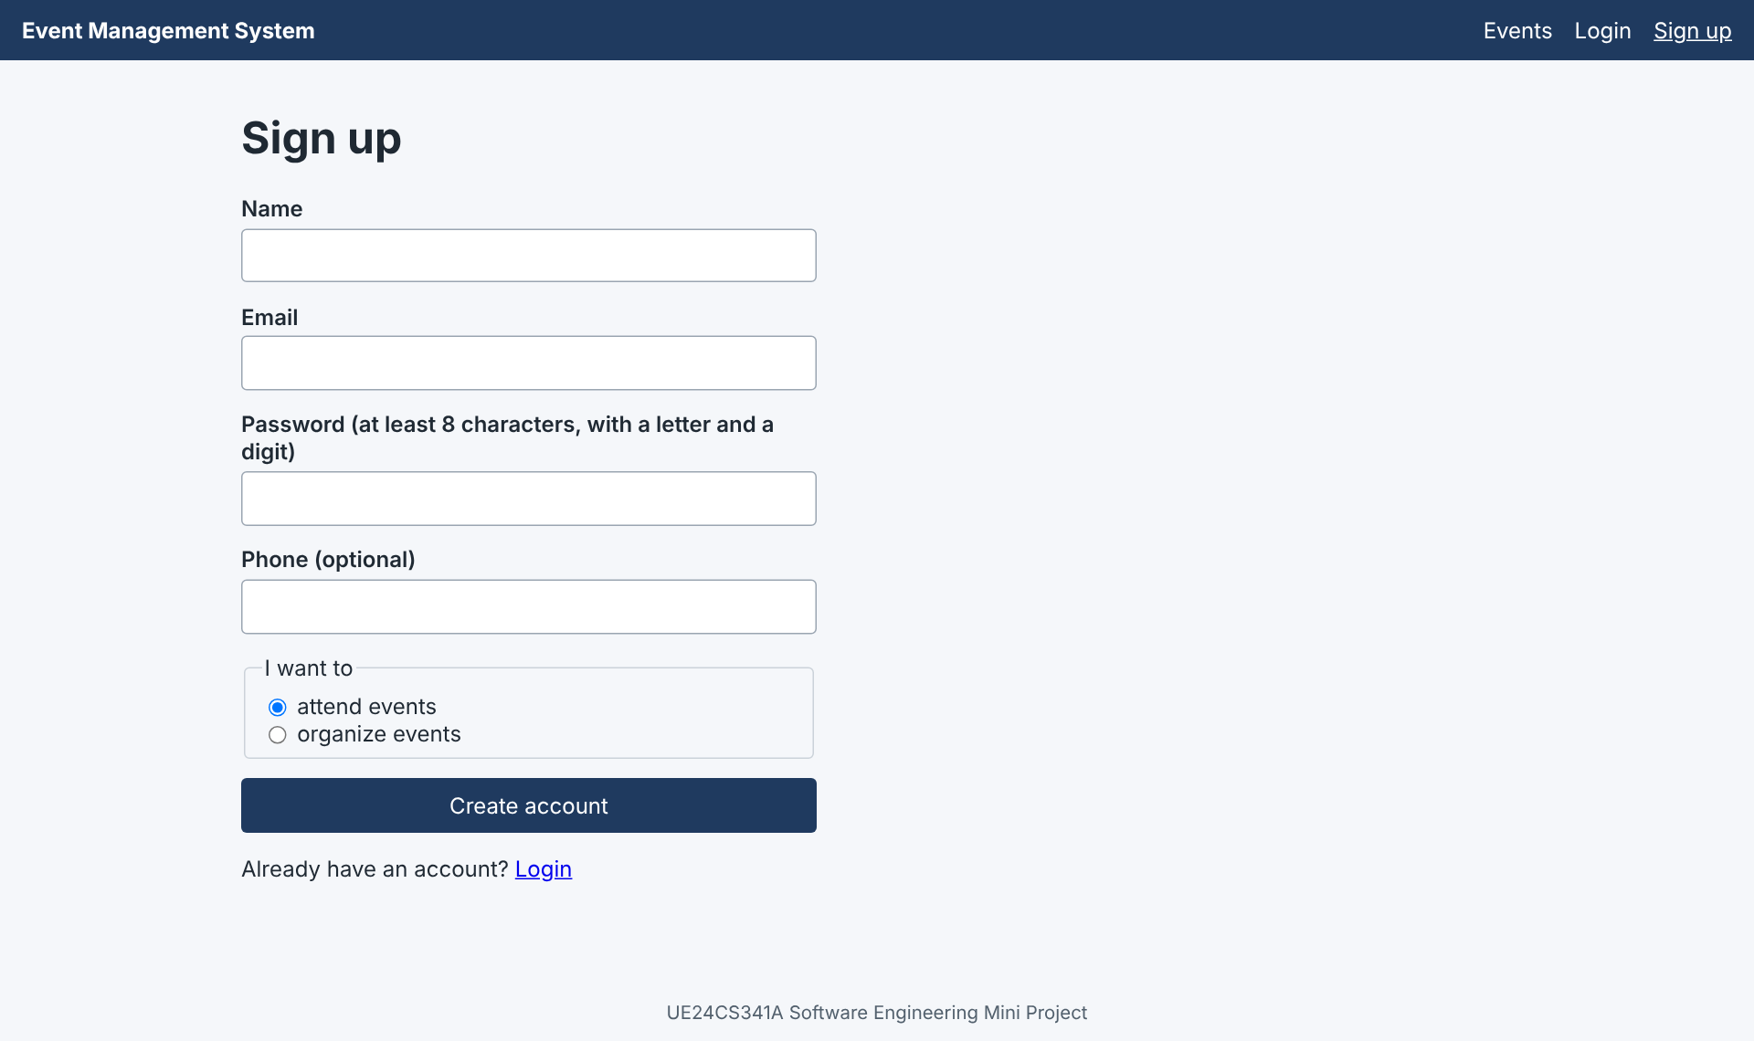
Figure 8.3: Sign-up form (EVT-F-001)
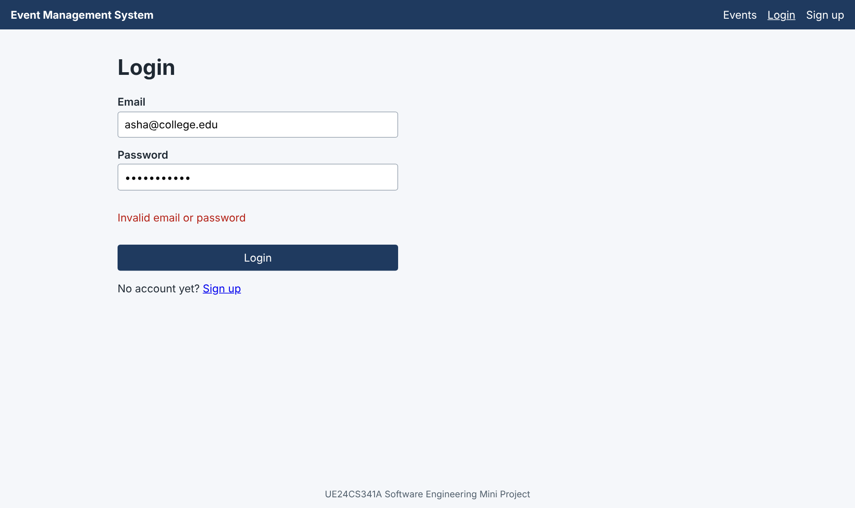
Figure 8.4: Wrong password: generic message, no hint which field is wrong (EVT-F-002)
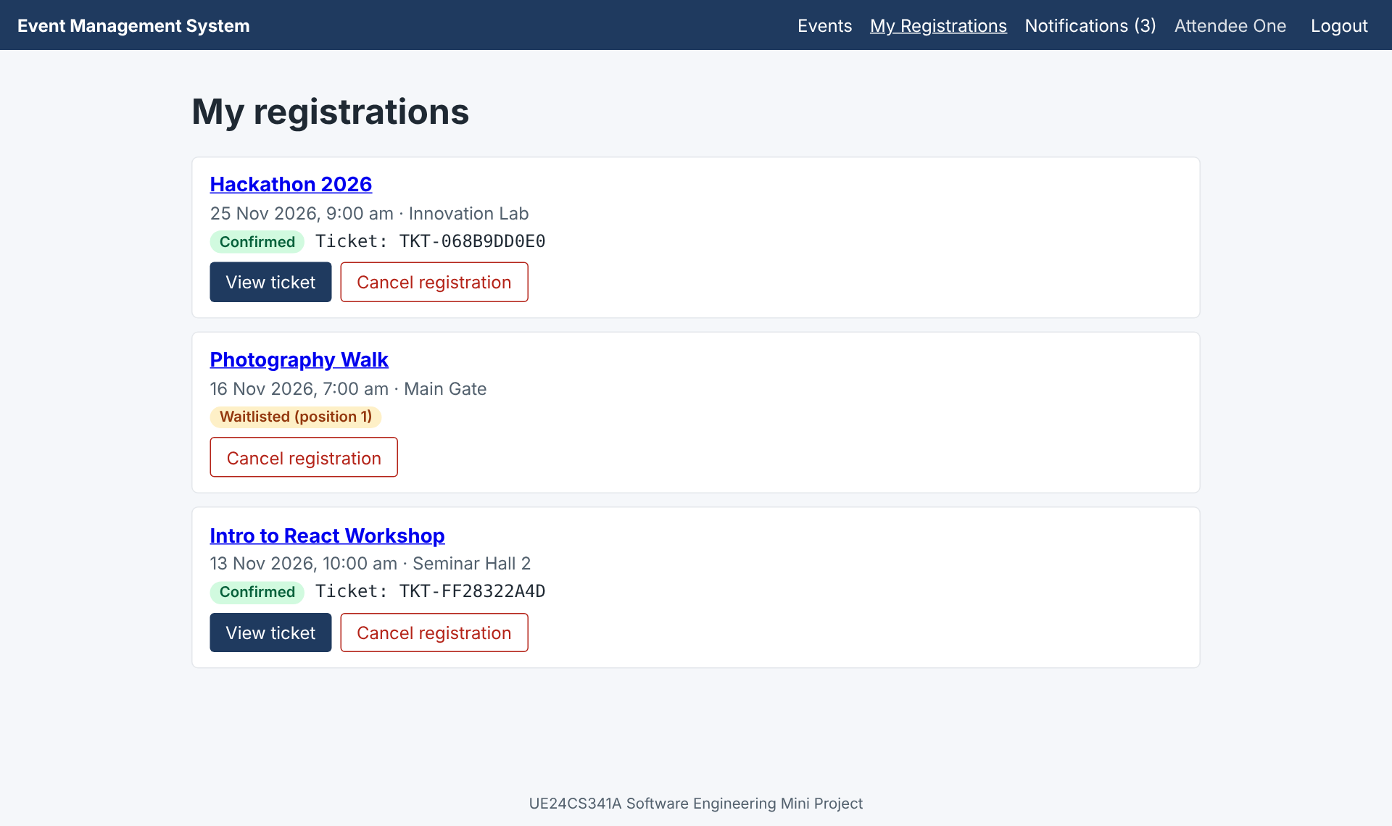
Figure 8.5: Attendee: My registrations with Confirmed and Waitlisted status (EVT-F-025)
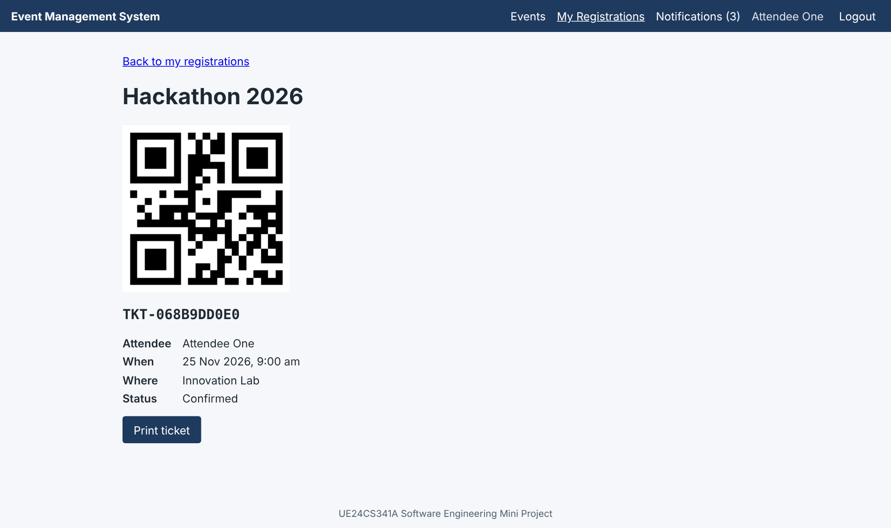
Figure 8.6: Ticket page with QR code (EVT-F-026)
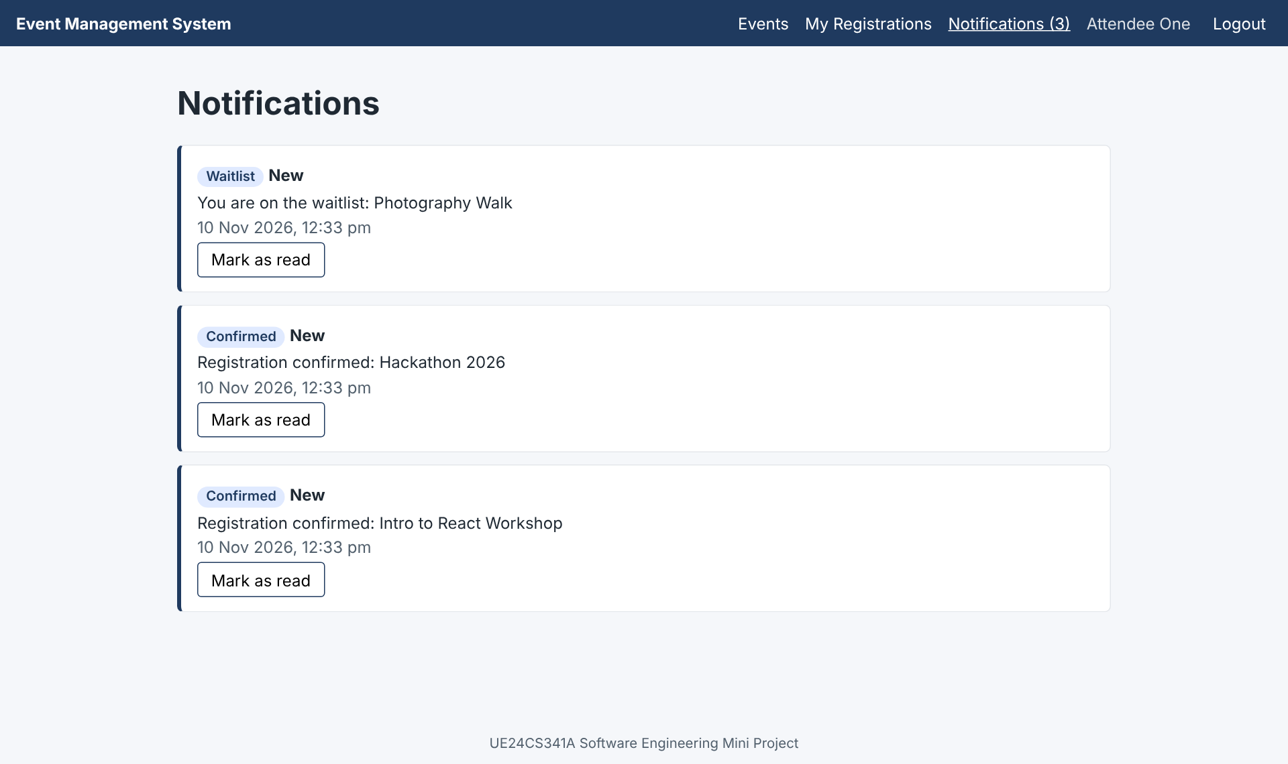
Figure 8.7: In-app notifications with unread count (EVT-F-034)
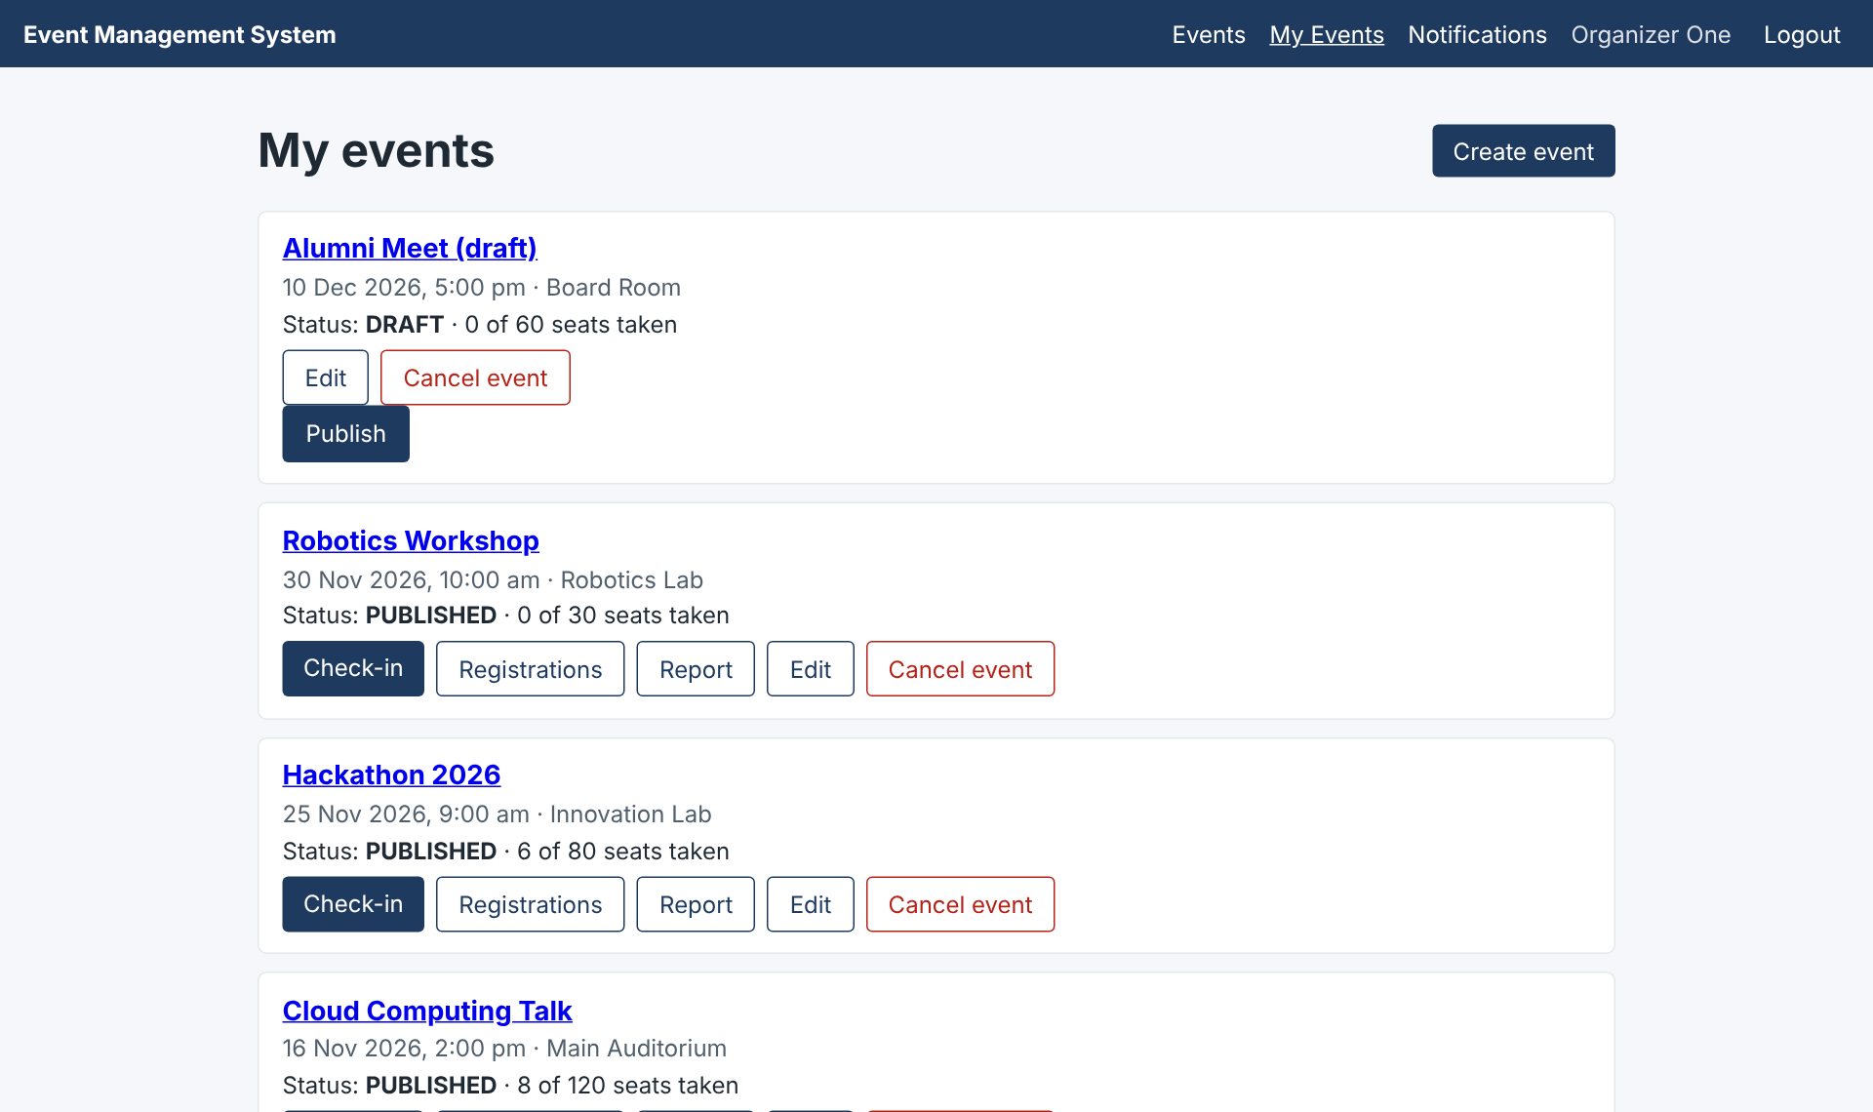
Figure 8.8: Organizer: My events with check-in, registrations, report, edit and cancel
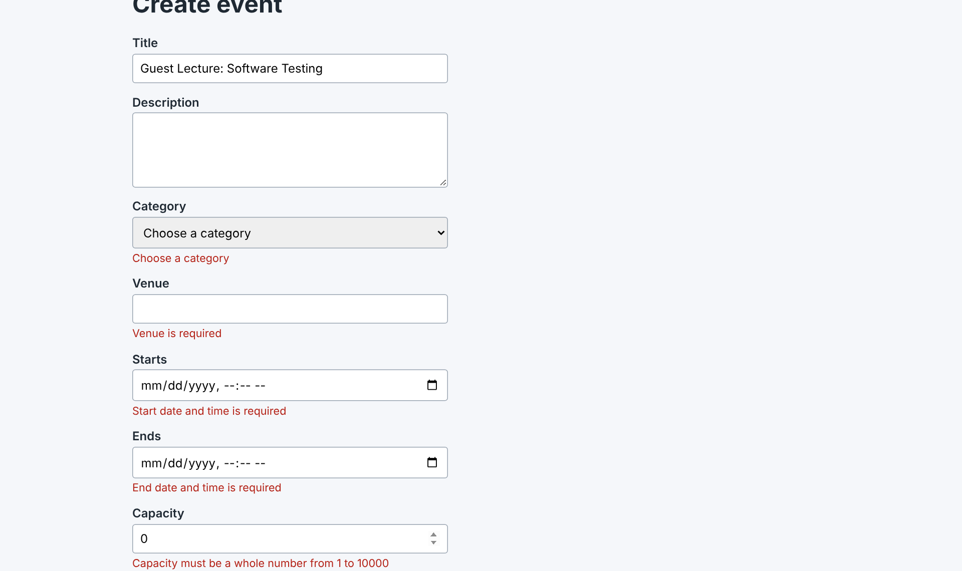
Figure 8.9: Create event: validation messages (EVT-F-011)
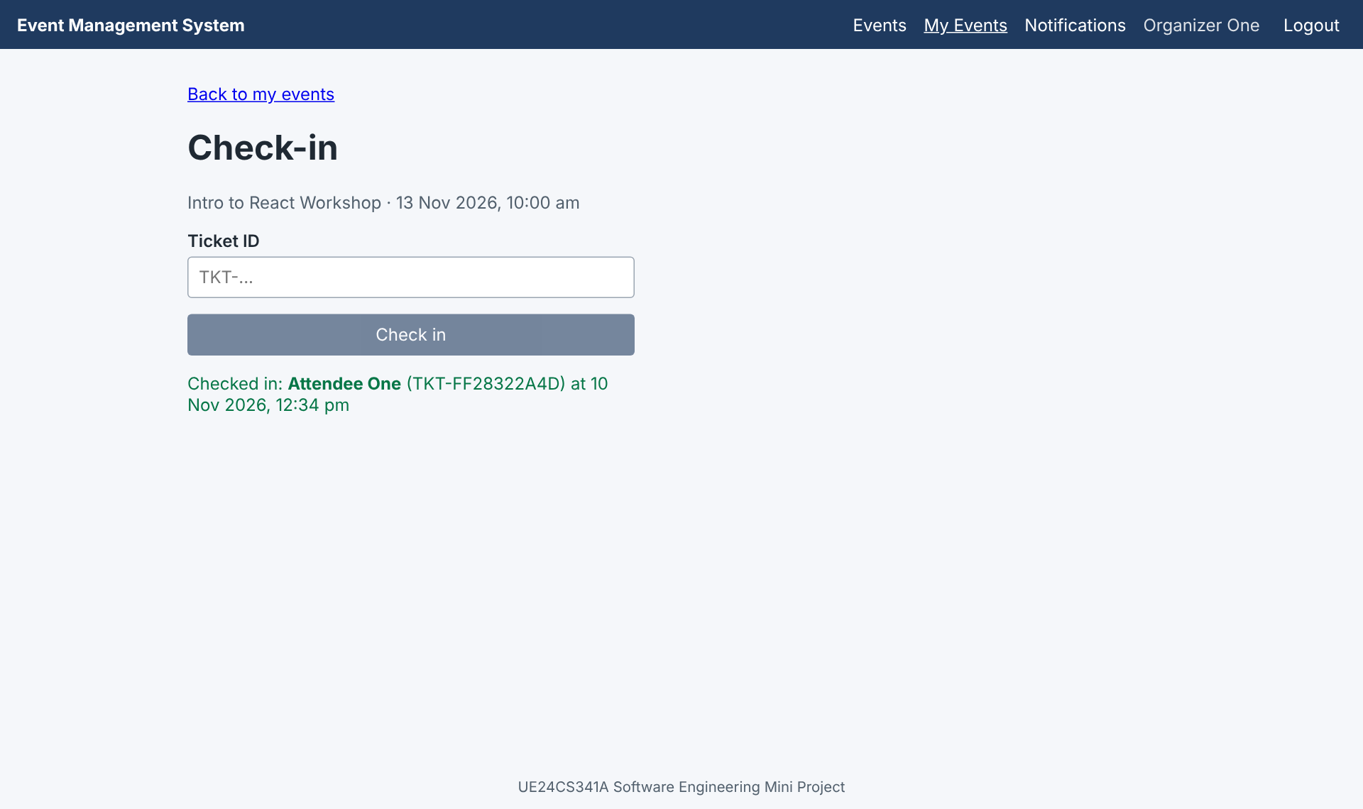
Figure 8.10: Check-in by ticket ID (EVT-F-030)
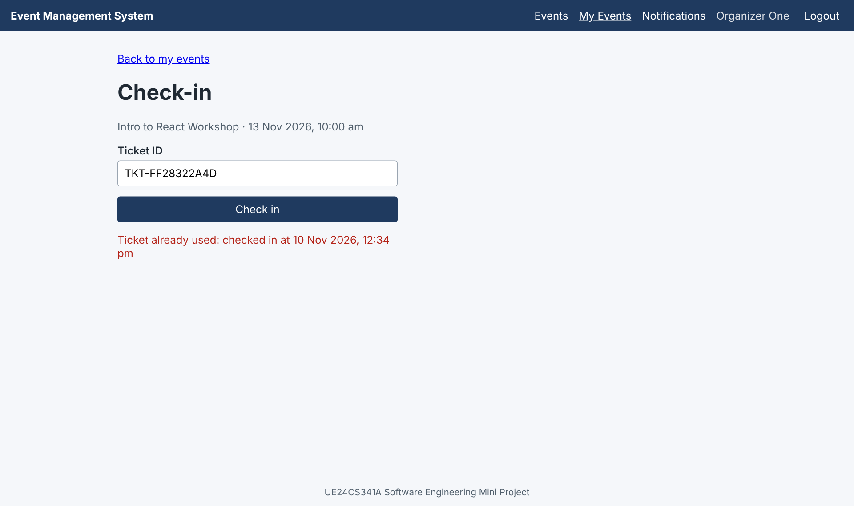
Figure 8.11: Second check-in of the same ticket is refused (EVT-F-031)
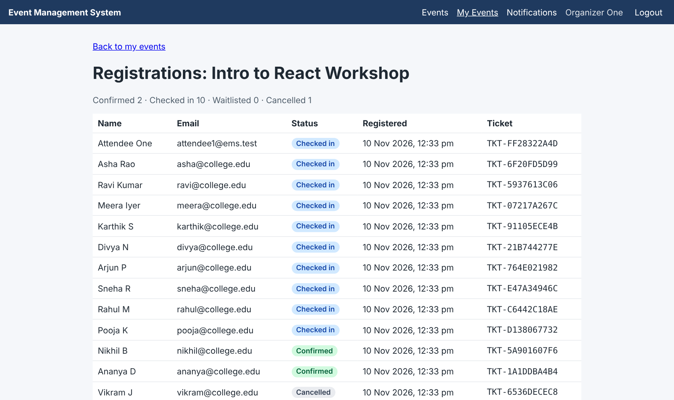
Figure 8.12: Organizer: registration list (EVT-F-027)
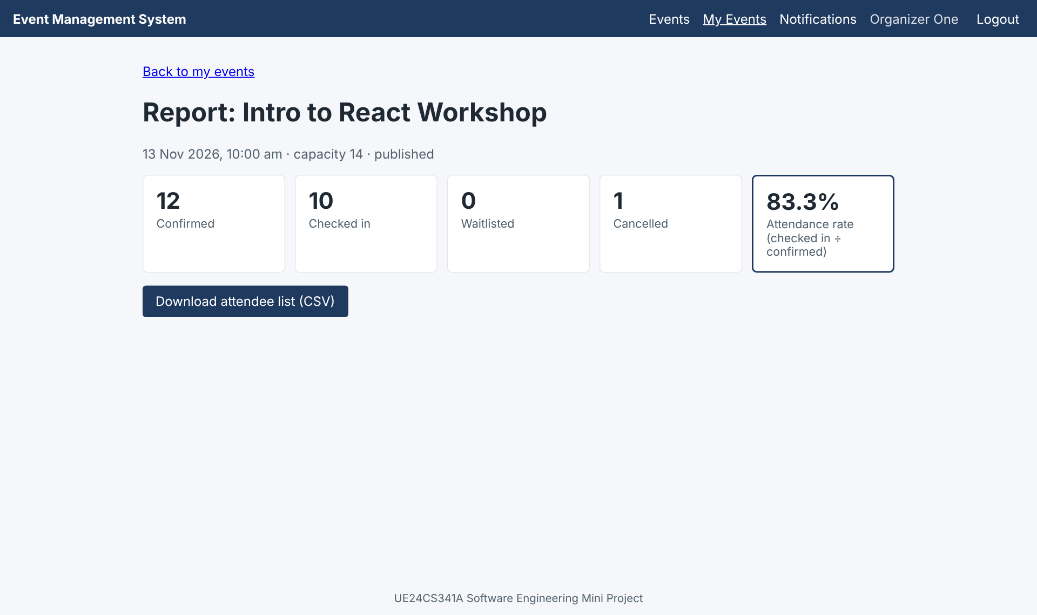
Figure 8.13: Attendance report with CSV export (EVT-F-035, EVT-F-036)
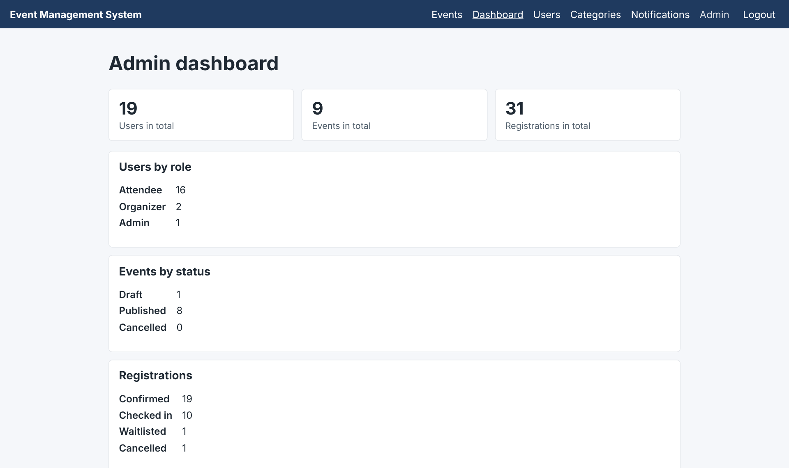
Figure 8.14: Admin dashboard (EVT-F-037)
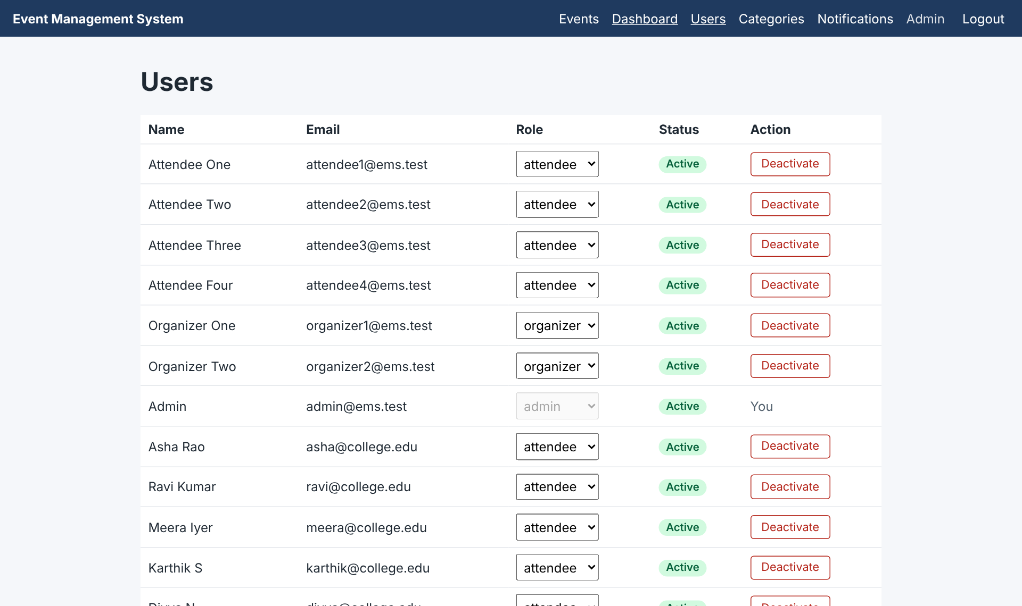
Figure 8.15: Admin: user and role management (EVT-F-006)
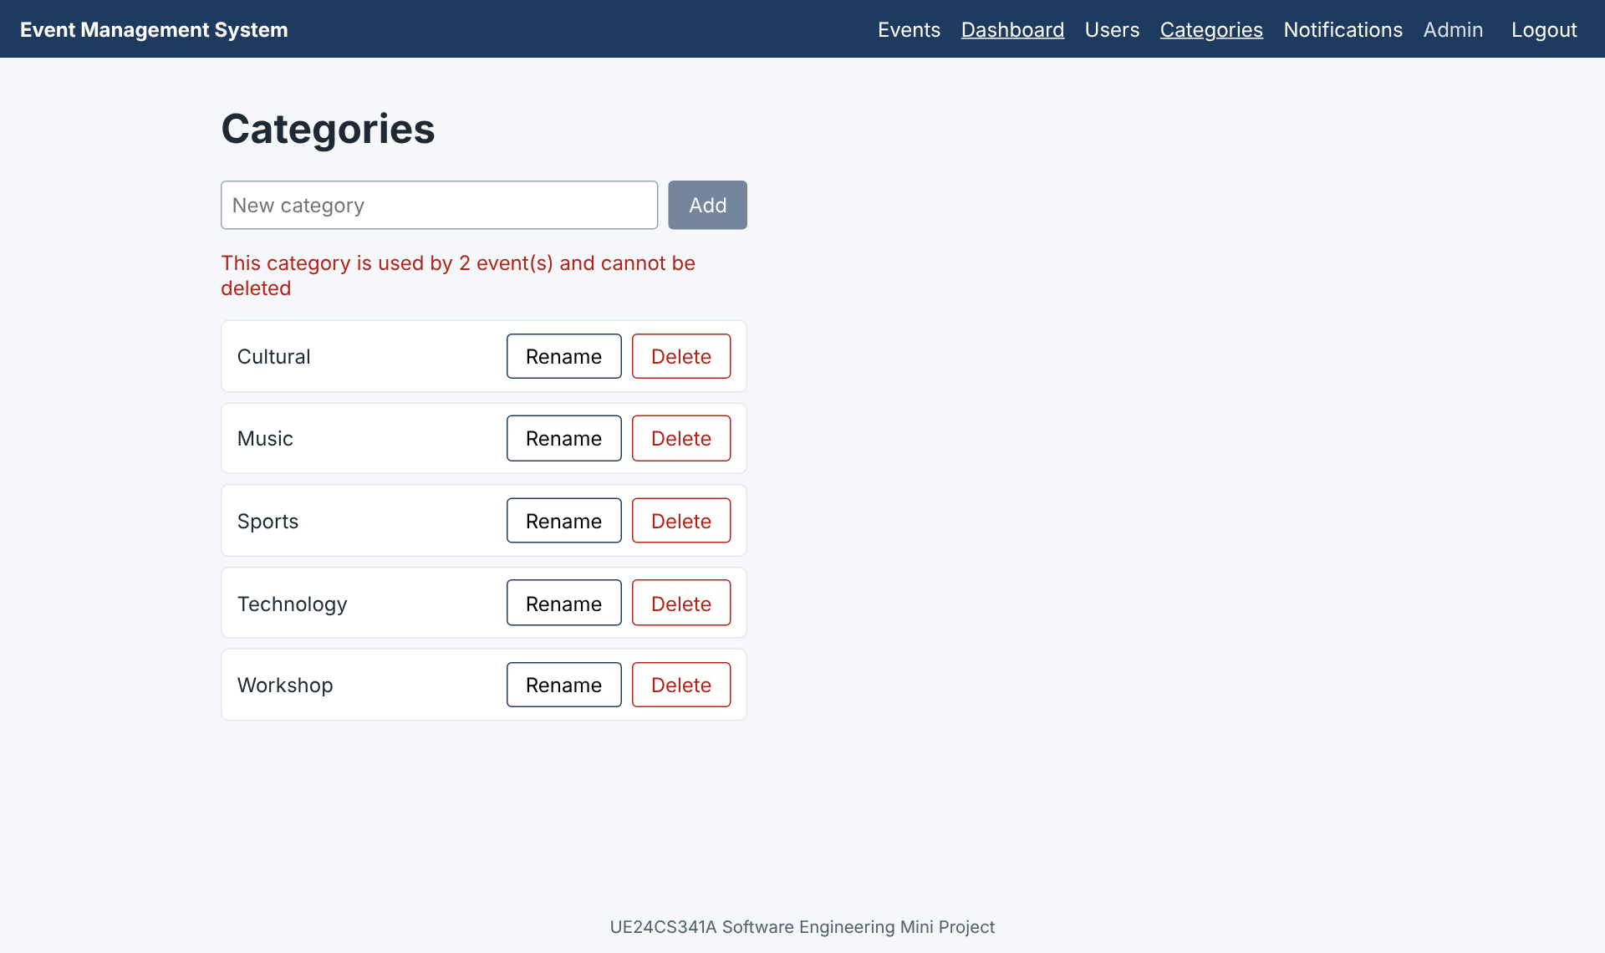
Figure 8.16: Admin: a category in use cannot be deleted (EVT-F-015)
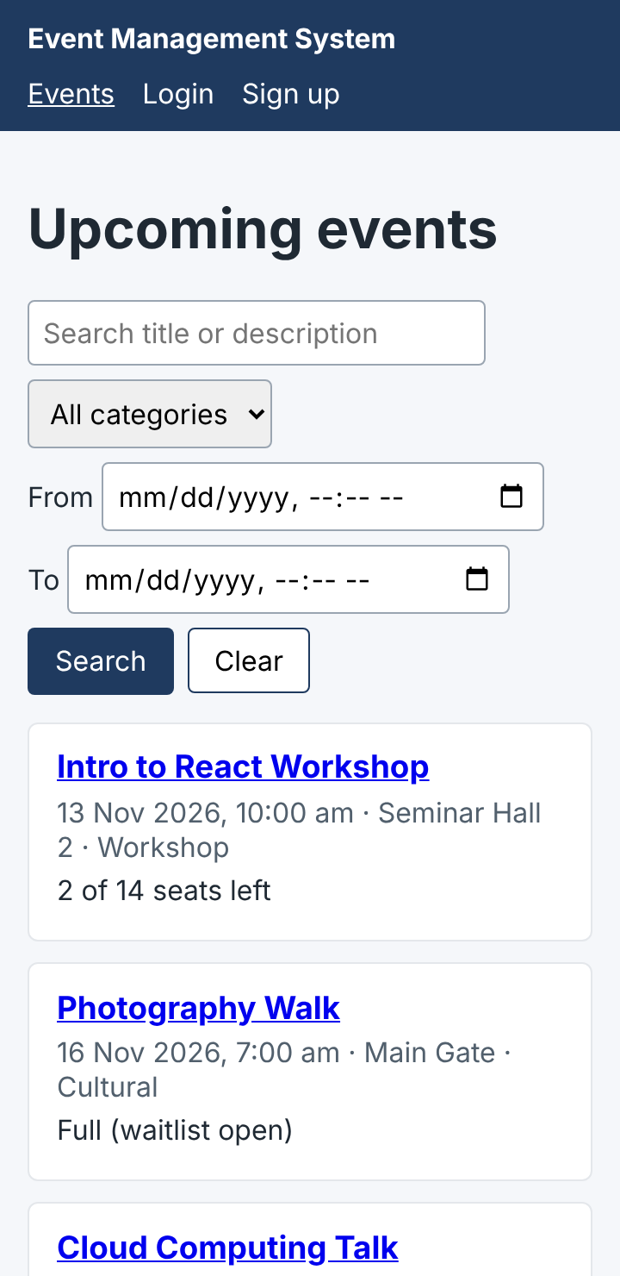
Figure 8.17: Mobile layout at 360 px (EVT-NF-003)

9. Conclusion
EMS was delivered as planned: all 48 backlog items over two sprints, by a team of four with one feature each. The system meets its functional and security requirements and its measurable non-functional targets, with no failed test cases.

What worked
- Requirements first, with IDs and acceptance criteria: the same IDs carried through the backlog, the pull requests, the tests and the traceability matrix, so progress and coverage were always visible.
- Feature ownership: each member could design, build, test and explain one complete feature.
- CI and branch protection: every change was linted, tested and reviewed before reaching main.
- A fixed order for dependent work kept the shared files free of conflicts.

Limitations and future work
- Availability was measured over a short period; a month-long measurement needs a deployed server.
- Browser testing was done in Chrome only.
- Future features (out of scope): online payments, seat maps, calendar integration, mobile apps.

Appendix: where to find each document
Document | Location in the repository
Proposal | docs/proposal/proposal.pdf
SRS, Test Plan, SAD (final, IEEE format) | docs/submission/ (Word and PDF)
Project plan | docs/project-plan/project-plan.pdf
Diagrams (sources and images) | docs/diagrams/
Sprint reviews and deviations | docs/sprint-reviews/
Sprint videos | docs/videos/sprint1-demo.mp4, sprint2-demo.mp4
Test reports | docs/test-reports/
Backlog and sprint board | GitHub Project "EMS Product Backlog"

