Software Architecture and Design Specification
Project: Vehicle Parking System
Version: 1.0
Team: Team 10, Department of Computer Science and Engineering, PES University
Prepared by:
- Ruturaj Rajaram Shedbale (PES1UG24CS606)
- Punith Nikhil G V (PES1UG24CS601)
- Revathi D B (PES1UG24CS604)
- P Manohar Reddy (PES1UG24CS586)
Date: 28 September 2026
Status: Draft

Revision History
Version | Date | Author | Change Summary
1.0 | 28-Sep-2026 | Team 10 | Initial draft

1. Introduction

1.1 Purpose
This document specifies the software architecture and design of the Vehicle Parking System, Version 1.0, developed by Team 10. It translates the functional and non-functional requirements defined in the Software Requirements Specification (SRS v1.0) into an architecture and design that developers can implement and testers can verify against the Test Plan (v1.0).

1.2 Scope
Covers the architecture and design of user registration and authentication, vehicle entry and automated slot allocation, vehicle exit and fee calculation, real-time parking slot availability, and administrative dashboard and reporting, as defined in SRS Sections 5.1–5.5.

1.3 Audience
Developers, project guides/evaluators, testers, and project team members, consistent with the intended audience defined in SRS Section 1.2.

1.4 Definitions
JWT (JSON Web Token), REST (Representational State Transfer), API (Application Programming Interface), RBAC (Role-Based Access Control), CRUD (Create, Read, Update, Delete), MERN (MongoDB, Express.js, React.js, Node.js).

2. Document Overview

2.1 How to use this document
Provides architectural deliverables including UML diagrams, the chosen architecture pattern, technology stack, data model, API design, and security considerations for the Vehicle Parking System. Requirement IDs (REQ-x.x) referenced throughout trace back to SRS Section 5.

2.2 Related Documents
Software Requirements Specification (SRS) v1.0 — Vehicle Parking System, Team 10; Test Plan v1.0 — Vehicle Parking System, Team 10 (40 test cases across Unit, Integration, and System testing); Requirement Traceability Matrix (SRS Appendix C).

3. Architecture

3.1 Goals & Constraints
Goals: real-time accuracy of slot availability, automated and error-free slot allocation and fee calculation, secure role-based authentication, and a responsive interface usable by owners, staff, and administrators (SRS Section 2.4).
Constraints (per SRS Section 2.5): the system must be built on the MERN stack; it must support concurrent access from multiple gate terminals without double-allocating a slot; the UI must be responsive on desktop and mobile; authentication must use hashed passwords and JWTs; role assignment must be enforced server-side, with public registration restricted to the Owner role and Staff/Admin roles assignable only by an existing Administrator; the project must be completed within the academic semester timeline.

3.2 Stakeholders & Concerns
Stakeholder | Concerns
Vehicle Owner | Ease of registration, accurate real-time slot availability, transparent fee calculation, access to parking history/receipts
Gate Staff | Fast, low-friction entry/exit logging (3 clicks or fewer per SRS 6.4)
Administrator | Accurate occupancy and revenue reporting, control over slot/pricing configuration and staff/admin accounts
Developers / Testers / Evaluators | Modularity, maintainability, and traceability of design to SRS requirements and test cases

3.3 Component (UML) Diagram
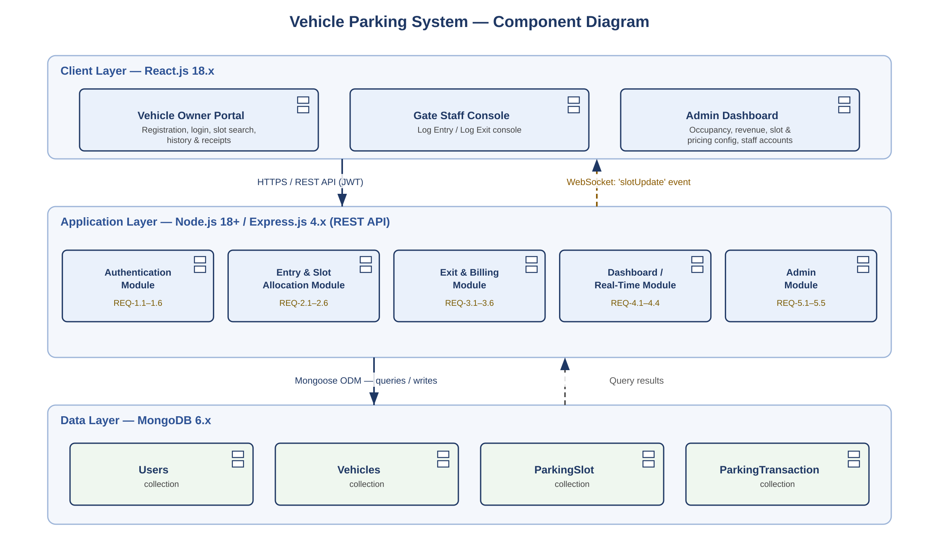
Figure 1: Component diagram — Client, Application, and Data layers.

3.4 Component Descriptions
- Client Layer (React.js 18.x): Vehicle Owner Portal, Gate Staff Console, and Admin Dashboard (SRS Section 3.1).
- Authentication Module: handles registration, bcrypt password hashing, JWT issuance/validation, and role-based route protection (REQ-1.1–REQ-1.6).
- Entry & Slot Allocation Module: records vehicle entry, allocates the nearest available slot matching vehicle type, marks it Occupied, and generates a unique entry ticket (REQ-2.1–REQ-2.6).
- Exit & Billing Module: calculates parking duration and fee, releases the slot, generates a digital receipt, and records payment method (REQ-3.1–REQ-3.6).
- Dashboard / Real-Time Module: broadcasts slot-status changes to connected clients via WebSockets (Socket.IO) or short-interval polling, and supports filtering by zone/vehicle type (REQ-4.1–REQ-4.4).
- Admin Module: slot and pricing configuration, staff/admin account management, and occupancy/revenue reporting with CSV/PDF export (REQ-5.1–REQ-5.5).
- Database (MongoDB 6.x): persists Users, Vehicles, ParkingSlot, and ParkingTransaction collections (SRS Appendix B).

3.5 Chosen Architecture Pattern and Rationale
A layered, modular MVC-style architecture was chosen for clear separation of concerns between presentation, business logic, and data persistence, directly supporting the maintainability quality attribute in SRS Section 6.4. A microservices approach was considered but rejected as unnecessarily complex for a single-facility academic mini-project.

3.6 Technology Stack & Data Stores
Component | Name & Version | Purpose
Frontend | React.js 18.x | Client-side single page application
Backend | Express.js 4.x on Node.js 18+ | REST API implementing business logic
Database | MongoDB 6.x | Persistent storage of users, vehicles, slots, and transactions
Authentication | JSON Web Tokens (JWT) | Stateless session/authentication management
Real-Time Communication | WebSockets / Socket.IO or short-interval polling | Live slot-status updates to connected clients
Payment Gateway (optional) | Razorpay/Stripe sandbox | Simulated online fee payment

3.7 Risks & Mitigations
Risk | Mitigation
Race condition causing double-allocation of a slot under concurrent gate terminal access | Atomic database operations / optimistic locking when allocating a slot (SRS 2.5 concurrency constraint)
Real-time sync failure between clients and server | Fall back to short-interval polling if the WebSocket connection drops
Duplicate vehicle entry for a vehicle already parked | Server-side uniqueness check against active entries before allocation (REQ-2.5)
Loss of billing data from accidental deletion of an in-progress transaction | Disallow deletion of active transactions; maintain an audit trail (SRS 6.2 Safety)

3.8 Traceability to Requirements
Requirement | Architecture Component | Related Test Cases
REQ-1.1 – REQ-1.6: Registration & Authentication | Authentication Module | UT_01–UT_03, IT_01–IT_03, ST_01–ST_02
REQ-2.1 – REQ-2.6: Vehicle Entry & Slot Allocation | Entry & Slot Allocation Module | UT_04–UT_06, IT_04–IT_06, ST_03–ST_04
REQ-3.1 – REQ-3.6: Vehicle Exit & Fee Calculation | Exit & Billing Module | UT_07–UT_09, IT_07–IT_09, ST_05–ST_06
REQ-4.1 – REQ-4.4: Real-Time Slot Availability | Dashboard / Real-Time Module | UT_10–UT_12, IT_10–IT_12, ST_07–ST_08
REQ-5.1 – REQ-5.5: Admin Dashboard & Reporting | Admin Module | UT_13–UT_15, IT_13–IT_15, ST_09–ST_10

3.9 Security Architecture
Threat Modeling (STRIDE), mapped to SRS Section 6.3 Security Requirements:
- Spoofing → JWT-based authentication issued only after email/password verification.
- Tampering → all slot allocation and fee calculation logic is enforced server-side, never trusted from the client.
- Information Disclosure → HTTPS/TLS for all client-server communication; passwords hashed with bcrypt and never logged.
- Denial of Service → rate limiting on authentication and entry/exit endpoints.
- Elevation of Privilege → role-based access control enforced on both client and server for every protected endpoint; the 'Staff' and 'Admin' roles are never selectable at public registration and can only be granted by an existing Administrator (REQ-1.1, REQ-5.4); session tokens expire after a configurable inactivity period.

4. Design

4.1 Design Overview
The Vehicle Parking System is designed with layered, modular components separating the user interface, business logic, and data persistence, to ease maintenance and testing and to keep each module independently traceable to its SRS requirements and Test Plan cases.

4.2 UML Sequence Diagrams
At least 2 sequence diagrams covering flows specific to this project:
- Registration & Login (REQ-1.1–REQ-1.6)
- Vehicle Entry & Slot Allocation (REQ-2.1–REQ-2.6)
- Vehicle Exit & Fee Calculation (REQ-3.1–REQ-3.6)
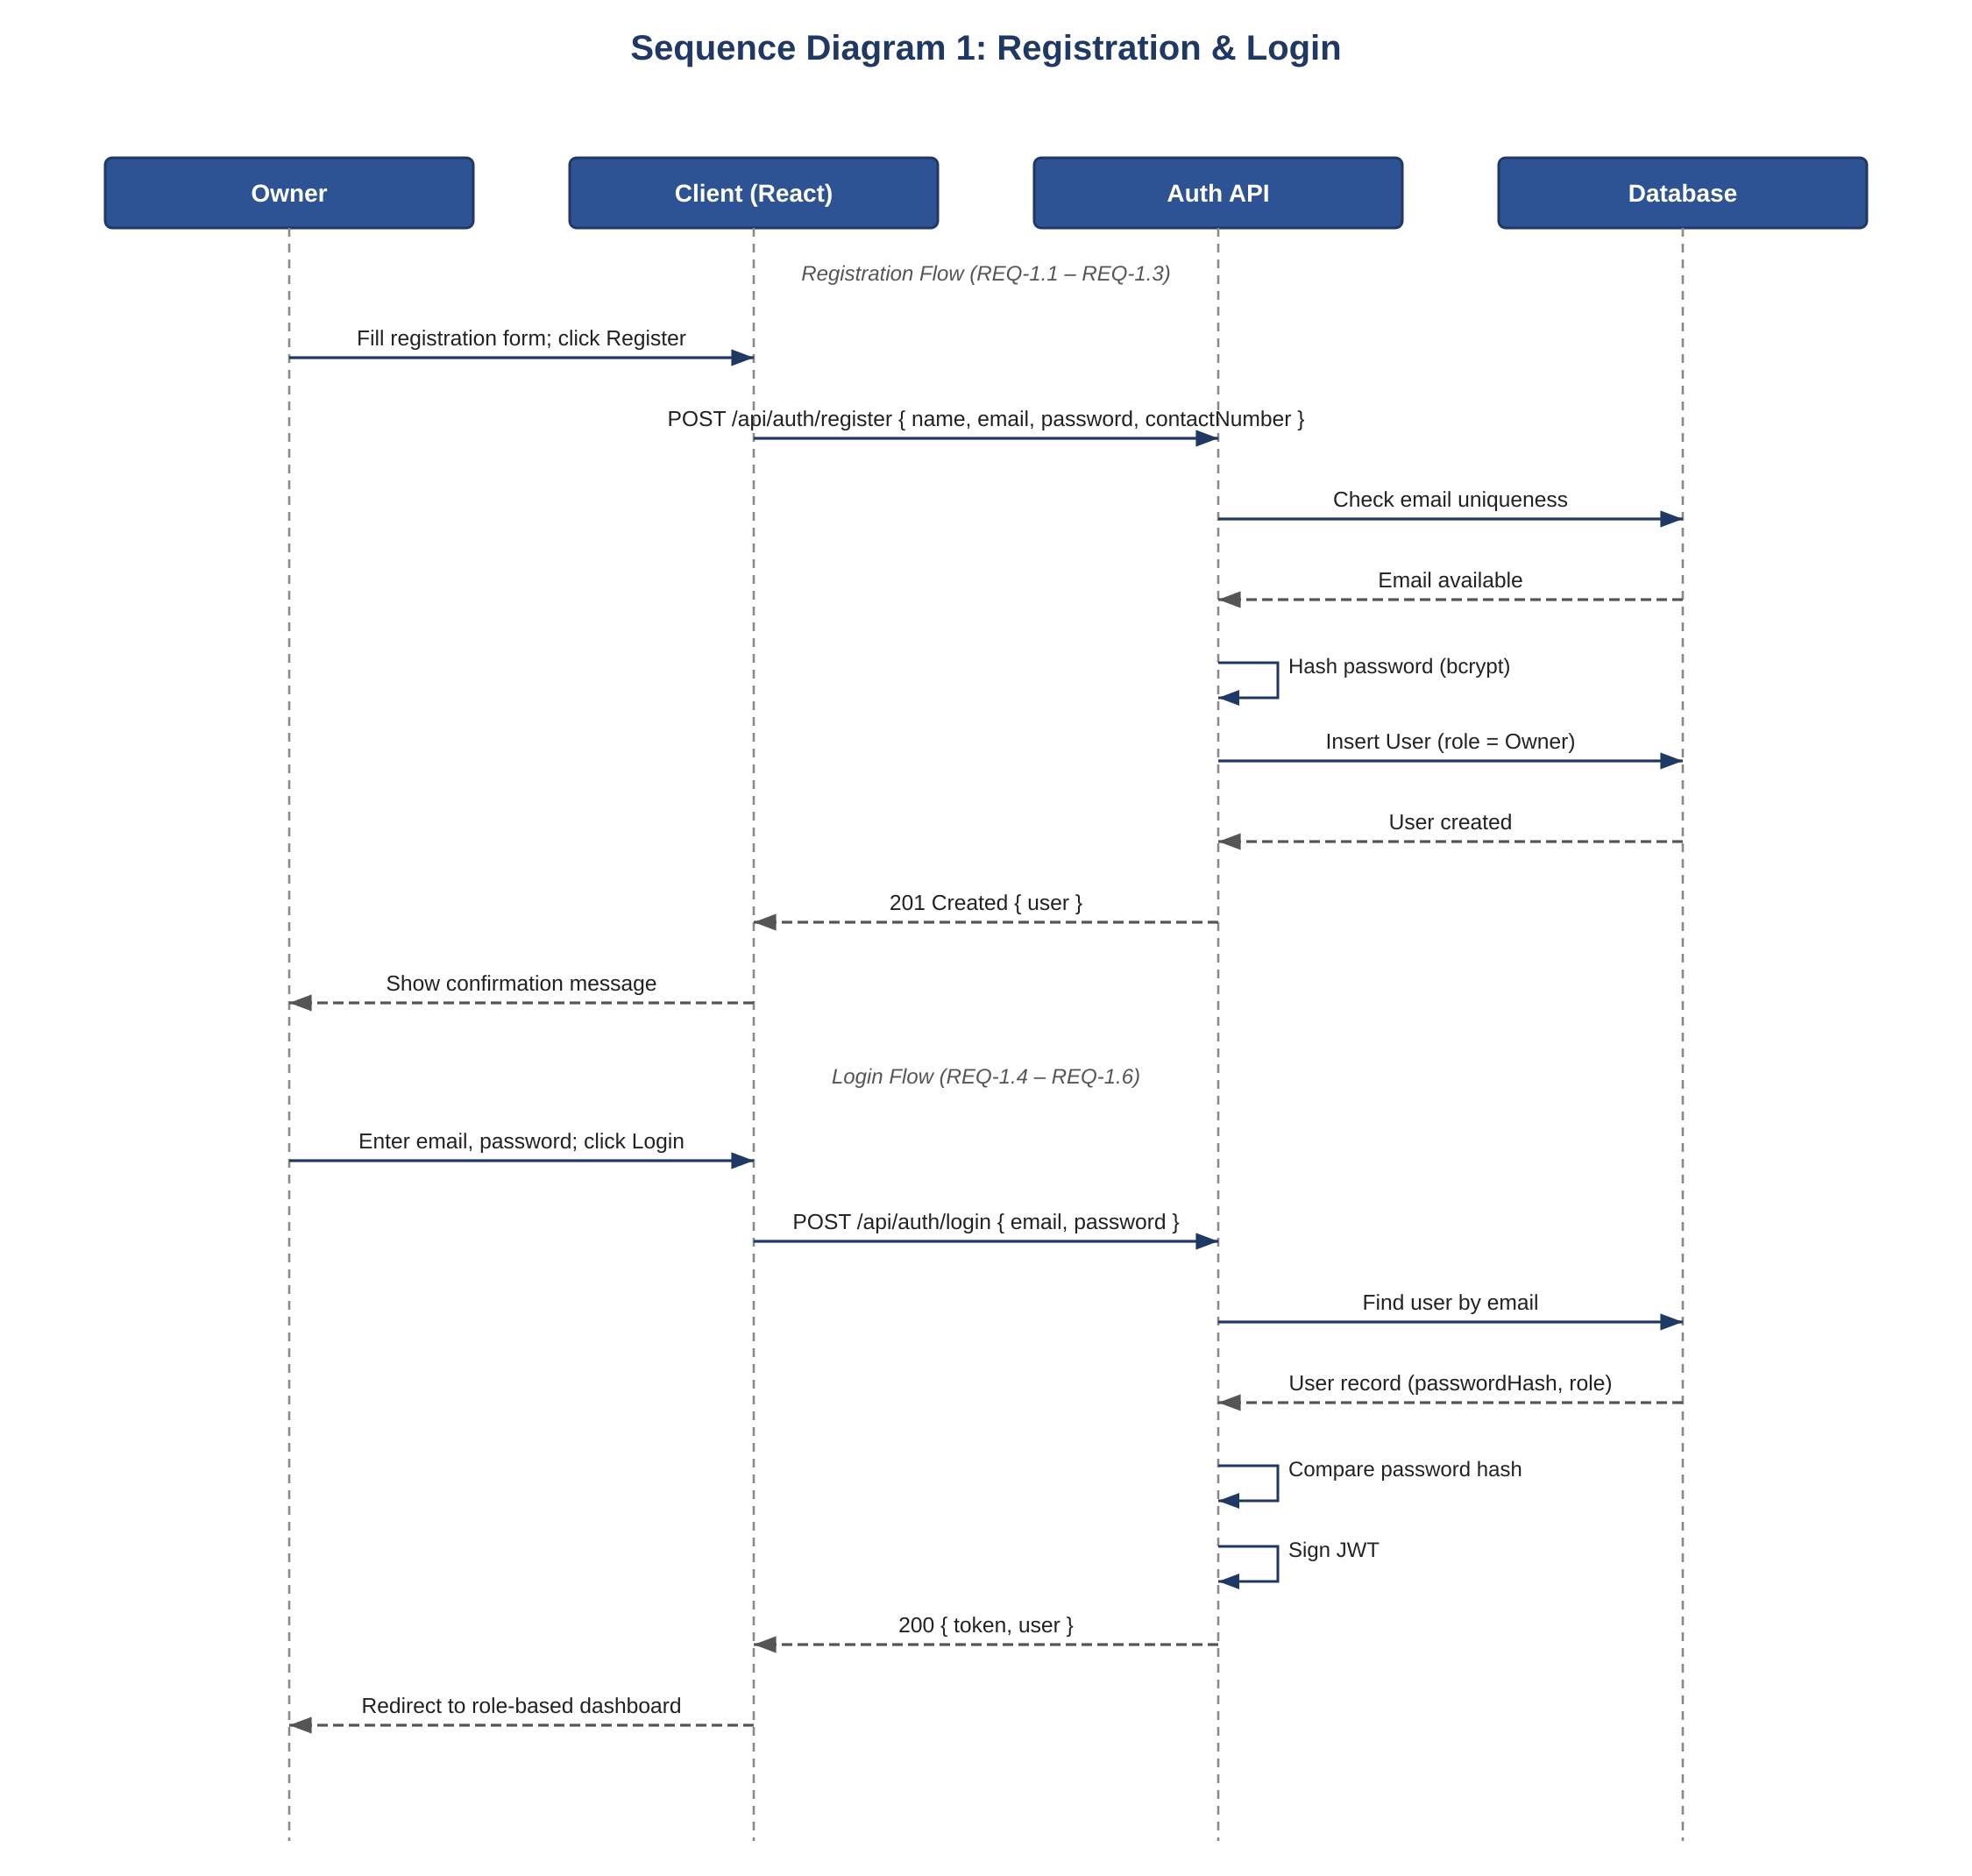
Figure 2: Sequence diagram — Registration & Login (REQ-1.1–REQ-1.6).
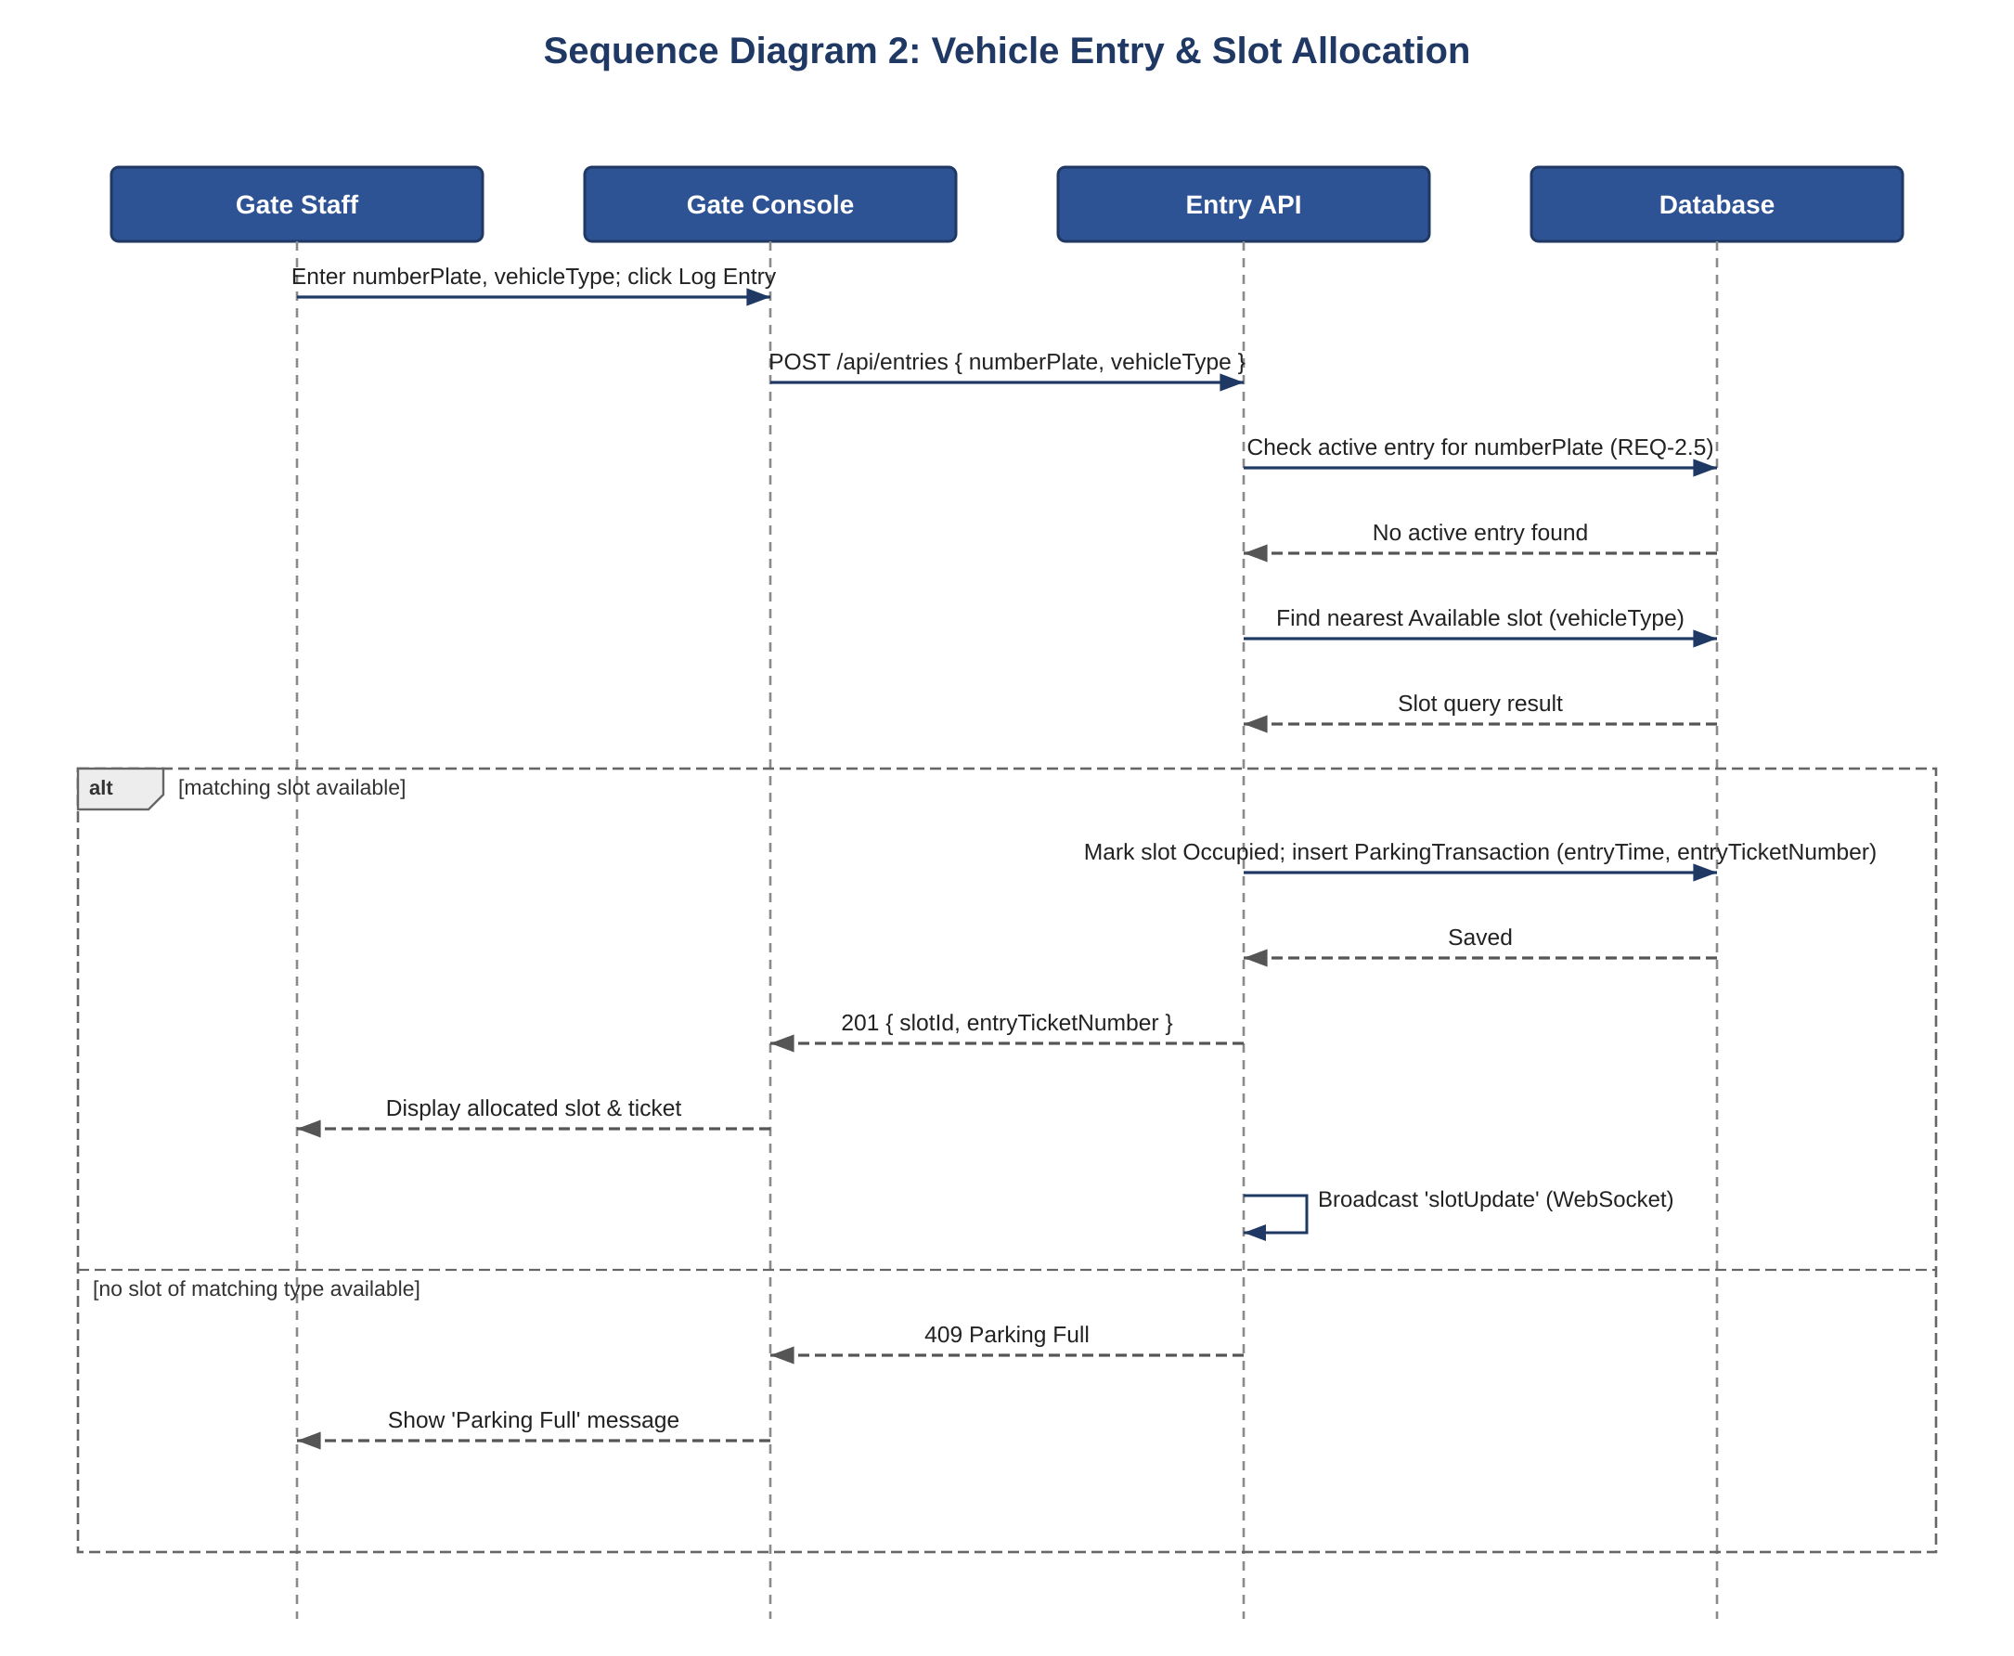
Figure 3: Sequence diagram — Vehicle Entry & Slot Allocation (REQ-2.1–REQ-2.6).
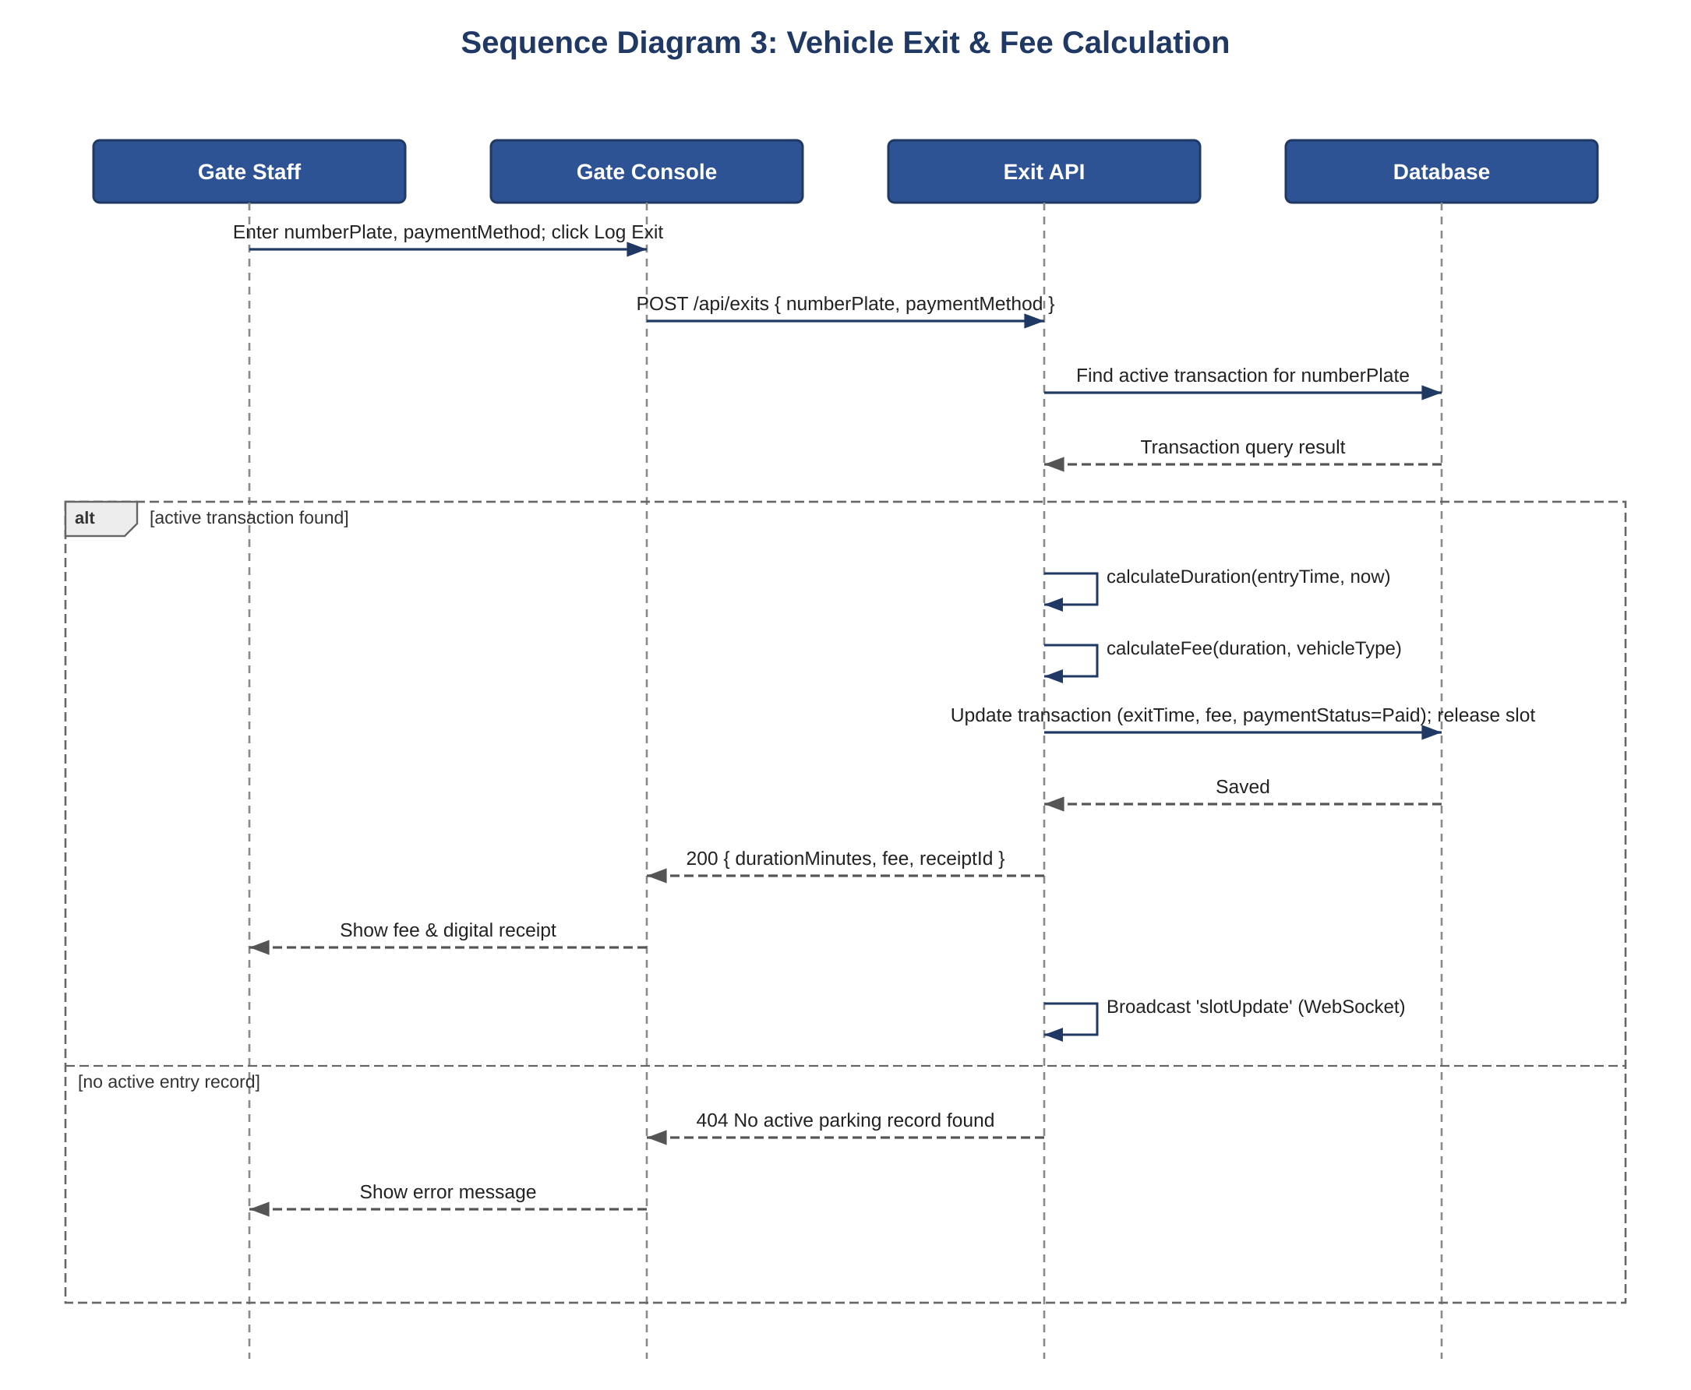
Figure 4: Sequence diagram — Vehicle Exit & Fee Calculation (REQ-3.1–REQ-3.6).

4.3 API Design
REST endpoints, consistent with the Integration Test cases defined in the Test Plan:
Endpoint | Method | Request | Response / Errors
/api/auth/register | POST | { name, email, password, contactNumber } | 201 created user (role auto-set to Owner); 409 if email already registered
/api/auth/login | POST | { email, password } | 200 { token, user }; generic error on invalid credentials
/api/entries | POST | { numberPlate, vehicleType } | 201 { slotId, entryTicketNumber }; 409 Parking Full; 400 duplicate entry
/api/exits | POST | { numberPlate, paymentMethod } | 200 { durationMinutes, fee, receiptId }; 404 no active entry record
/api/slots | GET | ?zone=&vehicleType= (optional) | 200 [ { slotId, zone, vehicleType, status } ]
/api/reports | GET | ?startDate=&endDate= | 200 { occupancy, revenue } aggregated for the range
/api/admin/slots | POST | { zone, slotNumber, vehicleType } | 201 created slot; Admin role required
/api/admin/users/{id} | PATCH | { status: 'active' | 'inactive' } | 200 updated account; Admin role required

Real-Time Channel: the server broadcasts a 'slotUpdate' event over the WebSocket (Socket.IO) channel whenever an entry or exit changes a slot's status, so connected dashboards update without a page refresh (REQ-4.2).

4.4 Data Model
Core entities, consistent with the field layouts in SRS Appendix B:
Entity | Key Fields
User | userId, name, email (unique), passwordHash, contactNumber, role (Owner / Staff / Admin)
Vehicle | vehicleId, ownerId, numberPlate, vehicleType
ParkingSlot | slotId, zone, slotNumber, status (Available / Occupied / Reserved), vehicleType
ParkingTransaction | transactionId, vehicleNumberPlate, vehicleType, slotId, entryTicketNumber, entryTime, exitTime, fee, paymentStatus, paymentMethod

4.5 Error Handling, Logging & Monitoring
All API responses follow a standard JSON structure containing a status code, message, and data payload (SRS Section 3.3). No sensitive information (passwords, tokens) is written to logs. An audit trail is maintained for all entry, exit, and administrative configuration changes (SRS 6.2). Monitoring includes slot allocation failure rate, average parking duration, and API response times.

4.6 UX Design
Three role-specific interfaces (SRS Section 3.1): the Vehicle Owner Portal (login/registration, slot-availability dashboard, parking history/receipts), the Gate Staff Console (a simplified 'Log Entry' / 'Log Exit' screen completable in three clicks or fewer per SRS 6.4), and the Admin Dashboard (occupancy statistics, revenue charts, slot/pricing configuration, and staff/user management). All screens share a consistent style guide and display clear, specific error messages.

5. Appendices

5.1 Glossary
Slot — a single designated physical parking space that can hold one vehicle. Entry Ticket — a unique reference generated when a vehicle enters, used to match the corresponding exit. JWT — a compact, signed token used for stateless authentication. MERN Stack — MongoDB, Express.js, React.js, Node.js. Occupancy Rate — the percentage of total slots currently occupied. Role — the access level (Owner, Staff, Admin) assigned to a User account.

5.2 References
IEEE recommended practice for software requirements specification (base template for the SRS); MongoDB Documentation (mongodb.com/docs); Express.js Documentation (expressjs.com); React.js Documentation (react.dev); Node.js Documentation (nodejs.org/en/docs).

5.3 Tools
PlantUML, draw.io, Postman/Swagger, MongoDB Atlas.

