PES UNIVERSITY, BANGALORE
VEHICLE PARKING SYSTEM
FINAL SOFTWARE ENGINEERING DELIVERABLES
Team 10 | Department of Computer Science and Engineering
Version 1.0 | Final Consolidated Submission

1. Security Objectives
The following security objectives complement the security requirements defined in the SRS and the STRIDE-based security architecture in the SAD.
SO-1 — Confidentiality: Protect user, authentication, and parking transaction information from unauthorized access, disclosure, or modification.
SO-2 — Authorization: Ensure that only authorized users can perform Staff and Administrator operations and access protected system functions.
SO-3 — Integrity: Maintain the integrity of parking slot allocation, entry/exit records, and fee calculations against unauthorized modification.

2. UML Use Case Diagram
The diagram below provides the required project-specific UML use-case model using the three actors defined by the SRS.
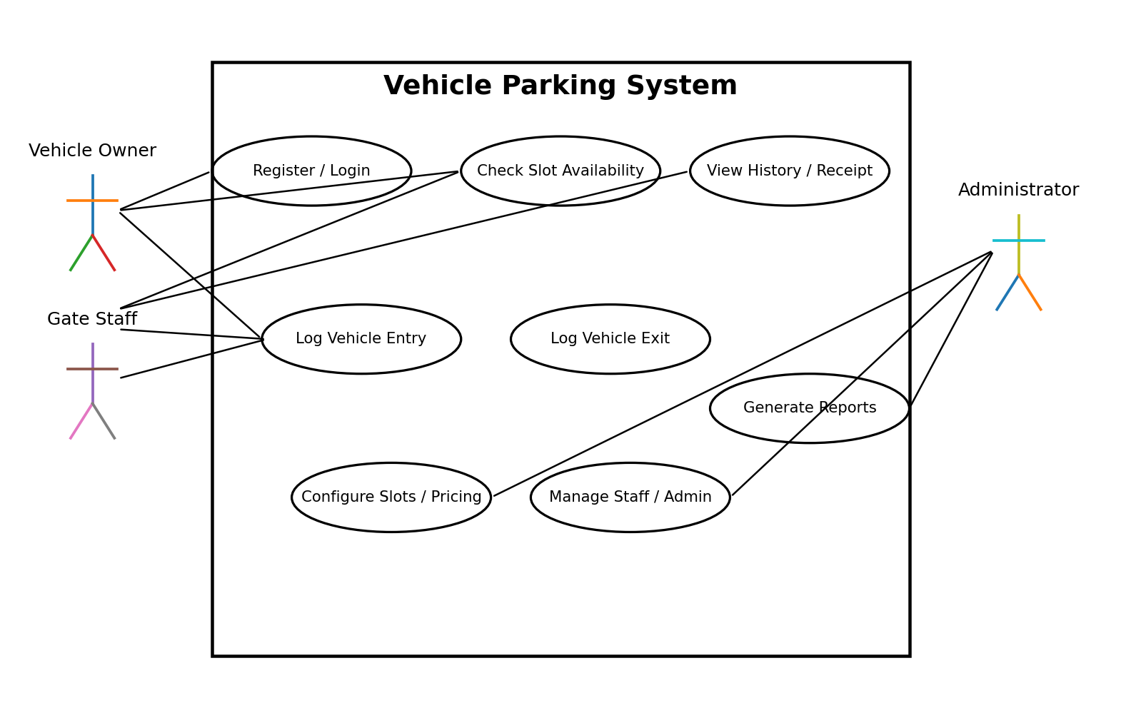
Figure 1: UML Use Case Diagram — Vehicle Parking System.

3. Entity-Relationship Diagram
The ER model uses the four core entities defined by the SRS: User, Vehicle, ParkingSlot, and ParkingTransaction.
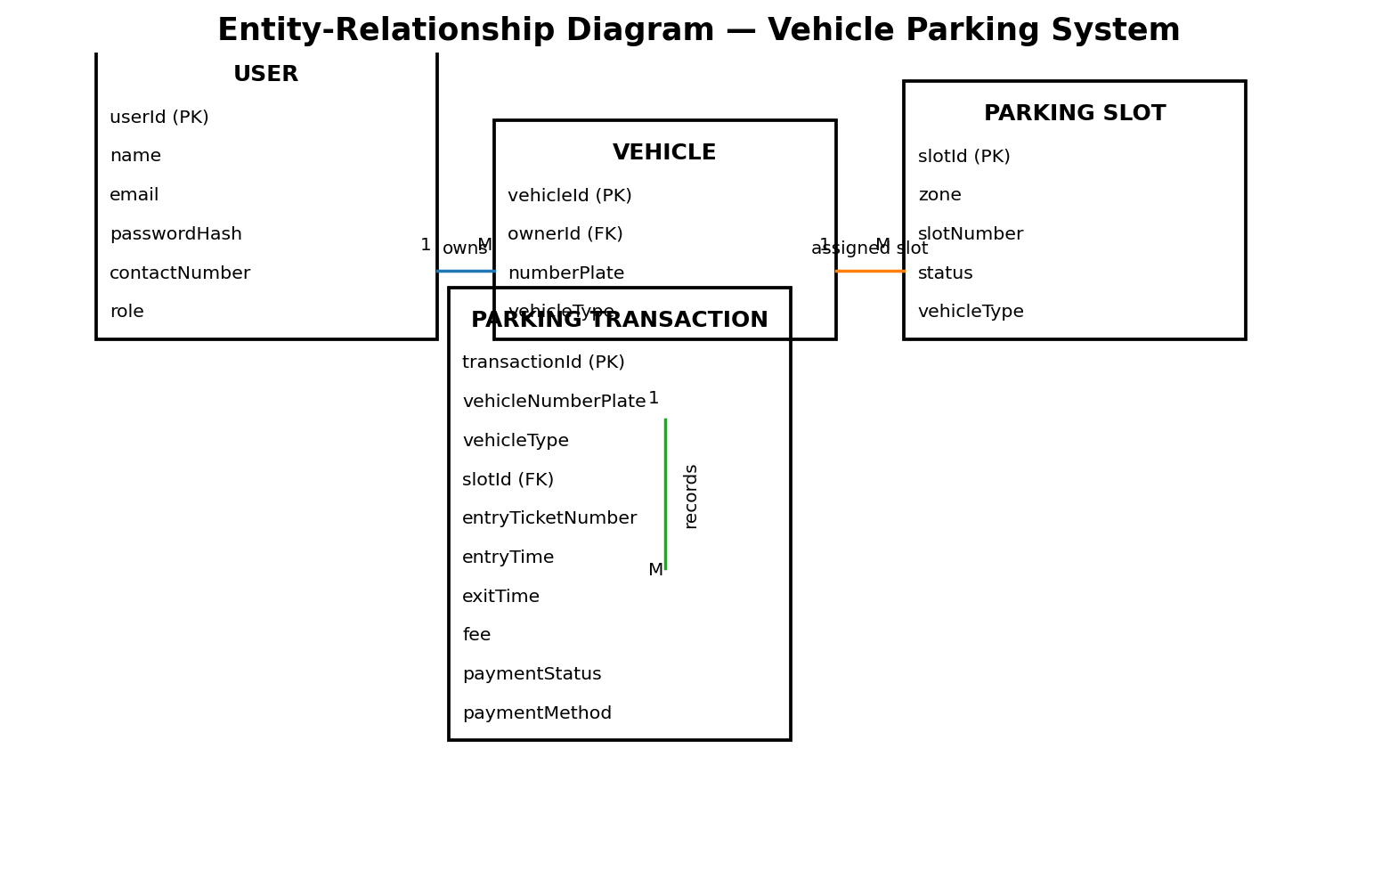
Figure 2: Entity-Relationship Diagram — Vehicle Parking System.

4. Component Architecture
The project uses a layered, modular MVC-style architecture separating presentation, business logic, and data persistence. The components correspond to the architecture described in the SAD.
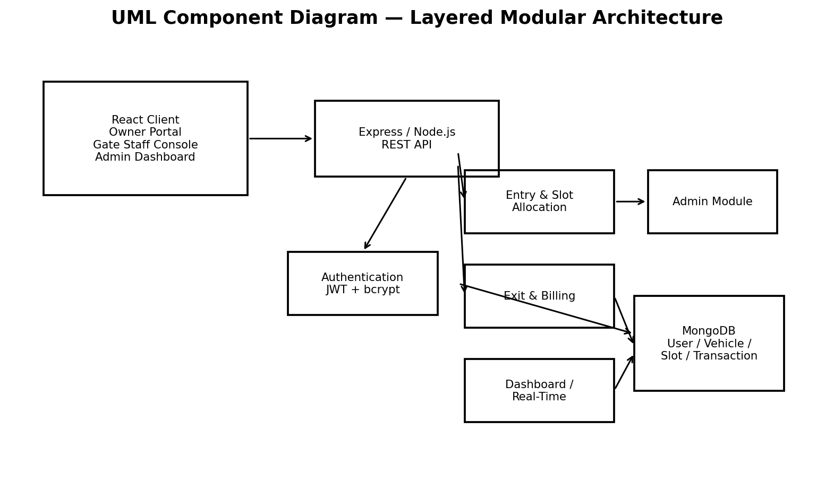
Figure 3: UML Component Diagram — Layered Modular Architecture.

5. Sequence Diagrams
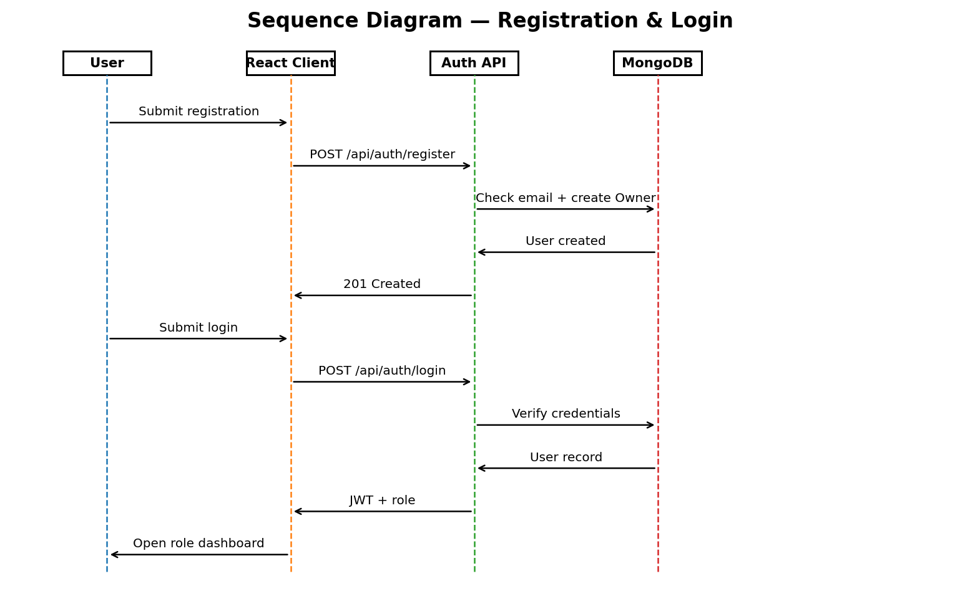
Figure 4: Sequence Diagram — Registration & Login (REQ-1.1–REQ-1.6).
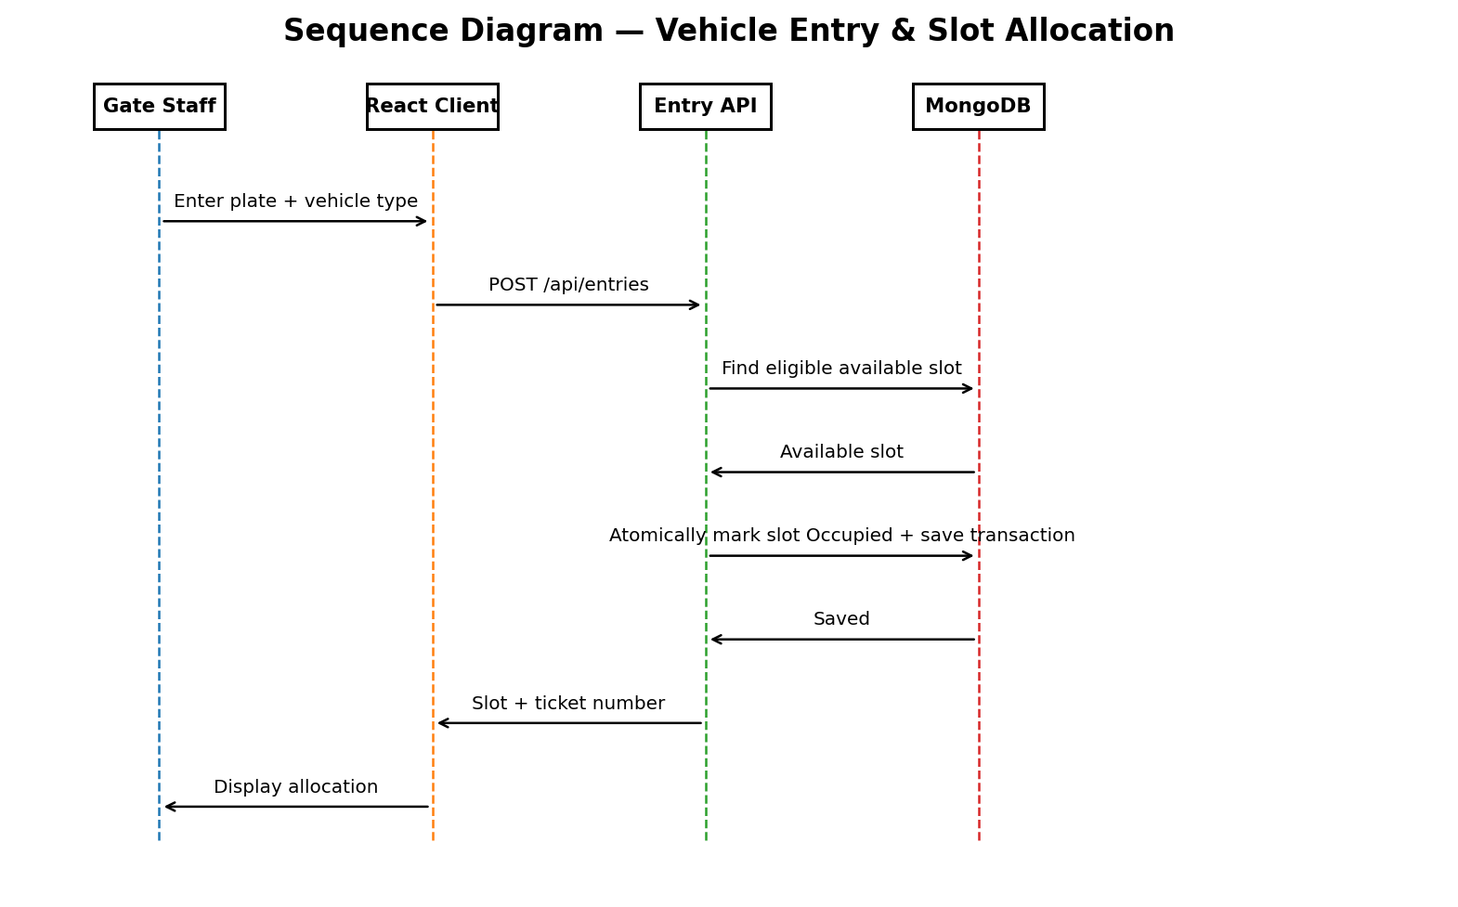
Figure 5: Sequence Diagram — Vehicle Entry & Slot Allocation (REQ-2.1–REQ-2.6).
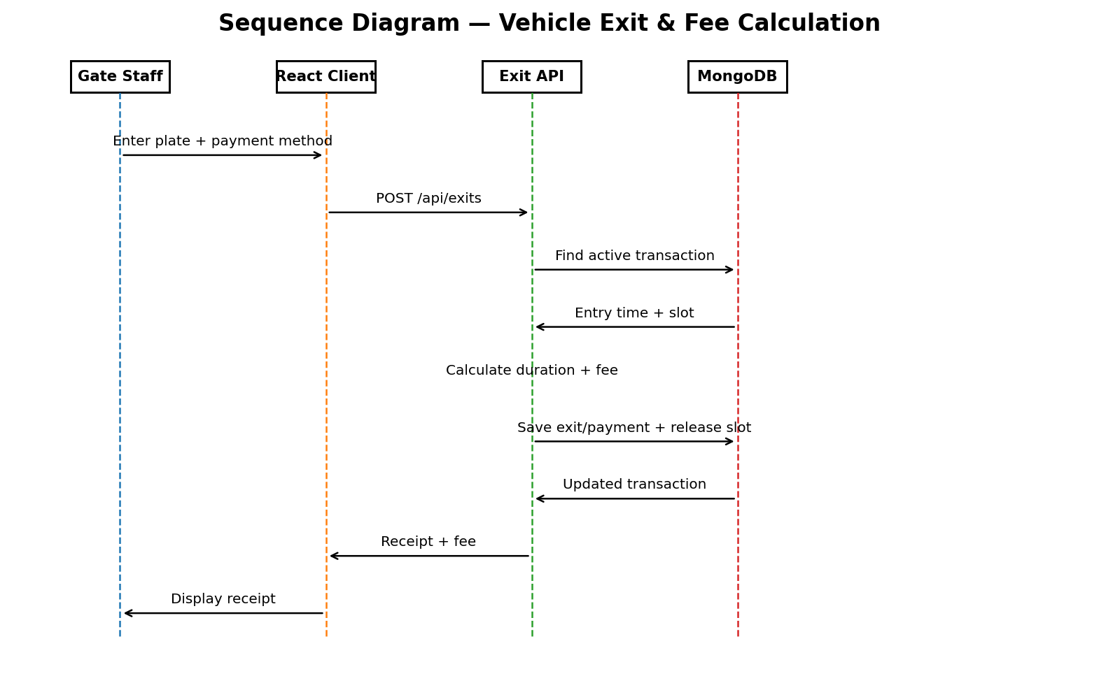
Figure 6: Sequence Diagram — Vehicle Exit & Fee Calculation (REQ-3.1–REQ-3.6).

6. Security Validation Test Cases
These security validation cases are added to the Test Plan as a dedicated security-validation section. Actual Result and Status remain for execution by the testing team.
ID | Test | Method | Expected Result | Traceability
SEC-01 | Password protection | Create a user and inspect the stored user record. | Password is stored as a secure one-way hash; plaintext is not stored or logged. | SO-1 / REQ-1.3
SEC-02 | Unauthorized role access | Access an Admin-only endpoint using an Owner or Staff account. | Request is rejected and protected data is unchanged. | SO-2 / REQ-1.5
SEC-03 | Privileged role injection | Submit public registration with role=Staff or role=Admin. | Server rejects/ignores the supplied privileged role and creates only Owner. | SO-2 / REQ-1.1
SEC-04 | Invalid/expired JWT | Use an invalid or expired token on a protected endpoint. | Server rejects the request and does not expose protected data. | SO-2 / REQ-1.4
SEC-05 | Transport security | Access protected client-server communication in the configured deployment. | Communication uses HTTPS/TLS. | SO-1 / SRS 6.3
SEC-06 | Server-side authorization | Attempt to change slot/pricing configuration without Admin authorization. | Server rejects the operation even if the client is manipulated. | SO-2 / REQ-5.1
SEC-07 | Login protection | Submit incorrect credentials repeatedly according to the defined lockout scenario. | Temporary account protection is triggered and a warning is displayed. | SO-2 / REQ-1.6
SEC-08 | Sensitive logging | Perform authentication and inspect application logs. | Passwords and tokens are not written to logs. | SO-1 / SRS 6.3

7. Non-Functional Test Validation
The existing Test Plan already contains the 12-item Non-Functional Test Checklist. The following finalized wording preserves those existing checks and makes their acceptance conditions explicit.
ID | Category | Test Condition | Acceptance Result
NFR-01 | Performance | Slot-availability query | Within 2 seconds under normal load of up to 100 concurrent users.
NFR-02 | Performance | Vehicle entry/exit operation | Within 3 seconds including allocation/release.
NFR-03 | Performance | Daily transaction capacity | At least 500 parking transactions per day without performance degradation.
NFR-04 | Safety | Active transaction deletion | Active/in-progress parking transactions cannot be deleted.
NFR-05 | Safety/Audit | Audit trail | Entry, exit, and administrative configuration changes are recorded.
NFR-06 | Security | Password protection | Passwords are hashed and plaintext passwords are not stored or logged.
NFR-07 | Security | Transport security | Client-server communication uses HTTPS/TLS.
NFR-08 | Security | RBAC | Role-based access control is enforced on client and protected server endpoints.
NFR-09 | Security | JWT expiry | JWT session tokens expire after the configured inactivity period.
NFR-10 | Usability | Staff workflow | Gate staff can complete an entry or exit in three clicks or fewer.
NFR-11 | Reliability | Restart recovery | Slot status remains correctly reconciled after a server restart.
NFR-12 | Portability | Browser support | Web client functions on the latest two major versions of Chrome, Firefox, and Edge.

8. Corrected Requirement Traceability Matrix
The Test Plan contains 40 functional test cases: 15 Unit, 15 Integration, and 10 System tests. The corrected RTM below aligns the system-test references with the actual Test Plan numbering.
Requirement | Description | Architecture Reference | Design Reference | Unit/Integration Tests | System Tests
REQ-1.1–REQ-1.6 | Registration & Authentication | Authentication Module | Auth Module Design | UT_01–UT_03; IT_01–IT_03; IT_16–IT_17 | ST_01–ST_02
REQ-2.1–REQ-2.6 | Vehicle Entry & Slot Allocation | Entry & Slot Allocation Module | Entry Module Design | UT_04–UT_06; IT_04–IT_06 | ST_03–ST_04
REQ-3.1–REQ-3.6 | Vehicle Exit & Fee Calculation | Exit & Billing Module | Exit/Billing Module Design | UT_07–UT_09; IT_07–IT_09 | ST_05–ST_06
REQ-4.1–REQ-4.4 | Real-Time Slot Availability | Dashboard / Real-Time Module | Dashboard Module Design | UT_10–UT_12; IT_10–IT_12 | ST_07–ST_08
REQ-5.1–REQ-5.5 | Admin Dashboard & Reporting | Admin Module | Admin Module Design | UT_13–UT_15; IT_13–IT_15 | ST_09–ST_10

9. Final Architecture and Design References
Architecture Pattern: Layered, modular MVC-style architecture separating presentation, business logic, and data persistence.
Technology Stack: React.js 18.x, Express.js 4.x on Node.js 18+, MongoDB 6.x, JWT, bcrypt, and WebSockets/Socket.IO or short-interval polling.
Core Modules: Authentication; Entry & Slot Allocation; Exit & Billing; Dashboard / Real-Time; Admin Module; MongoDB data layer.
Security Architecture: STRIDE-based controls covering spoofing, tampering, information disclosure, denial of service, and elevation of privilege.
API Design: REST endpoints for registration, login, entry, exit, slots, reports, admin slots, and admin user management; slotUpdate is broadcast through the real-time channel.
Error Handling & Monitoring: Standard JSON API responses; no sensitive information in logs; audit trail for entry, exit, and administrative configuration changes; monitoring of slot allocation failures, parking duration, and API response times.

10. Final Submission Status
The project documentation now contains the missing project-specific security objectives, UML use-case model, ER model, component architecture, three sequence diagrams, dedicated security validation cases, the finalized non-functional acceptance conditions, and a corrected RTM aligned to the current 40-test Test Plan.
Execution-dependent fields such as Actual Result, Status, Passed/Failed counts, and defect observations must remain blank until the team executes the tests. This is intentional and prevents the document from claiming unverified test results.

