Software Requirements Specification (SRS)
Project: Chat Application (Socket Programming)
Version: 1.0
Authors: Pranay Shah (PES2UG24CS366); Nikhil Mahabala Shekar (PES2UG24CS318); Prarthana Herur (PES2UG24CS367); Nikhil B Menon (PES2UG24CS317)
Date: 03-09-2026
Status: Draft

Team Members & Contribution
Name | SRN | Contribution
Pranay Shah | PES2UG24CS366 | Requirements gathering and stakeholder analysis; Sections 1-2 (Introduction, Overall Description); Section 6 (Quality Attributes & Acceptance Tests); overall document structuring, compilation, formatting, and final review
Nikhil Mahabala Shekar | PES2UG24CS318 | Section 4.1-4.3 functional requirements (Authentication, Direct Messaging, Group Chat/Rooms)
Prarthana Herur | PES2UG24CS367 | Section 5 (NFRs & Security), Section 7 (UML Use-Case Diagrams) and Section 8 (RTM)
Nikhil B Menon | PES2UG24CS317 | Section 3 (External Interfaces) and Section 4.4-4.7 functional requirements (Presence, History, File Sharing, Notifications)

Revision History
Version | Date | Author | Change Summary | Approval
1.0 | 03-09-2026 | Pranay Shah, Nikhil Mahabala Shekar, Prarthana Herur, Nikhil B Menon | Initial SRS drafted for Chat Application project | Pending

Approvals
Role | Name | Signature / Email | Date
Course Coordinator
Faculty Guide

Table of Contents
1. Introduction
2. Overall Description
3. External Interface Requirements
4. System Features (Detailed)
5. Non-Functional Requirements (Detailed)
6. Quality Attributes & Acceptance Tests
7. System Models and Diagrams
8. Requirements Traceability Matrix (RTM)

1. Introduction

1.1 Purpose
This document is a Software Requirements Specification (SRS) for a real-time Chat Application built using socket-based communication (WebSockets). It defines the functional and non-functional requirements, external interfaces, and verification criteria for the system, and is intended for use by developers, testers, and evaluators as a reference during design, implementation, and assessment.

1.2 Scope
The Chat Application enables registered users to exchange text messages in real time over persistent WebSocket connections, either one-to-one or within group chat rooms. The system covers client-side chat UI interactions, a server-side application layer (Node.js with the ws/Socket.IO library, or Python Flask-SocketIO), message routing and broadcast, presence tracking, message persistence, and basic administrative moderation. It excludes voice/video calling, end-to-end call signalling, and integration with external enterprise messaging platforms, which are considered out of scope for this version.

1.3 Audience
Developers, QA Engineers, System Integrators, Project Evaluators, and Course Instructors.

1.4 Definitions, Acronyms and Abbreviations
- WS — WebSocket, a full-duplex communication protocol over a single TCP connection
- API — Application Programming Interface
- UI — User Interface
- TLS — Transport Layer Security
- JWT — JSON Web Token, used for stateless session authentication
- DB — Database
- UUID — Universally Unique Identifier
- RTT — Round-Trip Time
- XSS — Cross-Site Scripting
- RTM — Requirements Traceability Matrix

2. Overall Description

2.1 Product Perspective
The Chat Application is a standalone, self-contained client-server system. Clients (web browser or lightweight desktop client) connect to a central chat server over a persistent WebSocket connection. The server is implemented using Node.js with the ws/Socket.IO library, or alternatively Python Flask-SocketIO, and is responsible for connection management, message routing/broadcast, room management, presence tracking, and persistence of chat history to a database.

2.2 Major Product Functions
- User registration and authentication
- Real-time one-to-one (direct) messaging
- Group chat rooms with join/leave/create functionality
- Online/offline/typing presence indicators
- Persistent message history and retrieval
- File and media sharing within a chat
- Push/in-app notifications for new messages
- Administrative moderation (mute, ban, message removal, audit logs)

2.3 User Roles and Characteristics
- Registered User: general chat participant; expects low-latency delivery, an intuitive UI, and reliable message history.
- Room Owner/Moderator: a registered user with elevated privileges over a specific chat room (add/remove members, delete messages in that room).
- Administrator: manages the overall platform — user accounts, global moderation, and audit/logging.

2.4 Operating Environment
Server: Node.js runtime (or Python 3.x with Flask-SocketIO) deployed on a Linux-based cloud VM or container, behind a reverse proxy (e.g. Nginx) terminating TLS. Client: any modern web browser supporting the WebSocket API (Chrome, Firefox, Edge, Safari) or a lightweight cross-platform desktop/mobile client. Database: a relational or NoSQL store (e.g. PostgreSQL / MongoDB / Redis for presence and session caching).

2.5 Constraints
- Must operate over standard HTTP/HTTPS ports with WebSocket upgrade (ws:// or wss://).
- Must support at least 500 concurrent WebSocket connections per server instance for the target deployment.
- Must comply with general data-protection practice for storing user credentials and personal chat data (hashed passwords, encrypted transport).
- Limited to text and common media file types (images, short audio clips, documents up to a configured size limit) for the initial release.

3. External Interface Requirements

3.1 User Interfaces
A responsive web-based chat UI comprising: a login/registration screen, a contact/room list panel, an active conversation panel with a message composer, typing and online-status indicators, and a notification toast/badge. The UI shall follow accessible design practices (sufficient colour contrast, keyboard navigation, screen-reader friendly labels for message controls).

3.2 Hardware Interfaces
- Standard client hardware: keyboard, pointing device/touchscreen, microphone/camera only if optional media capture is used, network interface (Wi-Fi/Ethernet/mobile data).
- Server hardware: standard cloud compute instance with network interface capable of sustaining many concurrent persistent connections.

3.3 Software Interfaces
- WebSocket Gateway API — bidirectional event-based interface (Socket.IO events / ws message frames) for message send, receive, typing, presence, and room events.
- Authentication API — REST endpoints (JSON over HTTPS) for registration, login, and JWT token issuance/refresh.
- Persistence API — internal service layer connecting to the database for storing/retrieving users, rooms, and messages.
- Notification Service — optional integration with a push-notification provider (e.g. Firebase Cloud Messaging) for offline users.

3.4 Communications
- TLS 1.2+ (wss://) enforced for all WebSocket traffic and HTTPS for all REST calls.
- Automatic reconnect with exponential backoff on the client if the WebSocket connection drops; queued outgoing messages are resent on reconnect.
- Heartbeat/ping-pong frames used to detect and clean up stale connections on the server.

4. System Features (Detailed)
Each requirement below includes acceptance criteria and a reference test case. IDs follow CHAT-F-###.

4.1 User Registration & Authentication
Description: Register new users and authenticate returning users, issuing a secure session token.
Req ID | Requirement (shall...) | Type | Priority | Source/Stakeholder | Acceptance criteria / Test case ref | Comments / Dependencies
CHAT-F-001 | The system shall allow a new user to register an account using a unique username/email and a password. | Functional | High | End User | AC-CHAT-F-001: Valid unique registration creates an account and returns success. Test: TC-Auth-01 | Password hashing required
CHAT-F-002 | The system shall authenticate a returning user via username/email and password and issue a session token (JWT). | Functional | High | End User | AC-CHAT-F-002: Correct credentials return a valid JWT; incorrect credentials are rejected. Test: TC-Auth-02 | Depends on CHAT-F-001
CHAT-F-003 | The system shall reject login attempts with invalid credentials and lock the account for 5 minutes after 5 consecutive failed attempts. | Functional | High | Security | AC-CHAT-F-003: 6th consecutive failure returns a lockout message. Test: TC-Auth-03 | Audit log entry required

4.2 Real-Time Direct Messaging
Description: Establish persistent connections and deliver one-to-one messages in real time, with offline queuing.
Req ID | Requirement (shall...) | Type | Priority | Source/Stakeholder | Acceptance criteria / Test case ref | Comments / Dependencies
CHAT-F-010 | The system shall establish a persistent WebSocket connection between an authenticated client and the server upon login. | Functional | High | System | AC-CHAT-F-010: Connection upgrade succeeds and client receives a connection-ack event. Test: TC-Msg-01 | Requires CHAT-F-002
CHAT-F-011 | The system shall deliver a one-to-one text message from a sender to an online recipient in real time (target < 1s). | Functional | High | End User | AC-CHAT-F-011: Recipient receives the message within the target latency in a test environment. Test: TC-Msg-02 | Requires open WS connection
CHAT-F-012 | The system shall queue messages for offline recipients and deliver them upon the recipient's next reconnect. | Functional | High | End User | AC-CHAT-F-012: Offline recipient receives all queued messages, in order, after reconnecting. Test: TC-Msg-03 | Depends on message persistence

4.3 Group Chat / Chat Rooms
Description: Create, join, and broadcast messages within named group chat rooms.
Req ID | Requirement (shall...) | Type | Priority | Source/Stakeholder | Acceptance criteria / Test case ref | Comments / Dependencies
CHAT-F-020 | The system shall allow a user to create a named group chat room and become its owner. | Functional | High | End User | AC-CHAT-F-020: Room is created and creator is listed as owner/member. Test: TC-Room-01
CHAT-F-021 | The system shall allow a user to join an existing public room or a private room via invite. | Functional | High | End User | AC-CHAT-F-021: User appears in room member list after joining. Test: TC-Room-02
CHAT-F-022 | The system shall broadcast a message sent to a room to all currently connected members of that room. | Functional | High | End User | AC-CHAT-F-022: All online members receive the broadcast message. Test: TC-Room-03 | Depends on CHAT-F-020/021
CHAT-F-023 | The system shall allow a room owner to remove a member from the room. | Functional | Medium | Room Owner | AC-CHAT-F-023: Removed member loses access to the room and is notified. Test: TC-Room-04

4.4 Presence & Typing Indicators
Description: Reflect a user's connection and composing activity to relevant contacts in real time.
Req ID | Requirement (shall...) | Type | Priority | Source/Stakeholder | Acceptance criteria / Test case ref | Comments / Dependencies
CHAT-F-030 | The system shall display a user's online/offline status to their contacts and room members in real time. | Functional | Medium | End User | AC-CHAT-F-030: Status indicator updates within 3s of a connection state change. Test: TC-Pres-01
CHAT-F-031 | The system shall show a "typing..." indicator to the recipient(s) while a user is composing a message. | Functional | Low | End User | AC-CHAT-F-031: Typing indicator appears/disappears based on composer activity. Test: TC-Pres-02

4.5 Message History & Persistence
Description: Durably store messages and allow paginated retrieval of past conversation history.
Req ID | Requirement (shall...) | Type | Priority | Source/Stakeholder | Acceptance criteria / Test case ref | Comments / Dependencies
CHAT-F-040 | The system shall persist all sent messages (direct and room) with sender, timestamp, and content to the database. | Functional | High | System | AC-CHAT-F-040: Every delivered message has a corresponding persisted record. Test: TC-Hist-01
CHAT-F-041 | The system shall allow a user to retrieve and scroll through the message history of a conversation or room, paginated. | Functional | Medium | End User | AC-CHAT-F-041: Requesting history returns the correct paginated set in chronological order. Test: TC-Hist-02 | Depends on CHAT-F-040

4.6 File & Media Sharing
Description: Allow controlled sharing of images and documents within a conversation.
Req ID | Requirement (shall...) | Type | Priority | Source/Stakeholder | Acceptance criteria / Test case ref | Comments / Dependencies
CHAT-F-050 | The system shall allow a user to upload and share an image or document (up to a configured size limit) within a conversation. | Functional | Medium | End User | AC-CHAT-F-050: Uploaded file within the limit is shared and visible/downloadable to recipients. Test: TC-Media-01 | Storage service required
CHAT-F-051 | The system shall reject file uploads that exceed the configured size limit or an disallowed file type. | Functional | Medium | Security | AC-CHAT-F-051: Oversized/disallowed file is rejected with a clear error message. Test: TC-Media-02

4.7 Notifications
Description: Alert users to new activity both in-app and via push notification when offline.
Req ID | Requirement (shall...) | Type | Priority | Source/Stakeholder | Acceptance criteria / Test case ref | Comments / Dependencies
CHAT-F-060 | The system shall show an in-app unread-message badge/count for conversations and rooms with new activity. | Functional | Medium | End User | AC-CHAT-F-060: Badge count increments on new message and clears on read. Test: TC-Notif-01
CHAT-F-061 | The system shall send a push notification to an offline or backgrounded user when they receive a new direct message. | Functional | Low | End User | AC-CHAT-F-061: Push notification is received on a registered device within a reasonable delay. Test: TC-Notif-02 | Requires notification service integration

5. Non-Functional Requirements (Detailed)
NFRs below are measurable and tied to test plans. IDs follow CHAT-NF-###.
Req ID | Requirement | Category | Priority | Acceptance criteria / Measurement
CHAT-NF-001 | End-to-end message delivery latency (sender send to recipient receive, both online) shall be ≤ 1 second for 95% of messages under normal load. | Performance | High | 95th percentile ≤ 1s measured in a load test. Test: TC-Perf-01
CHAT-NF-002 | The server shall support at least 500 concurrent active WebSocket connections per instance without degradation beyond the latency target. | Scalability | High | Load test sustains 500 concurrent connections with NF-001 latency intact. Test: TC-Perf-02
CHAT-NF-003 | The system shall provide 99.5% monthly uptime, excluding scheduled maintenance windows. | Reliability/Availability | High | Uptime monitoring reports ≥99.5% per month. Test: Ops reports
CHAT-NF-004 | The chat UI shall be usable on both desktop and mobile-width browsers (responsive layout) without loss of core functionality. | Usability | Medium | Manual/automated UI test across at least 3 viewport sizes passes. Test: TC-UX-01
CHAT-NF-005 | The system shall log application errors and key events in a structured format suitable for automated monitoring and alerting. | Maintainability/Observability | Medium | Log review confirms structured, timestamped entries for defined event types. Test: TC-OPS-01

5.1 Security

5.1.1 Security Objectives
- Protect user credentials and session tokens from disclosure or tampering, both in transit and at rest.
- Ensure that only authenticated, authorized users can send messages as themselves, join rooms they are permitted to, or access moderation functions.
- Prevent injection of malicious content (e.g. script injection via chat messages) that could compromise other users' clients.

5.1.2 Security Requirements
Req ID | Requirement (shall...) | Type | Priority | Acceptance criteria / Test case ref
CHAT-SR-001 | TLS 1.2+ (wss:// / https://) shall be mandatory for all WebSocket and REST network connections. | Security | High | AC-CHAT-SR-001: Plaintext (ws:// / http://) connections are refused by the server. Test: TC-Sec-01
CHAT-SR-002 | User passwords shall be stored using a salted, adaptive hashing algorithm (e.g. bcrypt/argon2) and never in plaintext. | Security | High | AC-CHAT-SR-002: Database inspection confirms only salted hashes are stored. Test: TC-Sec-02
CHAT-SR-003 | All session/authentication tokens (JWT) shall have a bounded expiry and be validated on every WebSocket message and REST request. | Security | High | AC-CHAT-SR-003: Expired or tampered tokens are rejected with an authentication error. Test: TC-Sec-03
CHAT-SR-004 | All user-supplied message content shall be sanitised/escaped before rendering to prevent script injection (XSS). | Security | High | AC-CHAT-SR-004: A message containing script tags renders as inert text, not executable script. Test: TC-Sec-04
CHAT-SR-005 | Administrative and moderation actions (ban, mute, message deletion) shall be restricted to authorized roles and recorded in an audit log. | Security | Medium | AC-CHAT-SR-005: Non-privileged users are denied access; privileged actions appear in the audit log. Test: TC-Sec-05

6. Quality Attributes & Acceptance Tests
Exit criteria for acceptance: All high-priority functional requirements implemented and verified, no critical NFR or security-requirement failures, and the RTM shows all planned test cases passed.
Acceptance test suites: Registration & Authentication, Direct Messaging, Group Chat/Rooms, Presence, Message History, File Sharing, Notifications, Performance, and Security.

7. System Models and Diagrams

7.1 UML Use-Case Diagrams
Two use-case diagrams are provided below, covering the Registered User and Administrator/Moderator actors and their principal interactions with the Chat Application.
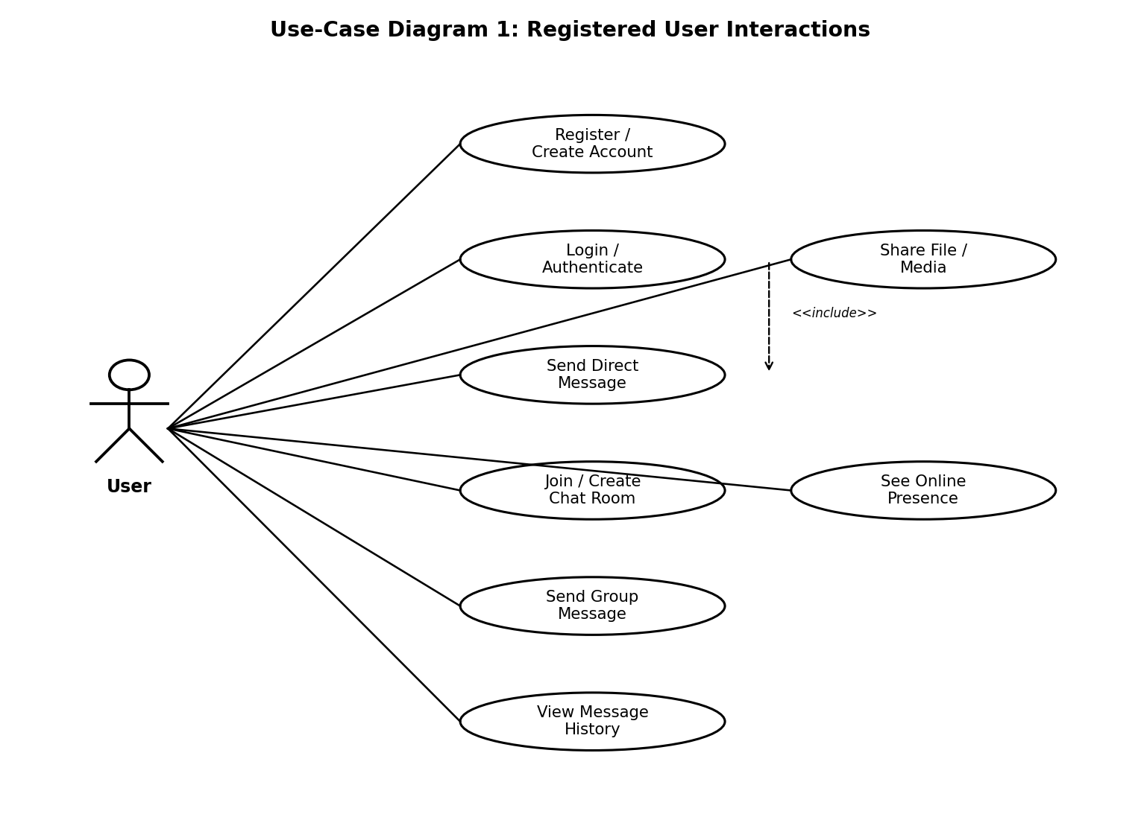
Figure 1: Use-Case Diagram — Registered User Interactions
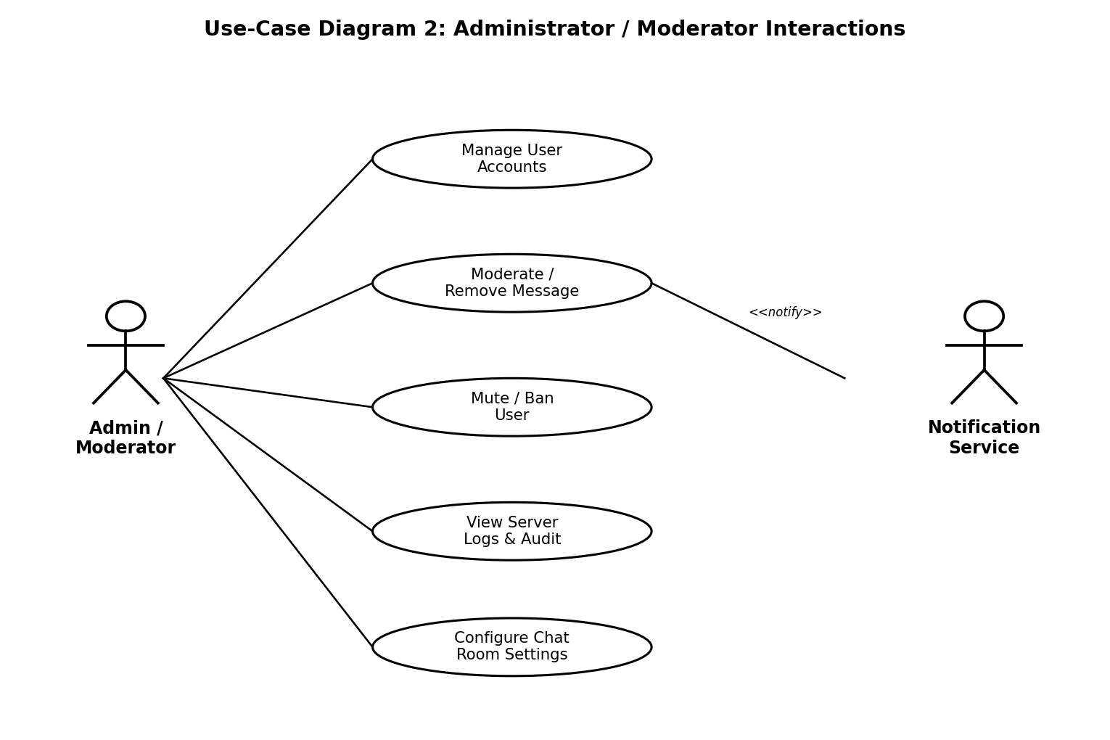
Figure 2: Use-Case Diagram — Administrator / Moderator Interactions

8. Requirements Traceability Matrix (RTM)
Req ID | Requirement (short) | Section ref / Design Spec | Module | Test case(s) | Status (N/P/A) | Comments
CHAT-F-002 | Authenticate user | 4.1 / DS-Auth-01 | AuthModule | TC-Auth-02 | N
CHAT-F-011 | Real-time direct message delivery | 4.2 / DS-Msg-01 | MessagingModule | TC-Msg-02 | N
CHAT-F-022 | Broadcast message to room | 4.3 / DS-Room-01 | RoomModule | TC-Room-03 | N
CHAT-F-041 | Retrieve paginated message history | 4.5 / DS-Hist-01 | HistoryModule / DB | TC-Hist-02 | N
CHAT-NF-001 | Message delivery latency target | 5 / DS-Perf-01 | MessagingModule | TC-Perf-01 | N
CHAT-SR-004 | Sanitise message content (XSS) | 5.1.2 / DS-Sec-01 | MessagingModule / UI | TC-Sec-04 | N

