Mini Project 6: Online Exam Portal

Software Requirements Specification

1. Introduction

1.1 Purpose
This document specifies the software requirements for the Online Exam Portal, a web-based system that enables an Admin to create and manage multiple-choice examinations, and Students to attempt these examinations and view their results once released. This SRS is intended to guide the design, implementation, and testing of the system for this mini-project.

1.2 Document Conventions
- Requirements are labeled using the format FR-XX for Functional Requirements and NFR-XX for Non-Functional Requirements.
- Security-specific requirements are labeled SEC-OBJ-XX (objectives) and SEC-REQ-XX (requirements).
- The keyword "shall" indicates a mandatory requirement; "should" indicates a recommended but non-mandatory requirement.

1.3 Product Scope
The Online Exam Portal is a two-role web application (Student, Admin) that supports creation and delivery of MCQ-only exams. Students may attempt questions in any order, mark any question for review regardless of attempt status, and track progress via a color-coded question grid. Admins create exams, manage questions, view submissions, and control when results become visible to Students. The system deliberately excludes proctoring, plagiarism detection, and non-MCQ question types to keep scope appropriate for a single-semester mini-project.

1.4 References
- IEEE Std 830-1998, IEEE Recommended Practice for Software Requirements Specifications.

2. Overall Description

2.1 Product Perspective
The Online Exam Portal is a new, self-contained web application. It is not a component of, nor dependent on, any pre-existing institutional system, and has no legacy predecessor.

2.2 Product Functions
- Admin: create exams, add/edit/delete MCQ questions, view student submissions, release results.
- Student: log in, attempt exam questions in any order, mark questions for review, track progress via a question grid, submit answers (manually or via auto-submit on timeout), and view results once released.

2.3 User Classes and Characteristics
Student: End user attempting exams. Assumed to have basic web-browsing familiarity; no technical expertise required.
Admin: Course instructor or teaching staff managing exams. Assumed to have basic familiarity with web-based dashboards.

2.4 Operating Environment
Client-side: any modern desktop or laptop browser (Chrome/Firefox, latest 2 versions) with internet access. Server-side: Python 3.x with the Django web framework, deployed on a standard Linux server with a relational database.

2.5 Design and Implementation Constraints
- Must be implementable and demonstrable within a single-semester mini-project timeline.
- Only MCQ-type questions are supported (single correct answer out of 4 options).
- No third-party proctoring or plagiarism-detection integration is required.

2.6 Assumptions and Dependencies
- Students and Admins have valid, pre-provisioned accounts (self-registration is out of scope).
- A stable internet connection is available to all users during an exam window.
- "Marked for Review" is a Student-facing navigation aid only and has no effect on auto-grading.

3. Specific Requirements
This section contains all software requirements to a level of detail sufficient to enable designers to design a system to satisfy those requirements, and testers to test that the system satisfies those requirements, per IEEE Std 830-1998.

3.1 External Interface Requirements
ID | Interface | Description
EI-01 | Hardware | Any device (desktop, laptop, tablet) with a modern web browser and internet connectivity; no special hardware required.
EI-02 | Software | Client: Google Chrome or Firefox (latest 2 versions). Server: Python 3.x with Django framework; relational database (e.g., PostgreSQL/SQLite).
EI-03 | User Interface | Responsive web UI with two views: Student exam-taking view (question panel + navigator grid + submit button) and Admin dashboard (exam/question management, submissions, release-results control).
EI-04 | Communication | HTTPS over standard TCP/IP; RESTful API calls between browser client and Django backend.

3.2 Functional Requirements
The following functional requirements are written to be clear, unambiguous, concise, and measurable/testable, per the specification method required for this deliverable.
ID | Requirement | Description (measurable / testable) | Priority
FR-01 | Student Login | The system shall allow a Student to log in using a unique username and password within 2 seconds of submission on a standard broadband connection. | High
FR-02 | Admin Login | The system shall allow an Admin to log in using a unique username and password with role-based access distinct from Student accounts. | High
FR-03 | Create Exam | The Admin shall be able to create a new exam by specifying a title, duration (in minutes), and a start/end availability window. | High
FR-04 | Add Questions | The Admin shall be able to add, edit, or delete MCQ questions (one correct option out of exactly 4 options) to a created exam. | High
FR-05 | Display Exam | The system shall display exam questions to a logged-in Student only during the exam's configured availability window. | High
FR-06 | Answer in Any Order | The system shall allow the Student to answer questions in any order and revisit any previously visited question at any time before submission. | High
FR-07 | Change Answer | The system shall allow the Student to change a previously selected answer for any question at any time before final submission. | High
FR-08 | Mark for Review | The system shall allow the Student to toggle a "Mark for Review" flag on any question, independent of whether that question has been answered. | High
FR-09 | Question Status Panel | The system shall display a side panel showing a grid of all question numbers, each color-coded to indicate exactly one of the following states: Not Visited, Not Answered, Answered, Marked for Review, or Answered & Marked for Review. | High
FR-10 | Navigate via Grid | The system shall allow the Student to jump directly to any question by clicking its number in the question status grid. | Medium
FR-11 | Manual Submit | The system shall provide a "Submit" button that, when clicked, asks for confirmation and then finalizes and locks the Student's answers. | High
FR-12 | Auto Submit | The system shall automatically submit the Student's answers when the configured exam duration elapses, without requiring further action from the Student. | High
FR-13 | Auto Grading | The system shall automatically compute the Student's score immediately upon submission, based only on selected answers (Marked for Review status shall have no effect on scoring). | High
FR-14 | Release Control | The system shall keep a Student's score hidden from that Student until the Admin explicitly releases results for that exam. | High
FR-15 | Release Results | The Admin shall be able to release results for a completed exam via a single action, after which all Students who attempted that exam can view their score. | High
FR-16 | View Result Page | The system shall provide a dedicated results page where a Student can view their total score for an exam once results are released. | Medium
FR-17 | View Submissions | The Admin shall be able to view a list of Students who attempted a given exam along with their submission status and score. | Medium

3.3 Non-Functional Requirements
ID | Category | Requirement
NFR-01 | Performance | The system shall load any exam question page within 3 seconds under normal load (up to 50 concurrent students) on a standard broadband connection.
NFR-02 | Reliability | The system shall auto-save a Student's selected answer to the server within 2 seconds of selection, so that a browser refresh or crash does not lose more than the last unsaved action.
NFR-03 | Usability | A first-time Student user shall be able to understand how to answer, mark for review, and submit an exam without external help, verified via a 5-user usability walkthrough.
NFR-04 | Availability | The system shall be available for Students to attempt an exam for 100% of its configured availability window, excluding scheduled maintenance.
NFR-05 | Maintainability | The codebase shall follow a layered architecture (presentation, business logic, data access) so that a new question type could be added by modifying no more than 2 modules.
NFR-06 | Scalability | The system shall support at least 50 concurrent exam attempts without a measurable (>20%) increase in average response time, for this mini-project's demonstration scale.
NFR-07 | Portability | The Student and Admin web interfaces shall render correctly on the latest two versions of Google Chrome and Mozilla Firefox.

3.4 Security Requirements

3.4.1 Security Objectives
ID | Security Objective
SEC-OBJ-01 | Prevent unauthorized users from accessing exam content or submitting answers on behalf of another Student.
SEC-OBJ-02 | Protect the integrity of submitted answers and computed scores from tampering after submission.

3.4.2 Security Requirements
ID | Security Requirement
SEC-REQ-01 | The system shall authenticate every user via an username/password pair before granting access to any exam or admin function; passwords shall be stored using a salted one-way hash (e.g., bcrypt), never in plain text.
SEC-REQ-02 | The system shall enforce role-based access control such that only Admin accounts can create/edit exams and release results, and only the owning Student account can view or submit that Student's own exam attempt.
SEC-REQ-03 | The system shall reject any submission request for an exam attempt that has already been finalized (submitted or auto-submitted), preventing re-submission or post-hoc answer tampering.
SEC-REQ-04 | The system shall serve the application only over HTTPS in the deployed environment to protect credentials and answers in transit.

3.5 Other Requirements
None identified beyond those stated above; this mini-project does not require legal, licensing, or regulatory compliance provisions (e.g., FERPA/GDPR-style handling) beyond standard password protection already captured under Section 3.4.

Appendix A: UML Use Case Diagram
Figure A.1 shows the two actors (Student, Admin) and their use cases within the Online Exam Portal system boundary.
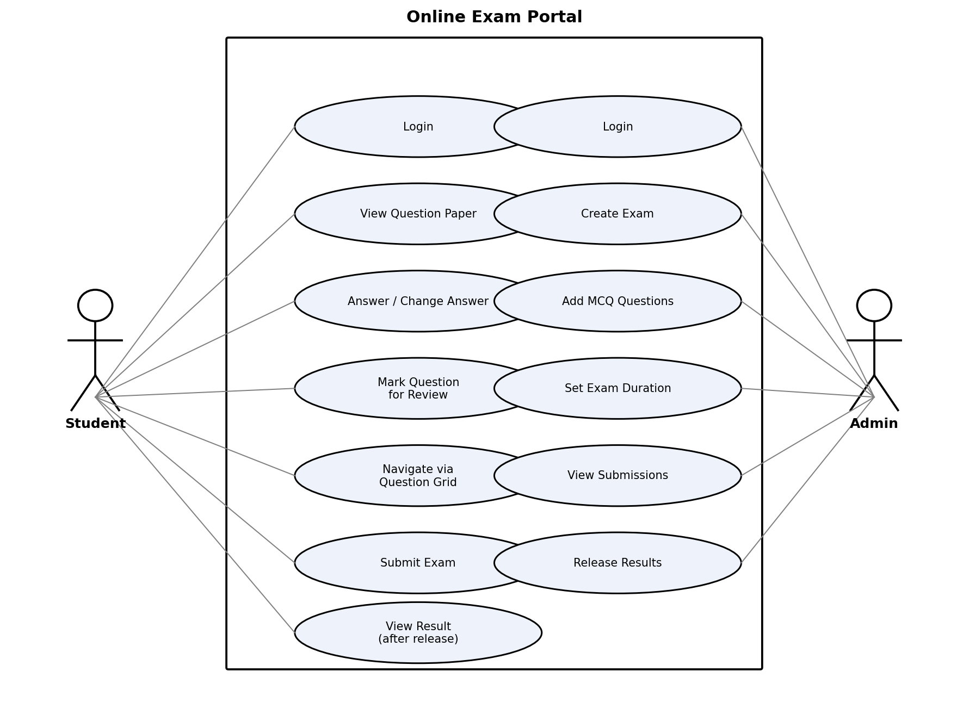
Figure A.1: Use Case Diagram - Online Exam Portal

