Software Architecture and Design Specification
Project: Collaborative Study Material & Quiz Platform
Version: 1.0
Authors: Neha Prabhu, Nisarga, Pradhyumn Anand, Neeraj R Rugi
Date: 03-10-2026
Status: Draft

Name | SRN
Neha Prabhu | PES2UG24CS312
Nisarga | PES2UG24CS325
Pradhyumn Anand | PES2UG24CS358
Neeraj R Rugi | PES2UG24CS311

Revision History
Version | Date | Author(s) | Change Summary
1.0 | 03-10-2026 | Project Team | Initial SAD drafted from SRS and STP

Approvals
Role | Name | Signature/Date
Project Team | Neha Prabhu / Nisarga / Pradhyumn Anand / Neeraj R Rugi
Project Evaluator

1. Introduction
1.1 Purpose
This Software Architecture and Design Specification (SAD) describes the architecture and detailed design of the Collaborative Study Material & Quiz Platform. It translates the functional, non-functional and security requirements in the SRS into a modular system structure, component responsibilities, interactions, interfaces and security controls.
1.2 Scope
The platform is a web-based academic system for centralized study-material sharing, question-bank management, quiz creation and publication, quiz attempts with automatic evaluation, result history, performance analysis, and administrative user/content management. Online proctoring, live video classes/conferencing and payment processing are outside the project scope.
1.3 Audience
- Developers and project team members
- QA/test engineers
- Project evaluators and instructors
- Students and contributors who use the platform
- Administrators responsible for user and content management

1.4 Definitions
Term | Definition
Study Material | Digital academic resource such as notes, documents, presentations or reference files shared through the platform.
Question Bank | Collection of questions stored and organized for reuse in quizzes.
Quiz | Set of questions published for a learner to attempt within the platform.
Contributor | Instructor or authorized user who can upload materials and create/manage questions or quizzes.
Performance Analysis | Reports and summaries derived from quiz attempts, scores and question-wise results.
RBAC | Role-Based Access Control used to restrict functions according to Student, Contributor/Instructor and Administrator roles.
SAD | Software Architecture and Design Specification.
SRS | Software Requirements Specification.
STP | Software Test Plan.

2. Document Overview
2.1 How to use this document
Sections 1 and 2 introduce the project and explain the document. Section 3 defines the system architecture, components, technology boundaries, risks, requirement traceability and security architecture. Section 4 describes detailed design, sequence flows, API interfaces, error handling, logging, monitoring, UX and open issues. Section 5 provides the glossary, references and tools.
2.2 Related Documents
- Collaborative Study Material & Quiz Platform — Software Requirements Specification (SRS), Version 1.0, dated 03-09-2026.
- Collaborative Study Material & Quiz Platform — Software Test Plan (STP), Version 1.0, dated 15-09-2026.
- Requirements Traceability Matrix (RTM) included in the SRS/STP.
2.3 Document Conventions
Requirement identifiers are retained from the SRS: CSMQ-F for functional requirements, CSMQ-NF for non-functional requirements and CSMQ-SR for security requirements. Component names in this SAD describe logical modules and do not imply a specific implementation framework unless stated in the SRS.

3. Architecture
3.1 Goals & Constraints
- Provide clear separation between presentation, business services, data access and persistence.
- Support authentication and role-based authorization for Student, Contributor/Instructor and Administrator.
- Support study-material, question-bank, quiz, result/performance and administration workflows.
- Maintain consistency between questions, quizzes, attempts and results.
- Protect credentials, uploaded content and performance records.
- Support common operations such as login, search and result retrieval within the SRS performance target.
- Support the two most recent major versions of major desktop browsers.
- Constraints: Python-based application server, relational database, file storage for uploaded materials, and normal dependence on application server/database availability.

3.2 Stakeholders & Concerns
Stakeholder | Main Concerns
Students | Easy navigation, access to permitted materials, quiz attempts, scores and performance history.
Contributor / Instructor | Material upload/management, question and quiz management, publication and relevant learner results.
Administrator | User activation/deactivation, role management and inappropriate-content removal.
Developers | Modularity, maintainability, clear interfaces and data consistency.
QA/Test Team | Testability, traceability, predictable error handling, security and compatibility.
Project Evaluators | Requirement coverage, understandable architecture and design documentation.

3.3 Component (UML) Diagram
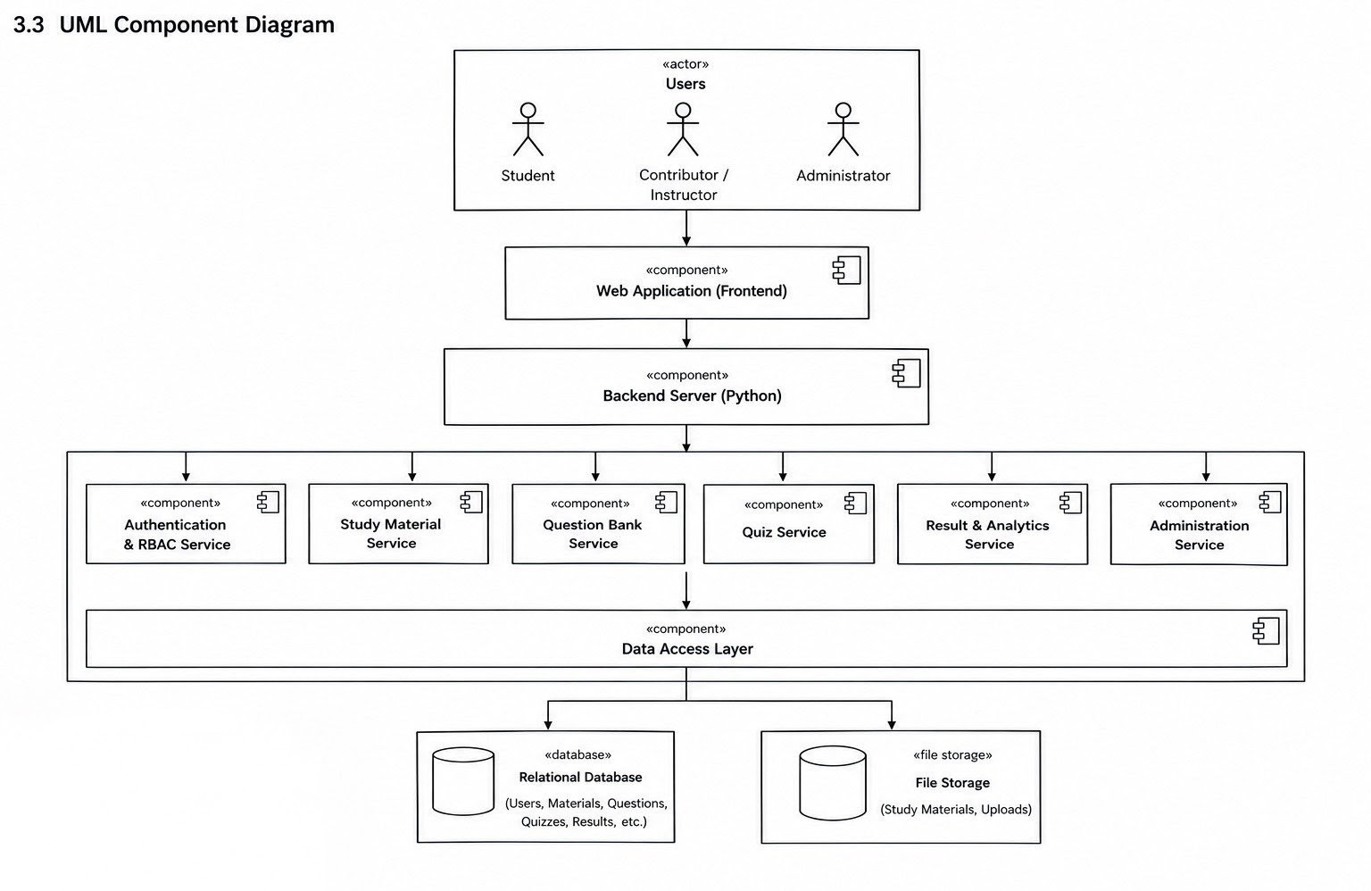

3.4 Component Descriptions
Component | Responsibility | Main Requirements
Web Interface / UI | Provides login, dashboards, material library/upload, question-bank, quiz, result/performance and admin screens. | CSMQ-F-001–018, CSMQ-NF-003, CSMQ-NF-005
Authentication & RBAC | Authenticates users, manages sessions and checks role permissions for protected operations. | CSMQ-F-001–003, CSMQ-SR-001–003
Study Material Service | Validates, stores, searches, retrieves, updates and removes permitted study materials. | CSMQ-F-004–007, CSMQ-SR-005
Question Bank Service | Creates, edits, deletes and organizes questions for authorized contributors. | CSMQ-F-008–009, CSMQ-SR-002, CSMQ-SR-005
Quiz Service | Builds quizzes from questions, publishes/unpublishes them, accepts attempts and coordinates scoring. | CSMQ-F-010–013
Result & Performance Service | Stores completed attempts and provides score history and average/quiz-wise/topic-wise summaries. | CSMQ-F-014–016, CSMQ-NF-002
Administration Service | Supports administrator operations for user activation/deactivation and inappropriate-content review/removal. | CSMQ-F-017–018, CSMQ-SR-002
Data Access Layer | Provides a controlled boundary between services and persistent data stores. | CSMQ-NF-002, CSMQ-NF-004
Relational Database | Stores users, roles, materials metadata, questions, quizzes, attempts and results. | CSMQ-F-001–003, CSMQ-F-008–018
File Storage | Stores uploaded study-material files while database records hold associated metadata. | CSMQ-F-004–007, CSMQ-SR-005

3.5 Chosen Architecture Pattern and Rationale
A layered architecture is selected for the platform. The presentation layer handles browser interaction; the application/service layer contains authentication, materials, questions, quizzes, results and administration logic; and the data-access/persistence layer manages the relational database and file storage. This separation supports the SRS requirement for modular organization (CSMQ-NF-004), makes unit and integration testing easier, and allows changes in one module with minimal unrelated changes. A microservices architecture is not required by the SRS and would introduce additional deployment and communication complexity for this project.
3.6 Technology Stack & Data Stores
Area | Specified / Derived Design
Client | Standard web browser on desktop or mobile device.
Backend | Python-based application server; the SRS does not prescribe a specific Python web framework.
Database | Relational database for persistent users, materials metadata, questions, quizzes, attempts and results.
File Storage | File storage for uploaded study materials.
Communication | HTTP/HTTPS between client and backend; HTTPS required in production.
Development/Deployment OS | Windows or Linux, as stated in the SRS.
Testing/Support Tools | Selenium or Playwright, Postman, JMeter or Locust, and Jira/equivalent are listed as indicative tools in the STP.

3.7 Risks & Mitigations
Risk | Mitigation
Stable build delivery is delayed | Use early smoke-test builds and keep interfaces modular so testing can begin incrementally.
Application server/database downtime | Maintain a backup environment and document restart/recovery procedures.
Incorrect question/answer configuration | Validate question-bank data before quiz creation and attempt testing.
Large or malformed uploads | Apply file type, size and input validation before storage or processing.
Ambiguous RBAC rules | Maintain an explicit role-permission matrix and validate it against the SRS/STP security tests.
Inconsistent quiz/result data | Use controlled service operations and database transactions/constraints where appropriate.

3.8 Traceability to Requirements
Requirement Group | Architectural Components
CSMQ-F-001–003 Authentication & User Management | Web Interface; Authentication & RBAC; Relational Database
CSMQ-F-004–007 Study Material Management | Web Interface; Study Material Service; Data Access; Relational DB; File Storage
CSMQ-F-008–011 Question Bank & Quiz Management | Web Interface; Question Bank Service; Quiz Service; Data Access; Relational DB
CSMQ-F-012–016 Attempts, Scoring & Performance | Web Interface; Quiz Service; Result & Performance Service; Relational DB
CSMQ-F-017–018 Administration | Web Interface; Administration Service; Authentication & RBAC; Relational DB
CSMQ-NF-001–006 Non-functional requirements | All service components; Data Access; browser/client interface; deployment environment
CSMQ-SR-001–005 Security requirements | Authentication & RBAC; input/file validation; secure communication; database/file-storage controls

3.9 Security Architecture
Security is implemented as a cross-cutting concern. Protected pages and operations pass through authentication and authorization checks. Role permissions are enforced for Student, Contributor/Instructor and Administrator functions. Passwords are stored using a secure one-way hashing mechanism and never in plaintext. Production client-server communication uses HTTPS. Uploaded files and user-provided inputs are validated before storage or processing.
Threat / Concern | Control
Unauthenticated access | Authentication required before protected operations; redirect/reject unauthenticated requests.
Unauthorized role access | RBAC checks for Student, Contributor/Instructor and Administrator operations.
Credential disclosure | One-way password hashing; no plaintext passwords in storage or logs.
Network interception | HTTPS in production.
Malicious/malformed input or upload | Validate type, size, format and input fields before processing/storage.
Session misuse | Logout terminates the session and protected pages require a valid authenticated session.

4. Design
4.1 Design Overview
The design follows the layered architecture defined in Section 3. A user interacts through the web interface. Authentication and RBAC protect operations. Domain services perform material, question, quiz, result/performance and administrative operations. The data-access layer isolates persistent storage. Uploaded study-material files are kept in file storage while their metadata is maintained in the relational database.

4.2 UML Sequence Diagrams
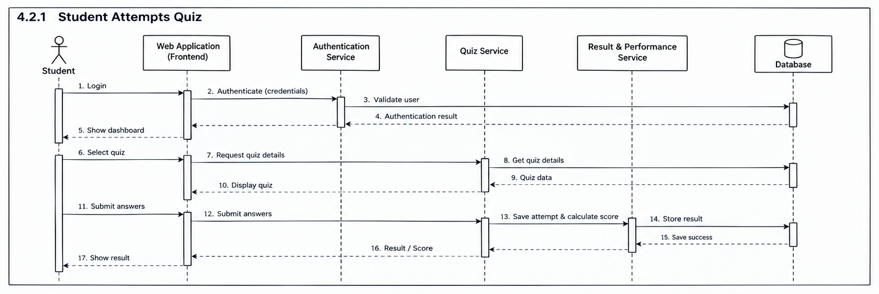

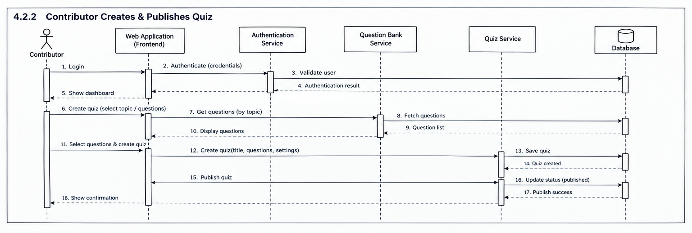

4.3 API Design
The SRS specifies standard web requests between the frontend and Python backend but does not define exact endpoint names. The following interfaces are proposed logical API contracts and should be changed to match the team's actual implementation if different.
Interface | Method | Request | Response | Errors
User Login | POST /api/login | {username/email, password} | {status, session/user role information} | 401 Invalid credentials; 403 inactive/unauthorized account
Quiz Submission | POST /api/quizzes/{quiz_id}/submit | {answers: [...] } | {status, score, result_id} | 401 unauthenticated; 403 unauthorized; 404 quiz not found; 400 invalid submission
Material Search | GET /api/materials?query=&category= | Search/filter parameters | {materials: [...]} | 400 invalid parameters; 401 if authentication is required by policy
Create Quiz | POST /api/quizzes | {title, questions: [...], configuration} | {status, quiz_id} | 401 unauthenticated; 403 insufficient role; 400 invalid quiz/question data
4.4 Error Handling, Logging & Monitoring
- Use consistent HTTP status codes and clear user-facing error messages.
- Do not expose passwords, session secrets or other sensitive information in error messages or logs.
- Validate inputs at the service boundary and reject malformed requests safely.
- Record application errors with timestamp, module, operation and non-sensitive diagnostic information.
- Monitor common operation response time, failed login attempts, upload failures, quiz submission failures and database/storage errors.
- Use the STP performance target for common operations as the acceptance reference and track failures during testing.

4.5 UX Design
- Provide a clear login/registration flow and role-specific dashboard.
- Keep navigation consistent for Material Library, Question Bank, Quizzes and Results/Performance.
- Provide search/filter controls for study materials.
- Show validation errors near the relevant input field.
- Display quiz progress and a clear submission action.
- Present score and performance summaries in a readable form.
- Provide administrator actions for user/content management without exposing functions to unauthorized roles.
- Support the desktop/mobile browser operating environment stated in the SRS.

4.6 Open Issues & Next Steps
- Select and document the exact Python web framework if not already fixed by implementation.
- Select and document the exact relational database technology and file-storage mechanism.
- Finalize endpoint names, request/response schemas and authentication/session mechanism based on implementation.
- Create final UML component and sequence diagrams using a diagramming tool.
- Finalize the role-permission matrix and confirm it against the SRS/STP.
- Define deployment configuration and production HTTPS setup.
- Complete implementation-specific database schema and data-access design.
- Execute STP functional, integration, security, performance, usability and compatibility tests.

5. Appendices
5.1 Glossary
Term | Meaning
API | Application Programming Interface used for communication between software components.
RBAC | Role-Based Access Control.
SRS | Software Requirements Specification.
SAD | Software Architecture and Design Specification.
STP | Software Test Plan.
RTM | Requirements Traceability Matrix.
UAT | User Acceptance Testing.
HTTPS | Secure HTTP used for protected client-server communication.
Question Bank | Organized collection of reusable quiz questions.
Performance Analysis | Summary of learner results such as average, quiz-wise and topic-wise performance.

5.2 References
- Collaborative Study Material & Quiz Platform — SRS v1.0, Project Team, 03-09-2026.
- Collaborative Study Material & Quiz Platform — STP v1.0, Project Team, 15-09-2026.
- SAD Template — Software Architecture and Design Specification, provided project template.
- OWASP Top 10, referenced by the STP for security test design.

5.3 Tools
Tool / Technology | Purpose
Python | Backend/application-server language specified by the SRS.
Relational Database | Persistent storage for application data.
Web Browser | Client interface on desktop/mobile.
PlantUML / draw.io | Suitable tools for creating UML architecture and sequence diagrams; use the tool approved by the project team.
Postman | API testing, listed as an indicative STP tool.
Selenium / Playwright | UI/functional testing, listed as indicative STP tools.
JMeter / Locust | Performance testing, listed as indicative STP tools.
Jira or equivalent | Defect tracking, listed as an indicative STP tool.

