Software Requirements Specification (SRS)
Project: Real-Time Chat Application using WebSockets
Stack: JavaScript (Node.js + WebSockets)
Version: 1.0
Authors:
Anagha B Poojari (PES1UG24CS056)
Amartya Sinha (PES1UG24CS051)
Anirudh Ganesh Prabhu (PES1UG24CS063)
Date: 28-09-2026
Status: Draft for review

Revision history
Version | Date | Author | Change summary | Approval
1.0 | 28-09-2026 | Anagha B Poojari | First version of the SRS with placeholders for diagrams

Table of Contents
1. Introduction
2. Overall description
3. External interface requirements
4. System features (detailed)
5. Non-functional requirements (detailed)
5.1 Security
6. Quality attributes & Acceptance tests
7. System models and diagrams
8. Requirements Traceability Matrix (RTM)

1. Introduction

1.1 Purpose
This document is the Software Requirements Specification (SRS) for a Real-Time Chat Application built with Node.js and WebSockets. It lists the functional and non-functional requirements, the external interfaces, the security needs and the ways each requirement will be checked. It is meant to be the common reference for the developers, testers and evaluators of the project.

1.2 Scope
The system lets registered users exchange text messages instantly, either one-to-one or inside groups, using a browser-based client. It covers user registration and login, real-time messaging, group chat, online status and typing indicators, message history, connection handling and basic monitoring. It does not cover voice or video calls, file sharing, end-to-end encryption, push notifications to mobile devices, or native mobile apps.

1.3 Audience
Developers, QA engineers, the project guide and course evaluators.

1.4 Definitions
Acronyms: API, UI, WS (WebSocket), WSS (WebSocket Secure), TLS, JWT (JSON Web Token), REST, XSS (Cross-Site Scripting), SRS, RTM, DB.

2. Overall description

2.1 Product perspective
The chat application follows a client-server model. A web client (HTML, CSS and JavaScript) opens a persistent WebSocket connection to a Node.js server. The server handles login through a small REST API, keeps track of connected users, routes messages between them and stores everything in a lightweight SQLite database. The application is self-contained and does not depend on any external service.

2.2 Major product functions
- Register and authenticate users
- Real-time one-to-one messaging
- Offline message storage and delivery
- Group creation and group chat
- Online/offline presence and typing indicators
- Message history with pagination
- Message delete (own messages)
- Heartbeat, automatic reconnect, logging and health check

2.3 User roles and characteristics
- User: any registered person; basic computer skills; expects messages to appear instantly.
- Group admin: a user who created a group and can add or remove its members.
- System administrator: deploys and monitors the server, reads logs and the health endpoint.

2.4 Operating environment
Server: Node.js 18+ on Windows or Linux, using the "ws" WebSocket library, Express for REST endpoints and SQLite for storage. Client: latest versions of Chrome, Firefox or Edge with an internet or LAN connection.

2.5 Constraints
- The real-time channel must use the WebSocket protocol (RFC 6455).
- Implementation language is JavaScript (Node.js) for the server and browser JavaScript for the client.
- The project must be completed within one academic semester by a small student team.
- Only free and open-source libraries may be used.

2.6 Assumptions and dependencies
- Users have a modern browser and a stable network connection.
- A TLS certificate is available for the deployed server (self-signed is enough for testing).
- Usernames are unique and cannot be changed after registration.

3. External interface requirements

3.1 User interfaces
A single-page web UI with a login/registration screen, a contact and group list on the left, a chat window with message input on the right, and small indicators for online status, typing and message status (sent, delivered, read). The layout adjusts for small screens and uses readable contrast and font sizes.

3.2 Hardware interfaces
No special hardware is needed. The server runs on a standard PC or virtual machine and the client on any device with a browser.

3.3 Software interfaces
- WebSocket API between browser and server (JSON messages such as auth, message, typing, presence, ack, error).
- REST API over HTTP(S) for register, login, history and health check (JSON).
- SQLite database accessed by the server through a Node.js driver.
- Libraries: ws, express, jsonwebtoken, bcrypt.

3.4 Communications
- HTTPS and WSS with TLS 1.2 or higher in deployment; plain HTTP/WS only for local development.
- All WebSocket payloads are JSON text frames with a "type" field.
- Client reconnects with exponential backoff; server uses ping/pong heartbeats every 30 seconds.

4. System features
Each requirement below has acceptance criteria and a reference test case. Functional requirement IDs follow the pattern CHAT-F-###.

4.1 Authentication
Description: Register users and authenticate them with username/password. The server issues a JWT that is also used to authenticate the WebSocket connection.
Req ID | Requirement | Type | Priority | Source / Stakeholder | Acceptance criteria / Test case ref | Comments / Dependencies
CHAT-F-001 | The system shall allow a new user to register with a unique username, email and password. | Functional | High | End user | AC-CHAT-F-001: Registration succeeds for unique username; duplicate username returns an error.  Test: TC-Auth-01 | Needs user DB table
CHAT-F-002 | The system shall authenticate a registered user by username and password and return a signed JWT on success. | Functional | High | End user / Security | AC-CHAT-F-002: Valid credentials return token; wrong credentials return 401.  Test: TC-Auth-02 | Depends on CHAT-F-001
CHAT-F-003 | The system shall verify the JWT during the WebSocket handshake and refuse the connection if the token is missing, invalid or expired. | Functional | High | Security | AC-CHAT-F-003: Connection with bad token is closed with code 4401.  Test: TC-Auth-03 | Depends on CHAT-F-002
CHAT-F-004 | The system shall temporarily block login for a username after 5 consecutive failed attempts for 5 minutes. | Functional | Medium | Security | AC-CHAT-F-004: 6th attempt within the window is rejected with a lockout message.  Test: TC-Auth-04 | Counter kept in memory
CHAT-F-005 | The system shall let a logged-in user log out, which closes the user's WebSocket connection and clears the token on the client. | Functional | Medium | End user | AC-CHAT-F-005: After logout the socket is closed and the server marks the user offline.  Test: TC-Auth-05 | Depends on CHAT-F-030

4.2 One-to-One Messaging
Description: Instant text messaging between two users, with offline storage and delivery status. IDs CHAT-F-010 to CHAT-F-013.
Req ID | Requirement | Type | Priority | Source / Stakeholder | Acceptance criteria / Test case ref | Comments / Dependencies
CHAT-F-010 | The system shall deliver a text message from one user to another online user in real time over WebSocket. | Functional | High | End user | AC-CHAT-F-010: Recipient receives the message without refreshing the page.  Test: TC-Msg-01 | Core feature
CHAT-F-011 | The system shall store a message addressed to an offline user and deliver it when that user next connects. | Functional | High | End user | AC-CHAT-F-011: Offline message appears after the recipient logs in.  Test: TC-Msg-02 | Depends on CHAT-F-040
CHAT-F-012 | The system shall show the status of each sent message as Sent, Delivered or Read. | Functional | Medium | End user | AC-CHAT-F-012: Status changes when the server or recipient acknowledges the message.  Test: TC-Msg-03 | Uses ACK events
CHAT-F-013 | The system shall reject empty messages and messages longer than 1000 characters. | Functional | Medium | Business / Security | AC-CHAT-F-013: Server returns an error event and does not store the message.  Test: TC-Msg-04 | Validation on server

4.3 Group Chat
Description: Creating groups, managing members and broadcasting messages to group members. IDs CHAT-F-020 to CHAT-F-023.
Req ID | Requirement | Type | Priority | Source / Stakeholder | Acceptance criteria / Test case ref | Comments / Dependencies
CHAT-F-020 | The system shall allow a user to create a chat group with a name and at least one other member. | Functional | High | End user | AC-CHAT-F-020: Group is created and the creator is set as admin.  Test: TC-Grp-01 | Group table
CHAT-F-021 | The system shall allow the group admin to add and remove members. | Functional | Medium | End user | AC-CHAT-F-021: Added user sees the group; removed user stops receiving messages.  Test: TC-Grp-02 | Depends on CHAT-F-020
CHAT-F-022 | The system shall broadcast a group message to all online members of that group. | Functional | High | End user | AC-CHAT-F-022: All online members receive the message; non-members do not.  Test: TC-Grp-03 | Membership check required
CHAT-F-023 | The system shall allow a member to leave a group. | Functional | Low | End user | AC-CHAT-F-023: User no longer appears in member list after leaving.  Test: TC-Grp-04

4.4 Presence and Typing Indicators
Description: Showing who is online and who is typing. IDs CHAT-F-030 to CHAT-F-032.
Req ID | Requirement | Type | Priority | Source / Stakeholder | Acceptance criteria / Test case ref | Comments / Dependencies
CHAT-F-030 | The system shall update and broadcast a user's status (online/offline) when the user connects or disconnects. | Functional | Medium | End user | AC-CHAT-F-030: Contacts see the status change within 2 seconds.  Test: TC-Pres-01 | Connection registry

4.5 Message History
Description: Saving messages and retrieving them later. IDs CHAT-F-040 to CHAT-F-042.
Req ID | Requirement | Type | Priority | Source / Stakeholder | Acceptance criteria / Test case ref | Comments / Dependencies
CHAT-F-040 | The system shall persist every one-to-one and group message with sender, receiver/group, content and timestamp. | Functional | High | Business | AC-CHAT-F-040: Message can be found in the database after being sent.  Test: TC-Hist-01 | SQLite database
CHAT-F-041 | The system shall provide a REST endpoint to fetch chat history in pages of 50 messages, newest first. | Functional | High | End user | AC-CHAT-F-041: Page 1 returns 50 messages, page 2 returns the next 50.  Test: TC-Hist-02 | Depends on CHAT-F-040
CHAT-F-042 | The system shall allow a user to delete their own message, which is then hidden for all participants. | Functional | Low | End user | AC-CHAT-F-042: Deleted message shows as removed and is not returned by history.  Test: TC-Hist-03 | Soft delete

4.6 Connection Management and Monitoring
Description: Keeping connections healthy and giving the administrator basic visibility. IDs CHAT-F-050 to CHAT-F-053.
Req ID | Requirement | Type | Priority | Source / Stakeholder | Acceptance criteria / Test case ref | Comments / Dependencies
CHAT-F-050 | The system shall send heartbeat (ping/pong) messages every 30 seconds and close connections that do not respond. | Functional | Medium | Operations | AC-CHAT-F-050: Dead connection is removed within 60 seconds and user marked offline.  Test: TC-Conn-01 | ws ping/pong
CHAT-F-051 | The client shall automatically try to reconnect with an increasing delay (1s, 2s, 4s up to 30s) after a dropped connection. | Functional | Medium | End user | AC-CHAT-F-051: Client reconnects on its own once the server is back.  Test: TC-Conn-02 | Client-side
CHAT-F-052 | The system shall log connections, disconnections and errors with timestamps. | Functional | Medium | Operations | AC-CHAT-F-052: Log file contains entries for each event.  Test: TC-Ops-01 | No message text in logs

Total functional requirements: 20.

5. Non-functional requirements (detailed)
The NFRs below are measurable and linked to test cases. IDs follow the pattern CHAT-NF-###.
Req ID | Requirement | Category | Priority | Acceptance criteria / Measurement
CHAT-NF-001 | Message delivery latency (server receipt to recipient socket) shall be ≤ 200 ms for 95% of messages with up to 200 concurrent users. | Performance | High | p95 ≤ 200 ms in load test. Test: TC-Perf-01
CHAT-NF-002 | The server shall support at least 200 concurrent WebSocket connections on a machine with 2 vCPU and 2 GB RAM. | Scalability | High | 200 clients connected with no dropped connections for 10 min. Test: TC-Perf-02
CHAT-NF-003 | The system shall be available 99% of the time per month, excluding planned maintenance. | Reliability | Medium | Uptime report shows ≥ 99%. Test: TC-Rel-01
CHAT-NF-004 | The web client shall work on the latest two versions of Chrome, Firefox and Edge, and shall be usable on screens from 360 px wide. | Usability / Compatibility | Medium | UI works and is readable on the listed browsers. Test: TC-UX-01
CHAT-NF-005 | The system shall retain logs for at least 90 days. | Audit / Maintainability | Medium | Logs older than 90 days are still available. Test: TC-Ops-03
CHAT-NF-006 | The server shall run on Node.js 18 or higher on both Windows and Linux without code changes. | Portability | Medium | Server starts and passes smoke tests on both OS. Test: TC-Port-01
CHAT-NF-007 | The code shall follow ESLint rules and have at least 70% unit test coverage on the server modules. | Maintainability | Low | Lint has zero errors; coverage report ≥ 70%. Test: TC-Maint-01

5.1. Security

5.1.1 Security Objectives
ID | Objective
SO-1 | Confidentiality: messages and credentials must not be readable by anyone other than the intended sender and receiver(s), whether in transit or at rest.
SO-2 | Authentication and authorization: only registered users can connect, and users can only read or send messages in conversations and groups they belong to.
SO-3 | Integrity: messages must not be modified, forged or injected (including scripts) between sender and receiver.
SO-4 | Availability: the service should stay usable and resist simple abuse such as message flooding and connection spamming.

5.1.2 Security Requirements
Req ID | Requirement (shall...) | Type | Priority | Acceptance criteria / Test case ref
PRJ-SR-001 | All client-server communication shall use TLS 1.2+ (HTTPS and wss://) in deployment. | Security | High | Plain ws:// connection is refused in production config. Test: TC-Sec-01
PRJ-SR-002 | Passwords shall be stored only as bcrypt hashes (cost factor ≥ 10), never in plaintext. | Security | High | Database inspection shows only hashes. Test: TC-Sec-02
PRJ-SR-003 | JWTs shall be signed with a secret kept in an environment variable and shall expire within 1 hour. | Security | High | Expired token is rejected; secret not present in source code. Test: TC-Sec-03
PRJ-SR-004 | All user-supplied text shall be validated and escaped before being stored or displayed to prevent XSS. | Security | High | Message containing <script> is shown as plain text. Test: TC-Sec-04
PRJ-SR-005 | The server shall limit each user to 20 messages per 10 seconds and close the connection on repeated violations. | Security | Medium | 21st message in the window is rejected with a rate-limit error. Test: TC-Sec-05
PRJ-SR-006 | The server shall check that the sender belongs to a group or conversation before accepting or broadcasting a message. | Security | High | Message from a non-member is rejected. Test: TC-Sec-06
PRJ-SR-007 | The WebSocket handshake shall only accept connections from allowed origins. | Security | Medium | Connection from a disallowed Origin header is refused. Test: TC-Sec-07
PRJ-SR-008 | Error responses shall not reveal stack traces, file paths or database details to the client. | Security | Medium | Forced server error returns a generic message. Test: TC-Sec-08

6. Quality attributes & Acceptance tests
- Exit criteria for acceptance: all high-priority functional requirements are implemented and verified, there are no failed critical NFR or security tests, and the RTM shows every test case as passed.
- Acceptance test suites: Authentication, One-to-One Messaging, Group Chat, Presence, History, Connection/Operations, Performance, Security and Usability tests.
- Quality attributes targeted: performance (low latency), reliability (reconnect and heartbeat), security, usability, portability and maintainability.
- Suggested tools: Jest (unit tests), a WebSocket test client script or Postman (integration), and Artillery or a simple Node load script (performance).

7. System models and diagrams

7.1 UML Use-Case diagram
Use-case diagram 1 shows the actors (User, Group Admin, System Administrator) and their main interactions with the chat system.

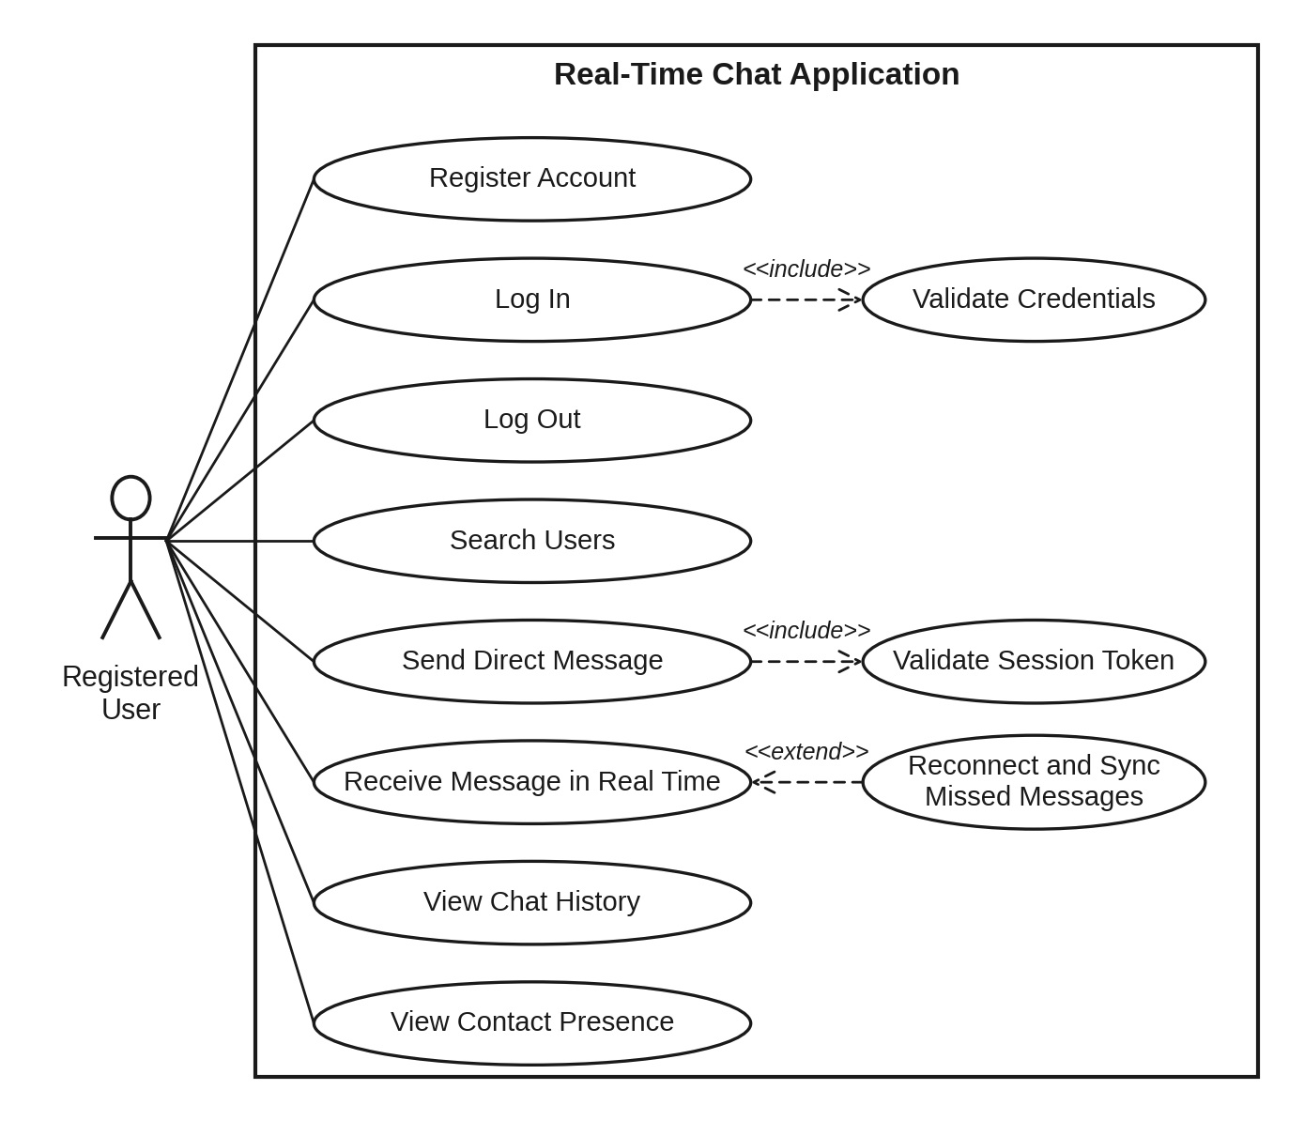

7.2 UML Use-Case diagram (Group chat and administration)
Use-case diagram 2 shows the group management and administration use cases in more detail.
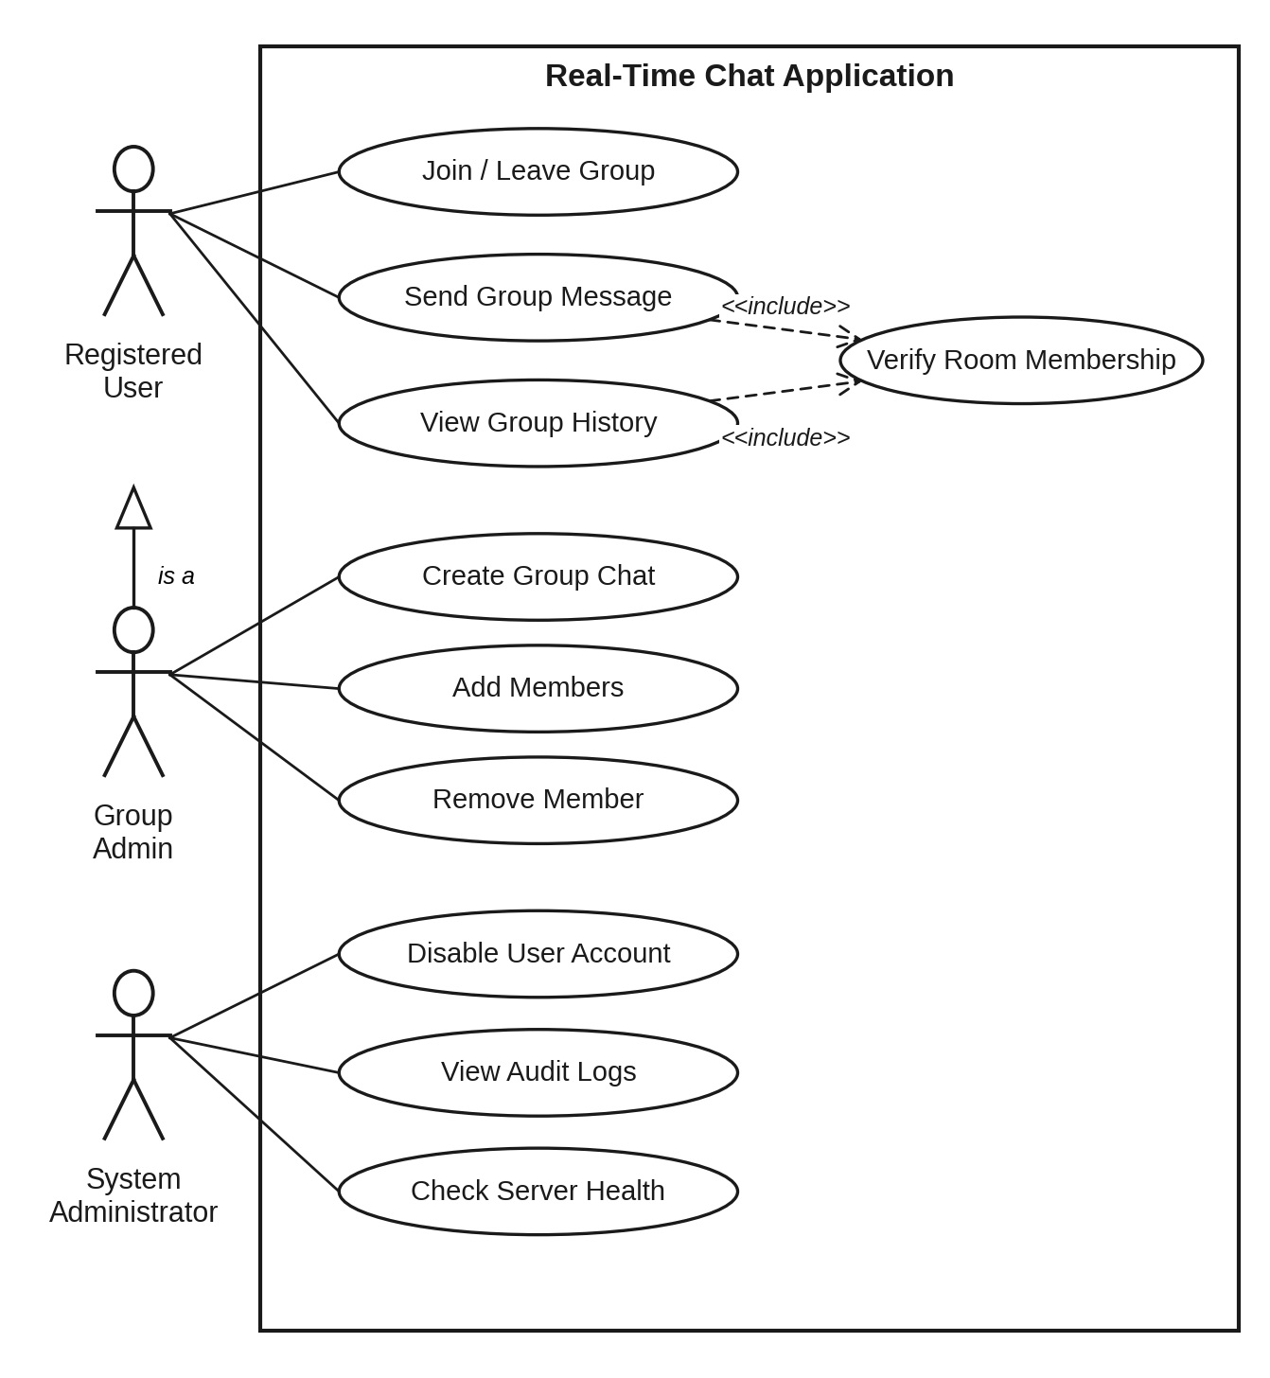

8. Requirements Traceability Matrix (RTM)
Status key: N = Not started, P = In progress, A = Accepted. Design references (DS-xxx) will be matched with the Architecture & Design Specification.
Req ID | Requirement short | Section ref / Design Spec | Module | Test case(s) | Status | Comments
CHAT-F-001 | User registration | 4.1 / DS-Auth-01 | AuthModule / REST API | TC-Auth-01 | N
CHAT-F-002 | Login and JWT issue | 4.1 / DS-Auth-02 | AuthModule / REST API | TC-Auth-02 | N
CHAT-F-003 | JWT check on WS handshake | 4.1 / DS-Auth-03 | AuthModule / REST API | TC-Auth-03 | N
CHAT-F-004 | Login lockout after 5 failures | 4.1 / DS-Auth-04 | AuthModule / REST API | TC-Auth-04 | N
CHAT-F-005 | Logout | 4.1 / DS-Auth-05 | AuthModule / REST API | TC-Auth-05 | N
CHAT-F-010 | Real-time 1-to-1 message | 4.2 / DS-Msg-01 | MessageHandler | TC-Msg-01 | N
CHAT-F-011 | Offline message delivery | 4.2 / DS-Msg-02 | MessageHandler | TC-Msg-02 | N
CHAT-F-012 | Message status (sent/delivered/read) | 4.2 / DS-Msg-03 | MessageHandler | TC-Msg-03 | N
CHAT-F-013 | Message length validation | 4.2 / DS-Msg-04 | MessageHandler | TC-Msg-04 | N
CHAT-F-020 | Create group | 4.3 / DS-Grp-01 | GroupManager | TC-Grp-01 | N
CHAT-F-021 | Add/remove members | 4.3 / DS-Grp-02 | GroupManager | TC-Grp-02 | N
CHAT-F-022 | Group broadcast | 4.3 / DS-Grp-03 | GroupManager | TC-Grp-03 | N
CHAT-F-023 | Leave group | 4.3 / DS-Grp-04 | GroupManager | TC-Grp-04 | N
CHAT-F-030 | Online/offline status | 4.4 / DS-Pres-01 | PresenceManager | TC-Pres-01 | N
CHAT-F-031 | Typing indicator | 4.4 / DS-Pres-02 | PresenceManager | TC-Pres-02 | N
CHAT-F-032 | Online user list | 4.4 / DS-Pres-03 | PresenceManager | TC-Pres-03 | N
CHAT-F-040 | Persist messages | 4.5 / DS-Hist-01 | MessageStore / REST API | TC-Hist-01 | N
CHAT-F-041 | Paged history endpoint | 4.5 / DS-Hist-02 | MessageStore / REST API | TC-Hist-02 | N
CHAT-F-042 | Delete own message | 4.5 / DS-Hist-03 | MessageStore / REST API | TC-Hist-03 | N
CHAT-F-050 | Heartbeat ping/pong | 4.6 / DS-Conn-01 | ConnectionManager / Logger | TC-Conn-01 | N
CHAT-F-051 | Auto reconnect | 4.6 / DS-Conn-02 | ConnectionManager / Logger | TC-Conn-02 | N
CHAT-F-052 | Connection and error logging | 4.6 / DS-Conn-03 | ConnectionManager / Logger | TC-Ops-01 | N
CHAT-F-053 | Health endpoint | 4.6 / DS-Conn-04 | ConnectionManager / Logger | TC-Ops-02 | N
CHAT-NF-001 | Delivery latency | 5 / DS-Perf-01 | WebSocket Server | TC-Perf-01 | N
CHAT-NF-002 | 200 concurrent users | 5 / DS-Perf-02 | WebSocket Server | TC-Perf-02 | N
CHAT-NF-003 | 99% availability | 5 / DS-Rel-01 | Server / Deployment | TC-Rel-01 | N
CHAT-NF-004 | Browser support | 5 / DS-UI-01 | Web Client | TC-UX-01 | N
CHAT-NF-005 | 90-day log retention | 5 / DS-Ops-01 | Logger | TC-Ops-03 | N
CHAT-NF-006 | Node 18+ portability | 5 / DS-Port-01 | Server | TC-Port-01 | N
CHAT-NF-007 | Lint and unit tests | 5 / DS-Maint-01 | All modules | TC-Maint-01 | N
PRJ-SR-001 | TLS / wss | 5.1.2 / DS-Sec-01 | Server config | TC-Sec-01 | N
PRJ-SR-002 | bcrypt password hashing | 5.1.2 / DS-Sec-02 | AuthModule | TC-Sec-02 | N
PRJ-SR-003 | JWT secret and expiry | 5.1.2 / DS-Sec-03 | AuthModule | TC-Sec-03 | N
PRJ-SR-004 | XSS input escaping | 5.1.2 / DS-Sec-04 | MessageHandler / Client | TC-Sec-04 | N
PRJ-SR-005 | Rate limiting | 5.1.2 / DS-Sec-05 | RateLimiter | TC-Sec-05 | N
PRJ-SR-006 | Membership check | 5.1.2 / DS-Sec-06 | MessageHandler | TC-Sec-06 | N
PRJ-SR-007 | Origin check | 5.1.2 / DS-Sec-07 | WebSocket Server | TC-Sec-07 | N
PRJ-SR-008 | Safe error messages | 5.1.2 / DS-Sec-08 | ErrorHandler | TC-Sec-08 | N

