Software Requirements Specification

for

Smart Complaint Management System
Version 1.0 approved
Prepared by Team-8
SE-MiniProject-Team-8
08-09-2026
Table of Contents
Table of Contents ii
Revision History ii
1. Introduction 1
1.1 Purpose 1
1.2 Intended Audience and Reading Suggestions 1
1.3 Product Scope 1
1.4 References 1
2. Overall Description 2
2.1 Product Perspective 2
2.2 Product Functions 2
2.3 User Classes and Characteristics 2
2.4 Operating Environment 2
2.5 Design and Implementation Constraints 2
2.6 Assumptions and Dependencies 3
3. External Interface Requirements 3
3.1 User Interfaces 3
3.2 Software Interfaces 3
3.3 Communications Interfaces 3
4. Analysis Models
5. System Features 4
5.1 System Feature 1 4
5.2 System Feature 2 (and so on) 4
6. Other Nonfunctional Requirements 4
6.1 Performance Requirements 4
6.2 Safety Requirements 5
6.3 Security Requirements 5
6.4 Software Quality Attributes 5
6.5 Business Rules 5
7. Other Requirements 5
Appendix A: Glossary 5
Appendix B: Field Layouts 5
Appendix C: Requirement Traceability matrix 6

Revision History
Name | Date | Reason For Changes | Version
Preetham | 08-09-26 | Initial SRS preparation | 1.0.0
Kavya | 08-09-26 | Added 1.Introduction and 2. Overall Description | 1.0.0
Zahoor | 08-09-26 | Added 3. External Interface Requirements and 4. Analysis Models | 1.0.0
Hemanth | 08-09-26 | Added 5.System Features and 6. Other Nonfunctional Requirements | 1.0.0
Preetham | 09-09-26 | Updated and Refined Functional Requirements (5 – System Features) | 1.0.1
Kavya | 09-09-26 | Updated Requirement Traceability Matrix (Appendix B) | 1.0.2
Zahoor | 09-09-26 | Updated System Features (User Authentication) | 1.0.3
Hemanth | 09-09-26 | Updated External Interface Requirements (UI, Software Interfaces) | 1.0.4
Preetham | 11-09-26 | Final review and refinement of document structure and consistency | 1.1.0

Introduction

Purpose
This document specifies the software requirements for the Smart Complaint Management System (SCMS), Version 1.0, a web-based application intended for use within a university setting. This SRS covers the complete system: complaint submission, escalation-based routing, resolution tracking, appeals, audit logging, and reporting

Intended Audience
This document is intended for:
- Course instructors/evaluators assessing the SRS deliverable
- The development team (student author) implementing the system in subsequent SDLC phases
- Testers, who will derive test cases from Section 5 (System Features)
Readers should review Section 2 (Overall Description) for context before proceeding to Section 5 (System Features), which contains the detailed functional requirements (REQ-IDs) referenced throughout the Test Plan and Traceability Matrix.

Product Scope
SCMS allows university students to file complaints (academic, administrative, facilities, or other categories) that are routed through a fixed escalation hierarchy — Faculty-in-Charge, Grievance Committee, and Dean — based on severity and handler action. The system replaces informal, undocumented complaint handling (in-person visits, emails with no tracking) with a system that provides status visibility, accountability via an audit trail, and a formal appeal mechanism. The goal for this phase is a functional mini-project scoped for a single-semester build; the design anticipates extension to a fuller production system in later coursework.

References

IEEE SRS template (as adapted by PES University, Dept. of CSE) — this document's structural basis

Overall Description

Product Perspective
SCMS is a new, self-contained web application. It is not a replacement for an existing system and has no dependency on other university IT systems in this phase.

Product Functions
At a high level, SCMS lets users:
- Register and log in with role-based access (Student, Faculty-in-Charge, Grievance Committee, Dean)
- Submit a complaint with a category and self-assessed severity
- Have the complaint auto-assigned to the appropriate handler based on severity
- Resolve, reject, or escalate a complaint (handler actions)
- Appeal a rejected complaint once, reopening it at the next escalation level
- View a complete audit trail of every status change on a complaint
- View role-appropriate dashboards (student: own complaints; Dean: only complaints that reached final escalation)
- Submit anonymized post-resolution feedback

User Classes and Characteristics
User Class | Characteristics
Student | Primary user; files and tracks complaints; low-to-moderate technical expertise assumed; uses the system infrequently (only when filing/checking a complaint)
Faculty-in-Charge | Level-1 handler for Low/Medium severity complaints; moderate frequency of use
Grievance Committee | Level-2 handler; receives escalated complaints and High-severity complaints directly
Dean | Final escalation level; lowest frequency of use; sees only complaints that reached this level

Operating Environment

The Smart Complaint Management System will operate as a web-based application accessible through modern web browsers such as Google Chrome, Mozilla Firefox, and Microsoft Edge. The application will be developed using Python 3 and the Flask web framework, with HTML, CSS, and JavaScript used for the client-side interface. SQLite will be used as the relational database for storing user accounts, complaints, audit records, and feedback. The system can be developed and executed on a standard desktop or laptop running Windows or Linux with a minimum of 4 GB RAM and a modern web browser. For the mini-project phase, the application will be hosted locally or on a university-provided development server

Design and Implementation Constraints

● The system shall be developed using Python 3 with the Flask web framework.
● SQLite shall be used as the relational database for the mini-project implementation.
● The system shall use server-side role-based access control for all protected operations.
● The system shall use a fixed three-level escalation hierarchy: Faculty-in-Charge, Grievance Committee, and Dean.
● Only Low, Medium, and High severity values shall be supported.
● No external university ERP, SSO, or third-party authentication system shall be required.
● No background scheduler shall be used for SLA checking; overdue checks shall be manually triggered by an authorized user.
● The implementation shall remain sufficiently simple for completion within the one-semester project timeline.

2.6 Assumptions and Dependencies

The system is assumed to be deployed for a single university and used by Students, Faculty-in-Charge, Grievance Committee members, and the Dean. The system will operate in English and will use a relational database for storing user, complaint, audit, and feedback data. Users are assumed to have valid university credentials and access to a modern web browser.
The system does not depend on an existing university ERP, SSO, or other external system. Complaint routing depends on the predefined severity levels and escalation hierarchy specified in this SRS. SLA overdue checking is performed manually by an authorized user, and no automated scheduler is assumed. The system is dependent on the availability of the application server, database, and network connection required to access the web application.

External Interface Requirements

User Interfaces
Role-specific web dashboards: a complaint submission form (student), a queue/action view (Faculty-in-Charge, Grievance Committee), and a read-only summary view (Dean). Standard elements: login screen, navigation header, status badges (color-coded by state), and a complaint detail view showing the full audit trail.

Software Interfaces
Relational database for persistence (complaint records, audit log, user accounts). No third-party software integrations are required for this phase.

Communications Interfaces
HTTP/HTTPS for client-server communication. Email notifications (if implemented per REQ-9-adjacent features) would use SMTP.

Analysis Models

Use Case Diagram
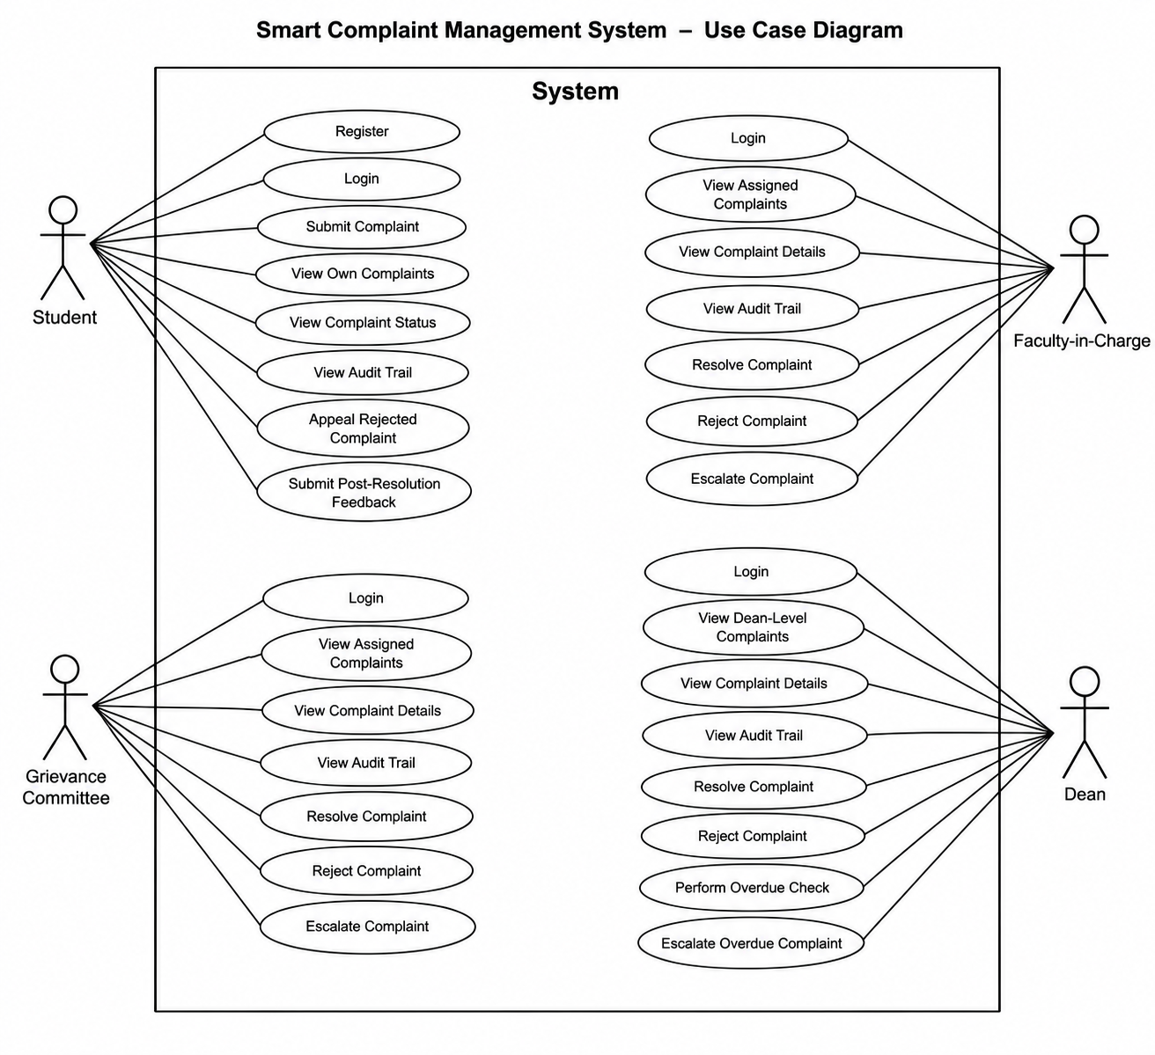

System Features

1. User Authentication & Role Management

Description
Allows the four user classes (Student, Faculty-in-Charge, Grievance Committee, Dean) to register/log in and be restricted to role-appropriate actions and views.

Stimulus/Response Sequences
- User navigates to login page, enters credentials, submits → system authenticates and redirects to role-specific dashboard.
- Student navigates to registration page, enters university ID and details → system creates account pending role assignment (default: Student).

Functional Requirements
REQ-1.1: The system shall allow a student to register using a university ID, name, email, and password.
REQ-1.2: The system shall authenticate users via university ID/email and password before granting access.
REQ-1.3: The system shall restrict each authenticated user to actions and views permitted for their assigned role.
REQ-1.4: The system shall reject login attempts with invalid credentials and display an appropriate error message without revealing whether the ID or password was incorrect.

2. Complaint Submission

Description
Allows a student to file a new complaint with a category and self-tagged severity.

Stimulus/Response Sequences
- Student selects 'New Complaint', fills category, description, and severity (Low/Medium/High), submits → system creates the complaint record with status 'Submitted' and routes it per REQ-3.

Functional Requirements
REQ-2.1: The system shall allow a logged-in student to submit a complaint with a category, free-text description, and a self-selected severity level (Low, Medium, High).
REQ-2.2: The system shall reject submission if category, description, or severity is missing, and shall display a field-specific validation message.
REQ-2.3: The system shall timestamp each complaint at submission and assign it a unique Complaint ID.

3. Severity-Based Auto-Assignment

Description
Routes a newly submitted complaint to the correct initial handler based on its severity, without manual dispatch.

Stimulus/Response Sequences
- On submission, system evaluates severity: Low/Medium → assigned to Faculty-in-Charge; High → assigned directly to Grievance Committee.

Functional Requirements
REQ-3.1: The system shall automatically assign a complaint with severity Low or Medium to the Faculty-in-Charge handler queue.
REQ-3.2: The system shall automatically assign a complaint with severity High directly to the Grievance Committee queue, bypassing Faculty-in-Charge.
REQ-3.3: The system shall notify the assigned handler (in-app) upon assignment.

4. Handler Actions (Resolve / Reject / Escalate)

Description
Allows the currently assigned handler to act on a complaint: mark it resolved, reject it with a reason, or escalate it to the next level.

Stimulus/Response Sequences
- Handler opens an assigned complaint, selects Resolve/Reject/Escalate, optionally enters remarks, submits → system updates complaint status and, for Escalate, reassigns to the next level handler.

Functional Requirements
REQ-4.1: The system shall allow the currently assigned handler to mark a complaint as Resolved, with mandatory resolution remarks.
REQ-4.2: The system shall allow the currently assigned handler to mark a complaint as Rejected, with a mandatory rejection reason.
REQ-4.3: The system shall allow the currently assigned handler to Escalate a complaint to the next level in the hierarchy (Faculty-in-Charge → Grievance Committee → Dean), except that a complaint already at Dean level cannot be escalated further.
REQ-4.4: The system shall prevent a handler from acting on a complaint not currently assigned to their role/level.

5. Appeal Mechanism

Description
Allows a student to appeal a single Rejected complaint, reopening it one level above where it was rejected.

Stimulus/Response Sequences
- Student views a Rejected complaint, selects 'Appeal', enters appeal justification, submits → system reopens the complaint and assigns it to the next level above the rejecting handler, provided no prior appeal exists on this complaint.

Functional Requirements
REQ-5.1: The system shall allow a student to appeal a complaint only if its current status is Rejected and it has not been appealed before.
REQ-5.2: Upon appeal, the system shall reassign the complaint to the escalation level directly above the level that rejected it, and set status to 'Under Appeal Review'.
REQ-5.3: The system shall reject a second appeal attempt on the same complaint with a message stating only one appeal is permitted.
REQ-5.4: If a complaint rejected at Dean level is appealed, the system shall flag it for final review at Dean level with no further escalation path available.

6. Audit Trail

Description
Maintains an append-only, complete history of every status change, actor, and timestamp for each complaint.

Stimulus/Response Sequences
- Any status-changing action (submit, assign, resolve, reject, escalate, appeal) triggers an audit log entry, viewable by the student and any handler with visibility into that complaint.

Functional Requirements
REQ-6.1: The system shall record an immutable audit log entry for every status change on a complaint, capturing actor, action, previous status, new status, and timestamp.
REQ-6.2: The system shall display the full audit trail for a complaint to the submitting student and to any handler who has held or currently holds assignment of it.
REQ-6.3: The system shall not allow any user, including Admin/Dean, to edit or delete existing audit log entries.

7. Role-Specific Dashboards

Description
Presents each role with a dashboard scoped to what they need: students see their own complaints, handlers see their assigned queue, and Dean sees only complaints that reached final escalation.

Stimulus/Response Sequences
- User logs in and lands on their dashboard; content is filtered server-side by role and, for Dean, by escalation level reached.

Functional Requirements
REQ-7.1: The system shall display, on a student's dashboard, only complaints submitted by that student, with current status.
REQ-7.2: The system shall display, on a handler's dashboard, only complaints currently assigned to their role/level.
REQ-7.3: The system shall display, on the Dean's dashboard, only complaints that have reached Dean-level escalation, and shall exclude complaints resolved at earlier levels.

8. SLA Overdue Flagging (Admin/Dean-Triggered)

Description
Lets a Dean/Admin identify complaints that have exceeded a defined time-in-status threshold, without requiring an automated background scheduler.

Stimulus/Response Sequences
- Dean opens 'Overdue Review', triggers a check → system computes and lists complaints exceeding the SLA threshold (e.g. 7 days) in their current status.

Functional Requirements
REQ-8.1: The system shall allow a Dean/Admin to manually trigger an overdue check that lists all complaints whose time-in-current-status exceeds a configurable SLA threshold (default 7 days).
REQ-8.2: The system shall display, for each overdue complaint, the current handler, days overdue, and a one-click escalate action.

9. Post-Resolution Feedback

Description
Collects anonymized feedback from the student after a complaint is marked Resolved.

Stimulus/Response Sequences
- On viewing a Resolved complaint for the first time, student is prompted for a satisfaction rating and optional comment, submitted anonymously with respect to the handler.

Functional Requirements
REQ-9.1: The system shall prompt the submitting student for a satisfaction rating (1-5) and optional comment once a complaint is marked Resolved.
REQ-9.2: The system shall store feedback without attaching the student's identity to the handler-facing view of that feedback.

Other Nonfunctional Requirements

Performance Requirements

The system shall load a user's dashboard within 2 seconds under normal load (assumption: low concurrent user count appropriate to a single-university mini-project deployment).

Safety Requirements

Not applicable in the physical-safety sense; primary concern is data integrity (see 6.3) rather than harm from system failure.

Security Requirements
- Passwords shall be stored hashed, never in plaintext.
- Role-based access control shall be enforced server-side on every request, not only in the client UI.
- Audit log entries shall be immutable (see REQ-6.3).

Software Quality Attributes

- Maintainability: escalation-level logic should be centralized (e.g. a single state-transition function/module) rather than duplicated across handler role code, to keep the state machine easy to extend later.
- Usability: status should be visible via color-coded badges without requiring the user to open each complaint.

Business Rules

- Only the currently assigned handler for a complaint may act on it (see REQ-4.4).
- A complaint may be appealed at most once (see REQ-5.3).
- Complaints cannot be escalated beyond Dean level (see REQ-4.3).

Also include Domain requirements here.

Other Requirements

No other Requirements
Appendix A: Glossary
Term | Definition
Complaint | A grievance submitted by a student, tracked through the escalation hierarchy to resolution or rejection.
Severity | Student-assigned classification (Low/Medium/High) that determines initial routing.
Escalation Level | One of: Faculty-in-Charge (L1), Grievance Committee (L2), Dean (L3).
SLA | Service Level Agreement - the maximum time a complaint should remain in a given status before being flagged overdue.
Audit Trail | The immutable, chronological log of all actions taken on a complaint.
Appeal | A single permitted student-initiated reopening of a Rejected complaint, escalating one level above the rejecting handler.

Appendix B: Field Layouts
User
Field | Length | Data Type | Description | Mandatory
user_id | 10 | Integer | Unique user identifier | Y
university_id | 20 | String | University/student/staff ID | Y
name | 100 | String | User's full name | Y
email | 100 | String | User email address | Y
password_hash | 255 | String | Hashed password | Y
role | 30 | String | Student, Faculty, Committee, or Dean | Y
created_at | — | DateTime | Account creation timestamp | Y

Complaint
Field | Length | Data Type | Description | Mandatory
complaint_id | 10 | Integer | Unique complaint identifier | Y
student_id | 10 | Integer | ID of submitting student | Y
category | 50 | String | Complaint category | Y
description | 1000 | String | Complaint description | Y
severity | 10 | String | Low, Medium, or High | Y
status | 30 | String | Current complaint status | Y
current_level | 10 | Integer | Current escalation level | Y
assigned_to | 10 | Integer | Current handler ID | N
submitted_at | — | DateTime | Complaint submission time | Y
status_updated_at | — | DateTime | Time current status began | Y
rejection_reason | 500 | String | Reason for rejection | N
resolution_remarks | 500 | String | Remarks on resolution | N
appealed | 5 | Boolean | Whether an appeal has already occurred | Y

Audit Log
Field | Length | Data Type | Description | Mandatory
audit_id | 10 | Integer | Unique audit record ID | Y
complaint_id | 10 | Integer | Associated complaint | Y
actor_id | 10 | Integer | User performing the action | Y
action | 50 | String | Action performed | Y
previous_status | 30 | String | Status before action | Y
new_status | 30 | String | Status after action | Y
timestamp | — | DateTime | Time of action | Y

Feedback
Field | Length | Data Type | Description | Mandatory
feedback_id | 10 | Integer | Unique feedback ID | Y
complaint_id | 10 | Integer | Associated resolved complaint | Y
rating | 1 | Integer | Satisfaction rating from 1–5 | Y
comment | 500 | String | Optional student feedback | N
submitted_at | — | DateTime | Feedback submission time | Y

Appendix C: Requirement Traceability Matrix

Sl. No | Requirement ID | Brief Description | Architecture Ref. | Design Ref. | Code File Ref. | Test Case ID | System Test Case ID
1 | REQ-1.1 | Student registration | TBD | TBD | TBD | UT_01-UT_02 | ST_01
2 | REQ-2.1 | Complaint submission | TBD | TBD | TBD | UT_03-UT_05 | ST_02
3 | REQ-3.1/3.2 | Severity-based routing | TBD | TBD | TBD | IT_01-IT_02 | ST_03
4 | REQ-4.1-4.4 | Handler actions | TBD | TBD | TBD | UT_06-UT_09 | ST_04
5 | REQ-5.1-5.4 | Appeal mechanism | TBD | TBD | TBD | IT_03-IT_04 | ST_05

