Smart Complaint Management System
  - Software Architecture and Design Specification
Section 3 Architecture | Member 3 scope
Prepared by Mohammed Zahoor Mashahir | PES1UG24CS579
Team 8 | Version 1.0

3 Architecture
We select a layered modular monolith for SCMS. A single Flask application coordinates complaint workflows through separate authentication, complaint, routing, audit, feedback and query modules. SQLite provides durable storage. This structure supports the fixed university escalation hierarchy while keeping deployment and transaction management manageable for the mini-project.
This architecture provides the component boundaries and data ownership for the Section 4 design. The design supports Students, Faculty-in-Charge at L1, Grievance Committee at L2 and Dean at L3. It uses manual SLA review and in-app notifications. No university ERP, SSO, external email service or background SLA scheduler is required.

3 1 Architecture pattern and rationale
Presentation routes validate requests and invoke application services. ComplaintService coordinates use cases; RoutingPolicy owns level transitions; the Repository isolates SQLite access. Services share an explicit transaction context when a complaint change requires audit, assignment or notification records. The modules are logical components within one deployment unit, not independent network services.
Option | Fit for SCMS | Tradeoff
Layered modular monolith | Selected. Matches Flask and SQLite constraints and allows one atomic workflow transaction. | Modules can be maintained independently, but share deployment and database availability.
Microservices | Separate deployment and service-owned stores would add complexity for a small team. | Distributed writes, authentication and operation are disproportionate to this scope.
Unstructured single module | Simple initially, but duplicates role checks and routing rules. | Does not meet NFR-MAIN-01 separation of functionality.

3 1 1 Technology and scope constraints
Python 3, Flask and SQLite are SRS constraints. Use a modern browser and a Windows or Linux host. Dependency versions are pinned when implementation begins. This specification describes proposed architecture; it does not report an implemented web application or passed acceptance tests.

3 2 UML component diagram
Figure AC01 shows the presentation, application and persistence layers. Dependencies point toward the required component. AuthService supplies verified identity and policy; application services enforce it on every protected use case.
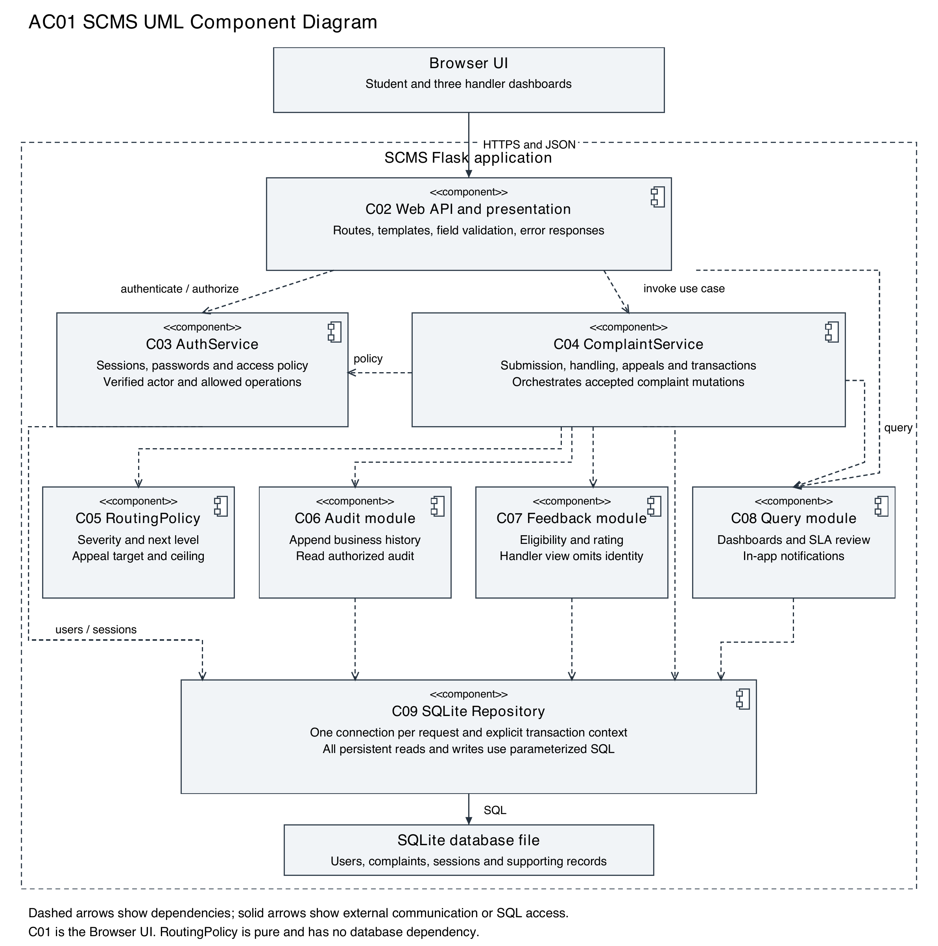
AC01. C01 is the Browser UI. C02 exposes the browser-facing interface. C04 owns workflow transactions. C06 to C08 access C09 using the same transaction when called during a mutation; read requests use their own request connection.

3 3 Component descriptions and interfaces
ID and component | Responsibility | Communicates with
C01 Browser UI | Registration, login, complaint forms, status and role-specific dashboards. Displays errors and permitted actions. | C02 over HTTPS; never C09 or the database.
C02 Web API and presentation | Flask routes and templates; request parsing, validation, authentication guard and consistent responses. | C03 identity; C04 use cases; C07 feedback; C08 queries.
C03 AuthService | Registration, password verification, session lifecycle and ownership/role/assignment access policy. | C09 users/sessions; verified actor supplied to C02 and service callers.
C04 ComplaintService | Coordinates submission, resolve, reject, escalation and appeal. Owns the transaction boundary. | C03 policy, C05 routing, C06 audit, C08 notices and C09 state.
C05 RoutingPolicy | Pure initialLevel, nextLevel and appealTarget decisions. Enforces L3 ceiling centrally. | C04 only; no persistent state.
C06 Audit module | Appends accepted business events and returns authorized chronological history. | C03 visibility; C09 audit and assignment history.
C07 Feedback module | Resolved-owner eligibility, rating validation, one feedback record and identity-suppressed handler view. | C03 policy; C09 complaints and feedback.
C08 Query module | Filtered dashboards, manual SLA calculation and notifications. SLA escalation delegates to C04. | C03 policy; C04 escalation; C09 read models/notices.
C09 SQLite Repository | Parameterized persistence, request connections, constraints and transaction support. | SQLite file; C03, C04, C06, C07 and C08.

3 3 1 Interface ownership
AuthService, ComplaintService, RoutingPolicy and SQLite Repository retain the interface names in Section 4. Audit and feedback are dedicated modules beneath those interfaces. Query methods support listVisible, audit reads, SLA review and notification reads. Every service receives a verified actor and checks resource policy; no caller treats UI visibility as authorization.
Repository mutation helpers accept the caller transaction. Audit and notification helpers do not open a second independent transaction during a complaint change. This avoids a complaint committing without its required history. Detailed HTTP payloads and error contracts remain in Section 4.

3 4 Runtime workflows and state rules

3 4 1 Submission and assignment
C02 authenticates the Student and validates category, description and severity. C04 asks C05 for the initial level: Low/Medium to L1 and High to L2. C09 inserts the unique complaint, timestamps and initial assignment; C06 records SUBMIT/ASSIGN; C08 creates the role-queue notice. A single successful commit precedes confirmation. Invalid input or failed persistence leaves no partial complaint or success message.

3 4 2 Handler actions and appeal
C03 checks the current assignment before normal handler mutations. C04 validates state, mandatory remarks/reason and expected_version. C05 permits L1 to L2 and L2 to L3; L3 has no next level. A rejection records rejected_level. An owning Student may appeal once while Rejected: L1 to L2, L2 to L3, or L3 final review at L3. A unique appeal constraint and conditional update protect against concurrent duplicate appeals.
Operation | Resulting state | Required invariant
Submit | Submitted at L1 or L2 | Student owner, valid fields, persisted unique ID.
Resolve | Resolved | Current handler and nonblank remarks.
Reject | Rejected | Current handler, reason and rejecting level recorded.
Escalate | Escalated at next level | Current handler; L3 ceiling; no terminal-state action.
Appeal | Under Appeal Review | Owning Student; Rejected; not previously appealed.

3 4 3 Dashboards audit and feedback
Students see their own complaints. Faculty/Committee see their current queue. The Dean sees complaints that reached L3 and excludes earlier-level resolutions. Owners and handler levels with current or historic assignment can read audit history; historic visibility grants no mutation right. C07 prompts the owner for feedback on a resolved complaint without existing feedback and omits identity from the handler projection.

3 4 4 Manual SLA review
C08 computes elapsed time from status_updated_at using the configured threshold, default 7 days. A protected overdue view shows the current queue, days overdue and escalation availability. Escalation delegates to C04 and C05 after a fresh permission, state, version and threshold check. The scope of this exception to normal assigned-handler authority requires team review; it is not a general cross-queue handling permission.

3 5 Deployment and reliability
Deploy one SCMS application on a Windows or Linux host, with its SQLite file on durable local storage outside the web root. Use a dedicated WSGI server and HTTPS termination for shared deployment. The Flask development server is limited to local development. The browser can reach only the application HTTP interface.
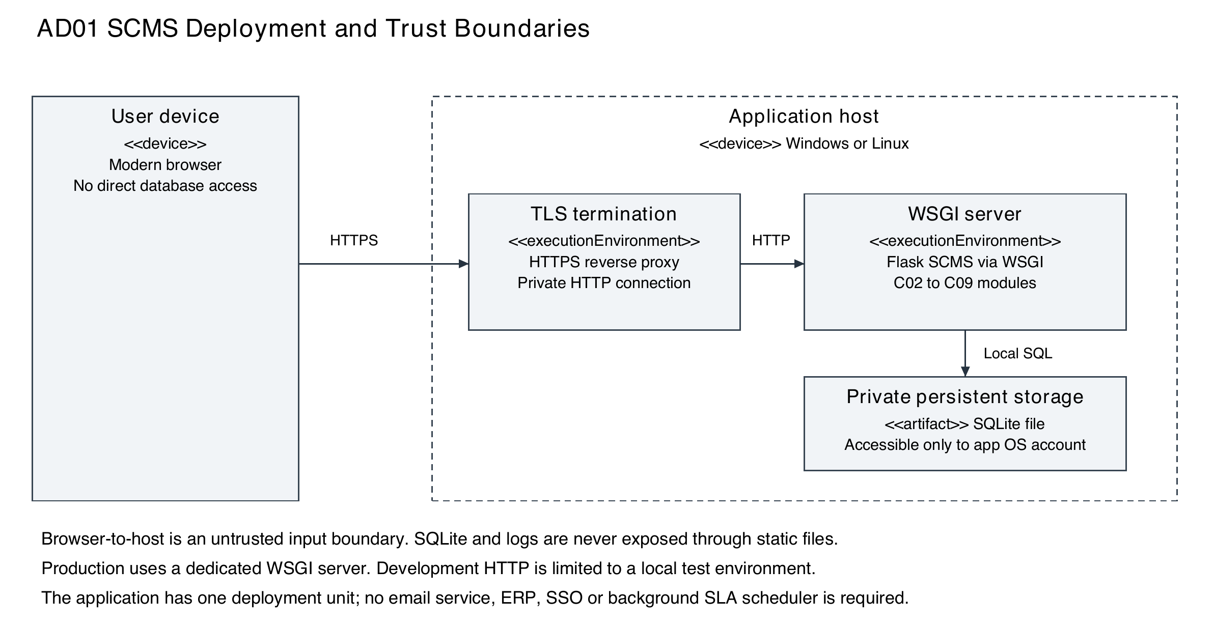

3 5 1 Persistence and recovery
Use short transactions and a bounded SQLite busy timeout. On lock, disk or constraint failure, roll back the entire workflow and return the Section 4 error contract. A client checks persisted state before repeating an ambiguous submission after a lost response. An SQLite-aware backup captures a consistent database; verify restoration to a separate location and normal restart persistence before release.

3 5 2 Operations and growth
One host remains a single point of availability. Protect the database, backup, secrets and operational logs using OS permissions. Observe request latency, denied actions, failed transactions and database contention without recording sensitive request content. Pagination and targeted indexes support the 2-second dashboard and 3-second submission targets; measure these under an agreed workload rather than assuming them.
Revisit PostgreSQL and deployment capacity if concurrent writes or recovery needs exceed SQLite on one host. This is an extension path, not a current dependency. Review retention and backup frequency with the university before deployment; the SRS supplies no quantitative retention or availability target.

3 6 Logical data model
Figure AE01 identifies the persistent entities and cardinalities. users and complaints provide the core domain. Assignment, audit, appeal and notification records preserve workflow history, while sessions and settings support authentication and manual SLA review.
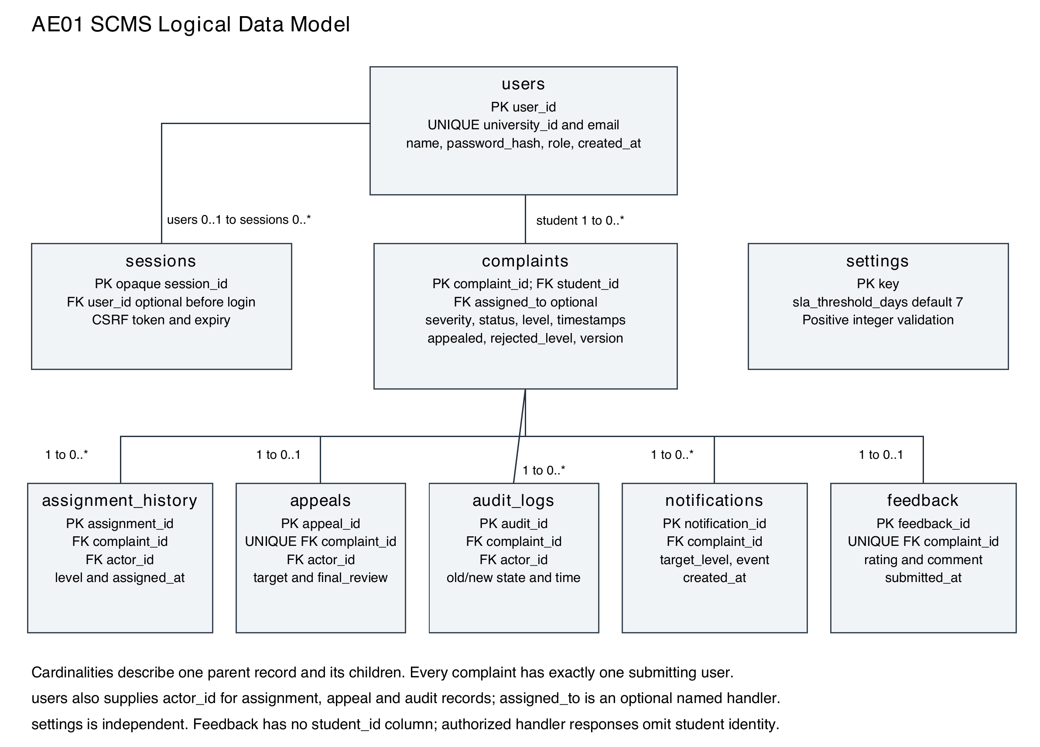

3 6 1 Relationship and privacy rules
A complaint belongs to one student. An optional assigned_to value names a handler; current_level determines the handler queue. Each complaint has zero or one appeal and zero or one feedback record, and may have many assignment, audit and notification records. assignment_history, appeals and audit_logs each retain an actor_id referencing users. sessions.user_id is null only for a pre-login CSRF session.
Feedback stores the complaint link but no student_id. The handler-facing projection omits owner name, ID and email and never joins them into the feedback response. This satisfies identity suppression in REQ-9.2; a complaint link can still provide context, so this design does not promise unlinkability from complaint history.

3 7 Core database schema
SQLite INTEGER primary keys identify persistent records. Use TEXT for strings and UTC ISO 8601 timestamps, and INTEGER with CHECK IN (0,1) for booleans. All mandatory SRS fields use NOT NULL. Foreign keys are enabled on every connection. Field lengths below preserve SRS Appendix B. Supporting state fields extend the schema to enforce Section 4 workflows.

3 7 1 Users
Field | Type and constraint | Purpose
user_id | INTEGER PRIMARY KEY | User identity for domain relations.
university_id | TEXT NOT NULL UNIQUE; length 1-20 | University account identifier.
name; email | TEXT NOT NULL; 1-100 each; email UNIQUE | Profile and contact address.
password_hash | TEXT NOT NULL; length <=255 | Salted adaptive hash encoding.
role | TEXT NOT NULL; enum Student/Faculty/Committee/Dean | Stored values map to SRS user classes.
created_at | TEXT NOT NULL UTC timestamp | Creation time.

3 7 2 Complaints
Field | Type and constraint | Purpose
complaint_id; student_id | INTEGER PK; INTEGER NOT NULL FK users | Unique record and submitting owner.
category; description | TEXT NOT NULL; 1-50 and 1-1000 | Validated complaint content.
severity; status | TEXT NOT NULL; constrained enumerations | Low/Medium/High and Section 3 4 states.
current_level; assigned_to | INTEGER NOT NULL CHECK 1-3; optional FK users | Role queue and optional named handler.
submitted_at; status_updated_at | TEXT NOT NULL UTC timestamps | Submission and current-state start time.
rejection_reason; resolution_remarks | TEXT nullable; maximum 500 each | Required when rejected/resolved.
appealed; rejected_level | Boolean default 0; nullable INTEGER CHECK 1-3 | Single-appeal flag and rejecting queue.
final_review; version | Boolean default 0; INTEGER >=1 default 1 | Dean review and concurrency control.

3 7 3 Audit logs
audit_id INTEGER PK; complaint_id and actor_id required FK; action TEXT up to 50; previous_status and new_status TEXT up to 30; timestamp required UTC TEXT. previous_level and new_level record queue changes. Use an explicit initial-state sentinel within the 30-character limit for submission history. Reject UPDATE/DELETE through application routes and database triggers; privileged database-owner access is a separate trust boundary.

3 8 Supporting schema and consistency
Entity | Keys and fields | Constraints and use
sessions | Opaque random session_id PK; optional user_id FK; CSRF token; expires_at. | Rotate on login; remove at logout/expiry. Anonymous sessions carry no authenticated role.
assignment_history | assignment_id INTEGER PK; complaint_id and actor_id FK; level; assigned_at. | Level CHECK 1-3. Records all reached queues for historic visibility.
appeals | appeal_id INTEGER PK; complaint_id UNIQUE FK; actor_id FK; justification; submitted_at; rejected_level; target_level; final_review. | One appeal per complaint; levels 1-3. Justification 1-1000 is a proposed design limit.
notifications | notification_id INTEGER PK; complaint_id FK; target_level; event; created_at. | Role queue notice stored with assignment. Access to complaint is checked when opened.
feedback | feedback_id INTEGER PK; complaint_id UNIQUE FK; rating; optional comment; submitted_at. | Rating INTEGER CHECK 1-5; comment <=500; resolved-owner eligibility enforced before write.
settings | key TEXT PK; value TEXT. | sla_threshold_days is validated as a positive integer, default 7; configured by trusted setup.

3 8 1 Transaction boundary and concurrency
A mutation uses one Repository connection for complaint state, assignment history, audit and notifications. Check the actor, legal transition and expected version within that transaction, then update WHERE complaint_id=? AND version=? and require exactly one affected row. Increment version only after a valid transition. Appeal eligibility and its unique insert are in the same transaction. Any failed write rolls back all associated changes.

3 8 2 Referential integrity and indexing
Use foreign-key restrictions rather than cascading deletion for complaint history. No complaint/audit deletion UI is specified. Parameterize values; validate and allowlist sort/filter options. Index complaints(student_id, submitted_at), complaints(current_level, status), complaints(status, status_updated_at), assignment_history(complaint_id, level), audit_logs(complaint_id, timestamp, audit_id) and notifications(target_level, created_at). Unique indexes enforce account, appeal and feedback constraints.
current_level maps 1 to Faculty, 2 to Committee and 3 to Dean. assigned_to is optional and must match that level if supplied. Historic assignment affects reads only. Database constraints, application transition rules and server-side authorization work together; foreign keys alone cannot enforce role or workflow eligibility.

3 9 Security architecture
SO-01 requires authenticated, authorized access to accounts and complaints. SO-02 requires integrity and accountability of complaint processing. C03 enforces both role and resource scope; C04 commits state and audit together. The public browser boundary accepts untrusted input, and the database and operational files remain private to the host.

3 9 1 Identity sessions and provisioning
Public registration creates only Student accounts. Trusted deployment setup provisions Faculty, Committee and Dean accounts and SLA permission. Store a salted adaptive password hash using a maintained library such as Werkzeug; select an encoding that fits the 255-character field. Verify with the corresponding library helper. Use generic failed-login messages and a bounded login throttle as an additional design safeguard.
A signed Secure, HttpOnly, SameSite=Lax cookie carries an opaque session ID; persistent session records establish the actor and current role. Rotate session ID and CSRF token on login, expire sessions and revoke on logout. Verify CSRF on mutations, including login and registration. Keep signing secrets outside source control; use HTTPS for shared deployment and disable debug mode.

3 9 2 Access control and threat handling
Threat | Architectural control | Requirement
Wrong-role or cross-owner access | C03 verifies identity, ownership, assignment and permitted action before every service call and read. | SEC-02; REQ-1.3; REQ-4.4
Password disclosure or account enumeration | Salted adaptive hashes; generic failures; no hashes/passwords in responses or logs. | SEC-01; SEC-04
SQL injection or stored script content | C09 parameterizes SQL; allowlist query structure; escape user text in C02 output. | SO-01; SO-02
CSRF or stolen session token | CSRF verification, secure cookie attributes, HTTPS and session revocation. | SO-01; additional safeguards
Audit edits or partial workflow state | Append-only C06; no mutation route; trigger protection; atomic C04 transaction. | REQ-6.1 to REQ-6.3; SEC-03
Duplicate appeal or stale mutation | Unique appeal and feedback constraints plus optimistic version checking. | REQ-5.1 to REQ-5.4; SO-02

3 9 3 Privacy and operational access
Return minimum role-specific fields and apply Cache-Control: no-store to protected data. Denied access to an invisible complaint uses a generic not-found result. Logs exclude complaint text, appeal justification, feedback comments, passwords, hashes, cookies and CSRF tokens. Authorized handler feedback views exclude student identity. Database owner, backup and log administrators remain privileged; database audit triggers do not defend against host compromise.

3 10 Functional requirement traceability
Requirement IDs and meanings below come from SRS feature sections, which take precedence over mislabelled Appendix C rows. Each of the 28 functional requirements maps to an owning component and an architecture section. These are architecture references for insertion into the SRS traceability matrix, not implementation or test-execution claims.
SRS IDs | Architectural responsibility | Section
REQ-1.1 | C02/C03/C09 create Student account with validated university ID and credentials. | 3 3; 3 7; 3 9
REQ-1.2 to REQ-1.4 | C03 verifies sessions, role/resource policy and generic failed authentication. | 3 3; 3 9
REQ-2.1 to REQ-2.3 | C02 validation and C04/C09 durable complaint with unique ID and UTC timestamp. | 3 4 1; 3 7
REQ-3.1 to REQ-3.3 | C05 severity routing and C08 in-app queue notice under C04 transaction. | 3 3; 3 4 1
REQ-4.1 to REQ-4.4 | C03 assignment checks; C04 required remarks/reason; C05 next-level and L3 ceiling. | 3 4 2; 3 8
REQ-5.1 to REQ-5.4 | C04 eligible single appeal; C05 target; C09 uniqueness and final-review flag. | 3 4 2; 3 8
REQ-6.1 to REQ-6.3 | C06 immutable history, C03 owner/historic-handler visibility and C09 protections. | 3 4 3; 3 7 3; 3 9
REQ-7.1 to REQ-7.3 | C08/C03 own-student, current-queue and reached-L3 dashboard projections. | 3 4 3; 3 9
REQ-8.1 to REQ-8.2 | C08 manual threshold review; C04/C05 scoped escalation. Open policy decision in 3 11. | 3 4 4; 3 8; 3 11
REQ-9.1 to REQ-9.2 | C07 resolved-owner prompt and handler projection without student identity. | 3 4 3; 3 6; 3 9

3 10 1 Security and business rule mapping
SRS IDs | Component and architectural control
SEC-01; SEC-04 | C03 real password hashing and generic failed-login response; Section 3 9 1.
SEC-02; SO-01 | C03 server authorization, C02 browser boundary and private C09 store; Section 3 9.
SEC-03; SO-02 | C04 atomic state/history and C06 immutable audit; Sections 3 7 3 and 3 8.
BR-01 to BR-03 | C03 authentication, ownership and assigned-handler permissions; Sections 3 3 and 3 4.
BR-04 to BR-06 | C05 routing, C04 appeal eligibility and C06 history; Section 3 4.
BR-07; BR-08 | C08 manual SLA review and C07 resolved feedback eligibility; Sections 3 4 and 3 11.

3 10 2 Nonfunctional requirement traceability
SRS IDs | Architectural support | Validation required
NFR-PERF-01 | C08 indexed, paginated dashboard queries; C09 targeted indexes. | Dashboard <=2 seconds under an agreed normal workload.
NFR-PERF-02 | C04 short transaction and no external notification dependency. | Valid submission confirmation <=3 seconds under that workload.
NFR-DATA-01; NFR-DATA-03 | C09 durable SQLite file, database PK and required relationships. | Stored records survive restart and IDs remain unique.
NFR-DATA-02 | C02/C04 validate before writes; C09 transaction rollback. | Invalid input creates no complaint or partial workflow data.
NFR-DATA-04 | C06 UTC audit timestamps, stable timestamp/audit_id ordering and protected rows. | History remains complete and chronological.
NFR-USAB-01; NFR-USAB-02 | C01/C02 field labels, validation errors, textual status and status badges. | Review input errors and visible state in role-specific UI flows.
NFR-MAIN-01 | C03-C08 separate modules; C05 centralized routing; C09 persistence boundary. | Review dependencies and modify routing without duplicating handler rules.
NFR-REL-01; NFR-REL-02 | Persistent file, consistent backup and commit-before-confirmation. | Restart, storage-failure and recovery scenarios on the implemented app.

3 10 3 Validation boundary
The repository test_scms.py provides an in-memory domain simulation. Its results cannot demonstrate HTTP access policy, cryptographic hashing, SQLite durability, browser usability or deployment performance. Member 2 should link architecture controls to tests against the implemented application, including transaction failure and simultaneous appeal attempts.
The SRS does not quantify the normal workload. The team must specify concurrent users, complaint volume, request mix and measurement environment before evaluating the 2-second and 3-second targets. No measured performance, security assurance or successful recovery is claimed by this specification.

3 10 4 Architecture review checklist
Review AC01 module names against Section 4 interfaces; inspect access filters for each role; verify transaction ownership; check one-appeal and feedback constraints; review manual SLA authority; and link every functional/security requirement to a component. Release validation follows implementation and the approved Test Plan.

3 11 Design alignment and architecture decisions

3 11 1 Alignment with Section 4
This architecture retains AuthService, ComplaintService, RoutingPolicy and SQLite Repository, so both existing sequence diagrams and detailed API contracts can use the same names. Audit, feedback and query responsibilities are modular parts of the same Flask application. The proposed persistent entities, optimistic version field, in-app notices and shared transaction boundary match Section 4 data design.
The Member 4 design already defines detailed endpoints, error handling and operational logging. Insert this Section 3 before Section 4 in the combined Software Architecture and Design Specification. Endpoint payloads remain owned by Section 4; this architecture assigns their modules and trust boundaries.

3 11 2 Decisions requiring team review
Issue | Architecture position
Admin and SLA authority | The SRS defines four user classes but REQ-8 names Admin/Dean. Provision SLA_REVIEW to Dean in this scope; Admin is a trusted administrative capability, not a fifth public registration role.
SLA versus assignment policy | REQ-8.2 allows overdue escalation while REQ-4.4 limits handler actions to assignment. Treat SLA escalation as a narrowly scoped exception requiring team sign-off; ordinary Resolve/Reject/Escalate stays assignment-bound.
SLA terminal states | Show overdue records required by REQ-8.1, but enable escalation only for active Submitted/Escalated/Under Appeal Review records below L3. Align Section 4 overdue listing, which currently focuses on active records, during integration.
SRS traceability labels | Appendix C contains REQ41.3 and descriptions shifted from feature-section meanings. Use REQ-1.4 for generic credential failure and preserve all feature-section IDs; Member 1 should correct the source RTM.
Proposed schema rules | One feedback per complaint, 1000-character appeal justification and terminal-state restrictions are Section 4 design choices. Confirm them without presenting them as new SRS requirements.

3 11 3 Source references
Team 8 repository baseline: d83e2a506e9a5e81d41bff908544432f5b44cd79. SRS.docx Version 2.0; SCMS_Test_Plan_2.0.docx Version 2.0; Member 4/SCMS_Software_Design_FINAL (2).docx Section 4. Original Section 4 contribution: c4ab642d4c94024b6abedcd3ecc214098680de7d. Member allocation: deliverable-2-workflow, Member 3 Software Architecture.
Technical references: Flask Deploying to Production, flask.palletsprojects.com/en/stable/deploying/; SQLite Foreign Key Support, sqlite.org/foreignkeys.html; Werkzeug Security Utilities, werkzeug.palletsprojects.com/en/stable/utils/. These support the WSGI deployment, per-connection foreign-key enforcement and maintained password-hash helper choices.

