Software Architecture and Design Specification
Project: Collaborative Study Material & Quiz Platform
Version: 1.2
Authors: Group 17 – Jagadeesh (PES1UG24CS347), Alifiya (PES1UG25CS841), Pushkar (PES1UG24CS350), Vedh (PES1UG24CS853)
Date: 14-10-2026

Revision History
Version | Date | Author | Change Summary
1.0 | 03-10-2026 | Project Team | Integrated final architecture and design specification for all project features (Account Management, Material Sharing, Question Bank & Quizzes, Performance & Collaboration) and the security architecture. Includes the component diagram, component descriptions, team-wide requirements traceability, STRIDE security architecture, seven UML sequence diagrams, integrated API design, error handling, logging and monitoring, UX design and appendices.
1.1 (draft) | 11-10-2026 | Project Team | Revision against SRS Revision 1.2 (draft): requirement mappings corrected (REQ-MAT, REQ-QZ, SEC, NFR) and SO, BR and DC traced; ownership of components, interfaces, requirements and endpoints added (Section 3.10); component diagram redrawn; sequence diagrams 4.1 to 4.7 redrawn and 4.8 to 4.10 added; API endpoints annotated with requirements, validation and owner; data model added (Section 4.7); user messages aligned with SRS Appendix B.7; Group & Notification Service renamed Study Group & Collaboration Service; open-decision register added (Appendix 5.4). Not approved.
1.2 (draft) | 14-10-2026 | Project Team | Four-member team (Jagadeesh, Alifiya, Pushkar, Vedh) taken over from SRS Revision 1.2 and Appendix D: four-member references removed from goals, constraints, Section 3.10, ownership columns of Sections 3.4, 3.8, 3.9 and 4.3, data model and approvals; Section 3.10 regenerated from Appendix D (Quiz Engine authoring: Member 2, execution and Grading Service: Member 4; Material Sharing and File Storage: Member 4); Figures 3.1 and 4.11 redrawn with Member 4; profile-picture limit stated as 2 MB (REQ-ACC-09); RTM architecture references aligned with SRS Appendix C where the design supports it, remaining differences recorded (Section 3.8, OD-14); design items without an SRS requirement recorded (OD-15); OD-01 recorded as decided; references updated to SRS Revision 1.2 and STP Revision 1.2. No requirement, use case or endpoint added or removed. Not approved.

Approvals
Role | Name | Signature/Date
Member 1 | Jagadeesh | Jagadeesh 14/10/26
Member 2 | Alifiya | Alifiya 14/10/26
Member 3 | Pushkar | Pushkar 14/10/26
Member 4 | Vedh | Vedh 14/10/26
Project guide | Ashok Kumar Patil | ____________________

1. Introduction
1.1 Purpose
This document specifies the architecture and design of the Collaborative Study Material & Quiz Platform, a web application for sharing study material, building a question bank, taking auto-graded quizzes and analysing performance. It is a single integrated team specification covering every feature of the platform.
1.2 Scope
This document covers the complete architecture and design of the platform. In scope:
- Account Management: registration, authentication, session handling, logout and profile management.
- Material Sharing: upload, viewing and listing, download, sharing, update, removal and revocation of access to study material.
- Question Bank & Quizzes: question management, quiz creation and publication, timed attempts and automatic grading, results and quiz submissions.
- Performance & Collaboration: personal, topic-wise and class performance analysis, study groups and Admin moderation of collaborative content.
- Security architecture: the controls, applied across all four areas, that realise the security objectives and security requirements of the SRS.
Requirements, use cases and security objectives are those defined in the SRS; this document does not change them.
1.3 Audience
Developers, QA engineers, security reviewers, instructors, and maintenance teams.
1.4 Definitions
SRS (Software Requirements Specification), STP (Software Test Plan), RTM (Requirements Traceability Matrix), UML, UC (use case), REQ / SEC / NFR (functional, security and non-functional requirement identifiers of the SRS), SO (security objective, SO-01 to SO-06), BR (business rule), DC (design constraint), UI and COM (user and communication interface items of the SRS), OD (open decision, Appendix 5.4), REST, JWT (JSON Web Token), RBAC (Role-Based Access Control), TLS, MERN (MongoDB, Express.js, React, Node.js), ODM (object-document mapper), SPA (single-page application), STRIDE (threat-classification model), ADR (Architecture Decision Record), MCQ (multiple-choice question). Further architecture terms are in Appendix 5.1.

2. Document Overview
2.1 How to use this document
Provides the architectural deliverables: component diagram, component descriptions, architecture pattern, technology stack, risks, requirements traceability, STRIDE security architecture, UML sequence diagrams, API design, error handling, UX design and open issues.
Section 3 (Architecture) describes the system as a whole: 3.3 and 3.4 give the component diagram and descriptions, 3.8 traces every SRS requirement group to the architecture and 3.9 describes the security architecture. Section 4 (Design) describes the detailed design: 4.2 gives the sequence diagrams of the main flows, 4.3 the single integrated API and 4.4 the error handling, logging and monitoring for the whole platform. Section 5 contains the glossary, references and tools.
Section 3.10 records the ownership of every component, interface, requirement and cross-cutting responsibility among the four team members; Section 4.7 gives the data model; Appendix 5.4 lists the open decisions of this revised draft.
2.2 Related Documents
SRS (Collaborative Study Material & Quiz Platform, Revision 1.2, draft of 17-10-2026, cover re-issued 18-10-2026, pending team approval): source of all requirement IDs, use cases and the security objectives SO-01 to SO-06.
STP (Software Test Plan, Revision 1.2, draft of 18-10-2026, pending team approval): test cases that verify the requirements traced in Section 3.8; test-case ownership follows SRS Appendix D, as does Section 3.10 of this document. Its API paths, error codes and the SAD-derived messages were compared with Section 4.3 and 4.4 on 18-10-2026 (see the final report); this is not an approval.
Project Guidelines and Deliverables Part-2: supplied and used for this revision. Deliverables Part-1, the SAD template and the team CONTRIBUTING.md: not supplied; mandatory-structure and convention compliance is unverified (OD-02, OD-10).
RTM (Requirements Traceability Matrix, Appendix C of the SRS): requirement-to-test traceability; Section 3.8 of this document adds requirement-to-architecture traceability.

3. Architecture
3.1 Goals & Constraints
Goals:
(1) secure – meet security objectives SO-01 to SO-06 of the SRS;
(2) responsive – login within 2 seconds, quiz results available within 2 seconds of submission as specified by REQ-QZ-12, and material sharing or access revocation within 2 seconds as specified by NFR-PERF-03, and page loads within 3 seconds for 95% of requests with 200 concurrent users as specified by NFR-PERF-01 and NFR-PERF-02;
(3) reliable – a submitted quiz attempt is never lost or altered and material operations do not expose a partially completed state;
(4) modular and testable, so that four developers can build and test their features independently;
(5) usable from modern desktop and mobile browsers.
Constraints: MERN stack (MongoDB, Express.js, React, Node.js); TLS 1.2 or higher for all communication; passwords stored only as salted bcrypt hashes; study materials limited to PDF, DOCX, PPTX and PNG files up to 25 MB; a four-member project team (SRS Revision 1.2, DC-11 and Appendix D) and one-semester schedule.
3.2 Stakeholders & Concerns
Students: usability, fast and fair quizzes, confidentiality of their materials and results.
Faculty: control over questions and quizzes, integrity of results.
Administrators: ability to moderate content and manage users.
Developers: modularity, clear interfaces, testability.
Instructors/evaluators: traceability to the SRS and quality of documentation.
Security reviewers: access control and protection of data.

3.3 Component (UML) Diagram

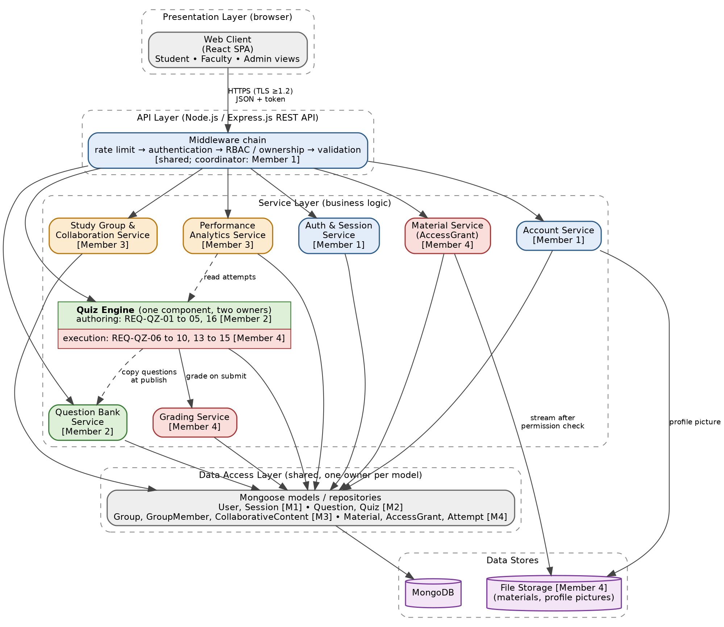
Figure 3.1: Component diagram (layered architecture): Web Client → API Layer (middleware chain) → Service Layer → Data Access Layer → MongoDB / File Storage. Colour = primary owner: blue Member 1, green Member 2, orange Member 3, rose Member 4, grey shared. The Quiz Engine is one component with quiz-authoring and quiz-execution responsibilities (Section 3.10.3). TLS 1.2+ is terminated by the Nginx reverse proxy in front of the API Layer.

3.4 Component Descriptions
Every component shown in Figure 3.1 is described below with its responsibility, inputs and outputs, access checks, SRS requirements, dependencies and owner. The Study Group & Collaboration Service is the service for study groups and collaborative-content moderation; version 1.0 of this document called it the Group & Notification Service, and it is renamed here to match SRS Section 3.1.2 and the SRS Requirement Traceability Matrix. Ownership is summarised in Section 3.10.
Web Client (React SPA)
Responsibility: user interface for Students, Faculty and Admin; navigation, forms, quiz screens, performance charts and group screens; shows the quiz countdown for display only.
Inputs / outputs: in: user input; out: HTTPS/JSON requests with the session token, rendered pages and field-level error messages.
Security / access checks: holds no secrets and never receives quiz answer keys; hides controls the role may not use, but all enforcement is on the server.
SRS requirements: UI-01 to UI-18, NFR-PERF-01, NFR-QUAL-01, NFR-QUAL-04, SEC-QZ-02, DC-05.
Dependencies: API Layer (REST/JSON over HTTPS).
Owner: each member builds the screens of the member's own feature; shared shell and navigation need team agreement (OD-06).
API Layer (Express.js) and middleware chain
Responsibility: routes requests through rate limiting, authentication (token and session check), role and ownership authorization and input validation before the controller is called; central error handler; builds Student-facing projections without answer keys.
Inputs / outputs: in: HTTP requests; out: controller calls, standard {error: {code, message}} responses.
Security / access checks: deny by default; RBAC and ownership middleware; express-validator and express-mongo-sanitize; upload type and size limits; rate limiting.
SRS requirements: REQ-ACC-10, REQ-MAT-10, REQ-QB-07, REQ-QZ-17, REQ-QZ-18, REQ-PA-06, REQ-COL-06, DC-02, DC-07, SEC-ACC-01 to SEC-ACC-06, SEC-MAT-01 to SEC-MAT-04, SEC-QZ-01 to SEC-QZ-05, NFR-PERF-02, NFR-QUAL-03.
Dependencies: Auth & Session Service (token and session validation); every service.
Owner: Member 1 (coordinator of the shared middleware: authentication, role and ownership checks, central error handler, route index). Members 2, 3 and 4 supply the routes, validation rules and controllers of their own endpoints.
Nginx reverse proxy (deployment element)
Responsibility: terminates TLS in front of the API Layer, serves the React build and restarts with the Docker deployment.
Inputs / outputs: in: HTTPS traffic; out: plain HTTP to Express.
Security / access checks: TLS 1.2 or higher only.
SRS requirements: SEC-COM-01, DC-03, NFR-QUAL-02, NFR-PERF-01, NFR-PERF-02.
Dependencies: API Layer.
Owner: requirement owners per SRS Appendix D – SEC-COM-01: Member 1; DC-03: Member 3; operation of the Nginx deployment itself has no owner; team agreement required (OD-06).
Auth & Session Service
Responsibility: registration, login with bcrypt comparison, failed-login counter and lock-out after 5 failures for 15 minutes, creation of the server-side session record and signed token, 30-minute inactivity expiry, logout and token invalidation.
Inputs / outputs: in: registration data, credentials; out: token with expiresIn 1800, session status.
Security / access checks: passwords stored only as salted bcrypt hashes; identical message for unknown e-mail and wrong password; a token is valid only while its session record is valid; security events audited.
SRS requirements: REQ-ACC-01 to REQ-ACC-07, REQ-ACC-10, SEC-ACC-01 to SEC-ACC-06, BR-01, BR-08, DC-04, DC-08.
Dependencies: Data Access Layer (User, Session).
Owner: Member 1.
Account Service
Responsibility: viewing and updating the permitted profile fields (full name, institution, profile picture).
Inputs / outputs: in: profile data (multipart/form-data when a picture is sent); out: profile data.
Security / access checks: users can access only their own profile; e-mail address and role cannot be changed; picture validated for type and size.
SRS requirements: REQ-ACC-08, REQ-ACC-09, REQ-ACC-10, SEC-ACC-05, BR-06, DC-06.
Dependencies: File Storage (profile picture; owned by Member 4), Data Access Layer (User).
Owner: Member 1.
Material Service
Responsibility: upload with type and size checks, ownership, listing and viewing, download, update, removal, sharing and revoking access through AccessGrant records; SHA-256 checksum at upload; blocks access before deleting a file.
Inputs / outputs: in: metadata and file (multipart), recipient user ID; out: material data, file stream, grant records.
Security / access checks: ownership or AccessGrant checked before every view or download; only the owner may update, remove, share or revoke; permission read from the database on every request.
SRS requirements: REQ-MAT-01 to REQ-MAT-11, SEC-MAT-01 to SEC-MAT-04, NFR-PERF-03, NFR-SAFE-02, NFR-SAFE-03, BR-02 to BR-05, BR-07, DC-06.
Dependencies: File Storage, Data Access Layer (Material, AccessGrant, User lookup for the share recipient).
Owner: Member 4.
File Storage
Responsibility: stores uploaded files (materials and profile pictures) on server disk outside the web root; can be replaced by object storage.
Inputs / outputs: in: file from the Material or Account Service; out: file stream to the Material Service only.
Security / access checks: no public URL; streamed only after the permission check; scheduled copy for backup.
SRS requirements: REQ-ACC-09, REQ-MAT-01, REQ-MAT-06, REQ-MAT-08, REQ-MAT-11, SEC-MAT-01, NFR-SAFE-01 to NFR-SAFE-03.
Dependencies: server disk (object storage is a deployment option).
Owner: Member 4 (Material Service owner); the Account Service (Member 1) stores profile pictures here through the File Storage interface (REQ-ACC-09; SRS Appendix D.4).
Question Bank Service
Responsibility: adding, searching/filtering, editing and removing questions; verifies that question IDs exist when a quiz is created.
Inputs / outputs: in: question data, search parameters; out: question data (including the answer key, to Faculty only).
Security / access checks: Faculty only; only the owner may edit or remove; Students receive 403.
SRS requirements: REQ-QB-01 to REQ-QB-07, REQ-QZ-18 (unavailable question), SEC-QZ-01, NFR-PERF-05.
Dependencies: Data Access Layer (Question).
Owner: Member 2.
Quiz Engine
Responsibility – quiz authoring: Draft → Published life cycle; creation and validation of title, time limit, availability window and 1 to 50 questions; copy of the selected questions into the quiz at publication; editing of Draft quizzes and deletion with confirmation, rejected once any Student has started an attempt; the quiz owner's view of the submissions of the owner's own quizzes (REQ-QZ-16). Responsibility – quiz execution: listing of published quizzes without questions; attempt start only inside the availability window and only once per Student; server-side start time and deadline; answer saving; submission; auto-submit when the time limit expires; rejection of late answers; immutability of submitted attempts; a Student's own attempts and results. The two responsibilities are separate parts of one component, owned by two members (authoring: Member 2; execution: Member 4), that share the Quiz and Attempt models (Section 3.10.3); grading is in the Grading Service.
Inputs / outputs: in: quiz data, answers; out: quiz and attempt data (questions without correct options or explanations while the attempt is open).
Security / access checks: Faculty owner for management and submissions; Student for attempts; attempt owner for results; server clock only; one attempt per Student per quiz; submitted attempts immutable; an unavailable quiz, question or attempt returns no details.
SRS requirements: authoring (Member 2): REQ-QZ-01 to REQ-QZ-05, REQ-QZ-16, SEC-QZ-01, SEC-QZ-03; execution (Member 4): REQ-QZ-06 to REQ-QZ-10, REQ-QZ-13 to REQ-QZ-15, SEC-QZ-02, SEC-QZ-04, SEC-QZ-05, NFR-PERF-06; shared (Member 2): REQ-QZ-17, REQ-QZ-18 (REQ-QZ-11, REQ-QZ-12 and REQ-QZ-14 are completed by the Grading Service).
Dependencies: Question Bank Service (question existence and copy source), Grading Service, Data Access Layer (Quiz, Attempt).
Owner: authoring – Member 2; execution – Member 4 (Section 3.10.3).
Grading Service
Responsibility: compares the submitted answers with the answer keys held in the quiz copy and computes score, percentage and per-question correctness.
Inputs / outputs: in: attempt and quiz copy; out: stored result.
Security / access checks: runs only on the server; result stored with the immutable attempt; answer keys never logged. Only answers received before the deadline are graded. If grading cannot be completed, the submission is kept unchanged, the result is shown as pending and grading is retried (UC-QZ-05); the response contract for a pending result is an open decision (OD-08).
SRS requirements: REQ-QZ-11, REQ-QZ-12, REQ-QZ-14, SEC-QZ-02, SEC-QZ-05, NFR-PERF-04.
Dependencies: Data Access Layer (Attempt, quiz copy).
Owner: Member 4.
Performance Analytics Service
Responsibility: retrieves completed attempts and aggregates them into personal, topic-wise and class performance statistics.
Inputs / outputs: in: user or quiz identifier; out: attempt lists and statistics.
Security / access checks: Student sees only own data; Faculty sees only quizzes they own; others receive 403.
SRS requirements: REQ-PA-01 to REQ-PA-06, SEC-QZ-03.
Dependencies: read-only attempt-query interface of the Quiz Engine (Section 3.10.3), quiz owner information, question topic (OD-03).
Owner: Member 3.
Study Group & Collaboration Service
Responsibility: creates and manages study groups, maintains group membership (duplicate membership rejected), performs Admin-only moderation of collaborative content.
Inputs / outputs: in: group data, join and moderation requests; out: group and membership data. In-application notification records of version 1.0 are not required by the SRS and need a scope decision (OD-09); push notifications are a future enhancement.
Security / access checks: Student role for creating and joining groups; Admin role for moderation; unavailable items return 404 without details.
SRS requirements: REQ-COL-01 to REQ-COL-07, SEC-ACC-01.
Dependencies: Data Access Layer (Group, GroupMember, CollaborativeContent).
Owner: Member 3.
Data Access Layer (Mongoose)
Responsibility: models and repositories for User, Session, Material, AccessGrant, Question, Quiz, Attempt, Group, GroupMember and collaborative-content data (Notification records: OD-09); indexes and connection pool.
Inputs / outputs: in: repository calls from services; out: documents.
Security / access checks: the only code that touches the database; sanitised queries; no business rules.
SRS requirements: REQ-MAT-03, REQ-QB-04, NFR-PERF-01, NFR-PERF-02, NFR-SAFE-02.
Dependencies: MongoDB.
Owner: one owner per model – User, Session: Member 1; Question, Quiz: Member 2; Group, GroupMember, collaborative content: Member 3; Material, AccessGrant, Attempt: Member 4; layer-wide conventions (naming, indexes, connection pool): team agreement (OD-05).
MongoDB
Responsibility: persistent store for all application data.
Inputs / outputs: in/out: documents via Mongoose.
Security / access checks: access only from the server network; daily backup.
SRS requirements: NFR-SAFE-01, NFR-PERF-02.
Owner: no owner in the baseline; team agreement required (OD-06).

3.5 Chosen Architecture Pattern and Rationale
Layered architecture implemented as a modular monolith: Presentation (React) → API / middleware (Express routes and middleware chain) → Service layer (business logic) → Data access layer (Mongoose) → Database / file storage (MongoDB and File Storage).
Rationale: clear separation of concerns; security checks are enforced in one place (middleware and service layer) for every feature; each service can be developed and unit-tested independently; one deployable unit is simple to build and demonstrate; grading runs in-process, which easily meets the 2-second target; it fits the MERN constraint.
Rejected alternatives: microservices – unnecessary operational complexity and distributed transactions for an expected load of a few hundred users; client-side grading – insecure, since answer keys and scores would be exposed and changeable (SEC-QZ-02, SEC-QZ-05).
Key decisions (ADR summary): ADR-1 layered modular monolith. ADR-2 MongoDB document store; quiz questions are copied into the quiz when it is published, so a published quiz and its attempts are self-contained. ADR-3 signed token plus a server-side session record, so that logout and 30-minute inactivity can invalidate a token. ADR-4 grading and the quiz timer run only on the server.
Revision note: the layered modular monolith, the MERN stack and ADR-1 to ADR-4 are unchanged because no source document requires a change. Quiz authoring and quiz execution are documented as separate responsibilities inside the existing Quiz Engine (Section 3.10.3); this adds no component.

3.6 Technology Stack & Data Stores
Client: React 18, React Router, Axios, Chart.js for performance charts.
Server: Node.js 20 LTS, Express.js 4, Mongoose ODM; jsonwebtoken for tokens, bcrypt for password hashing, helmet (security headers), express-rate-limit, express-validator (input validation), express-mongo-sanitize (NoSQL injection protection), multer (uploads).
Data stores: MongoDB 7 with collections users, sessions, materials, accessGrants, questions, quizzes (with embedded question copies), attempts (with embedded answers and result), groups, groupMembers, collaborativeContent (a notifications collection, if kept, is outside the SRS: OD-09); file storage on server disk outside the web root (can be replaced by object storage).
Communication and deployment: HTTPS with TLS 1.2 or higher through an Nginx reverse proxy; REST/JSON.
Quality tools: Jest and Supertest for tests, ESLint, Git/GitHub.
Consistency with the SRS: all technologies stay within the MERN constraint; no additional runtime platform or database is introduced, and password hashing (bcrypt) and TLS 1.2+ match the SRS security requirements.

3.7 Risks & Mitigations
Risk: browser or connection fails during a quiz and answers are lost → Mitigation: each answer is saved to the server when selected; the Student can resume the attempt; at the deadline the server auto-submits the answers saved so far.
Risk: many Students submit requests concurrently and processing becomes slow → Mitigation: grading is a simple in-memory comparison of at most 50 answers; indexes are maintained on attempt and quiz identifiers; load testing shall include 200 concurrent users in accordance with NFR-PERF-01 and NFR-PERF-02, including quiz submission and grading activity; if grading fails, the submission is retained and grading is retried.
Risk: a Student changes the device clock or tampers with the timer → Mitigation: start time, deadline and acceptance of answers use the server clock only (SEC-QZ-04).
Risk: answer keys leak to the client → Mitigation: Student-facing responses are built from a projection that excludes correct options and explanations until submission (SEC-QZ-02); tested explicitly.
Risk: direct download of material files by URL → Mitigation: files are stored outside the web root and served only after an ownership or grant check (SEC-MAT-01).
Risk: password guessing → Mitigation: lock-out after 5 failed logins for 15 minutes and rate limiting.
Risk: the single server is a single point of failure → Mitigation: daily database backups and a reproducible deployment (Docker) so the system can be restored quickly.
Risk: team members change shared data models and break each other's code → Mitigation: shared Mongoose models follow the data model of Section 4.7, derived from the field layouts of SRS Appendix B; changes are agreed in the group and covered by tests.

3.8 Traceability to Requirements
Every requirement group of the SRS is mapped below to the architecture component(s) that implement it and to the design section or diagram that shows it. Requirement IDs are unchanged from the SRS.
Requirement(s) | Architecture component(s) | Design reference | Primary owner
Account Management
REQ-ACC-01 to REQ-ACC-03 (register, validation, password rule) | Auth & Session Service, API Layer (validation) | Fig 4.8; 4.3 POST /auth/register; 4.4 | Member 1
REQ-ACC-04 to REQ-ACC-06 (authenticate within 2 s, single error message, lock-out) | Auth & Session Service | Fig 4.3; 4.3 POST /auth/login; 4.4 | Member 1
REQ-ACC-07 (session end, token invalidation) | Auth & Session Service, API Layer (authentication middleware) | 3.9; 4.3 POST /auth/logout | Member 1
REQ-ACC-08, REQ-ACC-09 (profile) | Account Service, File Storage | 4.1; 4.3 /account/profile | Member 1
REQ-ACC-10 | API Layer, Auth & Session Service | 3.9; 4.3 conventions; 4.4 (401) | Member 1
SEC-ACC-01, SEC-ACC-04 | API Layer, Auth & Session Service | 3.9; Fig 4.3 | Member 1
SEC-ACC-02, SEC-ACC-03, SEC-ACC-06 | Auth & Session Service | 3.9; Fig 4.3, 4.8 | Member 1
SEC-ACC-05 | Account Service | 3.9; 4.3 PUT /account/profile | Member 1
Material Sharing
REQ-MAT-01 to REQ-MAT-03 (upload, type and size rules, owner and library) | Material Service, File Storage, Data Access Layer | Fig 4.4; 4.3 POST /materials, GET /materials | Member 4
REQ-MAT-04 (view owned or shared) | Material Service, AccessGrant (Data Access Layer) | 4.3 GET /materials, GET /materials/:id | Member 4
REQ-MAT-05 (share) | Material Service, AccessGrant | Fig 4.4; 4.3 POST /materials/:id/share | Member 4
REQ-MAT-06 (download) | Material Service, AccessGrant, File Storage | Fig 4.9; 4.3 GET /materials/:id/download | Member 4
REQ-MAT-07 (update) | Material Service, File Storage | 4.1; 4.3 PUT /materials/:id | Member 4
REQ-MAT-08 (remove) | Material Service, AccessGrant, File Storage | 4.1; 4.3 DELETE /materials/:id | Member 4
REQ-MAT-09 (revoke) | Material Service, AccessGrant | Fig 4.9; 4.3 DELETE /materials/:id/access/:userId | Member 4
REQ-MAT-10 | API Layer, Material Service, AccessGrant, Auth & Session Service (session check) | 3.9; Fig 4.4, 4.9; 4.3; 4.4 | Member 4
REQ-MAT-11 | Material Service, File Storage | Fig 4.9; 4.3 (404); 4.4 | Member 4
SEC-MAT-01 to SEC-MAT-04 | API Layer, Material Service, AccessGrant, File Storage | 3.9; Fig 4.4, 4.9 | Member 4
Common security
SEC-COM-01 | Nginx reverse proxy (TLS 1.2+) | 3.6; 3.9 | Member 1 (coordinator)
Question Bank
REQ-QB-01 to REQ-QB-03, REQ-QB-05 (add, validate, owner, edit) | Question Bank Service | Fig 4.10; 4.3 /questions | Member 2
REQ-QB-04 (search and filter) | Question Bank Service, Data Access Layer (indexes) | Fig 4.10; 4.3 GET /questions | Member 2
REQ-QB-06 (remove; published quizzes unchanged) | Question Bank Service, Quiz Engine (question copy) | Fig 4.10; 4.1; 4.3 DELETE /questions/:id | Member 2
REQ-QB-07 | API Layer (RBAC and ownership middleware), Question Bank Service, Auth & Session Service (session check) | 3.9; 4.3; 4.4 | Member 2 (collab. Member 1)
Quizzes
REQ-QZ-01 to REQ-QZ-03 (create, validate, Draft) | Quiz Engine (authoring), Question Bank Service | Fig 4.1; 4.3 POST /quizzes | Member 2
REQ-QZ-04 (copy questions at publication) | Quiz Engine (authoring), Question Bank Service | Fig 4.1; 4.3 POST /quizzes/:id/publish | Member 2
REQ-QZ-05 (edit Draft, delete; rejected once an attempt has started) | Quiz Engine (authoring; attempt-existence check) | Fig 4.1; 4.3 PUT, DELETE /quizzes/:id | Member 2
REQ-QZ-06 (list for Students) | Quiz Engine (execution) | 4.3 GET /quizzes | Member 4
REQ-QZ-07 (start rules) | Quiz Engine (execution) | Fig 4.2; 4.3 POST /quizzes/:id/attempts | Member 4
REQ-QZ-08 to REQ-QZ-10 (questions and timer, answers, auto-submit) | Quiz Engine (execution), API Layer (Student projection) | Fig 4.2; 4.3 attempts | Member 4
REQ-QZ-11, REQ-QZ-12, REQ-QZ-14 (grading, 2-second result, immutability) | Grading Service, Quiz Engine (execution) | Fig 4.2; 4.3 POST /attempts/:id/submit | Member 4
REQ-QZ-13, REQ-QZ-15 (results, own attempts) | Grading Service (stored result), Quiz Engine (execution), Data Access Layer | 4.3 GET /attempts/:id/result, /attempts/mine | Member 4 (collab. Member 3)
REQ-QZ-16 (quiz submissions) | Quiz Engine (execution), Data Access Layer | 4.3 GET /quizzes/:id/submissions | Member 2 (collab. Members 3, 4)
REQ-QZ-17 (role and ownership access) | API Layer (RBAC and ownership middleware), Quiz Engine (service-layer checks), Auth & Session Service | 3.9; Fig 4.1, 4.2; 4.3; 4.4 | Member 2 (collab. Member 1)
REQ-QZ-18 (unavailable item) | API Layer (central error handler), Quiz Engine, Question Bank Service | Fig 4.1, 4.2, 4.10; 4.4 | Member 2
SEC-QZ-01 | API Layer, Question Bank Service, Quiz Engine (authoring), Auth & Session Service (session check) | 3.9; Fig 4.1, 4.10 | Member 2
SEC-QZ-02 | API Layer (Student projection), Quiz Engine (execution) | 3.9; Fig 4.2 | Member 4
SEC-QZ-03 | Quiz Engine (execution), API Layer, Auth & Session Service (session check) | 3.9; 4.3 results and submissions | Member 2
SEC-QZ-04 | Quiz Engine (execution; server clock) | 3.9; Fig 4.2 | Member 4
SEC-QZ-05 | Quiz Engine (execution), Grading Service | 3.9; Fig 4.2 | Member 4
Performance & Collaboration
REQ-PA-01, REQ-PA-02 | Performance Analytics Service, Data Access Layer | Fig 4.5; 4.3 /performance/personal | Member 3 (collab. Member 4)
REQ-PA-03 (topic-wise; topic source open: OD-03) | Performance Analytics Service, Data Access Layer | Fig 4.6; 4.3 /performance/topics | Member 3 (collab. Member 4)
REQ-PA-04, REQ-PA-05, REQ-PA-06 | Performance Analytics Service, API Layer (RBAC and ownership), Data Access Layer, Auth & Session Service (session check) | Fig 4.6; 4.3 /performance/class/:quizId; 4.4 | Member 3 (collab. Members 1, 2, 4)
REQ-COL-01 to REQ-COL-04 | Study Group & Collaboration Service, Data Access Layer | Fig 4.7; 4.3 /groups | Member 3
REQ-COL-05 to REQ-COL-07 | Study Group & Collaboration Service, API Layer (RBAC, error handling), Data Access Layer, Auth & Session Service (session check) | Fig 4.7; 4.3 moderation; 4.4 | Member 3 (collab. Member 1)
Non-functional requirements
NFR-PERF-01 (95% of page loads within 3 s, 200 users) | Web Client, API Layer (pagination), Data Access Layer (indexes), Nginx | 3.1; 3.6; 4.4 monitoring | Member 1 (coordinator)
NFR-PERF-02 (200 concurrent users, under 1% failed) | API Layer (rate limiting), Nginx, Data Access Layer (connection pool, indexes), MongoDB | 3.7; 4.4 monitoring | Member 1 (coordinator)
NFR-PERF-03 (share and revocation within 2 s) | Material Service, AccessGrant (permission read on every request) | 4.1; Fig 4.9; 4.3 | Member 4
NFR-PERF-04 (grading within 2 s) | Grading Service, Data Access Layer (indexes) | Fig 4.2; 4.4 monitoring | Member 4
NFR-PERF-05 (bank search within 2 s) | Question Bank Service, Data Access Layer (indexes) | Fig 4.10; 4.4 monitoring | Member 2
NFR-PERF-06 (quiz questions within 3 s) | Quiz Engine (execution), Data Access Layer (indexes) | Fig 4.2; 4.4 monitoring | Member 4
NFR-SAFE-01 (daily backup, restore within 24 h) | MongoDB (scheduled dump), File Storage (scheduled copy), Docker deployment | 3.7; 4.4 | Member 1 (operation: OD-06)
NFR-SAFE-02 (interrupted operations keep previous state) | Material Service, File Storage, Data Access Layer | 4.1; Fig 4.4; 4.4 | Member 4
NFR-SAFE-03 (downloaded file identical) | Material Service (SHA-256 checksum), File Storage | 4.1; Fig 4.9; 4.3 download | Member 4
NFR-QUAL-01 (usability) | Web Client (consistent navigation, inline field errors) | 4.5 | Member 1 (coordinator)
NFR-QUAL-02 (99% availability) | Nginx, Docker deployment (automatic restart), monitoring, daily backups | 3.7; 4.4 | Member 3 (coordinator)
NFR-QUAL-03 (robustness) | API Layer (validation, sanitisation, upload limits, central error handler) | 3.9; 4.4 | Member 1 (coordinator)
NFR-QUAL-04 (browser portability) | Web Client (React SPA, responsive layout) | 4.5 | Member 1 (coordinator)
NFR-QUAL-05 (modular, independently testable) | Layered modular monolith with separate services | 3.5; 4.1; 3.10 | Member 3 (coordinator)
NFR-QUAL-06 (traceability to test cases) | This section, the SRS RTM (Appendix C) and the Test Plan | 3.8; 2.2 | Member 3 (coordinator)
Security objectives (SRS 3.3.3.1)
SO-01 to SO-06 | Controls and requirement links in Section 3.9 (table of security objectives) | 3.9 | Member 1 (security coordinator)
Business rules (SRS 3.3.5)
BR-01 | API Layer (authentication middleware), Auth & Session Service | 3.9; 4.3 conventions | Member 1
BR-02 to BR-05 | Material Service, AccessGrant | 4.1; 4.3 materials | Member 4
BR-06 | Account Service | 4.3 PUT /account/profile | Member 1
BR-07 (uploader responsible for copyright) | Policy rule; no architectural control specified (OD-11) | – | Member 4
BR-08 (Admin accounts not created by public registration) | Auth & Session Service (registration accepts Student and Faculty only); creation of Admin accounts is not specified (OD-11) | 4.3 POST /auth/register | Member 1 (collab. Member 3)
Domain requirement (English messages, no ID) | Web Client, API Layer (error messages) | 4.4; 4.5 | Member 3 (as in SRS Appendix D)
Design constraints (SRS 3.4)
DC-01 (MERN) | Whole architecture | 3.5; 3.6 | Member 1 (coordinator)
DC-02 (defined API) | API Layer; integrated API | 4.3 | Member 2 (coordinator)
DC-03 (TLS 1.2+) | Nginx reverse proxy | 3.6; 3.9 | Member 3 (coordinator)
DC-04 (bcrypt) | Auth & Session Service | 3.9 | Member 1
DC-05 (browsers) | Web Client | 4.5 | Member 1
DC-06 (file types, size and field limits) | API Layer, Material Service, Account Service, File Storage | 4.3 conventions; 4.4 | Member 4
DC-07 (server-side checks) | API Layer middleware, all services | 3.9; 4.1 | Member 1 (coordinator)
DC-08 (server-side expiry and lock-out) | Auth & Session Service | 3.9; Fig 4.3 | Member 1
DC-09 (scope) | Whole architecture (Section 1.2) | 1.2; OD-09 | Member 3 (coordinator)
DC-10 (IDs unchanged) | This section | 3.8 | Member 2 (coordinator)
DC-11 (four-member project team) | Not an architecture element; four-member project team (SRS DC-11, Appendix D) | 3.1; 3.10 | Member 4 (coordinator)
Coverage (checked against the SRS Revision 1.2 requirement lists): REQ-ACC-01 to 10, REQ-MAT-01 to 11, REQ-QB-01 to 07, REQ-QZ-01 to 18, REQ-PA-01 to 06, REQ-COL-01 to 07, SEC-ACC-01 to 06, SEC-MAT-01 to 04, SEC-COM-01, SEC-QZ-01 to 05, SO-01 to 06, NFR-PERF-01 to 06, NFR-SAFE-01 to 03, NFR-QUAL-01 to 06, BR-01 to 08 and DC-01 to 11 are traced above. Corrections to version 1.0: the REQ-MAT rows now follow the SRS (04 view, 05 share, 06 download, 07 update, 08 remove, 09 revoke, 11 unavailable); REQ-QZ-17 and REQ-QZ-18 are also mapped to the Quiz Engine and Question Bank Service. “Primary owner” is the member responsible for implementing and verifying the row; “collab.” marks collaborating members. Ownership follows SRS Appendix D (four members), as shown in Section 3.10. Architecture references were compared with the “Architecture Reference” column of SRS Appendix C on 18-10-2026. The SRS column names feature-level components; this table adds the API Layer and Data Access Layer where the design uses them. The SRS names Auth & Session Service for the session check behind the access-control middleware and Grading Service for stored results; these were added to the rows of REQ-MAT-10, REQ-QB-07, REQ-PA-06, REQ-COL-06, SEC-QZ-01, SEC-QZ-03 and REQ-QZ-13. “Client application” in the SRS means the Web Client and “Database” means MongoDB. Differences that remain (SEC-COM-01 is realised by the Nginx reverse proxy, not by the Client application or the Auth & Session Service; NFR-SAFE-01 also involves the Docker deployment) are recorded as OD-14; the SRS was not changed. A mapping here shows where a requirement is realised in the design; it does not state that the requirement is implemented or tested.

3.9 Security Architecture
Security controls by layer: TLS 1.2+ for all traffic (Nginx); authentication with a signed token that is checked against a server-side session record (30-minute inactivity, invalidated on logout); role-based and ownership-based authorization in middleware and again in the service layer (deny by default); input validation and NoSQL-injection sanitisation on every request; bcrypt hashing for passwords; Student-facing quiz responses built by projection without answer keys; files outside the web root; audit logging of security events without sensitive data.
Threat Modeling (STRIDE):
Spoofing → bcrypt-hashed credentials, lock-out after 5 failures, signed token plus session record, TLS (SEC-ACC-01, 02, 03, 04, 06).
Tampering → ownership checks on materials, questions and quizzes (SEC-ACC-05, SEC-MAT-02, SEC-MAT-03, SEC-QZ-01); scores computed only on the server and submitted attempts immutable (SEC-QZ-05); input validation and sanitisation.
Repudiation → audit log of login, logout, material sharing, quiz publication, attempt start and submission, with server timestamps.
Information disclosure → TLS (SEC-COM-01); no answer keys or explanations sent before submission (SEC-QZ-02); results visible only to the attempt owner and submissions only to the quiz owner (SEC-QZ-03); material access only for owner and authorized users (SEC-MAT-01); no passwords or tokens in logs.
Denial of service → rate limiting, 25 MB upload limit, pagination, at most 50 questions per quiz, one attempt per Student per quiz.
Elevation of privilege → RBAC middleware for Student, Faculty and Admin; Students cannot reach question-bank or quiz-management endpoints (REQ-QB-07, REQ-QZ-17, REQ-MAT-10, REQ-PA-06, REQ-COL-06); ownership checked on every update, delete and view-submissions call.
Security controls and the SRS requirements they implement (together they realise security objectives SO-01 to SO-06 of the SRS):
Security control | Implemented by | SRS requirements | Primary owner
TLS 1.2+ for all traffic | Nginx reverse proxy | SEC-COM-01 | Member 1 (coordinator)
Authentication; bcrypt-hashed passwords; lock-out after 5 failed logins (15 min) | Auth & Session Service | SEC-ACC-01 to SEC-ACC-06 | Member 1
Server-side sessions: signed token checked against a session record; 30-minute inactivity timeout; token invalidated on logout | Auth & Session Service, API Layer authentication middleware | SEC-ACC-01 to SEC-ACC-06, REQ-ACC-10 | Member 1
RBAC (Student, Faculty, Admin) and ownership checks, in middleware and again in services | API Layer, all services | REQ-QB-07, REQ-QZ-17, REQ-MAT-10, SEC-MAT-03, SEC-QZ-01 | Member 1 (mechanism); each member applies ownership checks in own services
Input validation and NoSQL-injection sanitisation on every request | API Layer (express-validator, express-mongo-sanitize) | NFR-QUAL-03 | Member 1 (mechanism); each member supplies own validation rules
Protected file storage outside the web root; streaming only after permission check; SHA-256 checksum | Material Service, File Storage | SEC-MAT-01 to SEC-MAT-04, NFR-SAFE-03 | Member 4
Answer-key protection: Student responses built by projection without correct options or explanations until submission | API Layer, Quiz Engine (execution) | SEC-QZ-02 | Member 4 (collab. Member 1)
Server-side grading and server-clock timer | Grading Service, Quiz Engine (execution) | SEC-QZ-04, SEC-QZ-05, REQ-QZ-11 | Member 4
Immutable submitted attempts; one attempt per Student per quiz | Quiz Engine (execution), Data Access Layer | SEC-QZ-05, REQ-QZ-14 | Member 4
Result and submission visibility limited to attempt owner and quiz owner | Quiz Engine (execution), API Layer | SEC-QZ-03 | Member 2 (collab. Member 4)
Audit logging of security events with server timestamps, without sensitive data | Logger used by all services (see 4.4) | Repudiation control of the STRIDE model | Unassigned (OD-06)
Rate limiting, upload limit (25 MB), pagination, at most 50 questions per quiz | API Layer | NFR-PERF-02, NFR-QUAL-03 | Member 1

Security objectives and the controls that realise them (SRS Section 3.3.3.4)
Figure | Flow | Use case(s) | Requirements | Error / validation branches
4.1 (a, b) | Create, edit and publish a quiz | UC-QZ-01, UC-QZ-02 | REQ-QZ-01 to 05, 17, 18; SEC-QZ-01 | 401, 403, 400, 404 question or quiz unavailable, 409 attempt started
4.2 (a, b) | Attempt a quiz and automatic grading | UC-QZ-04, UC-QZ-05 | REQ-QZ-07 to 12, 14, 17, 18; SEC-QZ-02 to 05; NFR-PERF-04, 06 | 403 QUIZ_NOT_OPEN / QUIZ_CLOSED, 409, 410 TIME_EXPIRED, grading failure (pending result)
4.3 | Authenticate user | UC-ACC-02 | REQ-ACC-04 to 06, 10; SEC-ACC-01, 02, 06 | 400, 401 invalid credentials, 423 account locked
4.4 (a, b) | Upload and share material | UC-MAT-01, UC-MAT-03 | REQ-MAT-01 to 03, 05, 10, 11; SEC-MAT-02; NFR-SAFE-02, 03 | 400, 401, 403, 404, 500 (previous state kept)
4.5 | View personal performance | UC-PA-01 | REQ-PA-01, 02 | 401, 403, empty result
4.6 | View class and topic-wise performance | UC-PA-02, UC-PA-03 | REQ-PA-03 to 06 | 403 not quiz owner, 404, empty result
4.7 (a, b) | Create or join study group; moderate content | UC-COL-01, UC-COL-02 | REQ-COL-01 to 07 | 403, 404, 409 ALREADY_MEMBER
4.8 | Register account | UC-ACC-01 | REQ-ACC-01 to 03; SEC-ACC-03; BR-08 | 400 field and rule
4.9 | Download material and revoke access | UC-MAT-02, UC-MAT-04, UC-MAT-07 | REQ-MAT-04, 06, 09, 10, 11; SEC-MAT-01, 02, 04; NFR-PERF-03 | 403, 404
4.10 (a, b) | Manage the question bank | UC-QB-01 to UC-QB-04 | REQ-QB-01 to 07; REQ-QZ-18; SEC-QZ-01; NFR-PERF-05 | 400, 401, 403, 404

3.10 Team Ownership and Cross-Cutting Responsibilities
This section assigns each component, shared interface, requirement group and cross-cutting responsibility to one of the four team members, following SRS Revision 1.2 Appendix D (baseline workload decision confirmed by the team on 18-10-2026). It is an ownership overlay on the existing architecture and adds no component, endpoint or requirement. Open decision OD-01 (four-member team) is decided: four members. The SRN of Member 4 is still to be supplied. Section 3.10.6 confirms that the owners equal those of SRS Appendix D.
3.10.1 Team and responsibilities
Member | Name | Responsibility | Components owned
Member 1 | Jagadeesh (PES1UG24CS347) | Account management, authentication, sessions, access-control middleware; security coordination. Qualitative property (from SRS NFRs; team to confirm): confidentiality of account credentials and sessions (SEC-ACC-03, SEC-ACC-04). | Auth & Session Service; Account Service; API Layer middleware chain (shared coordinator); security coordination
Member 2 | Alifiya (PES1UG25CS841) | Question bank and quiz authoring. Qualitative property: question-bank search within 2 seconds for up to 1,000 questions (NFR-PERF-05). | Question Bank Service; Quiz Engine (authoring part)
Member 3 | Pushkar (PES1UG24CS350) | Performance analytics, collaboration, study groups and moderation. Qualitative property: features built as separate, independently testable modules (NFR-QUAL-05). | Performance Analytics Service; Study Group & Collaboration Service
Member 4 | Vedh (SRN not supplied) | Material management and sharing, file storage, quiz execution, attempts, timing, submission and grading. Qualitative property: downloaded file identical to the uploaded file, checked by checksum (NFR-SAFE-03). | Material Service with AccessGrant; File Storage; Quiz Engine (execution part); Grading Service

3.10.2 Component and ownership matrix
Component | Primary owner | Depends on | Access-control rule it enforces
Web Client | Each member for own feature screens; shared shell: OD-06 | API Layer | Hides unavailable controls only; no enforcement
API Layer and middleware chain | Member 1 (coordinator); Members 2, 3, 4 own their routes, validators, controllers | Auth & Session Service | Authentication, role and ownership checks, validation, deny by default
Nginx, Docker deployment, CI | Unassigned (OD-06); requirement owners: SEC-COM-01 Member 1, DC-03 Member 3 | – | TLS 1.2+ only
Auth & Session Service | Member 1 | Data Access Layer | Token valid only while its session record is valid
Account Service | Member 1 | File Storage (Member 4), Data Access Layer | Own profile only; e-mail and role read-only
Material Service (AccessGrant) | Member 4 | File Storage, Data Access Layer, User lookup (Member 1) | Owner or AccessGrant; owner-only update, remove, share, revoke
File Storage | Member 4 | Server disk | No public URL; streamed after the permission check
Question Bank Service | Member 2 | Data Access Layer | Faculty only; owner for edit and remove
Quiz Engine (authoring, execution) | Authoring: Member 2; execution: Member 4 | Question Bank Service, Grading Service, Data Access Layer | Faculty owner / Student / attempt owner; server clock
Grading Service | Member 4 | Data Access Layer | Server only
Performance Analytics Service | Member 3 (collab. Member 4) | Attempt-query interface (3.10.3) | Student own data; Faculty owner of the quiz
Study Group & Collaboration Service | Member 3 | Data Access Layer | Student create and join; Admin moderation
Data Access Layer | One owner per model (3.4); conventions: OD-05 | MongoDB | Only code that accesses the database
MongoDB | Unassigned (OD-06) | – | Server network access only

3.10.3 Quiz authoring and quiz execution boundary
Quiz authoring is owned by Member 2; quiz execution, with the Grading Service, is owned by Member 4 (SRS Appendix D). The boundary is defined so that the two members can build and test their parts separately and so that Member 3 has a stable interface to the attempt data. Quiz authoring ends when a quiz is Published and its questions are copied into it; quiz execution begins when a Student lists or starts a published quiz.
Data object | Written by | Read by | Rule
Question (bank) | Question Bank Service | Quiz Engine (authoring) at creation and publication | Removal does not change published quizzes (REQ-QB-06)
Quiz definition | Quiz Engine (authoring) | Quiz Engine (execution); Performance Analytics (owner check) | Execution never edits a quiz; Draft quizzes are not shown to Students
Question copy (in the quiz) | Quiz Engine (authoring), once at publication | Execution (projection), Grading Service (keys); Analytics (topic, OD-03) | Unchanged after publication; keys never sent before submission
Attempt | Quiz Engine (execution) | Authoring: existence only; Analytics: completed attempts only | One per Student per quiz; immutable once submitted
Result | Grading Service | Execution; Analytics; quiz owner view | Computed on the server only, within 2 seconds
Shared interfaces: (A) published-quiz read, from the authoring part (Member 2) to the execution part and the Grading Service (Member 4); (B) attempt-existence check, from the execution data (Member 4) to the authoring part (Member 2), used for the 409 on editing or deleting an attempted quiz (REQ-QZ-05); (C) completed-attempt query interface, provided by Member 4 (REQ-QZ-15) and used by Member 3 for REQ-PA-01 to REQ-PA-05 and by Member 2 for the quiz-owner view of submissions (REQ-QZ-16) – SRS Appendix D.4 names the overlaps REQ-QZ-15 / REQ-PA-01 and REQ-QZ-16 / REQ-PA-04, REQ-PA-05, whose owners (Members 4, 2 and 3) must agree one attempt-query interface; GET /quizzes/:id/submissions and GET /performance/class/:quizId return the same data to the same Faculty owner and should share one implementation.
3.10.4 Material management boundaries
All material areas belong to Member 4. Material management depends on the authentication and role middleware and the session check owned by Member 1 (cross-member interface), and the Account Service (Member 1) stores profile pictures through File Storage (Member 4) (REQ-ACC-09; SRS Appendix D.4).
Area | Endpoint(s) | Requirements (SRS) | Authentication and authorization interface
Upload | POST /materials | REQ-MAT-01, 02, 03 | Authenticated user (role scope: OD-07); uploader recorded as owner; type and 25 MB limit checked before storing
Library and metadata | GET /materials, GET /materials/:id | REQ-MAT-03, 04, 11 | Owned or shared items only; view needs owner or AccessGrant
Update and removal | PUT, DELETE /materials/:id | REQ-MAT-07, 08 | Owner only; removal blocks access first, then deletes the file
Sharing | POST /materials/:id/share | REQ-MAT-05 | Owner only; recipient must be a registered user (User lookup); creates an AccessGrant
Downloads | GET /materials/:id/download | REQ-MAT-06; NFR-SAFE-03 | Owner or AccessGrant; permission read from the database on each request; streamed through the Material Service
Revocation | DELETE /materials/:id/access/:userId | REQ-MAT-09; NFR-PERF-03 | Owner only; the next request by the grantee is denied
Authorization (cross-cutting) | All /materials endpoints | REQ-MAT-10; SEC-MAT-01 to 04; BR-02 to 05 | Authentication middleware supplies req.user (shape per CONTRIBUTING.md, OD-10); ownership and grants checked in the Material Service

3.10.5 Cross-cutting responsibilities
Responsibility | Owner | Basis
Shared middleware (authentication, role and ownership checks, validation framework, central error handler, route index) | Member 1 | SRS Appendix D.4: Member 1 provides the middleware; other members apply it to their own endpoints
Security coordination (SO-01 to SO-06, SEC-COM-01) | Member 1 | SRS Appendix D.4
Performance, backup and robustness coordination (NFR-PERF-01, 02, NFR-SAFE-01, NFR-QUAL-01, 03, 04) | Member 1 | SRS Appendix D.4 (STP Section 9)
Availability, modularity and traceability verification (NFR-QUAL-02, 05, 06) | Member 3 | SRS Appendix D.4
API definition (DC-02) and requirement-ID consistency (DC-10) | Member 2 | SRS Appendix D.6
TLS configuration (DC-03) | Member 3 | SRS Appendix D.6; Nginx deployment itself: OD-06
Database conventions (naming, indexes, connection pool) | Team agreement (OD-05) | No basis in the supplied documents
Logging and monitoring (Section 4.4) | Team agreement (OD-06); each service emits its own events | No basis in the supplied documents
Deployment (Docker, Nginx), CI and integration of modules | Team agreement (OD-06) | No basis in the supplied documents
Testing | Each member tests own modules (owners per STP Rev 1.2, which follows SRS Appendix D) | SRS Appendix D.4
File types, size limits and field limits (DC-06) and file storage interface | Member 4 (Member 1 supports for the 2 MB profile picture) | SRS Appendix D.6; REQ-ACC-09 / File Storage interface
Four-member project team within the course schedule (DC-11) | Member 4 | SRS Appendix D.6

3.10.6 Reconciliation with SRS Appendix D
SRS Appendix D allocates requirements to four members and this section follows it without change; the table confirms the mapping. No requirement text or ID changes.
SRS Appendix D member | SRS responsibility | Owner in this draft
M1 (Jagadeesh) | Account Management, authentication, sessions, middleware, security coordination | Member 1 – same
M2 (Alifiya) | Question Bank and Quiz Authoring; REQ-QZ-16, 17, 18; SEC-QZ-01, 03 | Member 2 – same
M3 (Pushkar) | Performance Analytics and Collaboration | Member 3 – same
M4 (Vedh) | REQ-MAT-01 to 11; SEC-MAT-01 to 04; BR-02 to 05, 07; NFR-PERF-03, NFR-SAFE-02, 03; DC-06; File Storage | Member 4 – same
M4 (Vedh) | Quiz Execution: REQ-QZ-06 to 15; SEC-QZ-02, 04, 05; NFR-PERF-04, 06; Grading | Member 4 – same
M4 (Vedh) | DC-11 coordination | Member 4 – same (SRS Appendix D.6)

4. Design

4.1 Design Overview
The platform is designed as layered modules. A request passes through the middleware chain (rate limit, authentication, authorization, validation), then a controller, a service, the data access layer and finally storage (MongoDB or File Storage). The request flow is: rate limit → authentication → authorization → validation → controller → service → data access → storage. Controllers contain no business rules; services contain the rules of the SRS; models only access MongoDB.
Suggested code structure: server/{routes, controllers, services, models, middleware}, client/{pages, components, api}.
Quiz design: a quiz is Draft until published; at publication the selected questions (text, options, correct option, explanation) are copied into the quiz, so later changes to the bank do not affect it. An attempt moves In Progress → Submitted → Graded. The attempt stores the server start time and deadline, the selected answers, and after grading the score, percentage and per-question correctness. A Student can have only one attempt per quiz. Each question copy also stores its position in the quiz and the ID of the bank question it was taken from, and an attempt records its submission type, Manual or Auto (SRS Appendix B.10 and B.11). The SRS definition of the copy does not include the question topic, which topic-wise analysis needs (OD-03).
Account management design: Account Management is implemented through the Auth & Session Service and Account Service. Registration and authentication requests pass through the API Layer, where input validation and authentication controls are applied. Passwords are compared using bcrypt and are stored only as salted bcrypt hashes. After successful authentication, the Auth & Session Service creates a server-side session record and issues a signed token. The token is accepted only while the corresponding session is valid. The Auth & Session Service maintains the failed-login counter and locks an account for 15 minutes after five consecutive failed login attempts. A session expires after 30 minutes of inactivity or when the user logs out, and the associated session record is invalidated. The Account Service handles viewing and updating permitted profile information and prevents modification of protected fields such as email address and role.
Material sharing design: Material Sharing is implemented through the Material Service, AccessGrant records, File Storage and the Data Access Layer. During upload, the Material Service validates the title, subject, description, file type and file size before storing the material. Supported files are PDF, DOCX, PPTX and PNG, with a maximum size of 25 MB. The authenticated uploader is recorded as the material owner. Material files are stored outside the web root and are streamed only through the Material Service after an ownership or access-grant check. Sharing creates an AccessGrant for the selected registered user. Revoking access removes or invalidates the corresponding grant so that the next access request is denied. Update and removal operations require ownership authorization. Material access checks are performed before viewing or downloading the file. To keep operations safe, the Material Service writes an uploaded file to temporary storage, computes and stores its SHA-256 checksum, and creates or updates the database record only after the file has been stored. If any step fails or is interrupted, the previous state is kept and no success response is returned. Removal blocks access first and deletes the file afterwards.
Performance & Collaboration design: Performance Analytics is implemented through the Performance Analytics Service and the Data Access Layer. The service retrieves completed quiz attempts and uses the stored score, percentage, submission date and quiz information to generate personal performance and topic-wise analysis for Students. Faculty performance views are restricted to quizzes owned by the requesting Faculty member and contain the performance information of Students who submitted attempts for the selected quiz. Topic-wise grouping depends on topic information that the SRS copy of a question does not contain (OD-03).
Study group functionality is implemented through the Study Group & Collaboration Service and the Data Access Layer. An authenticated Student can create a study group or join an existing study group. Group membership is stored separately so that duplicate membership can be detected and rejected. Students can retrieve the groups to which they belong.
Collaborative-content moderation is restricted to authenticated Admin users. The API Layer performs authentication and role checks, and the Study Group & Collaboration Service performs the corresponding business operation. Requests from non-Admin users are rejected with an access-denied response. If a requested study group or collaborative content is unavailable, the system returns an appropriate unavailable response without exposing details of the unavailable item.
Architecture rules. All endpoint paths are relative to the /api base path where specified in Section 4.3. Routes are mounted through the established route index. On a protected endpoint the middleware order is authenticate, role authorization, validation rules, validation and then the controller; rate limiting precedes authentication. Controllers remain thin, business logic belongs in services and models are responsible for database interaction. The req.user shape and role definitions (Student, Faculty, Admin) follow the team CONTRIBUTING.md, which was not supplied for this revision (OD-10).
Quiz authoring and execution. The Quiz Engine is one component with two responsibilities owned by two members – authoring by Member 2, execution by Member 4 (Section 3.10.3). Authoring writes quiz definitions and the question copy; execution reads them, writes attempts and calls the Grading Service; Performance Analytics reads completed attempts only.

4.2 UML Sequence Diagrams
This section contains ten project-specific UML sequence diagrams covering all four feature areas; the long diagrams 4.1, 4.2, 4.4, 4.7 and 4.10 are split into parts (a) and (b). Each shows its actors and components, the messages of the success flow and the validation, authorization and error branches, and is tied to use cases (UC) and requirements (REQ/SEC) of the SRS. Persistence is shown through the Data Access Layer, as in Figure 3.1. Figures 4.1 to 4.7 of version 1.0 were redrawn for consistent names and endpoints and for the rejection paths required by the SRS; Figures 4.8 to 4.10 are new (see the diagram audit in the revision report).
Figure | Flow | Use case(s) | Requirements | Error / validation branch
4.1 | Create and publish a quiz | UC-QZ-01, UC-QZ-02 | REQ-QZ-01 to REQ-QZ-05, REQ-QZ-17, SEC-QZ-01 | 401/403 (not Faculty), 400 invalid fields
4.2 | Attempt a quiz and automatic grading | UC-QZ-04, UC-QZ-05 | REQ-QZ-06 to REQ-QZ-16, SEC-QZ-02 to SEC-QZ-05 | 403 QUIZ_NOT_OPEN / QUIZ_CLOSED, 409 ALREADY_ATTEMPTED, deadline auto-submit
4.3 | Authenticate user | UC-ACC-02 | REQ-ACC-04 to REQ-ACC-06, SEC-ACC-01, 02, 06 | 401 invalid credentials, 423 account locked
4.4 | Upload and share material | UC-MAT-01, UC-MAT-03 | REQ-MAT-01 to REQ-MAT-05, SEC-MAT-01, 02 | 400 invalid field or unsupported file
4.5 | View personal performance | UC-PA-01 | REQ-PA-01, REQ-PA-02 | 401 not authenticated (4.4)
4.6 | View class and topic-wise performance | UC-PA-02, UC-PA-03 | REQ-PA-03 to REQ-PA-06 | 403 not quiz owner
4.7 | Create or join study group; moderate content | UC-COL-01, UC-COL-02 | REQ-COL-01 to REQ-COL-07 | 409 already a member, 403 non-Admin

Sequence diagram 1: Create, edit and publish a quiz (UC-QZ-01, UC-QZ-02)
Figure 4.1(a): Sequence diagram – Create a quiz (UC-QZ-01)
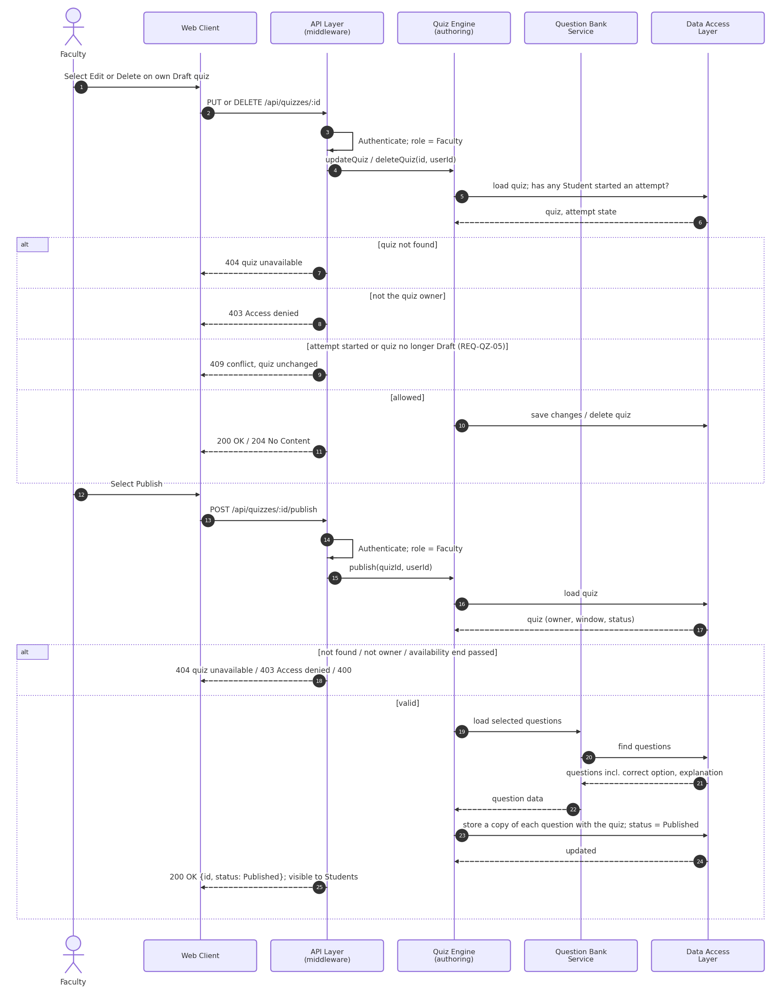
Figure 4.1(b): Sequence diagram – Edit, delete and publish a quiz (UC-QZ-02)
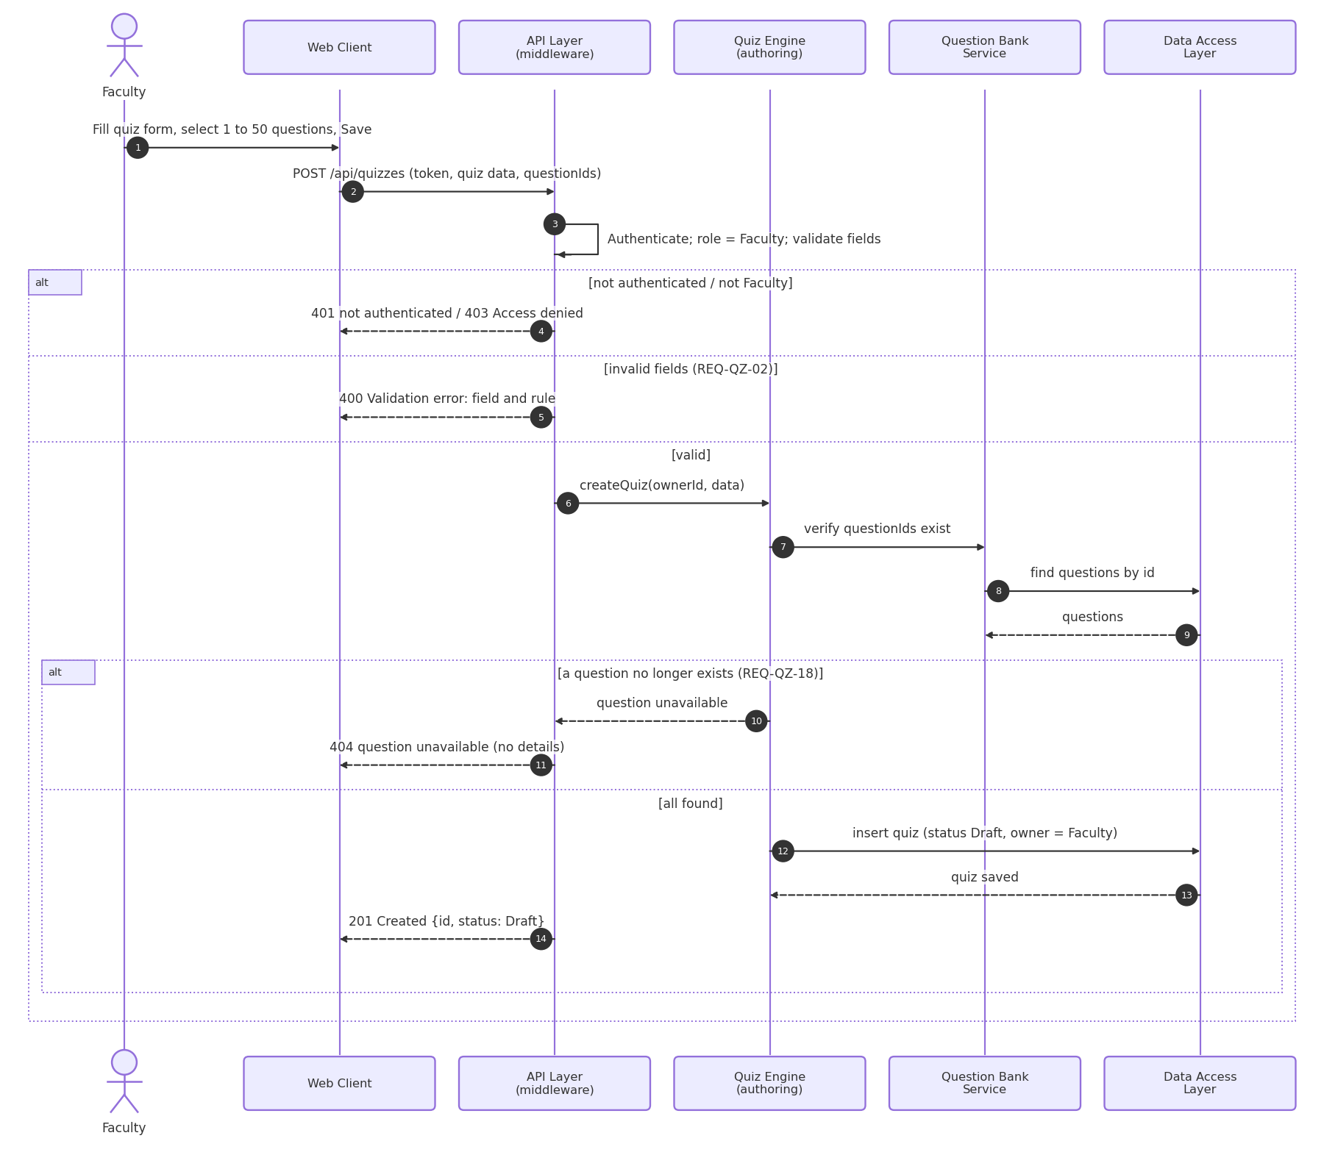
Sequence diagram 2: Attempt a quiz and automatic grading (UC-QZ-04, UC-QZ-05)
Figure 4.2(a): Sequence diagram – Start a quiz attempt and save answers (UC-QZ-04)
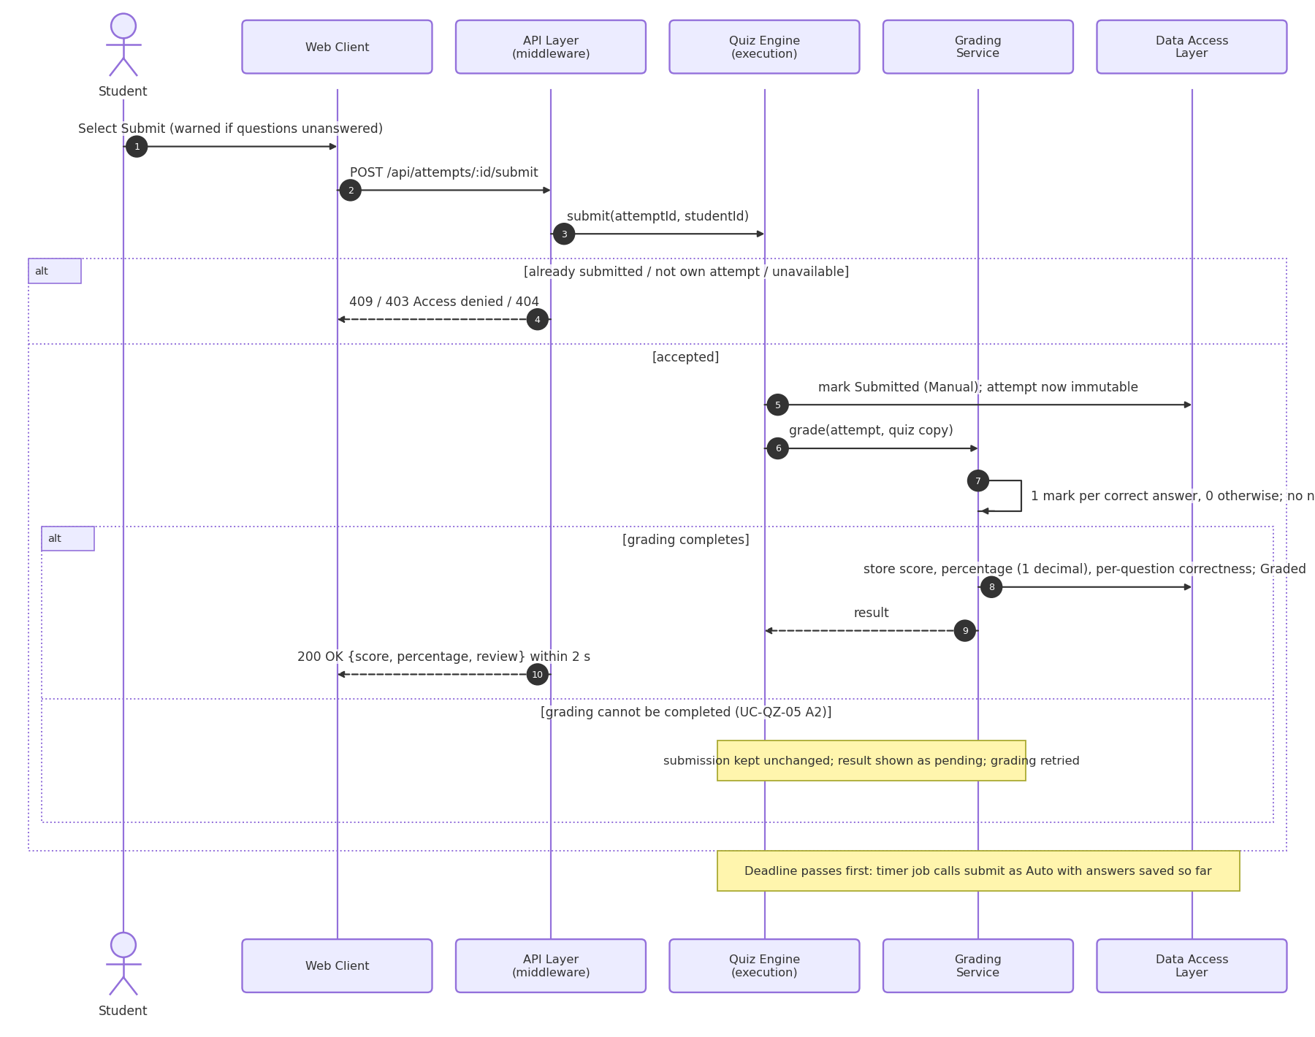
Figure 4.2(b): Sequence diagram – Submit, automatic grading and auto-submit (UC-QZ-04, UC-QZ-05)
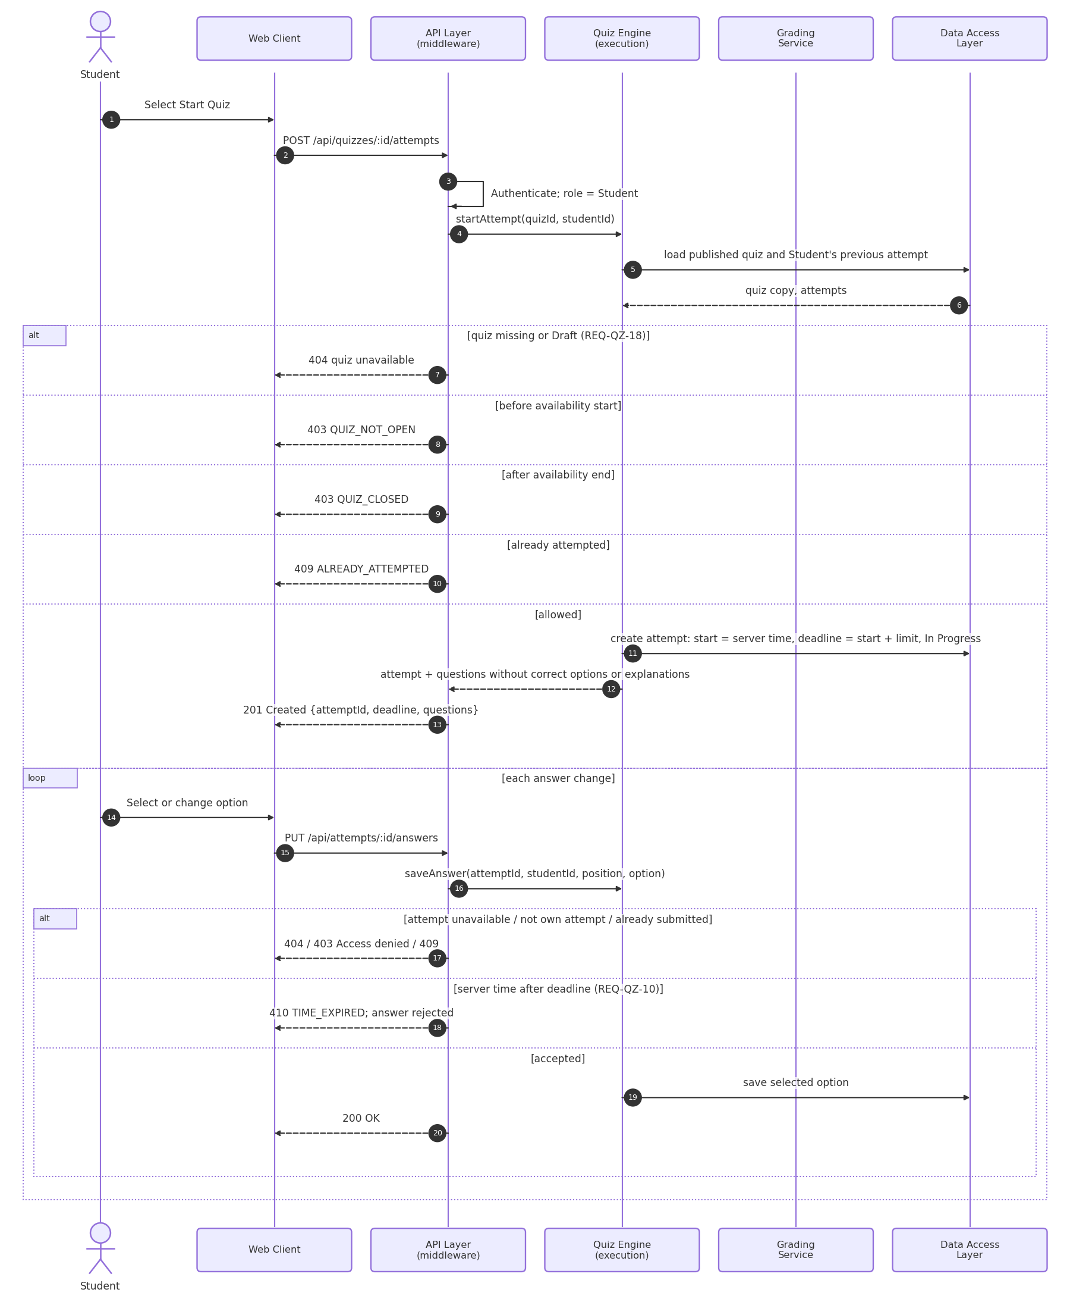
Sequence diagram 3: Authenticate User
Use Case: UC-ACC-02 Authenticate User
Requirements: REQ-ACC-04, REQ-ACC-05, REQ-ACC-06, REQ-ACC-10, SEC-ACC-01, SEC-ACC-02, SEC-ACC-06
Figure 4.3: Sequence diagram – Authenticate User (UC-ACC-02)
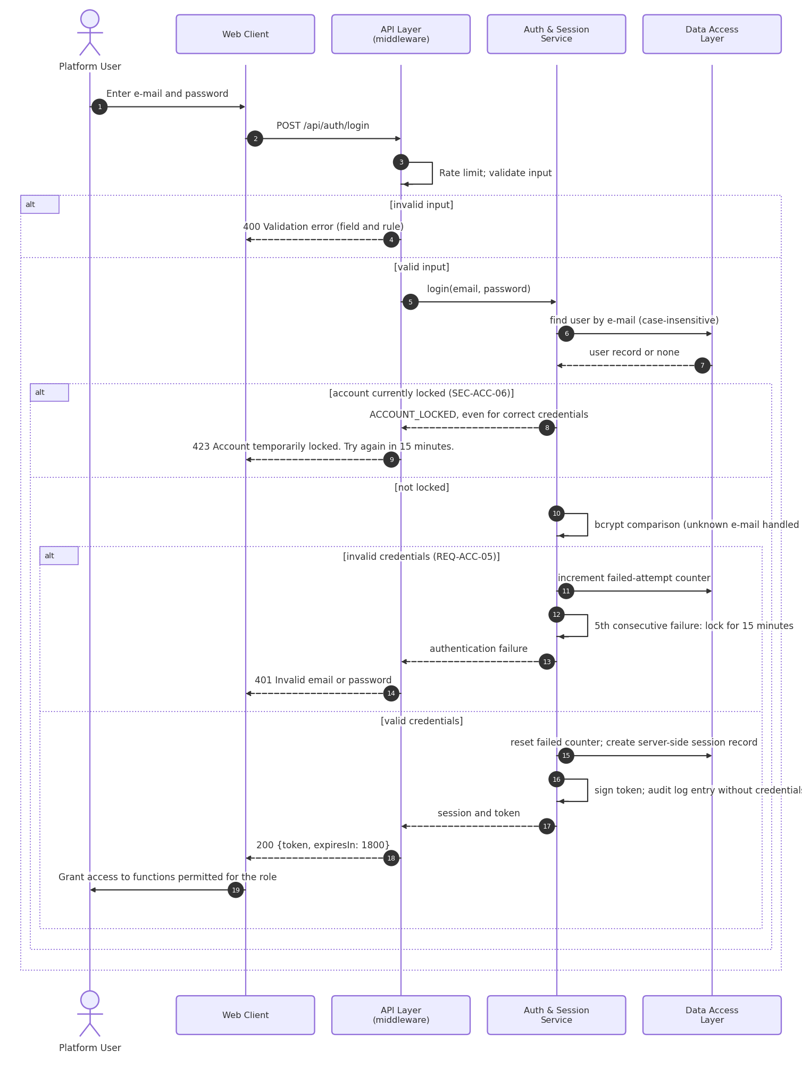
Sequence diagram 4: Upload and Share Material
Use Cases: UC-MAT-01 Upload Material, UC-MAT-03 Share Material
Requirements: REQ-MAT-01 to REQ-MAT-03, REQ-MAT-05, REQ-MAT-10, REQ-MAT-11, SEC-MAT-02, NFR-SAFE-02, NFR-SAFE-03
Figure 4.4(a): Sequence diagram – Upload material (UC-MAT-01)
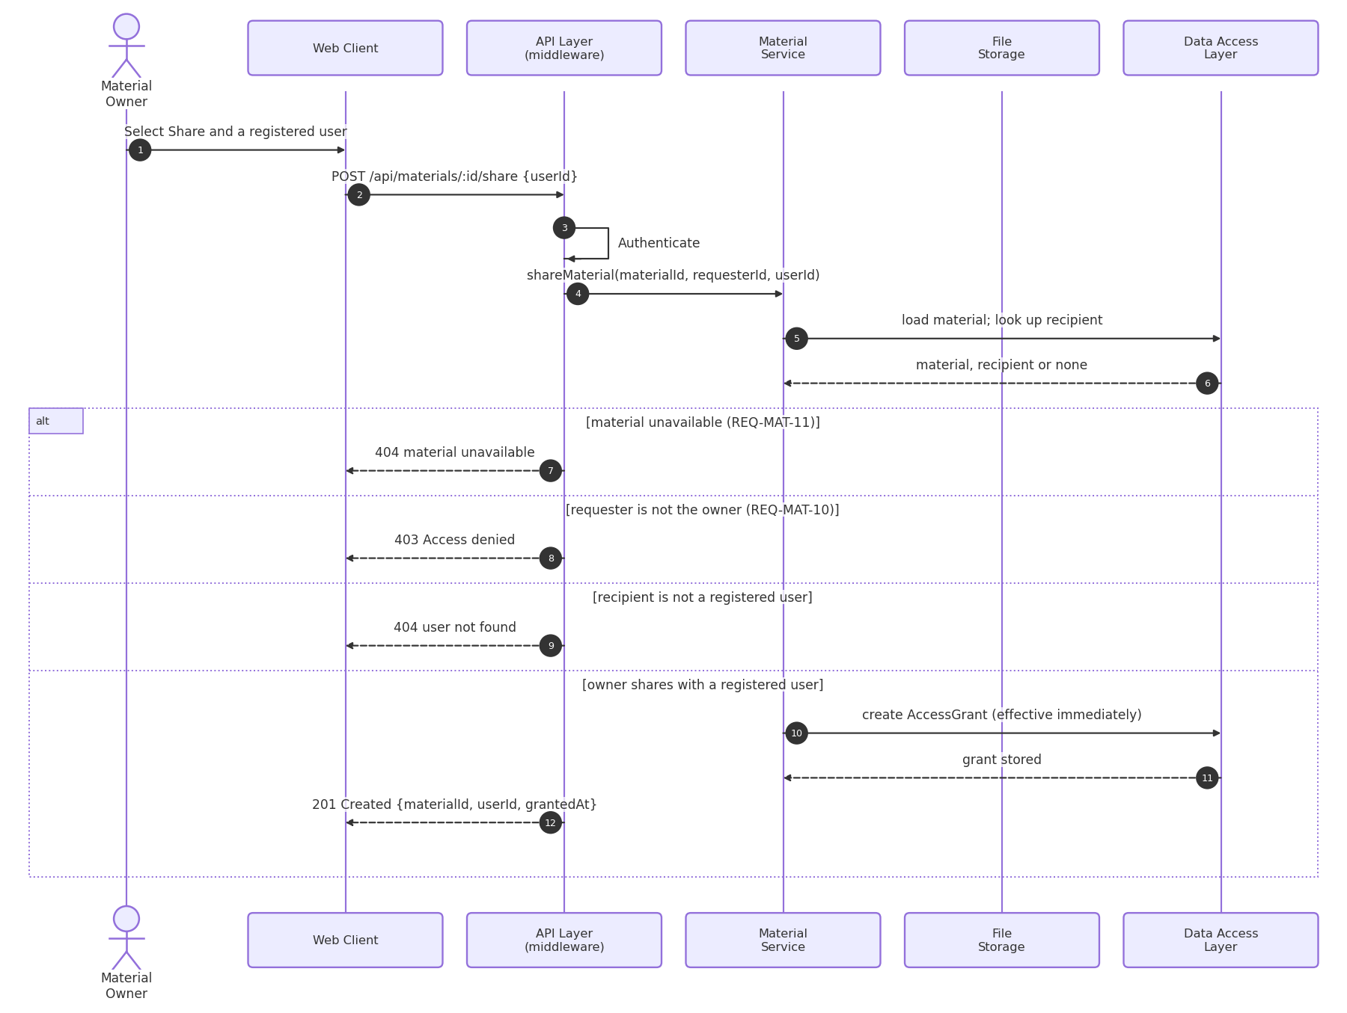
Figure 4.4(b): Sequence diagram – Share material (UC-MAT-03)
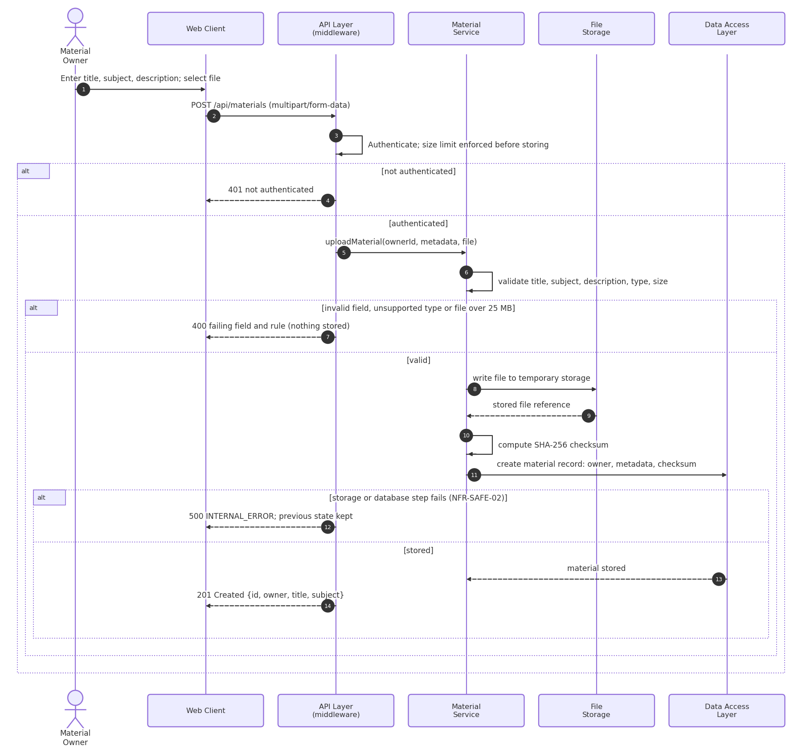
Sequence diagram 5: View Personal Performance
Use Case: UC-PA-01 View Personal Performance
Requirements: REQ-PA-01, REQ-PA-02
Figure 4.5: Sequence diagram – View Personal Performance (UC-PA-01)
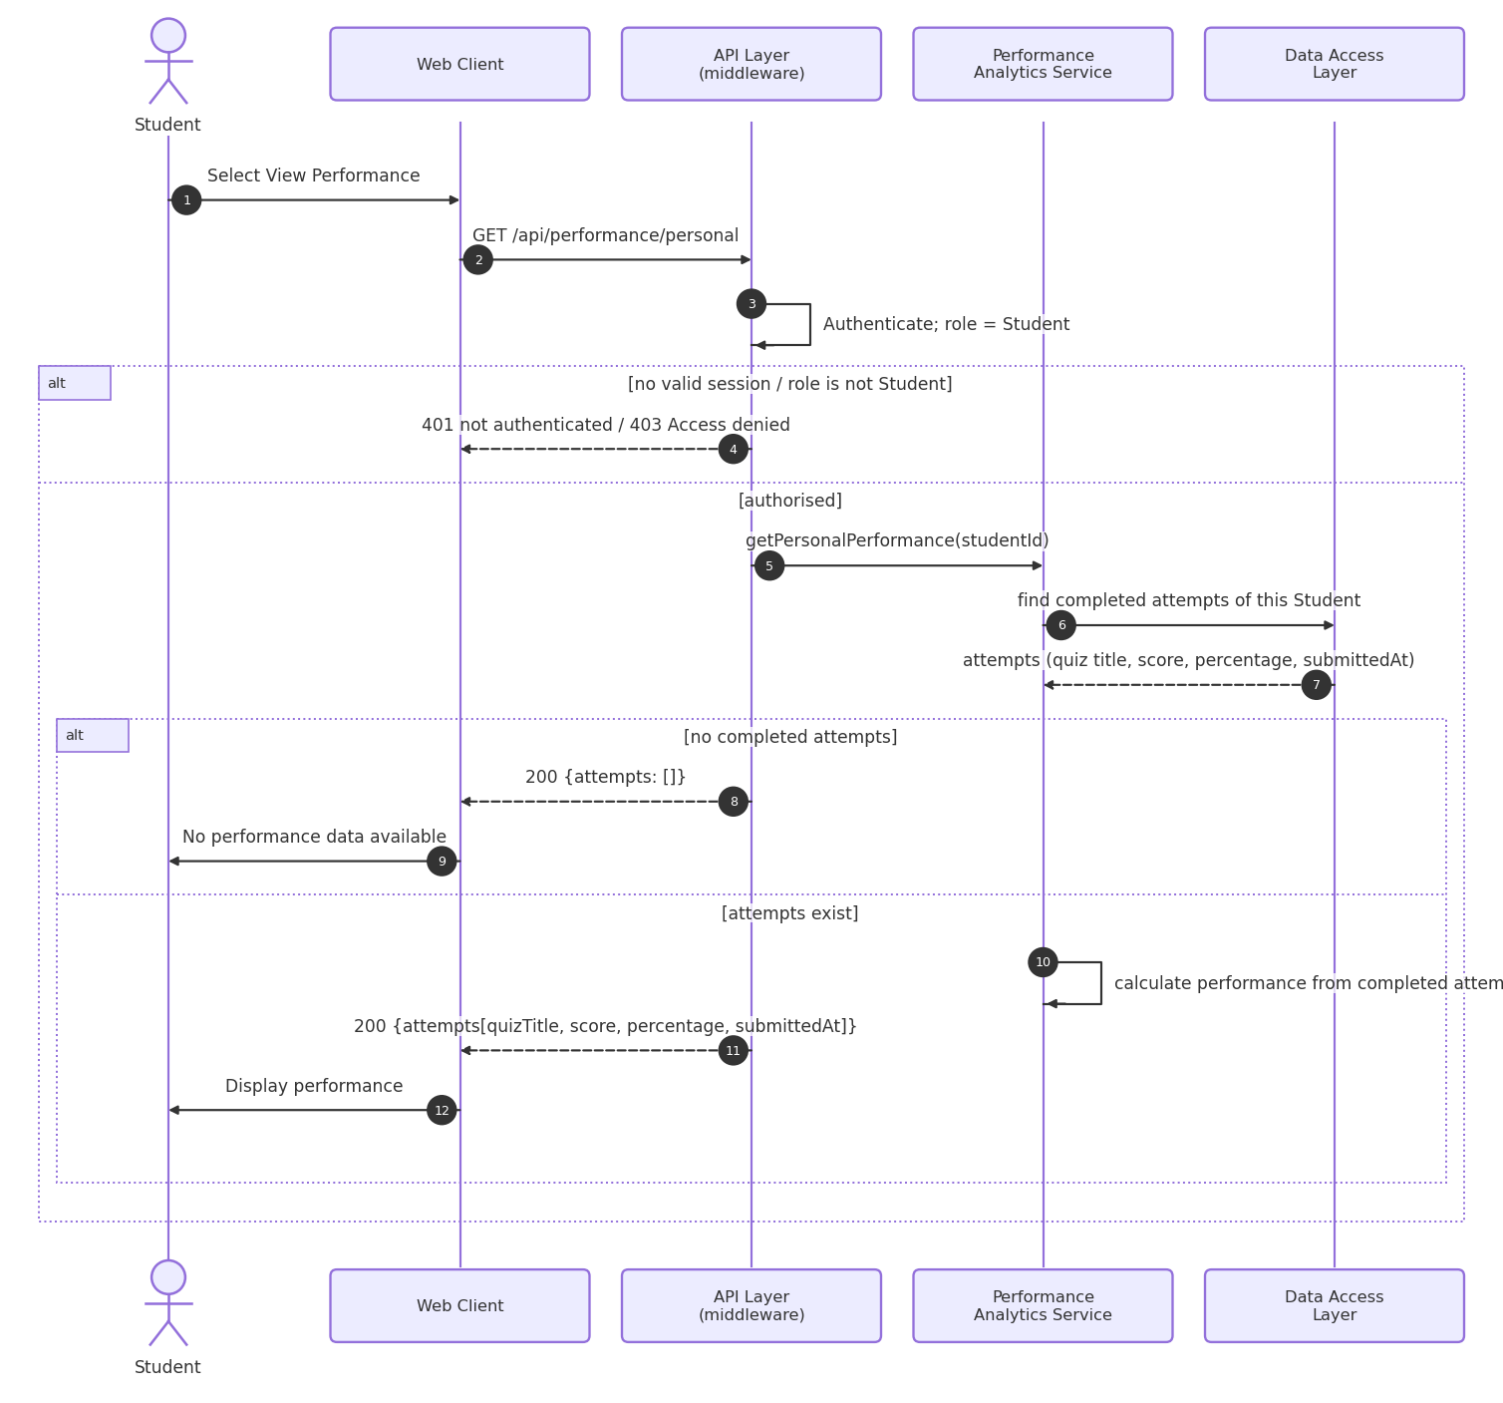
Sequence diagram 6: View Class and Topic-wise Performance
Use Cases: UC-PA-02 View Class Performance, UC-PA-03 View Topic-wise Analysis
Requirements: REQ-PA-03 to REQ-PA-06
Figure 4.6: Sequence diagram – View Class and Topic-wise Performance (UC-PA-02, UC-PA-03)
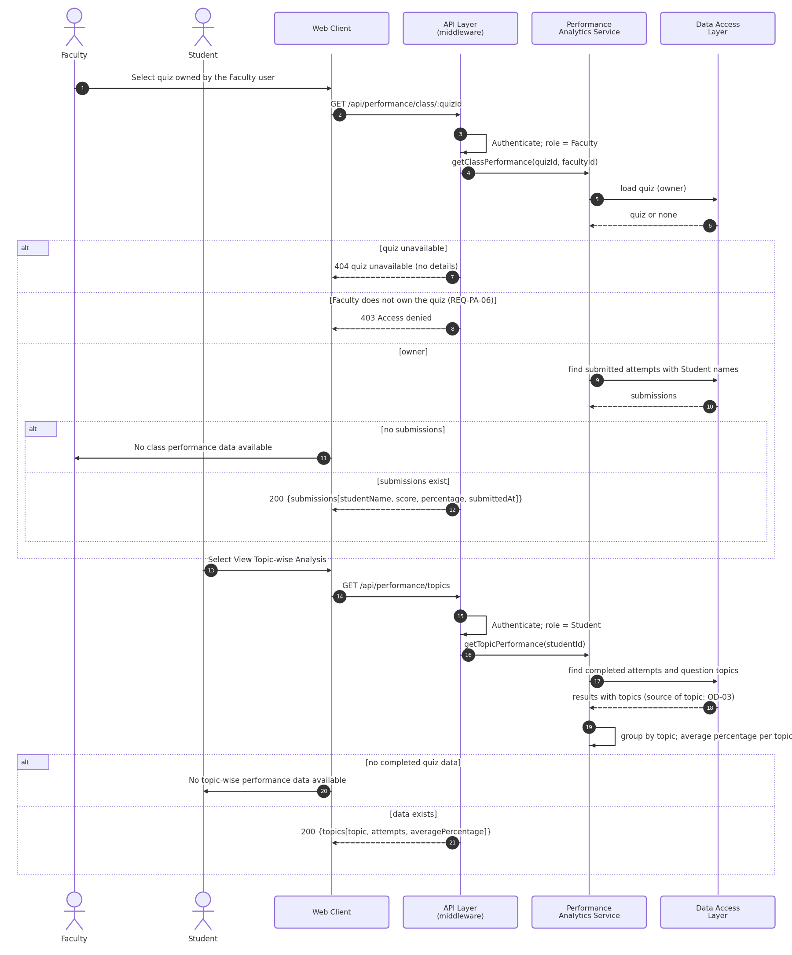
Sequence diagram 7: Create or Join Study Group and Moderate Content
Use Cases: UC-COL-01 Create or Join Study Group, UC-COL-02 Moderate Content
Requirements: REQ-COL-01 to REQ-COL-07
Figure 4.7(a): Sequence diagram – Create or join a study group (UC-COL-01)
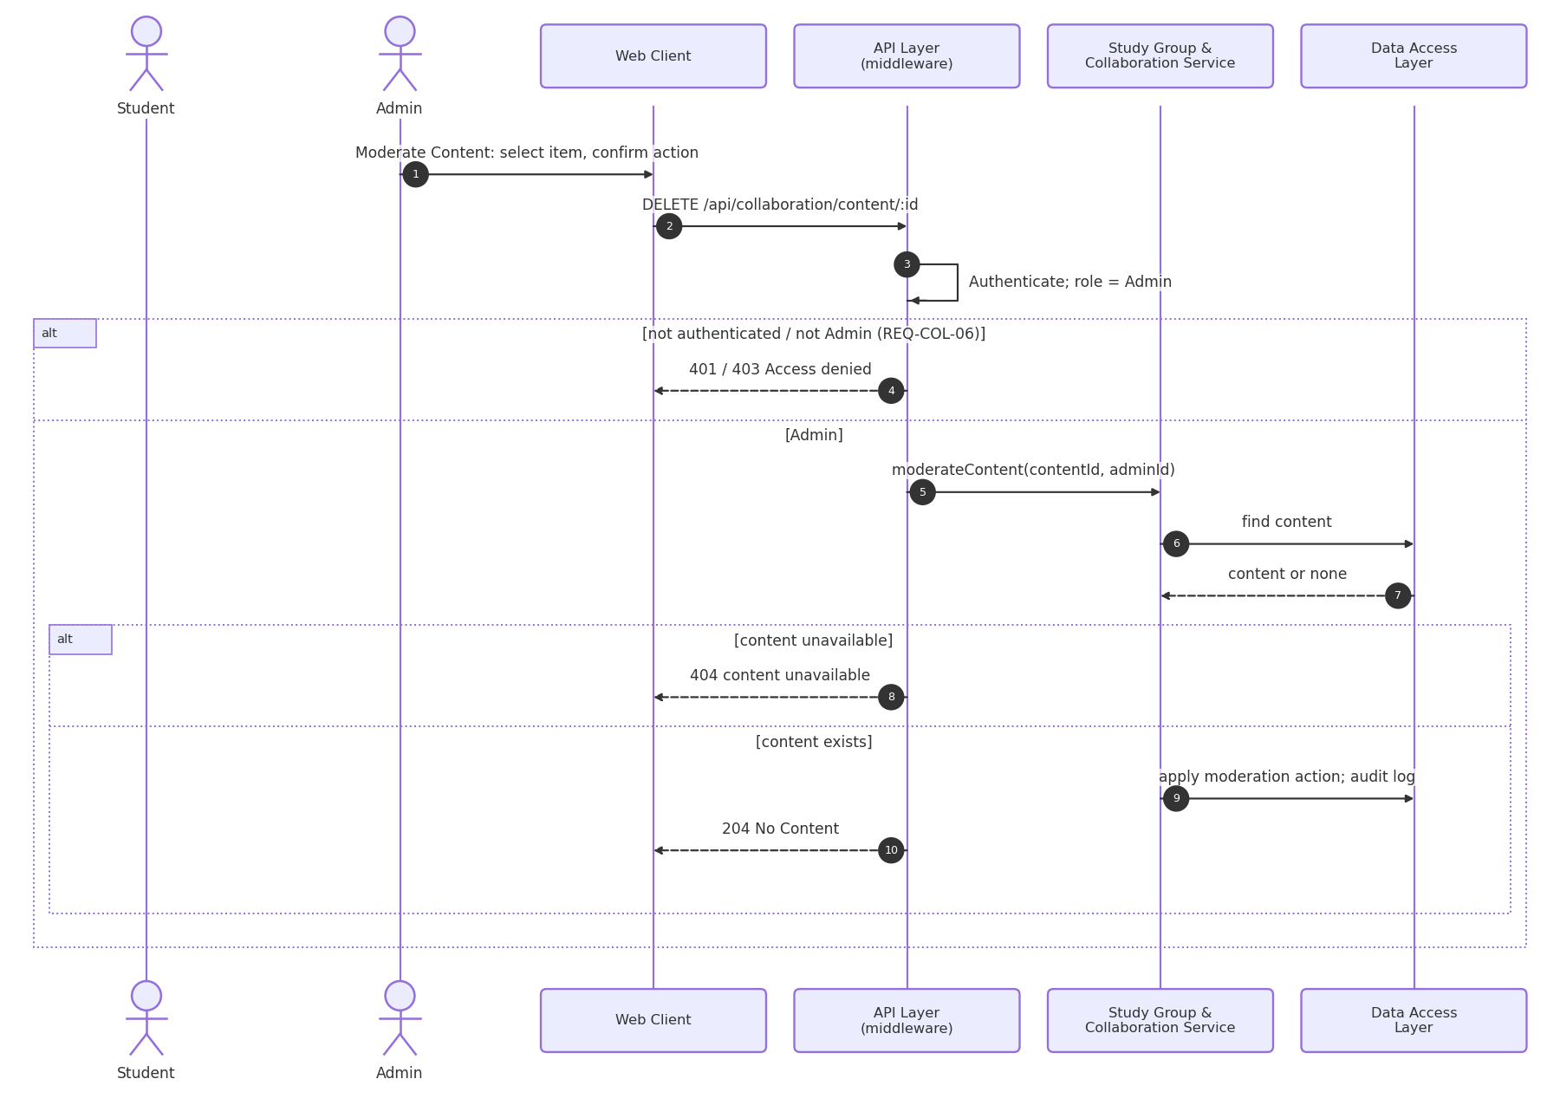
Figure 4.7(b): Sequence diagram – Moderate content (UC-COL-02)
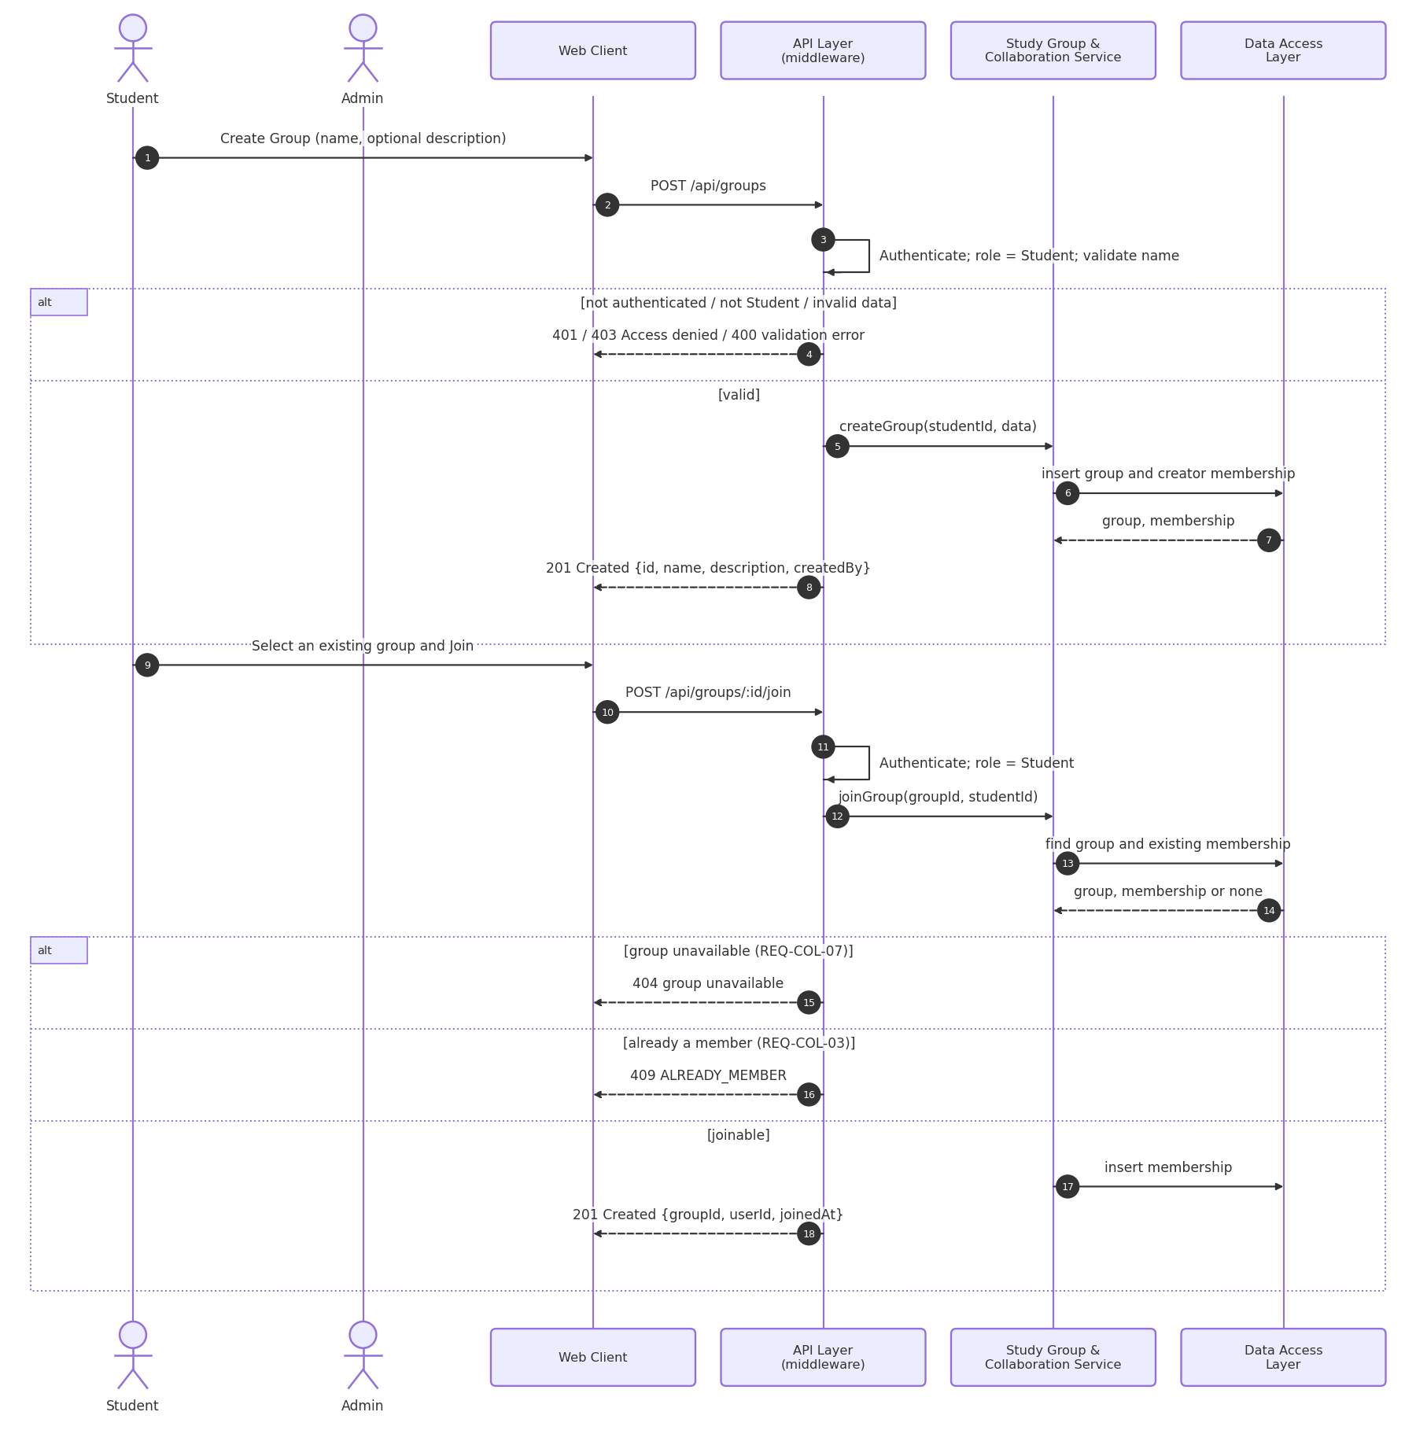
Note on Figures 4.5 to 4.10: endpoint labels in the figures use the normative paths of Section 4.3 with the /api prefix. The Study Group & Collaboration Service of Figure 4.7 is the service of the same name in Figure 3.1. Open points shown in the figures: the source of question topics (OD-03) and the response for a pending result (OD-08).
Sequence diagram 8: Register Account
Use Case: UC-ACC-01 Register Account
Requirements: REQ-ACC-01 to REQ-ACC-03, SEC-ACC-03, BR-08
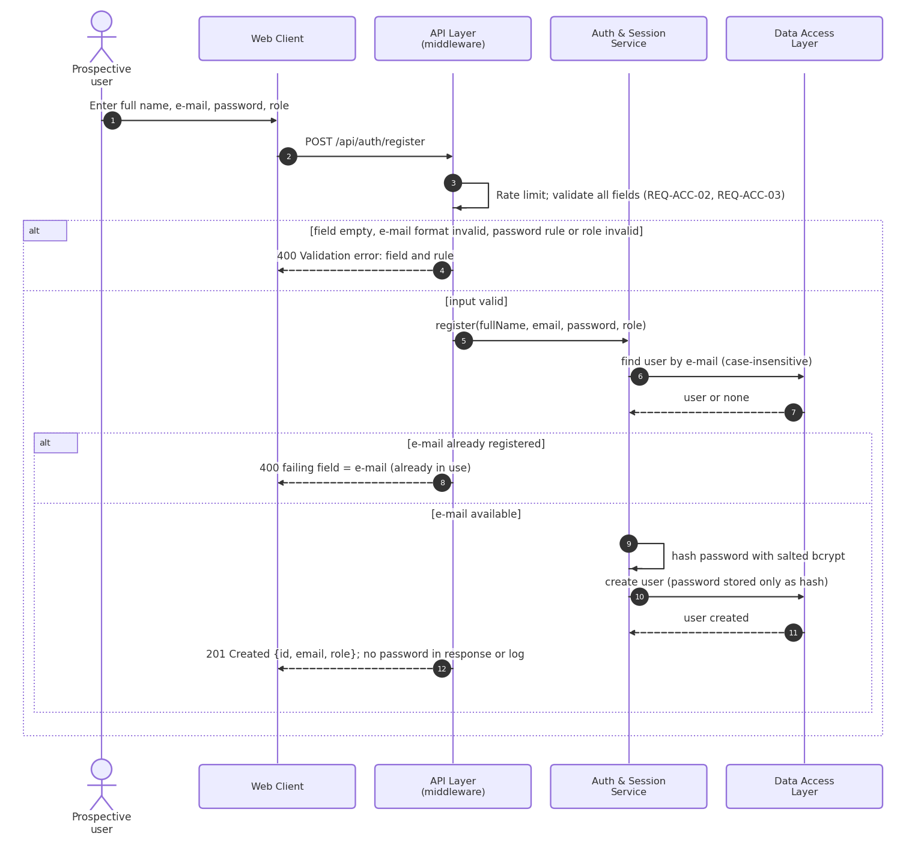
Figure 4.8: Sequence diagram – Register Account (UC-ACC-01)
Sequence diagram 9: Download Material and Revoke Access
Use Cases: UC-MAT-04 Download Material, UC-MAT-07 Revoke Material Access
Requirements: REQ-MAT-04, REQ-MAT-06, REQ-MAT-09, REQ-MAT-10, REQ-MAT-11, SEC-MAT-01, SEC-MAT-02, SEC-MAT-04, NFR-PERF-03, NFR-SAFE-03
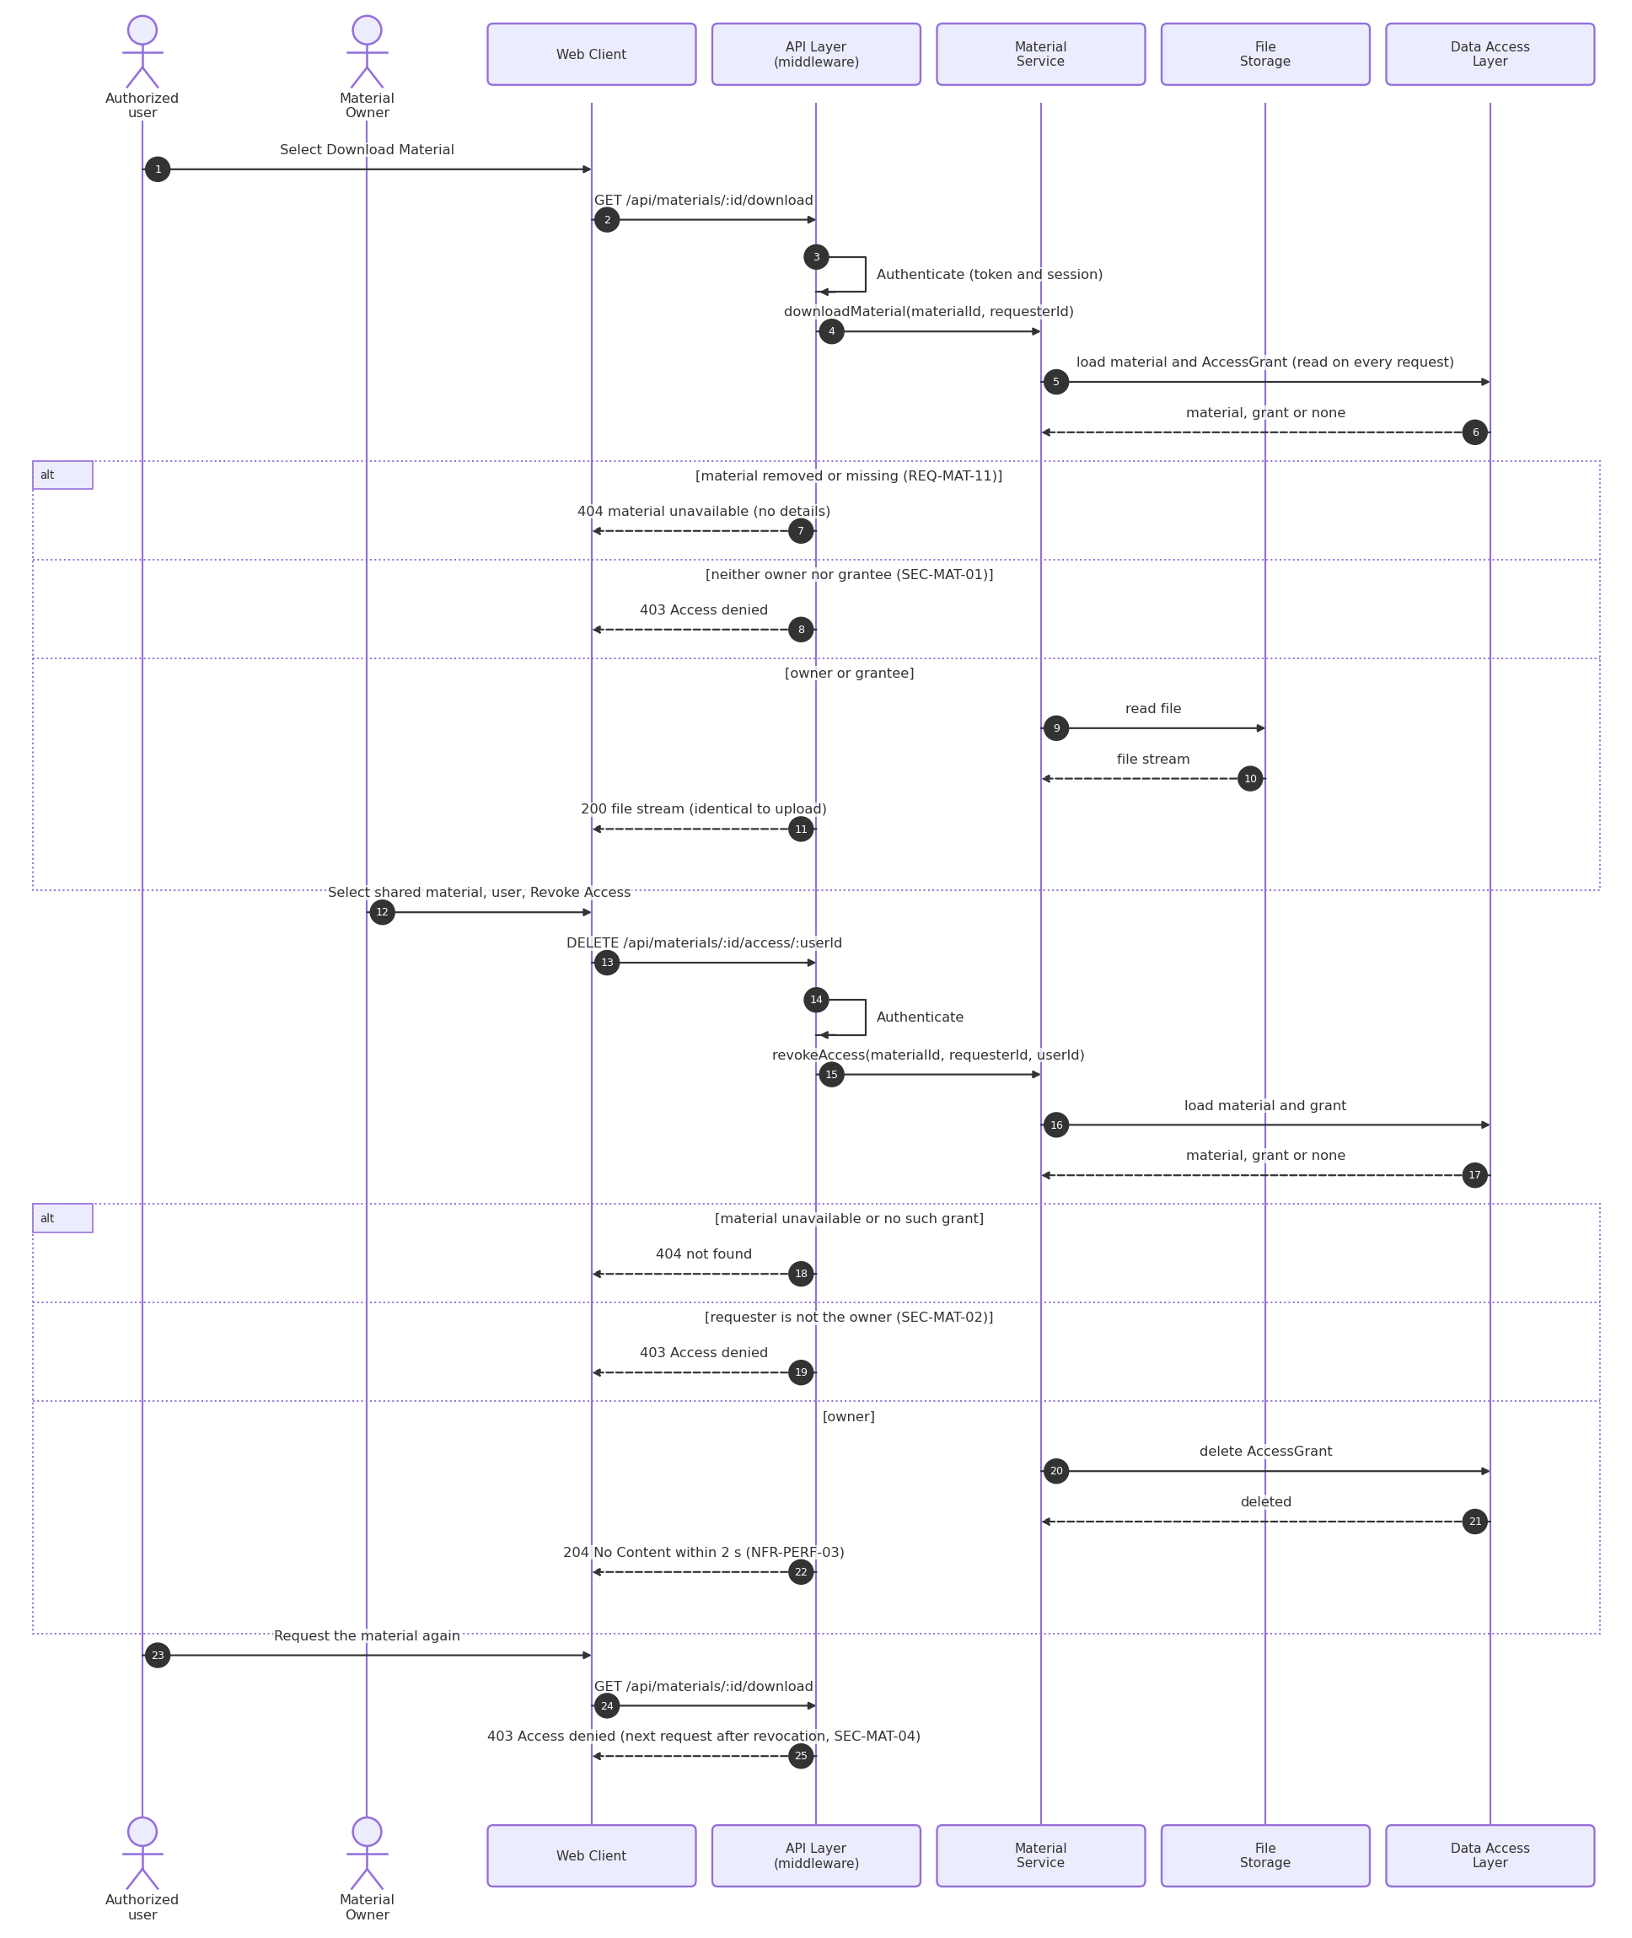
Figure 4.9: Sequence diagram – Download Material and Revoke Access (UC-MAT-04, UC-MAT-07)
Sequence diagram 10: Manage the Question Bank
Use Cases: UC-QB-01 to UC-QB-04
Requirements: REQ-QB-01 to REQ-QB-07, REQ-QZ-18, SEC-QZ-01, NFR-PERF-05
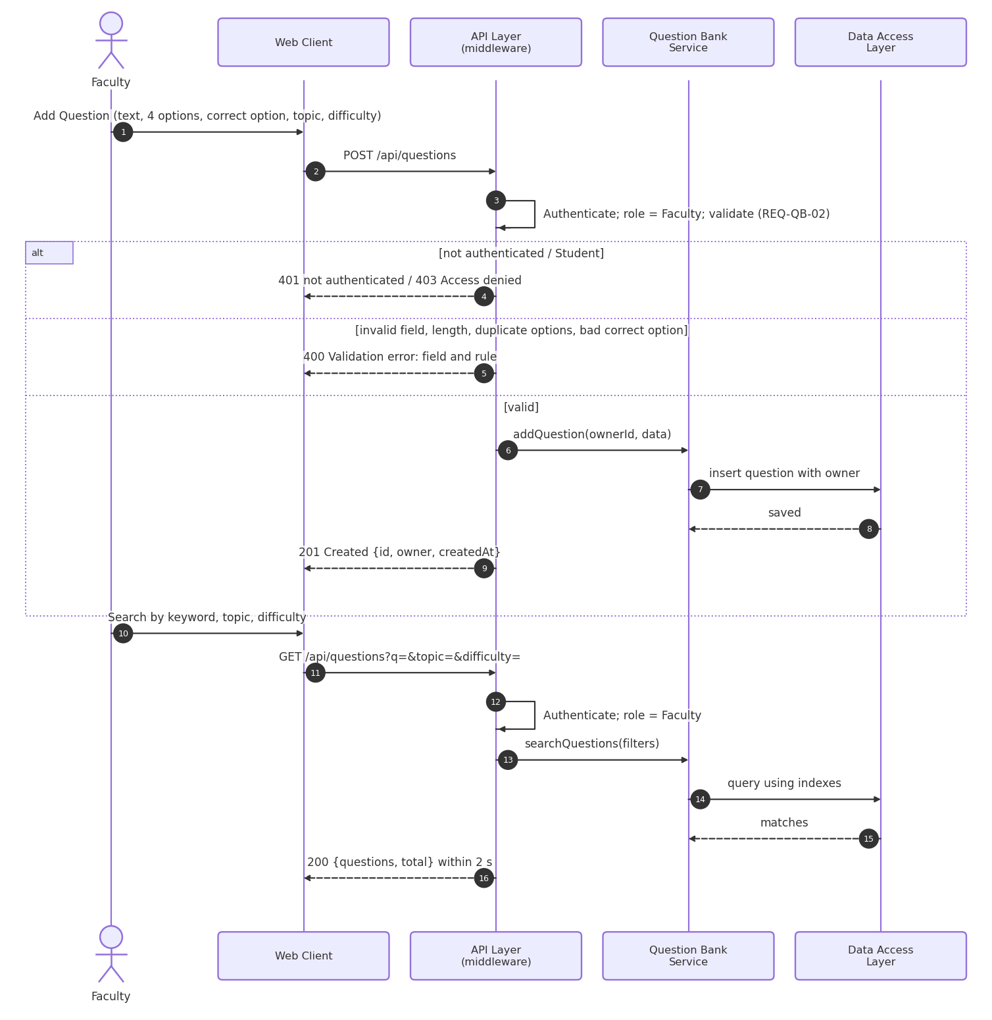
Figure 4.10(a): Sequence diagram – Add and search questions (UC-QB-01, UC-QB-02)
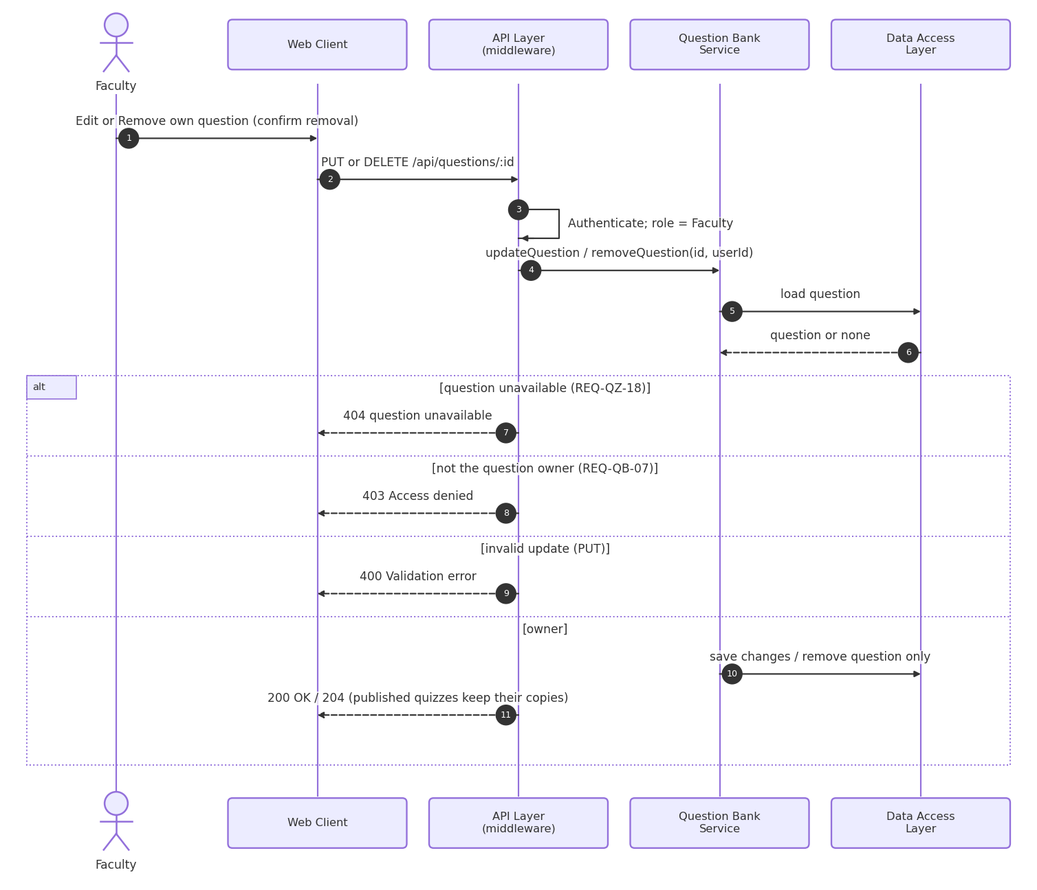
Figure 4.10(b): Sequence diagram – Edit and remove a question (UC-QB-03, UC-QB-04)

4.3 API Design
Interface definition for all components of the platform in one integrated API.
All endpoint paths below are relative to the /api base path (for example /auth/login is served at /api/auth/login).
Route mounting and middleware order: every route is mounted through the route index; on a protected endpoint the order is authenticate, role authorization, validation rules, validation, controller (Section 4.1). Each endpoint below states its requirement IDs and its responsible member; the ownership matrix at the end of this section lists them together.
Conventions
Format: requests and responses are JSON (application/json) except where multipart/form-data is stated.
Authentication: every endpoint except POST /auth/register and POST /auth/login requires the header Authorization: Bearer <token>. The token is issued by /auth/login and is accepted only while its server-side session record is valid (30 minutes of inactivity; invalidated on logout). A missing, expired or invalidated token returns 401.
Authorization: role and ownership checks are enforced on the server by the API Layer middleware and again in the service layer; client-side checks are for display only.
File uploads: supported material types are PDF, DOCX, PPTX and PNG, with a maximum size of 25 MB; other types or larger files return 400. The limit is enforced before the file is stored.
Lists: list endpoints accept optional page and limit query parameters.
Errors: every error uses the structure {error: {code, message}}; validation errors also name the failing field and rule (see 4.4). 429 RATE_LIMITED may be returned by any endpoint when the rate limit is exceeded.
Component: Auth & Session Service (Account Management)
Endpoint: /auth/register
Method: POST
Authorization: Public
Request: {fullName, email, password, role: "Student"|"Faculty"}
Response: 201 {id, email, role}
Errors: 400 validation error identifying the failing field and rule
Validation: fullName 1–100 characters; e-mail valid, at most 254 characters, unique ignoring case (already registered returns 400 naming the e-mail field); password at least 8 characters with an uppercase letter, a lowercase letter and a digit; role Student or Faculty (Admin accounts are not created here, BR-08).
Requirements: REQ-ACC-01 to REQ-ACC-03; SEC-ACC-03; BR-08
Owner: Member 1
Endpoint: /auth/login
Method: POST
Authorization: Public
Request: {email, password}
Response: 200 {token, expiresIn: 1800}
Errors: 400 validation error, 401 INVALID_CREDENTIALS ("Invalid email or password"), 423 ACCOUNT_LOCKED (15 minutes after 5 consecutive failures)
Validation: e-mail and password required. Messages: “Invalid email or password”; “Account temporarily locked. Try again in 15 minutes.”
Requirements: REQ-ACC-04 to REQ-ACC-06; SEC-ACC-01, 02, 06
Owner: Member 1
Endpoint: /auth/logout
Method: POST
Authorization: Authenticated user
Request: –
Response: 204 (session record invalidated; the token is rejected afterwards)
Errors: 401 not authenticated
Requirements: REQ-ACC-07; SEC-ACC-04
Owner: Member 1
Component: Account Service (Account Management)
Endpoint: /account/profile
Method: GET
Authorization: Authenticated user (own profile)
Request: –
Response: 200 {fullName, institution, profilePicture, email, role}
Errors: 401 not authenticated
Requirements: REQ-ACC-08, REQ-ACC-10
Owner: Member 1
Endpoint: /account/profile
Method: PUT
Authorization: Authenticated user (own profile)
Request: multipart/form-data {fullName?, institution?, profilePicture? (image file)}; plain JSON is accepted when no picture is sent
Response: 200 {id, fullName, institution, profilePicture}
Errors: 400 validation error (field and rule, unsupported picture type or size, or an attempt to change e-mail or role), 401 not authenticated
Note: The profile picture is stored in File Storage. A profile picture larger than 2 MB is rejected with 400 VALIDATION_ERROR naming the profilePicture field (REQ-ACC-09, DC-06); the 25 MB limit applies to study-material uploads only (REQ-MAT-02). The accepted picture types are not specified in the SRS (OD-13). E-mail address and role are not editable.
Validation: fullName 1–100 characters and not empty; institution at most 100; profile picture at most 2 MB (accepted picture types: OD-13); e-mail and role cannot be changed.
Requirements: REQ-ACC-08, REQ-ACC-09; SEC-ACC-05
Owner: Member 1
Component: Material Service (Material Sharing)
Endpoint: /materials
Method: POST
Authorization: Authenticated Student or Faculty
Request: multipart/form-data {title, subject, description, file (PDF, DOCX, PPTX or PNG, max 25 MB)}
Response: 201 {id, owner, title, subject}
Errors: 400 failing field and rule or unsupported file type/size, 401 not authenticated, 403 Access denied (other roles), 500 storage failure (nothing is created)
Validation: title 1–100 characters; subject required, at most 100; description 1–500 characters; one file, PDF, DOCX, PPTX or PNG, at most 25 MB.
Note: the role restriction is retained from version 1.0; SRS REQ-MAT-01 and UC-MAT-01 name any authenticated user, Admin included (OD-07).
Requirements: REQ-MAT-01 to REQ-MAT-03
Owner: Member 4
Endpoint: /materials
Method: GET
Authorization: Authenticated user
Request: query: page?, limit?
Response: 200 {materials[{id, title, subject, owner}], total} – materials owned by or shared with the user
Errors: 401 not authenticated
Note: SRS Appendix B.6 also lists the owner name and the access status (“Owner” or “Shared with me”); these response fields are not yet in the contract (OD-13).
Requirements: REQ-MAT-03, REQ-MAT-04
Owner: Member 4
Endpoint: /materials/:id
Method: GET
Authorization: Material owner or user with an AccessGrant
Request: –
Response: 200 {id, title, subject, description, owner}
Errors: 401 not authenticated, 403 Access denied, 404 material unavailable
Requirements: REQ-MAT-04, REQ-MAT-10, REQ-MAT-11
Owner: Member 4
Endpoint: /materials/:id/download
Method: GET
Authorization: Material owner or user with an AccessGrant
Request: –
Response: 200 file stream (identical to the uploaded file)
Errors: 401 not authenticated, 403 Access denied, 404 material unavailable
Requirements: REQ-MAT-06, REQ-MAT-10, REQ-MAT-11; SEC-MAT-01; NFR-SAFE-03
Owner: Member 4
Endpoint: /materials/:id
Method: PUT
Authorization: Material owner
Request: multipart/form-data with any permitted updated fields {title?, subject?, description?, file?}
Response: 200 {id, updatedAt}
Errors: 400 failing field and rule or unsupported file type/size, 401, 403 Access denied, 404 material unavailable, 500 (previous state kept)
Validation: same rules as upload; the file is optional.
Requirements: REQ-MAT-07, REQ-MAT-10; SEC-MAT-03; NFR-SAFE-02
Owner: Member 4
Endpoint: /materials/:id
Method: DELETE
Authorization: Material owner
Request: –
Response: 204
Errors: 401 not authenticated, 403 Access denied, 404 material unavailable
Requirements: REQ-MAT-08, REQ-MAT-10, REQ-MAT-11; SEC-MAT-03, 04; NFR-SAFE-02
Owner: Member 4
Endpoint: /materials/:id/share
Method: POST
Authorization: Material owner
Request: {userId: registeredUserId}
Response: 201 {materialId, userId, grantedAt}
Errors: 400 missing or malformed userId, 401, 403 Access denied, 404 material unavailable or recipient is not a registered user (user not found)
Validation: userId required and must identify a registered user.
Requirements: REQ-MAT-05, REQ-MAT-10; SEC-MAT-02; NFR-PERF-03
Owner: Member 4
Endpoint: /materials/:id/access/:userId
Method: DELETE
Authorization: Material owner (revoke access)
Request: –
Response: 204 (the next access request by that user is denied)
Errors: 401, 403 Access denied, 404 material or access grant unavailable
Requirements: REQ-MAT-09, REQ-MAT-10; SEC-MAT-02, 04; NFR-PERF-03
Owner: Member 4
Component: Question Bank Service (Question Bank)
Endpoint: /questions
Method: POST
Authorization: Faculty
Request: {text, options[4], correctOption, topic, difficulty, explanation?}
Response: 201 {id, owner, createdAt}
Errors: 400 failing field and rule, 401, 403 Access denied
Validation: text at most 500 characters; exactly four distinct options, each at most 200; correctOption one of the four options; topic at most 50; difficulty Easy, Medium or Hard; explanation optional, at most 300.
Requirements: REQ-QB-01 to REQ-QB-03, REQ-QB-07; SEC-QZ-01
Owner: Member 2
Endpoint: /questions?q=&topic=&difficulty=
Method: GET
Authorization: Faculty
Request: query parameters (optional page, limit)
Response: 200 {questions[{id, text, topic, difficulty, owner}], total}
Errors: 401, 403 Access denied (Students)
Requirements: REQ-QB-04, REQ-QB-07; NFR-PERF-05
Owner: Member 2
Endpoint: /questions/:id
Method: PUT
Authorization: Faculty owner of the question
Request: any question field
Response: 200 {id, updatedAt}
Errors: 400 failing field and rule, 401, 403 Access denied (not owner), 404 question unavailable
Validation: same rules as POST /questions for every field sent.
Requirements: REQ-QB-02, REQ-QB-05, REQ-QB-07, REQ-QZ-18
Owner: Member 2
Endpoint: /questions/:id
Method: DELETE
Authorization: Faculty owner of the question
Request: –
Response: 204 (published quizzes keep their own copy)
Errors: 401, 403 Access denied, 404 question unavailable
Requirements: REQ-QB-06, REQ-QB-07
Owner: Member 2
Component: Quiz Engine – quiz authoring (Quizzes)
Endpoint: /quizzes
Method: POST
Authorization: Faculty
Request: {title, description?, timeLimitMinutes, availableFrom, availableUntil, questionIds[1..50]}
Response: 201 {id, status: "Draft"}
Errors: 400 failing field and rule, 401, 403 Access denied, 404 question unavailable
Validation: title 1–100 characters; description at most 300; timeLimitMinutes 5 to 180; availableUntil later than availableFrom; 1 to 50 questionIds.
Requirements: REQ-QZ-01 to REQ-QZ-03, REQ-QZ-17; SEC-QZ-01
Owner: Member 2
Endpoint: /quizzes/:id
Method: PUT
Authorization: Faculty owner (Draft only)
Request: quiz fields
Response: 200 {id}
Errors: 400 failing field and rule, 401, 403 Access denied, 404 quiz unavailable, 409 quiz already attempted or no longer Draft
Validation: same rules as POST /quizzes for every field sent.
Requirements: REQ-QZ-05, REQ-QZ-17, REQ-QZ-18; SEC-QZ-01
Owner: Member 2
Endpoint: /quizzes/:id
Method: DELETE
Authorization: Faculty owner
Request: –
Response: 204
Errors: 401, 403 Access denied, 404 quiz unavailable, 409 quiz already attempted
Requirements: REQ-QZ-05, REQ-QZ-17, REQ-QZ-18; SEC-QZ-01
Owner: Member 2
Endpoint: /quizzes/:id/publish
Method: POST
Authorization: Faculty owner
Request: –
Response: 200 {id, status: "Published"} (selected questions copied into the quiz)
Errors: 400 availability end already passed, 401, 403 Access denied, 404 quiz unavailable
Requirements: REQ-QZ-04, REQ-QZ-17; SEC-QZ-01
Owner: Member 2
Component: Quiz Engine (execution) – quiz listing and quiz submissions (Quizzes)
Endpoint: /quizzes
Method: GET
Authorization: Student
Request: –
Response: 200 {quizzes[{id, title, questionCount, timeLimitMinutes, availableFrom, availableUntil, attempted}]} (no questions or answers)
Errors: 401, 403 Access denied
Requirements: REQ-QZ-06, REQ-QZ-17; SEC-QZ-02
Owner: Member 4
Endpoint: /quizzes/:id/submissions
Method: GET
Authorization: Faculty owner
Request: –
Response: 200 {submissions[{studentName, score, percentage, submittedAt}]}
Errors: 401, 403 Access denied, 404 quiz unavailable
Requirements: REQ-QZ-16, REQ-QZ-17; SEC-QZ-03
Owner: Member 2
Component: Quiz Engine (execution) and Grading Service – attempts and grading (Quizzes)
Endpoint: /quizzes/:id/attempts
Method: POST
Authorization: Student
Request: –
Response: 201 {attemptId, deadline, questions[{position, text, options[4]}]} (no correct options)
Errors: 401, 403 Access denied, 403 QUIZ_NOT_OPEN or QUIZ_CLOSED, 404 quiz unavailable, 409 ALREADY_ATTEMPTED
Requirements: REQ-QZ-07, REQ-QZ-08, REQ-QZ-17, REQ-QZ-18; SEC-QZ-02, 04; NFR-PERF-06
Owner: Member 4
Endpoint: /attempts/:id/answers
Method: PUT
Authorization: Student attempt owner
Request: {position, selectedOption}
Response: 200
Errors: 400 invalid position or option, 401, 403 Access denied, 404 attempt unavailable, 409 already submitted, 410 TIME_EXPIRED
Validation: position within the quiz; selectedOption one of A to D. Rejected with 410 after the deadline (message “Time limit expired”).
Requirements: REQ-QZ-09, REQ-QZ-10, REQ-QZ-14; SEC-QZ-04, 05
Owner: Member 4
Endpoint: /attempts/:id/submit
Method: POST
Authorization: Student attempt owner
Request: –
Response: 200 {score, total, percentage, questions[{yourAnswer, correctOption, correct, explanation}]} within 2 seconds
Errors: 401, 403 Access denied, 404 attempt unavailable, 409 already submitted
Note: if grading cannot be completed the submission is kept and grading is retried; the response for a pending result is not yet specified (OD-08).
Requirements: REQ-QZ-11, REQ-QZ-12, REQ-QZ-14; SEC-QZ-05; NFR-PERF-04
Owner: Member 4
Endpoint: /attempts/mine
Method: GET
Authorization: Student (own attempts)
Request: –
Response: 200 {attempts[{quizTitle, score, percentage, submittedAt}]}
Errors: 401 not authenticated
Requirements: REQ-QZ-15; SEC-QZ-03
Owner: Member 4
Endpoint: /attempts/:id/result
Method: GET
Authorization: Student attempt owner
Request: –
Response: 200 detailed result as for submit
Errors: 401, 403 Access denied, 404 attempt unavailable
Requirements: REQ-QZ-13, REQ-QZ-17, REQ-QZ-18; SEC-QZ-03
Owner: Member 4
Component: Performance Analytics Service (Performance)
Endpoint: /performance/personal
Method: GET
Authorization: Authenticated Student
Request: –
Response: 200 {attempts[{quizTitle, score, percentage, submittedAt}]}
Errors: 401 not authenticated, 403 Access denied (other roles)
Requirements: REQ-PA-01, REQ-PA-02
Owner: Member 3
Endpoint: /performance/topics
Method: GET
Authorization: Authenticated Student
Request: –
Response: 200 {topics[{topic, attempts, averagePercentage}]}
Errors: 401 not authenticated, 403 Access denied (other roles)
Requirements: REQ-PA-03
Owner: Member 3
Endpoint: /performance/class/:quizId
Method: GET
Authorization: Faculty owner of the quiz
Request: –
Response: 200 {submissions[{studentName, score, percentage, submittedAt}]}
Errors: 401 not authenticated, 403 Access denied, 404 quiz unavailable
Requirements: REQ-PA-04 to REQ-PA-06
Owner: Member 3
Component: Study Group & Collaboration Service (Collaboration)
Endpoint: /groups
Method: POST
Authorization: Authenticated Student
Request: {name, description?}
Response: 201 {id, name, description, createdBy}
Errors: 400 validation error, 401 not authenticated, 403 Access denied
Validation: name required; length limits are not specified in the SRS (OD-13).
Requirements: REQ-COL-01
Owner: Member 3
Endpoint: /groups/:id/join
Method: POST
Authorization: Authenticated Student
Request: –
Response: 201 {groupId, userId, joinedAt}
Errors: 401, 403 Access denied, 404 group unavailable, 409 ALREADY_MEMBER
Requirements: REQ-COL-02, REQ-COL-03, REQ-COL-07
Owner: Member 3
Endpoint: /groups
Method: GET
Authorization: Authenticated Student (own groups)
Request: –
Response: 200 {groups[{id, name, description, createdBy}]}
Errors: 401 not authenticated, 403 Access denied
Requirements: REQ-COL-04
Owner: Member 3
Endpoint: /collaboration/content/:id
Method: DELETE
Authorization: Authenticated Admin (moderation)
Request: –
Response: 204
Errors: 401 not authenticated, 403 Access denied (non-Admin), 404 content unavailable
Note: the SRS speaks of “moderation actions” without listing them; deletion is the only action in this contract (OD-13).
Requirements: REQ-COL-05 to REQ-COL-07
Owner: Member 3
API ownership matrix
Every endpoint above has one primary implementation owner. All paths are relative to /api. Endpoint definitions are unchanged except the clarification of the share errors (400 for a malformed userId, 404 for an unknown recipient, as in SRS UC-MAT-03). Contracts still missing or ambiguous are listed under OD-08 and OD-13.
Endpoint | Owner | Collaborators / interfaces | Requirements
POST /auth/register | Member 1 | Authentication and role middleware (same owner) | REQ-ACC-01 to REQ-ACC-03; SEC-ACC-03; BR-08
POST /auth/login | Member 1 | Authentication and role middleware (same owner) | REQ-ACC-04 to REQ-ACC-06; SEC-ACC-01, 02, 06
POST /auth/logout | Member 1 | Authentication and role middleware (same owner) | REQ-ACC-07; SEC-ACC-04
GET /account/profile | Member 1 | Authentication and role middleware (same owner) | REQ-ACC-08, REQ-ACC-10
PUT /account/profile | Member 1 | Authentication and role middleware (same owner) | REQ-ACC-08, REQ-ACC-09; SEC-ACC-05
POST /materials | Member 4 | Member 1 (authentication and role middleware) | REQ-MAT-01 to REQ-MAT-03
GET /materials | Member 4 | Member 1 (authentication and role middleware) | REQ-MAT-03, REQ-MAT-04
GET /materials/:id | Member 4 | Member 1 (authentication and role middleware) | REQ-MAT-04, REQ-MAT-10, REQ-MAT-11
GET /materials/:id/download | Member 4 | Member 1 (authentication and role middleware) | REQ-MAT-06, REQ-MAT-10, REQ-MAT-11; SEC-MAT-01; NFR-SAFE-03
PUT /materials/:id | Member 4 | Member 1 (authentication and role middleware) | REQ-MAT-07, REQ-MAT-10; SEC-MAT-03; NFR-SAFE-02
DELETE /materials/:id | Member 4 | Member 1 (authentication and role middleware) | REQ-MAT-08, REQ-MAT-10, REQ-MAT-11; SEC-MAT-03, 04; NFR-SAFE-02
POST /materials/:id/share | Member 4 | Member 1 (authentication and role middleware; User lookup) | REQ-MAT-05, REQ-MAT-10; SEC-MAT-02; NFR-PERF-03
DELETE /materials/:id/access/:userId | Member 4 | Member 1 (authentication and role middleware) | REQ-MAT-09, REQ-MAT-10; SEC-MAT-02, 04; NFR-PERF-03
POST /questions | Member 2 | Member 1 (authentication and role middleware) | REQ-QB-01 to REQ-QB-03, REQ-QB-07; SEC-QZ-01
GET /questions | Member 2 | Member 1 (authentication and role middleware) | REQ-QB-04, REQ-QB-07; NFR-PERF-05
PUT /questions/:id | Member 2 | Member 1 (authentication and role middleware) | REQ-QB-02, REQ-QB-05, REQ-QB-07, REQ-QZ-18
DELETE /questions/:id | Member 2 | Member 1 (authentication and role middleware) | REQ-QB-06, REQ-QB-07
POST /quizzes | Member 2 | Question Bank Service (same owner) | REQ-QZ-01 to REQ-QZ-03, REQ-QZ-17; SEC-QZ-01
PUT /quizzes/:id | Member 2 | Member 4: attempt-existence check (interface B) | REQ-QZ-05, REQ-QZ-17, REQ-QZ-18; SEC-QZ-01
DELETE /quizzes/:id | Member 2 | Member 4: attempt-existence check (interface B) | REQ-QZ-05, REQ-QZ-17, REQ-QZ-18; SEC-QZ-01
POST /quizzes/:id/publish | Member 2 | Question Bank Service (same owner) | REQ-QZ-04, REQ-QZ-17; SEC-QZ-01
GET /quizzes | Member 4 | Member 1 (authentication and role middleware); Member 2: published-quiz read (interface A) | REQ-QZ-06, REQ-QZ-17; SEC-QZ-02
GET /quizzes/:id/submissions | Member 2 | Member 3: same data as /performance/class/:quizId; Member 4: attempt data (interface C) | REQ-QZ-16, REQ-QZ-17; SEC-QZ-03
POST /quizzes/:id/attempts | Member 4 | Member 1 (authentication and role middleware); Member 2: published-quiz read (interface A) | REQ-QZ-07, REQ-QZ-08, REQ-QZ-17, REQ-QZ-18; SEC-QZ-02, 04; NFR-PERF-06
PUT /attempts/:id/answers | Member 4 | Member 1 (authentication and role middleware) | REQ-QZ-09, REQ-QZ-10, REQ-QZ-14; SEC-QZ-04, 05
POST /attempts/:id/submit | Member 4 | Member 1 (authentication and role middleware); Grading Service (same owner) | REQ-QZ-11, REQ-QZ-12, REQ-QZ-14; SEC-QZ-05; NFR-PERF-04
GET /attempts/mine | Member 4 | Member 3 uses the same attempt data (interface C) | REQ-QZ-15; SEC-QZ-03
GET /attempts/:id/result | Member 4 | Member 1 (authentication and role middleware) | REQ-QZ-13, REQ-QZ-17, REQ-QZ-18; SEC-QZ-03
GET /performance/personal | Member 3 | Member 4 (interface C) | REQ-PA-01, REQ-PA-02
GET /performance/topics | Member 3 | Member 4 (interface C; topic OD-03); Member 2 (question topic) | REQ-PA-03
GET /performance/class/:quizId | Member 3 | Member 4 (interface C); Member 2 (quiz owner view) | REQ-PA-04 to REQ-PA-06
POST /groups | Member 3 | Member 1 (authentication and role middleware) | REQ-COL-01
POST /groups/:id/join | Member 3 | Member 1 (authentication and role middleware) | REQ-COL-02, REQ-COL-03, REQ-COL-07
GET /groups | Member 3 | Member 1 (authentication and role middleware) | REQ-COL-04
DELETE /collaboration/content/:id | Member 3 | Member 1 (Admin role middleware) | REQ-COL-05 to REQ-COL-07
Missing contracts (not invented): the SRS interfaces and use cases need operations that this API does not define – listing a Faculty user's own quizzes or reading one quiz (UC-QZ-02, UC-QZ-07, UC-PA-02, UI-10, UI-16), listing the users who hold access to a material (UC-MAT-07), listing collaborative content for moderation (UI-18), and the response for a pending result (UC-QZ-05). They are recorded as OD-08 and need a documented decision.

4.4 Error Handling, Logging & Monitoring
Error handling. All errors use the format {error: {code, message}} defined in 4.3; validation errors also carry the name of the failing field. A central Express error handler converts exceptions into this format, so stack traces and internal details never reach the client. Validation runs in the middleware chain before the controller, and a rejected request changes no data.
Error codes
HTTP | Error code | Meaning
400 | VALIDATION_ERROR | Input failed validation; the message names the failing field and rule. No data is changed.
401 | NOT_AUTHENTICATED / INVALID_CREDENTIALS | Token missing, invalid, expired or logged out; or wrong e-mail or password ("Invalid email or password").
403 | ACCESS_DENIED, QUIZ_NOT_OPEN, QUIZ_CLOSED | Role or ownership check failed ("Access denied"); quiz not yet open or already closed.
404 | NOT_FOUND | Item removed or unavailable; no details of the item are returned.
409 | ALREADY_ATTEMPTED, ALREADY_SUBMITTED, ALREADY_MEMBER, QUIZ_ALREADY_ATTEMPTED | Conflict with the current state of the item.
410 | TIME_EXPIRED | Operation arrived after its deadline (answer saved after the attempt deadline).
423 | ACCOUNT_LOCKED | Account locked for 15 minutes after 5 consecutive failed logins.
429 | RATE_LIMITED | Rate limit exceeded.
500 | INTERNAL_ERROR | Unexpected server error; generic message returned, details logged.

Errors by feature area
Account Management: 400 invalid registration or profile data (including unsupported picture type or size and attempts to change e-mail or role); 401 invalid credentials or invalid/expired/logged-out token; 423 account locked.
Material Sharing: 400 invalid metadata, unsupported file type or file above 25 MB, invalid recipient; 403 user is neither owner nor grantee, or is not the owner for update, remove, share or revoke; 404 material, user or grant unavailable; 500 storage failure.
Question Bank: 400 invalid question; 403 Students, or Faculty who do not own the question; 404 question unavailable.
Quizzes: 400 invalid quiz data or availability end already passed at publication; 403 not the quiz owner, or QUIZ_NOT_OPEN / QUIZ_CLOSED; 404 quiz, question or attempt unavailable; 409 ALREADY_ATTEMPTED, already submitted, or quiz already attempted (cannot be edited or deleted); 410 TIME_EXPIRED for an answer after the deadline (the server auto-submits the answers saved so far); 500 grading failure (the submission is retained and grading is retried; the Student sees a pending result, UC-QZ-05 – response contract OD-08).
Performance: 401 unauthenticated; 403 role not permitted or Faculty requesting a quiz they do not own; 404 quiz unavailable, without details.
Collaboration: 400 invalid group data; 403 non-Student creating or joining, or non-Admin moderating; 404 group or content unavailable; 409 ALREADY_MEMBER.
Failed operations. A failed or interrupted upload, update or removal leaves the previous state unchanged and returns no success response (NFR-SAFE-02). Messages never contain answer keys, passwords or tokens.
Logging. The server writes structured log entries with timestamp, event type, user ID, resource ID and outcome.
Logged: each request (method, path, status, user ID), and security events with server timestamps – successful and failed logins, account lock-out, logout and session expiry, access denials (403), material upload, sharing, revocation and removal, upload failures, quiz publication, attempt start and submission, grading failures, and Admin moderation actions.
Never logged: passwords, session tokens, quiz answer keys, and sensitive personal data beyond the user ID needed for audit.
Monitoring. The following are monitored and raise an alert when the target is exceeded or when the rate rises above the operational threshold set at deployment:
Monitored item | Target / alert condition | Requirement
Failed-login rate and authentication failures | abnormal rise (possible password guessing); lock-outs counted | SEC-ACC-01 to SEC-ACC-06
API error rate (4xx/5xx) and failed requests | below 1% failed requests at 200 concurrent users | NFR-PERF-02
Upload failures | any rise in failed or rejected uploads | NFR-SAFE-02, REQ-MAT-01
Material access denials (403) | abnormal rise (possible probing of other users' material) | SEC-MAT-01
Quiz submission and grading latency | result within 2 seconds of submission | REQ-QZ-12, NFR-PERF-04
Page-load and concurrent-user performance | 95% of page loads within 3 s with 200 users | NFR-PERF-01, NFR-PERF-02
Share and revocation latency | effective within 2 seconds | NFR-PERF-03
Availability | at least 99%; automatic restart on failure | NFR-QUAL-02
Server and resource health; daily backups | CPU, memory, disk and database connections; backup success | NFR-SAFE-01

4.5 UX Design
Platform-wide design. Responsive React interface that works on desktop and mobile browsers (NFR-QUAL-04), with consistent navigation, logout and help on every screen (NFR-QUAL-01). Navigation shows only the options allowed for the user's role. Validation errors are shown next to the field with the failing rule. Accessibility: keyboard-operable controls, sufficient colour contrast, text labels for all form fields and charts accompanied by tabular values.
Account screens. Registration, login and profile screens with inline validation; the profile screen shows the e-mail address and role as read-only. Session expiry after 30 minutes of inactivity redirects the user to the login screen with a clear message.
Material screens. Upload form with title, subject, description and a file picker that states the allowed types (PDF, DOCX, PPTX, PNG) and the 25 MB limit; list of own and shared materials; view and download; owner actions to edit, remove, share with a registered user and revoke access, each with a confirmation prompt for removal and revocation.
Question bank and quiz screens (Faculty). Question form with four options and the correct option, search and filter by topic and difficulty, quiz builder for selecting 1 to 50 questions, availability window and time limit, publish action and list of submissions.
Responsive React interface with consistent navigation, logout and help on every screen; errors shown next to the field. Quiz screens: a visible countdown, one-question-per-view navigation with an answered/unanswered indicator, a confirmation prompt before submission when questions are unanswered, keyboard-operable options, sufficient colour contrast, and a result page that shows the score first and then the per-question review.
Performance screens: Personal performance displays completed quiz attempts with score, percentage and submission date. Topic-wise analysis groups performance information by topic. Faculty class-performance views display Student performance for quizzes owned by the Faculty member.
Collaboration screens: Study group screens provide controls for creating and joining groups and display the groups to which the Student belongs. Moderation controls are available only to Admin users. Access-denied and unavailable-resource messages are displayed without exposing restricted or removed content.
Security-related user messages. "Invalid email or password" for any failed login without revealing which part was wrong; "Account temporarily locked. Try again in 15 minutes."; "Session expired. Please log in again."; "Access denied" for forbidden actions; "Material unavailable", "Quiz unavailable", "Group unavailable" and "Content unavailable" for removed or unavailable items; "Quiz not yet open", "Quiz closed", "Quiz already attempted" and "Time limit expired" for quiz-attempt refusals (wording of SRS Appendix B.7). Messages never reveal answer keys, other users' data or internal details.

4.6 Open Issues & Next Steps
Design decisions recorded in this draft (pending team approval).
- Questions are single-correct multiple choice only; quizzes are open to every registered Student and are not limited to study-group members.
- Performance Analytics consumes the attempt fields quizId, score, percentage, submittedAt and the quiz/question topic information (the source of topic is open: OD-03); the exact database field names follow the shared Mongoose data model derived from the field layouts of SRS Appendix B (Section 4.7).
- The collaboration service is named Study Group & Collaboration Service (renamed from Group & Notification Service to match the SRS); in-application notification records of version 1.0 are not required by the SRS and need a scope decision (OD-09); push notifications are out of scope for this release.
- Material files are stored on server disk outside the web root; moving them to object storage is a deployment option that does not change the Material Service interface.
To be set during deployment and load testing, within the architecture. Concrete alert thresholds for monitoring, log retention period and index tuning are set during deployment and load testing against the targets of NFR-PERF-01 to NFR-PERF-06.
Next steps. Implement the services per Section 4.1, execute the Test Plan against the traced requirements and keep the RTM synchronised with Section 3.8, and resolve the open decisions of Appendix 5.4 (OD-01 team composition is decided; the SRN of Member 4 is outstanding) before the document is approved.
Future enhancements. Push notifications, multi-select and descriptive questions, question images, negative marking, quizzes restricted to study groups, caching with Redis.

4.7 Data Model
The SRS contains field layouts (Appendix B) but no entity-relationship model; version 1.0 of this document referred to an ER model that is not in the SRS. Figure 4.11 and the table below give the logical data model used by the design. Fields marked * are design fields needed to meet SRS requirements (hashed passwords, lock-out, sessions, checksums, file references) and are not listed in SRS Appendix B.
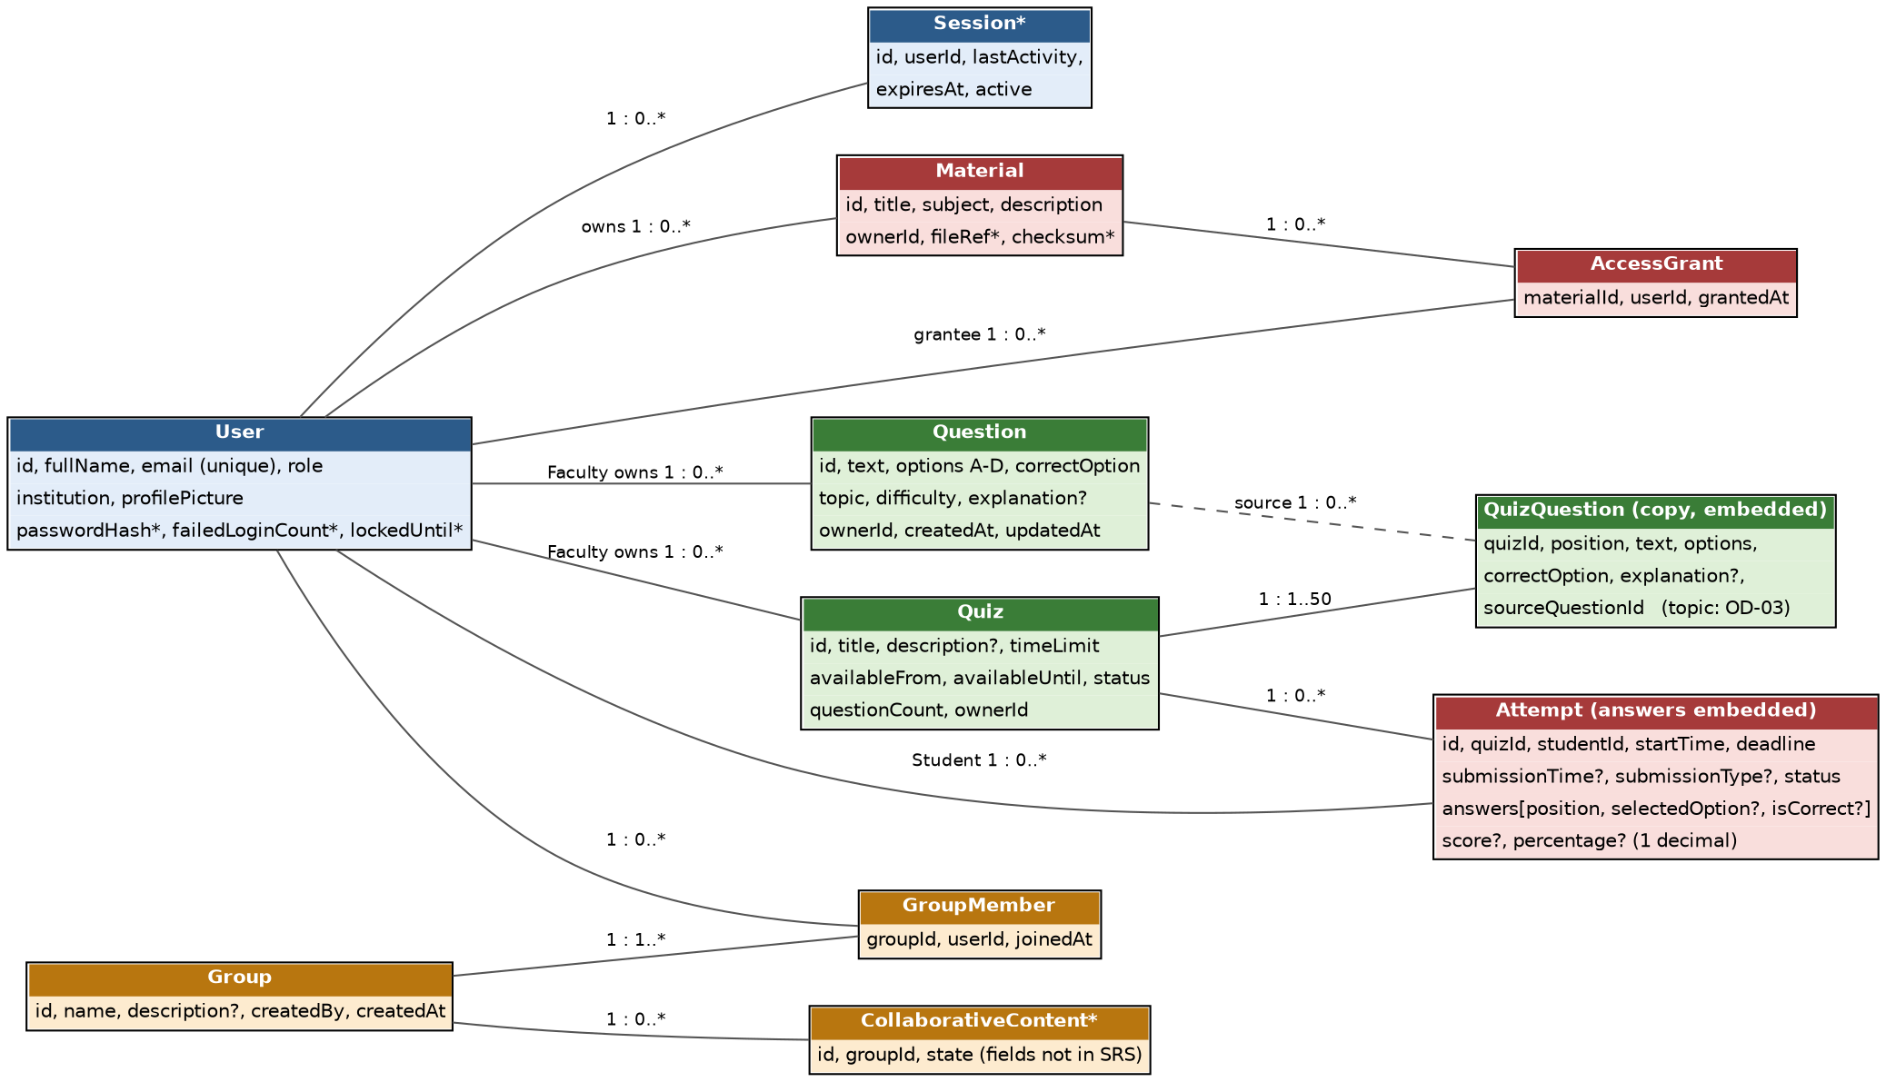
Figure 4.11: Logical data model (blue Member 1, green Member 2, orange Member 3, rose Member 4). The dashed relation records the source bank question of a quiz question copy.
Entity | Owner | Key fields (SRS Appendix B) | Relationships and rules
User | Member 1 | Full name, e-mail (unique, case-insensitive), role Student/Faculty/Admin, institution, profile picture (B.1, B.3) | Owns materials, questions, quizzes; Student has attempts and memberships
Session* | Member 1 | User, last activity, expiry, active flag | Valid session record required for every token (SEC-ACC-04)
Material | Member 4 | Title, subject, description, owner, file (B.4); checksum* | Exactly one owner (BR-02)
AccessGrant | Member 4 | Material, user, granted time (B.5) | Created by owner share; removed on revoke; registered users only (BR-05)
Question | Member 2 | Text, four options, correct option, topic, difficulty, explanation, owner, timestamps (B.8) | Owned by one Faculty user
Quiz | Member 2 | Title, description, time limit, available from/until, status, question count, owner (B.9) | Draft or Published; 1 to 50 question copies
Question copy (embedded in Quiz) | Member 2 | Quiz, position, text, options, correct option, explanation, source question (B.10) | Created at publication; topic not included (OD-03)
Attempt (answers embedded) | Member 4 | Quiz, student, start time, deadline, submission time and type, status, selected option and correctness per question, score, percentage (B.11) | One per Student per quiz; In Progress → Submitted → Graded; immutable after submission
Group, GroupMember | Member 3 | Group name, description, creator, created time (B.14); group, user, joined time (B.15) | A Student is a member of a group at most once (REQ-COL-03)
Collaborative content* | Member 3 | Not defined in the SRS | Moderated by Admin; fields need a decision (OD-13)

5. Appendices
5.1 Glossary
SRS, STP, RTM, UML, UC, SO, REST, JWT, RBAC, TLS, MERN, ODM, SPA, STRIDE, ADR, MCQ: as in Section 1.4.
Layered architecture – structure in which each layer calls only the layer below it (Presentation → API/middleware → Service → Data Access → Database/File Storage).
Modular monolith – one deployable application made of separate, independently testable modules (services).
API Layer – Express.js routes and middleware chain (rate limit, authentication, authorization, validation).
Middleware chain – ordered request checks executed before the controller.
Controller – thin handler that calls a service; contains no business rules.
Service – component holding the business rules of one feature area.
Data Access Layer – Mongoose models and repositories; the only code that accesses MongoDB.
File Storage – server disk store outside the web root for uploaded files.
Auth & Session Service – registration, login, lock-out, sessions and logout.
Server-side session – session record that must be valid for a token to be accepted.
Ownership check – verification that the requesting user owns the resource.
AccessGrant – record that gives a registered user access to a shared material.
Quiz Engine – component that manages quizzes and attempts, with quiz-authoring and quiz-execution responsibilities owned by two members (authoring: Member 2; execution: Member 4).
Grading Service – component that scores submitted attempts on the server.
Question copy – snapshot of a bank question stored in a published quiz.
Projection – response shape that omits fields such as correct options.
Performance Analytics Service – personal, topic-wise and class statistics.
Study Group & Collaboration Service – study groups, membership and Admin moderation of collaborative content (called Group & Notification Service in SAD version 1.0).
NoSQL injection – attack that alters database queries through crafted input; countered by sanitisation.
bcrypt – salted password-hashing function.
SHA-256 checksum – digest stored at upload to verify file integrity.
Rate limiting – restriction on the number of requests per client in a time window.
Audit log – timestamped record of security events.
Immutable attempt – submitted attempt that can no longer be changed.
5.2 References
IEEE 42010; OWASP Application Security Verification Standard; NIST SP 800-160; MongoDB, Express, React and Node.js documentation; Software Requirements Specification (SRS), Collaborative Study Material & Quiz Platform, Revision 1.2, draft of 17-10-2026, cover re-issued 18-10-2026 (including the RTM, Appendix C, and the requirement ownership matrix, Appendix D); Software Test Plan (STP), Revision 1.2, draft of 18-10-2026; Project Guidelines and Deliverables Part-2 (supplied); Deliverables Part-1, team CONTRIBUTING.md and the official SAD template (not supplied).
5.3 Tools
Graphviz, Mermaid, draw.io (diagrams); Jest, Supertest (testing); ESLint; Git/GitHub; Docker; Nginx.
5.4 Open-Decision Register
Open decisions of this revised draft. The document is not approved and makes no claim that the system is implemented, deployed or tested.
ID | Priority | Issue | Action needed
OD-01 | Decided | Team size and ownership: DECIDED by the team (18-10-2026) – four members (Jagadeesh, Alifiya, Pushkar, Vedh) with the baseline allocation of SRS Appendix D; Section 3.10 regenerated from Appendix D. Residual: the SRN of Member 4 has not been supplied. | Closed for team size and allocation. Supply the SRN of Member 4.
OD-02 | High | Deliverables Part-1, the SAD template and the team CONTRIBUTING.md were not supplied (Project Guidelines, Part-2 and STP Rev 1.2 were supplied); mandatory structure and conventions are unverified. | Supply Part-1 and the SAD template for a compliance check  Part-1 PDF is present in the supplied project files and must be checked. The official SAD/STP templates and CONTRIBUTING.md still need verification; do not state Part-1 was not supplied.
OD-03 | High | Topic-wise analysis (REQ-PA-03) needs question topic, but the question copy (REQ-QZ-04, Appendix B.10) has no topic and a bank question may be removed (REQ-QB-06). | Decide how topic is obtained; SRS clarification may be needed  PROPOSED (pending team approval): persist the topic in each published quiz-question snapshot at publication time; analytics shall group by that immutable snapshot topic, not by the mutable/deletable question-bank record. Existing published snapshots lacking topic data require migration or an explicit 'topic unavailable' bucket. Update SRS REQ-QZ-04/REQ-PA-03 and Appendix B data fields by change control before unblocking tests.
OD-04 | Medium | SRS Rev 1.2 and STP Rev 1.2 are drafts; SRS references 6 and 7 still cite SAD and STP version 1.0. | Update references after approval  After approval, update all cross-document references to the exact canonical SRS/SAD/STP revision and date. Current Rev 1.2 files are drafts; no source is approved by this recommendation.
OD-05 | Medium | Owner of Data Access Layer conventions (naming, indexes, pool). | Team agreement
OD-06 | Medium | No owner for Nginx, Docker, CI, logging and monitoring operation, backup operation, Web Client shell, MongoDB. | Team agreement  PROPOSED (pending team approval): assign deployment/operations owner for Nginx, Docker, CI, logs/monitoring and backups to Member 1 (Jagadeesh) as coordinator, with each module owner responsible for module logs and the whole team responsible for backup/restore rehearsal. Record explicit acceptance in the team decision log.
OD-07 | Medium | Upload role scope: SAD allows Student and Faculty; SRS REQ-MAT-01 and UC-MAT-01 name any authenticated user (Admin included), while the glossary defines Material Owner as Student or Faculty. | Decide; SRS wording may need alignment  PROPOSED (pending team approval): only Student and Faculty may upload materials; Admin is not a Material Owner. Amend SRS REQ-MAT-01/UC-MAT-01 to say 'authenticated Student or Faculty' and align glossary, role tests and API authorization. This recommendation follows the SRS glossary/ownership model but requires explicit approval because current REQ-MAT-01 says 'authenticated user'.
OD-08 | High | Missing API contracts: Faculty list or read own quizzes, list users holding access to a material, list content for moderation, pending-result response. | Specify and agree  PROPOSED contracts (pending team approval): (a) Faculty quiz list/read returns only quizzes owned by requester; (b) material-access list returns user ID/display name and grant status for owner-only access; (c) moderation queue returns content ID/type/author/createdAt/status and allowed actions; (d) pending grading returns HTTP 202 with {attemptId, status:'PENDING'} and result endpoint returns status plus score/percentage only when complete. Align endpoint paths, schemas and error codes in SAD §4.3–4.5 before unblocking tests.
OD-09 | Low | Notification records (version 1.0 design) are not required by the SRS and are outside DC-09 scope. | Keep or remove
OD-10 | Medium | req.user shape, role definitions, route index and middleware naming are in CONTRIBUTING.md, which was not supplied. | Verify against CONTRIBUTING.md
OD-11 | Low | BR-07 (copyright responsibility) and BR-08 (Admin accounts not through registration) have no specified mechanism. | Decide mechanism  PROPOSED (pending team approval): seed Admin accounts only through controlled development/test fixtures; no public Admin registration. For BR-07, keep it a policy constraint unless a system-enforced copyright mechanism is explicitly added to scope.
OD-12 | Low | Error codes ALREADY_ATTEMPTED and QUIZ_ALREADY_ATTEMPTED overlap; messages were aligned to SRS B.7. | Confirm codes and wording  PROPOSED (pending team approval): standardize the duplicate-attempt error code to ALREADY_ATTEMPTED, HTTP 409, with one SRS-consistent message. Update SAD and every affected STP expected result.
OD-13 | Low | Field-level gaps: GET /materials owner name and access status (SRS B.6 defines these display fields; the API contract lacks them), profile picture types, group field lengths, moderation actions, collaborative-content fields. | Specify  PROPOSED field contracts (pending team approval): profile pictures accept JPEG/PNG/WebP only, max 2 MiB; group name 1–100 chars and description 0–500 chars (confirm SRS Appendix B before adoption); material listing includes owner display name and current user's access status; moderation action enum is approve/remove/reject as applicable to SRS policy; collaborative-content records expose ID, groupId, authorId, type, body/file reference, status and createdAt. Confirm every limit/action against SRS and revise SRS if absent.
OD-14 | Low | SRS RTM architecture references differ from this SAD (Section 3.8): TLS is terminated at Nginx (the SRS names Client application and Auth & Session Service); NFR-SAFE-01 cites “Database” (design: MongoDB and Docker deployment); “Client application” means the Web Client; the collaboration service name. The SRS was not changed. | Correct the SRS RTM in a controlled change
OD-15 | Low | Design items with no SRS requirement, recorded as design decisions: audit logging and monitoring alert targets (4.4); rate limiting and HTTP 429 (3.9, 4.3); notification records (OD-09); Admin “manage users” (3.2); page and limit query parameters (4.3); design fields not in SRS Appendix B (Session, checksum, passwordHash, failedLoginCount, lockedUntil, fileRef, collaborative content: 4.7). | Keep as design decisions, or add SRS requirements by change control

5.5 Semantic Test-Alignment Recommendations (Draft)
This section records proposed decisions to support SRS-to-SAD-to-STP consistency. All items labelled PROPOSED require explicit team approval. No approval, implementation, deployment or test execution is implied by inclusion here.

OD-03
PROPOSED (pending team approval): persist the topic in each published quiz-question snapshot at publication time; analytics shall group by that immutable snapshot topic, not by the mutable/deletable question-bank record. Existing published snapshots lacking topic data require migration or an explicit 'topic unavailable' bucket. Update SRS REQ-QZ-04/REQ-PA-03 and Appendix B data fields by change control before unblocking tests.

OD-07
PROPOSED (pending team approval): only Student and Faculty may upload materials; Admin is not a Material Owner. Amend SRS REQ-MAT-01/UC-MAT-01 to say 'authenticated Student or Faculty' and align glossary, role tests and API authorization. This recommendation follows the SRS glossary/ownership model but requires explicit approval because current REQ-MAT-01 says 'authenticated user'.

OD-08
PROPOSED contracts (pending team approval): (a) Faculty quiz list/read returns only quizzes owned by requester; (b) material-access list returns user ID/display name and grant status for owner-only access; (c) moderation queue returns content ID/type/author/createdAt/status and allowed actions; (d) pending grading returns HTTP 202 with {attemptId, status:'PENDING'} and result endpoint returns status plus score/percentage only when complete. Align endpoint paths, schemas and error codes in SAD §4.3–4.5 before unblocking tests.

OD-13
PROPOSED field contracts (pending team approval): profile pictures accept JPEG/PNG/WebP only, max 2 MiB; group name 1–100 chars and description 0–500 chars (confirm SRS Appendix B before adoption); material listing includes owner display name and current user's access status; moderation action enum is approve/remove/reject as applicable to SRS policy; collaborative-content records expose ID, groupId, authorId, type, body/file reference, status and createdAt. Confirm every limit/action against SRS and revise SRS if absent.

TOD-02
PROPOSED (pending team approval): apply a per-user limit of 100 requests per 15-minute rolling window to authenticated API requests, with authentication endpoints additionally limited to 5 login attempts per 15 minutes per account+IP; return HTTP 429 and Retry-After seconds. Security review required; do not mark TC-AS-09 unblocked until approved.

TOD-03
PROPOSED (pending team approval): a quiz may be edited only while Draft; a Published quiz cannot be edited or deleted even if no attempt has started. Return HTTP 409 QUIZ_NOT_DRAFT for PUT and HTTP 409 QUIZ_ALREADY_PUBLISHED for DELETE; if any attempt has started, preserve existing ALREADY_ATTEMPTED conflict semantics. Amend SRS REQ-QZ-05 if needed and align SAD/STP.

TOD-04
PROPOSED (pending team approval): server clock is authoritative; effective deadline = earlier of (attempt start + time limit) and quiz availability end; requests at or after deadline are late; a persisted attempt is finalized on the first server operation/worker processing after deadline, with a scheduled worker preferred; answers accepted only when server receipt time is strictly before deadline. Lockout lasts 15 minutes from the fifth consecutive failed login. Update SRS/SAD wording if these are not already normative.

TOD-06
PROPOSED (pending team approval): define MB as MiB (1 MB = 1,048,576 bytes) consistently for the 25 MB material and 2 MB profile-picture limits, matching the current boundary-test fixtures; update SRS glossary/constraints.

TOD-07
PROPOSED (pending team approval): retain TC-AN-07 as an observed-period operational check only; do not call it full verification of the monthly 99% NFR. Full NFR-QUAL-02 coverage requires continuous monitoring for a complete calendar month (excluding announced maintenance) with uptime evidence and calculation.

