Software Requirements Specification (SRS)
Project: Student Record System
Version: 1.0
Authors: Student Project Team
Date: 05-09-2026
Status: Draft for Review
Version | Date | Author | Change summary | Approval
1.0 | 05-09-2026 | Student Project Team | Initial SRS adapted from provided template | Pending

Role | Name | Signature / Email | Date
Course Coordinator
Project Team

Table of Contents
1. Introduction
2. Overall description
3. External interfaces
4. System features (detailed)
5. Non-functional requirements (detailed)
6. Quality attributes & Acceptance tests
7. UML Use-Case Diagram
8. Requirements Traceability Matrix (RTM)

1. Introduction

1.1 Purpose
This document is the Software Requirements Specification (SRS) for the Student Record System. It defines functional and non-functional requirements, interfaces, verification criteria, security expectations, and traceability information for a student record-keeping system that manages student details, grades, and attendance.

1.2 Scope
The Student Record System covers maintaining student records, searching and viewing student details, recording and updating grades, recording and updating attendance, calculating academic summaries, and generating student reports. Detailed implementation decisions are outside the scope of this SRS.

1.3 Audience
The intended audience is the student development team, QA/test team, course instructor/coordinator, project evaluators, and future maintainers.

1.4 Definitions
Term | Definition
SRS | Software Requirements Specification
FR | Functional Requirement
NFR | Non-Functional Requirement
RTM | Requirements Traceability Matrix
UML | Unified Modeling Language
UI | User Interface
TC | Test Case

2. Overall description

2.1 Product perspective
The Student Record System is a standalone student-record management application. It provides an interface through which authorized users can manage student information, grades, and attendance and retrieve student-related summaries and reports. Exact storage and implementation details will be selected by the project team and documented in the design specification.

2.2 Major product functions (detailed)
• Student management: add, view, search, update, and delete student records.
• Grade management: add, update, and view grades and calculate academic summaries.
• Attendance management: record, update, and view attendance and calculate attendance percentage.
• Reporting: generate a consolidated student report and performance summary.
• Validation and access control: validate input and restrict record-changing operations to authorized users.

2.3 User roles and characteristics
User role | Characteristics / expected use
Teacher/Admin | Authorized user who manages student records, grades, attendance, and reports.
Student | User who views permitted personal details, grades, attendance, and performance information.

2.4 Operating environment
The system is intended to run on a desktop or laptop using the operating system and C/C++ development environment selected by the project team. The final compiler/toolchain and storage mechanism will be documented once finalized.

2.5 Constraints
• The project is to be implemented in C or C++, according to the project requirement.
• The system must satisfy the requirements and acceptance criteria in this SRS.
• Student data must be handled with appropriate validation and access control.
• The project is subject to the course schedule and available development resources.

3. External interface requirements

3.1 User interfaces
The system shall provide a clear menu-driven user interface appropriate to the selected implementation. It shall provide options for student management, grade management, attendance management, reports, and exit. Prompts and error messages shall be understandable and consistent.

3.2 Hardware interfaces
The system requires a computer/laptop with a display and keyboard. No specialized hardware interface is required by the current scope.

3.3 Software interfaces
The application shall interact with the selected operating system, C/C++ compiler/runtime environment, and storage mechanism. No external API is assumed unless added to the approved scope.

3.4 Communications
The current scope does not require network communication. If a networked component is introduced later, its protocol, authentication, and security requirements shall be documented.
Template minimum: at least 15 FRs, 5 NFRs, 2 security objectives, and 5 security requirements.

4. System features (detailed)
Each requirement includes acceptance criteria and a reference test case, following the provided SRS template.
Req ID | Requirement | Type | Priority | Source/Stakeholder | Acceptance criteria / Test case ref | Comments / Dependencies
SRS-F-001 | The system shall allow an authorized user to add a new student record with the required student details. | Functional | High | Teacher/Admin | AC-001: Valid record is stored and retrievable. TC-001 | Student Management
SRS-F-002 | The system shall allow an authorized user to view a student record by student identifier. | Functional | High | Teacher/Admin | AC-002: Correct record is displayed. TC-002 | Student Management
SRS-F-003 | The system shall allow a user to search for a student using the supported student identifier. | Functional | High | Teacher/Admin/Student | AC-003: Matching record is returned or no-match is reported. TC-003 | Student Management
SRS-F-004 | The system shall allow an authorized user to update permitted student details. | Functional | High | Teacher/Admin | AC-004: Updated values are stored and retrievable. TC-004 | Student Management
SRS-F-005 | The system shall allow an authorized user to delete a student record. | Functional | High | Teacher/Admin | AC-005: Authorized deletion removes normal retrieval. TC-005 | Student Management
SRS-F-006 | The system shall allow an authorized user to add grades for a student. | Functional | High | Teacher/Admin | AC-006: Valid grade data is associated with the correct student. TC-006 | Grade Management
SRS-F-007 | The system shall allow an authorized user to update previously recorded grades. | Functional | High | Teacher/Admin | AC-007: Updated grade replaces the previous value. TC-007 | Grade Management
SRS-F-008 | The system shall allow a permitted user to view a student's recorded grades. | Functional | High | Teacher/Admin/Student | AC-008: Correct grades are displayed. TC-008 | Grade Management
SRS-F-009 | The system shall calculate the academic average according to the grading rule approved for the project. | Functional | High | Teacher/Admin/Student | AC-009: Result matches the approved calculation. TC-009 | Grade Management
SRS-F-010 | The system shall display the grade/performance category derived from the approved project grading rule. | Functional | Medium | Teacher/Admin/Student | AC-010: Category matches the approved rule. TC-010 | Grade Management
SRS-F-011 | The system shall allow an authorized user to record attendance for a student. | Functional | High | Teacher/Admin | AC-011: Valid attendance data is stored for the correct student. TC-011 | Attendance Management
SRS-F-012 | The system shall allow an authorized user to update recorded attendance. | Functional | High | Teacher/Admin | AC-012: Updated attendance is reflected in subsequent views. TC-012 | Attendance Management
SRS-F-013 | The system shall allow a permitted user to view a student's attendance record. | Functional | High | Teacher/Admin/Student | AC-013: Correct attendance data is displayed. TC-013 | Attendance Management
SRS-F-014 | The system shall calculate a student's attendance percentage from stored attendance data. | Functional | High | Teacher/Admin/Student | AC-014: Percentage matches the approved calculation. TC-014 | Attendance Management
SRS-F-015 | The system shall generate a consolidated student report containing permitted details, grades, and attendance. | Functional | High | Teacher/Admin | AC-015: Report contains expected sections and correct data. TC-015 | Reporting
SRS-F-016 | The system shall display a student performance summary using approved grade and attendance calculations. | Functional | Medium | Teacher/Admin/Student | AC-016: Summary reflects stored data correctly. TC-016 | Reporting

5. Non-functional requirements (detailed)
NFRs are measurable/testable, following the provided template.
Req ID | Requirement | Category | Priority | Acceptance criteria / Measurement | Test
SRS-NF-001 | For the agreed normal local test environment, a search operation shall return the requested result or no-match message within 2 seconds for the agreed test dataset. | Performance | High | Measured response time ≤ 2 s. | TC-NF-001
SRS-NF-002 | The system shall preserve successfully stored student records across normal program restarts. | Reliability | High | Test records remain retrievable after restart. | TC-NF-002
SRS-NF-003 | The system shall provide clear prompts and error messages for normal operations and invalid inputs. | Usability | Medium | Review confirms required prompts/errors are understandable. | TC-NF-003
SRS-NF-004 | The system shall use modular components/functions so student, grade, attendance, and reporting functionality can be maintained independently where practical. | Maintainability | Medium | Design/code review confirms functional separation. | TC-NF-004
SRS-NF-005 | The system shall validate required student, grade, and attendance inputs before accepting them for storage or update. | Data Integrity | High | Invalid inputs are rejected without unintended changes. | TC-NF-005

5.1 Security

5.1.1 Security Objectives
SO-001: Protect student records from unauthorized access.
SO-002: Prevent unauthorized modification or deletion of student records and protect record integrity.

5.1.2 Security Requirements
Req ID | Requirement (shall...) | Type | Priority | Acceptance criteria / Test case ref
SRS-SR-001 | The system shall require authentication before allowing record-changing operations. | Security | High | Unauthenticated user cannot perform protected modifications. | TC-SEC-001
SRS-SR-002 | The system shall restrict student-record deletion to authorized users. | Security | High | Unauthorized deletion is rejected. | TC-SEC-002
SRS-SR-003 | The system shall validate user inputs before storing or updating student, grade, and attendance data. | Security | High | Invalid inputs are rejected without corrupting data. | TC-SEC-003
SRS-SR-004 | The system shall restrict student information access according to the user's authorized role and permitted operations. | Security | High | Operations outside role permissions are rejected. | TC-SEC-004
SRS-SR-005 | The system shall not expose authentication credentials in normal user-facing output or application logs. | Security | Medium | Credential values are not displayed/logged during authentication tests. | TC-SEC-005

6. Quality attributes & Acceptance tests
Acceptance exit criteria: all high-priority functional requirements are implemented and verified; no critical NFR/security failures remain; and the RTM shows verification evidence for the approved requirements.
Quality attribute / acceptance area | Acceptance condition | Representative tests
Functional correctness | Approved high-priority FRs pass acceptance tests. | TC-001 to TC-016
Performance | Search meets the defined response-time target. | TC-NF-001
Reliability / data preservation | Stored records remain available after normal restart. | TC-NF-002
Usability | Prompts and error messages are clear and consistent. | TC-NF-003
Maintainability | Design/code shows required functional separation. | TC-NF-004
Data integrity | Invalid inputs are rejected without unintended changes. | TC-NF-005
Security | Authentication, authorization, validation and credential-protection checks pass. | TC-SEC-001 to TC-SEC-005

Acceptance test suites
• Student management
• Grade management
• Attendance management
• Reporting and calculation
• Performance and usability
• Security and authorization
• Data integrity and persistence

7. System models and diagrams

7.1 UML Use-Case diagram
The provided SRS template states that at least 2 UML use-case diagrams are to be created. Create and embed the actual project-specific diagrams below.

Use-Case Diagram 1 — Teacher/Admin
Actor: Teacher/Admin. Use cases: Authenticate User; Add Student; View Student; Search Student; Update Student; Delete Student; Add Grades; Update Grades; View Grades; Record Attendance; Update Attendance; View Attendance; Generate Student Report; View Performance Summary.
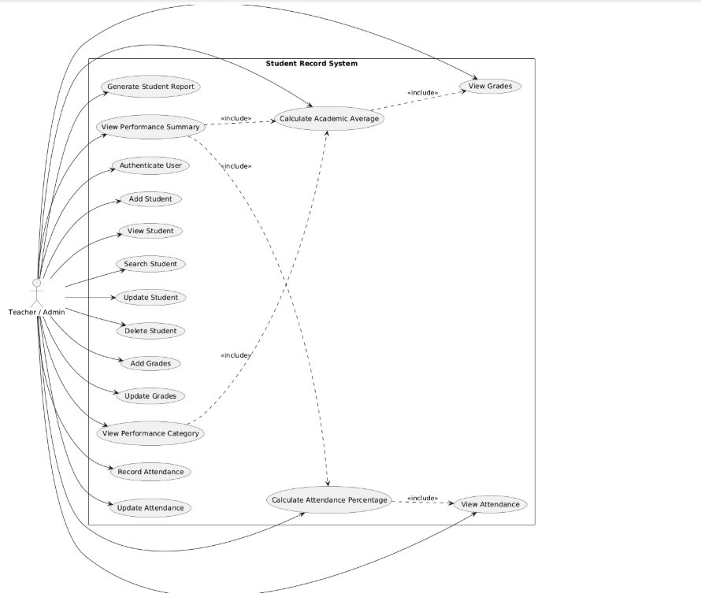

Use-Case Diagram 2 — Student
Actor: Student. Use cases: Authenticate User; View Own Student Details; View Own Grades; View Own Attendance; View Own Performance Summary.
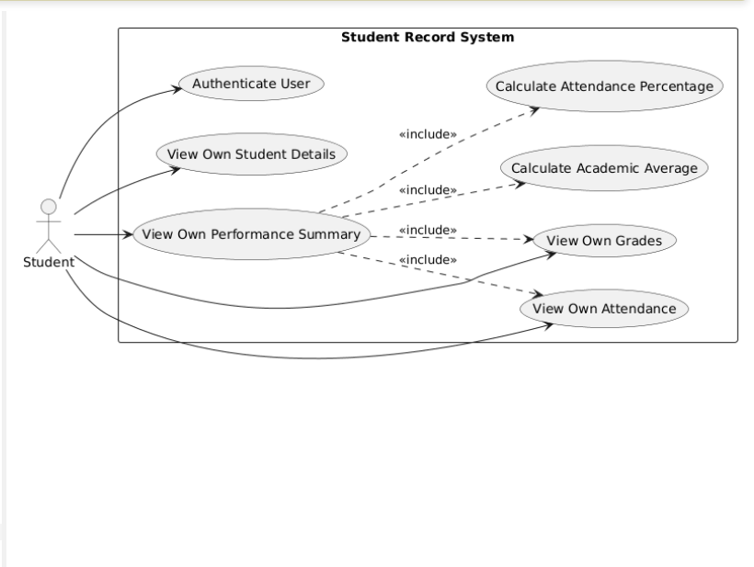8. Requirements Traceability Matrix (RTM)
Status convention: N = Not implemented/not verified, P = Partially implemented/verified, A = Accepted. At SRS stage, requirements are marked N.
Req ID | Requirement short | Section ref / Design Spec | Module | Test case(s) | Status (N/P/A) | Comments
SRS-F-001 | The system shall allow an authorized user to add a new ... | Section 4 / Design spec TBD | Student Management | TC-001 | N
SRS-F-002 | The system shall allow an authorized user to view a stu... | Section 4 / Design spec TBD | Student Management | TC-002 | N
SRS-F-003 | The system shall allow a user to search for a student u... | Section 4 / Design spec TBD | Student Management | TC-003 | N
SRS-F-004 | The system shall allow an authorized user to update per... | Section 4 / Design spec TBD | Student Management | TC-004 | N
SRS-F-005 | The system shall allow an authorized user to delete a s... | Section 4 / Design spec TBD | Student Management | TC-005 | N
SRS-F-006 | The system shall allow an authorized user to add grades... | Section 4 / Design spec TBD | Grade Management | TC-006 | N
SRS-F-007 | The system shall allow an authorized user to update pre... | Section 4 / Design spec TBD | Grade Management | TC-007 | N
SRS-F-008 | The system shall allow a permitted user to view a stude... | Section 4 / Design spec TBD | Grade Management | TC-008 | N
SRS-F-009 | The system shall calculate the academic average accordi... | Section 4 / Design spec TBD | Grade Management | TC-009 | N
SRS-F-010 | The system shall display the grade/performance category... | Section 4 / Design spec TBD | Grade Management | TC-010 | N
SRS-F-011 | The system shall allow an authorized user to record att... | Section 4 / Design spec TBD | Attendance Management | TC-011 | N
SRS-F-012 | The system shall allow an authorized user to update rec... | Section 4 / Design spec TBD | Attendance Management | TC-012 | N
SRS-F-013 | The system shall allow a permitted user to view a stude... | Section 4 / Design spec TBD | Attendance Management | TC-013 | N
SRS-F-014 | The system shall calculate a student's attendance perce... | Section 4 / Design spec TBD | Attendance Management | TC-014 | N
SRS-F-015 | The system shall generate a consolidated student report... | Section 4 / Design spec TBD | Reporting | TC-015 | N
SRS-F-016 | The system shall display a student performance summary ... | Section 4 / Design spec TBD | Reporting | TC-016 | N
SRS-NF-001 | For the agreed normal local test environment, a search ... | Section 5 / Design spec TBD | Performance | TC-NF-001 | N
SRS-NF-002 | The system shall preserve successfully stored student r... | Section 5 / Design spec TBD | Reliability | TC-NF-002 | N
SRS-NF-003 | The system shall provide clear prompts and error messag... | Section 5 / Design spec TBD | Usability | TC-NF-003 | N
SRS-NF-004 | The system shall use modular components/functions so st... | Section 5 / Design spec TBD | Maintainability | TC-NF-004 | N
SRS-NF-005 | The system shall validate required student, grade, and ... | Section 5 / Design spec TBD | Data Integrity | TC-NF-005 | N
SRS-SR-001 | The system shall require authentication before allowing... | Section 5.1 / Security design TBD | Security | TC-SEC-001 | N
SRS-SR-002 | The system shall restrict student-record deletion to au... | Section 5.1 / Security design TBD | Security | TC-SEC-002 | N
SRS-SR-003 | The system shall validate user inputs before storing or... | Section 5.1 / Security design TBD | Security | TC-SEC-003 | N
SRS-SR-004 | The system shall restrict student information access ac... | Section 5.1 / Security design TBD | Security | TC-SEC-004 | N
SRS-SR-005 | The system shall not expose authentication credentials ... | Section 5.1 / Security design TBD | Security | TC-SEC-005 | N

