Software Architecture and Design Specification
Project: Student Record System (SRS)
Version: 1.1
Authors: Team 12
Date: 12-11-2026
Status: Draft for review
Related documents: Software Requirements Specification (SRS) v0.3; Software Test Plan (STP) v1.1

Revision History
Version | Date | Author | Change Summary
0.1 | 05-09-2026 | Team 12 | Initial architecture draft.
1.0 | 27-09-2026 | Team 12 | Complete architecture and detailed design.
1.1 | 12-11-2026 | Team 12 | Re-structured to the SAD template; desktop client replaced by the browser (web) client; UML component, class and sequence diagrams added; design aligned with the implemented code on the main branch.

Approvals
Role | Name | Signature/Date
Project Guide
Team Lead, Team 12

Table of Contents
1. Introduction 3
1.1 Purpose 3
1.2 Scope 3
1.3 Audience 3
1.4 Definitions 3
2. Document Overview 4
2.1 How to use this document 4
2.2 Related Documents 4
3. Architecture 4
3.1 Goals & Constraints 4
3.2 Stakeholders & Concerns 6
3.3 Component (UML) Diagram 6
3.4 Component Descriptions 9
3.5 Chosen Architecture Pattern and Rationale 10
ADR-001: Use a browser-based web client 11
ADR-002: Use PostgreSQL as the DBMS 11
ADR-003: Three-tier client-server with a layered server 11
ADR-004: Bearer session tokens over TLS 12
3.6 Technology Stack & Data Stores 12
3.7 Risks & Mitigations 13
3.8 Traceability to Requirements 13
3.9 Security Architecture 14
4. Design 15
4.1 Design Overview 15
4.2 UML Sequence Diagrams 15
Sequence 1: Login and role resolution 15
Sequence 2: Teacher records a grade 16
Sequence 3: Student views attendance and percentage 17
4.3 API Design 18
4.4 Error Handling, Logging & Monitoring 20
4.5 UX Design 21
4.6 Open Issues & Next Steps 21
5. Appendices 21
5.1 Glossary 21
5.2 References 22
5.3 Tools 22

1. Introduction

1.1 Purpose
This Software Architecture and Design (SAD) document describes the architecture, component decomposition, and detailed design of the Student Record System (SRS) developed by Team 12. It translates the requirements captured in the Software Requirements Specification (SRS) into a concrete technical blueprint that guides implementation, testing, and maintenance.

1.2 Scope
The system is a web-based client-server application that allows administrators, teachers, and students to manage and view student records including personal details, grades, attendance, and timetables. The browser (web) client is served by the C++ server, so it runs on any platform with a current web browser. This document covers:
– The overall architectural style and the rationale behind it.
– The logical decomposition of the system into components and layers.
– The interfaces and contracts between components.
– Key runtime interactions (sequence flows) for the main use cases.
– The chosen technology stack and its justification.
– Design decisions recorded as Architecture Decision Records (ADRs).
– Traceability from SRS requirements to architectural elements.
– Security, error handling, and UX design considerations.

1.3 Audience
Developers, QA/test engineers, the project guide and evaluators, security reviewers, and future maintainers. The table shows how each group uses this document.
Audience | Use of this document
Development team | Implementation guidance; component responsibilities and interfaces.
Test team | Basis for integration and system test design.
Project guide / evaluator | Verification that the design satisfies the SRS.
Future maintainers | Understanding of architectural rationale and constraints.

1.4 Definitions
Term | Meaning
SAD | Software Architecture and Design
SRS | Software Requirements Specification
API | Application Programming Interface
REST | Representational State Transfer
JSON | JavaScript Object Notation
DTO | Data Transfer Object
DAO | Data Access Object
RBAC | Role-Based Access Control
TLS | Transport Layer Security
NFR / NF | Non-Functional Requirement
SR | Security Requirement
ADR | Architecture Decision Record
CRUD | Create, Read, Update, Delete
UI / UX | User Interface / User Experience

2. Document Overview

2.1 How to use this document
This document provides the architectural deliverables for the Student Record System: UML diagrams, Architecture Decision Records (ADRs), a STRIDE threat model, and the REST API design. Section 3 describes the architecture - goals and constraints, stakeholders, the UML component and class diagrams, component descriptions, the chosen pattern with its ADRs, the technology stack and data stores, risks, traceability to the SRS, and the security architecture. Section 4 describes the design - the request pipeline, UML sequence diagrams for the main flows, the API, error handling, logging and monitoring, UX design, and open issues. Section 5 holds the glossary, references, and tools.
Requirement identifiers (SRS-F-xxx, SRS-NF-xxx, SRS-SR-xxx, SO-xxx) refer to SRS v0.3 and use the same numbering as the GitHub repository and the Jira stories (SRS-14 to SRS-31).

2.2 Related Documents
– Software Requirements Specification (SRS), Student Record System, Team 12, v0.3.
– Software Test Plan (STP), Student Record System, Team 12, v1.1 - includes the requirements traceability matrix (RTM) and test cases.
– Sprint Work Plan, Team 12, and the Jira backlog (SRS-14 to SRS-31).
– docs/api.md (REST wire contract) and docs/security.md in the project repository.
– README.md in the project repository (build, run, and Docker Compose instructions).

3. Architecture

3.1 Goals & Constraints
Goals (architectural drivers).
The architecture is shaped by the following drivers, derived from the SRS:
– Multi-role access control: three distinct roles (Administrator, Teacher, Student) with different permissions (SRS-F-001 to SRS-F-003, SRS-SR-004).
– Data integrity: grades, attendance, and timetable data must remain consistent across concurrent operations (SRS-NF-002).
– Cross-platform delivery: the client must run on Windows and Linux (SRS-NF-006); this is met by a browser (web) client served by the server.
– Usability: forms must provide inline validation and clear error feedback (SRS-NF-003).
– Concurrency: the server must support at least 20 simultaneous clients (SRS-NF-007).
– Security: all traffic encrypted, sessions authenticated with bearer tokens (SRS-SR-007, SRS-SR-008).
Quality attribute goals.
Attribute | Goal | Architectural response
Security | Prevent unauthorised access; protect data in transit. | Server-side RBAC guard, TLS 1.2+, bearer session tokens, parameterised SQL.
Maintainability | Localise change; avoid ripple effects. | Layered architecture; domain services isolated behind interfaces.
Testability | Components testable in isolation. | Interface-based stores (e.g. StudentStore, GradeStore) replaced by fakes in GoogleTest route tests.
Usability | Low training cost; clear error messages. | Web pages with inline field validation; consistent dialog patterns.
Performance | Responsive UI under normal load. | Indexed queries and paginated lists; asynchronous fetch calls in the browser. A connection pool is planned (one connection per request today).
Portability | Run on Windows and Linux. | Browser client (no install); standard C++20 server packaged as a Docker image; PostgreSQL portable across OSes.

Constraints.
Constraint | Description
Language | C++20 for the server; HTML, CSS and JavaScript (ES modules, no build step) for the web client.
GUI toolkit | Browser-based web GUI served by the application server (see ADR-001).
Database | PostgreSQL 16 relational DBMS (see ADR-002).
Protocol | HTTPS only (TLS 1.2+) / REST with JSON payloads; no plain-HTTP mode.
Architecture | Three-tier client-server with a layered server.
Licensing | Only LGPL / permissive dependencies for coursework.
Team size | Small team; architecture must avoid unnecessary ceremony.

Assumptions.
– The server host runs Linux with Docker Compose (or PostgreSQL 16 installed directly) and has a TLS certificate and key configured.
– Each client host has a network path to the server over the campus LAN or VPN.
– Users have been provisioned with accounts by an administrator.
– Subjects (with their semester) and teacher-to-subject assignments are loaded into the database (migrations/seed) before timetable, grade and attendance entry.

3.2 Stakeholders & Concerns
Stakeholder | Main concerns | Addressed by
Administrator | Manage accounts and student records; data integrity; only Administrators may delete records or create timetable slots. | RBAC Guard, Account and Student services, transactions, conflict checks.
Teacher | Fast grade and attendance entry for own subjects; see own timetable. | Grades and Attendance pages, teacher_subjects scoping, role-scoped timetable.
Student | View own grades, attendance percentage and timetable; privacy of own record. | Ownership checks on every Student read; read-only pages.
Project guide / evaluator | Conformance with the SRS and the SAD template; traceability; security. | Sections 3.8 and 3.9, ADRs, UML diagrams.
Development team | Modularity, testability, conflict-free parallel work. | Layered server, store interfaces with fakes, CI on every change.
Operators / maintainers | Simple deployment, TLS set-up, repeatable database schema. | Docker Compose, ordered migrations, TLS-only server.

3.3 Component (UML) Diagram
Figure 1 is the single architecture diagram for the system. It shows the browser (web) client, the layers inside the C++ server, the database, and how they are deployed. The presentation layer holds the web pages, client-side validation and the API client; the application layer holds the REST router and route handlers, the cross-cutting services, and the domain services; the data access layer holds the stores and transactions. Each domain service owns a single entity or concern, which keeps the change surface small. In the code, each domain service is a module under server/src/ (accounts, students, grades, attendance, timetable, profile, auth).
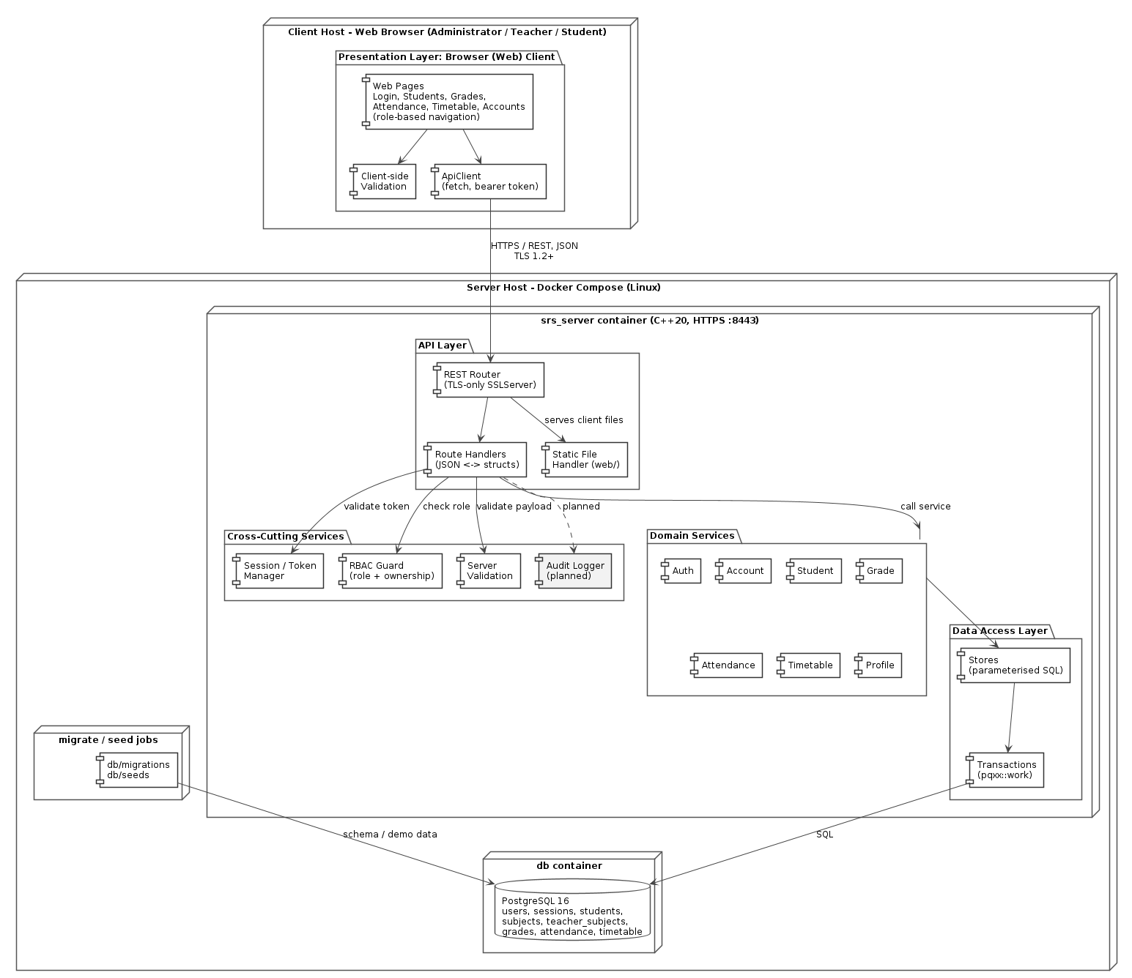
Figure 1 - UML component diagram: browser (web) client, layered C++ server, PostgreSQL database and Docker Compose deployment.
Figure 2 is the UML class diagram of the domain model. Each class is a PostgreSQL table (stereotype); a Student owns its grades and attendance (composition: they are deleted with the student), every grade, attendance entry and timetable slot belongs to a Subject, which carries the semester, and Teachers are linked to the subjects they teach through TeacherSubject.
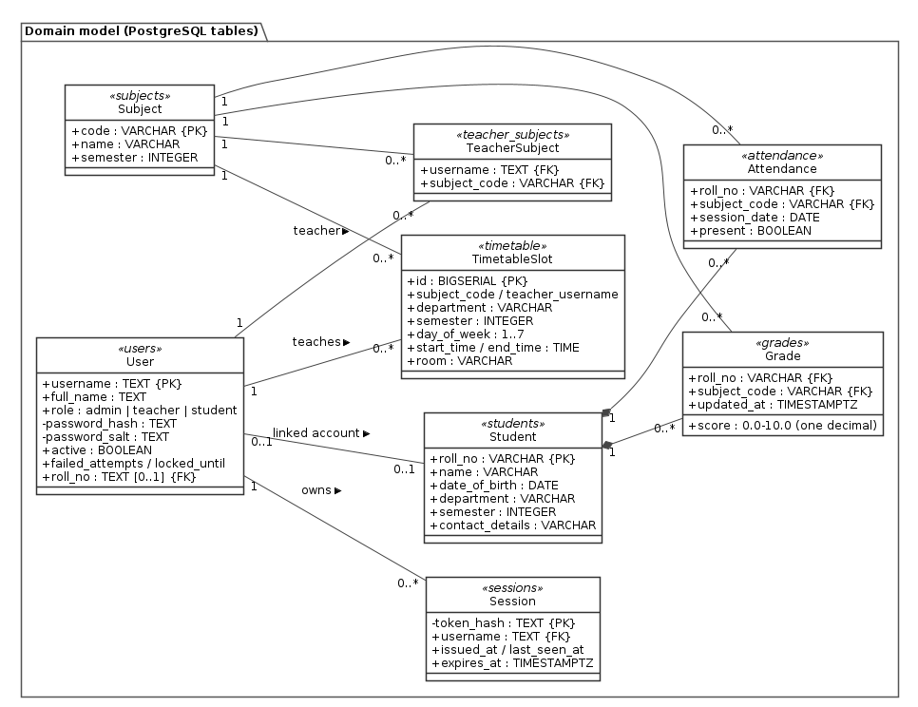
Figure 2 - UML class diagram: domain model (database entities and associations).
Figure 3 is the UML class diagram of the server code. Route handlers depend only on store interfaces; each interface has a PostgreSQL implementation (Pg*Store) and an in-memory fake used by the unit tests.
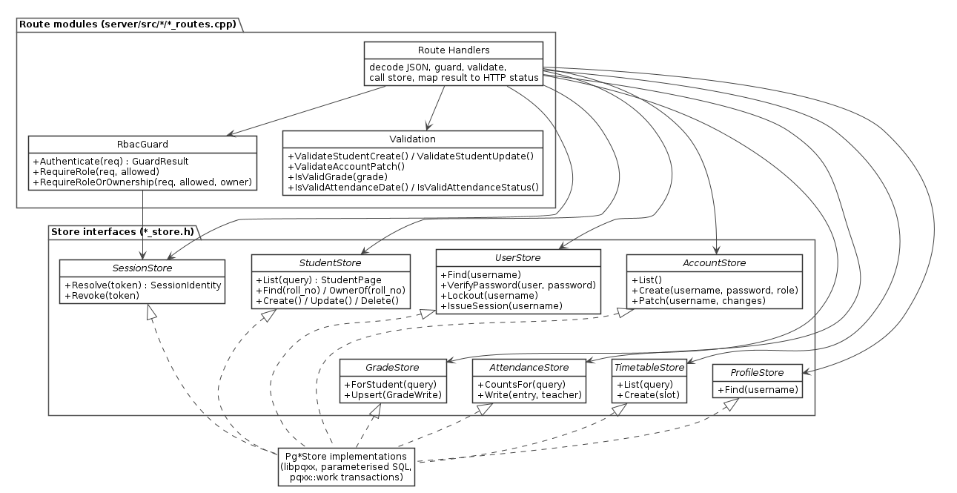
Figure 3 - UML class diagram: route handlers, guards and store interfaces in the server.

3.4 Component Descriptions
Component | Layer | Responsibility
Web Pages | Presentation | Forms, tables, dialogs and navigation (web/js/pages, shell.js).
Client-side Validation | Presentation | Immediate feedback on user input.
ApiClient | Presentation | REST/JSON calls over TLS (web/js/api.js).
REST Router | API | Routes HTTP requests to handlers.
Route Handlers | API | Convert JSON to structs and back (nlohmann/json), inside each route module.
Session / Token Manager | Cross-cutting | Issues and validates session tokens.
RBAC Guard | Cross-cutting | Enforces role-based permissions.
Server Validation | Cross-cutting | Validates payloads and business rules.
Audit Logger | Cross-cutting | Records security-relevant operations (planned).
Auth Service | Domain | Login, logout, credential checks.
Account Service | Domain | User account administration.
Student Service | Domain | Student record CRUD.
Grade Service | Domain | Grade recording and retrieval.
Attendance Service | Domain | Attendance recording and retrieval.
Timetable Service | Domain | Timetable management and conflict detection.
Profile Service | Domain | Returns the caller's own profile (GET /api/me).
Semester filtering | Domain | Semester comes from subjects; record endpoints accept a semester filter.
Stores | Persistence | Parameterised SQL access to entities (pg_*_store.cpp behind *_store.h).
Transactions | Persistence | Atomic writes using pqxx::work.
Connection Pool | Persistence | Planned; today each store call opens a connection.

Layers and their key components:
Layer | Responsibilities | Key components
Presentation | Render UI, collect input, validate inline, call the API client. | Web pages, Client-side Validation, ApiClient
API | Terminate HTTPS, decode JSON in route handlers, dispatch to services; serve the static web client files. | REST Router, Route Handlers, Static File Handler
Cross-cutting | Apply concerns common to all requests. | Session/Token Manager, RBAC Guard, Server Validation (Audit Logger planned)
Domain | Implement business rules for each entity. | Auth, Account, Student, Grade, Attendance, Timetable, Profile; semester filtering is shared by the record services
Persistence | Persist and retrieve entity state transactionally. | Stores, PostgreSQL transactions (pqxx::work), one connection per request (pool planned)

The principal interface contracts - the interfaces each component provides and which components consume them - are summarised in the table below.
Interface | Provided by | Consumed by | Purpose
IApiClient | ApiClient (web/js/api.js) | Web pages, Client Validation | Asynchronous REST/JSON calls over TLS.
IRouter | REST Router (api/router) | ApiClient | Dispatches HTTP requests to the correct handler.
IValidation | Server Validation (validation/) | Route handlers, Domain Services | Server-side validation of payloads and business rules.
IRbacGuard | RBAC Guard (auth/rbac, records/record_access) | Route handlers | Role and permission checks before dispatch.
IAuditLog | Audit Logger | Route Handlers, Domain Services | Records security-relevant and data-changing operations (planned; not implemented).
ITokenManager | Session / Token Manager (auth/session_store) | REST Router, Auth Service | Issues and validates bearer session tokens.
IStore | Stores (*_store.h interfaces, pg_*_store.cpp) | All domain services | Parameterised SQL access to entities.
IConnectionPool | Connection Pool (planned) | Stores | Will reuse database connections for 20+ concurrent clients; today each store call opens its own connection.

3.5 Chosen Architecture Pattern and Rationale
The system follows a three-tier client-server architecture with a layered server and a component-based decomposition inside each layer. The three tiers are:
1. Presentation Layer - the browser (web) client (HTML, CSS, JavaScript) that renders forms, tables, and dialogs.
2. Application Layer - the C++20 server (srs_server) hosting the HTTPS REST endpoint, serving the web client files, and running the cross-cutting services (RBAC, validation, session management) and domain services.
3. Data Layer - the persistence components and the PostgreSQL relational database.
This style was chosen because it separates concerns cleanly, allows the client and server to evolve independently behind the REST contract, and matches the deployment reality of a small team: one server executable (which also serves the web client) and one database.
Architectural principles.
– Separation of concerns: each layer exposes a narrow interface to the layer above.
– Single responsibility: one domain service per business entity or concern.
– Server-side enforcement: authorization and validation are never trusted to the client (SRS-SR-004, SRS-NF-005).
– Contract-first: components communicate through declared interfaces (see 3.4).
– Fail closed: an unrecognised role or malformed request is rejected, not defaulted.
Alternatives considered.
– Desktop client with direct database access - rejected: every client would hold database credentials and authorisation could not be enforced on the server.
– Microservices - rejected: too much operational overhead for a small team and a single database; the layered monolith already isolates each domain module.
– Native desktop GUI toolkit - replaced by the browser client (ADR-001): nothing to install or package for Windows and Linux.
The key decisions are recorded as ADRs:

ADR-001: Use a browser-based web client
Field | Value
Status | Accepted
Context | The SRS requires a usable, cross-platform UI (SRS-NF-003, SRS-NF-006) that works for all three roles on Windows and Linux.
Decision | Build the client as HTML/CSS/JavaScript web pages served by the C++ server from the same origin and opened in a standard web browser.
Rationale | Nothing to install or package for Windows and Linux; one deployable artefact; the REST contract stays the single interface between client and server. No framework or build step keeps the client small.
Consequences | The session token is kept in browser localStorage, so script integrity on the page matters; Windows/Linux portability is a browser concern.

ADR-002: Use PostgreSQL as the DBMS
Field | Value
Status | Accepted
Context | The SRS leaves the DBMS 'TBD in SAD'. The data is strongly relational (students, courses, enrolments, grades, attendance).
Decision | Use PostgreSQL 16 as the relational DBMS, accessed through libpqxx.
Rationale | Mature, free, ACID-compliant, good concurrency behaviour, strong constraint support, and portable across Linux and Windows. Its support for transactions and foreign keys directly supports SRS-NF-002.
Consequences | The schema must be normalised and indexed; the persistence layer uses parameterised SQL against PostgreSQL.

ADR-003: Three-tier client-server with a layered server
Field | Value
Status | Accepted
Context | The system must support multiple concurrent clients and enforce security server-side (SRS-NF-007, SRS-SR-004).
Decision | Separate the presentation, application, and data tiers, and layer the server internally.
Rationale | The client can evolve independently of the server behind a REST contract; authorization and validation live where they cannot be bypassed; and the layers keep the change surface small.
Consequences | A network hop is added to every operation; the web client must handle asynchronous responses and network failures.

ADR-004: Bearer session tokens over TLS
Field | Value
Status | Accepted
Context | Requests must be authenticated and confidential (SRS-SR-007, SRS-SR-008).
Decision | Issue a bearer token at login; require it on every request; carry all traffic over TLS 1.2+.
Rationale | Simple to implement and to send from the browser's fetch API; only the token hash is stored, so a database leak does not reveal live tokens.
Consequences | Tokens expire server-side (30 min idle, 8 h absolute) and are revoked on logout and account deactivation; replay protection depends on TLS.

3.6 Technology Stack & Data Stores
Tier | Technology
Client | HTML5, CSS3 and JavaScript ES modules (no framework, no build step); fetch API; unit tests with the Node.js test runner.
Server | C++20; cpp-httplib (TLS-only SSLServer); nlohmann/json; libpqxx 8; OpenSSL (TLS 1.2+, SHA-256); CMake; GoogleTest/CTest.
Database | PostgreSQL 16; schema in db/migrations (001-006, applied in order); demo data in db/seeds; checks in db/checks.
Deployment | Docker images; Docker Compose services: db, migrate, seed (dev profile), app (HTTPS 8443, published as 8080).
CI / tools | GitHub Actions (server build and tests, web tests, image build); Git/GitHub pull requests; Jira for the backlog.

The system deploys as one server executable and one database (outer boxes of Figure 1), started with Docker Compose: a PostgreSQL 16 container, a migration job that applies db/migrations in order, an optional development seed job, and the srs_server container, which serves both the REST API and the web client. Users only need a web browser. All client-server traffic is carried over HTTPS with TLS 1.2 or higher (SRS-SR-007); the server will not start without a certificate.
Data stores (PostgreSQL tables):
Table | Contents | Key rules
users | Accounts: username, full name, role, salted password hash, active flag, lockout counters, optional link to a student record. | Role is admin, teacher or student; no delete (deactivate).
sessions | Hash of each bearer token, owner, issue/last-seen/expiry times. | 30 min idle, 8 h absolute; revoked on logout or deactivation.
students | Roll number, name, date of birth, department, semester, contact. | Roll number immutable; delete cascades to grades and attendance.
subjects | Course code, name and the semester it belongs to. | Source of the semester for grades, attendance and timetable.
teacher_subjects | Which teacher teaches which subject. | Required before a teacher can grade, mark attendance or be scheduled.
grades | One grade per student and subject, with updated_at. | 0.0-10.0, one decimal; upsert.
attendance | One entry per student, subject and date (present or absent). | Duplicate gives 409; future dates rejected.
timetable | Slots: subject, teacher, department, semester, day, start/end time, room. | Teacher or room overlap gives 409.

3.7 Risks & Mitigations
Risk | Impact | Likelihood | Mitigation
Scope creep in the UI | High | Medium | Freeze the page list early; keep to plain HTML/JS; prioritise CRUD over polish.
Concurrency bugs under 20+ clients | High | Medium | Transactions, advisory lock on timetable writes, and load testing (SRS-NF-007); add a connection pool if needed.
Authorization bypassed on the client | High | Low | Enforce every permission in the RBAC Guard server-side (SRS-SR-004).
Schema churn late in the project | Medium | Medium | Stabilise the schema in design; use migrations for later changes.
Team unfamiliar with web client development | Medium | Medium | Plain HTML/CSS/JavaScript ES modules with no framework or build step; shared page shell and API client; unit tests for the client code.
Time lost to build/tooling issues | Medium | High | Commit a working CMake server and web client skeleton early; CI builds and tests every change; Docker Compose gives a one-command environment.

3.8 Traceability to Requirements
The table below maps the main SRS requirements to the architectural elements that satisfy them.
Requirement | Architectural element
SRS-F-001 to SRS-F-004 (authentication, session, logout) | Auth Service, Session/Token Manager, RBAC Guard, Login page
SRS-F-005 to SRS-F-006 (user account management) | Account Service, Accounts page
SRS-F-007 to SRS-F-011 (student records, search, CRUD) | Student Service, Student pages, Stores
SRS-F-012 to SRS-F-014 (grades, range validation, views) | Grade Service, Server Validation, Client-side Validation, Grades page
SRS-F-015 to SRS-F-018 (attendance, percentage) | Attendance Service, Attendance page
SRS-F-019 to SRS-F-021 (timetable, conflicts) | Timetable Service, Server Validation, Timetable page
SRS-F-023 (semester association / filter) | subjects.semester, semester filters on the record endpoints, Stores
SRS-NF-001 (search response <= 2 s) | Indexed queries, paginated lists, ApiClient async fetch calls (connection pool planned)
SRS-NF-002 (atomic writes, persistence) | PostgreSQL transactions (pqxx::work), Stores
SRS-NF-003 (inline validation, confirmations) | Client-side Validation, web pages, Server Validation
SRS-NF-004 (modularity / maintainability) | Layered architecture, interface-based components
SRS-NF-005 (server-side validation) | Server Validation, Route Handlers
SRS-NF-006 (portability) | Browser (web) client, standard C++20 server, Docker image, PostgreSQL
SRS-NF-007 (20+ concurrent clients) | Concurrent HTTP server threads, transactions (connection pool planned)
SRS-SR-001 (auth before record-changing ops) | Session/Token Manager, RBAC Guard
SRS-SR-002 (deletion restricted to Administrator) | RBAC Guard, Student Service
SRS-SR-003 (input validation) | Server Validation
SRS-SR-004 (server-side authorization) | RBAC Guard
SRS-SR-005 (no credential logging) | Server logging without credentials or tokens, Auth Service (Audit Logger planned)
SRS-SR-006 (salted password hashes) | Auth Service, user store
SRS-SR-007 (TLS 1.2+) | ApiClient, REST Router (TLS-only server)
SRS-SR-008 (session token protections) | Session/Token Manager, Auth Service
SO-001 (protect records from unauthorised access) | RBAC Guard, Session/Token Manager
SO-002 (prevent unauthorised modification/deletion) | RBAC Guard, transactions, Audit Logger (planned)
SO-003 (audit logging) | Audit Logger (planned - not implemented)
SO-004 (protect network channel) | ApiClient, REST Router, TLS 1.2+

3.9 Security Architecture
Security concerns are addressed throughout the architecture and are consolidated here as a STRIDE threat model. Each threat is mapped to the architectural elements that mitigate it; the traceability table in 5.3 links these to the SRS security requirements (SRS-SR-001 to SRS-SR-008) and objectives (SO-001 to SO-004).
Threat modeling (STRIDE):
Threat | Example | Mitigation
Spoofing | Forged client identity | Salted-hash login, hashed bearer tokens, server-side authentication
Tampering | Modified grade/attendance payload | Server-side validation, parameterised SQL, transactions
Repudiation | Denied record change | Audit Logger on all record-changing operations (planned - not yet implemented)
Information disclosure | Eavesdropping on the network | TLS 1.2+ on all client-server traffic
Denial of service | Connection flooding | Account lockout after 5 failed logins, session timeouts; connection pool limits planned
Elevation of privilege | Crafted request bypassing the UI | RBAC Guard enforced server-side

Security controls in the implementation:
– Passwords stored as salted SHA-256 hashes (16-byte random salt); never logged (SRS-SR-005, SRS-SR-006).
– Account lockout for 15 minutes after 5 consecutive failed logins; one generic 401 message for every login failure.
– Random 32-byte bearer tokens; only their SHA-256 hash is stored; 30-minute idle and 8-hour absolute expiry; revoked on logout and on account deactivation (SRS-SR-008).
– TLS-only server (TLS 1.2+); the server refuses to start without a certificate and key, and plain HTTP is refused (SRS-SR-007).
– Role and ownership checks on the server for every request; Teacher access limited to assigned subjects (SRS-SR-001, SRS-SR-002, SRS-SR-004).
– All SQL is parameterised; inputs are validated on the server before any store call (SRS-SR-003, SRS-NF-005).
– Audit logging of record-changing operations is planned (SO-003) and not yet implemented.

4. Design

4.1 Design Overview
Every request follows the same path: a web page calls the ApiClient, which serialises the request to JSON and sends it over TLS with the bearer token. The REST Router selects a route handler, which first asks the RBAC Guard to resolve the token and check the role (and, for Student reads, record ownership), then decodes the JSON and runs Server Validation. Only if the token is valid, the role is permitted, and the payload is well-formed does the request reach the store, which executes parameterised SQL (inside a transaction for writes) and returns the result back up the chain.
Inside the server each feature is a module under server/src/ (auth, accounts, students, grades, attendance, timetable, profile) with a routes file, a store interface and a PostgreSQL store. Shared code lives in api/ (router, error responses), auth/ (passwords, sessions, RBAC), records/ (record ownership and semester filter) and validation/. The web client mirrors this with one page module per feature in web/js/pages and a shared api.js client and shell.js layout.

4.2 UML Sequence Diagrams
The three sequence diagrams below cover the main flows of the project: login, a teacher recording a grade, and a student viewing attendance with the percentage.

Sequence 1: Login and role resolution
The login flow establishes the session token that every subsequent request carries. The password is never stored in plaintext; the Auth Service compares a salted SHA-256 hash, and the Session/Token Manager issues a random bearer token whose SHA-256 digest is stored with a 30-minute idle and 8-hour absolute expiry. Five consecutive failures lock the account for 15 minutes.
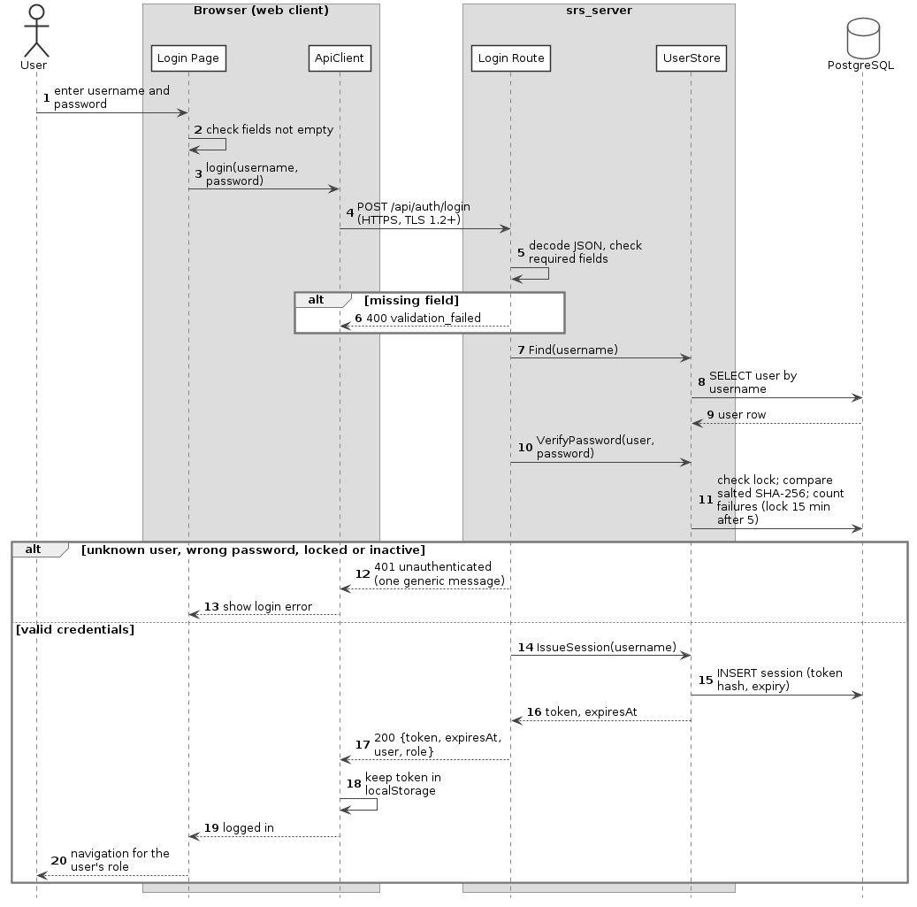
Figure 4 - UML sequence diagram: login and role resolution (POST /api/auth/login).

Sequence 2: Teacher records a grade
This flow exercises the guard chain, the domain logic, and transactional persistence. It also shows why authorization must be server-side: the same endpoint could be called by a crafted client, so the RBAC Guard - not the UI - decides whether the action is permitted.
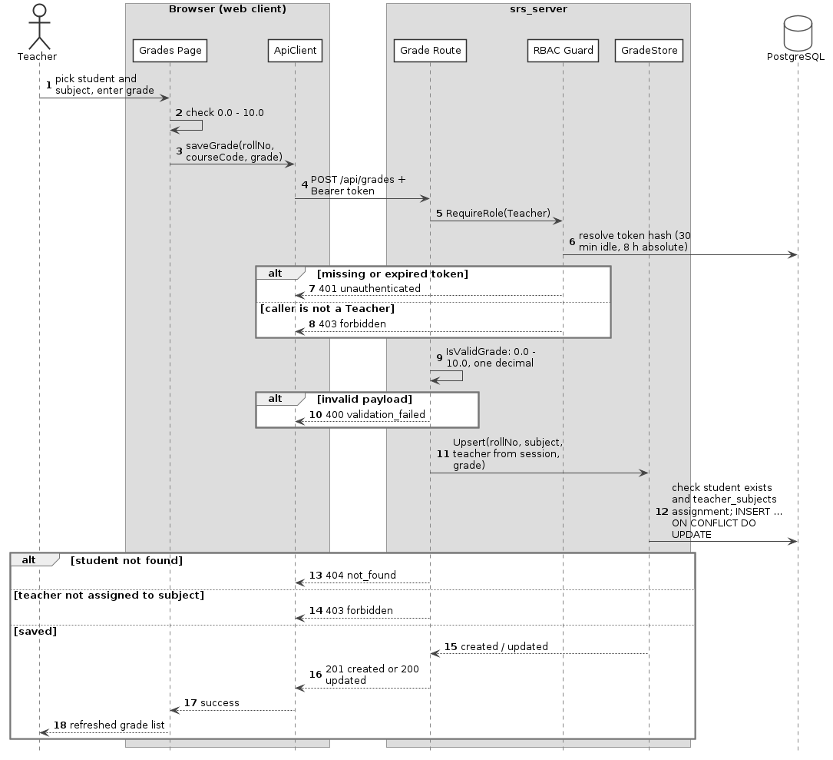
Figure 5 - UML sequence diagram: teacher records a grade (POST /api/grades).

Sequence 3: Student views attendance and percentage
Attendance and Semester Design: The Attendance Service records (POST) and updates (PUT) attendance per (student, course, date) for subjects the teacher is assigned to; a duplicate entry returns 409 and a future date is rejected. The percentage is calculated on the server as (present sessions / total conducted sessions) x 100, rounded to two decimal places; a count where present exceeds conducted is rejected, and no percentage is returned when nothing was conducted. Each subject carries a semester; grades, attendance and timetable slots inherit it, and the students, grades, attendance and timetable endpoints accept a semester filter.
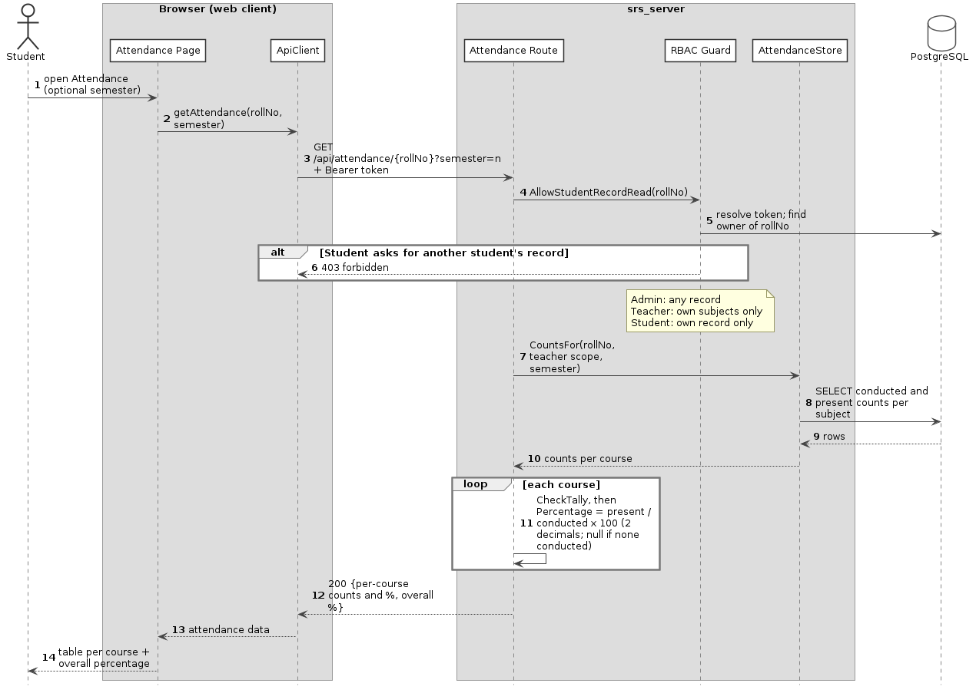
Figure 6 - UML sequence diagram: viewing attendance with per-course and overall percentage (GET /api/attendance/{rollNo}).

4.3 API Design
The API follows REST conventions: nouns for resources, HTTP verbs for operations, JSON for payloads, and standard status codes. All endpoints except login and /health require a valid bearer token. The table lists the endpoints implemented on the main branch; docs/api.md holds the field-level contract.
Interface definitions for four components:
Auth Service - login
Endpoint | /api/auth/login
Method | POST
Request | {"username": "t.sharma", "password": "..."}
Response | 200 {"token", "expiresAt", "user": {"username", "fullName", "role"}}
Errors | 400 validation_failed (missing field); 401 unauthenticated (unknown user, wrong password, locked or inactive account - same message).

Grade Service - record grade
Endpoint | /api/grades
Method | POST (Teacher)
Request | {"studentRollNo": "CS2024001", "courseCode": "CS301", "grade": 8.5}
Response | 201 (created) or 200 (updated) {"studentRollNo", "courseCode", "grade", "created"}
Errors | 400 validation_failed (grade outside 0.0-10.0 or more than one decimal); 401; 403 (not a Teacher, or not assigned to the subject); 404 student not found.

Attendance Service - view attendance
Endpoint | /api/attendance/{rollNo}?semester=&courseCode=
Method | GET (Admin, Teacher, Student self)
Request | -
Response | 200 {"studentRollNo", "items": [{"courseCode", "courseName", "semester", "conducted", "present", "percentage"}], "overall": {"conducted", "present", "percentage"}}
Errors | 401; 403 (another student's record, or a subject the teacher does not teach); 404.

Timetable Service - create slot
Endpoint | /api/timetable
Method | POST (Admin)
Request | {"courseCode", "teacher", "department", "semester", "dayOfWeek": 1-7, "startTime": "09:00", "endTime": "10:00", "room"}
Response | 201 {"id", "courseCode", "courseName", "dayOfWeek", "startTime", "endTime", ...}
Errors | 400 validation_failed / invalid_assignment (teacher not assigned or semester mismatch); 401; 403; 409 timetable_conflict (teacher or room already booked).

All endpoints implemented on the main branch:
Method | Endpoint | Role | Purpose
POST | /api/auth/login | Public | Authenticate and obtain a session token.
POST | /api/auth/logout | Any authenticated | Invalidate the session token.
GET | /api/me | Any authenticated | Return the caller's profile (role, linked roll number).
GET | /api/students | Admin, Teacher | List or search students (paginated; semester filter).
GET | /api/students/{rollNo} | Admin, Teacher, Student (self) | Retrieve a student record.
POST | /api/students | Admin | Create a student record.
PUT | /api/students/{rollNo} | Admin | Update a student record (roll number immutable).
DELETE | /api/students/{rollNo} | Admin | Delete a student record (cascades).
GET | /api/grades/{rollNo} | Admin, Teacher (own subjects), Student (self) | Retrieve grades.
POST | /api/grades | Teacher | Record or update a grade (upsert per student and subject).
GET | /api/attendance/{rollNo} | Admin, Teacher (own subjects), Student (self) | Retrieve attendance with per-course and overall percentage.
POST | /api/attendance | Teacher | Record attendance for a session.
PUT | /api/attendance/{rollNo}/{courseCode}/{date} | Teacher | Update recorded attendance.
GET | /api/timetable | Any authenticated (role-scoped) | Own schedule: Admin all (filters), Teacher own slots, Student own class.
GET | /api/timetable/{rollNo} | Admin, Student (self) | Retrieve a student's class timetable.
POST | /api/timetable | Admin | Create a timetable slot (conflict check).
GET | /api/accounts | Admin | List user accounts.
POST | /api/accounts | Admin | Create an Admin, Teacher or Student account.
PATCH | /api/accounts/{username} | Admin | Modify or deactivate a user account (no delete).
GET | /health | Public | Service health check.

4.4 Error Handling, Logging & Monitoring
Errors are handled consistently on both sides of the wire. The client distinguishes between validation errors (which it can fix locally) and server errors (which it surfaces to the user).
Every error uses one JSON shape: {"error": code, "message": text, "requestId": id, "fields": {field: problem}} - the fields object is present only for validation errors.
HTTP status | Meaning | Client behaviour
200 / 201 | Success. | Proceed and refresh the view.
400 | Malformed request or failed validation. | Show field-level inline errors where possible.
401 | Missing, expired or revoked token. | Return to the login page.
403 | Authenticated but not permitted. | Show a permission error; do not retry.
404 | Resource not found. | Show a not-found message.
409 | Conflict (e.g. duplicate or timetable clash). | Show a conflict message.
500 | Server fault. | Show a generic error and log the request id.

Logging and monitoring:
– No passwords, tokens or password hashes are written to logs (SRS-SR-005); CI checks the server logs for secrets.
– Each error response carries the request id, so a user-reported error can be matched to the server log.
– GET /health reports that the service is up; CI uses it to check the server starts over HTTPS. Docker Compose health-checks the database with pg_isready.
– CI (GitHub Actions) builds and tests every pull request and checks that plain HTTP is refused.
– Audit logging of record changes (SO-003) is planned.

4.5 UX Design
The web client has one page per feature and shows only the pages the signed-in role may use: Administrator - Students, Accounts, Grades, Attendance, Timetable; Teacher - Students, Grades, Attendance, My timetable (own subjects); Student - My grades, My attendance and My timetable.
– Inline validation: form fields are validated on submit, with the message shown next to the field (SRS-NF-003); the server repeats every check.
– Destructive actions (delete student, deactivate account) require a confirmation dialog.
– Table views support search and filtering, so users do not scroll through long lists.
– Role-based navigation: the navigation bar shows only the pages the role may use (e.g. Accounts is Admin only), but the server still enforces permissions independently.
– Consistent layout: forms use the same label/field/error arrangement throughout.
– Feedback: long-running requests show a status message and disable the form rather than freezing the page.

4.6 Open Issues & Next Steps
Open issues:
– Audit logging (SO-003) is not implemented.
– No connection pool: each store call opens its own connection; the 20-client load test (SRS-NF-007) has not been run.
– Student accounts are linked to student records by the seed data only; there is no screen or API for it.
– Subjects and teacher-subject assignments are maintained through migrations/seed data only.
Next steps:
– Replace bearer tokens with short-lived tokens plus refresh tokens.
– Add automated integration tests driven by the REST contract.
– Add an audit trail for record-changing operations (SO-003).
– Add a database connection pool and run the 20-client load test (SRS-NF-007).
– Add screens/API for maintaining subjects, teacher-subject assignments, and linking Student accounts to student records.

5. Appendices

5.1 Glossary
Term | Meaning
Bearer token | Random session token sent in the Authorization header; only its hash is stored.
RBAC | Role-Based Access Control: Administrator, Teacher, Student.
Ownership check | A Student may only read records whose roll number is linked to his or her account.
Store | Interface for reading/writing one entity; Pg*Store is the PostgreSQL implementation.
Upsert | Insert a row, or update it if it already exists (used for grades).
Semester filter | Optional semester query parameter on the record endpoints; the semester comes from the subject.
STRIDE | Spoofing, Tampering, Repudiation, Information disclosure, Denial of service, Elevation of privilege.
ADR | Architecture Decision Record.
TLS | Transport Layer Security (1.2 or higher).

5.2 References
– Software Requirements Specification (SRS), Student Record System, Team 12, v0.3.
– SAD Template, provided for the Software Engineering mini-project.
– ISO/IEC/IEEE 42010:2011 - Architecture description.
– UML 2.5 Specification, Object Management Group.
– OWASP Application Security Verification Standard (ASVS).
– Project repository: docs/api.md, docs/security.md, README.md.

5.3 Tools
PlantUML (all UML diagrams), CMake and GoogleTest, Node.js test runner, Docker and Docker Compose, GitHub and GitHub Actions, Jira.
Figure | Diagram | PlantUML source
1 | UML component diagram | architecture_uml.puml
2 | UML class diagram - domain model | class.puml
3 | UML class diagram - server classes | stores.puml
4 | UML sequence diagram - login | seq_login.puml
5 | UML sequence diagram - record grade | seq_grade.puml
6 | UML sequence diagram - view attendance | seq_attendance.puml

