Software Architecture and Design Document
Student Record System
Team 12

Field | Value
Project | Student Record System (SRS)
Document | Software Architecture and Design (SAD)
Team | Team 12
Version | 1.0
Status | Draft for review
Related documents | Software Requirements Specification (SRS) v1.0

Table of Contents
(Update field in Word: References > Update Table, or right-click the field and choose Update Field.)

1. Introduction

1.1 Purpose
This Software Architecture and Design (SAD) document describes the architecture, component decomposition, and detailed design of the Student Record System (SRS) developed by Team 12. It translates the requirements captured in the Software Requirements Specification (SRS) into a concrete technical blueprint that guides implementation, testing, and maintenance.

1.2 Scope
The system is a cross-platform desktop application that allows administrators, teachers, and students to manage and view student records including personal details, grades, attendance, and timetables. This document covers:
- The overall architectural style and the rationale behind it.
- The logical decomposition of the system into components and layers.
- The interfaces and contracts between components.
- Key runtime interactions (sequence flows) for the main use cases.
- The chosen technology stack and its justification.
- Design decisions recorded as Architecture Decision Records (ADRs).
- Traceability from SRS requirements to architectural elements.
- Security, error handling, and UX design considerations.

1.3 Intended Audience
Audience | Use of this document
Development team | Implementation guidance; component responsibilities and interfaces.
Test team | Basis for integration and system test design.
Project guide / evaluator | Verification that the design satisfies the SRS.
Future maintainers | Understanding of architectural rationale and constraints.

1.4 Definitions, Acronyms, Abbreviations
Term | Meaning
SAD | Software Architecture and Design
SRS | Software Requirements Specification
API | Application Programming Interface
REST | Representational State Transfer
JSON | JavaScript Object Notation
DTO | Data Transfer Object
DAO | Data Access Object
RBAC | Role-Based Access Control
TLS | Transport Layer Security
NFR / NF | Non-Functional Requirement
SR | Security Requirement
ADR | Architecture Decision Record
CRUD | Create, Read, Update, Delete
UI / UX | User Interface / User Experience

1.5 References
- Software Requirements Specification (SRS), Student Record System, Team 12, v1.0.
- SAD Template, provided for the Software Engineering mini-project.
- ISO/IEC/IEEE 42010:2011 - Architecture description.
- UML 2.5 Specification, Object Management Group.

1.6 Document Overview
Section 2 establishes the architectural goals and constraints. Section 3 presents the architecture itself: style, layers, components, and the technology stack. Section 4 details the design of key interactions and interfaces. Section 5 records the architecture decisions, risks, and traceability to requirements.

2. Architectural Goals and Constraints

2.1 Architectural Drivers
The architecture is shaped by the following drivers, derived from the SRS:
- Multi-role access control: three distinct roles (Administrator, Teacher, Student) with different permissions (SRS F-001 to F-003, SR-004).
- Data integrity: grades, attendance, and timetable data must remain consistent across concurrent operations (SRS NF-002).
- Cross-platform desktop delivery: the client must run on Windows and Linux (SRS NF-006).
- Usability: forms must provide inline validation and clear error feedback (SRS NF-003).
- Concurrency: the server must support at least 20 simultaneous clients (SRS NF-007).
- Security: all traffic encrypted, sessions authenticated with bearer tokens (SRS SR-007, SR-008).

2.2 Quality Attributes
Attribute | Goal | Architectural response
Security | Prevent unauthorised access; protect data in transit. | Server-side RBAC guard, TLS 1.2+, bearer session tokens, parameterised SQL.
Maintainability | Localise change; avoid ripple effects. | Layered architecture; domain services isolated behind interfaces.
Testability | Components testable in isolation. | Interface-based design; dependency injection at service boundaries.
Usability | Low training cost; clear error messages. | Qt widgets with inline validation; consistent dialog patterns.
Performance | Responsive UI under normal load. | Connection pooling; indexed queries; asynchronous network calls on the client.
Portability | Run on Windows and Linux. | Qt cross-platform toolkit; standard C++17; PostgreSQL portable across OSes.

2.3 Constraints
Constraint | Description
Language | C++17 for client and server.
GUI toolkit | Qt 5.15+ / Qt 6 (see ADR-001).
Database | PostgreSQL relational DBMS (see ADR-002).
Protocol | HTTPS / REST with JSON payloads.
Architecture | Three-tier client-server with a layered server.
Licensing | Only LGPL / permissive dependencies for coursework.
Team size | Small team; architecture must avoid unnecessary ceremony.

2.4 Assumptions
- The server host runs a supported Linux distribution with PostgreSQL installed.
- Each client host has a network path to the server over the campus LAN or VPN.
- Users have been provisioned with accounts by an administrator.
- The academic calendar (semesters, terms) is configured before timetable entry.

3. Architecture

3.1 Architectural Style
The system follows a three-tier client-server architecture with a layered server and a component-based decomposition inside each layer. The three tiers are:
1. Presentation Layer - the Qt desktop client that renders forms, tables, and dialogs.
2. Application Layer - the C++ server hosting the REST endpoint, cross-cutting services (RBAC, validation, audit, session management) and domain services.
3. Data Layer - the persistence components and the PostgreSQL relational database.
This style was chosen because it separates concerns cleanly, allows the client and server to evolve independently behind the REST contract, and matches the deployment reality of a small team where client and server are separate executables.

3.2 Architectural Principles
- Separation of concerns: each layer exposes a narrow interface to the layer above.
- Single responsibility: one domain service per business entity or concern.
- Server-side enforcement: authorization and validation are never trusted to the client (SR-004, NF-005).
- Contract-first: components communicate through declared interfaces (see 3.4).
- Fail closed: an unrecognised role or malformed request is rejected, not defaulted.

3.3 Component View
The system is decomposed into the components shown below. The presentation layer holds the Qt widgets and the API client; the application layer holds the REST router, the cross-cutting services, and the domain services; the data access layer holds the repositories. Each domain service owns a single entity or concern, which keeps the change surface small.
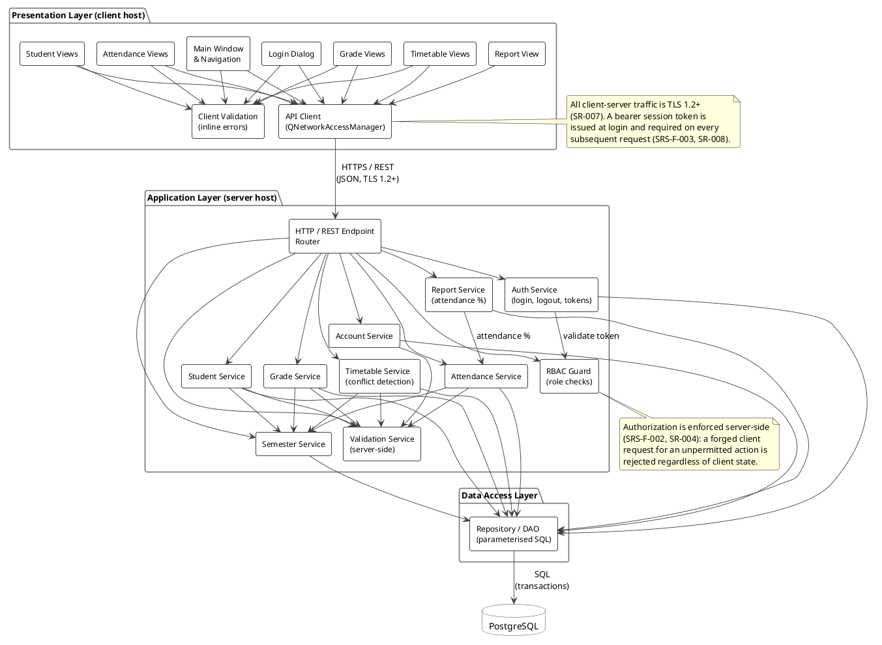
Figure 1 - Component diagram: logical decomposition of the system.

3.4 Interface View
The layered view below shows the same system organised by layer, and it exposes the dependency direction between layers: the Qt presentation layer drives the API client, which issues HTTPS/REST requests to the server. Inside the server the REST router passes each decoded request through the cross-cutting services - session validation, role checks, payload validation, and audit logging - before the request codec dispatches it to the relevant domain service. Domain services persist through the repository layer, which draws connections from the pool and issues SQL to PostgreSQL.
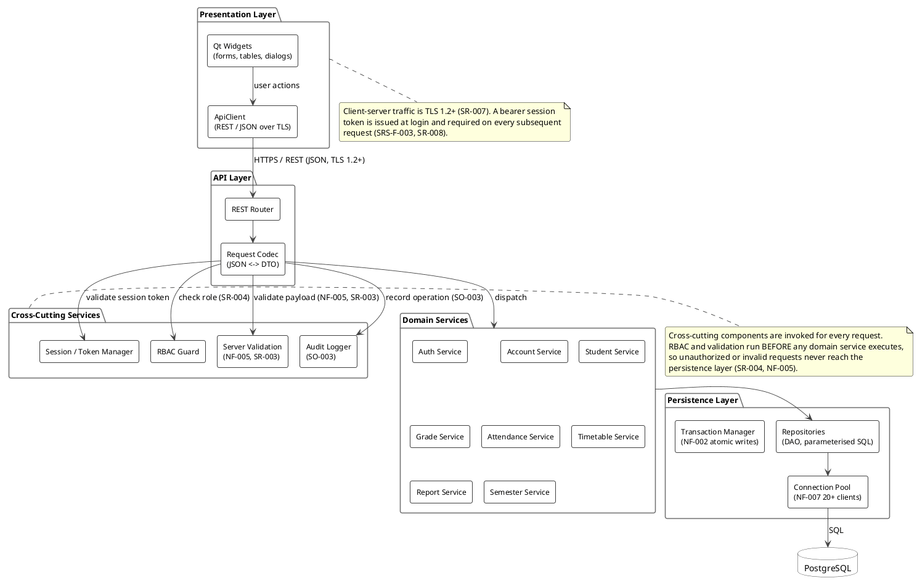
Figure 2 - Layered component view: dependency direction between layers and the cross-cutting services applied to every request.
The principal interface contracts - the interfaces each component provides and which components consume them - are summarised in the table below.
Interface | Provided by | Consumed by | Purpose
IApiClient | ApiClient | Qt Widgets, Client Validation | Asynchronous REST/JSON calls over TLS.
IRouter | REST Router | ApiClient | Dispatches HTTP requests to the correct handler.
IValidation | Server Validation | Request Codec, Domain Services | Server-side validation of payloads and business rules.
IRbacGuard | RBAC Guard | Request Codec | Role and permission checks before dispatch.
IAuditLog | Audit Logger | Request Codec, Domain Services | Records security-relevant and data-changing operations.
ITokenManager | Session / Token Manager | REST Router, Auth Service | Issues and validates bearer session tokens.
IRepository | Repositories (DAO) | All domain services | Parameterised SQL access to entities.
IConnectionPool | Connection Pool | Repositories | Reuses database connections for 20+ concurrent clients.

3.5 Layered Decomposition
Layer | Responsibilities | Key components
Presentation | Render UI, collect input, validate inline, call the API client. | Qt Widgets, Client-side Validation, ApiClient
API | Terminate HTTPS, decode JSON to DTOs, dispatch to services. | REST Router, Request Codec
Cross-cutting | Apply concerns common to all requests. | Session/Token Manager, RBAC Guard, Server Validation, Audit Logger
Domain | Implement business rules for each entity. | Auth, Account, Student, Grade, Attendance, Timetable, Report, Semester
Persistence | Persist and retrieve entity state transactionally. | Repositories, Transaction Manager, Connection Pool

3.6 Deployment View
The system deploys as two executables and one database. The Qt client runs on the user's workstation; the C++ server and PostgreSQL run on the server host. All client-server traffic is carried over HTTPS with TLS 1.2 or higher (SR-007).
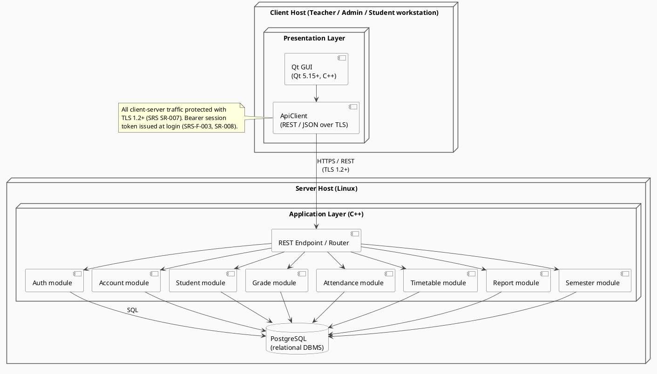
Figure 3 - Deployment view: client host, server host, and database.

4. Detailed Design

4.1 Design Overview
Every request follows the same path: the client builds a DTO and hands it to the ApiClient, which serialises it to JSON and sends it over TLS. The REST Router selects a handler; the Request Codec converts the JSON back into a DTO and invokes the cross-cutting guards. Only if the token is valid, the role is permitted, the payload is well-formed, and the audit entry is written does the request reach a domain service. The domain service performs the business logic and calls a repository, which executes parameterised SQL inside a transaction and returns the result back up the chain.

4.2 Sequence Flow 1: Login and Role Resolution
The login flow establishes the session token that every subsequent request carries. The password is never stored in plaintext; the Auth Service compares a salted hash and the Token Manager issues a bearer token with an expiry.
1. The user submits credentials in the Login Dialog.
2. Client-side validation checks that both fields are non-empty and well-formed.
3. ApiClient sends POST /api/auth/login with the credentials over TLS.
4. REST Router forwards the request to the Request Codec.
5. Request Codec decodes the JSON and calls Server Validation.
6. Server Validation accepts the payload; the Router invokes Auth Service.
7. Auth Service retrieves the account via the Account Repository, compares the salted hash, and reports success or failure.
8. On success, Session/Token Manager issues a bearer token and records the role; the Audit Logger records the login event.
9. The token and role are returned to the client, which stores them for the session and navigates to the role-appropriate main window.

4.3 Sequence Flow 2: Recording a Grade
This flow exercises the guard chain, the domain logic, and transactional persistence. It also shows why authorization must be server-side: the same endpoint could be called by a crafted client, so the RBAC Guard - not the UI - decides whether the action is permitted.
1. A teacher selects a student and enters a grade in the Grade View.
2. Client-side validation checks the range 0.0-10.0 and that the student is selected.
3. ApiClient sends POST /api/grades with the bearer token in the Authorization header.
4. REST Router resolves the handler and passes the request to the Request Codec.
5. Request Codec decodes the DTO; RBAC Guard verifies the teacher is permitted to grade that student in that course.
6. Server Validation checks the grade range, the student id, and the course id against the database.
7. Grade Service resolves the active semester via Semester Service and applies the grading policy.
8. The Grade Repository writes the row inside a transaction managed by the Transaction Manager, using a pooled connection.
9. Audit Logger records the change; the updated grade is returned to the client, which refreshes the Grade View.

4.4 API Design
The API follows REST conventions: nouns for resources, HTTP verbs for operations, JSON for payloads, and standard status codes. All endpoints except login require a valid bearer token.
Method | Endpoint | Role | Purpose
POST | /api/auth/login | Public | Authenticate and obtain a session token.
POST | /api/auth/logout | Any authenticated | Invalidate the session token.
GET | /api/students | Admin, Teacher | List or search students.
GET | /api/students/{id} | Admin, Teacher, Student (self) | Retrieve a student record.
POST | /api/students | Admin | Create a student record.
PUT | /api/students/{id} | Admin | Update a student record.
DELETE | /api/students/{id} | Admin | Delete a student record.
GET | /api/grades/{studentId} | Admin, Teacher, Student (self) | Retrieve grades.
POST | /api/grades | Admin, Teacher | Record a grade.
GET | /api/attendance/{studentId} | Admin, Teacher, Student (self) | Retrieve attendance.
POST | /api/attendance | Admin, Teacher | Record attendance.
GET | /api/timetable/{studentId} | Admin, Teacher, Student (self) | Retrieve timetable.
POST | /api/timetable | Admin | Create or update timetable entries.
GET | /api/reports/attendance/{studentId} | Admin, Teacher, Student (self) | Generate an attendance report.
GET | /api/accounts | Admin | Manage user accounts.

4.5 Error Handling
Errors are handled consistently on both sides of the wire. The client distinguishes between validation errors (which it can fix locally) and server errors (which it surfaces to the user).
HTTP status | Meaning | Client behaviour
200 / 201 | Success. | Proceed and refresh the view.
400 | Malformed request or failed validation. | Show field-level inline errors where possible.
401 | Missing or expired token. | Return to the login dialog.
403 | Authenticated but not permitted. | Show a permission error; do not retry.
404 | Resource not found. | Show a not-found message.
409 | Conflict (e.g. duplicate or timetable clash). | Show a conflict message.
500 | Server fault. | Show a generic error and log the request id.

4.6 UX and Validation Design
- Inline validation: fields are validated as the user leaves them, with the message shown next to the field (NF-003).
- Destructive actions (delete student, delete account) require a confirmation dialog.
- Table views support search and filtering, so users do not scroll through long lists.
- Role-based navigation: the main window shows only the views the role may use, but the server still enforces permissions independently.
- Consistent layout: forms use the same label/field/error arrangement throughout.
- Feedback: long-running requests show a busy indicator rather than freezing the UI.

5. Architecture Decisions, Risks and Traceability

5.1 Architecture Decision Records

ADR-001: Use Qt as the client GUI toolkit
Field | Value
Status | Accepted
Context | The SRS requires a usable, cross-platform desktop UI (NF-003, NF-006). The SRS named ImGui as a 'primary candidate' but did not commit to it.
Decision | Standardise on Qt 5.15+ / Qt 6 for the client.
Rationale | Qt provides a retained-mode widget set with tables, validators, dialogs, and a built-in HTTP/JSON stack, which minimises the code needed for a CRUD-heavy application. ImGui is immediate-mode and would require hand-coding every table, form, and dialog. Qt is LGPL and runs on Windows and Linux.
Consequences | The SRS's ImGui mention is superseded; the deployment diagram must be updated to say Qt only.

ADR-002: Use PostgreSQL as the DBMS
Field | Value
Status | Accepted
Context | The SRS leaves the DBMS 'TBD in SAD'. The data is strongly relational (students, courses, enrolments, grades, attendance).
Decision | Use PostgreSQL as the relational DBMS.
Rationale | Mature, free, ACID-compliant, good concurrency behaviour, strong constraint support, and portable across Linux and Windows. Its support for transactions and foreign keys directly supports NF-002.
Consequences | The schema must be normalised and indexed; the persistence layer uses parameterised SQL against PostgreSQL.

ADR-003: Three-tier client-server with a layered server
Field | Value
Status | Accepted
Context | The system must support multiple concurrent clients and enforce security server-side (NF-007, SR-004).
Decision | Separate the presentation, application, and data tiers, and layer the server internally.
Rationale | The client can evolve independently of the server behind a REST contract; authorization and validation live where they cannot be bypassed; and the layers keep the change surface small.
Consequences | A network hop is added to every operation; the client must handle asynchronous responses and offline failures.

ADR-004: Bearer session tokens over TLS
Field | Value
Status | Accepted
Context | Requests must be authenticated and confidential (SR-007, SR-008).
Decision | Issue a bearer token at login; require it on every request; carry all traffic over TLS 1.2+.
Rationale | Stateless on the server per request, simple to implement, and widely supported by Qt's network stack.
Consequences | Tokens must be stored carefully on the client and expired server-side; replay protection depends on TLS.

5.2 Risks and Mitigations
Risk | Impact | Likelihood | Mitigation
Scope creep in the UI | High | Medium | Freeze the screen list early; use Qt Designer; prioritise CRUD over polish.
Concurrency bugs under 20+ clients | High | Medium | Connection pooling, transactions, and load testing (NF-007).
Authorization bypassed on the client | High | Low | Enforce every permission in the RBAC Guard server-side (SR-004).
Schema churn late in the project | Medium | Medium | Stabilise the schema in design; use migrations for later changes.
Team unfamiliar with Qt | Medium | Medium | Build a skeleton early; keep to standard widgets and patterns.
Time lost to build/tooling issues | Medium | High | Commit a working CMake + Qt skeleton to the repository early.

5.3 Requirements Traceability
The table below maps the main SRS requirements to the architectural elements that satisfy them.
Requirement | Architectural element
F-001 to F-003 (authentication, roles) | Auth Service, Session/Token Manager, RBAC Guard, Login Dialog
F-004 to F-009 (student records, search) | Student Service, Account Service, Student Views, Repositories
F-010 to F-012 (grades, range validation) | Grade Service, Server Validation, Client-side Validation, Grade Views
F-013 to F-016 (attendance) | Attendance Service, Report Service, Attendance Views
F-017 to F-020 (timetable, conflicts) | Timetable Service, Semester Service, Timetable Views
F-021 to F-023 (reports) | Report Service, Report View
NF-002 (atomic writes) | Transaction Manager, Repositories
NF-003 (inline validation, confirmations) | Client-side Validation, Qt Widgets, Server Validation
NF-005 (server-side validation) | Server Validation, Request Codec
NF-006 (portability) | Qt 5.15+, standard C++17, PostgreSQL
NF-007 (20+ concurrent clients) | Connection Pool, Transaction Manager
SR-003 (input validation) | Server Validation
SR-004 (server-side authorization) | RBAC Guard
SR-007 (TLS 1.2+) | ApiClient, REST Router
SR-008 (session tokens) | Session/Token Manager, Auth Service
SO-003 (audit logging) | Audit Logger

5.4 Future Work
- Replace bearer tokens with short-lived tokens plus refresh tokens.
- Add automated integration tests driven by the REST contract.
- Introduce database migrations and seed data for repeatable test environments.
- Add export of reports to PDF or CSV.
- Add an installer or packaging step for Windows and Linux deployment.

Appendix A: Diagram Sources
All diagrams are authored in PlantUML and rendered to PNG. The sources live in docs/diagrams/ alongside the rendered images.
Figure | Source file | Rendered file
1 - Component overview | component_overview.puml | component_overview.png
2 - Layered / interface view | component_layers.puml | component_layers.png
3 - Deployment | deployment.puml | deployment.png

Appendix B: Glossary of Component Names
Component | Layer | Responsibility
Qt Widgets | Presentation | Forms, tables, dialogs and navigation.
Client-side Validation | Presentation | Immediate feedback on user input.
ApiClient | Presentation | REST/JSON calls over TLS.
REST Router | API | Routes HTTP requests to handlers.
Request Codec | API | Converts JSON to DTOs and back.
Session / Token Manager | Cross-cutting | Issues and validates session tokens.
RBAC Guard | Cross-cutting | Enforces role-based permissions.
Server Validation | Cross-cutting | Validates payloads and business rules.
Audit Logger | Cross-cutting | Records security-relevant operations.
Auth Service | Domain | Login, logout, credential checks.
Account Service | Domain | User account administration.
Student Service | Domain | Student record CRUD.
Grade Service | Domain | Grade recording and retrieval.
Attendance Service | Domain | Attendance recording and retrieval.
Timetable Service | Domain | Timetable management and conflict detection.
Report Service | Domain | Attendance and grade reports.
Semester Service | Domain | Semester and term management.
Repositories (DAO) | Persistence | Parameterised SQL access to entities.
Transaction Manager | Persistence | Atomic writes across related tables.
Connection Pool | Persistence | Reuses connections for concurrent clients.

