Software Requirements Specification
Event Management System
Version 1.5
Dharoor Shiva Sai Varun , Chirag Basanth Bellav , Gandhar Gokhale , Harshith J
Software Engineering

Table of Contents
Table of Contents
Revision History
1. Introduction
1.1 Purpose
1.2 Intended Audience
1.3 Product Scope
1.4 References
2. Overall Description
2.1 Product Perspective
2.2 Product Functions
2.3 User Classes and Characteristics
2.4 Operating Environment
2.5 Design and Implementation Constraints
2.6 Assumptions and Dependencies
3. External Interface Requirements
3.1 User Interfaces
3.2 Software Interfaces
3.3 Communications Interfaces
3.4 Hardware Interfaces
4. Analysis Models
5. System Features
System Feature 1: User Registration and Authentication
Description and Priority
Stimulus/Response Sequences
Functional Requirements
System Feature 2: Event Creation and Management
Description and Priority
Stimulus/Response Sequences
Functional Requirements
System Feature 3: Event Discovery, Search, and Filtering
Description and Priority
Stimulus/Response Sequences
Functional Requirements
System Feature 4: Event Registration and Ticket Booking
Description and Priority
Stimulus/Response Sequences
Functional Requirements
System Feature 5: Payment Processing
Description and Priority
Stimulus/Response Sequences
Functional Requirements
System Feature 6: Notifications
Description and Priorit
Stimulus/Response Sequences
Functional Requirements
System Feature 7: QR-Code Digital Ticketing and Check-In
Description and Priority
Stimulus/Response Sequences
Functional Requirements
System Feature 8: Admin Dashboard and Reporting
Description and Priority
Stimulus/Response Sequences
Functional Requirements
System Feature 9: Post-Event Feedback and Ratings
Description and Priority
Stimulus/Response Sequences
Functional Requirements
6. Other Nonfunctional Requirements
6.1 Performance Requirements
6.2 Safety Requirements
6.3 Security Requirements
6.4 Software Quality Attributes
6.5 Business Rules
7. Other Requirements
Appendix A: Glossary
Appendix B: Field Layouts
Appendix C: Requirement Traceability Matrix

Revision History

Name | Date | Reason For Changes | Version
Dharoor Shiva Sai Varun | 07-09-2026 | Initial draft- Section 1 (Introduction) and Section 2 (Overall Description) | 1.0
Chirag Basanth Bellav | 13-09-2026 | Added Section 3 (External Interface Requirements) and the Event Creation & Management feature in Section 5 | 1.1
Gandhar Sameer Gokhale | 18-09-2026 | Added section 4 including the ER Diagram Registration, Payment, and Notifications features in Section 5 | 1.2
Harshith J | 05-10-2026 | Final Part-1 review: added security objectives/IDs, analysis diagrams, and traceability updates | 1.4
Harshith J | 29-10-2026 | Implementation status, delivered-scope traceability and as-built UML diagrams aligned to repository | 1.5

1. Introduction

1.1 Purpose
This Software Requirements Specification (SRS) records the Event Management System target requirements and, through the implementation-status appendix, distinguishes them from the code delivered in the repository baseline reviewed on 29 October 2026. The current implementation covers account access, role/ownership controls, event lifecycle management, and public event discovery. Registration, waitlists, payment/refunds, attendee notifications, QR check-in, dashboards/reports and feedback remain planned requirements; their presence in this SRS does not mean those modules have been delivered.

1.2 Intended Audience
This document is intended for the development team (front-end, back-end, and QA), the project supervisor/instructor evaluating the proposal, and any future maintainers of the system. Developers should use Sections 2-3 to guide design and implementation; testers should use Section 3 to derive test cases; instructors/reviewers can use Sections 1-2 for a high-level overview.

1.3 Product Scope
The current delivered slice is a web application for account registration and login, role-based event management, and public discovery of upcoming published events. It does not currently support attendee event registration or ticket booking. The broader product objective remains to add registrations, payments, notifications, check-in and reporting in later iterations; those items are future scope until corresponding models, routes, UI and tests are merged.

1.4 References
- Project Guidelines document (course proposal requirements).
- IEEE SRS template (basis for this document's structure).
- [Payment gateway API documentation — to be added once a provider is selected]

2. Overall Description

2.1 Product Perspective
The current application is a client-server web application. The browser UI is React 18 with Vite; it calls a Node.js/Express REST API using JSON. Sequelize persists the implemented User and Event models to a local SQLite file configured by DATABASE_FILE. The repository does not currently include payment, registration, notification, ticketing or reporting services.

2.2 Product Functions
The full target product includes the future functions below; current implementation status is indicated in each item:
- Implemented: register Attendee/Organizer accounts, verify email through a development console link, log in with JWT, and enforce role/ownership checks.
- Implemented: create, edit, publish and cancel events with server-side validation and owner/admin checks.
- Implemented: browse future published events, search title/description, filter by category/venue/date, paginate, and view published details.
- Planned, not implemented: attendee registration, payments and waitlisting.
- Planned, not implemented: confirmation/reminder/change notifications. Verification links are logged to the backend console only.
- Planned, not implemented: QR ticket generation and check-in.
- Planned, not implemented: organizer/admin dashboards and CSV reporting.
- Planned, not implemented: post-event ratings and feedback.

2.3 User Classes and Characteristics
- Attendee — general public users with basic web/mobile literacy; primary goal is to find and register for events quickly.
- Organizer — event hosts (e.g., clubs, small businesses, individuals) who need to manage event details and registrations; assumed to have moderate technical comfort but no programming background.
- Administrator — a pre-provisioned role. In the current baseline, ADMIN can manage events through server-side event routes; an administrator dashboard, user-management UI, and platform reporting are not implemented.

2.4 Operating Environment
The current development environment uses Node.js (Node 24 is configured in CI), npm, a React/Vite frontend and a local SQLite database. The frontend is tested through a Vite production build. Browser responsiveness and production deployment on Linux/cloud are goals, not verified non-functional results in this repository snapshot.

2.5 Design and Implementation Constraints
- Implemented stack: JavaScript, React 18, Vite, React Router, Node.js, Express, Sequelize and SQLite. The repository uses a local database for development; production database provisioning and deployment configuration are not included.
- Planned constraint: integrate a payment gateway only when payment/ticketing modules are implemented. No payment gateway integration is present in the current baseline.
- Security baseline: passwords are stored as bcrypt hashes; responses do not expose password hashes; JWT authentication and server-side role/ownership checks are implemented. Production TLS/deployment hardening and payment-data compliance cannot be claimed because the payment flow and production deployment are absent.
- Development timeline is constrained by the academic term schedule.

2.6 Assumptions and Dependencies
- Future dependencies: a payment gateway and email/SMS provider will be required for planned payments and notifications. Neither provider is integrated in the current code baseline. Email verification is currently demonstrated by a development link printed in the backend terminal.
- Assumes users have access to email (and optionally SMS) for receiving notifications.
- Assumes the team will have access to a hosting environment (cloud or campus) for deployment and testing.

3. External Interface Requirements

3.1 User Interfaces
The current React UI provides account registration/login, public event browsing and details, and organizer event creation/editing/management. It does not provide attendee registration/checkout, QR check-in, or an admin reporting dashboard. UI-level restrictions complement but do not replace backend authorization.

3.2 Software Interfaces
The frontend calls the backend JSON REST API, by default at http://localhost:5000/api. Sequelize persists User and Event records to SQLite in local development. No payment gateway or email/SMS provider API is called by the current backend.

3.3 Communications Interfaces
The local development server uses HTTP at localhost:5000; this repository does not configure production HTTPS/TLS termination. JWT Bearer tokens protect authenticated API routes. Production deployments must provide HTTPS/TLS at the host/reverse-proxy layer before handling real user data.

3.4 Hardware Interfaces
QR-code check-in is a planned feature and is not implemented in the current baseline; there is no ticket or check-in route that uses a camera.

4. Analysis Models
The analysis figures below describe the current implemented baseline: (1) a use-case diagram for implemented account-access, event-management and event-discovery workflows; and (2) an entity-relationship diagram containing only the implemented User and Event models. Planned modules are explicitly noted as absent.
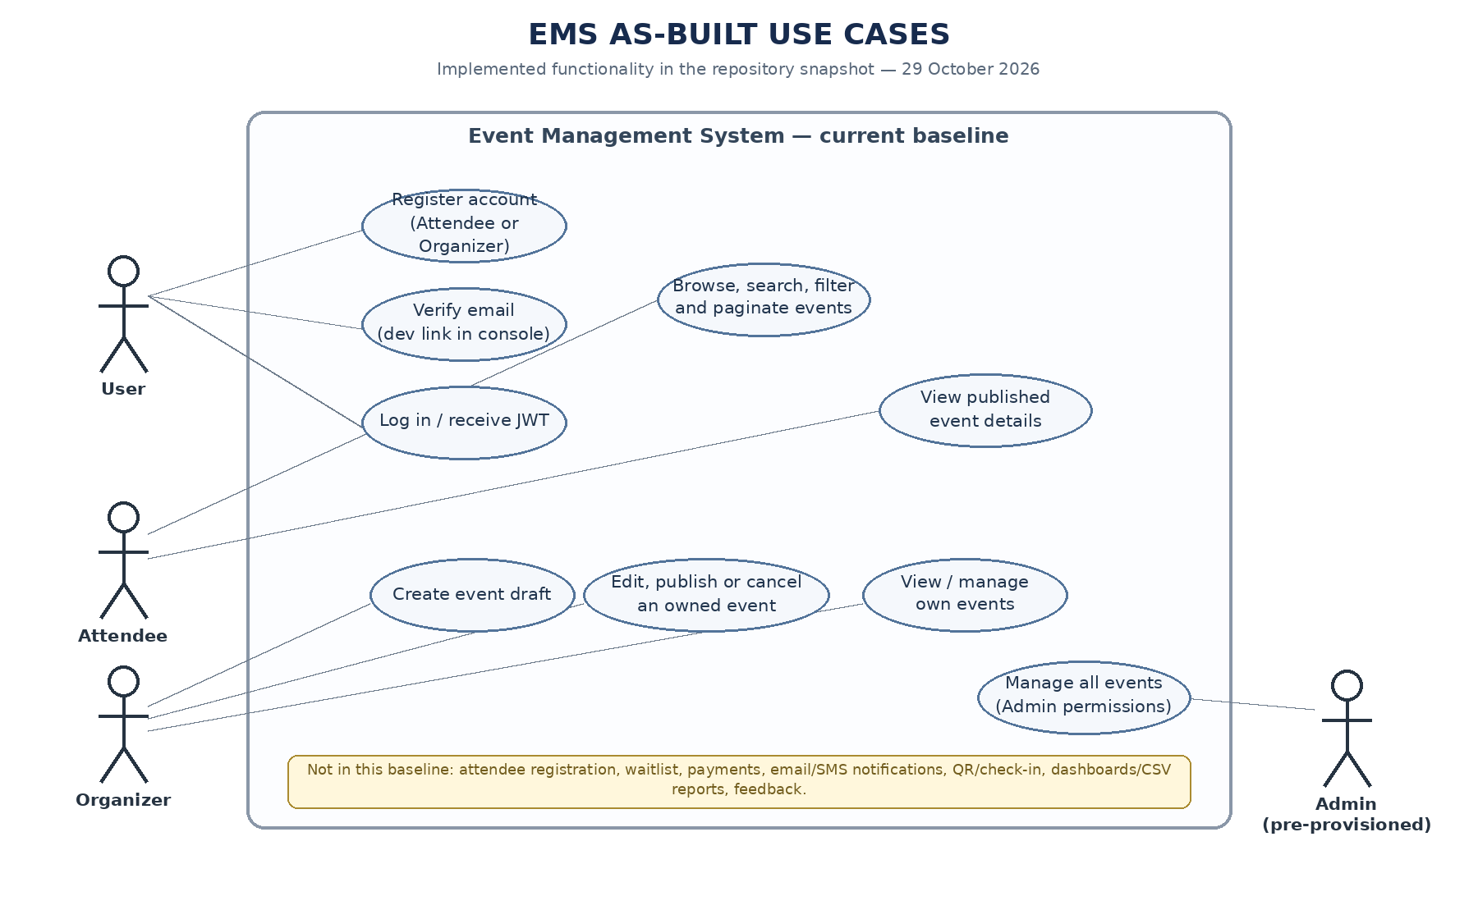
Figure 1 — UML Use Case Diagram
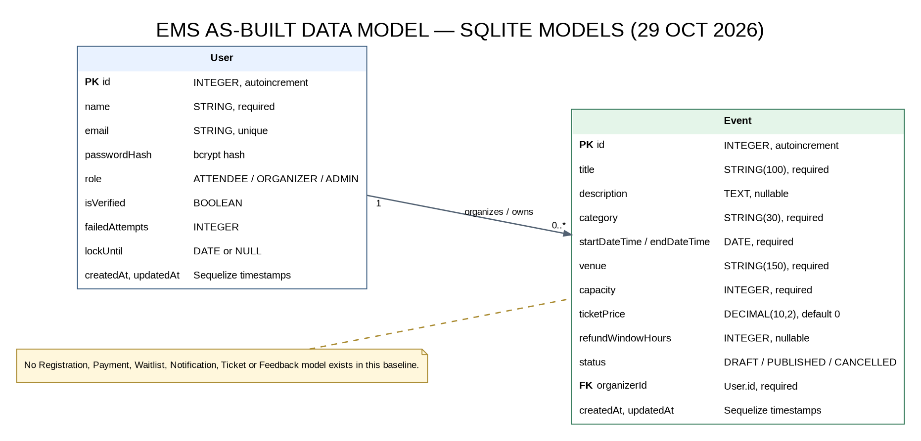
Figure 2 — High-Level Entity-Relationship Diagram

5. System Features
Status convention: REQ-1 to REQ-10 describe the implemented account/event slice (with email delivery caveat); REQ-11 to REQ-28 remain target requirements and are not implemented in the current code baseline. See Appendix D and docs/IMPLEMENTATION_BASELINE.md.

System Feature 1: User Registration and Authentication

Description and Priority
Allows organizers and attendees to create accounts, log in securely, and access features appropriate to role (Attendee, Organizer, Administrator). Priority: High.

Stimulus/Response Sequences
- User navigates to the Sign Up page and submits name, email, password, and desired role.
- System validates the input, creates the account, and sends verification email.
- User logs in with email and password; system authenticates and issues a session token.

Functional Requirements
REQ-1: The system shall allow a new user to register with a unique email address, password, and role selection (Attendee or Organizer).
REQ-2: The system shall verify a user's email address before allowing full access to the platform.
REQ-3: The system shall allow a registered user to log in using email and password, and shall lock the account for 15 minutes after 5 consecutive failed attempts.
REQ-4: The system shall enforce role-based access control so that only the Organizers can create events and only Administrators can access the admin dashboard.

System Feature 2: Event Creation and Management

Description and Priority
Allows an organizer to create, edit, publish, and cancel events, specifying details such as title, description, date/time, venue, capacity, category, and ticket price. Priority: High.

Stimulus/Response Sequences
- Organizer selects 'Create Event' and fills event details in a form.
- System validates the data (e.g., end date after start date, capacity greater than zero) and saves the event as a draft or publishes it.
- Organizer edits an existing event; system updates the record and notifies already-registered attendees of material changes.

Functional Requirements
REQ-5: The system shall allow an Organizer to create an event with title, description, category, start/end date-time, venue or virtual link, capacity, and optional ticket price.
REQ-6: The system shall allow an Organizer to save an event as a draft before publishing it publicly.
REQ-7: The system shall allow an Organizer to edit or cancel event they own, and shall notify all registered attendees when an event is cancelled or rescheduled.
REQ-8: The system shall prevent an Organizer from setting an event capacity of zero or a negative value.

System Feature 3: Event Discovery, Search, and Filtering

Description and Priority
Allows attendees to browse published events and narrow results by the category, date range, location, and price. Priority: Medium.

Stimulus/Response Sequences
- Attendee opens the Events page; system displays a paginated list of upcoming published events.
- Attendee enters a keyword or selects filters (category, date, location); system returns matching events.

Functional Requirements
REQ-9: The system shall display a list of all published, upcoming events, sorted by start date by default.
REQ-10: The system shall allow filtering of events by category, date range, and location, and support free-text keyword search on event title and description.

System Feature 4: Event Registration and Ticket Booking
Implementation status: PLANNED — not implemented in the code baseline reviewed on 29 October 2026. The following requirements describe intended future behavior and must not be recorded as delivered or tested.

Description and Priority
Allows an attendee to register for a free event or purchase a ticket for paid event, with automatic waitlisting once capacity is reached. Priority: High.

Stimulus/Response Sequences
- Attendee selects an event and clicks 'Register' or 'Book Ticket'.
- System checks remaining capacity; if available, reserves a spot and proceeds to payment (if applicable) or confirms registration directly.
- If the event is full, the system offers to add the attendee to a waitlist.

Functional Requirements
REQ-11: The system shall allow an authenticated attendee to register for an event with available capacity.
REQ-12: The system shall automatically place an attendee on a waitlist when an event has reached full capacity, and shall notify waitlisted attendees if a spot becomes available.
REQ-13: The system shall decrement available capacity atomically when a registration is confirmed to prevent overbooking during concurrent registrations.
REQ-14: The system shall allow an attendee to cancel their own registration up to a configurable cutoff time before the event.

System Feature 5: Payment Processing
Implementation status: PLANNED — not implemented in the code baseline reviewed on 29 October 2026. The following requirements describe intended future behavior and must not be recorded as delivered or tested.

Description and Priority
Allows attendees to pay for tickets to paid events through integrated, secure payment gateway. Priority: High.

Stimulus/Response Sequences
- Attendee proceeds to checkout for a paid event; system redirects to or embeds the payment gateway.
- Payment gateway confirms success or failure; system updates the registration and payment status accordingly.

Functional Requirements
REQ-15: The system shall integrate with a third-party payment gateway to process ticket payments via card and/or UPI.
REQ-16: The system shall confirm a registration 'Paid' only after receiving a successful payment confirmation from the gateway.
REQ-17: The system shall support issuing refunds for cancelled paid events or attendee-initiated cancellations within the refund policy window.

System Feature 6: Notifications
Implementation status: PLANNED — not implemented in the code baseline reviewed on 29 October 2026. The following requirements describe intended future behavior and must not be recorded as delivered or tested.

Description and Priority
Sends automated email and/or SMS notifications for registration confirmations, event reminders, and changes to an event. Priority: Medium.

Stimulus/Response Sequences
- Attendee successfully registers; system sends a confirmation email containing event details and a digital ticket.
- A configurable time before the event start, the system sends reminder notification to all registered attendees.

Functional Requirements
REQ-18: The system shall send an automated confirmation email immediately after a successful registration or payment.
REQ-19: The system shall send an automated reminder notification to registered attendees 24 hours before an event begins.
REQ-20: The system shall notify affected attendees promptly whenever an event they registered for is rescheduled or cancelled.

System Feature 7: QR-Code Digital Ticketing and Check-In
Implementation status: PLANNED — not implemented in the code baseline reviewed on 29 October 2026. The following requirements describe intended future behavior and must not be recorded as delivered or tested.

Description and Priority
Issues a unique QR-coded digital ticket to each confirmed registration and allows organizers to scan tickets for attendee check-in at the event. Priority: Medium.

Stimulus/Response Sequences
- System generates a unique QR code for each confirmed registration and includes it in the confirmation email.
- At the event, an organizer or staff member scans the attendee's QR code using the check-in interface.
- System validates the code and marks the attendee as checked in, rejecting duplicate scans.

Functional Requirements
REQ-21: The system shall generate a unique QR code for each confirmed registration.
REQ-22: The system shall provide a check-in interface that validates a scanned QR code against the event's registration list.
REQ-23: The system shall reject a QR code that has already been used for check-in and flag it as a duplicate scan attempt.

System Feature 8: Admin Dashboard and Reporting
Implementation status: PLANNED — not implemented in the code baseline reviewed on 29 October 2026. The following requirements describe intended future behavior and must not be recorded as delivered or tested.

Description and Priority
Provides administrators and organizers with a dashboard summarizing events, registrations, revenue, and attendance trends. Priority: Medium.

Stimulus/Response Sequences
- Organizer or Administrator logs in and opens the Dashboard.
- System displays summary metrics (total events, registrations, revenue) and allows drill-down into individual event reports.

Functional Requirements
REQ-24: The system shall provide Organizers with a dashboard showing registration counts, revenue, and capacity utilization for their own events.
REQ-25: The system shall provide Administrators with a platform-wide dashboard showing aggregate events, users, and revenue.
REQ-26: The system shall allow exporting of registration and attendance reports in CSV format.

System Feature 9: Post-Event Feedback and Ratings
Implementation status: PLANNED — not implemented in the code baseline reviewed on 29 October 2026. The following requirements describe intended future behavior and must not be recorded as delivered or tested.

Description and Priority
Allows attendees to submit a rating and comments about an event after it has concluded, and allows organizers to view aggregated feedback. Priority: Low.

Stimulus/Response Sequences
- After an event ends, the system sends attendees a feedback request notification.
- Attendee submits a star rating and optional comments; system stores and aggregates the feedback for the organizer.

Functional Requirements
REQ-27: The system shall prompt checked-in attendees to submit feedback (1-5 star rating and optional comment) after an event concludes.
REQ-28: The system shall display aggregated ratings and feedback to the event's Organizer.

6. Other Nonfunctional Requirements

6.1 Performance Requirements
- NFR-PERF-01: The event search and listing APIs target responses within 2 seconds under a defined workload of up to 100 concurrent users. A developer-run local synthetic-data benchmark on 29 October 2026 recorded 1,000/1,000 successful requests, p95 178.211 ms, max 259.926 ms and 100% under 2 seconds. This is one local run, not a production guarantee; details and limitations are recorded in docs/TESTING_AND_RESULTS.md.
- NFR-PERF-02: The target product shall support at least 500 concurrent registration attempts for a single high-demand event without data corruption or overbooking. Status: NOT TESTED — no registration flow/model exists in the current baseline.

6.2 Safety Requirements
Not applicable in the physical-safety sense; the primary 'safety' concern is data integrity: the system shall never allow registrations to exceed an event's stated capacity, and shall never lose a confirmed, paid registration record.

6.3 Security Objectives and Requirements

6.3.1 Security Objectives
SEC-OBJ-01: Protect user identity, personal information, and payment-related status data from unauthorized access, disclosure, or modification.
SEC-OBJ-02: Ensure that only authenticated and authorized users can perform privileged actions and that registration/payment records remain trustworthy and auditable.

6.3.2 Security Requirements
- NFR-SEC-01: Passwords shall be stored using a strong, salted hashing algorithm (e.g., bcrypt); plaintext passwords shall never be stored or logged.
- NFR-SEC-02: All payment data shall be handled through the payment gateway's PCI-compliant flow; the system shall not store raw card numbers.
- NFR-SEC-03: Role-based access control shall be enforced on every API endpoint, not just in the UI.
- NFR-SEC-04: Access JWTs shall expire after the configured JWT_EXPIRES_IN duration (default 1 day). Idle/inactivity-based session expiry is not implemented in the current baseline.

6.4 Software Quality Attributes
- NFR-USAB-01: An Organizer with no technical background shall be able to create and publish an event in under 5 minutes without external assistance.
- NFR-REL-01: The system shall target 99% uptime during active event registration windows.
- NFR-MAINT-01: The codebase shall follow a modular architecture separating the API, business logic, and data layers to ease future feature additions.
- NFR-SCAL-01: The system architecture shall allow horizontal scaling of the back end to handle registration spikes for popular events.

6.5 Business Rules
- Only users with the Organizer role may create or edit events; only the owning Organizer or an Administrator may edit a given event.
- An event cannot be published without a title, date/time, venue, and capacity.
- A registration is only considered confirmed once payment succeeds (for paid events) or immediately upon submission (for free events).
- Refunds for paid events follow the refund policy window configured by the Organizer at event creation.

7. Other Requirements
Database requirements: the system requires a relational database supporting transactional integrity for registration and payment records (to prevent overbooking under concurrent access). Internationalization: initial release targets English language and a single currency; multi-language and multi-currency support are out of scope for version 1.0 but should be considered in the schema design. Legal: the system should include a basic privacy policy and terms of use covering collection of attendee personal data.

Appendix A: Glossary
- Attendee — a user who registers for and/or attends an event.
- Organizer — a user who creates and manages events.
- Administrator — a user with platform-wide management privileges.
- Waitlist — a queue of attendees who registered after an event reached full capacity.
- Check-in — the process of validating an attendee's ticket at the event to confirm attendance.
- QR Ticket Code — a unique scannable code issued per confirmed registration, used for check-in.
- REST API — the interface through which the front end and back end communicate over HTTPS.

Appendix B: Field Layouts
The following table lists the core data fields, their lengths, data types, and whether each is mandatory. This complements the entity-relationship diagram referenced in Section 4.
Field | Length | Data Type | Description | Is Mandatory
Event ID | 10 | Numeric | Unique system-generated identifier for an event | Y
Event Name | 100 | String | Title of the event as shown to attendees | Y
Event Category | 30 | String | e.g., Workshop, Conference, Concert, Webinar | Y
Start Date/Time | 19 | DateTime | Scheduled start of the event | Y
End Date/Time | 19 | DateTime | Scheduled end of the event | Y
Venue / Location | 150 | String | Physical address or virtual meeting link | Y
Capacity | 6 | Numeric | Maximum number of attendees allowed | Y
Ticket Price | 10 | Decimal | Price per ticket; 0 for free events | N
Organizer ID | 10 | Numeric | Foreign key to the organizing user account | Y
Registration Status | 20 | String | Open, Closed, Waitlisted, Cancelled | Y
Attendee Name | 60 | String | Full name of the registering attendee | Y
Attendee Email | 100 | String | Used for confirmation and reminder notifications | Y
Payment Status | 20 | String | Pending, Paid, Refunded, N/A | N
QR Ticket Code | 40 | Alphanumeric | Unique code used for check-in scanning | Y

Sample report field mappings (registration vs. transaction reports):
Registration Report | Attendance Report
Registration ID | Registration ID
Attendee Name | Attendee Name
Attendee Email | Event Name
Registration Status | Check-in Status
Payment Status | Check-in Time
Registration Date | QR Ticket Code
Ticket Price | Attendance Status

Appendix C: Requirement Traceability Matrix
Sl. No | Requirement ID | Brief Description of Requirement | Architecture Reference | Design Reference | Code File Reference | Test Case ID | System Test Case ID
1 | REQ-1 | User registration | Auth Service | SAD 3.9 | Implemented: backend/src/controllers/authController.js; backend/src/routes/authRoutes.js; backend/src/middleware/auth.js | TC-AUTH-01 | TBD
2 | REQ-2 | Email verification | Auth Service | SAD 3.9 | Implemented: backend/src/controllers/authController.js; backend/src/routes/authRoutes.js; backend/src/middleware/auth.js | TC-AUTH-01 | TBD
3 | REQ-3 | Login and lockout | Auth Service | SAD 3.9 | Implemented: backend/src/controllers/authController.js; backend/src/routes/authRoutes.js; backend/src/middleware/auth.js | TC-AUTH-02 | TBD
4 | REQ-4 | RBAC enforcement | Auth Service | SAD 3.9 | Implemented: backend/src/controllers/authController.js; backend/src/routes/authRoutes.js; backend/src/middleware/auth.js | TC-SEC-02 | TBD
5 | REQ-5 | Create event | Event Management Service | SAD 3.4 | Implemented: backend/src/controllers/eventController.js; backend/src/routes/eventRoutes.js; backend/src/models/Event.js; frontend/src/pages/ | TC-EVT-01 | TBD
6 | REQ-6 | Save event as draft | Event Management Service | SAD 3.8 | Implemented: backend/src/controllers/eventController.js; backend/src/routes/eventRoutes.js; backend/src/models/Event.js; frontend/src/pages/ | TC-EVT-01 | TBD
7 | REQ-7 | Edit/cancel event and notify | Event Management + Notification | SAD 3.8 | Implemented: backend/src/controllers/eventController.js; backend/src/routes/eventRoutes.js; backend/src/models/Event.js; frontend/src/pages/ | TC-EVT-03 | TBD
8 | REQ-8 | Reject invalid capacity | Event Management Service | SAD 3.8 | Implemented: backend/src/controllers/eventController.js; backend/src/routes/eventRoutes.js; backend/src/models/Event.js; frontend/src/pages/ | TC-EVT-02 | TBD
9 | REQ-9 | List published upcoming events | Event Management + Web Client | SAD 3.8 | Implemented: backend/src/controllers/eventController.js; backend/src/routes/eventRoutes.js; backend/src/models/Event.js; frontend/src/pages/ | TC-EVT-04 | TBD
10 | REQ-10 | Search/filter events | Event Management + Web Client | SAD 3.8 | Implemented: backend/src/controllers/eventController.js; backend/src/routes/eventRoutes.js; backend/src/models/Event.js; frontend/src/pages/ | TC-EVT-04 | TBD
11 | REQ-11 | Register for available event | Registration Service | SAD 3.8 | Not implemented in the current baseline; planned requirement only | TC-REG-01 | TBD
12 | REQ-12 | Waitlist full events | Registration + Notification | SAD 3.8 | Not implemented in the current baseline; planned requirement only | TC-REG-02 | TBD
13 | REQ-13 | Atomic capacity decrement | Registration + Database | SAD 3.7 | Not implemented in the current baseline; planned requirement only | TC-PERF-02 | TBD
14 | REQ-14 | Cancel registration | Registration + Payment | SAD 3.8 | Not implemented in the current baseline; planned requirement only | TC-REG-03 | TBD
15 | REQ-15 | Payment gateway integration | Payment Service | SAD 3.8 | Not implemented in the current baseline; planned requirement only | TC-PAY-01 | TBD
16 | REQ-16 | Confirm paid registration | Payment + Registration | SAD 3.8 | Not implemented in the current baseline; planned requirement only | TC-PAY-01 | TBD
17 | REQ-17 | Refunds | Payment Service | SAD 3.8 | Not implemented in the current baseline; planned requirement only | TC-PAY-02 | TBD
18 | REQ-18 | Confirmation notification | Notification Service | SAD 3.8 | Not implemented in the current baseline; planned requirement only | TC-NOTIF-01 | TBD
19 | REQ-19 | 24-hour reminder | Notification Service | SAD 3.8 | Not implemented in the current baseline; planned requirement only | TC-NOTIF-01 | TBD
20 | REQ-20 | Change notification | Notification Service | SAD 3.8 | Not implemented in the current baseline; planned requirement only | TC-NOTIF-02 | TBD
21 | REQ-21 | Generate QR ticket | QR Check-in Service | SAD 3.8 | Not implemented in the current baseline; planned requirement only | TC-CHK-01 | TBD
22 | REQ-22 | Validate QR check-in | QR Check-in Service | SAD 3.8 | Not implemented in the current baseline; planned requirement only | TC-CHK-01 | TBD
23 | REQ-23 | Reject duplicate QR scan | QR Check-in Service | SAD 3.8 | Not implemented in the current baseline; planned requirement only | TC-CHK-02 | TBD
24 | REQ-24 | Organizer dashboard | Reporting Service | SAD 3.8 | Not implemented in the current baseline; planned requirement only | TC-REP-01 | TBD
25 | REQ-25 | Admin dashboard | Reporting Service | SAD 3.8 | Not implemented in the current baseline; planned requirement only | TC-REP-01 | TBD
26 | REQ-26 | CSV report export | Reporting Service | SAD 3.8 | Not implemented in the current baseline; planned requirement only | TC-REP-02 | TBD
27 | REQ-27 | Post-event feedback | Event Management + Database | SAD 3.8 | Not implemented in the current baseline; planned requirement only | TC-FB-01 | TBD
28 | REQ-28 | Feedback aggregation | Event Management + Database | SAD 3.8 | Not implemented in the current baseline; planned requirement only | TC-FB-01 | TBD
29 | NFR-PERF-01 | Search/list response time | Web Client + Event Management | SAD 3.7 | Local benchmark observation documented in docs/TESTING_AND_RESULTS.md; not a production guarantee | TC-PERF-01 | TBD
30 | NFR-PERF-02 | 500 concurrent registrations/no overbooking | Registration + Database | SAD 3.7 | Not tested: no registration workflow is implemented | TC-PERF-02 | TBD
31 | NFR-SEC-01 | Salted password hashing | Auth Service | SAD 3.9 | Implemented: backend/src/controllers/authController.js (bcrypt hash) | TC-SEC-01 | TBD
32 | NFR-SEC-02 | No raw card storage | Payment Service | SAD 3.9 | Not applicable to current code: no payment flow/provider | TC-SEC-03 | TBD
33 | NFR-SEC-03 | Server-side RBAC | Auth Service | SAD 3.9 | Implemented for protected event routes: backend/src/middleware/auth.js and backend/src/routes/eventRoutes.js | TC-SEC-02 | TBD
34 | NFR-SEC-04 | Session/token expiry | Auth Service | SAD 3.9 | TBD | TC-SEC-04 | TBD
35 | NFR-USAB-01 | Organizer usability | Web Client + Event Management | SAD 4.5 | TBD | TC-USAB-01 | TBD
36 | NFR-REL-01 | 99% uptime target | Overall architecture | SAD 3.5 | TBD | TC-REL-01 | TBD
37 | NFR-MAINT-01 | Modular architecture | Overall architecture | SAD 3.5 | TBD | N/A | TBD
38 | NFR-SCAL-01 | Horizontal scalability | Registration + Database | SAD 3.7 | TBD | TC-PERF-02 | TBD
This matrix is the requirement traceability matrix. Current code references and delivery status are captured in the Code File Reference column and Appendix D; requirements that refer to future modules are explicitly marked not implemented.

Appendix D: Current implementation status (29 October 2026)
The original feature descriptions are the target product requirements. The table below identifies the functionality present in the source code at this revision. A planned item remains a valid future requirement but is not evidence of a delivered feature.
Area / requirement | Status in current code baseline | Implementation evidence / limitation
REQ-1–REQ-4: Account access and RBAC | Implemented, with caveats | Register attendee/organizer, verify email via a development console link, bcrypt password storage, JWT login, lockout and route role/ownership checks. No real verification email provider; ADMIN is not self-registered.
REQ-5–REQ-8: Event management | Implemented | Create draft/published event, validate fields, edit/publish/cancel; organizer ownership and ADMIN event permissions are enforced server-side.
REQ-9–REQ-10: Event discovery | Implemented | Future published-event list, title/description search, category/venue/date filtering and pagination.
REQ-11–REQ-14: Registration / waitlist | Not implemented | No registration model or API routes; capacity concurrency requirement cannot be tested.
REQ-15–REQ-17: Payments / refunds | Not implemented | No payment model, gateway integration or refund workflow.
REQ-18–REQ-20: Notifications | Not implemented, except dev verification stub | Email verification URL is written to backend console; event confirmation, reminder and change notifications do not exist.
REQ-21–REQ-23: QR tickets / check-in | Not implemented | No QR ticket generation or check-in route.
REQ-24–REQ-26: Dashboards / reports | Not implemented | No reporting dashboard or CSV export endpoint.
REQ-27–REQ-28: Feedback | Not implemented | No feedback model, endpoint or UI.
NFR-PERF-01: Event search/list target | Met in one local benchmark only | 1,000/1,000 successful requests; p95 178.211 ms, max 259.926 ms, 100% under 2 seconds on synthetic data. See docs/TESTING_AND_RESULTS.md; not a production SLO.
NFR-PERF-02: Concurrent registration integrity | Not tested | Registration flow is absent in this baseline.
NFR-SEC-04: Expiry on inactivity | Partially implemented | Access JWT has a configured fixed expiry (default 1 day); idle-session expiry is not implemented.
Evidence references: docs/IMPLEMENTATION_BASELINE.md; docs/API_REFERENCE.md; docs/TESTING_AND_RESULTS.md

