Software Architecture and Design Specification
Project: Event Management System
Version: 1.6
Dharoor Shiva Sai Varun, Chirag Basanth Bellav , Gandhar -Gokhale , Harshith J
Section: 5C
Date: 04-10-2026
Status: Draft — NFR traceability reviewed 31 October 2026; implementation baseline remains as documented.
Revision History
Version | Date | Author | Change Summary
1.0 | 02-10-2026 | Dharoor Shiva Sai Varun | Initial draft — Sections 1-2 (Introduction, Document Overview)
1.1 | 03-10-2026 | Chirag Basanth Bellavi | Section 3 (Architecture): component diagram, pattern, tech stack
1.2 | 03-10-2026 | Gandhar Sameer Gokhal | Section 3.9 (Security Architecture) and Section 4 (Design): sequence diagrams, API design
1.4 | 05-10-2026 | Harshith | Final Part-1 review: aligned stack, API security, and traceability with SRS/Test Plan
1.5 | 29-10-2026 | Harshith J | Replaced target-state diagrams/API examples with as-built architecture, routes and explicit future-scope status.
Harshith J | 31-10-2026 | Aligned NFR IDs and verification mapping; documented availability-definition decisions. | 1.6

Approvals
Role | Name | Signature/Date
Project Supervisor / Instructor

1. Introduction

1.1 Purpose
This document specifies the architecture and design reviewed on 31 October 2026. Current code includes free-event registration/waitlisting, token-based check-in, notification records and feedback APIs. Payment/refunds, external notification delivery, QR scanning UI and reporting are absent or incomplete. Figures dated 29 October are historical; Appendix A and docs/NFR_TRACEABILITY.md provide the current status.

1.2 Scope
This revision documents the delivered architecture for account registration/verification/login, JWT-based authorization, event creation/edit/publish/cancel, and public event discovery. Planned services for event registration/waitlisting, payments, notifications, QR check-in and reporting are listed as future scope rather than depicted as running components.

1.3 Audience
Developers, QA engineers, the project supervisor/instructor, and future maintainers of the system.

1.4 Definitions
EMS (Event Management System), RBAC (RolesBased Access Control), REST (Representational State Transfer), JWT (JSON Web Token), QR (Quick Response code), TLS (Transport Layer Security), RTM (Requirements Traceability Matrix).

2. Document Overview

2.1 How to use this document
Section 3 describes the system architecture: components, chosen pattern, technology stack, risks, traceability to requirements, and security architecture. Section 4 describes detailed design: sequence diagrams, API design, error handling, and UX notes. Section 5 contains supporting appendices.

2.2 Related Documents
- Software Requirements Specification (SRS) — Event Management System, v1.5
- Software Test Plan (STP) — Event Management System
- Requirements Traceability Matrix (Appendix C of the SRS)

3. Architecture

3.1 Goals & Constraints
Current goals: protect account data; enforce JWT, role/ownership checks; preserve event/registration integrity; and maintain a modular/testable application. Constraints: local SQLite; production TLS, shared-database deployment, payment integration and concurrency/load evidence are not established.

3.2 Stakeholders & Concerns
- Attendees: ease of use, trustworthy payments, timely notifications.
- Organizers: accurate capacity tracking, clear dashboards, low setup effort.
- Project Supervisor/Instructor: traceability, adherence to IEEE documentation standards.
- Developers: modularity, testability, clear API contracts.

3.3 Component (UML) Diagram
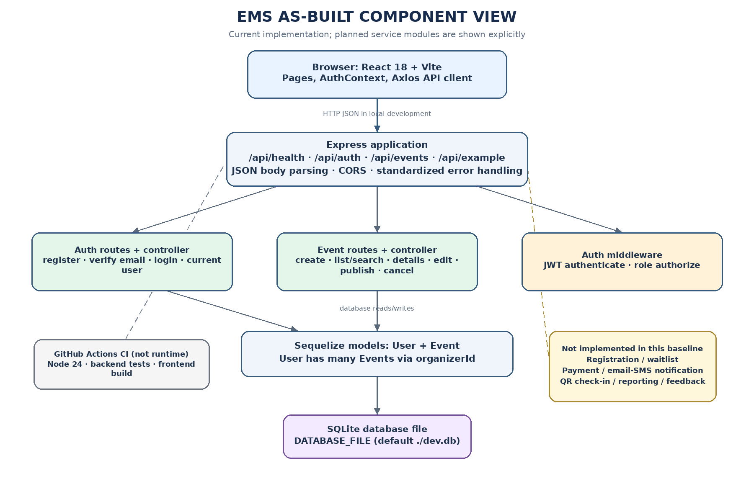
Figure 1 — As-built component diagram: React/Vite, Express routes/controllers, JWT middleware, Sequelize User/Event models and SQLite. Planned modules are marked as absent.

3.4 Component Descriptions
Component | Responsibility
Web Client (React.js SPA) | Implemented: React 18/Vite pages for account access, public event discovery/details and Organizer event management. No Admin dashboard, checkout or check-in UI.
Application Server (Node.js + Express) | Implemented: Express server mounts /api/health, /api/auth, /api/events and /api/example, JSON parsing, CORS and error handlers.
Auth Service | Implemented: register, verify email, login/JWT, bcrypt hash, login lockout/rate limit and public current-user route. Verification link is logged to console in development.
Event Management Service | Implemented in event routes/controller: create, list/search/filter, get details, manage own events, edit, publish, cancel, validation and owner/admin checks.
Registration & Waitlist Service | Implemented for free-event registration/waitlisting. Paid checkout/refunds absent; 500-attempt concurrency unverified.
Payment Service | Planned/not implemented. No payment route/model, gateway integration or refund flow exists.
Notification Service | Notification records/jobs exist; development dispatch is console-only; no external email/SMS provider.
QR Check-in Service | Token-based ticket/check-in API exists; QR generation/scanning UI absent.
Reporting & Admin Dashboard Service | Planned/not implemented. ADMIN can manage all events through protected routes, but there is no reporting dashboard or CSV export.
Relational Database (PostgreSQL/MySQL) | Implemented local store is SQLite via Sequelize. Current models: User and Event, with User.hasMany(Event) via organizerId. No production DB provisioning or registration/payment tables.

3.5 Chosen Architecture Pattern and Rationale
The delivered implementation is a layered monolithic application: a React/Vite single-page frontend calls one Node.js/Express server, which mounts authentication and event routers, delegates to controllers and middleware, and persists User/Event models with Sequelize to SQLite. The code is modular by route/controller/model, but independent domain services (registration, payment, notification, check-in and reporting) have not been implemented or deployed. This is a simpler current architecture than the target service layout in earlier drafts.

3.6 Technology Stack & Data Stores
- Front end: React 18, Vite, React Router, Axios API client and CSS.
- Back end: Node.js + Express, JSON REST API, bcrypt password hashing, JWT access tokens and express-rate-limit on login.
- Database: SQLite via Sequelize for local development. Only User and Event models are registered in the current server. PostgreSQL/MySQL production setup is not included.
- External services: none are integrated in the current baseline. Payment gateway and email/SMS provider integrations are future work.
- Transport security: the local Express server uses HTTP; production HTTPS/TLS termination must be supplied by deployment infrastructure and is not configured or verified in this repository.

3.7 Risks & Mitigations
- Current risk: registration capacity is guarded transactionally for free events, but concurrent-load behavior is unverified; paid-registration/payment handling remains absent.
- Future risk (payment module not implemented): payment gateway downtime will need explicit pending states, retry handling and reconciliation if a provider is integrated.
- Future risk (notification module not implemented): production notification delivery may need queued dispatch and backoff if an email/SMS provider is integrated.

3.8 Traceability to Requirements
The traceability table separates implemented account/event components from planned future components. A named future component in the table is a requirement/placeholder, not a deployed service in this repository snapshot.
Requirement (SRS) | Description | Architecture Component
REQ-1 to REQ-4 | User registration, email verification, login, RBAC | Auth routes/controller + JWT/RBAC middleware (implemented)
REQ-5 to REQ-8 | Event creation, draft/publish, edit/cancel, capacity validation | Event routes/controller + Event model (implemented)
REQ-9, REQ-10 | Event listing and search/filtering | Event controller + React event pages (implemented)
REQ-11 to REQ-14 | Registration/waitlisting/capacity/cancellation | Free registration/waitlisting/cancellation APIs exist; paid checkout/refunds absent; no 500-attempt test.
REQ-15 to REQ-17 | Payment gateway integration, payment confirmation, refunds | Planned only — named service is not implemented in current baseline
REQ-18 to REQ-20 | Confirmation/reminder/event-change notifications | Notification queue/jobs exist; console delivery only, no real provider
REQ-21 to REQ-23 | Token-based tickets and check-in | Token/check-in API exists; QR scanner UI absent
REQ-24 to REQ-26 | Organizer dashboard, Admin dashboard, CSV export | Planned only — named service is not implemented in current baseline
REQ-27, REQ-28 | Feedback submission and aggregation | Model/routes/API tests exist; complete UI/prompt absent
NFR traceability: NFR-PERF-01/02 (performance), NFR-SEC-01–04 (security), NFR-USAB-01 (usability), NFR-REL-01 (availability), NFR-MAINT-01 (maintainability) and NFR-SCAL-01 (scalability) map to docs/NFR_TRACEABILITY.md. It records current evidence and test IDs. Recommended target architecture is not current implementation evidence.

3.9 Security Architecture

Security Objectives
- To protect the attendee and organizer personal data (names, emails, payment status) from any unauthorized access or disclosure.
- Ensure only authenticated, authorized users can create, modify, or cancel events and registrations (no privilege escalation).

Security Requirements
- NFR-SEC-01 (SRS §6.3.2): Passwords shall use a strong salted hash (e.g., bcrypt); plaintext passwords shall never be persisted or logged.
- SAD deployment security control (no separate SRS NFR ID): production client-server/provider traffic shall use TLS 1.2 or higher. Local development uses HTTP; production TLS is not configured or verified. See Test Plan case TC-SEC-05.
- NFR-SEC-02 (SRS §6.3.2): if a payment gateway is added, use its PCI-compliant flow and do not store raw card data on EMS servers. No payment flow exists; PCI/payment compliance is not assessed.
- NFR-SEC-03 (SRS §6.3.2): protected event endpoints enforce authentication, role and ownership checks server-side; public health/event discovery/detail routes are intentionally public. A full endpoint-by-endpoint audit remains; registration/payment/check-in routes are absent.
- NFR-SEC-04 (SRS §6.3.2): access JWTs expire after configured JWT_EXPIRES_IN (default one day). This is token lifetime, not inactivity-based expiry.

Threat Modeling (STRIDE)
- Spoofing: JWT Bearer access tokens and email verification are implemented; the verification link is printed to the backend console in development rather than sent by email.
- Tampering: server-side event validation and owner checks are implemented. Registration/payment state-transition validation is future work because those flows do not exist.
- Information disclosure: passwords are bcrypt-hashed and public user responses omit the hash. Local HTTP is used; TLS and payment-data controls must be verified in a deployed environment when payment is implemented.
- Denial of service: the login endpoint has a rate limiter (20 requests per 15 minutes per limiter key). No registration-endpoint rate limiter or production traffic controls are configured.
- Elevation of privilege: protected event routes use server-side role and ownership checks for Organizer/Admin operations. The UI alone is not the security boundary.

4. Design

4.1 Design Overview
The current API is a layered monolith rather than a multi-service deployment. The two sequences below document actual authentication and event-lifecycle interactions:

4.2 UML Sequence Diagrams
Two implemented flows are shown: (1) account registration, development email verification and JWT login, and (2) event creation, publishing and public event discovery. Registration/payment and QR check-in sequences from earlier target-state drafts have been removed because those APIs do not exist in this baseline.
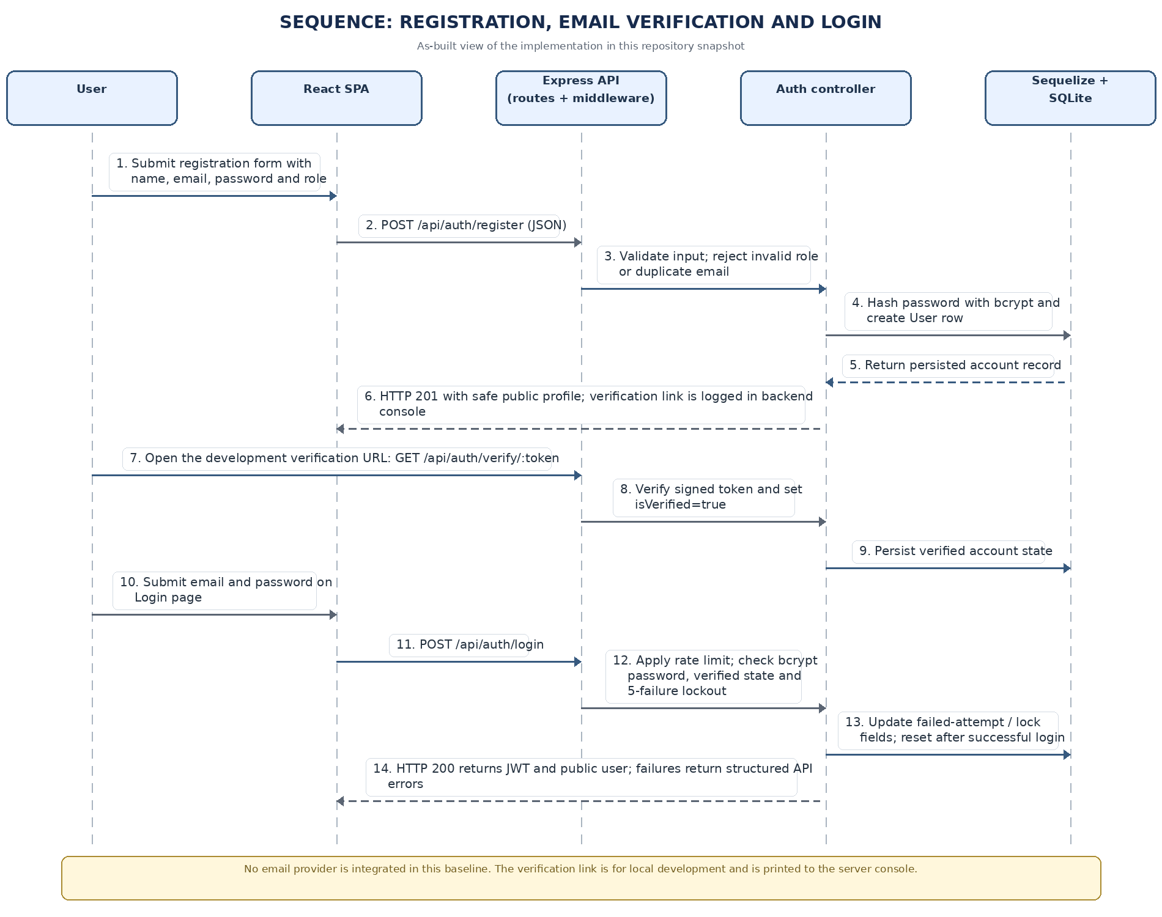
Figure 2 — As-built sequence diagram: account registration, email verification and login.
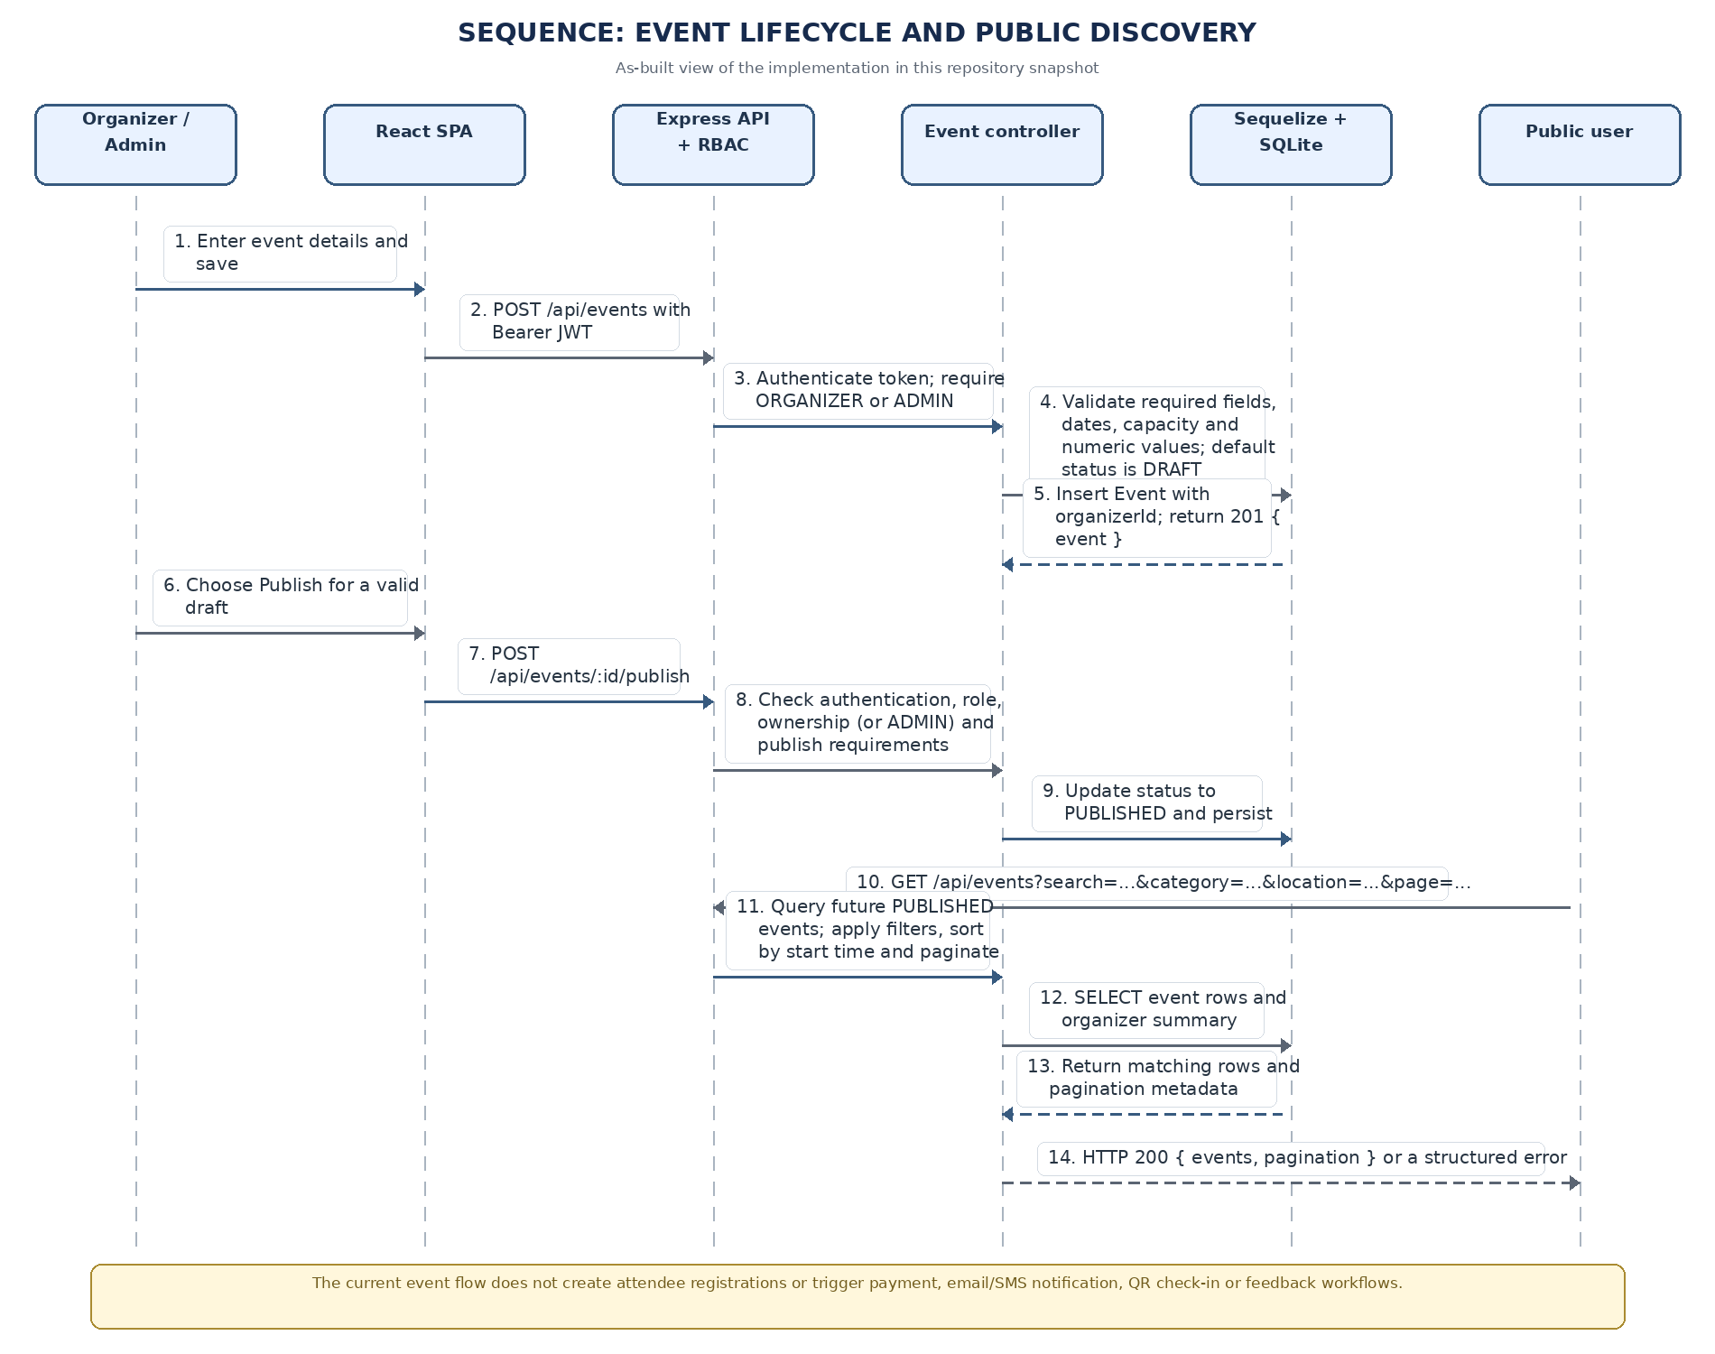
Figure 3 — As-built sequence diagram: event lifecycle and public discovery.

4.3 API Design
The current HTTP routes are listed below. Payload details and query parameters are documented in docs/API_REFERENCE.md. Event-registration and token-based check-in endpoints are mounted; payment and refund endpoints are not present.

Implemented API endpoints (summary)
Health and discovery: GET /api/health; GET /api/events (published-event listing, search, filters and pagination); GET /api/events/:id (published event details).
Authentication (public except /me): POST /api/auth/register; GET /api/auth/verify/:token; POST /api/auth/login; GET /api/auth/me (Bearer JWT).
Event management (Bearer JWT; ORGANIZER/ADMIN): GET /api/events/manage/mine; POST /api/events; PUT /api/events/:id; POST /api/events/:id/publish; POST /api/events/:id/cancel.
Response shape: JSON; create-event returns 201 with { event }; listing returns { events, pagination }; details returns { event }. See docs/API_REFERENCE.md for query and body contracts.
Common errors: 400 validation, 401 UNAUTHENTICATED, 403 FORBIDDEN, 404 NOT_FOUND, 409 state conflict and 423 ACCOUNT_LOCKED on login. Error envelope: { error: { code, message } }.

Future APIs — not implemented
No event registration, waitlist, payment/refund, email notification, QR-ticket/check-in, dashboard/export or feedback routes exist in this snapshot.
Do not document or call guessed paths for these features. Add route/controller/model tests when those modules are implemented.

4.4 Error Handling, Logging & Monitoring
All API errors use a standardized JSON envelope { error: { code, message } }. The generic error handler avoids returning internal details for server errors and avoids logging request passwords/tokens. The application does not currently implement production monitoring/alerting or metrics for payment, registration, notification or QR workflows.

4.5 UX Design
The current UI supports account access, public event search/details and the Organizer event create/edit/manage flow. Registration checkout, attendee ticket/check-in and admin reporting screens do not exist in this baseline.

4.6 Open Issues & Next Steps
- Run a controlled 500-attempt registration load test against an isolated database before claiming NFR-PERF-02 or the SRS §6.2 concurrency/integrity target.
- Select a particular payment gateway and notification provider and finalize their API contracts.
- Define the queueing mechanism for notification dispatch (e.g., a lightweight job queue) before implementing reminders at scale.

5. Appendices
5.1 Glossary: EMS, RBAC, REST, JWT, QR, TLS, RTM — see Section 1.4 for definitions.
5.2 References: SRS v1.6, Software Test Plan v1.6, IEEE 42010 (architecture description), OWASP Top 10, PCI-DSS.
5.3 Tools: Graphviz/PlantUML (diagrams), draw.io, Postman/Swagger (API design and testing).

Appendix A: As-built baseline and deferred components
This appendix is the implementation-status companion to the component and sequence diagrams in Sections 3 and 4. “Planned” means the current repository has no running service/route for the feature.
Area / requirement | Status in current code baseline | Implementation evidence / limitation
Frontend | Implemented | React 18, Vite, React Router, Axios API client; account, event discovery/details and organizer event-management pages.
Backend | Implemented | Node.js/Express monolith with auth/event routes and controllers, JWT authentication, role authorization and structured error handler.
Data store | Implemented for current scope | SQLite via Sequelize; only User and Event models are registered. User has many Events through organizerId.
Email verification | Development stub | Signed token verification exists; link printed to backend console. No outbound email integration.
Registration and waitlist | Implemented for free events | Registration model/API and functional capacity/waitlist coverage exist; payment/refunds absent, 500-attempt load not recorded.
Payments and refunds | Planned / absent | No payment model or gateway integration.
Notifications, QR/check-in, reporting, feedback | Partially implemented | Notification records, feedback APIs and token check-in exist; no real provider, QR scanner UI or reports.
Production security/scale | Not verified | Local server uses HTTP and SQLite; production TLS, shared database, availability, and scale testing remain future deployment tasks.
Evidence references: docs/IMPLEMENTATION_BASELINE.md; docs/API_REFERENCE.md; docs/TESTING_AND_RESULTS.md

