
Department of Creative Technologies

Full Stack Development Lab
Assignment 02

Muhammad Shamoil (232025)
Muhammad Abdullah (232017)
BSSE-6-A

Home Page
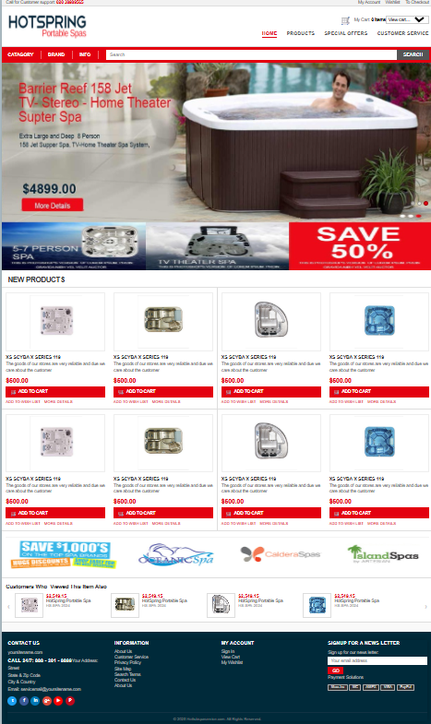

Products Page

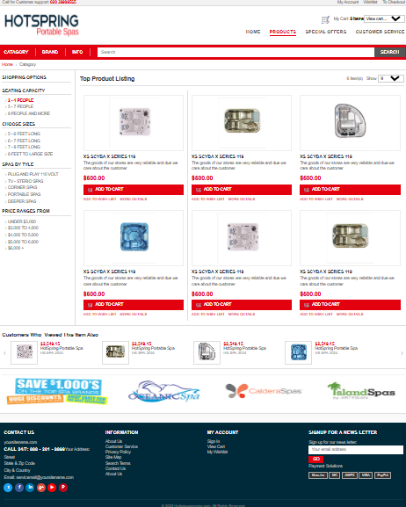

Product Details Page
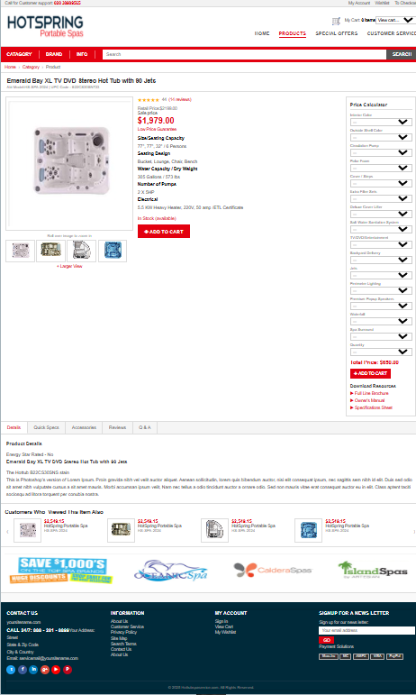

MY Account Page

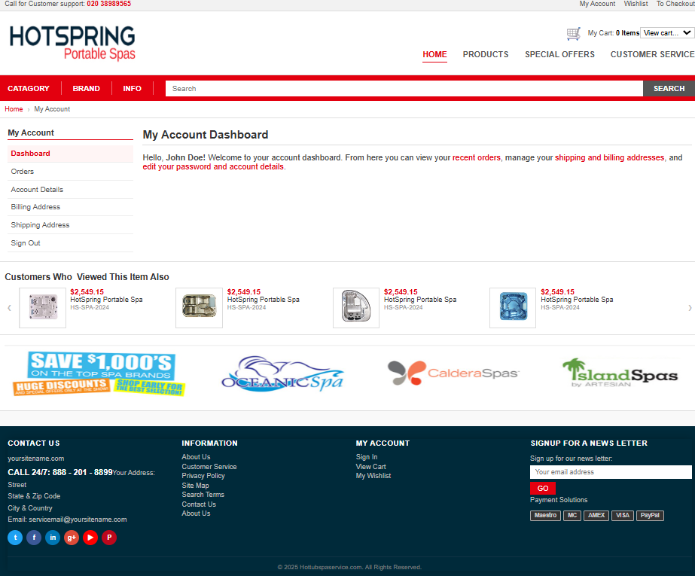

Contact Pae

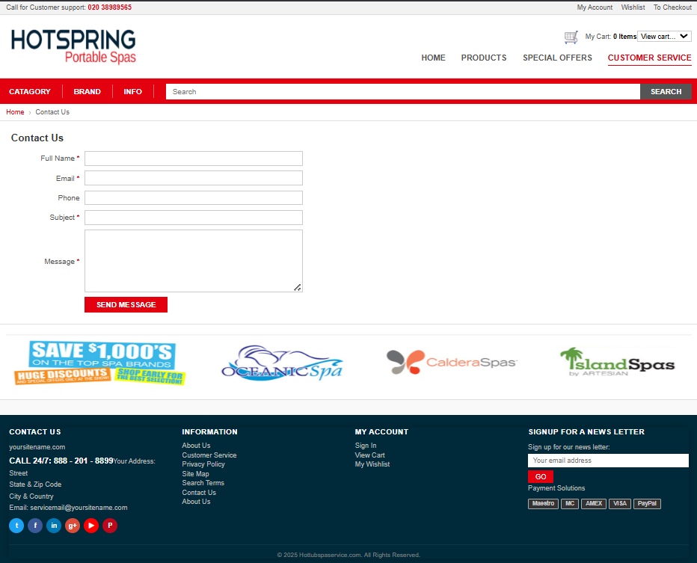

To Checkout Page

