
Department of Creative Technologies

Full Stack Development Lab
Lab 12

Github Link: https://github.com/SE-Muhammad-Shamoil/Full-stack-programming-lab
Muhammad Shamoil (232025)
BSSE-6-A

Home Page(zoomed out)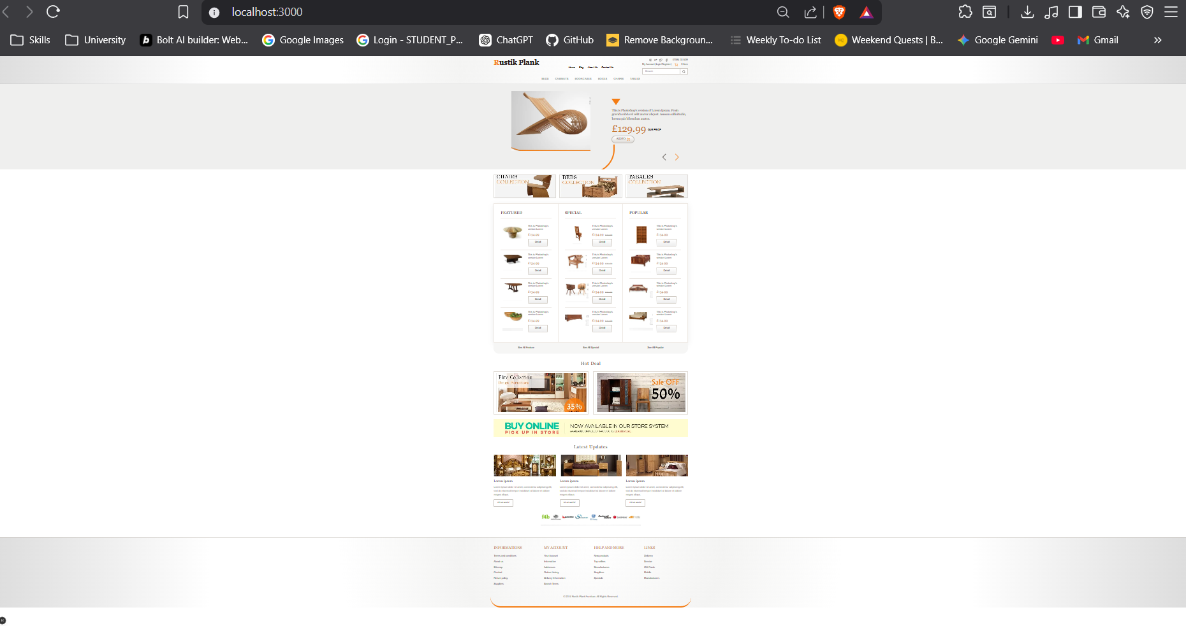

Home Page Closeup
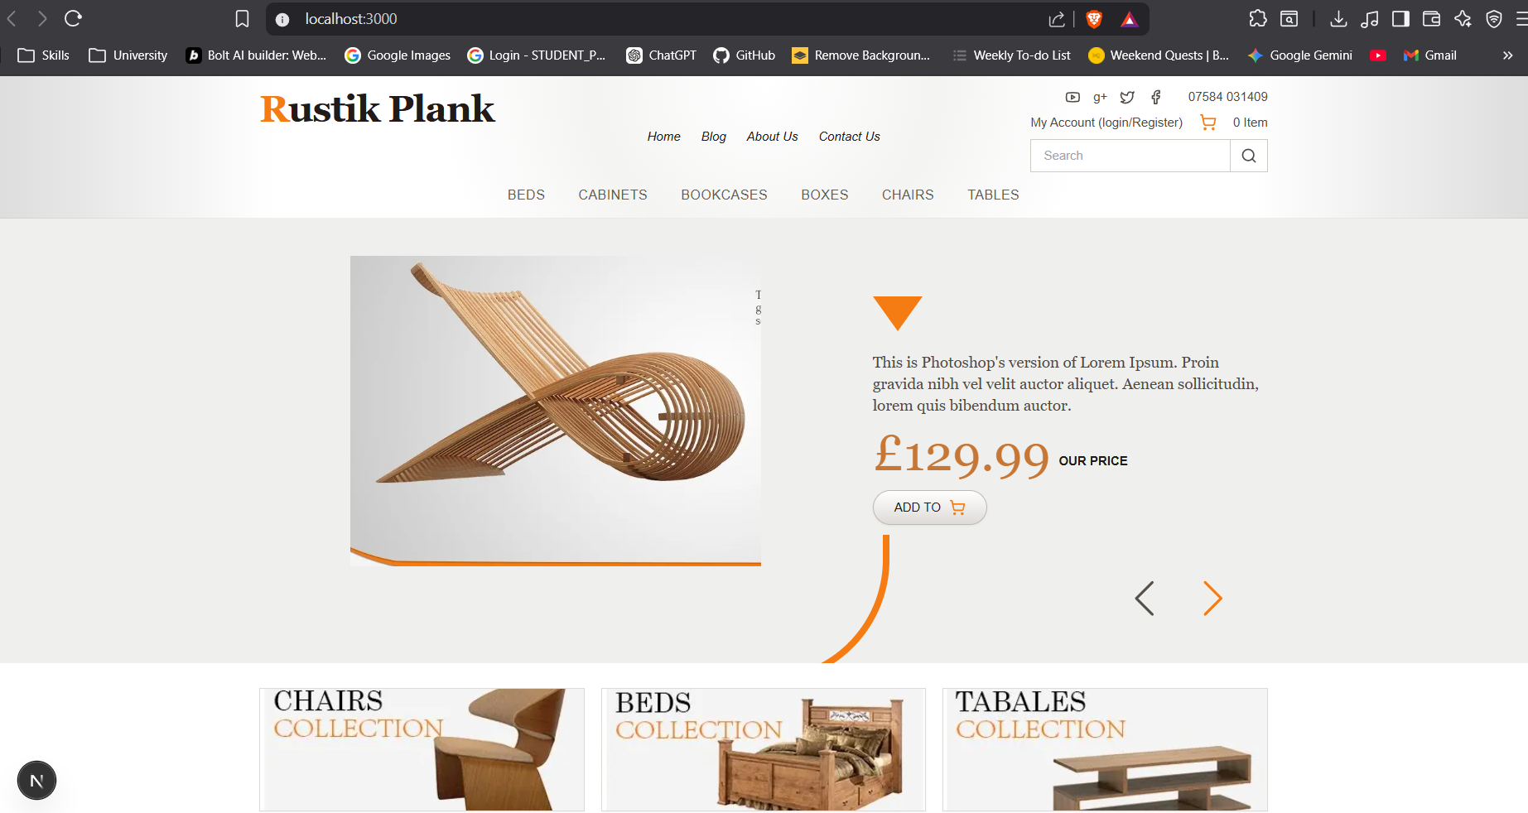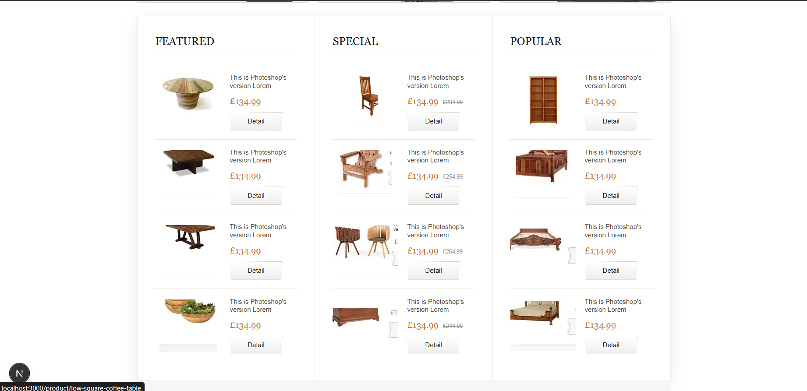
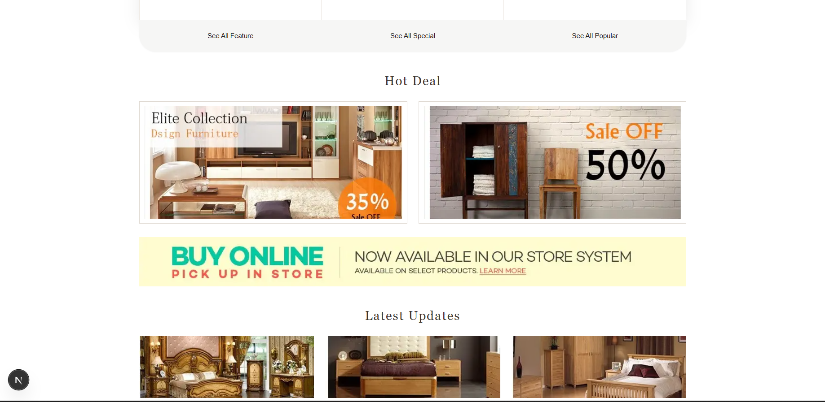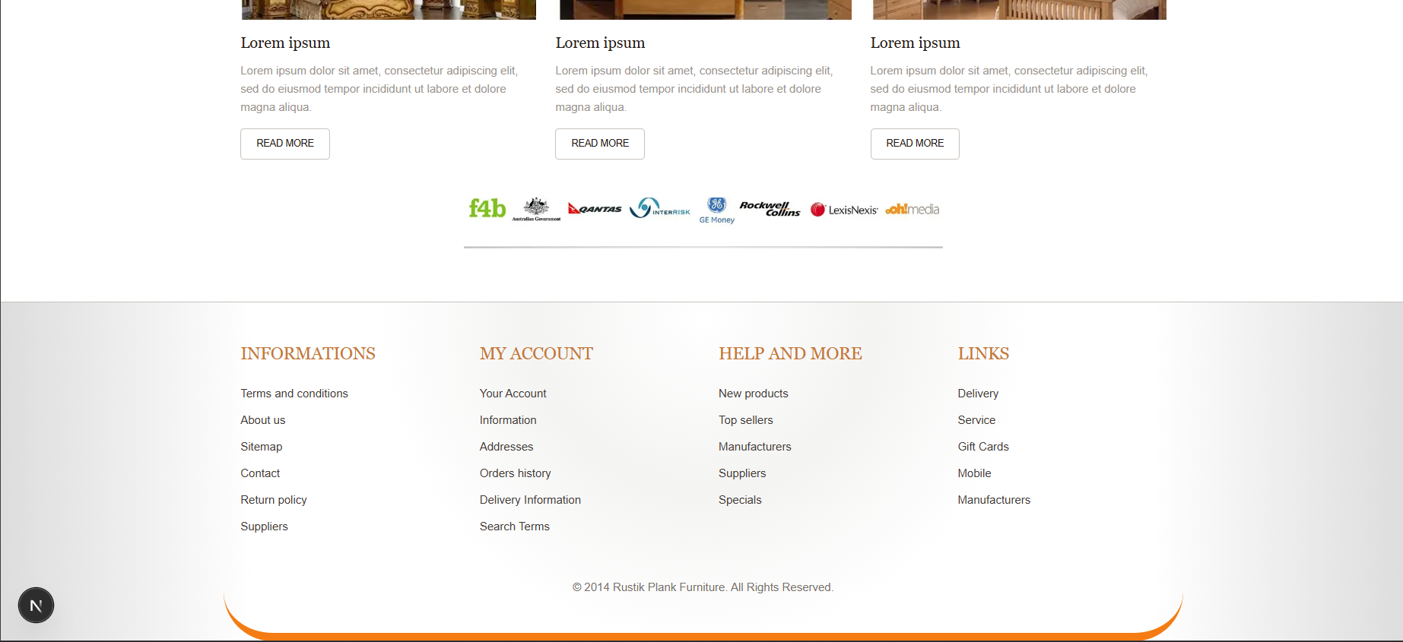

Shop Page (Products Fetched from database , image stored as object in Frontend/public/assests)

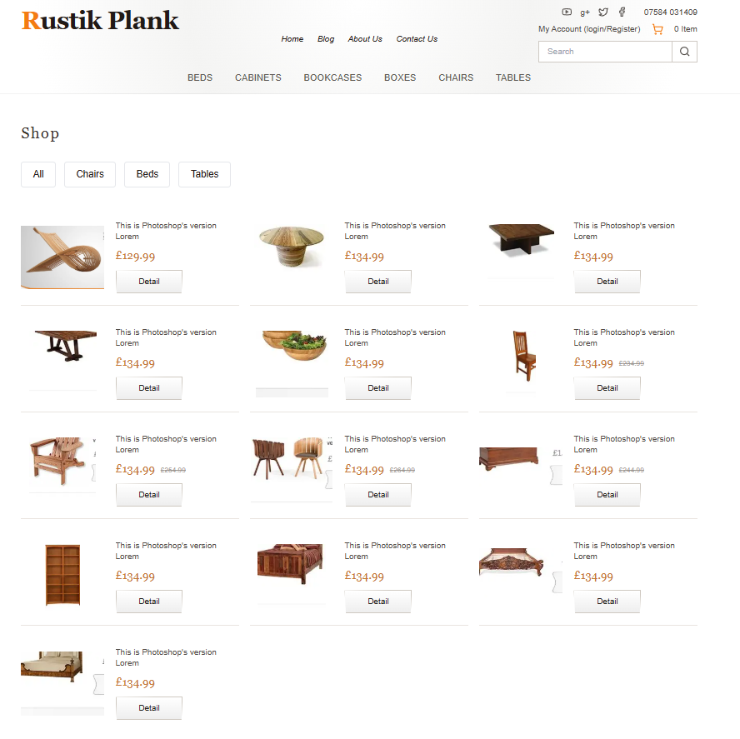

Product Page
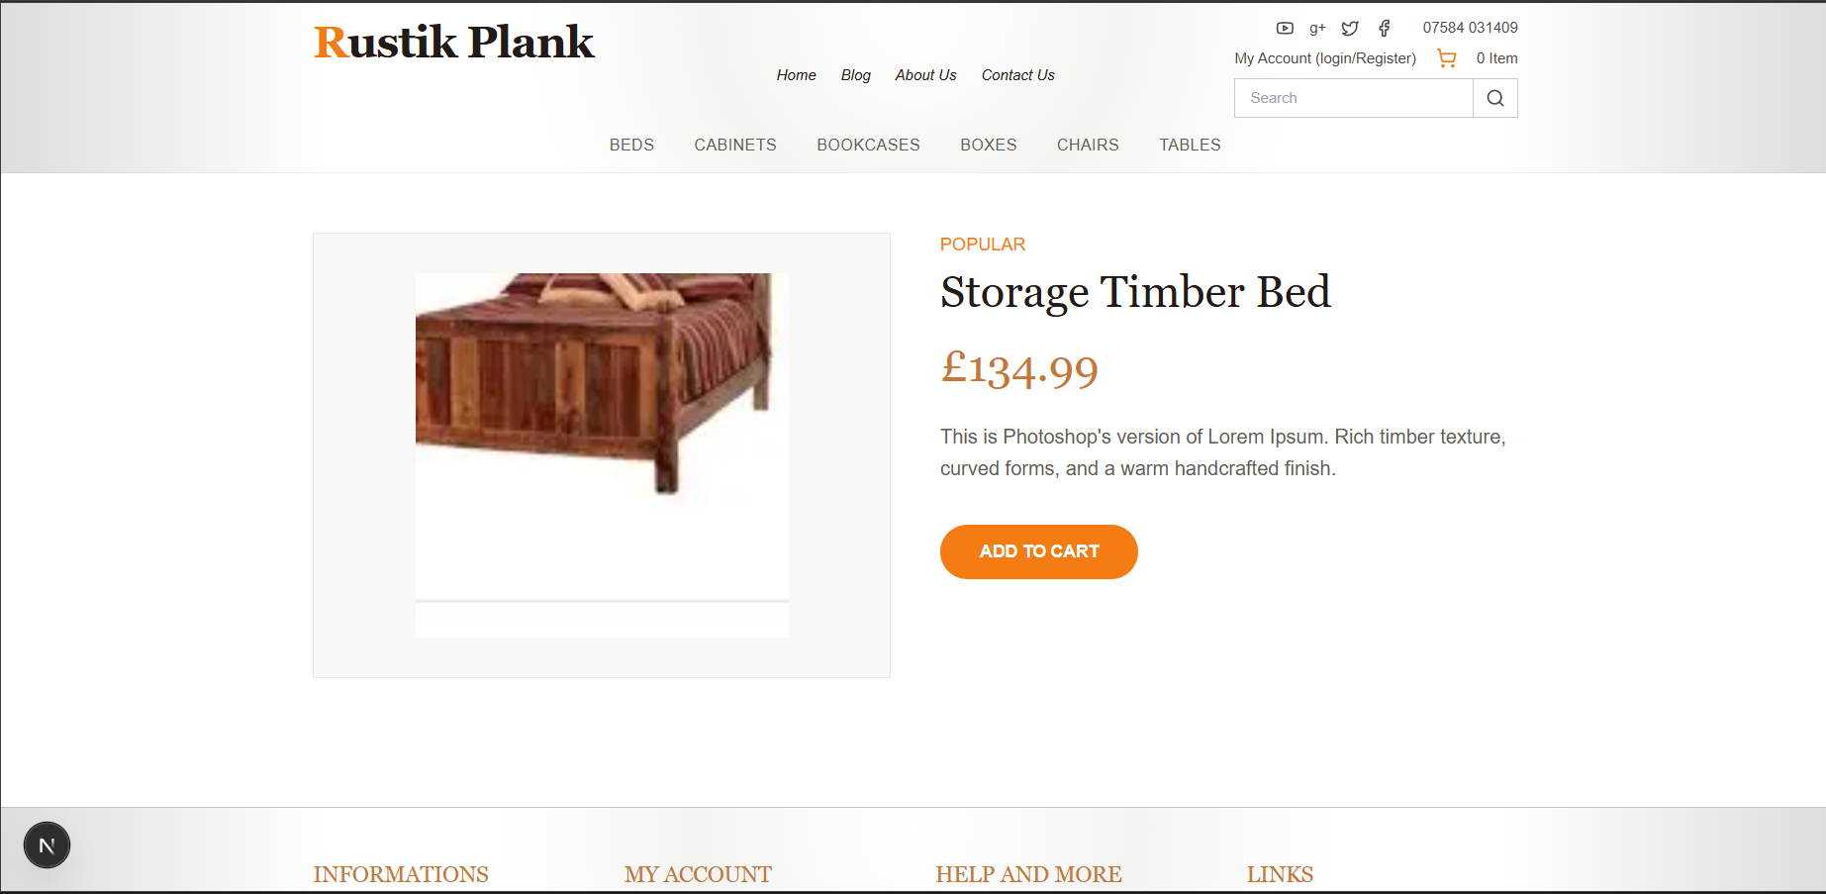

Express Terminal Logs
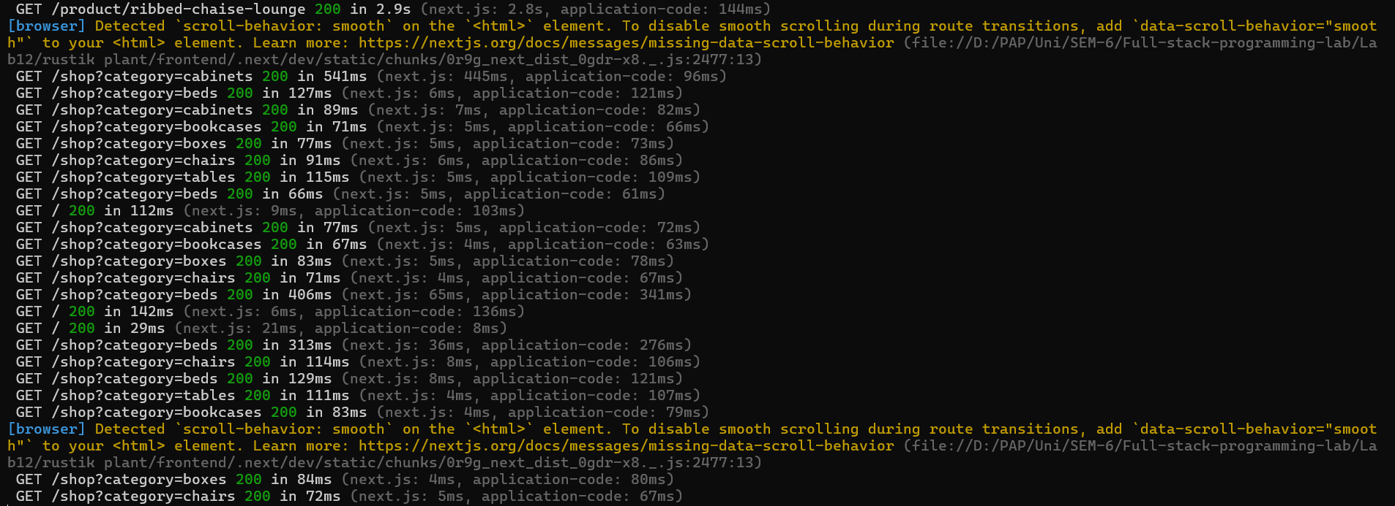

Categories Cluster
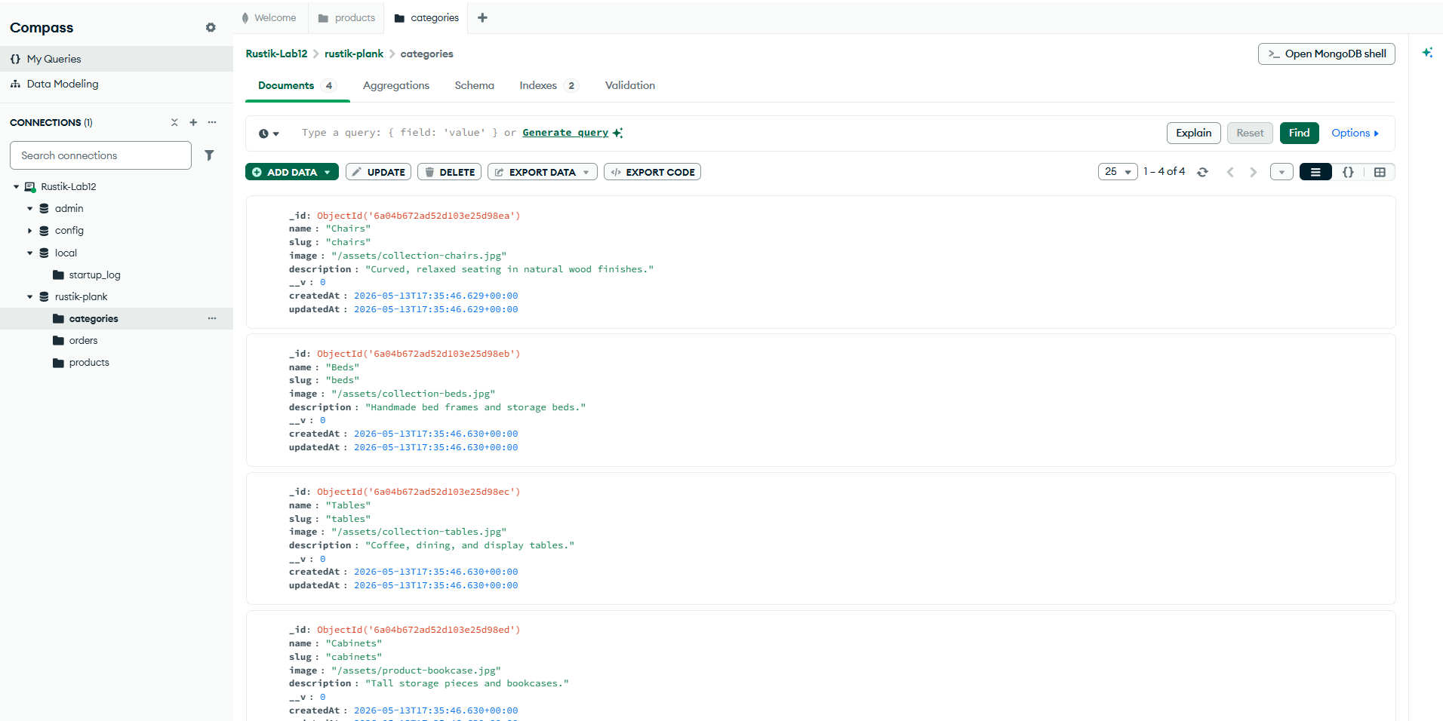

Products Cluster
