
Department of Creative Technologies

Full Stack Development Lab
Lab 13

https://github.com/SE-Muhammad-Shamoil/Full-stack-programming-lab
Muhammad Shamoil (232025)
BSSE-6-A

Weather Api

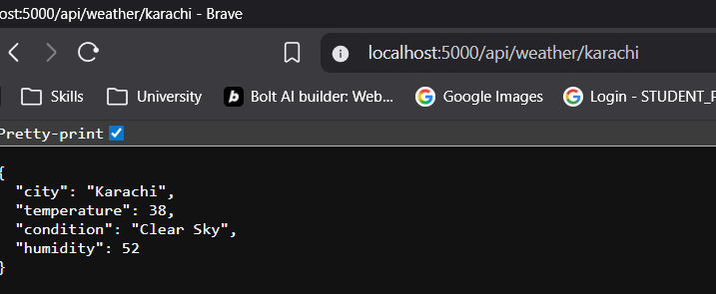

News Api

