
Department of Creative Technologies

Full Stack Development Lab
Lab 05

Muhammad Shamoil (232025)
BSSE-6-A

Task 01
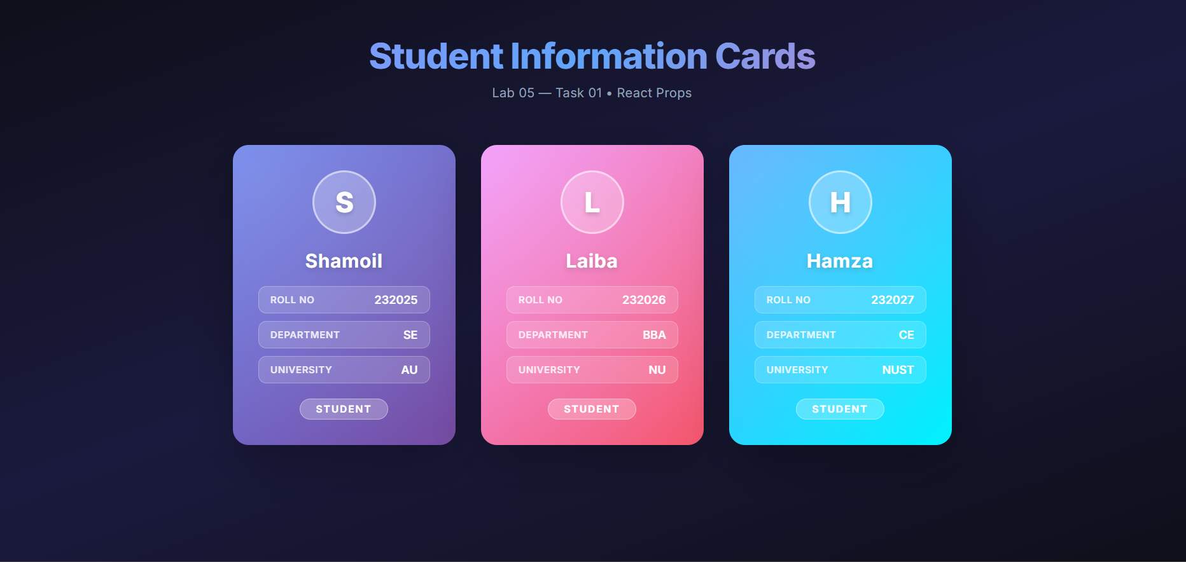

Task 02
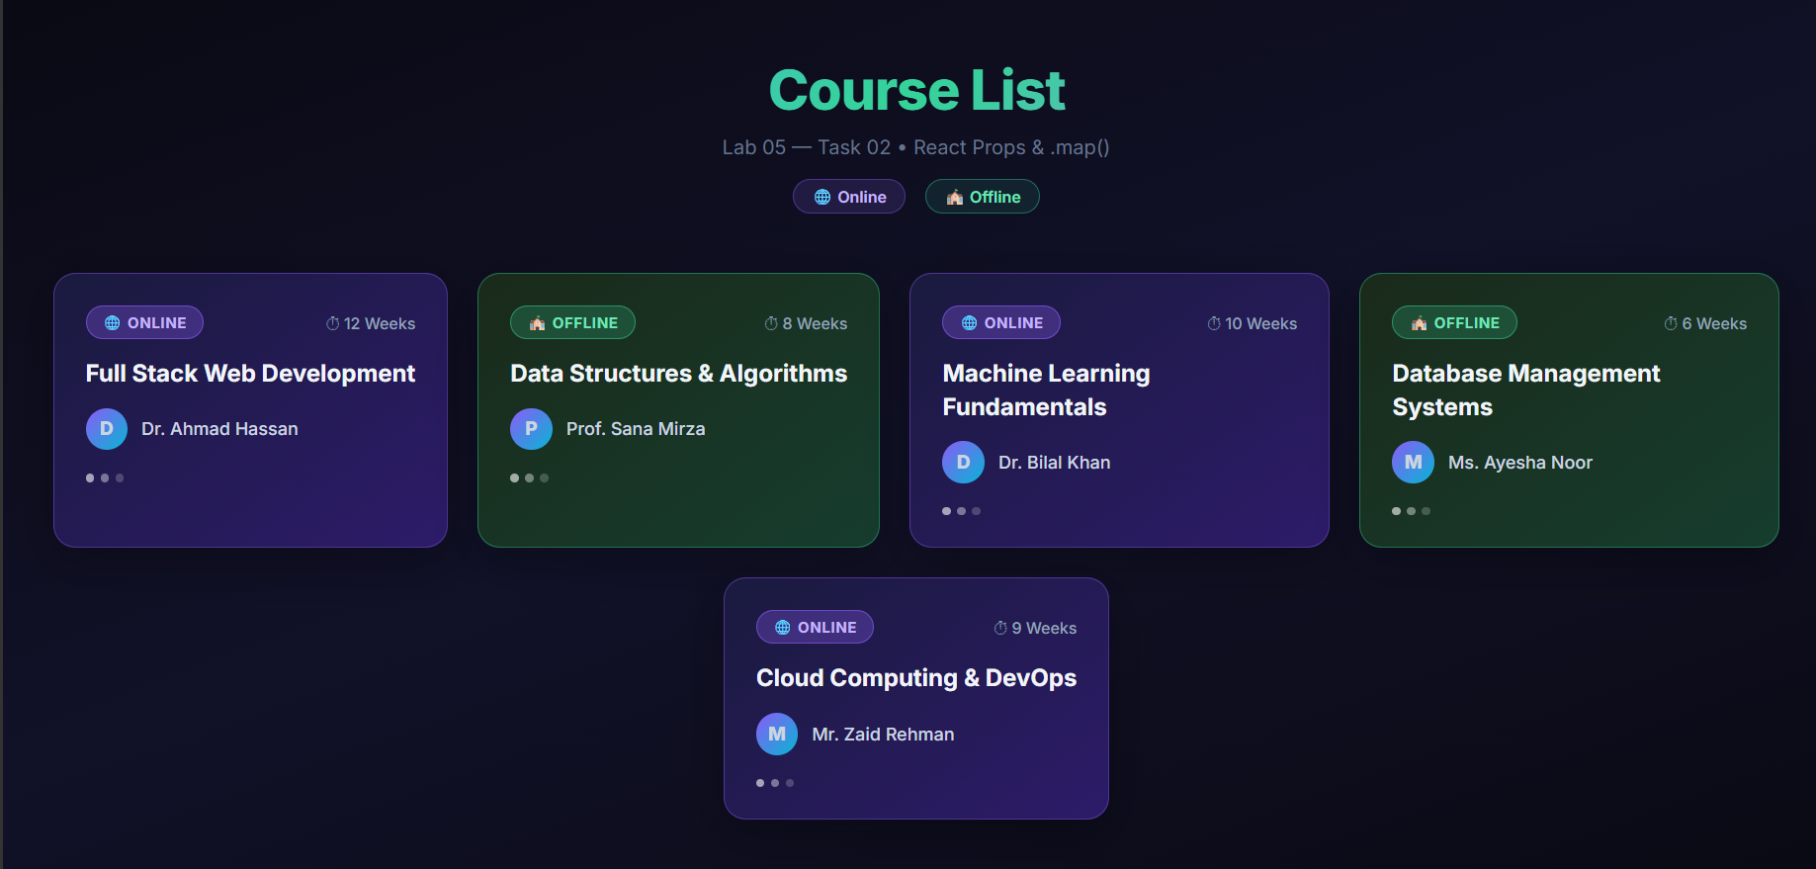

Task 03
