Lab 04 – Frontend Web Development
JavaScript Library (jQuery)



Muhammad Shamoil - 232025
Subject: Full Stack Development (FSD)
BSSE – 6 - A
Date: March 2026

Table of Contents
- Task-01: Dynamic List Manager
- Task-02: Animated Image Gallery
- Task-03: Interactive Form Validation
- Task-04: Tabbed Content with Smooth Scroll
- Task-05: Chained Style Editor
- Task-06: API Data Fetcher
- Task-07: Drag-and-Drop Sortable List
- Task-08: Quiz Game

Task-01: Dynamic List Manager
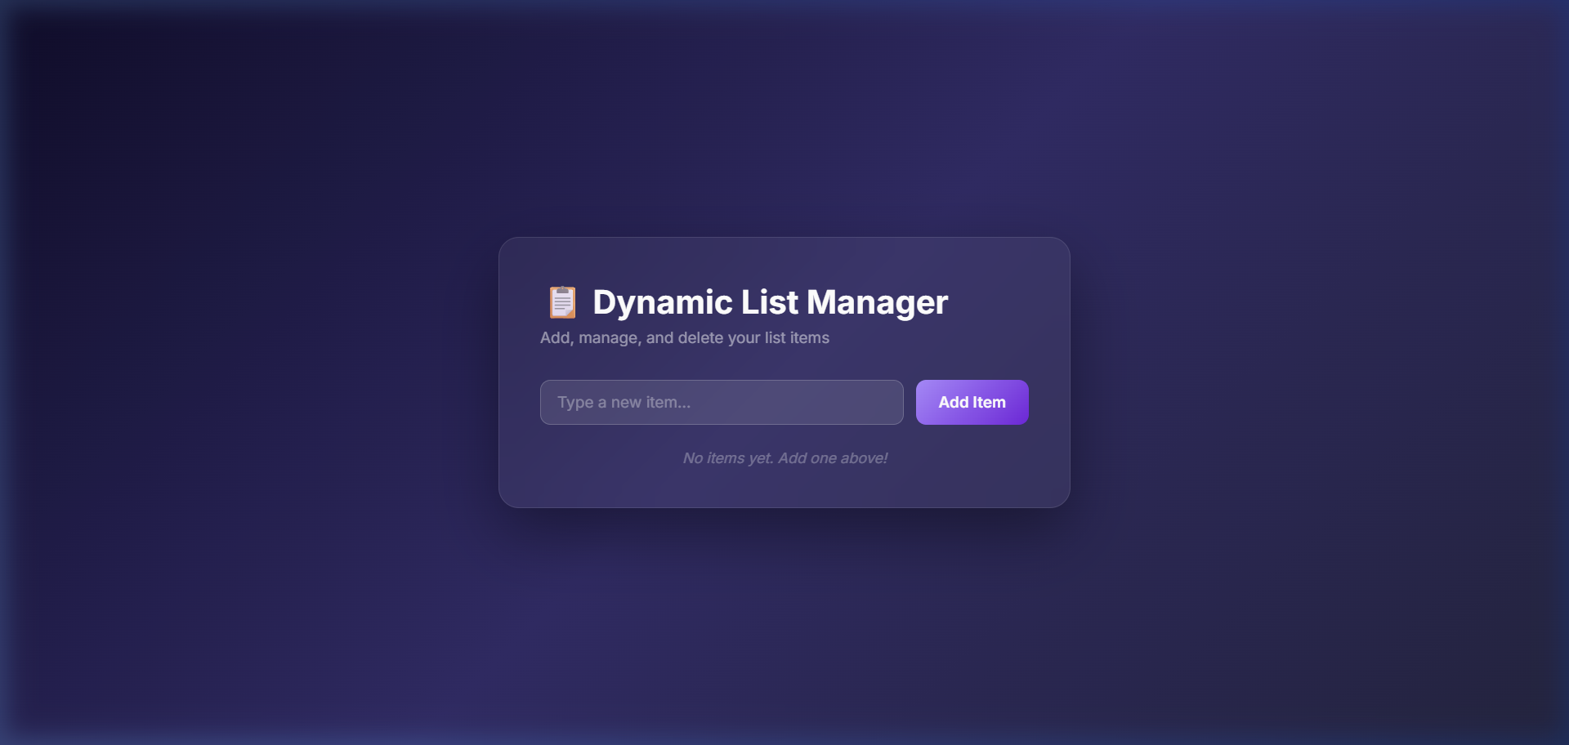

Task-02: Animated Image Gallery
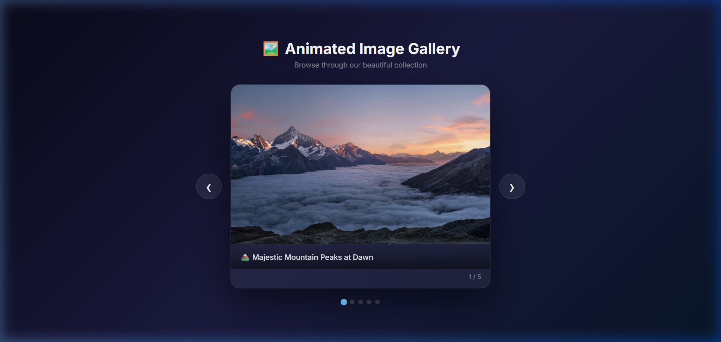

Task-03: Interactive Form Validation
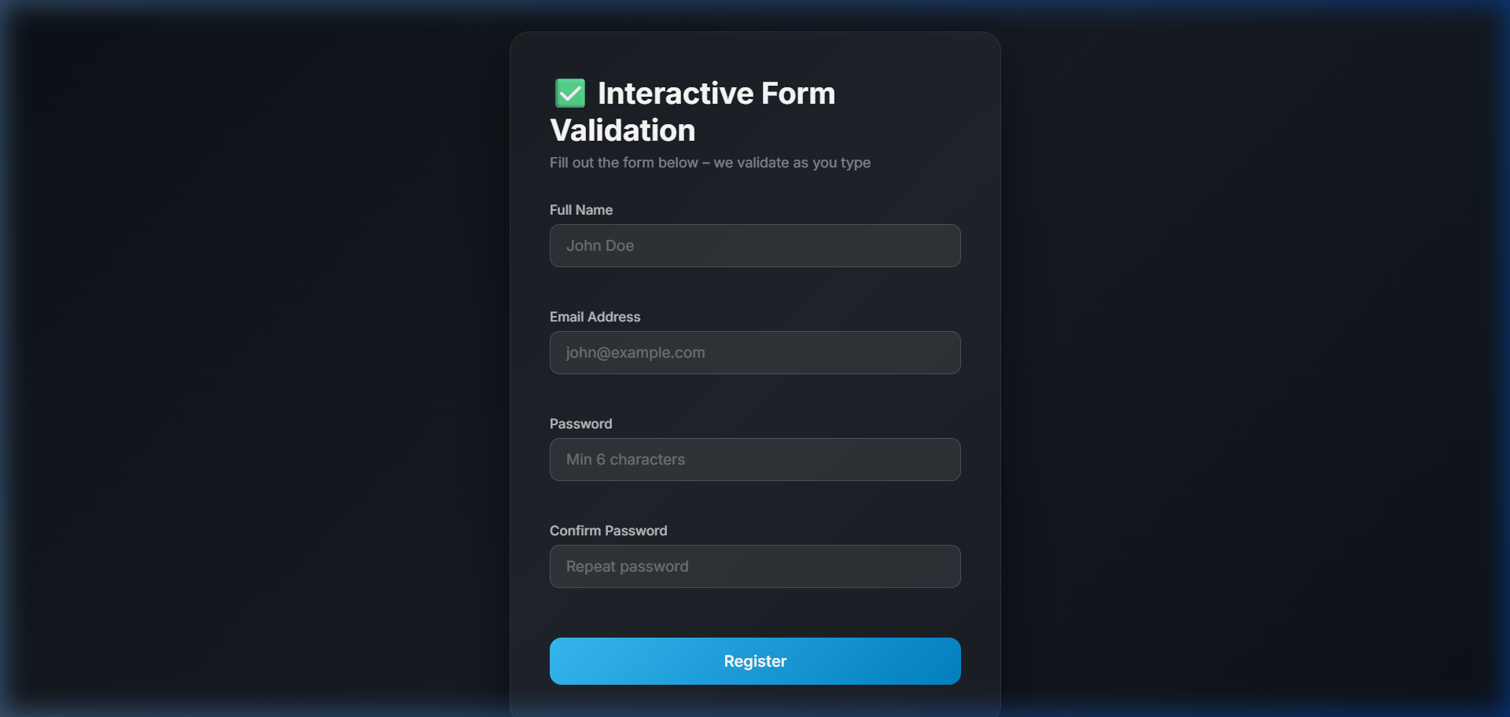

Task-04: Tabbed Content with Smooth Scroll
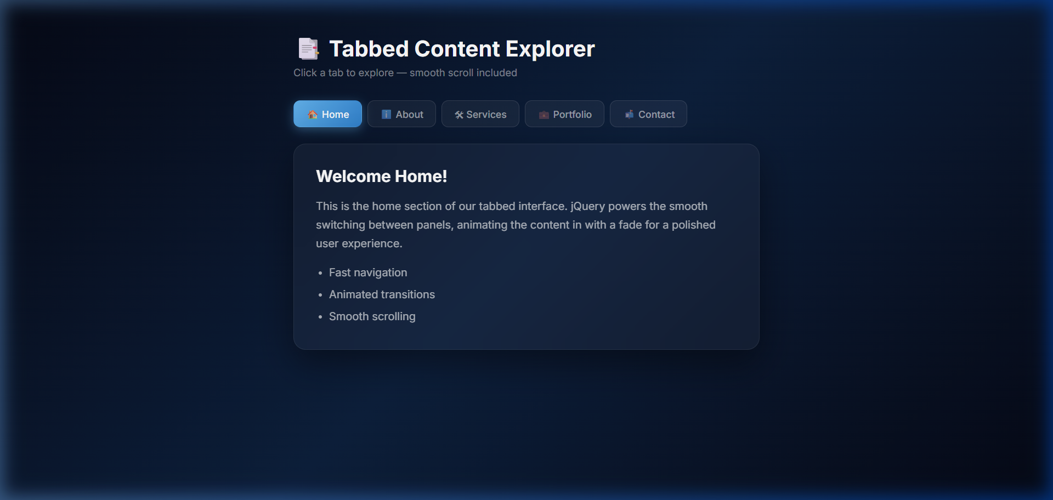

Task-05: Chained Style Editor
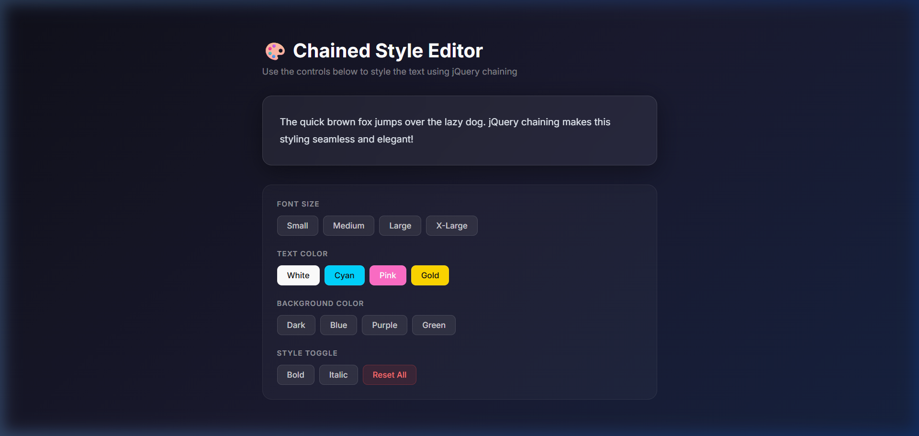

Task-06: API Data Fetcher
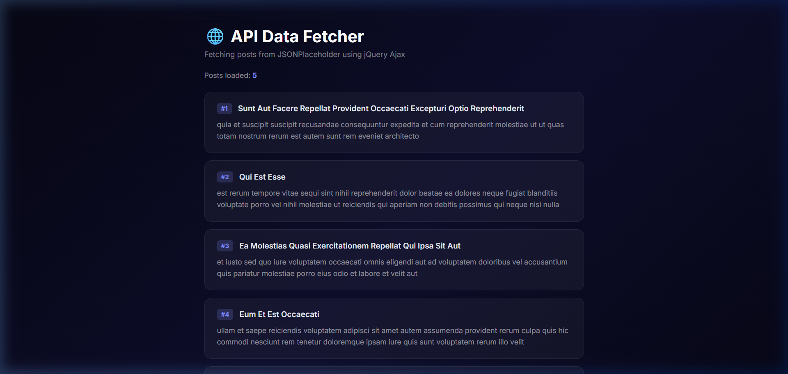

Task-07: Drag-and-Drop Sortable List
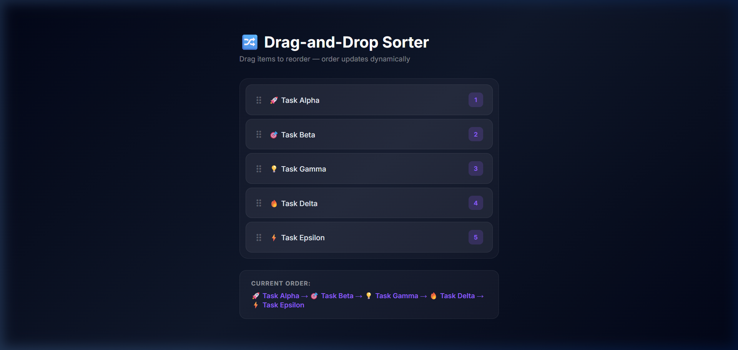

Task-08: Quiz Game
