
Department of Creative Technologies

Full Stack Development Lab
Lab 07

Muhammad Shamoil (232025)
BSSE-6-A
Contents
Home Page 2
Products Page 3
Product Description Page 4
About Page 5
Login 6
Contact Us 6
Forgot Password 7
My account Dashboard (Before Order) 7
Payment Page 8
My Account after ordering 9

Home Page

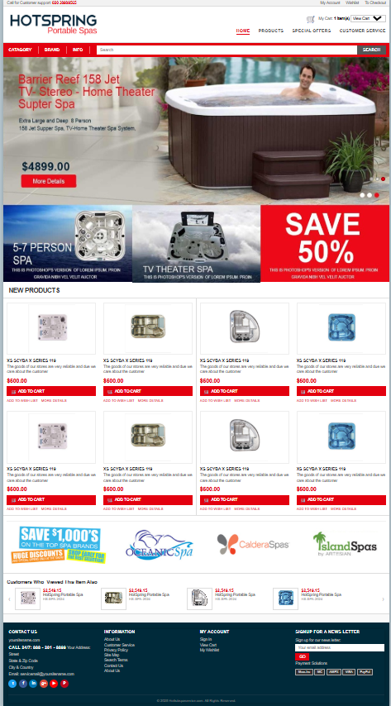

Products Page

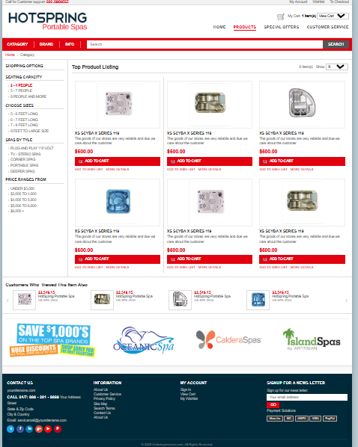

Product Description Page

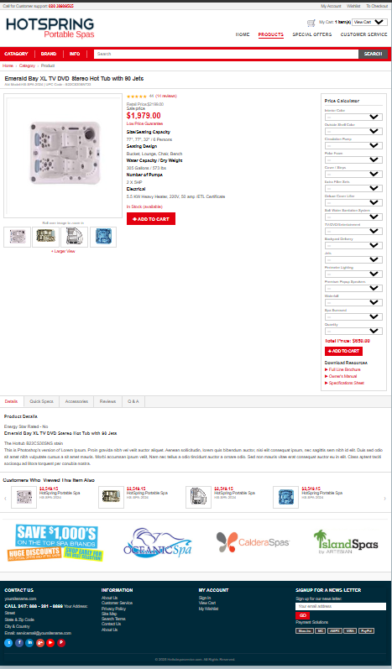

About Page

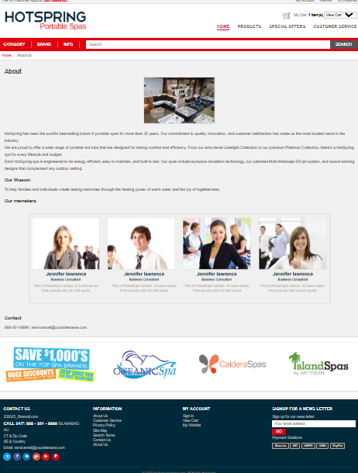

Login

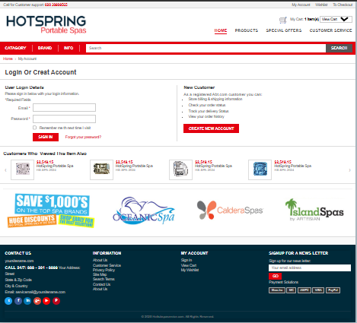

Contact Us

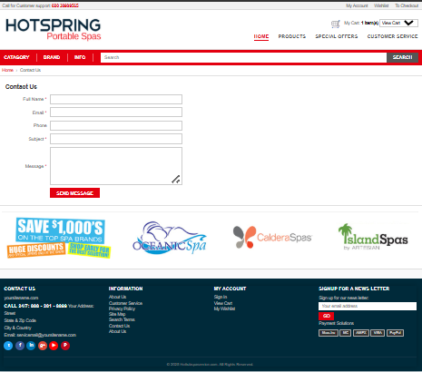

Forgot Password

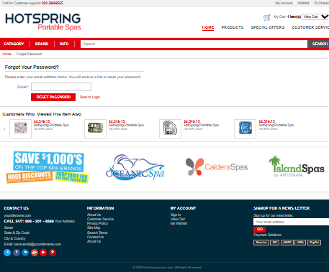

My account Dashboard (Before Order)

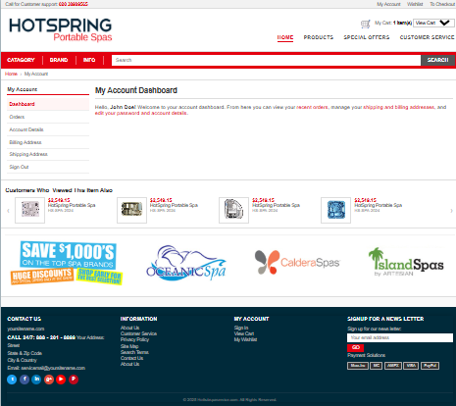

Payment Page

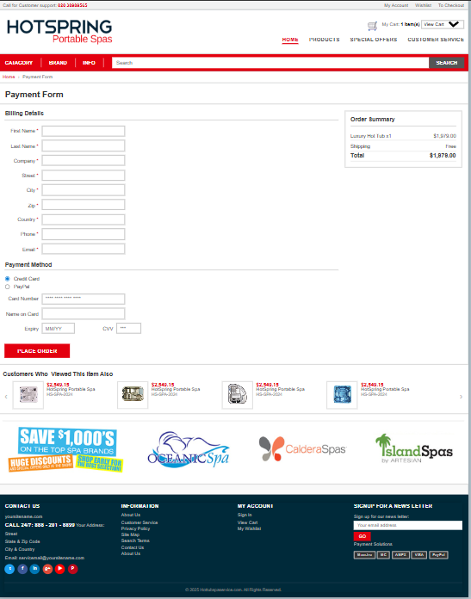

My Account after ordering

