PES UNIVERSITY
Software Engineering Mini-Project — Section B

IT Infrastructure Management Software
Software Architecture and Design Document (SAD)

Project | IT Infrastructure Management Software
Version | 2.0
Authors | Team 03 (SE Project 2026, Section B)
Date | 22-10-2026
Status | Baseline for evaluation
Repository | SE-Project-2026-B-sec/Team-03---IT-infrastructure-management-software

Table of Contents
Open in Word and press Ctrl+A then F9 to build the table of contents.

Revision History
Version | Date | Author | Change Summary
1.0 | 22-10-2026 | Team 03 | Initial architecture draft
2.0 | 22-10-2026 | Team 03 | Architecture rewritten to describe the implemented system; design spec IDs added for traceability; API examples taken from the running service

Approvals
Role | Name | Signature/Date
Course Coordinator
Team 03 Lead / Architect | Dilipan Y

1. Introduction

1.1 Purpose
This document specifies the architecture and design of the IT Infrastructure Management Software (ITIM) v1.0: its components, data model, security architecture, key interaction flows and REST interface. It translates the requirements of the SRS into a design that the code in src/ implements.

1.2 Scope
Hardware asset lifecycle, software license management, endpoint compliance auditing, procurement workflow, alerting and reporting, as scoped in SRS section 1.2.

1.3 Audience
Developers, QA engineers, security reviewers, course evaluators and operators.

1.4 Definitions
ADR (Architecture Decision Record), CSP (Content-Security-Policy), GCM (Galois/Counter Mode), HSTS (HTTP Strict Transport Security), JWT, RBAC, RPO/RTO, STRIDE (Spoofing, Tampering, Repudiation, Information disclosure, Denial of service, Elevation of privilege).

2. Document Overview

2.1 How to use this document
Section 3 describes the architecture: data model, components, the chosen pattern, risks, traceability and the threat model. Section 4 describes the design: interaction flows, the REST API, error handling and the user interface.

2.2 Related Documents
- Software Requirements Specification, including the RTM in section 8.
- Software Test Plan.

3. Architecture

3.1 Goals & Constraints
Goals
- Correctness of license and asset state: no seat over-allocation, no illegal lifecycle transitions.
- Security by default: authenticated and authorised API, encrypted secrets, tamper-evident audit trail.
- Reproducible builds and tests: the service runs on a stock Node.js installation with no runtime dependencies, so CI and local runs behave identically.
- Performance and scale as specified in IT-NF-001 and IT-NF-003.
Constraints
- Node.js 18.18 or later; standard library only at runtime.
- Single-node deployment; the full data set is held in memory.
- Secrets supplied through environment variables.

3.2 Stakeholders & Concerns
Stakeholder | Concerns
IT administrators and technicians | Fast tagging and lookup, accurate assignment history, simple seat allocation
Procurement and finance | Enforced approval order, separation of duties, traceable purchase orders
Compliance auditors | Accurate reconciliation, evidence that cannot be silently altered
Information security | Prohibited-software detection, key confidentiality, abuse resistance
Developers and evaluators | Modularity, testability, a CI pipeline that genuinely verifies the requirements

3.3 Component (UML) Diagram
The class diagram shows the domain entities, their key attributes and associations. Enumerated status values are listed as stereotyped classes.
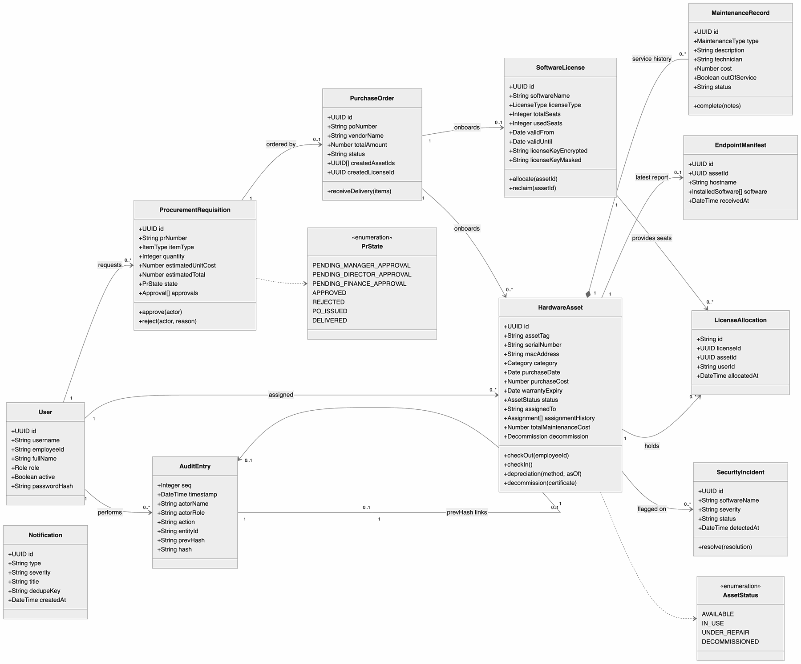
Figure 1: 3.3 Component (UML) Diagram
The module structure of the code:
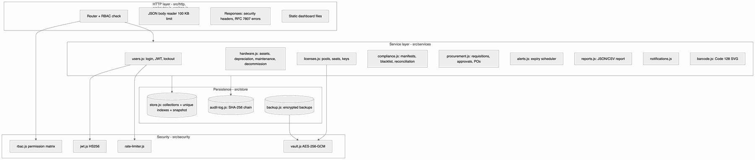
Figure 2: 3.3 Component (UML) Diagram

3.4 Component Descriptions
Component | Responsibility | Source
App / composition root | Loads configuration, builds services, creates the HTTP or HTTPS server, health probes, graceful shutdown | src/app.js, src/index.js, src/config.js
Router and HTTP layer | Route matching, authentication (JWT or agent key), RBAC check, JSON body parsing with size limit, security headers, RFC 7807 errors, static files with traversal protection | src/routes.js, src/http/*
User service | Demo user seeding, scrypt password verification, JWT issue/verify, login lockout | src/services/users.js
Hardware service | Asset registration and unique tags, check-out/in state machine, depreciation (SL/WDV), barcode labels, maintenance, decommissioning | src/services/hardware.js, src/services/barcode.js
License service | License pools, encrypted keys and masking, atomic seat allocation and reclaim | src/services/licenses.js
Compliance service | Manifest ingestion, blacklist detection and incidents, reconciliation, breach alerts | src/services/compliance.js
Procurement service | Requisitions, three-stage approval with separation of duties, purchase orders, delivery onboarding | src/services/procurement.js
Alert and notification services | Daily and on-demand expiry checks with de-duplicated in-app notifications | src/services/alerts.js, src/services/notifications.js
Report service | Compliance report (JSON/CSV) with SHA-256 content hash; CSV formula-injection protection | src/services/reports.js
Store | In-memory collections with unique case-insensitive indexes; atomic JSON snapshot (write temp file, fsync, rename) | src/store/store.js
Audit log | Append-only, frozen, hash-chained entries with verification | src/store/audit-log.js
Backup | AES-256-GCM encrypted, checksummed backups and verified restore | src/store/backup.js, scripts/backup.js, scripts/restore.js
Dashboard | Single-page application shell with hash routing and six role-aware views, asset detail panel and form dialogs (native <dialog>), charts drawn with DOM/SVG; renders data with DOM APIs only; self-hosted Inter typeface | public/

3.5 Chosen Architecture Pattern and Rationale
Pattern: layered modular monolith. Requests pass through the HTTP layer (authentication, authorisation, validation), then a service layer that holds all business rules, then a persistence layer. Services depend only on the layer below and on each other through a shared services registry, so each can be tested on its own.
ADR-1: Modular monolith rather than microservices. Microservices would add network hops, distributed transactions (for example allocating a seat while decommissioning an asset) and operational overhead that a single-department tool does not need. Module boundaries in code give most of the maintainability benefit.
ADR-2: In-memory store with atomic JSON snapshots rather than an external database. Chosen so the system and its 27 automated tests run anywhere with only Node.js installed, which makes the CI pipeline fully reproducible. Node.js executes each request handler's synchronous section without interruption, so the read-check-write sequence in seat allocation is atomic; TC-SAM-02 verifies this with concurrent requests. Trade-offs: single node, data must fit in memory (verified at 50,000 assets and 100,000 seats by TC-SCALE-01), and up to 200 ms of writes can be lost on a hard crash (IT-NF-006). The Store class is the only module that touches persistence, so it can later be replaced by a PostgreSQL implementation behind the same methods.
ADR-3: Zero runtime dependencies. JWT, AES-GCM, scrypt, Code 128 and routing use the Node.js standard library. This removes supply-chain risk from production; development tools (ESLint) are dev-only dependencies.

3.6 Technology Stack & Data Stores
Concern | Choice
Runtime | Node.js 18.18+ (CI matrix 18, 20, 22), CommonJS modules
HTTP | node:http / node:https (TLS 1.3 minimum)
Cryptography | node:crypto: HMAC-SHA256 (JWT), scrypt (passwords), AES-256-GCM (keys, backups), SHA-256 (audit chain, report hash)
Data store | In-memory maps with unique indexes; JSON snapshot file (DATA_FILE); encrypted backups (BACKUP_DIR)
Frontend | Static HTML, CSS and vanilla JavaScript (no framework, no build step); CSS custom-property design tokens for light/dark themes; Inter variable font (SIL OFL) served locally because the CSP blocks external hosts
Testing | node:test and node:assert
Quality and security tooling | ESLint 9 with eslint-plugin-security, npm audit, CodeQL (public repositories)
CI/CD | GitHub Actions

3.7 Risks & Mitigations
Risk | Impact | Mitigation
Concurrent requests take the same last seat | License over-allocation | Allocation check and decrement run in one synchronous section; verified by a concurrency test
Data loss on crash | Lost recent changes | Snapshot within 200 ms of each change, written atomically; encrypted backups; flush on shutdown
Data set outgrows memory | Service cannot start | Verified capacity documented; Store abstraction allows a database-backed implementation
Leaked product keys | Licence abuse, vendor penalties | AES-256-GCM at rest, masking, reveal only for Super Admin, every reveal audited
Insider edits audit records on disk | Loss of accountability | Hash chain detects edits, re-hashing and deletions; head hash appears in every report so it can be recorded externally
Ephemeral secrets in development | Tokens and encrypted keys unusable after restart | Secrets are mandatory when NODE_ENV=production; a startup warning is logged otherwise

3.8 Traceability to Requirements
Design spec (DS) IDs are referenced from the SRS RTM.
Design Spec | Requirement | Component | Implementation | Interface
DS-HAM-01 | IT-F-001 | Hardware service | createAsset, insertAsset, unique store indexes | POST /api/v1/assets
DS-HAM-02 | IT-F-002 | Hardware service | checkOut, checkIn state machine | POST /api/v1/assets/{id}/checkout, /checkin
DS-HAM-03 | IT-F-003 | Barcode encoder, Hardware service | renderLabelSvg (Code 128-B), findByTag | GET /api/v1/assets/{id}/label.svg, GET /api/v1/assets/by-tag/{tag}
DS-HAM-04 | IT-F-004 | Hardware service | computeDepreciation, yearsBetween | GET /api/v1/assets/{id}/depreciation
DS-SAM-01 | IT-F-005 | License service, Vault | createLicense, view | POST /api/v1/licenses, GET /api/v1/licenses
DS-SAM-02 | IT-F-006 | License service | allocate, reclaim | POST /api/v1/licenses/{id}/allocations, DELETE .../allocations/{assetId}
DS-SAM-03 | IT-F-007 | Compliance service | ingestManifest, computeReconciliation | POST /api/v1/telemetry/manifest, POST /api/v1/compliance/reconcile
DS-SAM-04 | IT-F-008 | Compliance service | blacklist, raiseIncident, resolveIncident | /api/v1/compliance/blacklist, /api/v1/compliance/incidents
DS-PROC-01 | IT-F-009 | Procurement service | createRequisition | POST /api/v1/procurement/requisitions
DS-PROC-02 | IT-F-010 | Procurement service | STAGES, assertCanDecide, approve, reject | POST .../requisitions/{id}/approve, /reject
DS-PROC-03 | IT-F-011 | Procurement, Hardware, License services | issuePurchaseOrder, receiveDelivery | POST .../requisitions/{id}/purchase-order, POST .../purchase-orders/{id}/deliver
DS-AUD-01 | IT-F-012 | Compliance, Notification services | reconcile breach state | GET /api/v1/notifications?type=LICENSE_BREACH
DS-AUD-02 | IT-F-013 | Alert service | runExpiryCheck, startScheduler | POST /api/v1/alerts/expiry/run
DS-AUD-03 | IT-F-014 | Report service | buildComplianceReport, toCsv, csvCell | GET /api/v1/compliance/report?format=json|csv
DS-MAINT-01 | IT-F-015 | Hardware service | addMaintenance, completeMaintenance | POST /api/v1/assets/{id}/maintenance
DS-MAINT-02 | IT-F-016 | Hardware, License services | decommission, reclaimAllForAsset | POST /api/v1/assets/{id}/decommission
DS-PERF-01 | IT-NF-001 | HTTP layer, Store | Indexed lookups, synchronous in-memory operations | All API endpoints
DS-REL-01 | IT-NF-002 | App | Health probes, error isolation in handle, stop() drain and flush, signal handlers | /health/live, /health/ready
DS-SCALE-01 | IT-NF-003 | Store | Unique indexes on tag, serial, MAC, username, employee ID; paginated search | GET /api/v1/assets
DS-AUDIT-01 | IT-NF-004 | Audit log | AuditLog.append, verify, frozen entries | GET /api/v1/audit, GET /api/v1/audit/verify
DS-UX-01 | IT-NF-005 | Dashboard | public/index.html, styles.css, app.js | /
DS-DR-01 | IT-NF-006 | Store, Backup | flushSync (atomic), createBackup, restoreBackup | npm run backup, npm run restore
DS-SEC-01 | PRJ-SR-001 | App | HTTPS server with minVersion: 'TLSv1.3', HSTS, redirect listener | TLS_CERT_FILE, TLS_KEY_FILE, HTTP_REDIRECT_PORT
DS-SEC-02 | PRJ-SR-002 | User service, RBAC | signToken, verifyToken, authenticate, PERMISSIONS | Authorization: Bearer, all /api/v1 routes
DS-SEC-03 | PRJ-SR-003 | Vault, License service | createVault, maskKey, revealKey | GET /api/v1/licenses/{id}/key
DS-SEC-04 | PRJ-SR-004 | Validator, HTTP layer, Dashboard | validate, readJsonBody, SECURITY_HEADERS, serveStatic | All endpoints
DS-SEC-05 | PRJ-SR-005 | Rate limiter, User service | FailureLimiter, RequestLimiter | POST /api/v1/auth/login, all /api/v1 routes

3.9 Security Architecture
Threat modelling with STRIDE. Each control is verified by the listed test case.
Threat Category | Threat | Countermeasure | Verified by
Spoofing | An attacker impersonates a user or an endpoint agent. | scrypt-hashed passwords; HS256 JWT with signature, algorithm (alg=none rejected), expiry, issuer and audience checks; agent key compared in constant time; login lockout. | TC-SEC-02, TC-SAM-03, TC-SEC-05
Tampering | Requests modify fields they should not (seat counts, roles), or data on disk is altered. | Strict schemas reject unknown fields; prototype-pollution keys rejected; TLS 1.3 in transit; audit chain detects edits to stored records; GCM authentication rejects modified ciphertext. | TC-SEC-04, TC-AUDIT-01, TC-SEC-03
Repudiation | An approver denies approving a purchase or revealing a key. | Every state change is appended to the hash-chained audit log with actor, role, IP and timestamp; key reveals are logged separately. | TC-AUDIT-01, TC-SEC-03
Information Disclosure | Product keys, internals or data leak to unauthorised users. | Keys encrypted at rest and masked in responses; reveal only for Super Admin; RBAC on reads; 500 responses carry no stack traces; CSP, nosniff, X-Frame-Options; static files confined to public/. | TC-SEC-03, TC-REL-01, TC-SEC-04
Denial of Service | Floods of requests, password guessing or huge payloads. | Per-IP API rate limit; per-account and per-IP login lockout; 100 KB body limit (1 MB for manifests); request and header timeouts against slow clients. | TC-SEC-05, TC-SEC-04
Elevation of Privilege | A user raises their own permissions or skips an approval stage. | Role read from the user store on every request (not trusted from the token); central permission matrix; stage-specific approver roles; separation of duties; disabled accounts rejected immediately. | TC-SEC-02, TC-PROC-02

4. Design

4.1 Design Overview
Each request runs through handle() in src/app.js: security headers, health probe short-circuit, static files, rate limit, route match, authentication, permission check, body parsing, then the service call. Services validate input against explicit schemas, enforce business rules, update the store, and append an audit entry. All state-changing service methods are synchronous, so each runs atomically with respect to other requests.

4.2 UML Sequence Diagrams

Sequence Diagram 1: Register a laptop, assign it and allocate a license seat
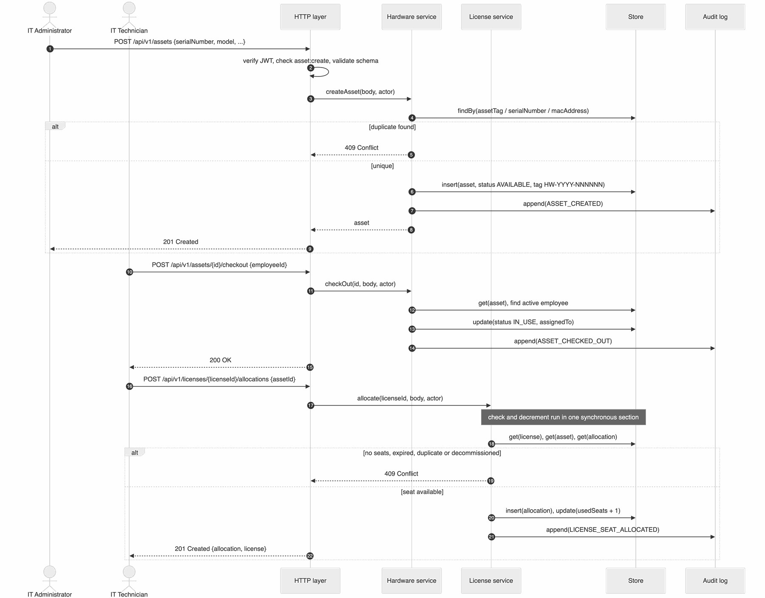
Figure 3: Sequence Diagram 1: Register a laptop, assign it and allocate a license seat

Sequence Diagram 2: Endpoint manifest ingestion, prohibited software and license breach
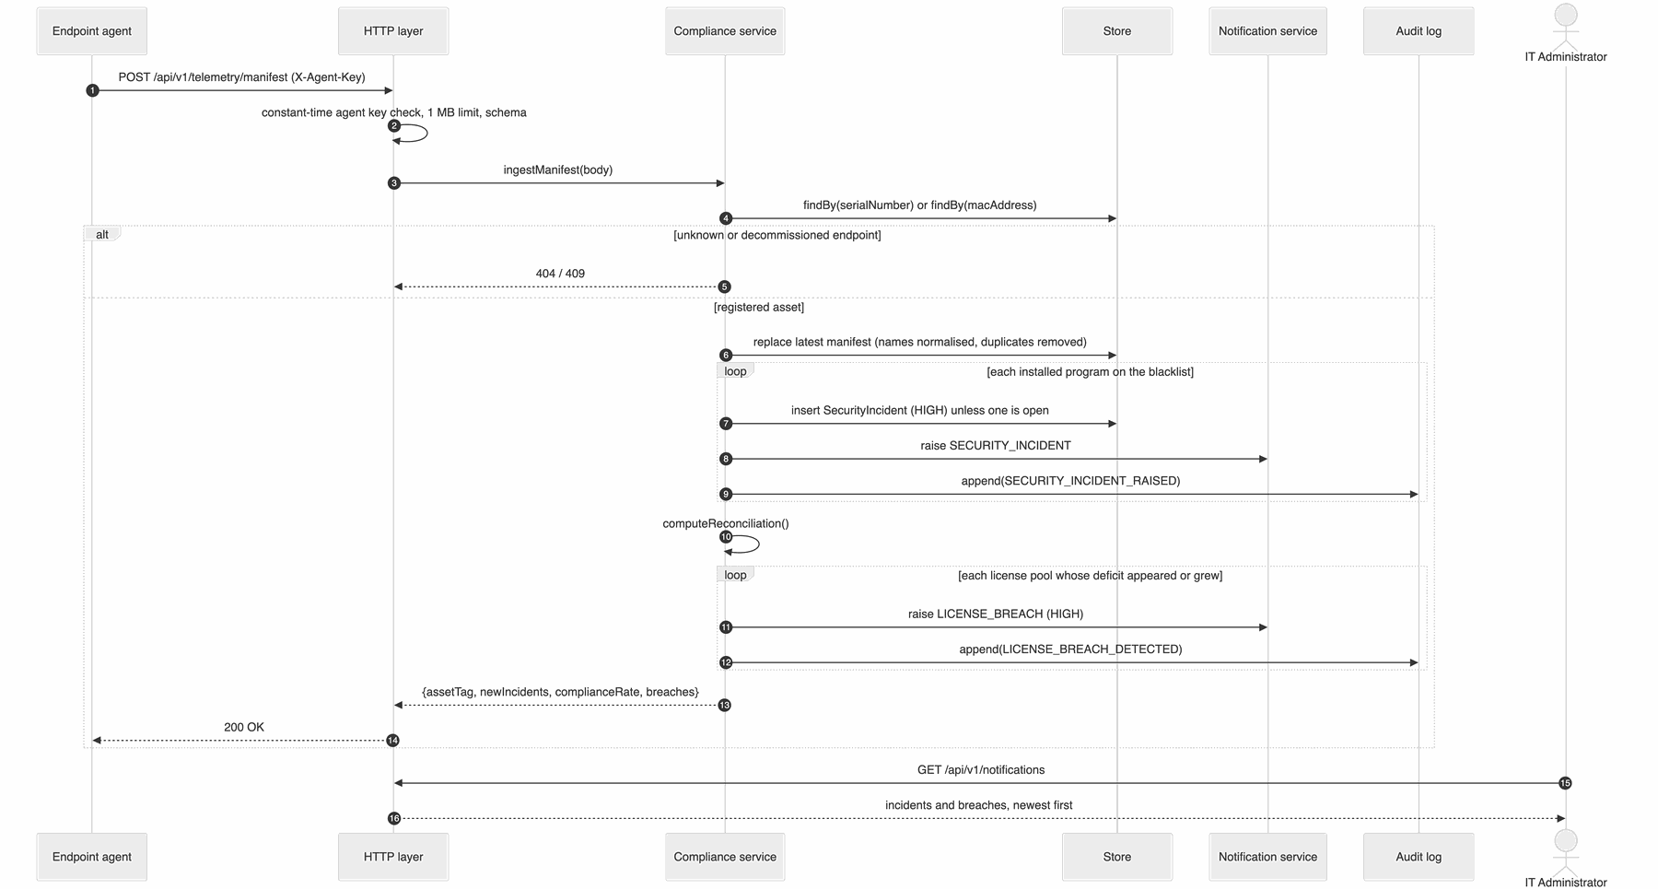
Figure 4: Sequence Diagram 2: Endpoint manifest ingestion, prohibited software and license breach

Sequence Diagram 3: Requisition approval and delivery onboarding
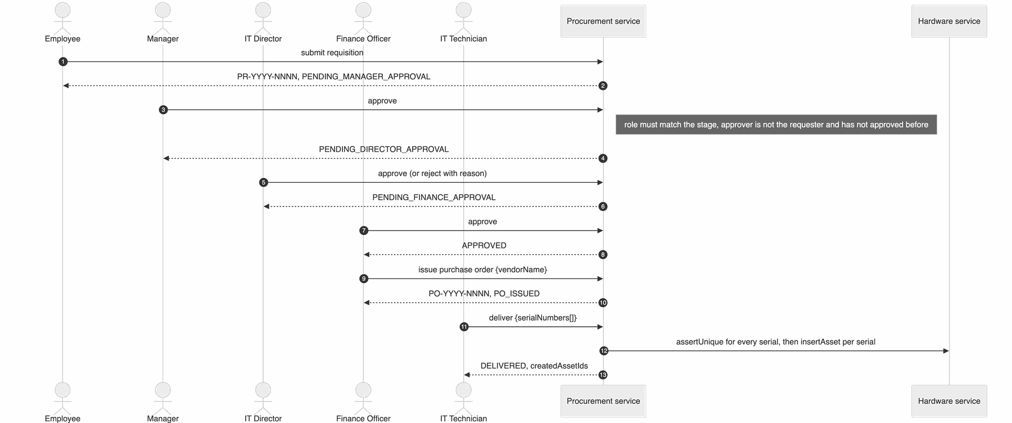
Figure 5: Sequence Diagram 3: Requisition approval and delivery onboarding

4.3 API Design
All endpoints are under /api/v1, accept and return JSON, and require Authorization: Bearer <token> unless noted. Errors use RFC 7807 problem details (section 4.4). Status codes common to all protected endpoints: 401 (missing or invalid token), 403 (role lacks permission), 429 (rate limited).
Endpoint summary
Method and path | Permission | Purpose
POST /auth/login | public | Obtain an access token
GET /auth/me, GET /dashboard/summary, GET /me/assets | any role | Current user, overview, own devices
GET /directory/employees | asset:assign | Active people (employee ID, name, department) for assignment pickers
POST /assets | asset:create | Register asset
GET /assets?status&category&q&page&pageSize | asset:read | Search assets
GET /assets/{id}, GET /assets/by-tag/{tag}, GET /assets/{id}/label.svg | asset:read | Read, scan lookup, barcode label
POST /assets/{id}/checkout, POST /assets/{id}/checkin | asset:assign | Assignment
GET /assets/{id}/depreciation?method&salvageValue&lifespanYears&rate&asOf | asset:read | Depreciation
GET/POST /assets/{id}/maintenance, POST /assets/{id}/maintenance/{mid}/complete | asset:read / asset:maintain | Maintenance
POST /assets/{id}/decommission | asset:decommission | Decommission
POST /licenses, GET /licenses, GET /licenses/{id} | license:manage / license:read | License pools
GET /licenses/{id}/key | license:reveal-key | Reveal raw key
GET/POST /licenses/{id}/allocations, DELETE /licenses/{id}/allocations/{assetId} | license:read / license:allocate | Seats
POST /telemetry/manifest | agent key | Manifest ingestion
GET/POST /compliance/blacklist, GET /compliance/incidents, POST /compliance/incidents/{id}/resolve | compliance:read / compliance:manage | Blacklist and incidents
GET /compliance/reconciliation | compliance:read | Current reconciliation, computed without side effects (used by dashboards)
POST /compliance/reconcile, GET /compliance/report?format=json|csv | compliance:manage / compliance:read | Reconciliation with breach alerts; audited report
POST /alerts/expiry/run, GET /notifications | alerts:run / notifications:read | Alerts
POST /procurement/requisitions, GET /procurement/requisitions[/{id}] | procurement:request / own or read-all | Requisitions
POST /procurement/requisitions/{id}/approve, /reject | stage role | Approval chain
POST /procurement/requisitions/{id}/purchase-order | procurement:order | Issue PO
GET /procurement/purchase-orders[/{id}], POST /procurement/purchase-orders/{id}/deliver | read-all / procurement:receive | POs and delivery
GET /audit, GET /audit/verify | audit:read | Audit trail
GET /admin/users | admin:users | User list

Component 1: Hardware Asset Management
Register asset — POST /api/v1/assets
Request:
{
"serialNumber": "5CD1234XYZ",
"manufacturer": "Dell",
"model": "Latitude 5430",
"category": "LAPTOP",
"purchaseDate": "2026-03-15",
"purchaseCost": 1250,
"warrantyExpiry": "2029-03-15",
"macAddress": "00:1A:2B:3C:4D:5E",
"specifications": { "cpu": "Intel Core i7-1265U", "ramGb": 16 }
}

Response 201 Created:
{
"id": "adbf1287-3d33-4bdd-b31d-df2290a7b232",
"assetTag": "HW-2026-000001",
"serialNumber": "5CD1234XYZ",
"manufacturer": "Dell",
"model": "Latitude 5430",
"category": "LAPTOP",
"purchaseDate": "2026-03-15",
"purchaseCost": 1250,
"warrantyExpiry": "2029-03-15",
"macAddress": "00:1A:2B:3C:4D:5E",
"location": null,
"specifications": { "cpu": "Intel Core i7-1265U", "ramGb": 16 },
"status": "AVAILABLE",
"assignedTo": null,
"assignmentHistory": [],
"totalMaintenanceCost": 0,
"source": "MANUAL",
"purchaseOrderId": null,
"decommission": null,
"createdAt": "2026-10-22T11:00:46.693Z",
"updatedAt": "2026-10-22T11:00:46.693Z"
}

Errors: 400 validation failure (lists every problem in errors), 409 duplicate tag, serial number or MAC address, 403 caller is not an administrator.
Check out asset — POST /api/v1/assets/{id}/checkout
Request:
{ "employeeId": "EMP-0101", "notes": "New starter laptop" }

Response 200 OK (abridged; the full asset is returned):
{
"id": "adbf1287-3d33-4bdd-b31d-df2290a7b232",
"assetTag": "HW-2026-000001",
"status": "IN_USE",
"assignedTo": "EMP-0101",
"checkedOutAt": "2026-10-22T11:00:46.716Z",
"assignmentHistory": [
{ "employeeId": "EMP-0101", "checkedOutAt": "2026-10-22T11:00:46.716Z", "notes": "New starter laptop" }
]
}

Errors: 404 asset or employee not found, 409 asset is not AVAILABLE (for example "Asset cannot be checked out while IN_USE").

Component 2: Software License Management
Allocate a seat — POST /api/v1/licenses/{licenseId}/allocations
Request:
{ "assetId": "adbf1287-3d33-4bdd-b31d-df2290a7b232" }

Response 201 Created (license abridged):
{
"allocation": {
"id": "2be5b7b0-be26-480f-89e5-b90587e2a06e:adbf1287-3d33-4bdd-b31d-df2290a7b232",
"allocationId": "7101c03d-f397-4775-9910-09e81f5277c6",
"licenseId": "2be5b7b0-be26-480f-89e5-b90587e2a06e",
"assetId": "adbf1287-3d33-4bdd-b31d-df2290a7b232",
"assetTag": "HW-2026-000001",
"userId": "EMP-0101",
"allocatedAt": "2026-10-22T11:00:46.720Z",
"allocatedBy": "technician"
},
"license": {
"id": "2be5b7b0-be26-480f-89e5-b90587e2a06e",
"softwareName": "IntelliJ IDEA Ultimate",
"totalSeats": 1,
"usedSeats": 1,
"availableSeats": 0,
"licenseKeyMasked": "XXXX-XXXX-XXXX-9876",
"hasKey": true
}
}

Errors: 404 license or asset not found; 409 with one of: no available seats, asset already holds a seat, license expired, asset decommissioned.
{
"type": "/problems/conflict",
"title": "Conflict",
"status": 409,
"detail": "No available seats: all 1 seats of IntelliJ IDEA Ultimate are allocated",
"instance": "/api/v1/licenses/2be5b7b0-be26-480f-89e5-b90587e2a06e/allocations",
"requestId": "de123613-94e4-42b7-8f10-cce52fe2576b"
}

Component 3: Endpoint Telemetry
Submit manifest — POST /api/v1/telemetry/manifest with header X-Agent-Key
Request:
{
"serialNumber": "5CD1234XYZ",
"hostname": "eng-laptop-01",
"agentVersion": "1.0.0",
"installedSoftware": [
{ "name": "IntelliJ IDEA Ultimate", "version": "2026.2" },
{ "name": "BitTorrent.exe", "version": "7.11" }
]
}

Response 200 OK:
{
"assetId": "adbf1287-3d33-4bdd-b31d-df2290a7b232",
"assetTag": "HW-2026-000001",
"softwareCount": 2,
"newIncidents": [
{
"id": "0756a0f8-337e-4df1-bb4a-79978e510e57",
"assetTag": "HW-2026-000001",
"softwareName": "BitTorrent.exe",
"normalizedName": "bittorrent",
"classification": "PROHIBITED_SOFTWARE",
"severity": "HIGH",
"status": "OPEN",
"recommendedAction": "Quarantine the endpoint and uninstall the prohibited software"
}
],
"complianceRate": 100,
"breaches": []
}

Errors: 400 neither serial number nor MAC given, 401 missing or wrong agent key, 404 endpoint not registered, 409 asset decommissioned, 413 manifest larger than 1 MB.

Component 4: Procurement
Approve a requisition — POST /api/v1/procurement/requisitions/{id}/approve
Request:
{ "comment": "Within team budget" }

Response 200 OK (abridged):
{
"prNumber": "PR-2026-0001",
"estimatedTotal": 900,
"state": "PENDING_DIRECTOR_APPROVAL",
"approvals": [
{ "stage": "PENDING_MANAGER_APPROVAL", "role": "MANAGER", "approverName": "Manu Manager", "comment": "Within team budget", "at": "2026-10-22T11:00:46.784Z" }
]
}

Errors: 403 wrong role for the stage ("This stage requires the MANAGER role"), own requisition, or already approved by this person; 404 not found; 409 not awaiting approval.

4.4 Error Handling, Logging & Monitoring
- Errors: every error is an RFC 7807 document with type, title, status, detail, instance and requestId; validation errors add an errors array; 429 responses add Retry-After. Unexpected exceptions are logged with their stack trace server-side and returned as a generic 500 with no internal detail.
- Logging: one JSON line per request (timestamp, level, requestId, method, path, status, durationMs, userId, ip) plus lifecycle events. Passwords, tokens and product keys are never logged. A caller-supplied X-Request-Id (8 to 64 safe characters) is propagated; otherwise one is generated.
- Monitoring: /health/live (process up) and /health/ready (accepting traffic, persistence healthy; 503 during shutdown or after a failed snapshot write). The business audit trail is separate from operational logs and can be verified at any time via /api/v1/audit/verify.

4.5 UX Design
Structure. A sign-in screen (brand panel plus sign-in card with one-click demo-role chips that fill the username) and an application shell: a sidebar with role-filtered navigation and badges (requests awaiting the user, high-severity alerts), a sticky top bar with the page title, a global asset-tag search (/ shortcut, scanner friendly), the theme toggle and an alerts shortcut. Views are addressed by URL hash (#/assets), so links and the browser back button work.
Views.
View | Content | Roles
Overview | Greeting with context ("1 request worth $4,798 needs your attention"), stat tiles, fleet-status stacked bar, compliance ring meter, seat-utilisation meters, recent alerts, requests waiting for the user, own devices | All (content varies by role)
Hardware assets | Search and filters, paginated table; selecting a row opens a side panel with the barcode label (downloadable), details, depreciation, assignment timeline and maintenance log, plus check-out / check-in / log-maintenance actions | IT staff, auditors
Software licenses | Summary tiles (pools, seat use, renewals due, expired), table with masked keys, seat meters and expiry badges; Super Admins can reveal a key (audited) | IT staff, auditors
Procurement | Filter chips (needs my action, in progress, delivered, rejected) and request cards with a six-step approval stepper and the actions valid for the user's role and the request's state | All
Compliance | Compliance ring, deficit / unlicensed / incident tiles, audit-chain integrity, reconciliation table, incidents with resolve action, JSON/CSV report download | Admins, auditors
Alerts | Filterable notification feed; admins can run the expiry check on demand | Admins, auditors

Visual language. Design tokens (CSS custom properties) define surfaces, text, accent gradient (indigo to violet) and status colours for both themes; the dark theme is a selected palette, not an inversion. Inter is used for all text with tabular figures only in table columns. Cards use 18 px radii and soft layered shadows; motion is limited to short entrance and progress animations and is disabled under prefers-reduced-motion.
Charts. Chosen by the data's job: a stacked bar for the asset-status split (part-to-whole, fixed categorical colour order validated for colour-vision deficiency with a 2 px gap between segments), a ring meter for the single compliance ratio (same-hue track), linear meters for seat utilisation, and stat tiles for headline numbers. Every chart has a text equivalent (legend with counts and percentages, or the adjacent table), and chart marks show the same value on hover and keyboard focus.
Feedback and states. Toast messages in a polite live region confirm every action; dialogs validate required fields before submitting and show server validation messages inline; skeleton placeholders cover first loads and refreshes keep the previous content at reduced opacity instead of flashing.
Accessibility. Semantic landmarks, skip link, programmatic labels on every control, table captions and header scopes, native <dialog> for modals and the side panel (focus is trapped while open and returned afterwards), visible focus rings, an off-canvas mobile menu that is removed from the tab order when closed, text contrast of at least 4.5:1 (including tinted status pills) and graphics contrast of at least 3:1 in both themes, all verified by TC-UX-01.

4.6 Open Issues & Next Steps
- Implement the endpoint agent (Windows, macOS, Linux) against the documented telemetry API.
- Email and chat delivery of notifications (current delivery is in-app).
- LDAP / Active Directory single sign-on and user provisioning.
- PDF export of the compliance report.
- PostgreSQL implementation of the Store interface for multi-node deployments.
- Periodic external anchoring of the audit head hash (for example in a write-once store).

5. Appendices

5.1 Glossary
ITAM, HAM, SAM, CMDB, PR, PO, RBAC, JWT, TLS, HSTS, CSP, GCM, RPO, RTO, STRIDE, WCAG.

5.2 References
- ISO/IEC/IEEE 42010:2022 Architecture description.
- ISO/IEC 19770-1:2017 IT asset management.
- NIST SP 800-88 Rev. 1, Guidelines for Media Sanitization.
- OWASP Top 10 (2021) and OWASP ASVS 4.0.
- RFC 7519 (JWT), RFC 7807 (Problem Details), RFC 8446 (TLS 1.3).
- WCAG 2.1.

5.3 Tools
Mermaid (diagrams), Node.js test runner, ESLint, GitHub Actions.

